# **Department of Computer Science and Engineering Islamic University of Technology (IUT)** A subsidiary organ of OIC

# **Lab Task**

# **On**

# **Command Pattern**

# SWE 4502

## **Name: SIANA RIZWAN Student ID: 180042105 Semester: Winter semester Academic Year: 2018-1019**

**Date of Submission: 19/08/2021**

UML Diagram

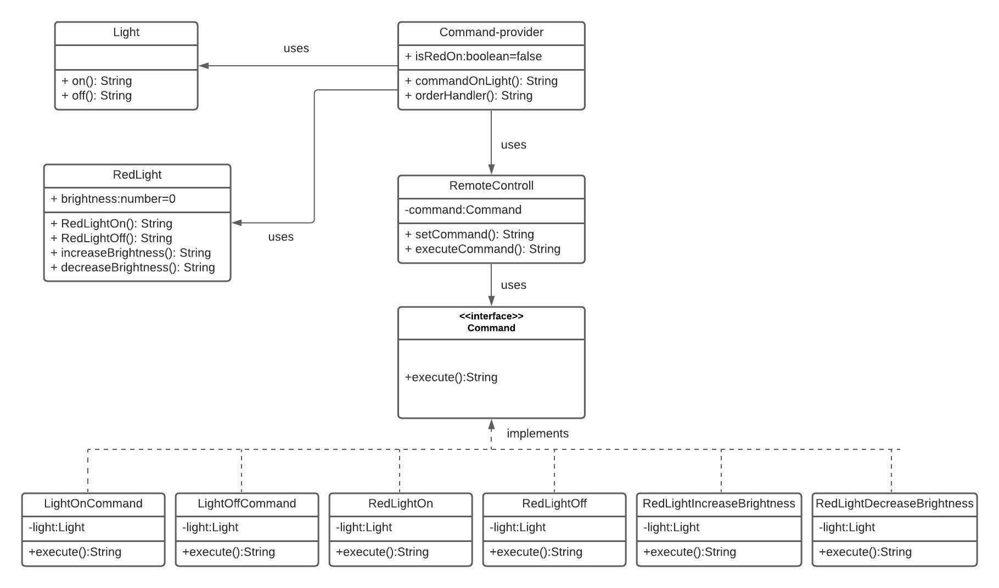

Code Implementation

1. The command pattern design has been implemented in the following way in the file command-RemoteControll.ts-

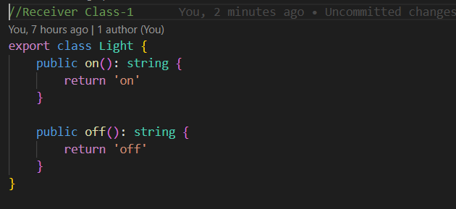

Two receiver classes for normal light on off and red light on off have been created

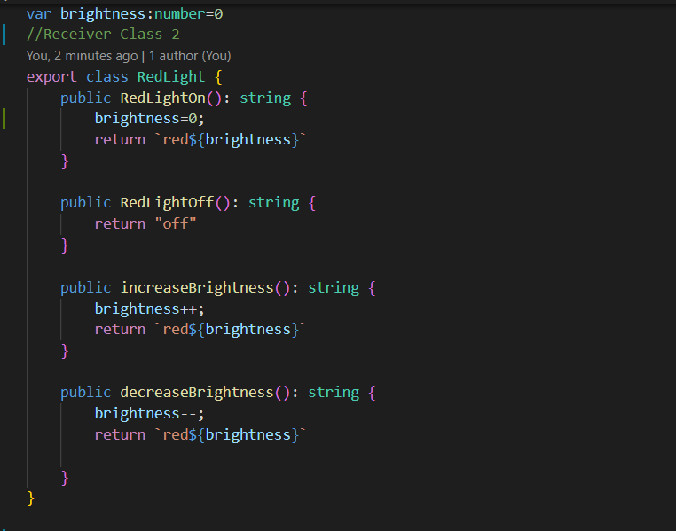

Interface that will bind the commands with receiver class have been created

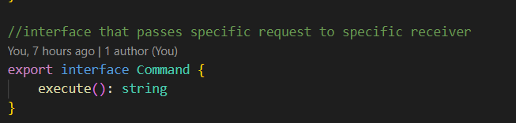

Next classes for specific commands have been created 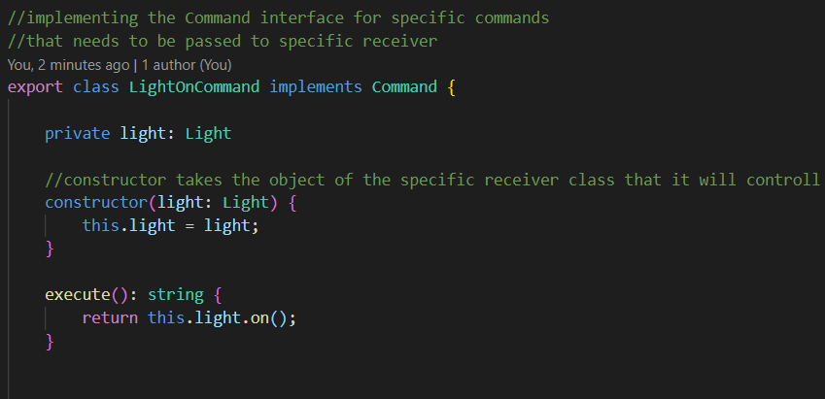

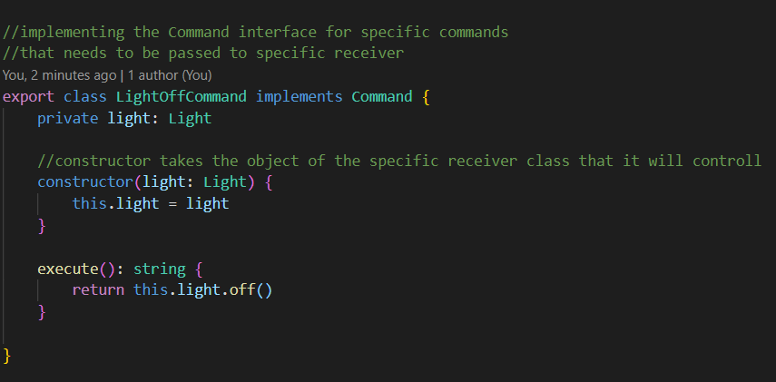

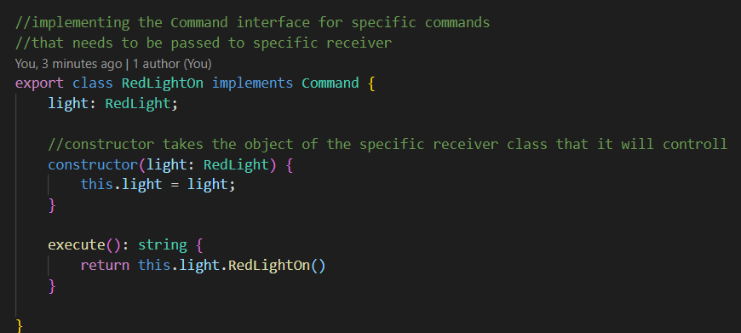

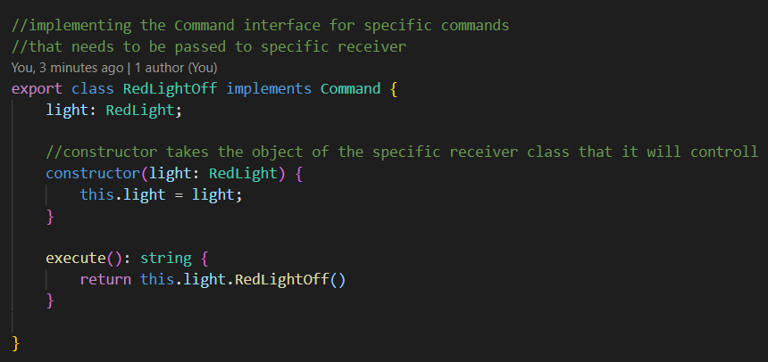

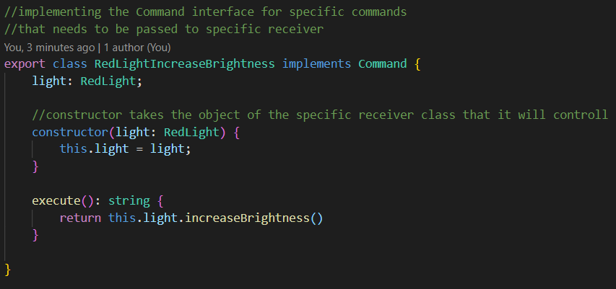

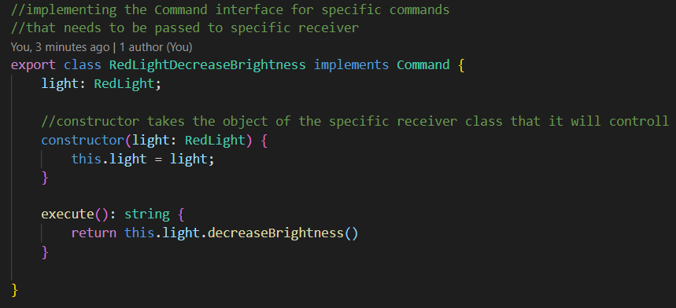

Lastly the invoker class has been created that will be used to invoke the specific command-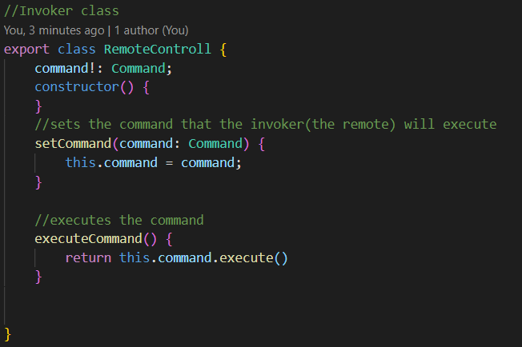

1. Next in the command-provider.ts file, commands have been set and defined according to the ui manipulation

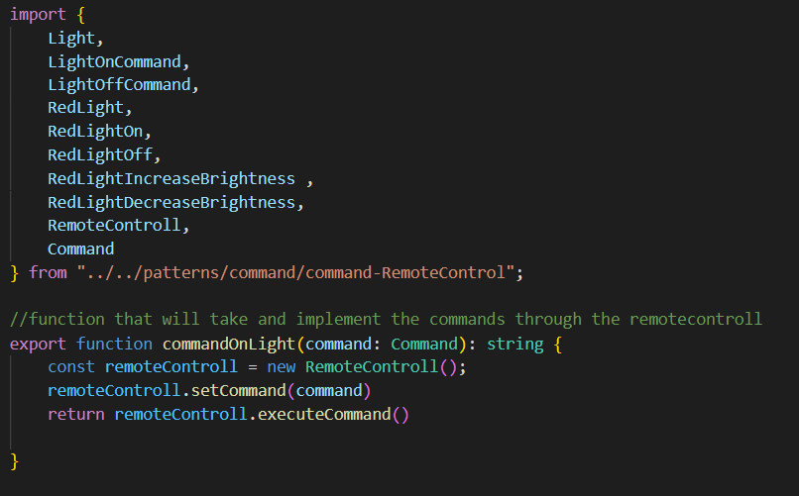

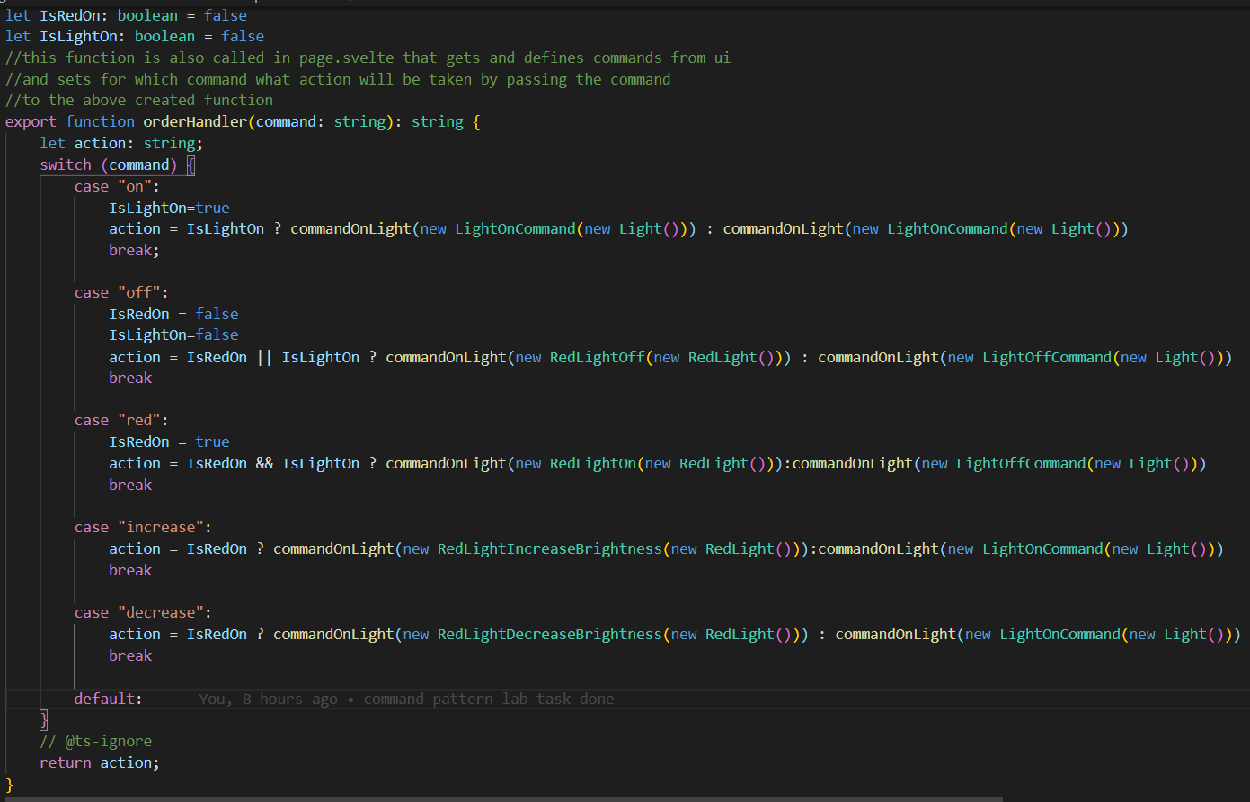

1. Lastly in Page. Svelte the actions in the UI have been set in the following way-

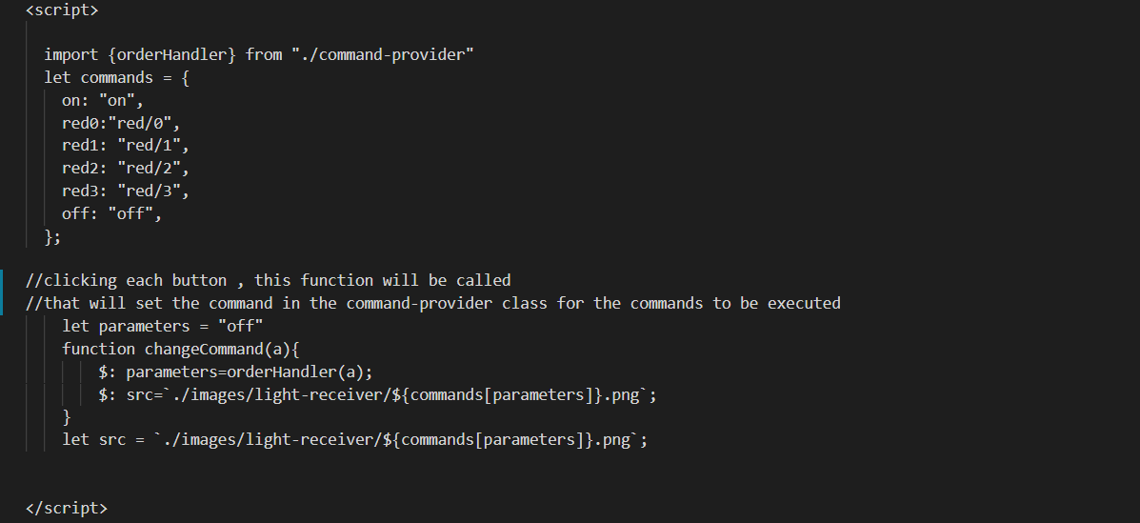

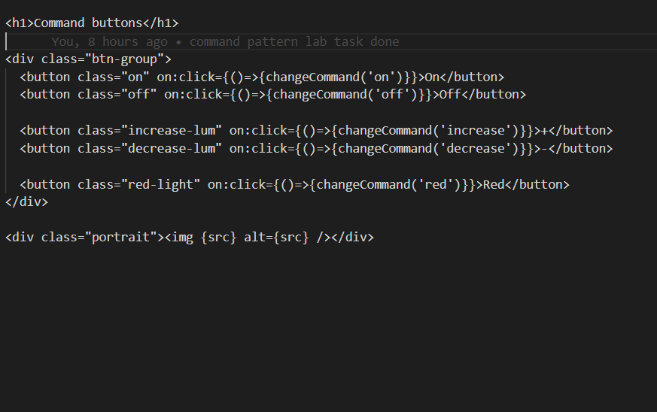

Unit Tests

