**SWE 4404: Software Project Lab II**

**Project Name: NGO Management System (NMS)**

**Team DeadInside**

**Team Members:**

SIANA RIZWAN – 180042105

FARZANA TABASSUM – 180042119

SABRINA ISLAM – 180042122

**Supervisor:**

Mohammad Anas Jawad  
Lecturer  
Department of Computer Science and Engineering  
Islamic University of Technology (IUT), OIC

**Abstract**

The purpose of our project ‘NGO Management System (NMS)’ is to automate the management system of an NGO which is user friendly, easy to manage, fast and cost effective. It deals with information of different type of personnel, inventory and events details and the overall accounts section of a particular NGO.

There are 2 types of users who will use this software- Admin and other type of employees. There is main 4 types of features:

1. Personnel information
2. Inventory
3. Events
4. Accounts

Admin can add personnel information and update or delete one if necessary. He can also manage the inventory. Here we store Food and Health related products in our inventory. An admin can schedule an event and assign employees, doctors, volunteers. He can also see the details of a particular event. As an admin, he can manage the accounts part of the NGO.

As an employee, one can add information of volunteers and donors. He can also assign supply details to an event.

**Introduction**

Defining the Problem:

For our SPL-2 project, we will try to automate the management system of an NGO, that mainly focuses on the health sector (food, basic health care and vaccination) of under privileged people.

Most of the time information regarding the operations of an NGO, is stored across multiple locations digitally or physically. As a result, interpretation of this data becomes messy and error prone. By using this software, one can perform all the necessary operations with just one software.

Purpose:

The purpose of the document is to provide detailed design specifications for the NGO

Management Software (NMS). It analyzes the stakeholders and identifies the problem and feasibility of the software.

Stakeholders:

Besides the three of us, Mohammad Anas Jawad sir can also help you to understand the details

of the project.

Stakeholders of NGO Management System software -

• Admin of the NGO

• NGO Employees

• Doctors

• Manager of an organization (Bernossaus- provides healthcare facilities for women and children)

• Volunteers of different NGO’s

Business Value:

Usually, NGOs store their operational information across multiple platforms- it can be a physical place(notebooks) or multiple virtual places. There is a possibility that while integrating the system one can make mistakes.

The benefits that one can receive from this software include reduction in human labor. By automating all the tasks, we remove the need of having people doing the functions of NGO manually and thus reducing the probability of making mistakes. It will also increase the efficiency of the NGO.

Existing Solution:

We have not found any existing solution for this project in the internet.

Intended Audience:

This SRS is intended for several audiences including the admin of an NGO as well as supervisor, designer, developers and testers of the project.

* The admin of an NGO will use this SRS to verify that the developer team has created a product that is acceptable to their NGO.
* The supervisor will use this SRS to ensure that the developers are on track during development of the system.
* The designer will use it as a basis for creating the layout of the software.
* The developers will use this SRS as a basis for developing the software’s functionality. They will link the requirements defined in this SRS to the software they create to ensure that they have created software that will fulfill the necessary requirements.
* The testers will use this SRS document to create test cases for each requirement. After completing some portions of the project, the testers will run the test cases to ensure that the software is fulfilling the its requirements. They will again run their tests after the project completion to ensure that all requirements documented in this SRS have been fulfilled.

Feasibility:

Since there is no desktop software available on internet aimed to NGO management system that we know of, we need approximately 3 months to build the software.

**Elicitation**

Need of the system:

NGO management system is intended as a tool for simplifying the task of management of an NGO. It automates the functioning of an NGO. It is not built upon any existing similar software and is not a part of any larger project of itself.

Scope of our Services:

The software will store detailed information about the organization’s employees, volunteers, doctors and patients. The admin can keep track of the food and medical essentials.

During this pandemic, it will also store basic COVID-19 protection essentials, so that the NGO can provide the underprivileged people with necessary support and equipment’s if needed.

Technical Environment:

System’s technical environment:

* Language: JavaFX, Java, Sql
* Technologies: IntelliJ, Oracle 18c

Design pattern: We followed MVC design pattern to implement the project.

Domain Constraints:

Employee/admin needs to manually give the input for the volunteers and donors information.

**Usage scenario**

Viewpoints of different users:

After analyzing we found out that the viewpoint of different user is slightly different though the purpose of the application remains the same.

Viewpoint of the Admin:

* User friendly system
* Will be able to create a profile for the other users using which other employees can login to the application
* Will be able to delete or update information of any employee
* Will be able to manage the accounts information, i.e.; will be able to keep a record of utility bills, salary expenses and other extra payments if required
* Will be able to keep a record of the events, that is, register or schedule events and its details (what type of event, when the event will occur etc.) and assign employees, doctors, volunteers.
* Will be able to keep a record of the services provided in any event such as-
  + - If the event is food distribution, then information (item name, quantity distributed, event name, date etc.) regarding food items that will be distributed will be stored
    - If the event is providing medical services, then information (medicine name, quantity distributed, event name, registered doctor, date etc.) regarding the medical service provided will be stored

Viewpoint of other Employees:

* User friendly system
* Will be able to login to the system after the admin verifies his profile
* Will be able to store personal details of the volunteers who will be participating in the events
* Will be able to store personal details of the donor and their donation history
* Will be able to keep a record of the events, that is, register or schedule events and its details (what type of event, when the event will occur etc.)
* Will be able to store, update, delete information details of the food or medical essentials that will be provided during any event, i.e.; manage the inventory
* Will be able to keep a record of the services provided in any event such as-
  + - If the event is food distribution, then information (item name, quantity distributed, event name, date etc.) regarding food items that will be distributed will be stored
    - If the event is providing medical services, then information (medicine name, quantity distributed, event name, registered doctor, date etc.) regarding the medical service provided will be stored

Collaboration of the requirements:

After prioritizing the viewpoints, we came to the following conclusion regarding the requirements of our application-

Final Requirements:

* User friendly, efficient and almost error free system
* Give specific user specific roles for ensuring different types of access
* Users will be able to login and logout
* Users will be able to keep a record of the events, that is, register or schedule events and its details (what type of event, when the event will occur, assigned personnel etc.)
* Users will be able to manage the inventory of the products that will be provided during any event
* Users will be able to keep a record of the services provided in any event according to its type (food or health service) such as- the information (item name, quantity distributed, event name, date etc.) regarding a particular item that will be distributed will be stored.

Summary of Usage Scenario:

There will be two kinds of users for our software: the admin and the employees of an NGO. The Admin will have the full access to the software and he can use all the features. The employees will be verified by the admin and they will manage the supply, service and event sections.

From employees’ perspective

Apart from the admin, all other employees need to registered by the admin before accessing the software. After signing in to the software, the employee can see the following tabs-

1. Employee
2. Doctor
3. Donor
4. Volunteer
5. Supply details
6. Event details
7. Log out

Upon selecting Employee/Doctor tab, an employee can view a list of all employees /doctors.

Upon selecting Donor tab, an employee can add a donor (name, dob, gender, email, phone number, address, occupation) or update/delete an existing one. Same goes for Volunteer tab.

Under Supply tab, s/he can choose any of the four options: Food, Medical, Vaccine, Emergency. There s/he can add new supplies (name, amount, unit price, purchase date, expiry date (if available), suppliers) that will be used in NGO’s event section and update or delete any supplies if necessary. The employee can also view the NGO’s current inventory which will be sorted by date.

The employees can select Event tab where he can see the current and upcoming events. Upon clicking on them he can assign volunteers and supply details. If it is a food related event, then food inventory will be shown. And if it is a health care related event, then the corresponding inventory will be shown. He can also insert the necessary amount of a product.

Upon clicking on the log out tab, the employee will be logged out of the software. S/he needs to sign in again to access the software.

From admin’s perspective

The admin has supreme power over the software. When first using the software, s/he needs to register to the software. After that, the admin can sign in to the software. The admin has access to the following tabs-

1. Employee
2. Doctor
3. Donor
4. Volunteer
5. Supply details
6. Event details
7. Accounts
8. Log out

The admin can register an employee (name, dob, gender, email, phone number, address, designation) and update or remove them when necessary.

He can also register a doctor (name, dob, gender, email, phone number, address, specialty, qualification, available hour) and update or remove them when necessary.

The functionalities for Donor, Volunteer, and Supply details are same as employee.

Upon clicking on Event details tab, admin can view the number of current and upcoming events and the list of those events. He can schedule an event (event type, name, date). He can also manage the events by inserting extra expense, changing the dates and assigning employees, volunteers and doctors. A detailed list of all the events are stored where he can see the corresponding budgets, personnel information, supply information according to the provided date.

The admin will handle the Account Tab. Admin can view the current financial situation of the company and he can also view the report generated monthly. There are four options to choose-

1. Salaries
2. Expenses
3. Event expense
4. Donation

Upon selecting Salaries, the admin can add a new designation along with its basic salary and update or remove one. The admin can also view the list of the designations along with how many employees are in that position.

All sort of expenses including rent, electricity bill, internet bill etc. can be added in Expenses Section according to the date. The admin can also view the list of the previous utility expenses according to the date. If there are any additional expenses made by the NGO, that information will also be stored under the Other Expenses Option.

The admin can view the expenses of an event according to a month.

The admin can add the detailed info (donor’s name, donation date, donation type, donation amount) under the Donation option. The admin can see a brief list regarding the donations according to the provided month.

Upon clicking on the log out tab, the admin will be logged out of the software. S/he needs to sign in again to access the software.

**Design**

Logical Design of the database (ERD):

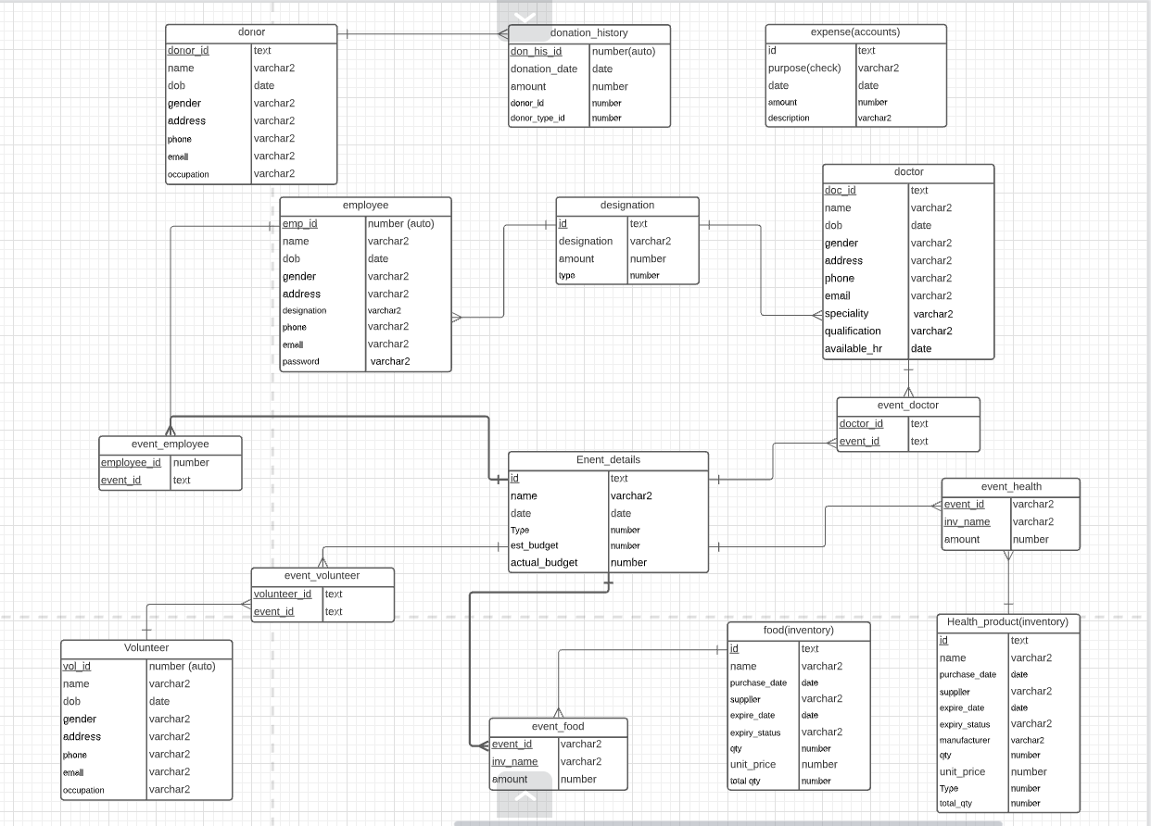

**Data Flow Modelling**

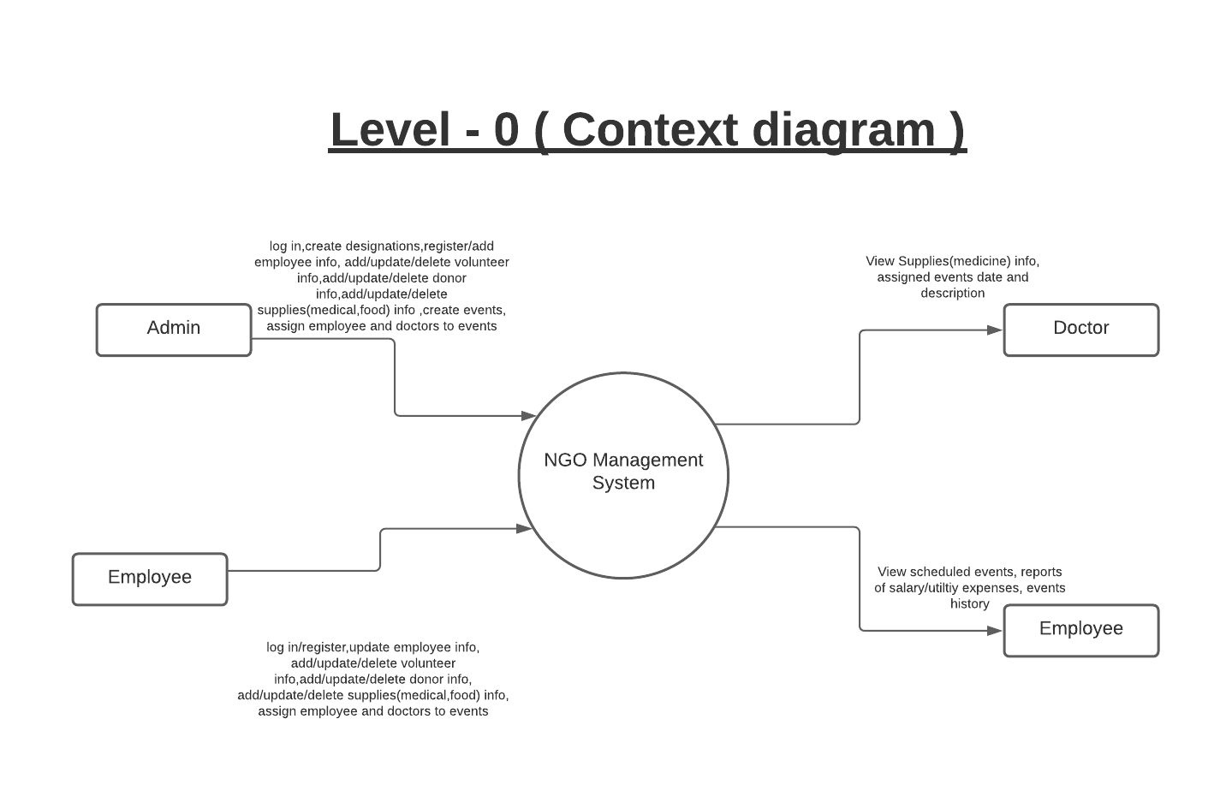

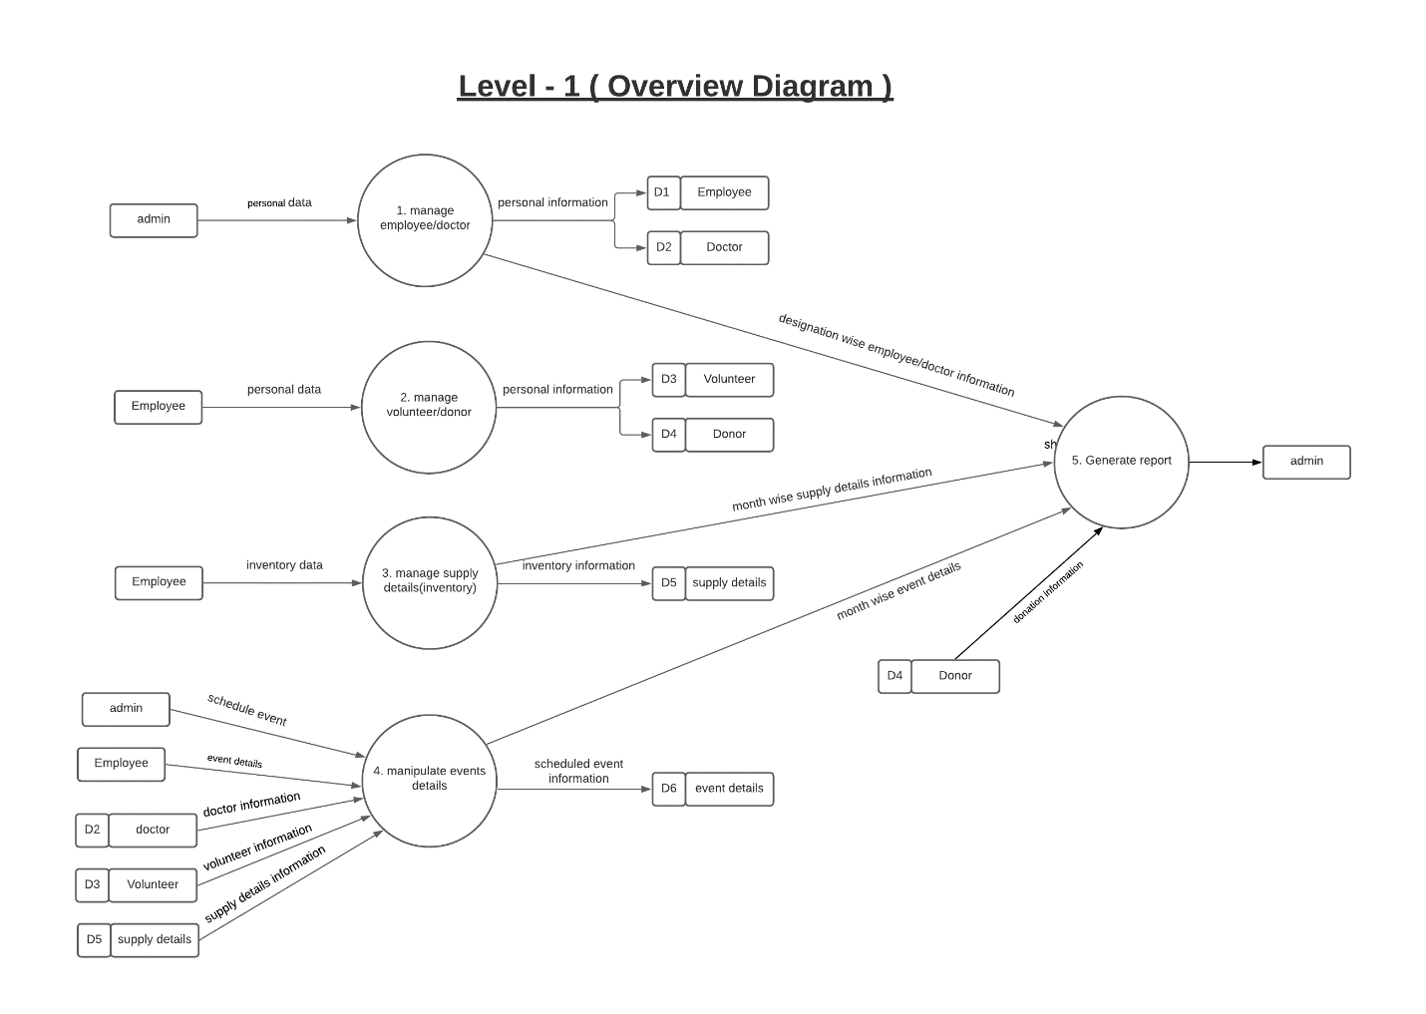

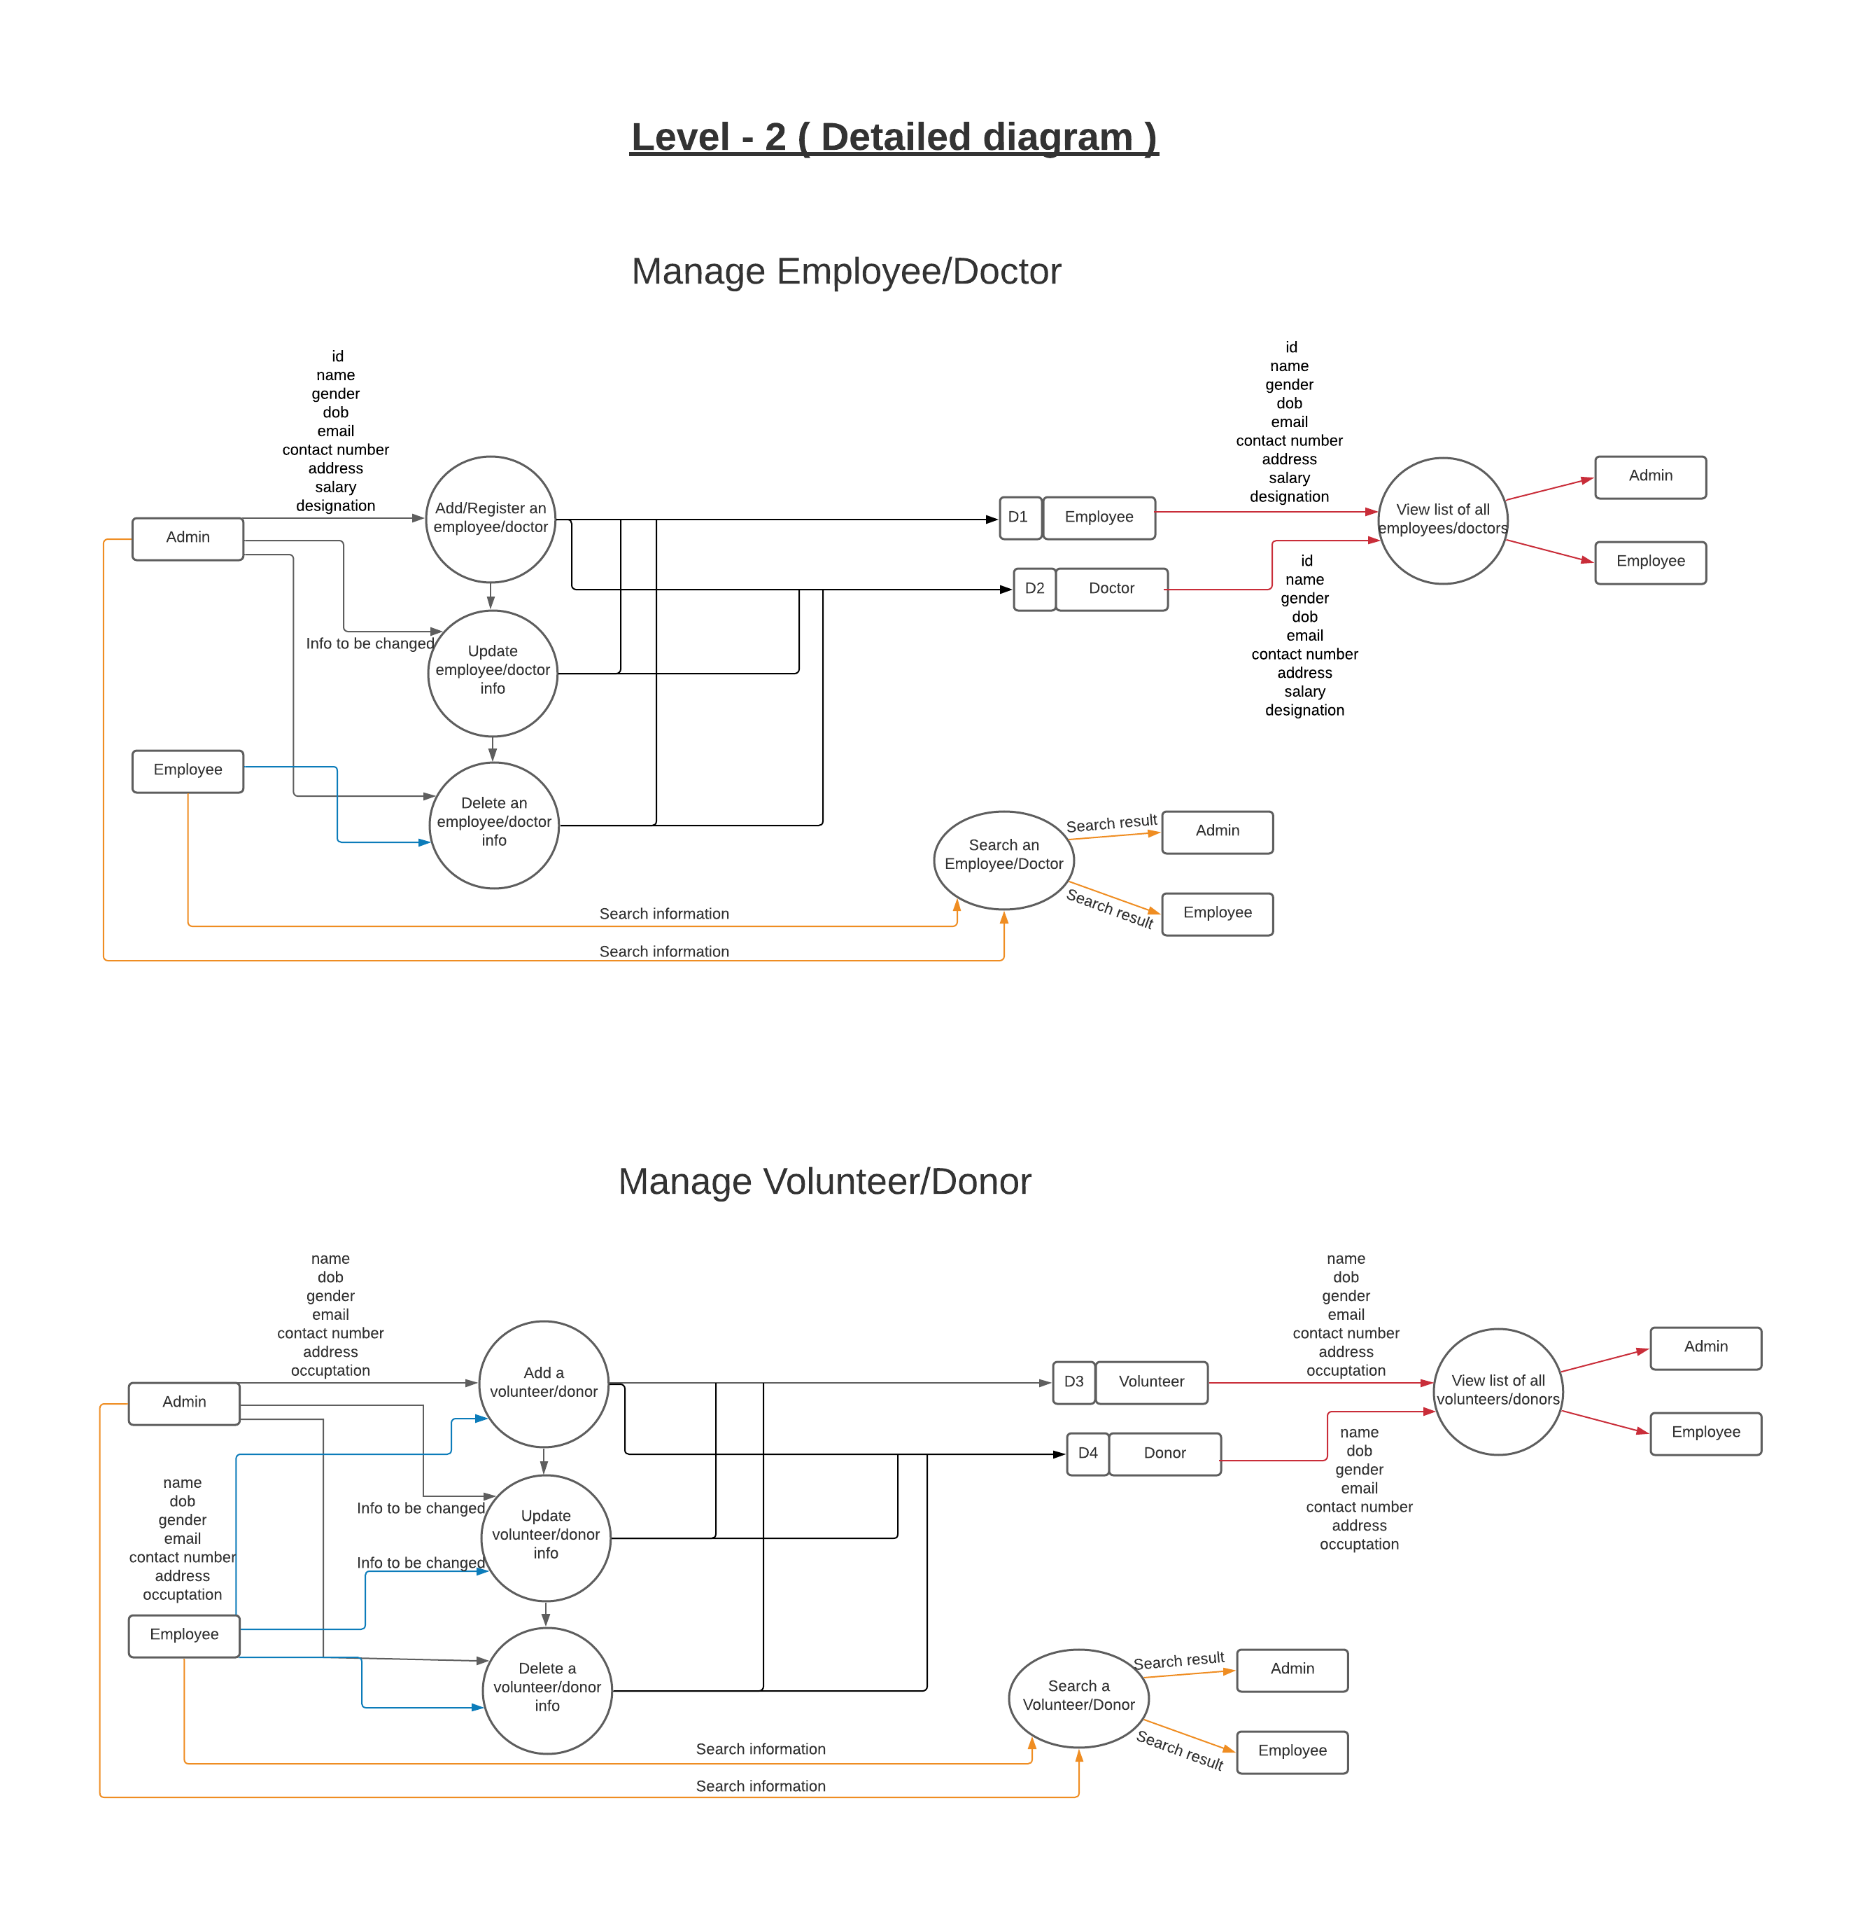

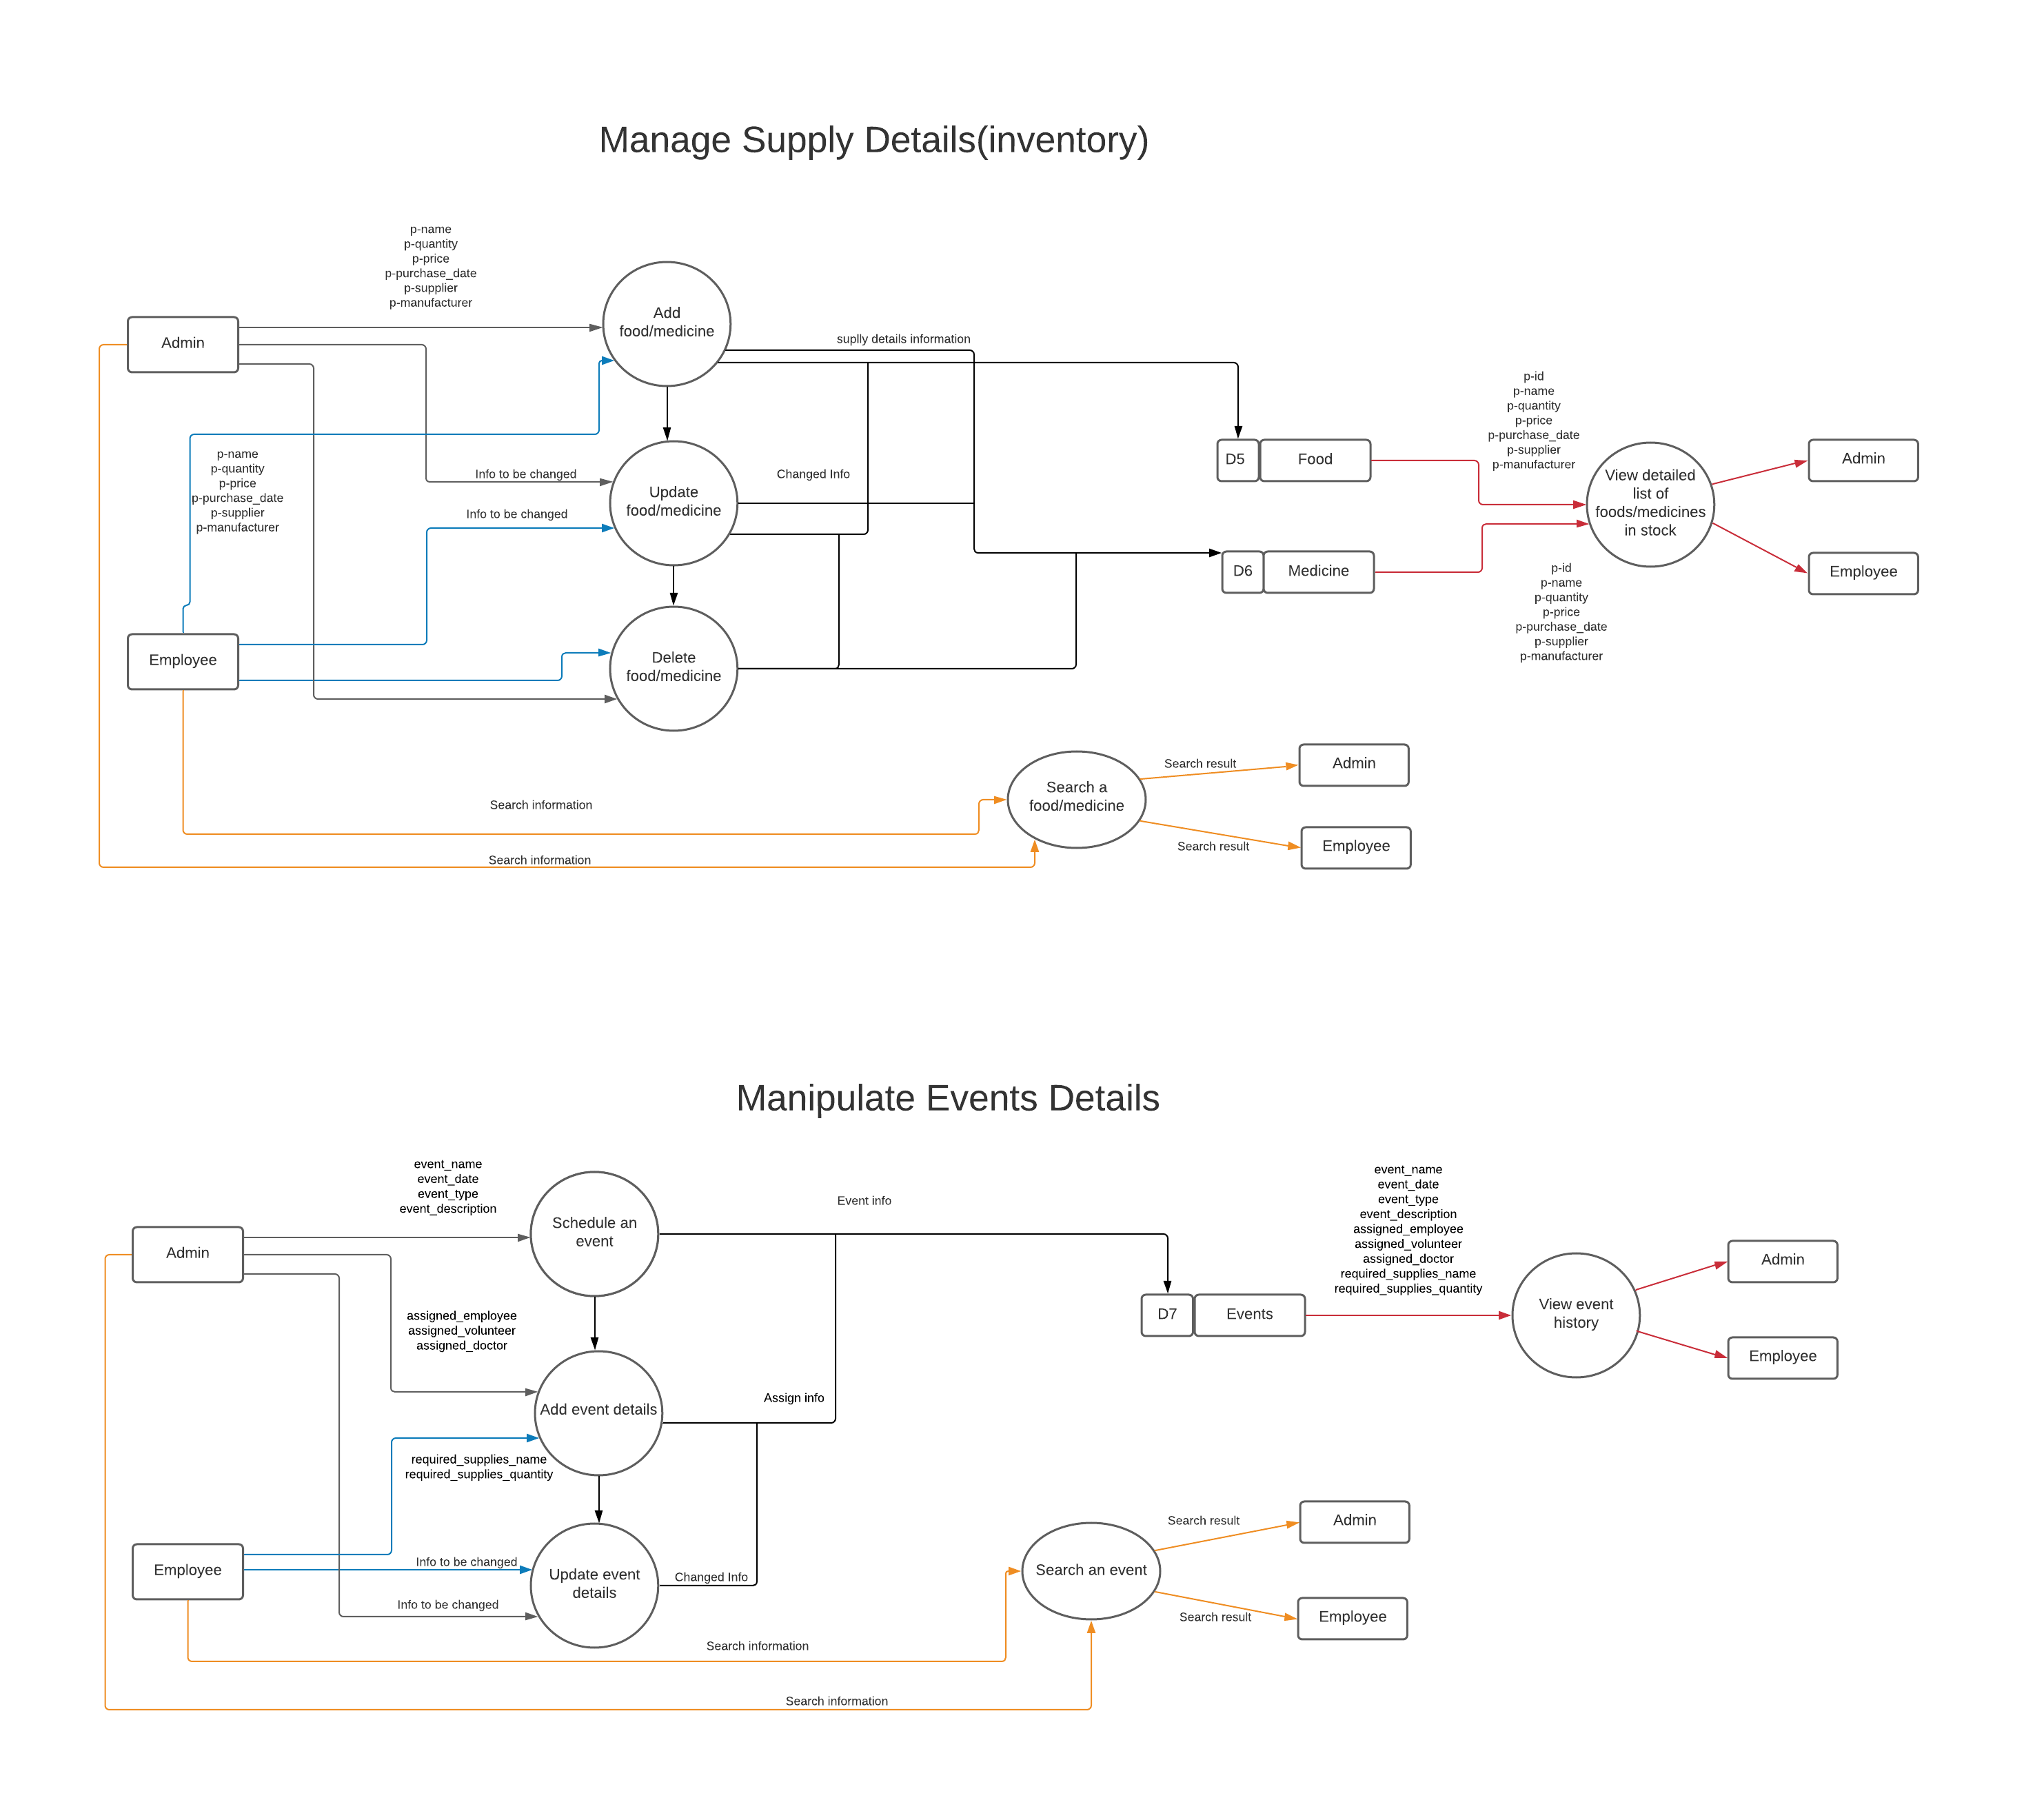

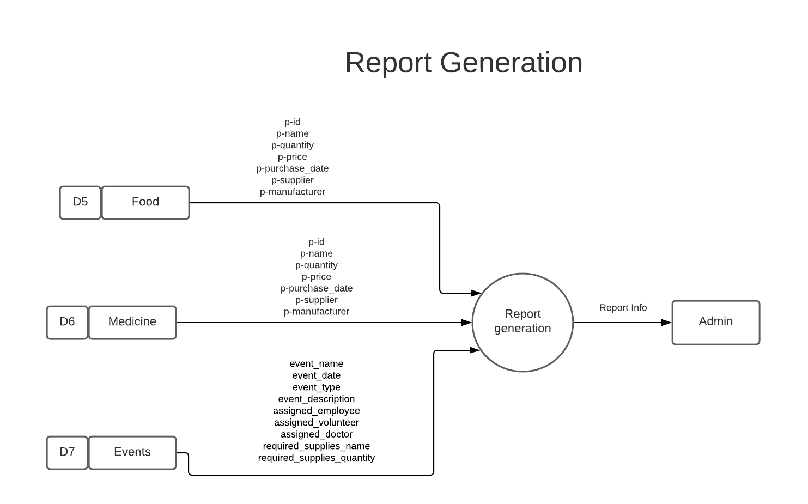

**Timeline**

**System Design with Screenshots**

Implementation:

Implementation is the stage of the project when the theoretical design is turned out into a working system. Thus, it can be considered to be the most critical stage in achieving a successful new system and in giving the user, confidence that the new system will work and be effective.

The implementation stage involves careful planning, investigation of the existing system and its constraints on implementation, designing of methods to achieve changeover and evaluation of changeover methods.

Graphic User Design (GUI) Design:

1. Register Panel:

User can create his/her own profile through registering to the system. Then using that account he/she can login to the system. But the designation of the user can only be added by the admin.

Without being assigned to a designation, the user cannot continue to work further on the features like scheduling and managing events, assigning anybody or anything to the event etc.

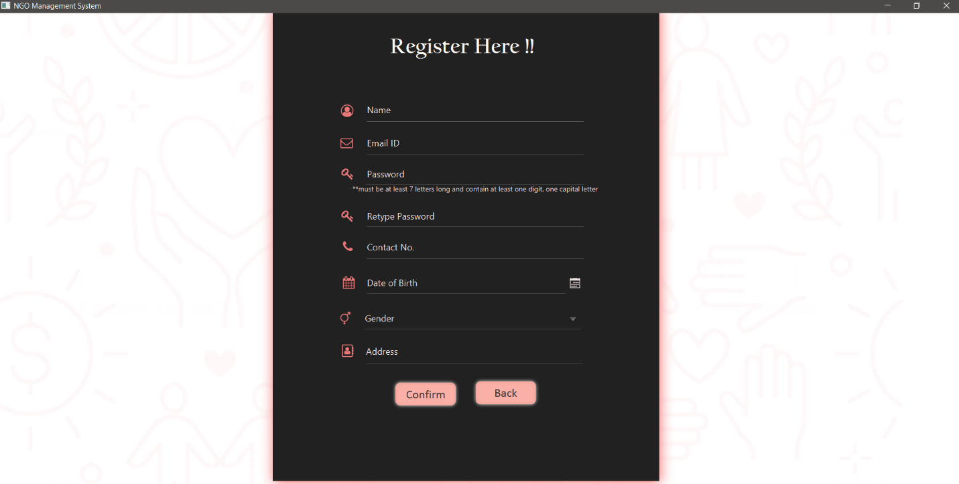

1. Login Panel:

User can login to the system using id name and password. The password is hashed and then stored to the database for security purposes.

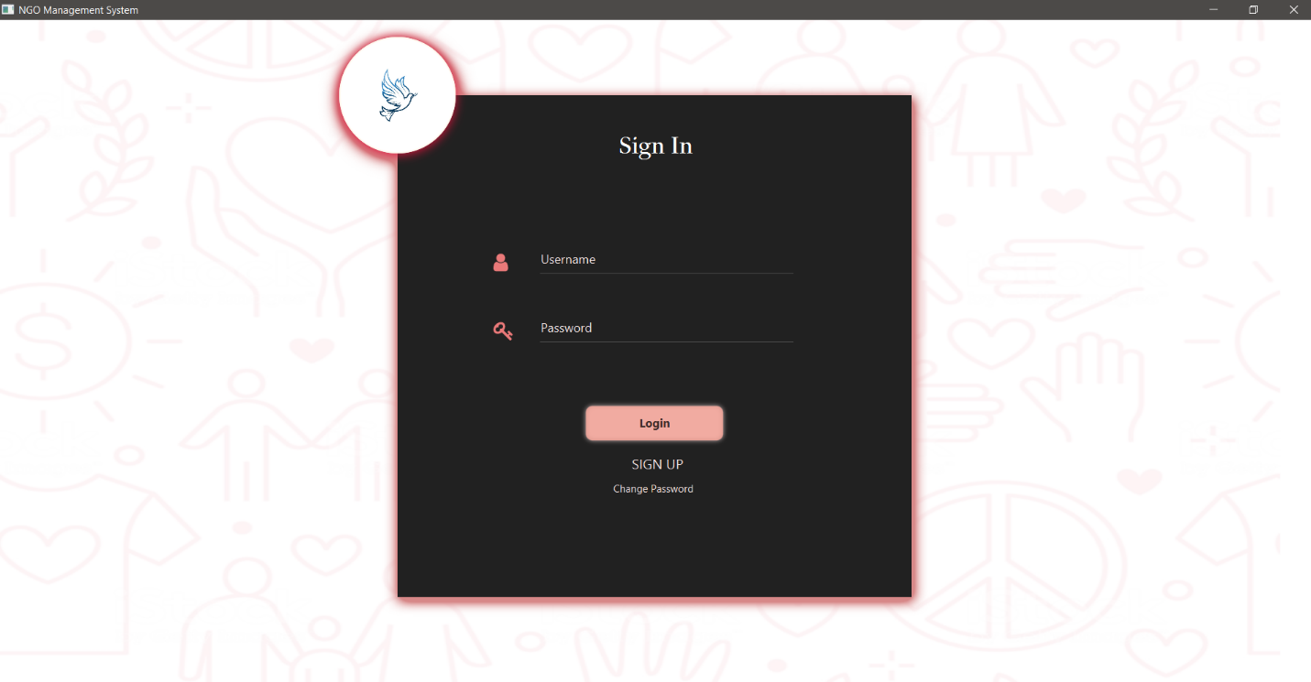

1. Dashboard:

The image of the dashboard for the admin is provided below. The dashboard for the other employees or stuffs won’t be containing the Accounts tab on the left side.

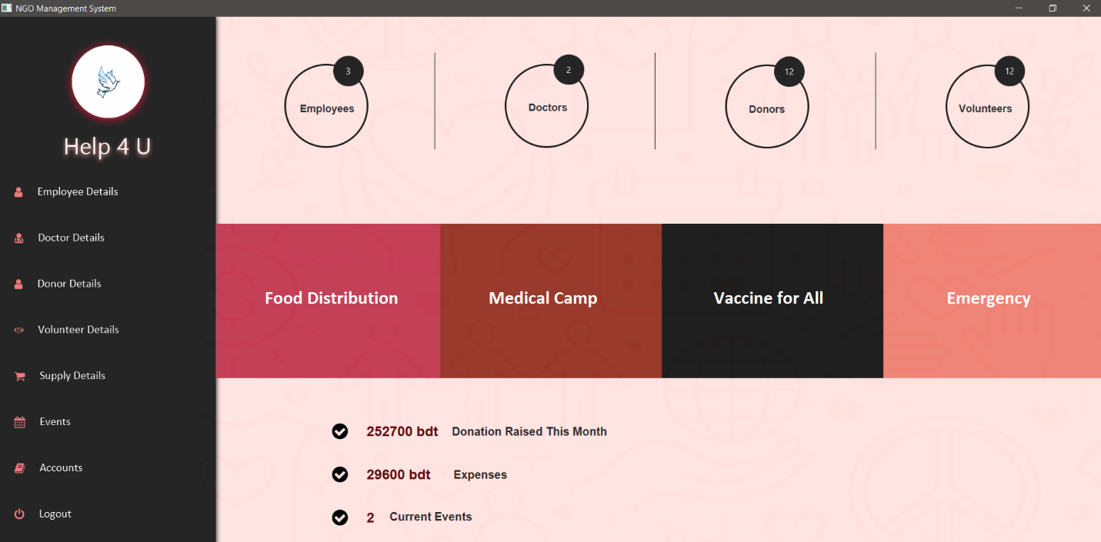

1. Personal Information:

In our system we will be storing the personal details of 4 categories of people namely of – employees, doctors, donors and volunteers. We can add, or delete information of any person and also can update some fields as necessary. We can also view the details of each person by doble clicking on the person in the table as provided in the image.

The admin has access to all the features mentioned above. But in case of other employees, they can only view the details of other employees. They don’t have access to edit any of the personal information of the other employees. In case of doctor, donor and volunteer, the employees other than the admin have access to all the features mentioned above.

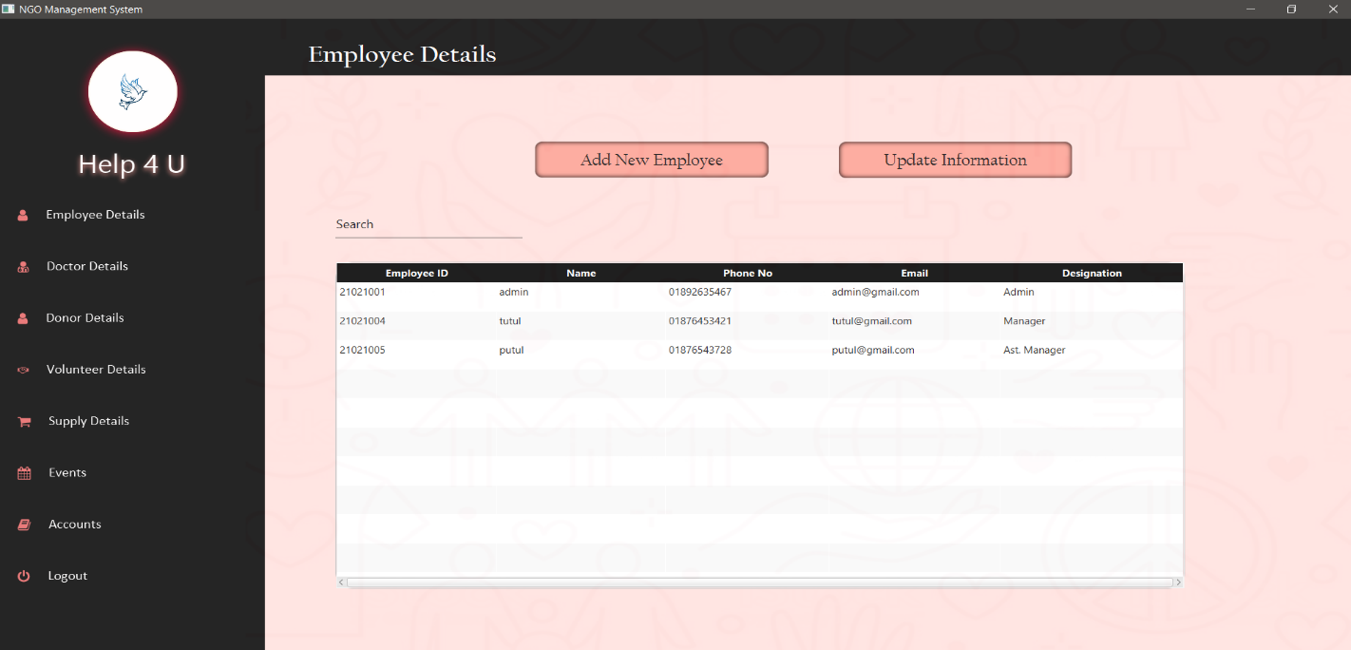 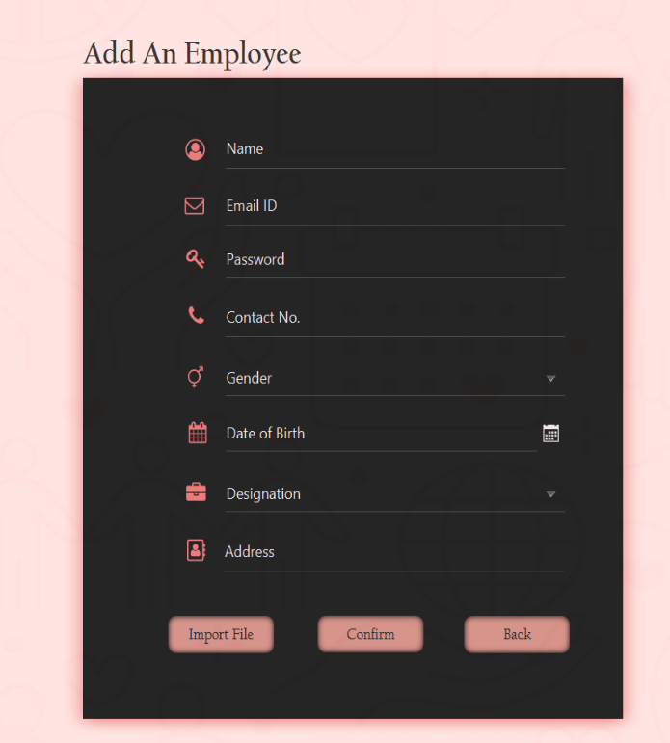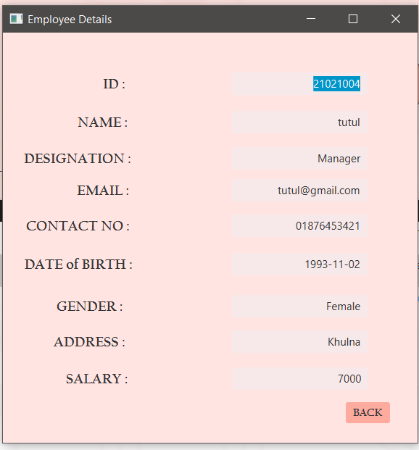

Similar UI for the doctor, donor and volunteer information add.

In the Donor details tab, there will be another extra button for adding the donation amount which is considered as the only incoming source for our Ngo according to our modelling.

Both the admin and other users of the system will have access to it.

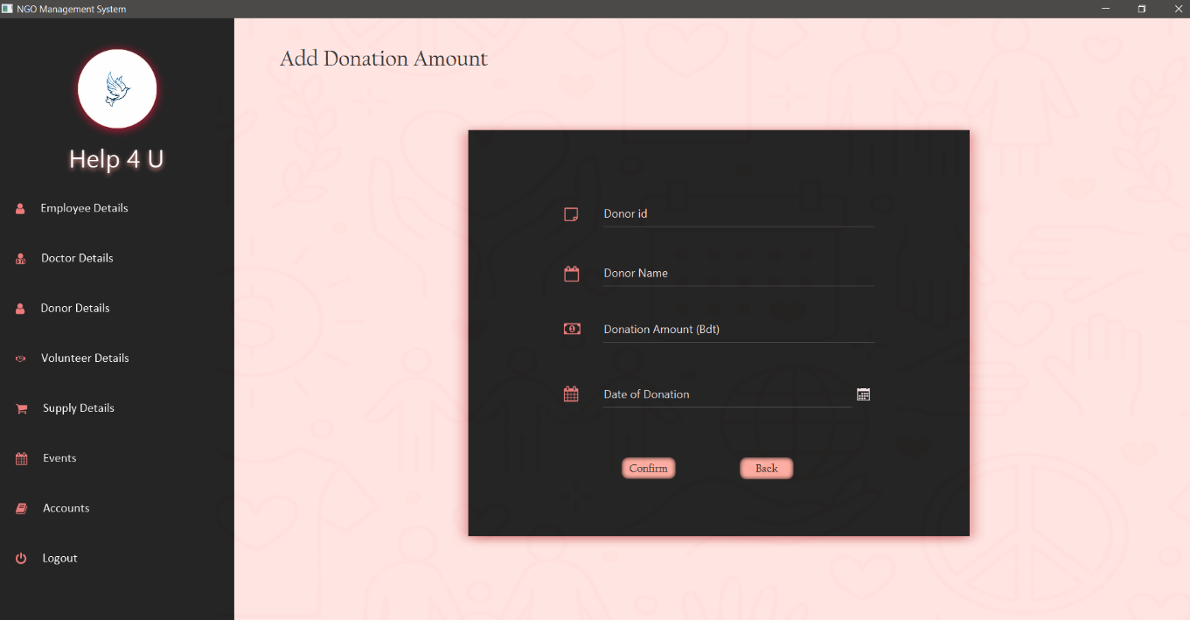

1. Supply Details:

For our Ngo, we have assumed that it will handle two types of events- events related to food and events related to providing medical services. That’s why in our system we will be storing 4 types of product information- food products, health products (medicines and vaccines) and emergency supplies.

Details of each product can be added, updated, viewed and deleted. Also, we can view the purchase history for a particular month for a specific product.

Similar UI for all the supply products.

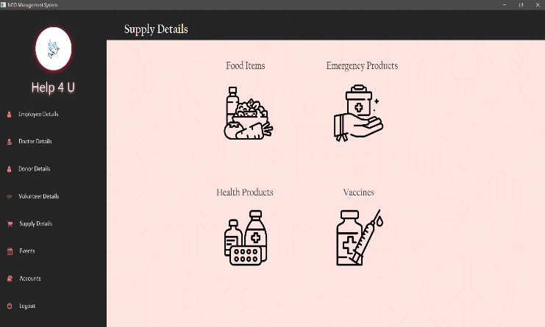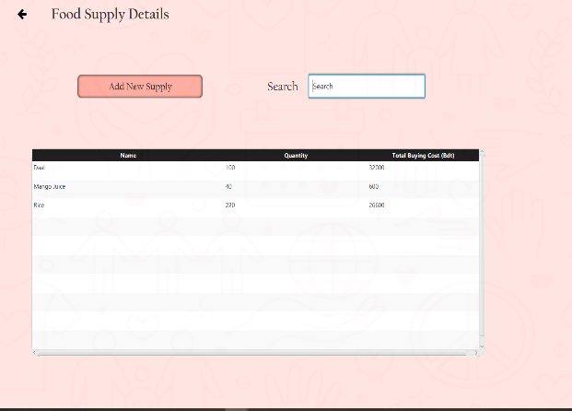

1. Event Details:

For the events management, admin can schedule an event, manage an event by assigning employees, doctors, volunteers and by adding any extra expenses, and can view the history of events for any period of months. Admin can also view a list of current events(events that are scheduled for the current month) and upcoming events.

In case of the other users that is general employees, employee can view the scheduled events by the admin and can manage an event by assigning volunteers and list of supplies that will be distributed in that event.

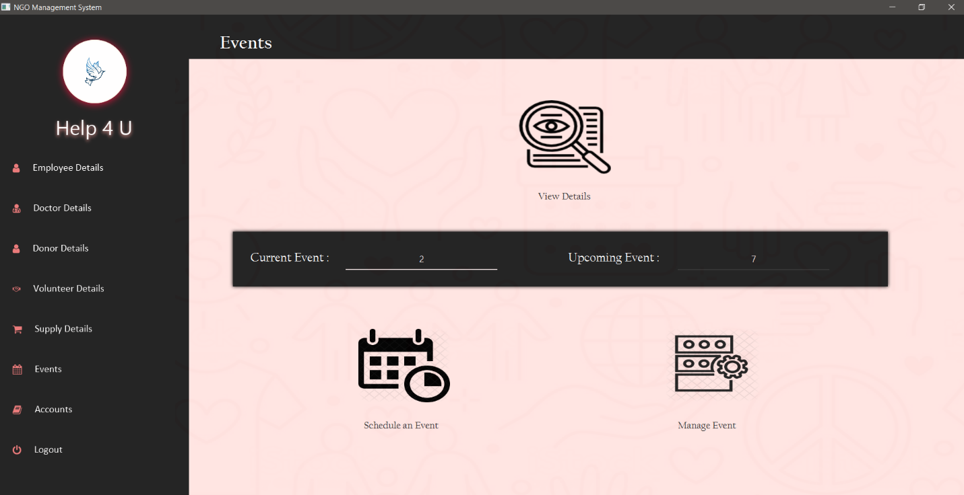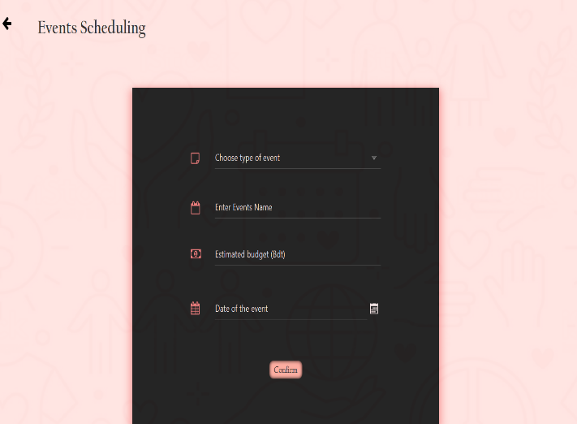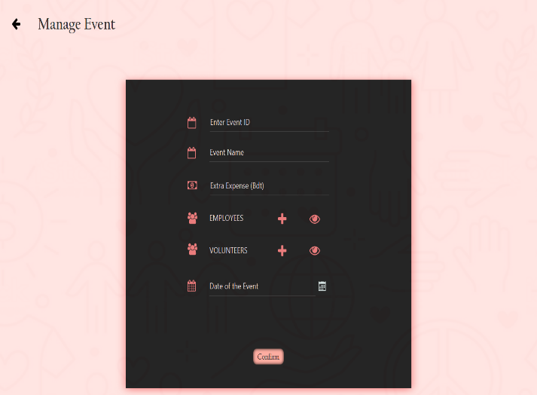

1. Accounts:

The accounts tab will only be visible to the admin.

In the accounts section, admin can add the designation in which the doctors or employees will be assigned, can add expenses details with date description and can view a summary report of the salary expenses, donation history, total expenses summary and event costs summary.

The designation details and expenses details information can be updated, sorted and deleted.

All the reports can be viewed for a particular month and a year and also can see the net amount for the particular category.

Similar Ui for all the reports.

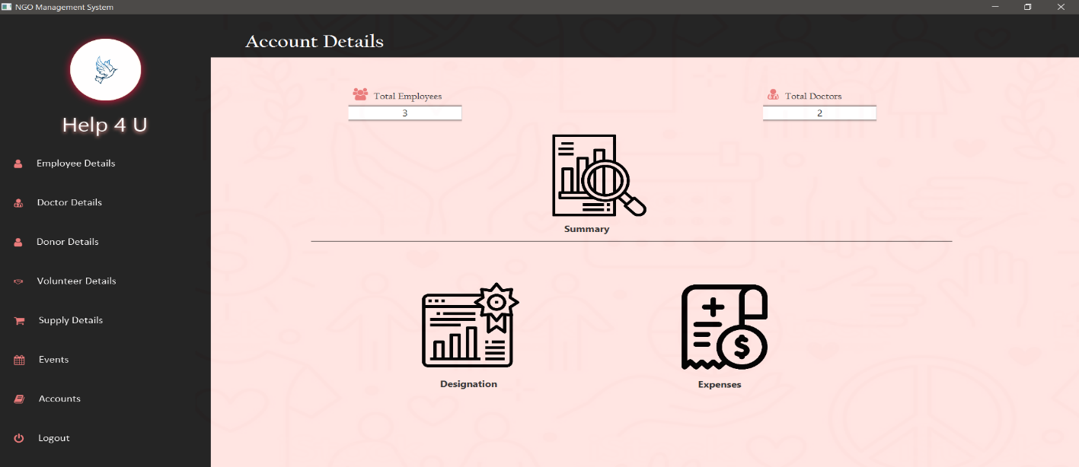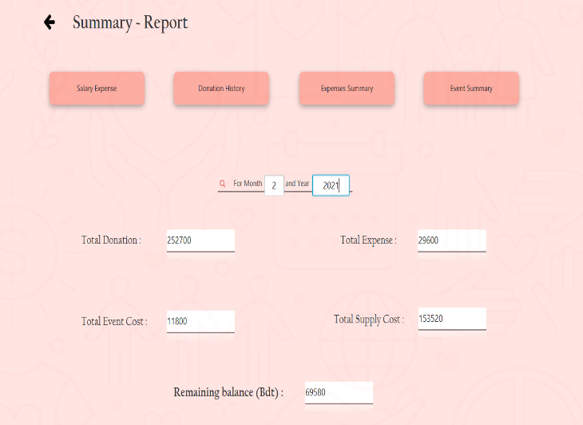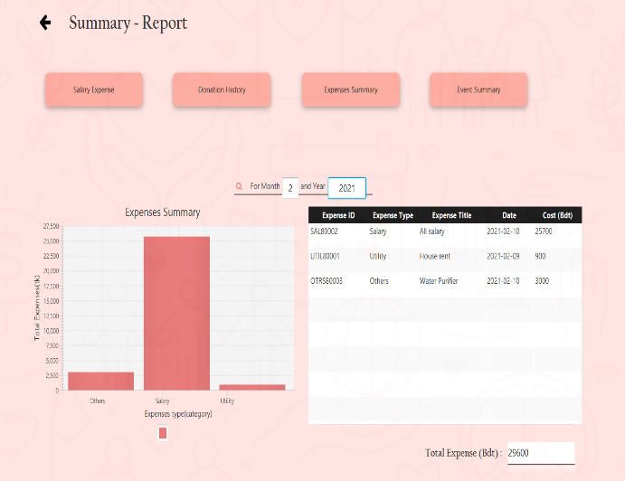

**Challenges**

Integrating features:

Scenario 1: Designing the flow of event scheduling, managing and assigning volunteers, supplies, employees and doctors was a bit complex. We took some time to sought out the complexity and after a lot of trials and errors, we could establish a user-friendly flow.

Scenario 2: While working with Event details, it had become difficult or complicated for us to merge all the other features together with the respective event. That is, establishing connection among an event, its assigned volunteers, doctors, employees and supplies that will be distributed in that respective event. After discussing with our respectable supervisor Mohammad Anas Zawad sir and taking almost a week and a half, we could establish the overall connection within them.

Scenario 3: While working with the accounts section, fetching every type of expenses and income sources for a specific month and year was a bit challenging though we could implement it and now the admin can view a detailed summary or report of every kind of expenses and income sources for any month and year.

Technical Issues:

Scenario 1: Hashing the password while inserting values to the database through external file was a complicated task. After discussing with our supervisor and doing some researches, we could implement the function.

**Future goal**

1. Keep track of employee:

The joining date of an employee, date of his/her salary received will be stored in the project for better employee management purpose.

1. Photo gallery:

We will have a photo gallery section in the dashboard where employees can upload/view photos of the corresponding event category.

1. Patient information store:

In future, we will store patient personal information along with their medical history. It will ease their experience with the NGO.