**Coursework Four Results by Pavlos Siaperas**

*The mean vector Hepatitis C data set*

1.164 3.916 0.448 5.679 4.865 3.778 4.127 3.604 0.217

*The covariance matrix of the Hepatitis C data set*

5.880 0.245 -0.004 -0.284 -0.346 -0.417 -0.481 -0.267 -0.067

0.245 7.572 0.073 -0.358 -0.346 0.257 2.273 0.946 -0.032

-0.004 0.073 0.247 -0.116 -0.039 -0.003 0.100 0.066 -0.005

-0.284 -0.358 -0.116 16.960 7.969 4.443 -1.036 -0.306 0.047

-0.346 -0.346 -0.039 7.969 8.361 4.921 -0.763 -0.752 -0.001

-0.417 0.257 -0.003 4.443 4.921 6.683 -0.087 -0.376 -0.141

-0.481 2.273 0.100 -1.036 -0.763 -0.087 20.583 1.122 0.014

-0.267 0.946 0.066 -0.306 -0.752 -0.376 1.122 4.317 0.119

-0.067 -0.032 -0.005 0.047 -0.001 -0.141 0.014 0.119 0.170

*The component magnitudes for image “c.pgm” in the principal component basis used in task 4.4*

1206.254 -1590.133 -248.136 -821.249 246.009 -771.900 963.633 376.967 161.599 -533.276

*The component magnitudes for image “c.pgm” in the principal component basis used in task 4.6*

1110.709 1537.080 410.837 -1887.013 941.699 -1515.164

*4.3 Eigenface Images*

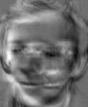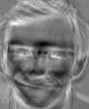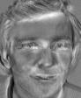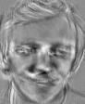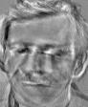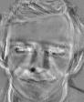

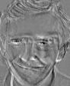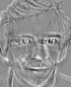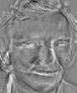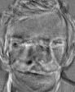

*4.4 Partial Reconstruction Images*

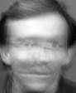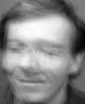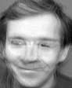

**

*4.6 Eigenface images*

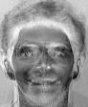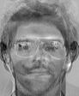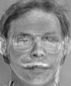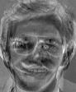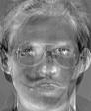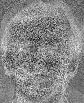

*4.6 Partial Reconstruction*

