Selenium grid guide:

1. Perform git pull this repository: <https://github.com/SiarheiRylach/vimeo_cameo_with_grid>.
2. Execute hub_3.14.0.bat file from command line. After that selenium hub will be started.
3. Cope url from console output for registration of Nodes.  
   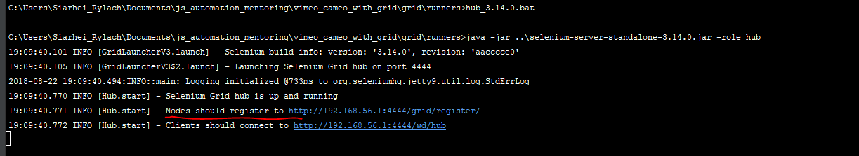
4. Paste url(without “/grid/register/” part) to REGISTER_IP field in se-node-chrome-3.14.0.bat(You can do it the same for se-node-firefox-3.14.0.bat or se-node-ie-3.14.0.bat. It depends on which instance you need to run).
5. Execute se-node-chrome-3.14.0.bat file from command line. After that node with chrome instance will be started. 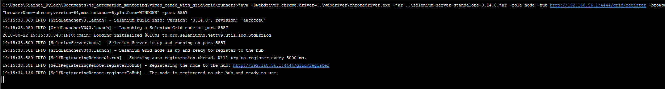
6. You can use {IP_HUB}/grid/console to see all nodes registered to the hub. In my case there are 3 nodes.  
   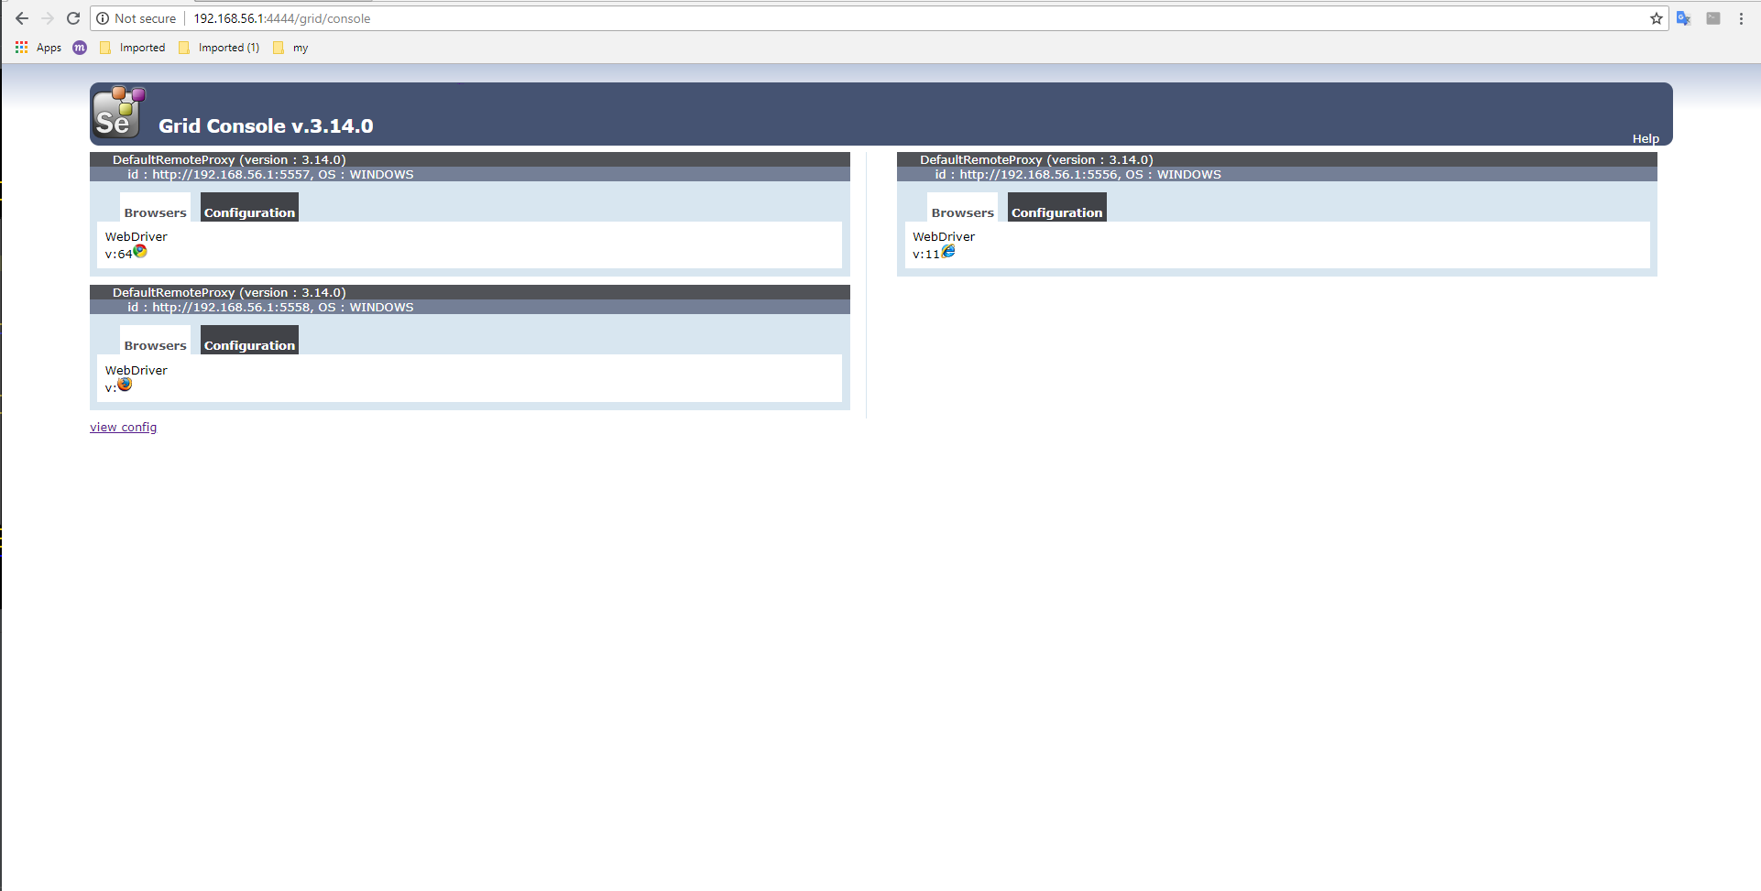
7. In case of using protractor seleniumAdress should be set(ip address of hub) and “directConnect: true” should be removed in the protractor.config.js  
   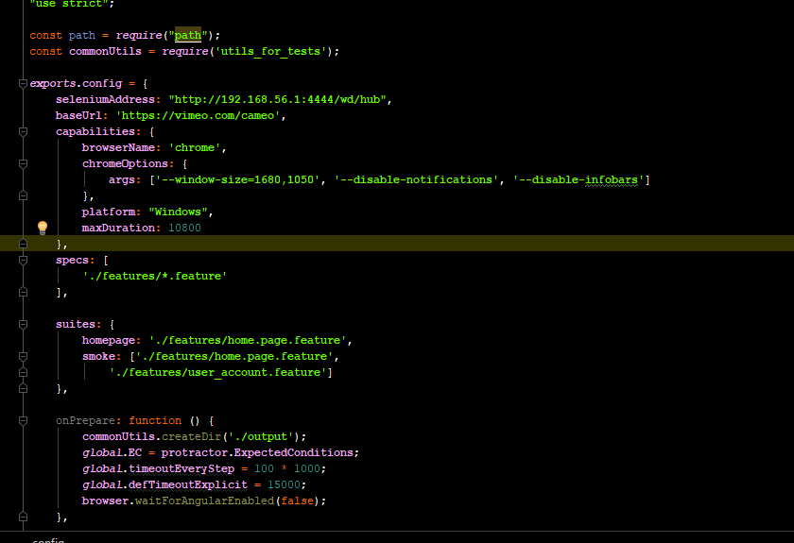
8. Use npm run e2e to execute your tests. In grid console you can see that chrome browser is disabled, because tests are executing at the moment.  
   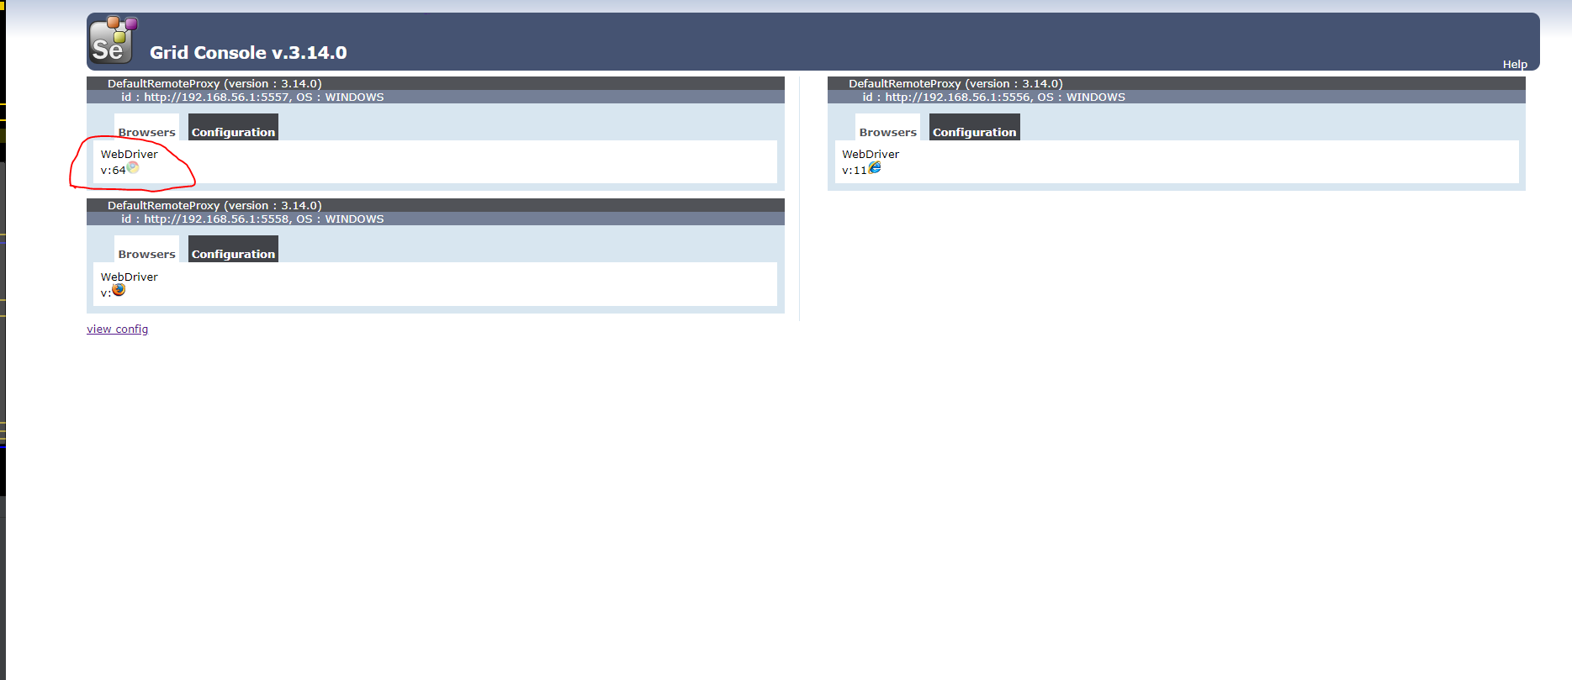
9. It will be executed on appropriate machine with appropriate browser and OS (These options are determined in protractor config, which OS and browser should be used). 