Type of Trials:

Static: 5 second motor Pos.- 5 second OpenSim Pos (keep angles in zero as much as you can)

Functional: OpenSim Pos 5s , do star shape right hand and left leg together , do star shape left hand and right leg.

Dynamic trial: before starting your dynamic do normal OpenSim pos + dynamic trial

Static and Functional approach

1. Use Static pose data
2. add Real Lab_Full_Body template and pick a name

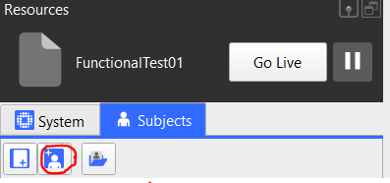

1. Go to the last frame
2. Run first line of Real VST Calibration pipeline
3. Check lables by comparing subject lable and your data
4. Run rest of pipline

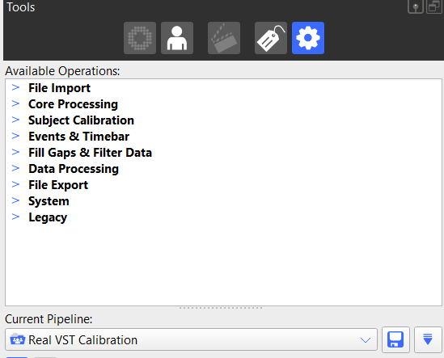

1. Save subject or if you want to save the template

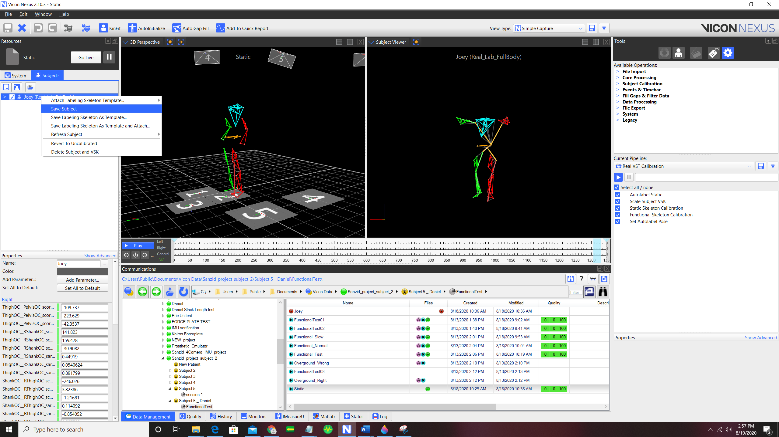

1. Load functional Test data

Functional Test: Star shape movement

1. Run Real Labeling pipeline

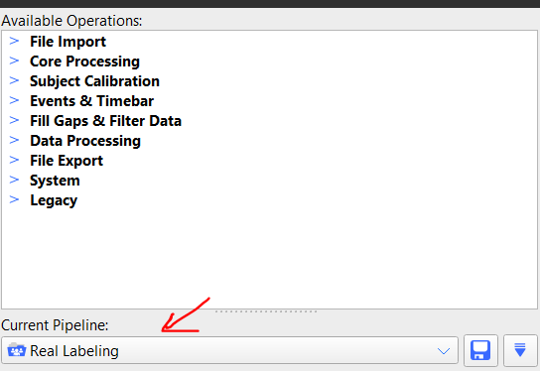

1. Go to quality tab and Fill gaps using the label tool



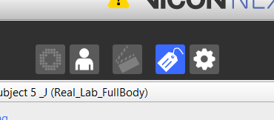

1. use rigid body fill when there are 3 other markers on segment (select all markers on the segment), use pattern fill when not (select 1 marker)

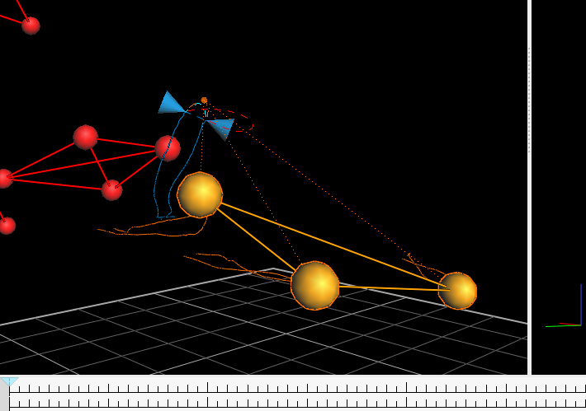

1. Go to graph (picture) and check the marker numbers remove all unlabeled trajectories (right-click any marker)

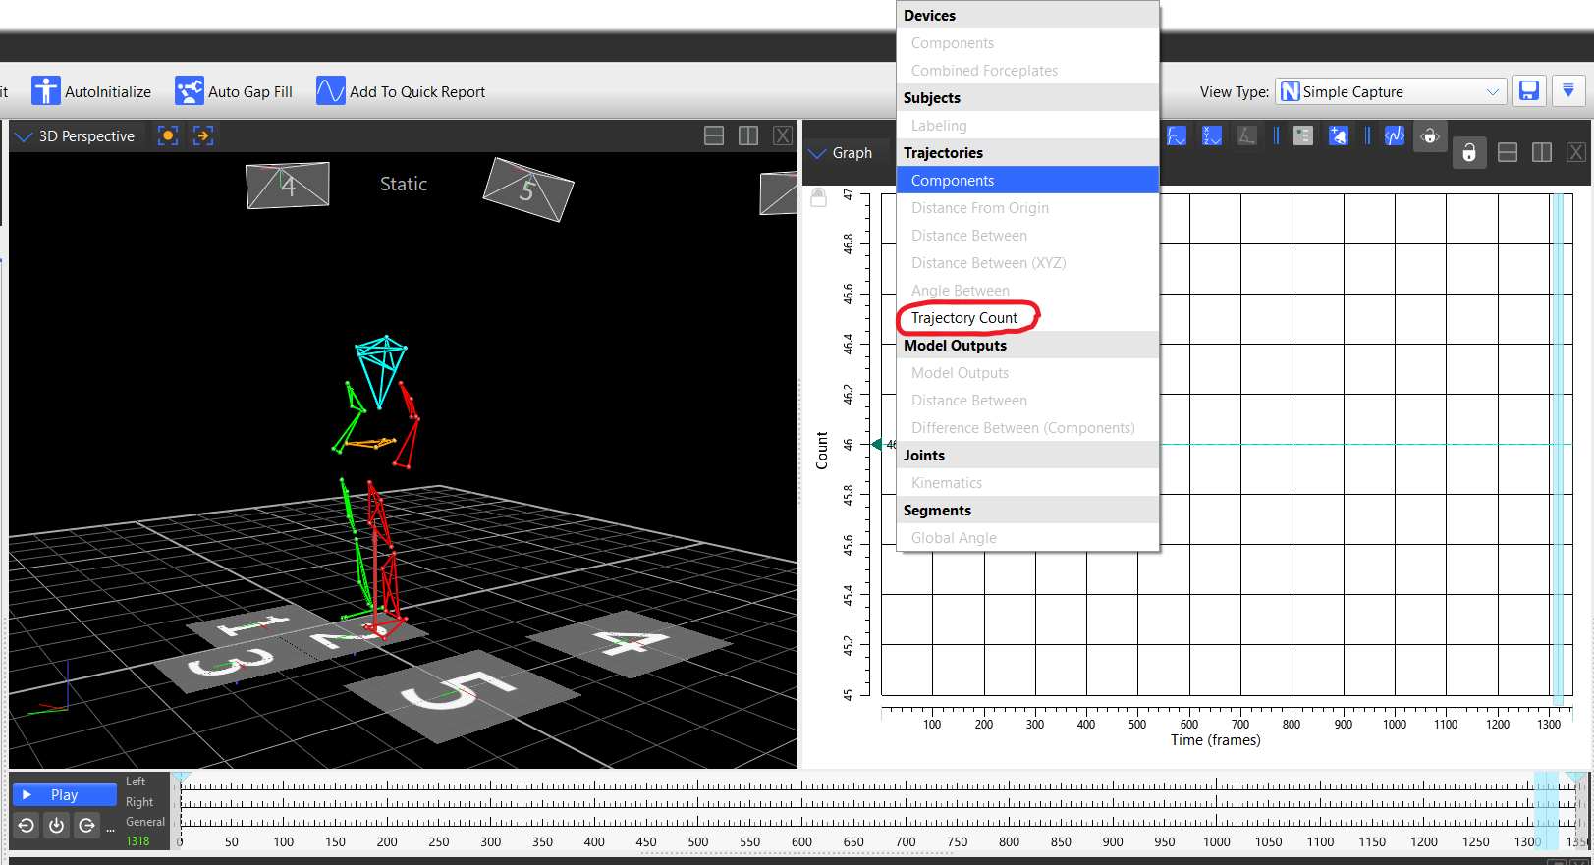

1. Run "Real Find Joint Center" pipeline

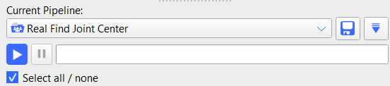

1. Rename Joint Center markers to (RHJC,LHJC,RSJC,LSJC) by selecting each of the added markers

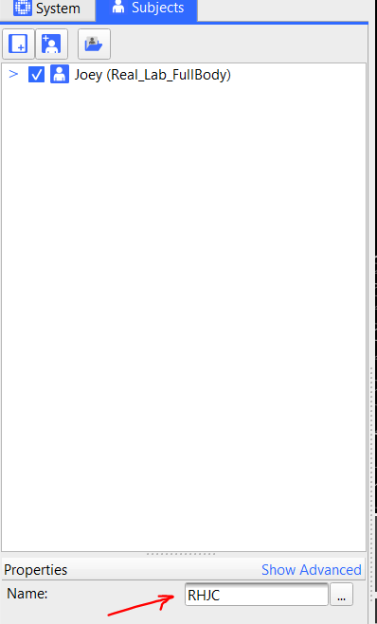

1. Save

**Dynamic trails**

1. Real Labeling
2. Fill the gaps
3. Look at the graph to check issues
4. Remove all unlabeled trajectories
5. Save