|  |  |  |  |  |  |
| --- | --- | --- | --- | --- | --- |
| Item | Marker Name | Marker Abbreviation | Marker Segment | Use in Kinematics | Description of Placement |
| 1 | Toe | TOE | Foot | No | Tip of big toe |
| 2 | Fifth Metacarpal | MT5 | Foot | Yes | Prominence on lateral side of foot |
| 3 | Heel | CAL | Foot | Yes | Posterior end of calcaneus |
| 4 | Medial Malleolus | MML | Shank | Yes | Medial prominence on ankle |
| 5 | Lateral Malleolus | LML | Shank | Yes | Lateral prominence on ankle |
| 6 | Arbitrary Shank | ASH | Shank | No | Anterior side of shank |
| 7 | Fibular Head | FIB | Shank | Yes | Lateral prominence on upper shank |
| 8 | Lateral Femoral Condyle | LFC | Thigh | Yes | Lateral prominence on lower thigh |
| 9 | Arbitrary Thigh | IAT | Thigh | Yes | Inferior side of thigh (top of knee) |
| 10 | Arbitrary Thigh | LAT | Thigh | No | Lateral side of thigh (In the middle of thigh) |
| 11 | Arbitrary Thigh | SAT | Thigh | No | Superior side of thigh. |
| 12 | Anterior Superior Iliac Spine | ASI | Pelvis | Yes | Anterior prominence of Iliac crest |
| 13 | Posterior Superior Iliac Spine | PSI | Pelvis | Yes | Posterior prominence of Iliac crest |
| 14 | Acromion | ACR | Torso | Yes | Superior prominence on lateral shoulder |
| 15 | Cervical vertebrae 7 | CEV7 | Torso | Yes | Posterior prominence on neck |
| 16 | Clavicle | CLAV | Torso | Yes | Superior end of sternum |
| 17 | Arbitrary Back | ABK | Torso | No | Arbitrary back |
| 18 | Arbitrary arm | SAA | Upper Arm | No | Superior side of arm (anterior) |
| 19 | Arbitrary arm | IAA | Upper Arm | No | Inferior side of arm (lateral) |
| 20 | Lateral Humeral Epicondyle | LHE | Upper Arm | Yes | Lateral prominence on elbow |
| 21 | Medial Humeral Epicondyle | MHE | Upper Arm | Yes | Medial prominence on elbow |
| 22 | Radial Styloid Process | RSP | Forearm | Yes | Lateral prominence on wrist |
| 23 | Ulnar Styloid Process | USP | Forearm | Yes | Medial prominence on wrist |
| 24 | Ulnar Head | UHD | Forearm | Yes | Tip of elbow |
| Virtual Markers | | | | | |
| 25 | Virtual Shoulder Joint Center | SJC | Upper Arm | No | Scara with functional movement |
| 26 | Virtual Hip Joint Center | HJC | Pelvis | No | Scara with functional movement |

46 Markers + 4 virtual markers

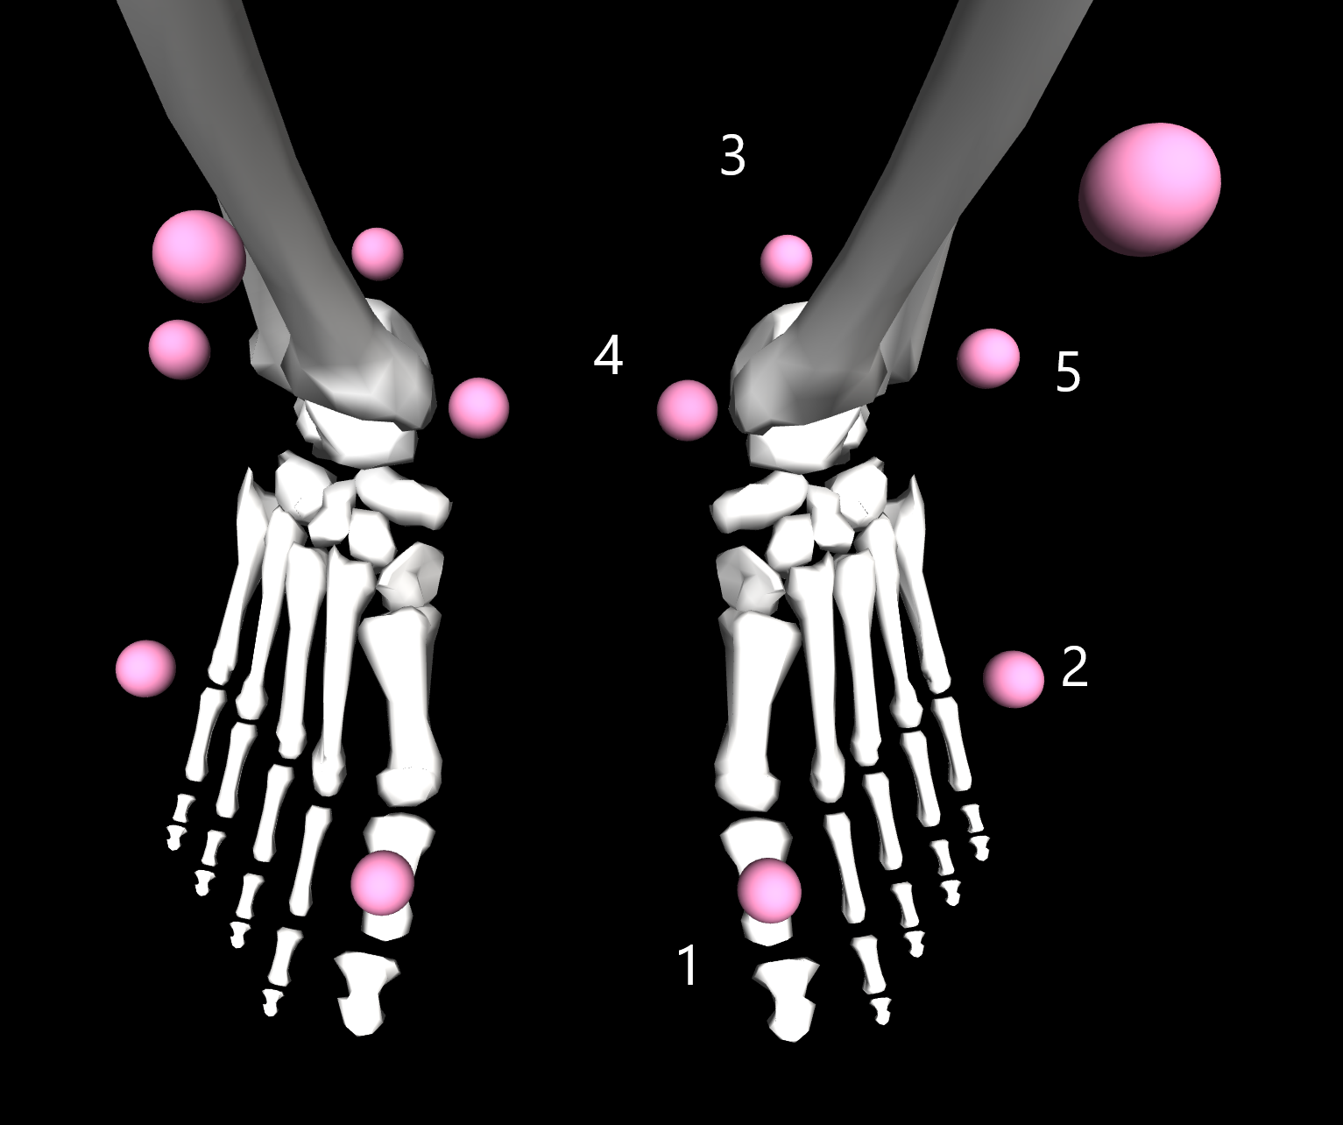

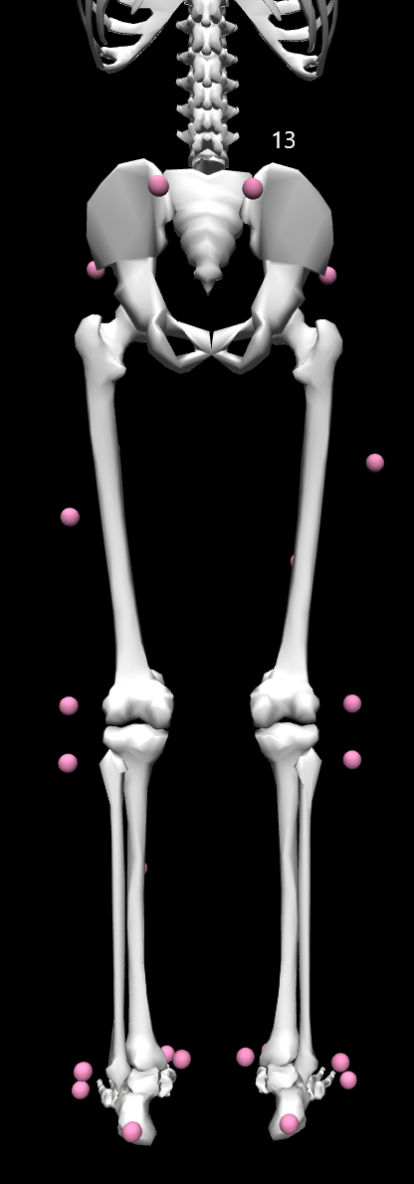 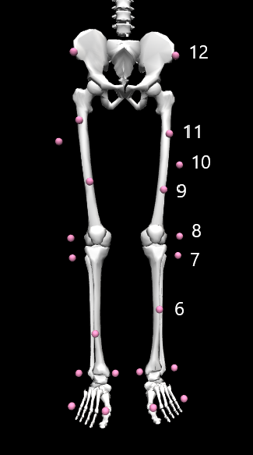 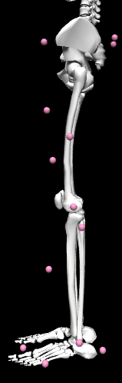

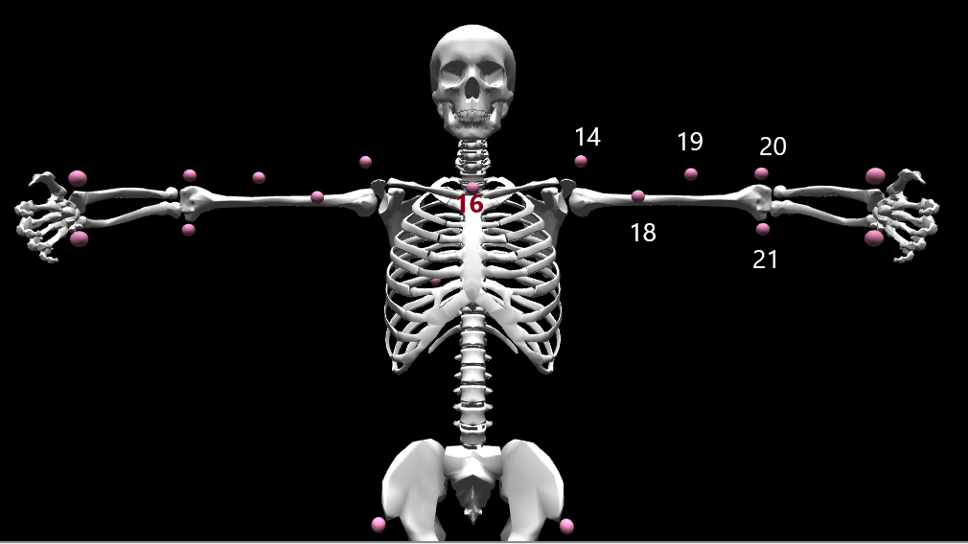

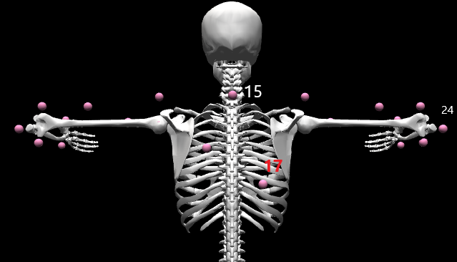

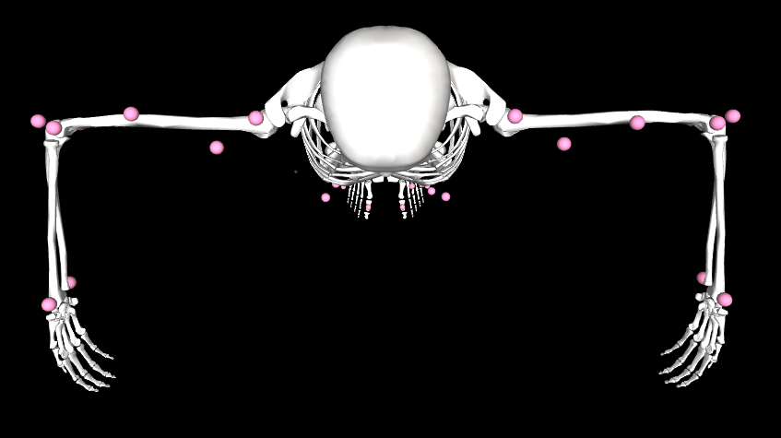

For images of sensor placement go to: <http://seniam.org/sensor_location.htm>

|  |  |  |  |  |  |
| --- | --- | --- | --- | --- | --- |
| Item | Sensor | Sensor Abbreviation | Segment | Muscle Actuation | Description of Placement |
| 1 | Tibialis Anterior | TIBA | Shank | Ankle Dorsiflexion | 1/3 on the line between the tip of the fibula and the tip of the medial malleolus |
| 2 | Soleus | SOLE | Shank | Ankle Plantarflexion | 2/3 of the line between the medial condyles of the femur to the medial malleolus |
| 3 | Peroneus Longus | PERL | Shank | Foot Eversion/ Ankle Plantarflexion | 25% on the line between the tip of the head of the fibula to the tip of the lateral malleolus |
| 4 | Peroneus Brevis | PERB | Shank | Foot Eversion/ Ankle Plantarflexion | Anterior to the tendon of the m. peroneus longus at 25% of the line from the tip of the lateral malleolus to the fibula-head |
| 5 | Medial Gastrocnemius | MGAS | Shank | Ankle Plantarflexion/ Knee Flexion | The most prominent bulge of the muscle |
| 6 | Lateral Gastrocnemius | LGAS | Shank | Ankle Plantarflexion/ Knee Flexion | 1/3 of the line between the head of the fibula and the heel |
| 7 | Rectus Femoris | RECF | Thigh | Knee Extension/ Hip Flexion | 50% on the line from the anterior superior iliac spine to the superior part of the patella |
| 8 | Vastus Medialis | VASM | Thigh | Knee Extension | 80% on the line between the anterior superior iliac spine and the joint space in front of the anterior border of the medial ligament |
| 9 | Vastus Lateralis | VASL | Thigh | Knee Extension | 2/3 on the line from the anterior superior iliac spine to the lateral side of the patella |
| 10 | Bicep Femoris | BICF | Thigh | Knee Flexion/ Hip Extension | 50% on the line between the ischial tuberosity and the lateral epicondyle of the tibia |
| 11 | Semitendinosus | SEMT | Thigh | Knee Flexion/ Hip Extension | 50% on the line between the ischial tuberosity and the medial epicondyle of the tibia |
| 12 | Gluteus Maximus | GLMX | Thigh | Hip Extension/ Hip Adduction/ Hip Abduction/ External Rotation | 50% on the line between the sacral vertebrae and the greater trochanter, the greatest prominence well above the greater trochanter |