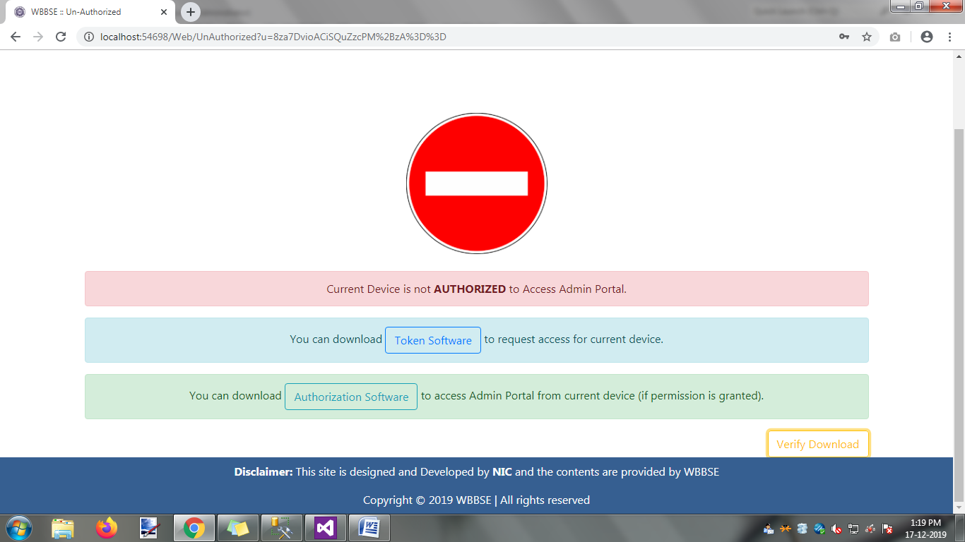

Click on the Token Software button,the following will happen

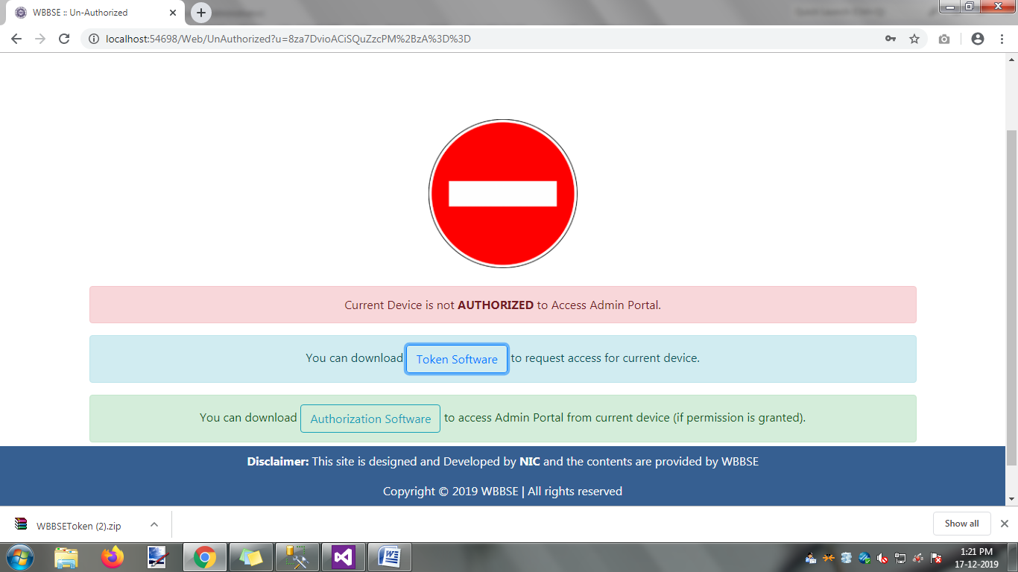

Download the file ‘WBBSEToken.Zip’.After completion of downloading file, the following step is as follows .

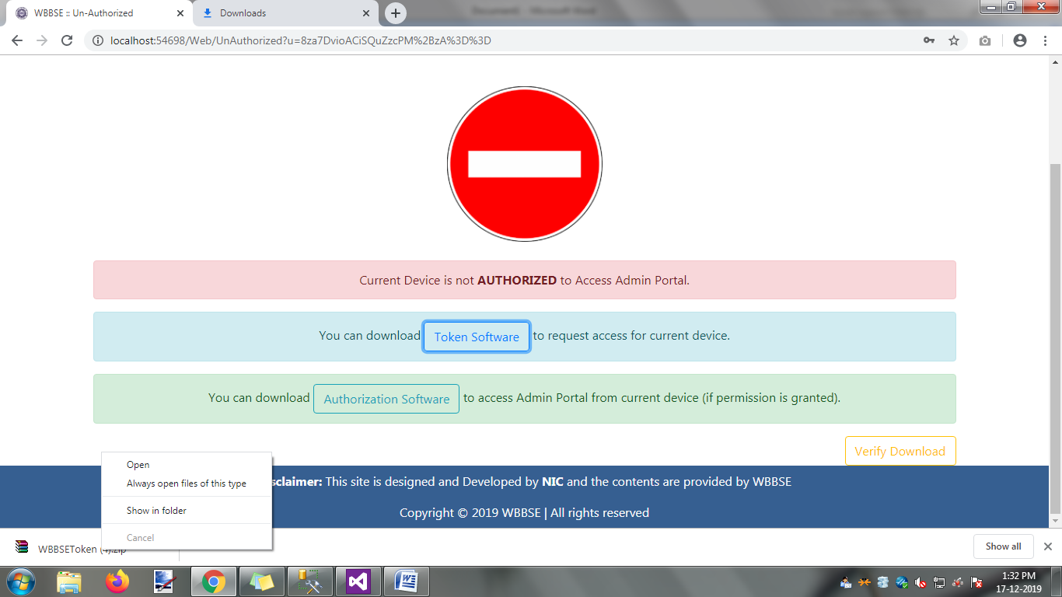

Click on the option ‘Show in folder’,the file download location is appear .

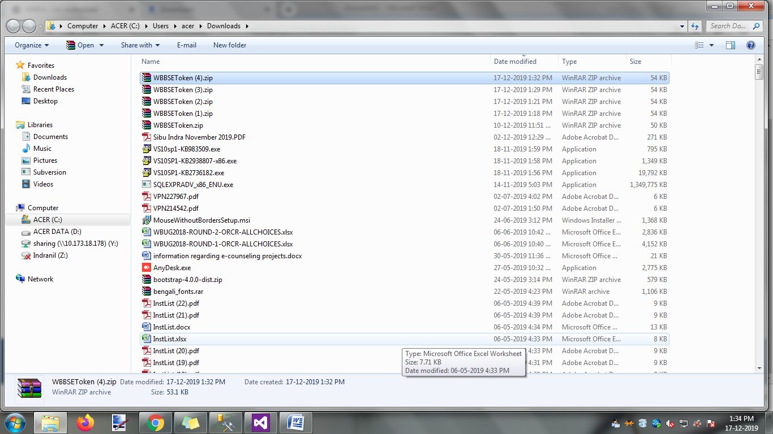

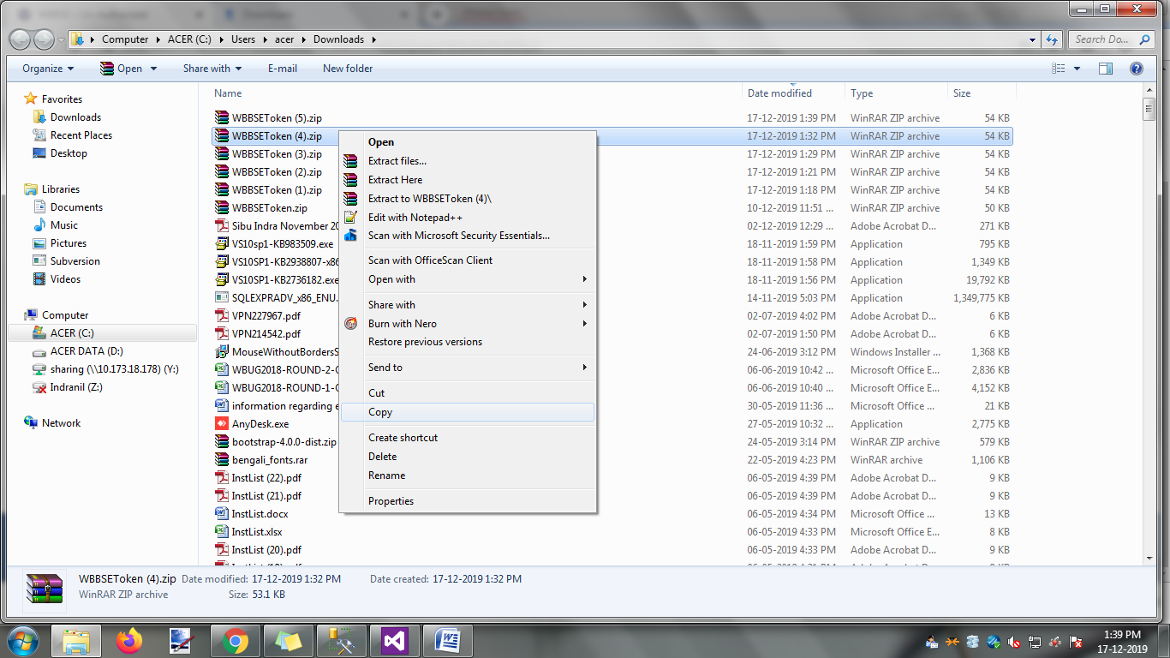

Create One new folder name as ‘WBBSETokenFile’ in your local drive.Copying the download file and it’s paste your destination location.

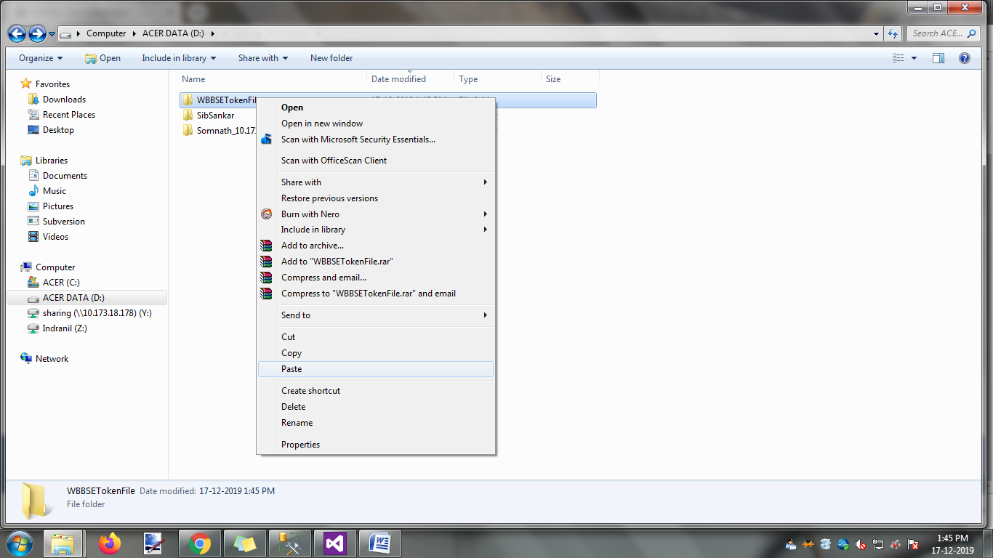

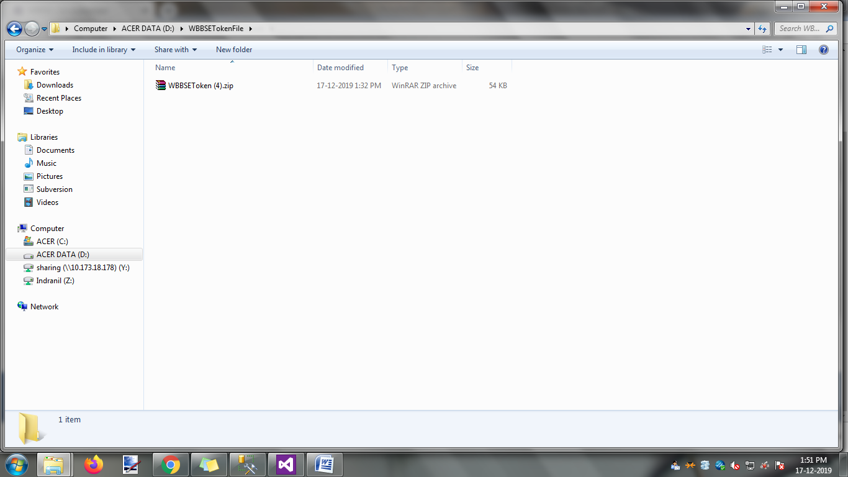

Click on the option ‘Extract Here’

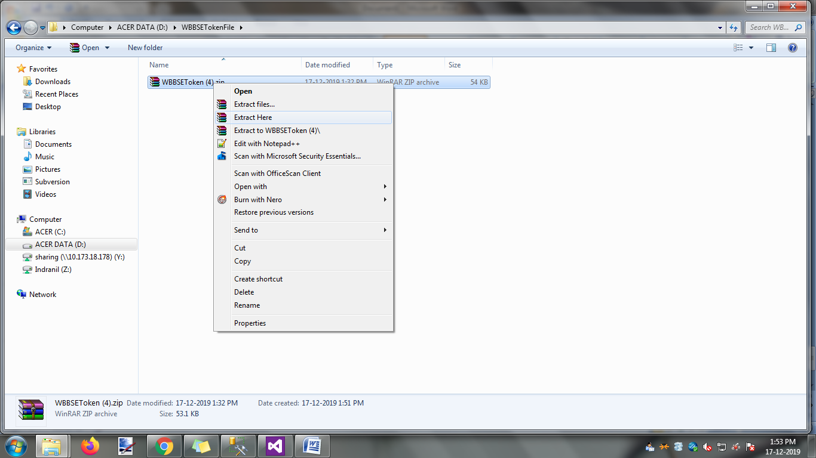

One new ‘WBBSEToken’ folder was created.

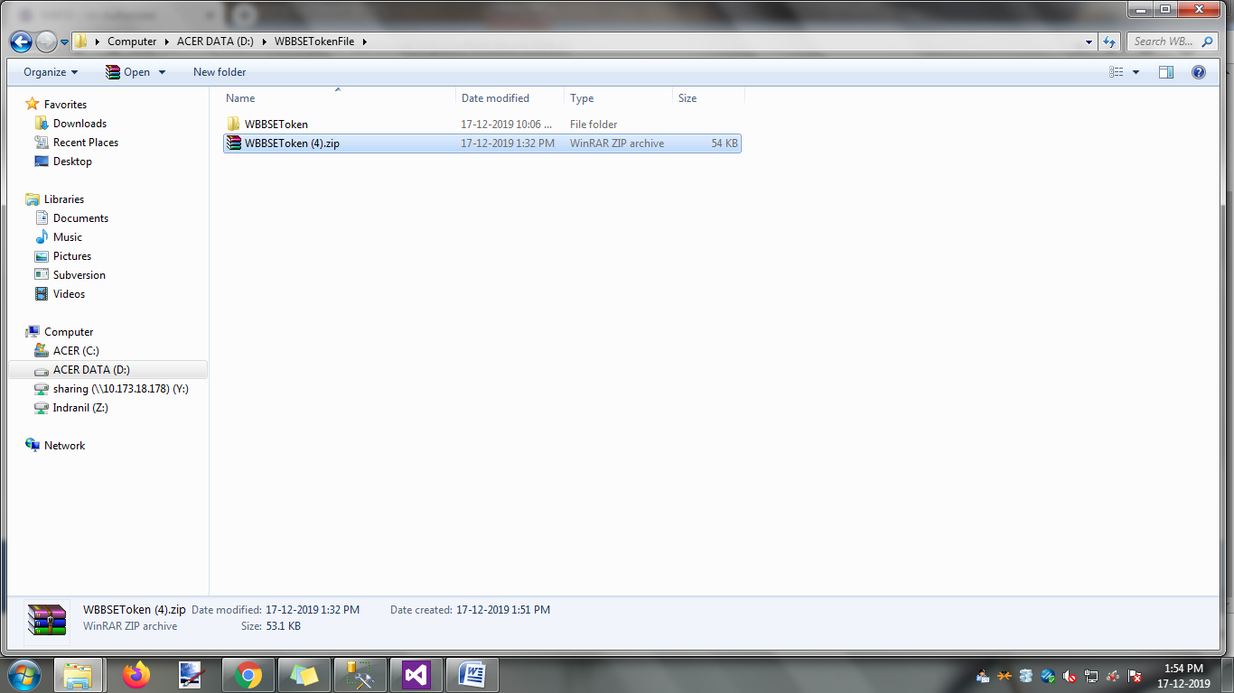

Click on ‘WBBSEToken’ folder ,open one new window and the following file are display.

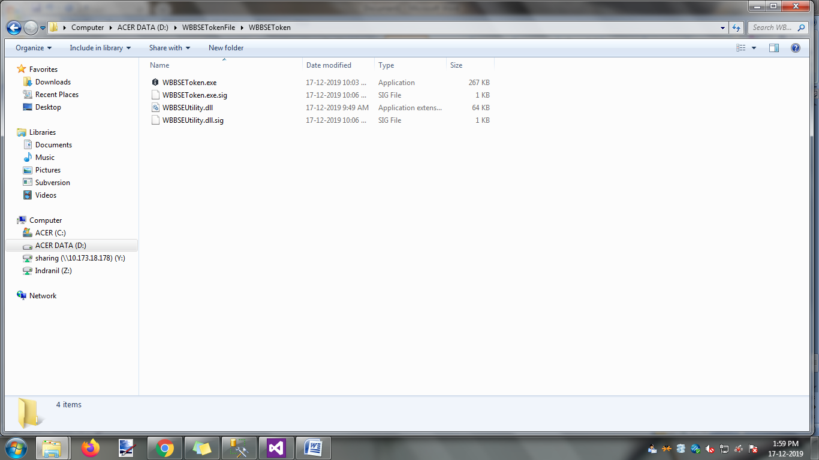

Click on the file ‘WBBSEToken.exe’

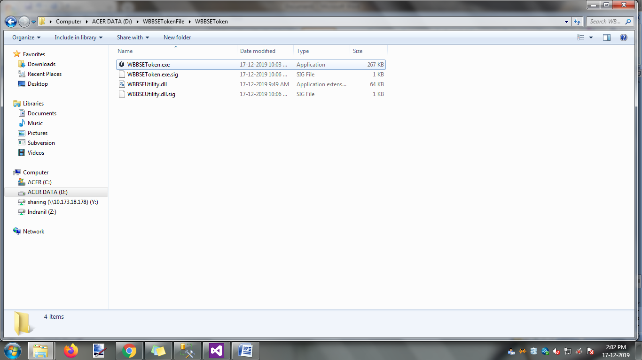

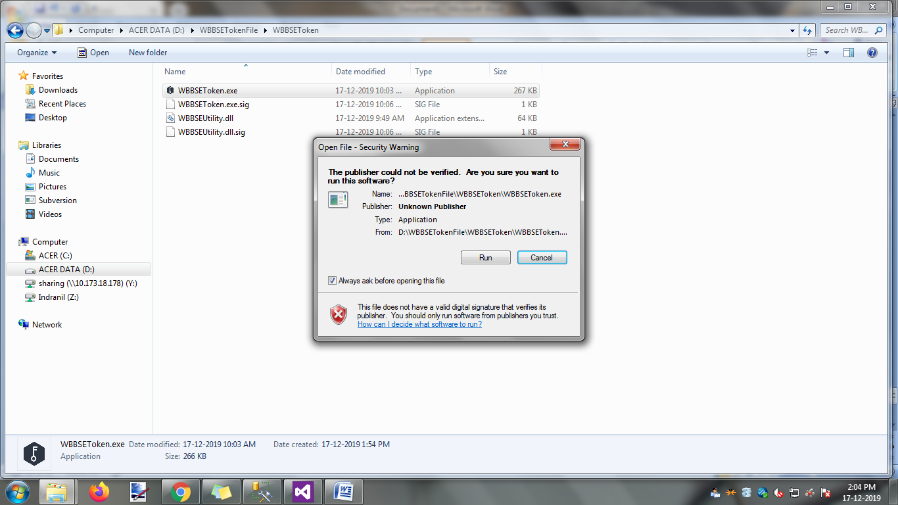

Click on ‘Run’ button.The following action is appear.

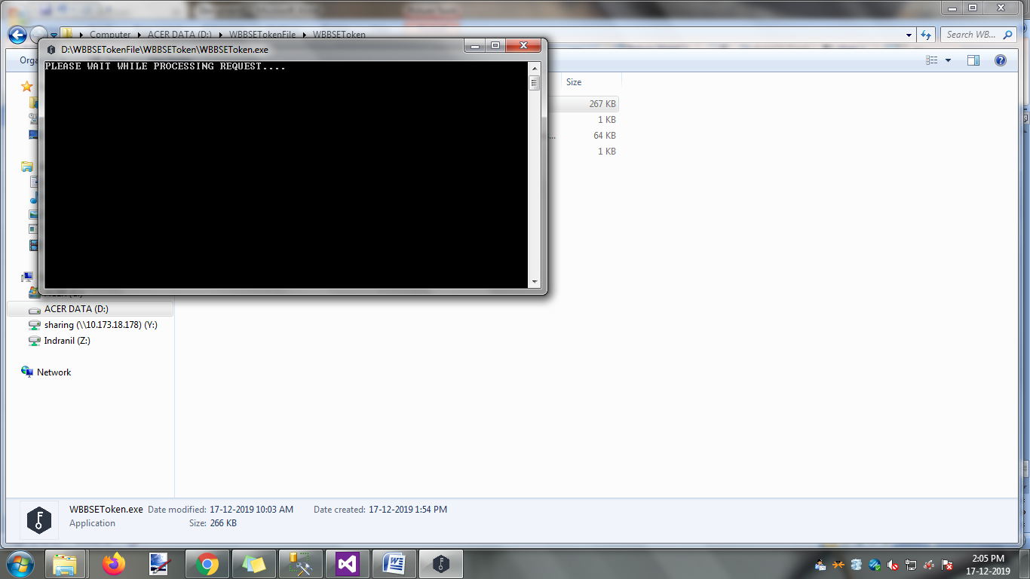

Open the web page in a default browser.

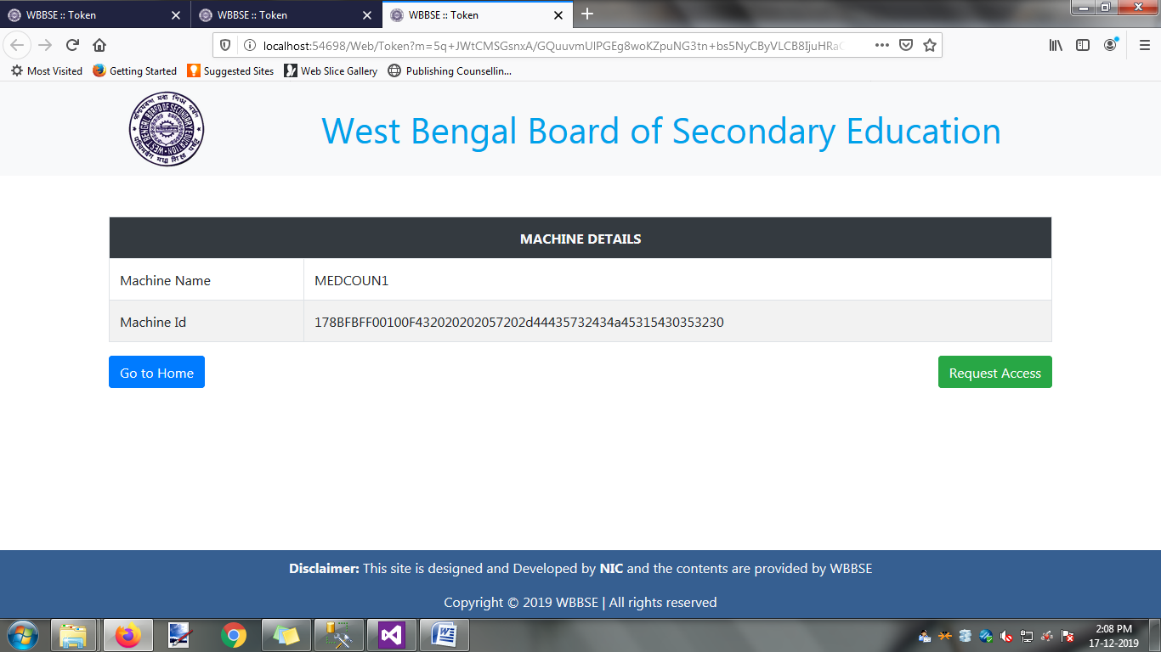

Click on ‘Request Access’ button

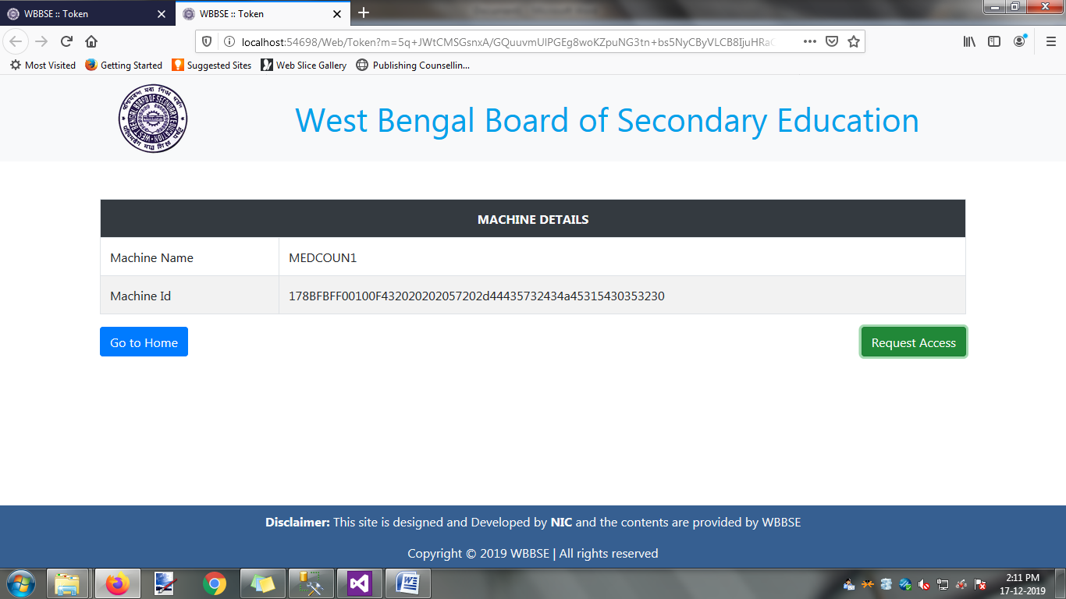

Open one alert window and the following option are comes .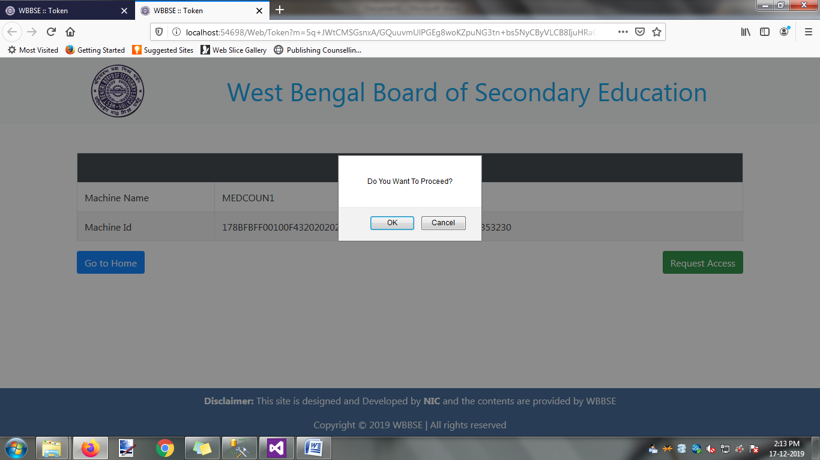

Click on the ‘ok’ button.The following web page is comes.

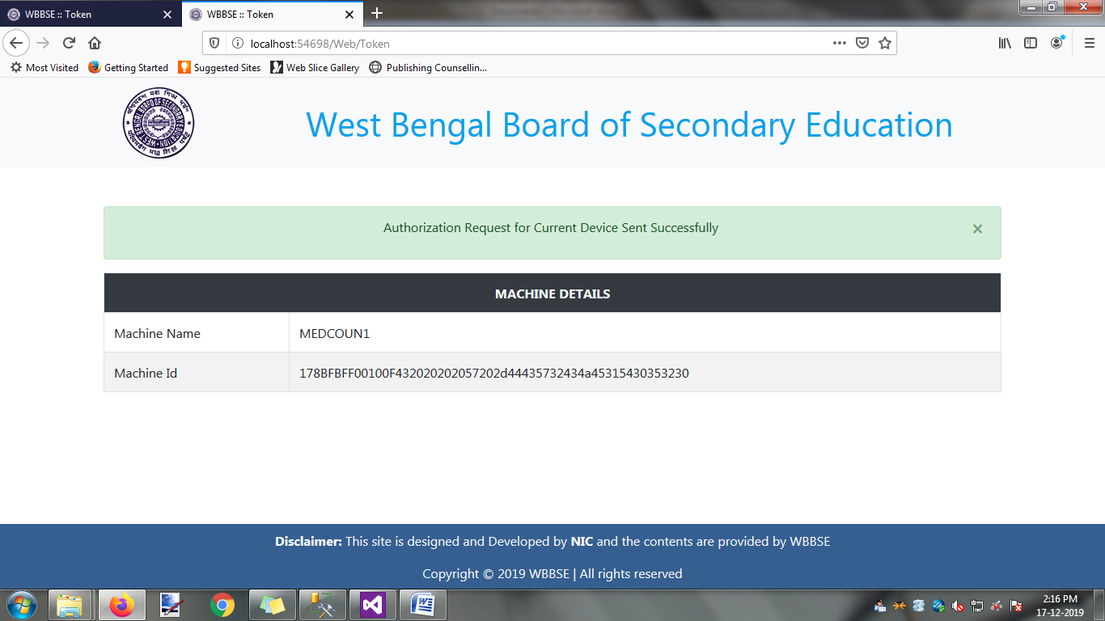

After making authorization request, you have to wait untill your request is verified and approved.