|  |  |
| --- | --- |
| **Project Case** |  |
| COMP6583 | COMP6583001  Computer Graphics |
| **Computer Graphics** | **O242-COMP6583-AX02-00** |
| ***Valid on*** *Odd Semester Year 2023/2024* | **Revision 00** |

1. Kelompok tidak diperkenankan untuk:

*Members of the group are prohibited from:*

* + - Melihat sebagian atau seluruh jawaban kelompok lain,

*Seeing a part or the whole answer from other groups,*

* + - Menyadur sebagian atau seluruh jawaban dari buku, catatan, video, dan jenis referensi lainnya,

*Retell a part or the whole answer from books, notes, videos, and other references,*

* + - Menyadur sebagian atau seluruh jawaban dari internet,

*Retell a part or the whole answer from the internet,*

* + - Mengumpulkan jawaban yang tidak sesuai dengan tema soal,

*Submitting an answer with a different theme from the given case,*

* + - Melakukan tindakan yang menyebabkan jawaban dicontek oleh orang lain atau kelompok lain, baik disengaja maupun tidak disengaja,

*Doing action that could result the answer being copied by someone or other groups, intentionally or unintentionally,*

* + - Melakukan tindakan kecurangan lainnya.

*Committing other dishonest actions.*

1. Jika kelompok terbukti melakukan tindakan seperti yang dicantumkan pada butir ke-1, maka nilai mahasiswa dan/atau kelompok yang melakukan kecurangan, baik menyontek atau dicontek, akan dinolkan sesuai dengan peraturan yang berlaku.

*If it has been proven that a group has committed dishonest actions outlined in point 1 above, the whole group related to the incident, regardless of which one copies or has their answer copied, will be issued a score of zero according to the regulation.*

1. Jawaban yang dapat diterima dan dinilai adalah jawaban yang dikumpulkan sebelum batas waktu yang telah ditentukan.

*The answer must be submitted before the designated deadline to be accepted and graded,*

1. Jawaban akan dinilai berdasarkan teknik atau metode yang diajarkan pada kelas praktikum dengan menggunakan software yang sudah ditentukan.

*The scoring will be based on the materials taught during the practicum classes using the designated software. Using different software than requested may result in your answer not being graded.*

1. Jika Anda tidak membaca peraturan ini, maka Anda dianggap sudah membaca dan menyetujuinya.

*By taking this exam, you agree to these regulations, regardless of whether you have read it or not.*

1. Persentase penilaian untuk matakuliah ini adalah sebagai berikut:

*The score will be distributed as follows:*

|  |  |  |
| --- | --- | --- |
| **Tugas Mandiri**  *Assignment* | **Proyek**  *Project* | **UAP**  *Final Exam* |
| 40% | 60% | - |

1. Perangkat lunak yang digunakan pada matakuliah ini adalah sebagai berikut:

*This course uses the following software:*

|  |
| --- |
| **Software**  *Software* |
| Three JS r145  Visual Studio Code  Web Browser (Google Chrome) |

1. Ekstensi file yang harus dikumpulkan untuk matakuliah ini adalah sebagai berikut:

*Your answers must be in the following file extensions:*

|  |  |  |
| --- | --- | --- |
| **Tugas Mandiri**  *Assignment* | **Proyek**  *Project* | **UAP**  *Final Exam* |
| HTML, CSS, JS, Asset Files | HTML, CSS, JS, GLB, Asset Files | - |

1. File yang harus dikumpulkan adalah keseluruhan jawaban beserta dengan aset yang digunakan (gambar, audio, video, dll) dan dokumentasi proyek yang berisikan link referensi aset dan penjelasan mengenai aplikasi yang dibuat (terlampir bersama dengan soal).

*Include other files that can support your project, such as: all files in your project, other files (image, audio, video, etc.) used in your project, *.doc file (documentation of your project) that contains all pages in your project, reference links of additional files (image, audio, video, etc.) used in your project, the description about how to use your application, etc.*

## Soal

*Case*

**AXkForTreasure**

AX, a game developer**,** is currently building his new game called **AXkForTreasure**. The game goal is to take a treasure which is guarded heavily by various traps in the middle of infinity realm. The game is scheduled to be completed in 3 **months,** but AX is still having a bad time picturing what the final **AXkForTreasure** scene will look like. As his friend and a three.js enthusiast, you are asked to design the scene using three.js library.

1. **Project Structure**

The project must contain a html file, javascript files, asset files, and the three.js library. You can get the three.js library from either one of these:

- Official website: <https://threejs.org/>

- Github: <https://github.com/mrdoob/three.js/>

- CDN link: <https://cdnjs.com/libraries/three.js>

For the html add this line of code snippet below.

|  |
| --- |
| <body style="margin:0; padding:0">  </body>  <script src="[Path to index.js file]" type="module"></script> |

You are free to split your code into several different JavaScript files, but code the main logic for creating the scene inside **“index.js”** file.

1. **Scene**

Create a **full screen scene** that can be **dynamically resized** to fit the window. The scene also has **shadow map** **enabled** using **PCFShadowMap** as the shadow map type and **anti-aliasing** turned on.

1. **Camera**

There will be **2 types** of **cameras.** Add a **keyboard interaction** to switch between the **2 cameras** when pressing **“Space Bar”** on the keyboard. Create the **cameras** with the specifications below:

1. **Orbiting camera**

This camera will focus on **Vector3(0,0,0)** and can be controlled using **OrbitControls**.

|  |  |
| --- | --- |
| **Property** | **Value** |
| **Type** | Perspective Camera |
| **Field of View** | 45 |
| **Aspect Ratio** | Window Ratio |
| **Position** | Vector3 (0, 20, 70) |

1. **Scene camera**

This camera will be the same as **Orbiting camera**, however the only difference is that this camera can’t be controlled using **OrbitControls**.

1. **Light**
2. **PointLight**

There will be only 1 **pointlight** and below are the specifics:

|  |  |
| --- | --- |
| **Property** | **Value** |
| **Intensity** | 2 |
| **Distance** | 200 |
| **Color** | #FF0000 |
| **Cast Shadow** | Yes |
| **Position** | Vector3(0, 13, 0) |

1. **SpotLight**

There will be **6** **spotlights**. Thisis the detail for **spotlight** **1** until **4**:

|  |  |
| --- | --- |
| **Property** | **Value** |
| **Intensity** | 0.6 |
| **Color** | #FFFFFF |
| **Cast Shadow** | Yes |
| **Distance** | 50 |

This is the position for **spotlight** **1** until **4**:

|  |
| --- |
| **Spotlight 1-4 position** |
| Vector3(13, 2, 13) |
| Vector3(13, 2, -13) |
| Vector3(-13, 2, 13) |
| Vector3(-13, 2, -13) |

This will be the details for **spotlight** **5** and **6:**

|  |  |
| --- | --- |
| **Property** | **Value** |
| **Intensity** | 0.8 |
| **Color** | #FF0000 |
| **Cast Shadow** | Yes |
| **Distance** | 50 |

This will be the position and target for **spotlight** **5** and **6**:

|  |  |
| --- | --- |
| **Position** | **Target** |
| Vector3(6, 13, 0) | Vector3(50, 0, 0) |
| Vector3(-6, 13, 0) | Vector3(-50, 0, 0) |

At the **beginning of the scene**, **spotlights** **5** and **6** will not be shown in the scene until the **final scene** is **triggered**.

1. **Objects**
2. **Ground**

Below are the specifications:

|  |  |
| --- | --- |
| **Property** | **Value** |
| **Geometry Type** | Plane |
| **Width** | 100 |
| **Height** | 100 |
| **Material Type** | Mesh Phong Material |
| **Side** | Doubleside |
| **Rotation** | - Math.PI / 2 |
| **Position** | Vector3 (0, 0, 0) |
| **Receive Shadow** | Yes |
| **Texture Map** |  |

***Figure 1. Ground***

1. **Altar**

**Place** the object exactly in the **middle of the scene**. **Load** model from the **GLTF** file “**assets/sand.jpg**”. Below are the specifications:

|  |  |
| --- | --- |
| **Property** | **Value** |
| **Cast Shadow** | Yes |
| **Receive Shadow** | Yes |

***Figure 2. Altar***

1. **Text**

|  |  |
| --- | --- |
| **Property** | **Value** |
| **String** | Don't click me! |
| **Font Type** | Helvetiker Bold |
| **Material Type** | MeshPhongMaterial |
| **Color** | FF0000 and 990000 |
| **Position** | Vector3 (-10, 18, 0) |
| **Cast Shadow** | Yes |
| **Receive Shadow** | Yes |

***Figure 3. Text***

1. **Treasure**

|  |  |
| --- | --- |
| **Property** | **Value** |
| **Geometry Type** | Sphere |
| **Radius** | 2 |
| **Width Segments** | 32 |
| **Height Segments** | 16 |
| **Material Type** | Mesh Phong Material |
| **Color** | #ffff00 |
| **Position** | Vector3 (0, 13, 0) |
| **Cast Shadow** | Yes |
| **Receive Shadow** | Yes |

***Figure 4. Treasure***

1. **Pillar**

There will be **4 pillars** in the scene. Below are the specifications for every pillar:

|  |  |
| --- | --- |
| **Property** | **Value** |
| **Geometry Type** | Cylinder |
| **Radius Top and Bottom** | 3 |
| **Height** | 30 |
| **Material Type** | Mesh Phong Material |
| **Cast Shadow** | Yes |
| **Receive Shadow** | Yes |
| **Texture** |  |

Below are the positions for the **4 pillars:**

|  |
| --- |
| **Pillar 1-4 position** |
| Vector3(15, 15, 15) |
| Vector3(-15, 15, 15) |
| Vector3(15, 15, -15) |
| Vector3(-15, 15, -15) |

***Figure 5. Pillar***

1. **Skybox**

|  |  |
| --- | --- |
| **Property** | **Value** |
| **Texture**  (In sequence: right, left, top, bottom, front, back) | A picture containing star, sky, space, constellation  Description automatically generatedA picture containing astronomical object, astronomy, star, outer space  Description automatically generatedA picture containing sky, star, constellation, space  Description automatically generated  A picture containing star, space, galaxy, constellation  Description automatically generatedA picture containing star, space, constellation, galaxy  Description automatically generatedA picture containing sky, star, constellation, space  Description automatically generated |

***Figure 6. Skybox***

1. **Final Scene**

When the player **clicks** the **treasure**, it will **trigger** the **final scene**. First the **treasure** will **disappear**. Then, **spotlights 5** and **6** will **appear** and all **spotlights color** will change to **red** (“**#FF0000**”). In this **final scene**, you will also need to make an **animation logic** for **2** of the **pillars** to **collapse**.

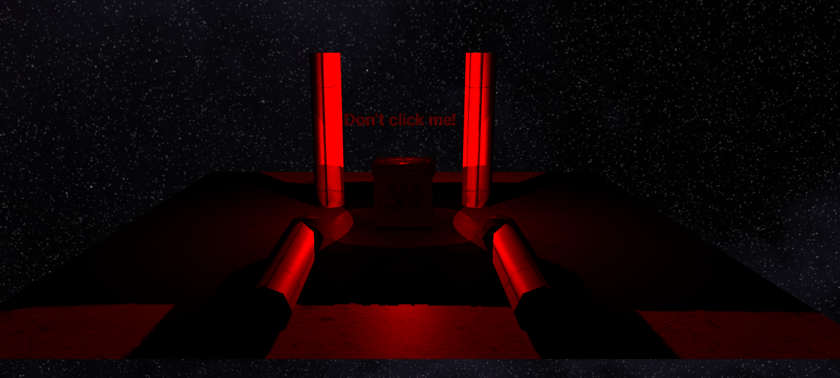

***Figure 7. Final Scene***

**References**:

<https://www.alamy.com/stock-photo-column-ancient-close-up-texture-background-175546255.html>

<https://dl.polyhaven.org/file/ph-assets/Textures/jpg/4k/coast_sand_01/coast_sand_01_diff_4k.jpg>

<https://sketchfab.com/3d-models/altar-for-diana-goddess-of-hunt-9e1eb85433104b7c9caf961925a25a6e>

<https://tools.wwwtyro.net/space-3d/index.html>