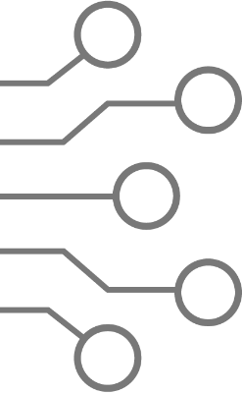


North South University
Department of Electrical & Computer Engineering

EEE 111 / ETE 111 – Lab
Analog Electronics – 1

Course Section : 6
Faculty : AQU
Lab Instructor : Mehrab Hossain Likhonn

Lab Report

Experiment No | : 05
Experiment Name | : Zener Diode Characteristics and Voltage regulation using Zener Diode
Date of Performance | : 28/02/2025
Date of Submission | :12/03/2025

Group No : 7

Group Member’s Name | ID | Writer | Signature
- Zaid Zarifur Rahman | 2131819642 | □
- Sibgat Ul Islam | 2111920642 | □
- Nazifa Tahsin | 2132652642 | □
- Abdullah Al Towhid | 2031045642 | □
5. |  | □

Experiment Name:
Zener Diode Characteristics and Voltage regulation using Zener Diode

Objective:
Study of Zener Diode Characteristics and its application in voltage regulation.
Theory:
There are different kinds of diodes which have wide ranging characteristics. Zener diodes specialize in operating in the breakdown region (in reverse bias) without damage. It is used to build voltage regulator circuits where it helps the load in holding an almost constant voltage despite large change in line voltage and load resistance.

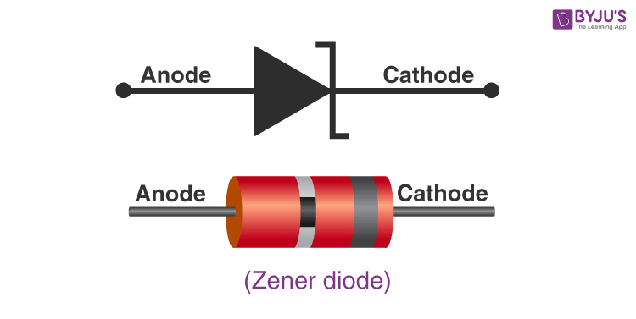
[1] Fig 1.1: Symbol of Zener Diode.

While in the forward bias, the Zener diode exhibit the I-V characteristics of a typical diode. However, in the leakage region (between zero and breakdown) it has a small reverse saturation current. In the breakdown region (the breakdown voltage may vary from 2 to 200 volts) the current increases sharply without virtually any change to the V_{z}. Here is a graph that overlays the IV characteristic of a typical diode and a Zener diode:

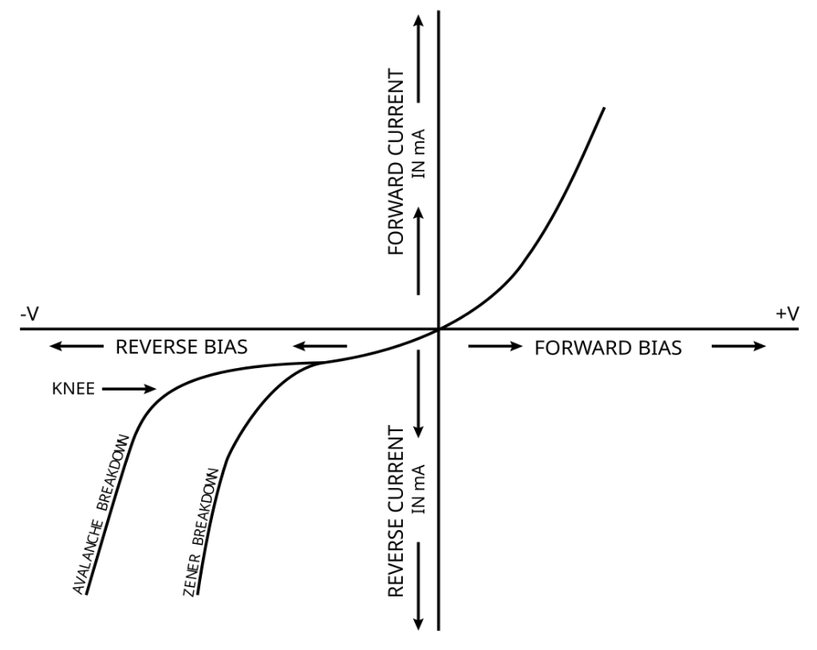

[2] Fig 1.2: I-V characteristic of normal diode and Zener diode.

Zener diodes can be applied for many purposes such as:
- Over-Voltage Protection: By limiting the voltage on load if placed parallel to the Zener diode
- Clipper circuits: An opposing pair of Zener diodes placed in series
- Voltage Regulator: Sets the voltage across parallel load to V_{z}
Let us look at a Voltage Regulator circuit:

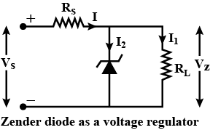
[3] Fig 1.3: Voltage Regulator circuit

The diagram shows that regardless of how high V_{s} gets, the potential difference across R_{L} will not get higher than V_{z}, due to being in parallel with the Zener diode in reverse bias.

Equipment List:

Serial NO. | Components | Specification | Quantity
1. | Zener Diode | 6 V_{z} | 1 piece
2. | Resistor | As required | As required
3. | DC Power Supply |  | 1 unit
4. | Digital Multimeter |  | 1 unit
5. | Bread Board |  | 1 unit
6. | Wires |  | As required

Circuit Diagram:
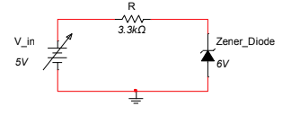
Figure 2.1(a): Reverse Bias Characteristic of Zener Diode. Source: Lab Manual for Experiment 03
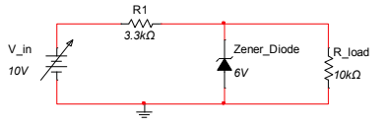
Figure 2.1(b): Voltage Regulation by changing Line Voltage. Source: Lab Manual for Experiment 03

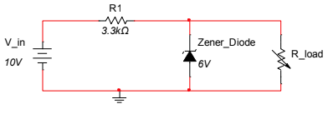
Figure 2.1(c): Voltage Regulation by changing Load Resistance. Source: Lab Manual for Experiment 03

Data, Results and Graph:

V_{T} = 0.750 V
R = 3.219 kΩ

Vin | V_{R} | V_{Z} | IR=(VR/R) = IZ
1 V | 0 V | 1.07 V | 0 mA
2 V | 0 V | 1.99 V | 0 mA
3 V | 0 V | 3.03 V | 0 mA
4 V | 0 V | 4.00 V | 0 mA
5 V | 0 V | 5.02 V | 0 mA
6 V | 0.15 V | 5.90 V | 0.046 mA
7 V | 0.93 V | 6.08 V | 0.289 mA
8 V | 1.92 V | 6.11 V | 0.59 mA
9 V | 2.93 V | 6.13 V | 0.91 mA
10 V | 3.88 V | 6.14 V | 1.20 mA
12 V | 5.90 V | 6.15 V | 1.83 mA
15 V | 8.84 V | 6.16 V | 2.74 mA
20 V | 13.98 V | 6.17 V | 4.34 mA

Table 1: Experimental Data from Zener Diode Reverse Bias Characteristics.

V_{RB} of Zener Diode Reverse Breakdown Voltage = (6.15V+6.16V+6.17V)/3
=>V_{RB} = 6.16V

# CALCULATION OF CURRENT IN RESISTOR R: I_{R}=(V_{R}/R)

V_{in} = 1V => (0/3.219) = 0mA
V_{in} = 2V => (0/3.219) = 0mA
V_{in} = 3V => (0/3.219) = 0mA
V_{in} = 4V => (0/3.219) = 0mA
V_{in} = 5V => (0/3.219) = 0mA
V_{in} = 6V => (0.15/3.219) = 0.046mA
V_{in} = 7V => (0.93/3.219) = 0.289mA
V_{in} = 8V => (1.92/3.219) = 0.59mA
V_{in} = 9V => (2.93/3.219) = 0.91mA
V_{in} = 10V => (3.88/3.219) = 1.20mA
V_{in} = 12V => (5.90/3.219) = 1.83mA
V_{in} = 15V => (8.84/3.219) = 2.74mA
V_{in} = 20V => (13.98/3.219) = 4.34mA

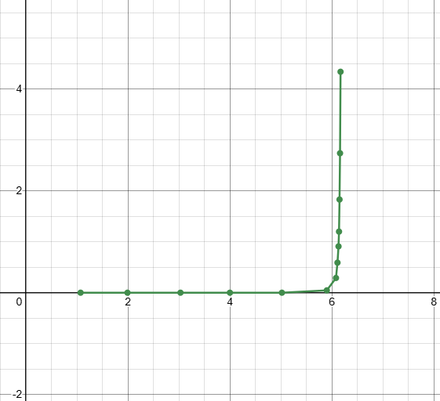

Graph: I_{Z} vs V_{Z}

R₁ = 3.129 kΩ

R_{load} = 9.96 kΩ

Vin | V_{R1} | V_{R_load} = VZ | % of Voltage Regulation
1 V | 0.25 V | 0.80 V | 87.61 %
3 V | 0 .72 V | 2.06 V | 63.31 %
5 V | 1.23 V | 3.82 V | 37.98 %
6 V | 1.47 V | 4.56 V | 25.97 %
7 V | 1.69 V | 5.29 V | 14.12 %
8 V | 2.13 V | 5.95 V | 3.40 %
9 V | 2.96 V | 6.06 V | 1.62 %
10 V | 3.89 V | 6.11 V | 0.81 %
12 V | 5.87 V | 6.14 V | 0.32 %
15 V | 8.94 V | 6.15 V | 0.16 %

Table 2: Experimental Data from Voltage Regulation by changing Line Voltage

# CALCULATION OF % OF VOLTAGE REGULATION: ((V_{RB} – V_{Z})/V_{RB)}*100%

V_{in} = 1V => ((6.16-0.80)/6.16) *100 = 87.61%
V_{in} = 3V => ((6.16-2.06)/6.16) *100 = 63.31%
V_{in} = 5V => ((6.16-3.82)/6.16) *100 = 37.98%
V_{in} = 6V => ((6.16-4.56)/6.16) *100 = 25.97%
V_{in} = 7V => ((6.16-5.29)/6.16) *100 = 14.12%
V_{in} = 8V => ((6.16-5.95)/6.16) *100 = 3.40%
V_{in} = 9V => ((6.16-6.06)/6.16) *100 = 1.62%
V_{in} = 10V => ((6.16-6.11)/6.16) *100 = 0.81%
V_{in} = 12V => ((6.16-6.14)/6.16) *100 = 0.32%
V_{in} = 15V => ((6.16-6.15)/6.16) *100 = 0.16%

R₁ = 3.129 kΩ

Rload | Rload (DMM) | V_{R1} (DMM) | V_{R_load} = V_{z}  (DMM) | % of Voltage Regulation
1.0 kΩ | 0.982 kΩ | 7.68 V | 2.34 V | 62.01%
1.5 kΩ | 1.479 kΩ | 6.78 V | 3.15 V | 48.86 %
2.2 kΩ | 2.174 kΩ | 5.98 V | 4.04 V | 34.41 %
3.3 kΩ | 3.229 kΩ | 5.01 V | 5.01 V | 18.66 %
4.7 kΩ | 4.643 kΩ | 4.17 V | 5.84 V | 5.19 %
6.8 kΩ | 6.70 kΩ | 3.94 V | 6.08 V | 1.29 %
10.0 kΩ | 9.97 kΩ | 3.91 V | 6.10 V | 0.97 %
33.0 kΩ | 33.26 kΩ | 3.89 V | 6.13 V | 0.48 %
56.0 kΩ | 55.09 kΩ | 3.89 V | 6.14 V | 0.32 %
100.0 kΩ | 98.40 kΩ | 3.89 V | 6.14 V | 0.32 %

Table 3: Experimental Data from Voltage Regulation by changing Load Resistance

# CALCULATION OF % OF VOLTAGE REGULATION: ((V_{RB} – V_{Z})/V_{RB)}*100%

R_{load} = 1.0 kΩ => ((6.16-2.34)/6.16) *100 = 62.01%
R_{load} = 1.5 kΩ => ((6.16-3.15)/6.16) *100 = 48.86%
R_{load} = 2.2 kΩ => ((6.16-3.04)/6.16) *100 = 34.41%
R_{load} = 3.3 kΩ => ((6.16-5.01)/6.16) *100 = 18.66%
R_{load} = 4.7 kΩ => ((6.16-5.84)/6.16) *100 = 5.19%
R_{load} = 6.8 kΩ => ((6.16-6.08)/6.16) *100 = 1.29%
R_{load} = 10.0 kΩ => ((6.16-6.10)/6.16) *100 = 0.97%
R_{load} = 33.0 kΩ => ((6.16-6.13)/6.16) *100 = 0.48%
R_{load} = 56.0 kΩ => ((6.16-6.14)/6.16) *100 = 0.32%
R_{load} = 100.0 kΩ => ((6.16-6.14)/6.16) *100 = 0.32%
Results and Discussion:
For the first circuit, we observed that by increasing V_{in}, V_{Z} steadily rises until the V_{RB} rating of the Zener diode is reached (6V). It falls in line with the theory, that the Zener diode will regulate the voltage across itself so that its V_{Z} rating is not crossed. I_{Z} stays 0mA until the 6 V_{in}, which is the breakdown voltage of the Zener diode. Afterwards, I_{Z} increases with V_{in}.
For the second circuit, which is a Voltage Regulation circuit, we observed that by increasing V_{in} the V_{R_load} increases until V_{RB} rating of the Zener diode is reached (6V). Once again, it falls in line that the Zener diode will regulate the voltage by creating a short circuit across itself in order to maintain the voltage across the load in parallel. VR% decreases with V_{in}. Data suggests that VR% tends towards 0%
For the third circuit, which is also a Voltage Regulation circuit, we observed that by increasing R_{load} the V_{R_load} increases until R_{load} reaches 6.8 kΩ. After that point, V_{R_load} stays at the V_{RB} voltage (~6V). The VR% also decreases as R_{load} is increases. Data suggests that VR% tends towards 0%.
On this experiment we have used zener diodes to observe it’s behavior when supplied with power. The zener diode has a lower limit of voltage that it can let pass through, till that lower limit is reached and that is “Breakdown Voltage”. We have experimented with zener diode by supplying different voltages. On the first circuit

Conclusion:
We learned about another variant of diodes, the Zener Diode. We saw that unlike a normal diode, the Zener diode can work in reverse bias as it has a lower breakdown voltage. This makes the Zener diode appropriate for applications such as Voltage Regulator, Clippers, and Over-Voltage Protectors. In our experiments, we learned about the reverse bias characteristics of a Zener diode. In the second and third experiment, we saw the effect of V_{in} and R_{load} on % of voltage regulation by the diode.

References:

[1] https://byjus.com/physics/zener-diode/

[2] By Fred the Oyster - File:I-V curve for a Zener Diode.jpg, CC BY-SA 3.0, https://commons.wikimedia.org/w/index.php?curid=16129785

[3] https://www.toppr.com/ask/question/draw-the-circuit-diagram-of-a-voltage-regulator-using-zener/

