

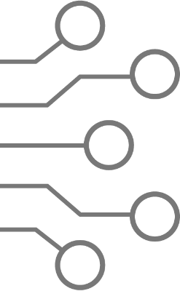

North South University

Department of Electrical & Computer Engineering

# EEE 111 / ETE 111 – Lab

Analog Electronics – 1

Course Section **: 6**

Faculty **: AQU**

Lab Instructor **: Mehrab Hossain Likhonn**

# Lab Report

|  |  |
| --- | --- |
|  |  |
| Experiment No | **: 05** |
| Experiment Name | **: Zener Diode Characteristics and Voltage regulation using Zener Diode** |
| Date of Performance | **: 28/02/2025** |
| Date of Submission | **:12/03/2025** |

Group No **: 7**

|  |  |  |  |
| --- | --- | --- | --- |
| *Group Member’s Name* | *ID* | *Writer* | *Signature* |
| 1. Zaid Zarifur Rahman | 2131819642 | □ |  |
| 1. Sibgat Ul Islam | 2111920642 | □ |  |
| 1. Nazifa Tahsin | 2132652642 | □ |  |
| 1. Abdullah Al Towhid | 2031045642 | □ |  |
| 5. |  | □ |  |

Experiment Name:

Zener Diode Characteristics and Voltage regulation using Zener Diode

Objective:

Study of Zener Diode Characteristics and its application in voltage regulation.

Theory:

There are different kinds of diodes which have wide ranging characteristics. Zener diodes specialize in operating in the breakdown region (in reverse bias) without damage. It is used to build voltage regulator circuits where it helps the load in holding an almost constant voltage despite large change in line voltage and load resistance.

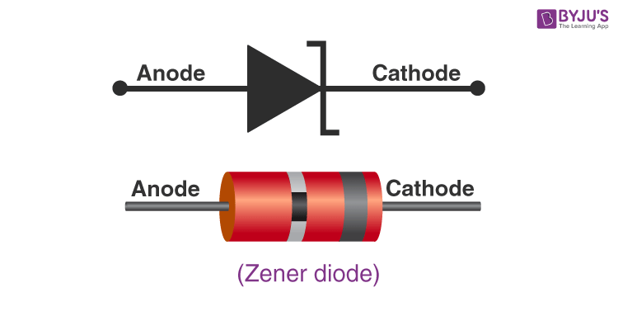

[1] Fig 1.1: Symbol of Zener Diode.

While in the forward bias, the Zener diode exhibit the I-V characteristics of a typical diode. However, in the leakage region (between zero and breakdown) it has a small reverse saturation current. In the breakdown region (the breakdown voltage may vary from 2 to 200 volts) the current increases sharply without virtually any change to the Vz. Here is a graph that overlays the IV characteristic of a typical diode and a Zener diode:

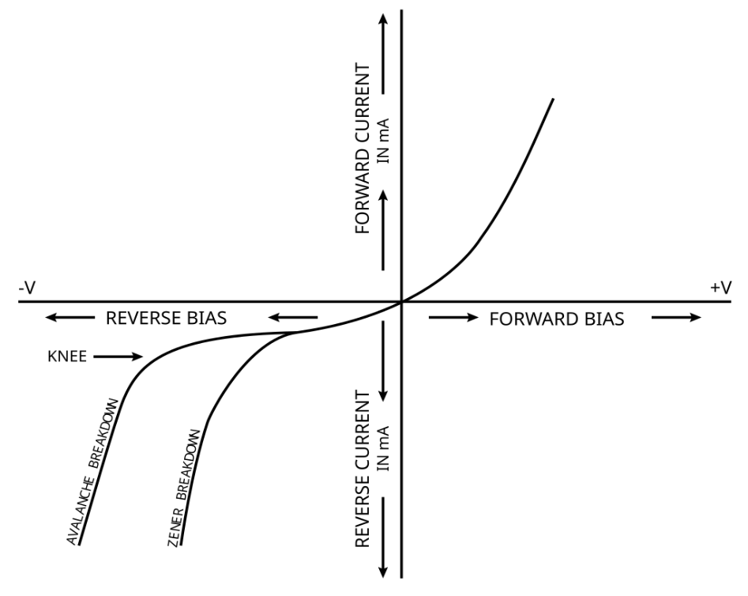

[2] Fig 1.2: I-V characteristic of normal diode and Zener diode.

Zener diodes can be applied for many purposes such as:

* Over-Voltage Protection: By limiting the voltage on load if placed parallel to the Zener diode
* Clipper circuits: An opposing pair of Zener diodes placed in series
* Voltage Regulator: Sets the voltage across parallel load to Vz

Let us look at a Voltage Regulator circuit:

[3] Fig 1.3: Voltage Regulator circuit

The diagram shows that regardless of how high Vs gets, the potential difference across RL will not get higher than Vz, due to being in parallel with the Zener diode in reverse bias.

Equipment List:

|  |  |  |  |
| --- | --- | --- | --- |
| Serial NO. | Components | Specification | Quantity |
| 1. | Zener Diode | 6 Vz | 1 piece |
| 2. | Resistor | As required | As required |
| 3. | DC Power Supply |  | 1 unit |
| 4. | Digital Multimeter |  | 1 unit |
| 5. | Bread Board |  | 1 unit |
| 6. | Wires |  | As required |

Circuit Diagram:

Figure 2.1(a): Reverse Bias Characteristic of Zener Diode. *Source: Lab Manual for Experiment 03*

Figure 2.1(b): Voltage Regulation by changing Line Voltage. *Source: Lab Manual for Experiment 03*

Figure 2.1(c): Voltage Regulation by changing Load Resistance. *Source: Lab Manual for Experiment 03*

Data, Results and Graph:

VT = 0.750 V

R = 3.219 kΩ

|  |  |  |  |
| --- | --- | --- | --- |
| Vin | VR | VZ | IR=(VR/R) = IZ |
| 1 V | 0 V | 1.07 V | 0 mA |
| 2 V | 0 V | 1.99 V | 0 mA |
| 3 V | 0 V | 3.03 V | 0 mA |
| 4 V | 0 V | 4.00 V | 0 mA |
| 5 V | 0 V | 5.02 V | 0 mA |
| 6 V | 0.15 V | 5.90 V | 0.046 mA |
| 7 V | 0.93 V | 6.08 V | 0.289 mA |
| 8 V | 1.92 V | 6.11 V | 0.59 mA |
| 9 V | 2.93 V | 6.13 V | 0.91 mA |
| 10 V | 3.88 V | 6.14 V | 1.20 mA |
| 12 V | 5.90 V | 6.15 V | 1.83 mA |
| 15 V | 8.84 V | 6.16 V | 2.74 mA |
| 20 V | 13.98 V | 6.17 V | 4.34 mA |

Table 1: Experimental Data from Zener Diode Reverse Bias Characteristics.

VRB of Zener Diode Reverse Breakdown Voltage = (6.15V+6.16V+6.17V)/3

=>VRB = 6.16V

# CALCULATION OF CURRENT IN RESISTOR R: **IR=(VR/R)**

Vin = 1V => (0/3.219) = 0mA

Vin = 2V => (0/3.219) = 0mA

Vin = 3V => (0/3.219) = 0mA

Vin = 4V => (0/3.219) = 0mA

Vin = 5V => (0/3.219) = 0mA

Vin = 6V => (0.15/3.219) = 0.046mA

Vin = 7V => (0.93/3.219) = 0.289mA

Vin = 8V => (1.92/3.219) = 0.59mA

Vin = 9V => (2.93/3.219) = 0.91mA

Vin = 10V => (3.88/3.219) = 1.20mA

Vin = 12V => (5.90/3.219) = 1.83mA

Vin = 15V => (8.84/3.219) = 2.74mA

Vin = 20V => (13.98/3.219) = 4.34mA

Graph: IZ vs VZ

R1 = 3.129 kΩ

Rload = 9.96 kΩ

|  |  |  |  |
| --- | --- | --- | --- |
| Vin | VR1 | VR_load = VZ | % of Voltage Regulation |
| 1 V | 0.25 V | 0.80 V | 87.61 % |
| 3 V | 0 .72 V | 2.06 V | 63.31 % |
| 5 V | 1.23 V | 3.82 V | 37.98 % |
| 6 V | 1.47 V | 4.56 V | 25.97 % |
| 7 V | 1.69 V | 5.29 V | 14.12 % |
| 8 V | 2.13 V | 5.95 V | 3.40 % |
| 9 V | 2.96 V | 6.06 V | 1.62 % |
| 10 V | 3.89 V | 6.11 V | 0.81 % |
| 12 V | 5.87 V | 6.14 V | 0.32 % |
| 15 V | 8.94 V | 6.15 V | 0.16 % |

Table 2: Experimental Data from Voltage Regulation by changing Line Voltage

# CALCULATION OF % OF VOLTAGE REGULATION: **((VRB – VZ)/VRB)*100%**

Vin = 1V => ((6.16-0.80)/6.16) *100 = 87.61%

Vin = 3V => ((6.16-2.06)/6.16) *100 = 63.31%

Vin = 5V => ((6.16-3.82)/6.16) *100 = 37.98%

Vin = 6V => ((6.16-4.56)/6.16) *100 = 25.97%

Vin = 7V => ((6.16-5.29)/6.16) *100 = 14.12%

Vin = 8V => ((6.16-5.95)/6.16) *100 = 3.40%

Vin = 9V => ((6.16-6.06)/6.16) *100 = 1.62%

Vin = 10V => ((6.16-6.11)/6.16) *100 = 0.81%

Vin = 12V => ((6.16-6.14)/6.16) *100 = 0.32%

Vin = 15V => ((6.16-6.15)/6.16) *100 = 0.16%

R1 = 3.129 kΩ

|  |  |  |  |  |
| --- | --- | --- | --- | --- |
| Rload | Rload (DMM) | VR1 (DMM) | VR_load = Vz  (DMM) | % of Voltage Regulation |
| 1.0 kΩ | 0.982 kΩ | 7.68 V | 2.34 V | 62.01% |
| 1.5 kΩ | 1.479 kΩ | 6.78 V | 3.15 V | 48.86 % |
| 2.2 kΩ | 2.174 kΩ | 5.98 V | 4.04 V | 34.41 % |
| 3.3 kΩ | 3.229 kΩ | 5.01 V | 5.01 V | 18.66 % |
| 4.7 kΩ | 4.643 kΩ | 4.17 V | 5.84 V | 5.19 % |
| 6.8 kΩ | 6.70 kΩ | 3.94 V | 6.08 V | 1.29 % |
| 10.0 kΩ | 9.97 kΩ | 3.91 V | 6.10 V | 0.97 % |
| 33.0 kΩ | 33.26 kΩ | 3.89 V | 6.13 V | 0.48 % |
| 56.0 kΩ | 55.09 kΩ | 3.89 V | 6.14 V | 0.32 % |
| 100.0 kΩ | 98.40 kΩ | 3.89 V | 6.14 V | 0.32 % |

Table 3: Experimental Data from Voltage Regulation by changing Load Resistance

# CALCULATION OF % OF VOLTAGE REGULATION: **((VRB – VZ)/VRB)*100%**

Rload = 1.0 kΩ => ((6.16-2.34)/6.16) *100 = 62.01%

Rload = 1.5 kΩ => ((6.16-3.15)/6.16) *100 = 48.86%

Rload = 2.2 kΩ => ((6.16-3.04)/6.16) *100 = 34.41%

Rload = 3.3 kΩ => ((6.16-5.01)/6.16) *100 = 18.66%

Rload = 4.7 kΩ => ((6.16-5.84)/6.16) *100 = 5.19%

Rload = 6.8 kΩ => ((6.16-6.08)/6.16) *100 = 1.29%

Rload = 10.0 kΩ => ((6.16-6.10)/6.16) *100 = 0.97%

Rload = 33.0 kΩ => ((6.16-6.13)/6.16) *100 = 0.48%

Rload = 56.0 kΩ => ((6.16-6.14)/6.16) *100 = 0.32%

Rload = 100.0 kΩ => ((6.16-6.14)/6.16) *100 = 0.32%

Results and Discussion:

For the first circuit, we observed that by increasing Vin, VZ steadily rises until the VRB rating of the Zener diode is reached (6V). It falls in line with the theory, that the Zener diode will regulate the voltage across itself so that its VZ rating is not crossed. IZ stays 0mA until the 6 Vin, which is the breakdown voltage of the Zener diode. Afterwards, IZ increases with Vin.

For the second circuit, which is a Voltage Regulation circuit, we observed that by increasing Vin the VR_load increases until VRB rating of the Zener diode is reached (6V). Once again, it falls in line that the Zener diode will regulate the voltage by creating a short circuit across itself in order to maintain the voltage across the load in parallel. VR% decreases with Vin. Data suggests that VR% tends towards 0%

For the third circuit, which is also a Voltage Regulation circuit, we observed that by increasing Rload the VR_load increases until Rload reaches 6.8 kΩ. After that point, VR_load stays at the VRB voltage (~6V). The VR% also decreases as Rload is increases. Data suggests that VR% tends towards 0%.

Conclusion:

We learned about another variant of diodes, the Zener Diode. We saw that unlike a normal diode, the Zener diode can work in reverse bias as it has a lower breakdown voltage. This makes the Zener diode appropriate for applications such as Voltage Regulator, Clippers, and Over-Voltage Protectors. In our experiments, we learned about the reverse bias characteristics of a Zener diode. In the second and third experiment, we saw the effect of Vin and Rload on % of voltage regulation by the diode.

References:

[1] https://byjus.com/physics/zener-diode/

[2] By Fred the Oyster - File:I-V curve for a Zener Diode.jpg, CC BY-SA 3.0, https://commons.wikimedia.org/w/index.php?curid=16129785

[3] https://www.toppr.com/ask/question/draw-the-circuit-diagram-of-a-voltage-regulator-using-zener/

