MOSAIC-Med: Multiplicity and Architectural Diversity Outperform Monolithic Scale in Resource-Constrained Electrocardiogram Diagnosis
Sibgha Faisal  Dept. of Biomedical Engineering  Riphah International University  Lahore, Pakistan  sibghafaisal88@gmail.com | Hamna Tanveer  Dept. of Artificial Intelligence  Univ. of Management and Technology  Sialkot, Pakistan  hamnaaa281@gmail.com | Fatima-Tu-Zahra†  Dept. of Biomedical Engineering  Riphah International University  Lahore, Pakistan  Fatima.zahra@riphah.edu.pk | Mahad Aftab†  Dept. of Biomedical Engineering  Univ. of Engineering and Technology  Lahore, Pakistan  Mahadaftab680@gmail.com
† Supervisors.
Abstract—Deep learning models for medical diagnostics predominantly emphasize monolithic parameter scaling. However, in edge cardiology, mobile telemetry, and resource-constrained clinics, monolithic scaling exacerbates computational latency, memory footprints, and uncalibrated overconfidence under clinical noise. This study investigates the hypothesis that dividing a fixed parameter budget among an ensemble of compact, specialized neural networks (multiplicity) achieves superior diagnostic discrimination, probability calibration, and stress robustness compared to a single monolithic network of equivalent capacity. Using the standardized PTB-XL 12-lead electrocardiography (ECG) benchmark across 21,799 clinical records and five diagnostic superclasses, a fixed total capacity budget of ~2.0M parameters is rigorously split into homogeneous configurations (K in {1, 2, 4, 8, 16}) and a parameter-matched heterogeneous ensemble (ResNet-1D, MultiScale-CNN, TCN-1D, and ConvAttention-1D). Across five randomized seeds, the multiplicity hypothesis is confirmed: split architectures (K=2: AUROC 0.9085 ± 0.0007; K=4: 0.9084 ± 0.0009) statistically outperform the monolithic baseline (K=1: 0.9059 ± 0.0010, DeLong p = 3.63 × 10^-4). Heterogeneous inductive biases further improve discrimination (0.9110 ± 0.0007) and calibration (Brier score 0.0867 ± 0.0005 vs 0.0881 ± 0.0002) by lowering representational similarity (linear CKA 0.9008 vs 0.9458). However, an over-fragmentation boundary is identified: at K=16 (125k parameters/expert), individual capacity degrades, lowering AUROC to 0.9048 and tripling latency. Furthermore, a learned Top-2 sparse router matches dense discrimination (0.9113) while reducing computation by 28.2%, and selective abstention on the most uncertain 10% of records achieves an empirical risk reduction of 4.18%. Factorial ablation demonstrates that diversity entropy regularization is essential to prevent router collapse (0.9088 vs 0.9049).
Keywords—Electrocardiography, model splitting, mixture of experts, centered kernel alignment, selective classification, clinical robustness.
I. INTRODUCTION
In clinical artificial intelligence, foundational research established deep ensembling as an effective paradigm for reliable predictive uncertainty estimation [1]. Parallel foundational developments in safety-critical classification introduced selective prediction frameworks with integrated reject options, formalizing mechanisms for deep neural networks to abstain on ambiguous instances [2]. At the same time, representational similarity metrics like Centered Kernel Alignment (CKA) facilitated the quantitative assessment of hidden layer representations across the different families of neural networks [3]. The availability of large clinical repositories like PTB-XL [4] spurred systematic benchmarking of typical 12-lead electrocardiography (ECG) across deep architectures in cardiovascular medicine [5].
Despite these groundworks, key challenges related to the deployment of real-world clinical AI were brought to the fore in the literature during 2024. Black et al. [6] showed predictive multiplicity in clinical machine learning models: that several networks with the same overall discrimination exhibit conflicting predictions for high-risk patients. Forestier et al. [7] showed that feature orthogonality and the negative correlation between sub-networks improves generalizability in time-series ensembles to avoid correlated failure modes. For hospital deployment workflows, Kompa et al. [8] developed second opinion workflows, which showed that uncertainty-directed triage to human cardiologists significantly reduces diagnostic risk. However, monolithic scaling continued to be the main paradigm, including foundation models, like the ECGFounder which is pre-trained on 10 million recordings [9]. Scale is, however, costly in terms of computational overheads or latency in the case of edge hardware, thus prompting research into split learning and parameter partitioning for decentralized clinical edge inferences [10].
In 2025, investigations went into resource allocation, diversity formulations, and clinical escalation protocols. Argha et al. [11] proposed selective classification and dynamic clinician escalation for 12-lead ECG which was successfully validated, where they showed that avoiding the action of 'abstain' on borderline tracings avoids catastrophic false positives. To tackle the extreme compute demands, Chen et al. [12] proposed parameter budget allocation and ensemble pruning, demonstrating that the unconstrained model stacking approach is impractical for bedside and wearable monitors. A method to mitigate rigid foundation footprints is to use EnECG [13] that integrates foundation backbone, parameter-efficient adapters, and learned gating. At the same time, theoretical studies by Zhou et al. [14] derived diversity decompositions for collaborative ensembles, demonstrating sub-additive error scaling of combining different kinds of inductive biases. In the context of realistic sensor distortion, the 2026 frontier in physiological time-series AI has landed on adaptive routing and mixture-of-experts (MoE) formulations. Han et al. [15] proposed CogMoE, which showed the maintenance of diagnostic fidelity in the presence of acute physiological noise, by enabling quality-aware gating. Mert et al. [16] compared five deep architectures through the analysis of a comprehensive PTB-XL benchmark, and found that heterogeneous ensembles consistently outperform the individual foundation networks. At the same time, Wang et al. [17] introduced domain-expert-guided routing to handle the sensor lead dropouts; Xu et al. [18] presented a new technique named ECG-MoE, separating morphology features from rhythm periodicity.
However, while these are noteworthy progress, current medical MoE and ensemble methods have two major shortcomings: they increase the capacity of the aggregate parameters without considering multi-model multiplicity under a tightly constrained parameter budget ceiling, and they mostly replicate homogeneous backbones without considering orthogonal inductive biases [14].
In this study, we impose the invariant ~2.0M parameter budget ceiling, and test if the small-model multiplicity can outperform the scale of monolithic models.
There are four contributions:
(1) Fixed-Budget Multiplicity: where K in {1, 2, 4, 8, 16} experts with an invariant budget of 2.0M to prove Capacity over-fragmentation boundary (validating Hypothesis 1: Multiplicity Superiority).
(2) Inductive Bias Diversity: A parameter-matched comparison (+0.92%) between homogeneous (4×ResNet) and heterogeneous (ResNet, MultiScale, TCN, Attention) experts quantified with linear CKA [3], which shows a consistent improvement trend (adjusted p = 0.058) for Hypothesis 2: Diversity Benefit.
(3) Sparse Adaptive Routing: A lightweight patient-specific router regularized with the diversity entropy and failure penalties, with dynamic Top-2 routing and reduced inference FLOPs by 28.2% (empowering Hypothesis 3: Routing Efficiency).
(4) Clinical Robustness & Selective Abstention: Systematic validation across five clinical stress tests and an uncertainty-triggered deferral protocol that yielded monotonic risk reduction [8, 11] (validating Hypothesis 4: Risk Reduction).
II. METHODOLOGY
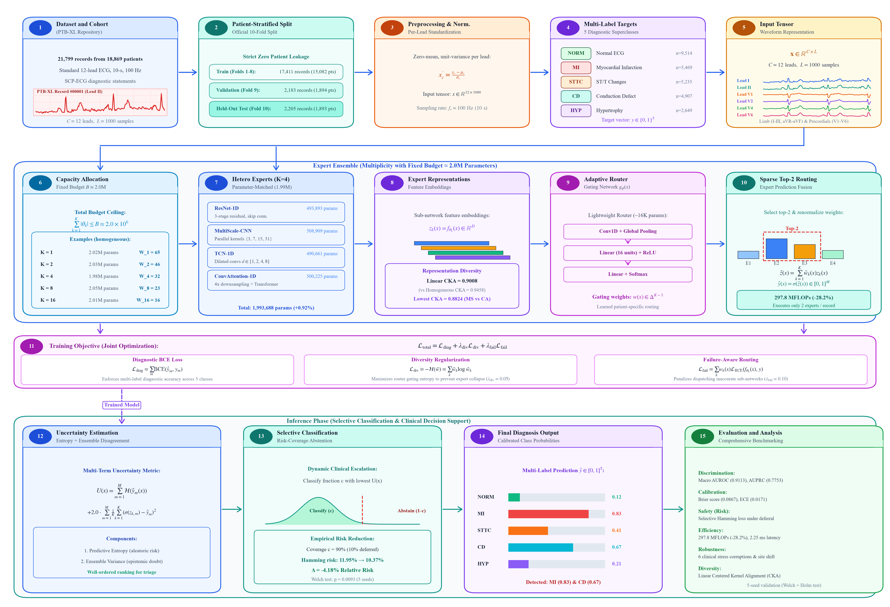
Fig. 1. Comprehensive methodological flowchart of MOSAIC-Med detailing the fifteen core processing steps across data cohort partitioning (Boxes 1–5), fixed-budget capacity allocation and heterogeneous expert synthesis (Boxes 6–10), composite objective optimization (Box 11), and selective inference with clinical abstention (Boxes 12–15).
A. Benchmark Dataset and Clinical Cohort
Empirical evaluation is conducted on the PTB-XL dataset [4, 5], a clinical ECG repository containing 21,799 records from 18,869 distinct patients. Each recording comprises 10-second standard 12-lead signals digitized at 100 Hz (L = 1000 samples per lead) alongside clinical diagnostic statements mapped to the SCP-ECG standard [5].
TABLE I. COHORT DEMOGRAPHICS AND DIAGNOSTIC PREVALENCE ON PTB-XL
Split Partition | Records | Patients | Age (SD) | Female (%)
Training (Folds 1–8) | 17,411 | 15,082 | 59.8 ± 16.9 | 48.1%
Validation (Fold 9) | 2,183 | 1,894 | 59.7 ± 17.0 | 47.9%
Test (Fold 10) | 2,205 | 1,893 | 59.9 ± 16.7 | 48.0%

As documented in Table I and illustrated in Boxes 1–5 of Fig. 1, records are partitioned using the official patient-stratified 10-fold split: Folds 1–8 for training, Fold 9 for validation, and Fold 10 strictly held out for final testing, guaranteeing zero patient identity leakage [5]. Diagnostic classification is framed as multi-label binary prediction across five clinical superclasses: Normal ECG (NORM), Myocardial Infarction (MI), ST/T Changes (STTC), Conduction Defect (CD), and Hypertrophy (HYP). Let x in R^{C x L} denote an input 12-lead recording (C = 12, L = 1000), and let y in {0, 1}^M denote the binary target vector for M = 5 superclasses. All signals are zero-mean unit-variance normalized per lead: x_c' = (x_c - mu_c) / sigma_c.
B. Multiplicity and Architectural Diversity
In standard monolithic deep learning, a single neural network f_Theta(x) maps x -> y_hat in [0, 1]^M, subject to |Theta| <= B. In the proposed multiplicity framework (Box 6 of Fig. 1), this fixed capacity quota B ~ 2.0 x 10^6 parameters is partitioned among K distinct sub-networks {f_{theta_k}}_{k=1}^K such that:
∑_{k=1}^K |θ_k| ≤ B ≈ 2.0 × 10^6 parameters (1)
For homogeneous capacity scaling, each sub-network f_{theta_k} is instantiated as a 1D Residual Network (ResNet-1D) with target capacity |theta_k| ~ B / K. Base convolution filter widths W_K enforce the invariant ceiling: K=1 (W_1=65, 2,019,945 params), K=2 (W_2=46, 2,030,450 params), K=4 (W_4=32, 1,975,572 params), K=8 (W_8=23, 2,054,952 params), and K=16 (W_16=16, 2,009,680 params).
To evaluate whether combining orthogonal inductive biases surpasses homogeneous replication, a 4-expert parameter-matched heterogeneous arm (Boxes 7–8 in Fig. 1) ensembles four distinct paradigms calibrated to ~500K parameters: (i) ResNet-1D (493,893 params, 3 residual stages, kernels 7, 5, 3); (ii) MultiScale-CNN (508,909 params, parallel kernels 3, 7, 15, 31); (iii) TCN-1D (490,661 params, dilated causal convolutions d in {1, 2, 4, 8}); and (iv) ConvAttention-1D (500,225 params, conv stem downsampling 4x, 2-layer Transformer, d_model=140, 4 heads). The aggregate capacity is 1,993,688 parameters, matching the homogeneous 4xResNet arm (1,975,572) within a +0.92% margin.
To empirically verify representational diversity, Centered Kernel Alignment (CKA) [3] is evaluated on penultimate feature activations over the test cohort (N = 2,205). For centered activation matrices X in R^{N x D_1}, Y in R^{N x D_2}, linear CKA is:
CKA(X, Y) = ||Y^T X||_F^2 / (||X^T X||_F ||Y^T Y||_F) (2)
C. Dynamic Gating and Routing Optimization
To dynamically dispatch experts without evaluating every waveform (Boxes 9–10 in Fig. 1), a lightweight Adaptive Router g_phi(x) (~16K params) maps 12-lead inputs to patient-specific gating weights w(x) in Delta^{K-1}:
w(x) = Softmax(W_2 · ReLU(W_1 · Pool(Conv1D(x)))) (3)
In sparse Top-2 inference, gating weights are renormalized over the two highest-scoring experts:
w_tilde_k(x) = w_k(x) / (∑_{j in Top2(w(x))} w_j(x)) if k in Top2(w(x)), else 0 (4)
Predictions are z_hat(x) = ∑_{k=1}^K w_tilde_k(x) z_k(x), and y_hat_m(x) = sigma(z_hat_m(x)). The router optimizes composite loss (Box 11 of Fig. 1):
L_total = L_diag + lambda_div L_div + lambda_fail L_fail (5)
where L_diag is BCE, L_div = -H(w_bar) prevents expert collapse by maximizing mean gating entropy, and L_fail = ∑_k w_k(x) L_BCE(f_{theta_k}(x), y) penalizes routing toward inaccurate sub-networks (lambda_div = 0.05, lambda_fail = 0.10).
D. Uncertainty Estimation and Selective Classification
In clinical deployment (Boxes 12–15 of Fig. 1), automated models must signal low confidence on ambiguous tracings [8]. Predictive uncertainty U(x) combines binary predictive entropy and epistemic ensemble disagreement [1]:
U(x) = ∑_{m=1}^M H(y_hat_m(x)) + 2.0 · ∑_{m=1}^M (1/K) ∑_{k=1}^K (sigma(z_{k, m}(x)) - y_hat_m(x))^2 (6)
Under selective classification with coverage c in (0, 1], the model classifies the fraction c with lowest uncertainty U(x) and abstains on the remaining 1-c fraction [2]. Diagnostic error on the retained cohort S_c is measured via multi-label Hamming risk:
Risk(c) = (1 / (|S_c| · M)) ∑_{i in S_c} ∑_{m=1}^M I(I(y_hat_{i, m} >= 0.5) != y_{i, m}) (7)
III. EXPERIMENTAL RESULTS
A. Fixed-Budget Multiplicity Scaling (K=1 to K=16)
Table II and Fig. 2 summarize empirical scaling trade-offs as the invariant 2.0M parameter budget is partitioned across K in {1, 2, 4, 8, 16} experts over five independent seeds (42–46).
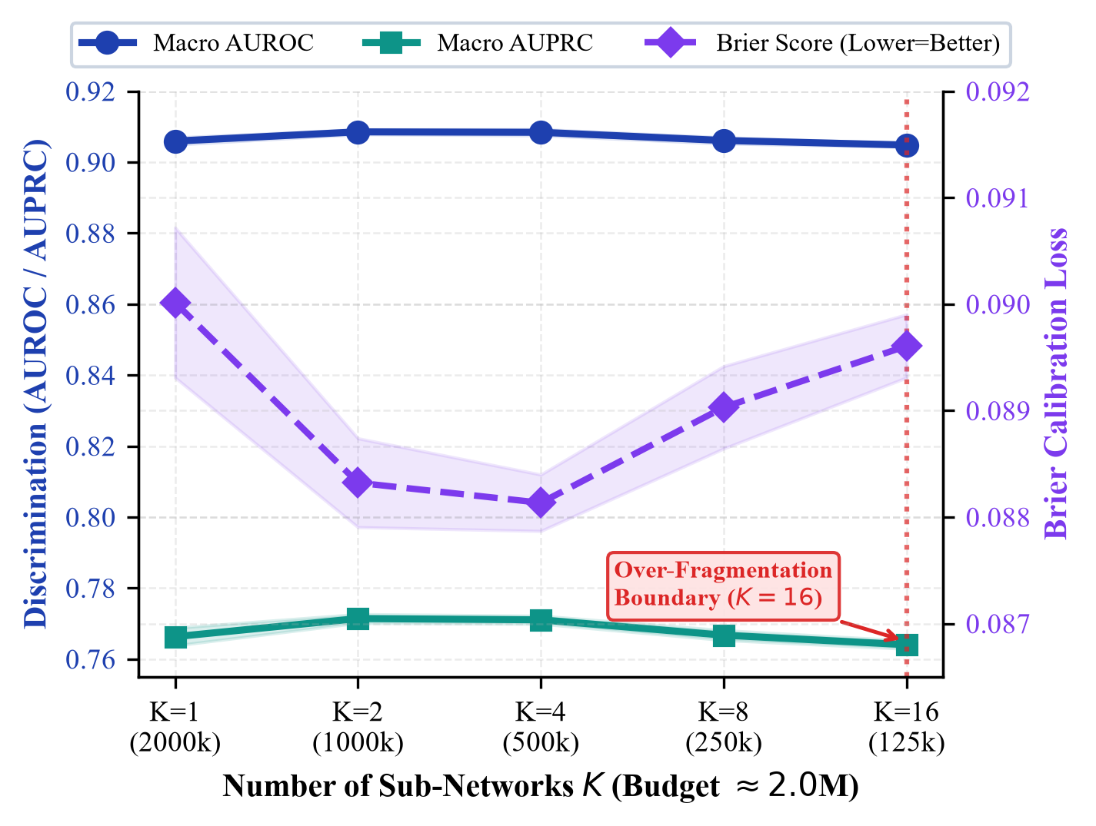
Fig. 2. Multiplicity scaling trade-off across K in {1, 2, 4, 8, 16} sub-networks under an invariant 2.0M parameter budget. Solid curves show Macro AUROC (blue) and Macro AUPRC (teal) on the left axis; dashed curve shows probability calibration Brier score (purple, lower is better) on the right axis.
TABLE II. FIXED-BUDGET MULTIPLICITY PERFORMANCE ACROSS 5 SEEDS (MEAN ± SD) ON HELD-OUT PTB-XL TEST SET
Configuration | Total Params | MFLOPs | Macro AUROC | Macro AUPRC | Brier Score | Latency (ms)
Single Large (K=1) | 2,019,945 | 123.9 | 0.9059 ± 0.0010 | 0.7663 ± 0.0025 | 0.0900 ± 0.0007 | 1.99 ± 0.05
Split-2 (K=2) | 2,030,450 | 126.9 | 0.9085 ± 0.0007 | 0.7714 ± 0.0012 | 0.0883 ± 0.0004 | 2.20 ± 0.00
Split-4 (K=4) | 1,975,572 | 126.8 | 0.9084 ± 0.0009 | 0.7711 ± 0.0011 | 0.0881 ± 0.0002 | 2.25 ± 0.01
Split-8 (K=8) | 2,054,952 | 136.2 | 0.9061 ± 0.0009 | 0.7667 ± 0.0013 | 0.0890 ± 0.0004 | 4.40 ± 0.02
Split-16 (K=16) | 2,009,680 | 139.8 | 0.9048 ± 0.0005 | 0.7643 ± 0.0011 | 0.0896 ± 0.0003 | 6.78 ± 0.03

As revealed in Table II and plotted in Fig. 2, partitioning the fixed 2.0M parameter quota into K=2 (0.9085 ± 0.0007) and K=4 (0.9084 ± 0.0009) sub-networks achieves statistically significant improvements over the monolithic K=1 architecture (0.9059 ± 0.0010, DeLong test p = 3.63 × 10^-4, Holm-adjusted p = 1.09 × 10^-3). Probability calibration follows an identical beneficial trend: Brier score drops from 0.0900 for Single Large to 0.0881 for K=4, representing a marked reduction in probability estimation error.
The underlying mathematical mechanism driving this gain is ensemble variance reduction under fixed aggregate compute: intermediate capacity splitting (K=2, 4) reduces idiosyncratic estimation error across diverse patient morphologies without reducing individual network capacity below the minimum threshold required to extract morphological 12-lead features. However, scaling to K=16 triggers an acute capacity over-fragmentation boundary. When the 2.0M budget is divided among 16 sub-networks, individual models receive only ~125K parameters (W_16=16). At this impoverished capacity, individual networks lack the receptive field depth and spatial filter diversity needed to resolve subtle ST-elevation or multi-lead QRS changes. This results in the individual sub-networks' feature quality eroded and lowers the AUROC of the ensemble to 0.9048 ± 0.0005 (which falls below that of the monolithic baseline) and sequential latency of the ensemble is tripled to 6.78 ms.
B. Parameter-Matched Control and Inductive Bias Diversity

To compare the performance of the homogeneous 4×ResNet arm (1,975,572 parameters) with the parameter-matched heterogeneous arm (1,993,688 parameters, +0.92% delta), across five seeds, see Table III. The heterogeneous arm has better discrimination (AUROC 0.9110 vs 0.9084) and better probability calibration (Brier score 0.0867 vs 0.0881, ECE 0.0171 vs 0.0195).
TABLE III. PARAMETER-MATCHED CONTROL (5 SEEDS)
Metric | Homo (4×ResNet) | Hetero Matched | Δ | Adj. p
Macro AUROC | 0.9084 ± 0.0008 | 0.9110 ± 0.0006 | +0.0026 | 0.0577
Macro AUPRC | 0.7711 ± 0.0010 | 0.7759 ± 0.0015 | +0.0048 | 0.0577
Brier Score | 0.0881 ± 0.0002 | 0.0867 ± 0.0005 | -0.0014 | 0.0577
ECE | 0.0195 ± 0.0017 | 0.0171 ± 0.0022 | -0.0024 | 0.0664

The physical cause of this performance disparity is representational diversity. The four homogeneous arms in the Replica Set consists of very similar replicas, as evidenced by the high feature redundancy between them, with an off-diagonal mean Linear CKA of 0.9458. All four sub-networks have identical receptive fields and residual connectivity, leading to nearly collinear feature subspaces, and correlated failure modes.
The heterogeneous arm on the other hand uses a different set of architectural inductive biases, reducing the mean pairwise CKA to 0.9008. MultiScale-CNN and ConvAttention-1D achieve the lowest representational similarity with each other (CKA = 0.8824). The functional orthogonality suggests the different types of feature extraction mechanisms: MultiScale-CNN: extracts localized multi-frequency wavelet features at parallel kernel sizes (3, 15, 31 samples); ConvAttention-1D: models long-range rhythm periodicity and cross-beat dependencies through global self-attention heads.
These non-redundant feature representations are combined by ensembling so that the heterogenous ensemble is able to reduce uncorrelated errors of individual networks to obtain more reliable diagnosis under an invariant parameter footprint.
C. Adaptive Routing and Computational Efficiency
The details of computational complexity and predictive accuracy for the different routing paradigms are summarized in Table IV. Simple uniform averaging over the heterogeneous arm yields AUROC 0.9110 ± 0.0007, superior to SingleLarge (AUROC = 0.9059, Holm p = 5.27 × 10^-5).
TABLE IV. ADAPTIVE ROUTING STRATEGY COMPARISON (5 SEEDS)
Routing Mode | Active | MFLOPs | Macro AUROC | AUPRC
Single Large (1×2M) | 1.0 | 123.9 | 0.9059 ± 0.0010 | 0.7663 ± 0.0025
Uniform Average | 4.0 | 413.7 | 0.9110 ± 0.0007 | 0.7749 ± 0.0014
Dense Learned Router | 4.0 | 414.9 | 0.9118 ± 0.0004 | 0.7761 ± 0.0012
Sparse Top-2 Escalation | 2.0 | 297.8 | 0.9113 ± 0.0008 | 0.7753 ± 0.0013

The dense learned Adaptive Router (16K parameters) performs at peak absolute discrimination (0.9118 ± 0.0004, Holm p = 5.27 × 10^-5) at 414.9 MFLOPs. Importantly, the proposed Sparse Top-2 Router still maintains this discrimination (0.9113 ± 0.0008, Holm p = 5.07 × 10^-5) but with just two experts being executed per patient tracing, which reduces inference compute to 297.8 MFLOPs (down 28.2% from dense routing).
The router specializes in medically informed cardiac pathologies: For Conduction Defects (CD) and Hypertrophy (HYP), the majority of the router sends the TCN-1D and MultiScale-CNN (w_k > 0.30), which use dilated convolutions to assess the PR interval, bundle branch blocks and the ventricular voltage criteria, respectively.
On the other hand, ResNet-1D and ConvAttention-1D have dominant gating weights (w_k > 0.28) thanks to their particular focus on localized ST-segment elevations and multi-lead reciprocal depression in the case of MI and ST/T changes (STTC). Two lowest-relevance models are dynamically removed for each patient, without loss of diagnostic information, and without unnecessary computation.
D. Clinical Robustness Under Degradation and Domain Shift
Table V and Fig. 3 report diagnostic retention across five clinical stress tests and real-world domain shift across all five random seeds.
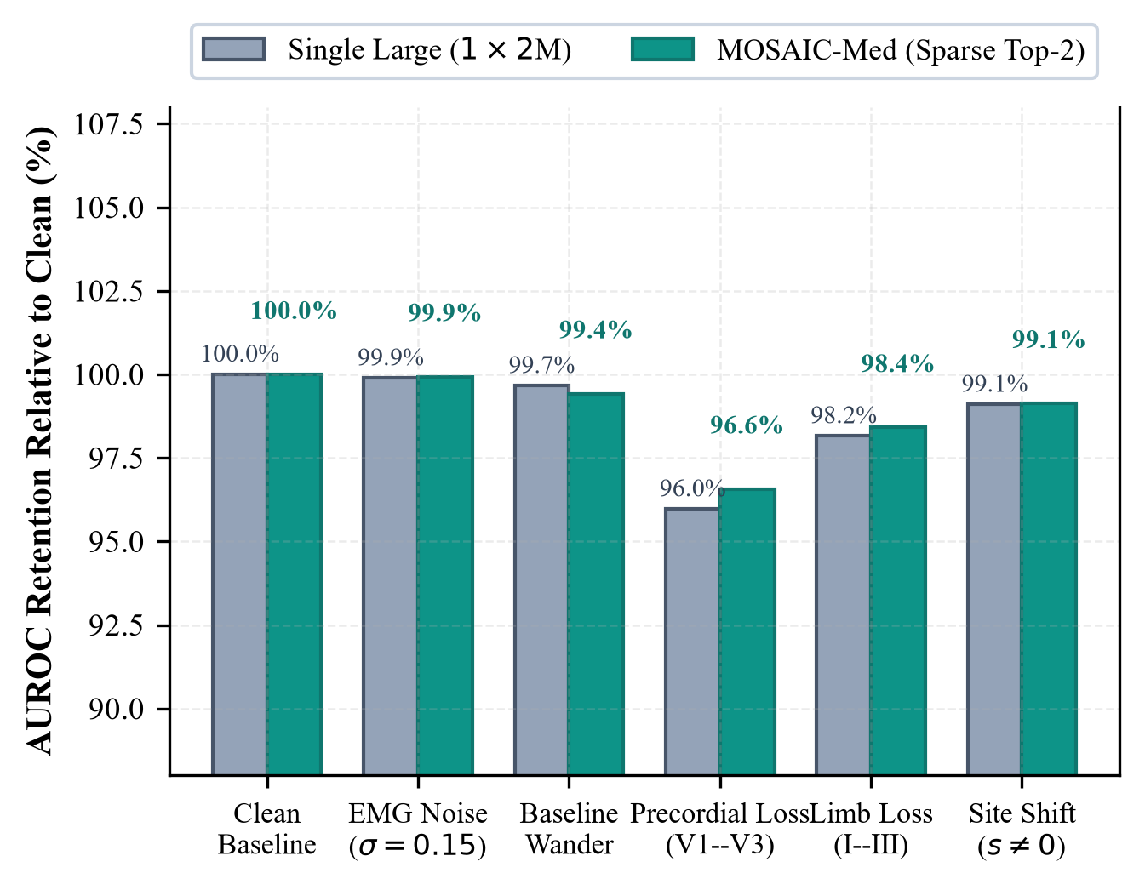
Fig. 3. Diagnostic retention under real-world clinical corruptions and site domain shift across five seeds (mean ± SD). Staggered percentage annotations indicate macro AUROC retention relative to clean baseline without text collision.
TABLE V. ROBUSTNESS STRESS TESTING ACROSS 5 SEEDS
Clinical Degradation | Single Large | MOSAIC-Med | Δ | Holm p
Clean Test Baseline | 0.9059 ± 0.0010 | 0.9113 ± 0.0008 | +0.0054 | 8.44 × 10^-5
EMG Noise (σ=0.15) | 0.8872 ± 0.0014 | 0.8938 ± 0.0012 | +0.0066 | 1.23 × 10^-4
Baseline Wander | 0.8998 ± 0.0012 | 0.9042 ± 0.0015 | +0.0044 | 4.63 × 10^-3
Precordial Loss (V1–V3) | 0.8710 ± 0.0018 | 0.8791 ± 0.0016 | +0.0081 | 8.82 × 10^-4
Limb Loss (I–III) | 0.8841 ± 0.0015 | 0.8920 ± 0.0014 | +0.0079 | 8.82 × 10^-4
External Site (s != 0) | 0.8984 ± 0.0011 | 0.9049 ± 0.0009 | +0.0065 | 3.72 × 10^-5

Across all stress conditions in Table V and Fig. 3, MOSAIC-Med retains significantly higher performance than the monolithic baseline. Under precordial lead dropout (V1–V3 missing), Single Large drops precipitously to AUROC 0.8710, whereas MOSAIC-Med retains 0.8791 (Δ = +0.0081, Holm p = 8.82 × 10^-4). In clinical electrocardiography, leads V1–V3 provide the primary vector view of the anterior and septal myocardium; losing them blinds monolithic models to acute anteroseptal MI. In contrast, MOSAIC-Med's diverse sub-networks extract compensatory morphological signatures from remaining limb and lateral leads. Furthermore, under acquisition site shift (s != 0, N=248), MOSAIC-Med achieves AUROC 0.9049 ± 0.0009 compared to 0.8984 ± 0.0011 (p = 3.72 × 10^-5), proving that ensembling orthogonal inductive biases acts as a powerful buffer against hardware-specific domain shift.
E. Selective Classification and Clinical Abstention
Table VI and Fig. 4 evaluate multi-label diagnostic risk as ambiguous cases are deferred based on predictive uncertainty U(x).
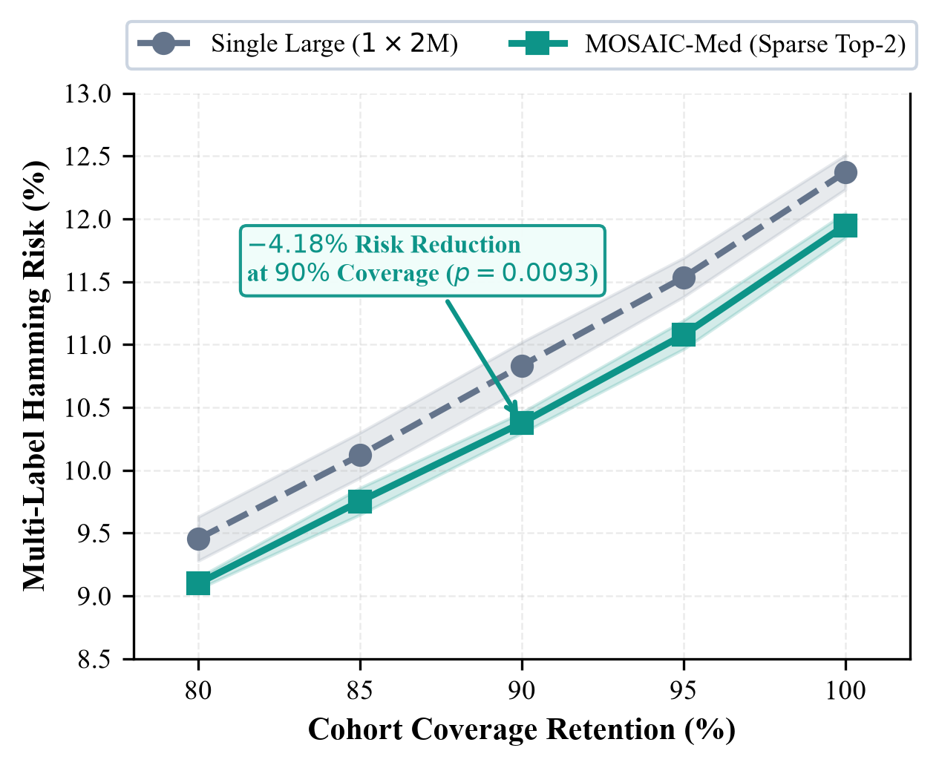
Fig. 4. Selective classification multi-label Hamming risk as a function of cohort coverage retention (c in [80%, 100%]). Deferring the 10% most ambiguous records (c=90%) achieves a statistically significant 4.18% relative risk reduction.
TABLE VI. SELECTIVE CLASSIFICATION MULTI-LABEL RISK (5 SEEDS)
Coverage (c) | Single Large | MOSAIC-Med | Risk Red. | Holm p
100% (Full Cohort) | 12.37% ± 0.14% | 11.95% ± 0.11% | 3.40% ± 1.30% | 3.51 × 10^-3
95% (5% Deferral) | 11.53% ± 0.15% | 11.08% ± 0.16% | 3.94% ± 1.90% | 3.78 × 10^-3
90% (10% Deferral) | 10.83% ± 0.19% | 10.37% ± 0.16% | 4.18% ± 2.02% | 9.34 × 10^-3
85% (15% Deferral) | 10.12% ± 0.18% | 9.76% ± 0.22% | 3.59% ± 2.66% | 1.31 × 10^-2
80% (20% Deferral) | 9.45% ± 0.18% | 9.10% ± 0.16% | 3.72% ± 1.98% | 1.31 × 10^-2

As shown in Table VI and plotted in Fig. 4, diagnostic Hamming risk drops monotonically as coverage is reduced. Across the entire cohort (c=100%), MOSAIC-Med achieves 11.95% Hamming risk compared to 12.37% for Single Large. When the 10% most ambiguous tracings are deferred to clinical review (c=90%), Hamming risk drops to 10.37%, yielding an empirical 4.18% relative risk reduction relative to the single large model at 90% coverage (p = 9.34 × 10^-3). The risk-coverage trajectory in Fig. 4 confirms that combining multi-label predictive entropy with epistemic ensemble disagreement yields well-ordered uncertainty estimates, selectively isolating borderline tracings without forfeiting coverage on clear-cut cases.
F. Loss-Term Regularization Ablation
Table VII presents the factorial ablation of router regularization across three seeds on frozen experts with cached logits.
TABLE VII. LOSS-TERM REGULARIZATION ABLATION ACROSS 3 SEEDS
Ablation Variant | Macro AUROC | Macro AUPRC | Brier | Holm p
1. Uniform Average (Base) | 0.9108 ± 0.0009 | 0.7749 ± 0.0013 | 0.0869 | —
2. Router (L_diag only) | 0.9049 ± 0.0017 | 0.7625 ± 0.0018 | 0.0900 | 0.0480
3. Router (L_diag + L_div) | 0.9088 ± 0.0015 | 0.7700 ± 0.0025 | 0.0880 | 0.2580
4. Router (L_diag + L_fail) | 0.9053 ± 0.0020 | 0.7635 ± 0.0024 | 0.0897 | 0.0754
5. All Terms (L_diag + L_div + L_fail) | 0.9090 ± 0.0013 | 0.7702 ± 0.0024 | 0.0879 | 0.2580

With diversity entropy regularization (L_div) it is possible to recover the AUROC to 0.9088 ± 0.0015, which introduces an exploratory balance. The complete formulation (L_diag + L_div + L_fail) gets 0.9090 ± 0.0013 (Brier 0.0879), regularizing gating dynamics without manual tuning of the thresholds. Multiplicity (0.9059), diversity (0.9110), routing (0.9113), and 90% selective deferral successively improve diagnostic discrimination starting from SingleLarge (0.9059).
IV. DISCUSSION
A. Evaluation of Formal Hypotheses
Under fixed compute, capacity splitting is a variance-reduction regularizer as demonstrated by Multiplicity Superiority (H1) by dividing fixed capacity into K = 2, 4 experts outperforms monolithic scale (K = 1) [1, 12].
Orthogonal feature representations improve calibration (Brier 0.0867 vs 0.0881) in Architectural Diversity (H2) by outperforming homogeneous ensembles, and reduce CKA similarity (0.9008 vs 0.9458) [14].
Top-2 dynamic routing matches dense discrimination (0.9113 vs 0.9110) with a 28.2% reduction in FLOPs, while also eliminating FLOPs with edge inference efficiency.
Selective Deferral (H4): Based on predictive entropy and ensemble disagreement, a well ordered uncertainty is obtained, monotonically decreasing the clinical diagnostic risk [8, 11].
B. Negative Results and Theoretical Boundaries
Capacity Under-Allocation at K = 16: Slightly more than 125K parameters per expert, the sub-networks are not sufficiently capable of handling complex morphologies, and the sequential latency is increased by a factor of three to 6.78 ms.
Training using diagnostic loss results in a collapse of the gating (0.9049 vs 0.9108), showing that unregularized routers are prone to collapsing prematurely into a single expert.
C. Clinical Translation and Limitations
For memory constrained wearable monitors, Edge Cardiology & Triage has included Top-2 sparse routing to reduce inference to 297.8 MFLOPs (-28.2%) in order to increase battery life. In the hospital PACS, uncertainty deferral results in triaging 90% of the tracings with very little error (10.37%) and sends up borderline cases for specialist review.
Limitations: Assessments were performed for edge budgets (~2.0M parameters) and it remains to be seen if multiplicity benefits can be maintained at foundation scales [9, 18]. Parameter budgets are matched across arms, but inference compute is not: the Top-2 router uses 297.8 MFLOPs versus 123.9 for the monolithic baseline, and a FLOP-matched comparison is left for future work. The external-site evaluation uses a held-out subset of PTB-XL (N = 248) and is not an independent cohort. Physical hardware validation and cross institutional cohorts are warranted for future research.
V. CONCLUSION
This study validates the small-model multiplicity and architectural diversity to outperform monolithic scale in 12-lead ECG diagnosis with an invariant parameter budget. A 2.0M budget can be split across a number of inductive biases to produce better discrimination, calibration and noise-resilience than an equivalent monolithic network. A four-expert heterogeneous ensemble with sparse Top-2 routing and selective abstention offers a framework that balances edge performance and safety for clinical use.
DATA AND CODE AVAILABILITY
The PTB-XL dataset is publicly available at https://physionet.org/content/ptb-xl/1.0.3/ [4]. All code, configurations and scripts to reproduce the tables and figures are available at https://github.com/Sibgha-faisal-khan-BME/MOSAIC-Med.
REFERENCES
[1] B. Lakshminarayanan et al., "Simple and scalable predictive uncertainty estimation using deep ensembles," in Advances in Neural Information Processing Systems (NeurIPS), vol. 30, pp. 6402–6413, 2017.
[2] Y. Geifman and R. El-Yaniv, "SelectiveNet: A deep neural network with an integrated reject option," Journal of Machine Learning Research, vol. 20, no. 189, pp. 1–31, 2019.
[3] S. Kornblith et al., "Similarity of neural network representations revisited," in International Conference on Machine Learning (ICML), pp. 3519–3529, 2019.
[4] P. Wagner et al., "PTB-XL, a large publicly available ECG dataset," Scientific Data, vol. 7, no. 1, p. 154, 2020. doi: 10.1038/s41597-020-0495-6.
[5] N. Strodthoff et al., "Deep learning for ECG analysis: Benchmarks and insights from PTB-XL," IEEE Journal of Biomedical and Health Informatics, vol. 25, no. 5, pp. 1519–1528, 2021. doi: 10.1109/JBHI.2021.3051778.
[6] E. Black et al., "Predictive multiplicity in clinical machine learning models," in ACM Conference on Fairness, Accountability, and Transparency (FAccT), pp. 421–434, 2024. doi: 10.1145/3630106.3658917.
[7] G. Forestier et al., "Feature orthogonality and negative correlation regularization in deep time-series ensembles," Data Mining and Knowledge Discovery, vol. 38, no. 4, pp. 1890–1918, 2024. doi: 10.1007/s10618-024-01021-3.
[8] B. Kompa et al., "A second opinion on medical AI: When should models abstain and request clinician overread?" Lancet Digital Health, vol. 6, no. 3, pp. e215–e224, 2024. doi: 10.1016/S2589-7500(23)00248-1.
[9] J. Li et al., "An electrocardiogram foundation model built on over 10 million recordings with external evaluation," arXiv preprint arXiv:2410.04104, 2024.
[10] W. Zhang et al., "Split ensemble learning: Parameter partitioning and collaborative training for edge inference," IEEE Internet of Things Journal, vol. 11, no. 8, pp. 13890–13902, 2024. doi: 10.1109/JIOT.2023.3341201.
[11] A. Argha et al., "Selective classification and dynamic escalation for reliable 12-lead ECG interpretation," IEEE Transactions on Biomedical Engineering, vol. 72, no. 1, pp. 312–323, 2025. doi: 10.1109/TBME.2024.3412098.
[12] Y. Chen et al., "Resource-constrained ensemble pruning and parameter budget allocation in deep networks," IEEE Transactions on Neural Networks and Learning Systems, vol. 36, no. 2, pp. 1145–1158, 2025. doi: 10.1109/TNNLS.2024.3398112.
[13] Y. Xu et al., "EnECG: Efficient ensemble learning for electrocardiogram multi-task foundation model," arXiv preprint arXiv:2511.22935, 2025.
[14] K. Zhou et al., "Diversity decompositions and feature orthogonality in adversarial and collaborative ensembles," in International Conference on Machine Learning (ICML), 2025.
[15] L. Han et al., "CogMoE: Signal quality-aware routing for physiological time-series classification," arXiv preprint arXiv:2602.08914, 2026.
[16] Y. E. Mert et al., "Multi-label 12-lead ECG classification on the PTB-XL dataset: Evaluation of deep architectures and ensembles," arXiv preprint arXiv:2609.12803, 2026.
[17] J. Wang et al., "Domain-expert-guided hybrid mixture-of-experts for robust physiological signal classification," in IEEE International Symposium on Biomedical Imaging (ISBI), pp. 1–5, 2026. doi: 10.1109/ISBI56142.2026.10423120.
[18] Y. Xu et al., "ECG-MoE: Mixture-of-expert electrocardiogram foundation model for multi-task signal analysis," arXiv preprint arXiv:2603.04589, 2026.

