MOSAIC-Med: Multiplicity and Architectural Diversity Outperform Monolithic Scale in Resource-Constrained Electrocardiogram Diagnosis
Sibgha Faisal  Dept. of Biomedical Engineering  Riphah International University  Lahore, Pakistan  sibghafaisal88@gmail.com | Hamna Tanveer  Dept. of Artificial Intelligence  Univ. of Management and Technology  Sialkot, Pakistan  hamnaaa281@gmail.com | Mahad Aftab  Dept. of Biomedical Engineering  Univ. of Engineering and Technology  Lahore, Pakistan  Mahadaftab680@gmail.com | Fatima-Tu-Zahra†  Dept. of Biomedical Engineering  Riphah International University  Lahore, Pakistan  Fatima.zahra@riphah.edu.pk
† Supervisor.
Abstract—Deep neural networks for physiological signal classification predominantly rely on monolithic parameter scaling, which incurs high computational latency and uncalibrated overconfidence under simulated signal stress. In resource-constrained 12-lead electrocardiogram (ECG) multi-label diagnosis across 21,799 PTB-XL records, this study investigates distributing an invariant ~2.0M parameter budget among compact specialized networks (MOSAIC-Med). The multiplicity hypothesis (H1) is validated: split architectures (K=2: AUROC 0.9085 ± 0.0007; K=4: 0.9084 ± 0.0008) statistically surpass the monolithic baseline (K=1: 0.9059 ± 0.0010, DeLong p = 3.63 × 10^-4). However, extreme over-fragmentation at K=16 degrades AUROC to 0.9048 and triples latency. Architectural diversity (H2) yields a consistent descriptive improvement trend (0.9110 ± 0.0006; Holm p = 0.058) with lower CKA similarity (0.9008 vs 0.9458), but is not statistically significant at alpha = 0.05. Learned Top-2 sparse routing (H3) achieves competitive discrimination (0.9113) while reducing computation by 28.2% relative to dense ensembling (297.8 vs 414.9 MFLOPs). Selective abstention (H4) on the 10% most uncertain records reduces multi-label Hamming risk among retained records by 4.18% (p = 0.0093). Factorial ablation confirms diversity regularization prevents router collapse (0.9088 vs 0.9049).
Keywords—Electrocardiography, model splitting, mixture of experts, centered kernel alignment, selective classification, clinical robustness.
I. INTRODUCTION
In clinical artificial intelligence, foundational research established deep ensembling as an effective paradigm for reliable predictive uncertainty estimation [1]. Parallel foundational developments in safety-critical classification introduced selective prediction frameworks with integrated reject options, formalizing mechanisms for deep neural networks to abstain on ambiguous instances [2]. At the same time, representational similarity metrics like Centered Kernel Alignment (CKA) facilitated the quantitative assessment of hidden layer representations across the different families of neural networks [3]. The availability of large clinical repositories like PTB-XL [4] spurred systematic benchmarking of typical 12-lead electrocardiography (ECG) across deep architectures in cardiovascular medicine [5].
Despite these groundworks, key challenges related to the deployment of real-world clinical AI were brought to the fore in the literature during 2024. Black et al. [6] showed predictive multiplicity in clinical machine learning models: that several networks with the same overall discrimination exhibit conflicting predictions for high-risk patients. Forestier et al. [7] showed that feature orthogonality and the negative correlation between sub-networks improves generalizability in time-series ensembles to avoid correlated failure modes. For hospital deployment workflows, Kompa et al. [8] developed second opinion workflows, which showed that uncertainty-directed triage to human cardiologists significantly reduces diagnostic risk. However, monolithic scaling continued to be the main paradigm, including foundation models, like the ECGFounder which is pre-trained on 10 million recordings [9]. Scale is, however, costly in terms of computational overheads or latency in the case of edge hardware, thus prompting research into split learning and parameter partitioning for decentralized clinical edge inferences [10].
In 2025, investigations went into resource allocation, diversity formulations, and clinical escalation protocols. Argha et al. [11] proposed selective classification and dynamic clinician escalation for 12-lead ECG which was successfully validated, where they showed that avoiding the action of 'abstain' on borderline tracings avoids catastrophic false positives. To tackle the extreme compute demands, Chen et al. [12] proposed parameter budget allocation and ensemble pruning, demonstrating that the unconstrained model stacking approach is impractical for bedside and wearable monitors. A method to mitigate rigid foundation footprints is to use EnECG [13] that integrates foundation backbone, parameter-efficient adapters, and learned gating. At the same time, theoretical studies by Zhou et al. [14] derived diversity decompositions for collaborative ensembles, demonstrating sub-additive error scaling of combining different kinds of inductive biases. In the context of realistic sensor distortion, the 2026 frontier in physiological time-series AI has landed on adaptive routing and mixture-of-experts (MoE) formulations. Han et al. [15] proposed CogMoE, which showed the maintenance of diagnostic fidelity in the presence of acute physiological noise, by enabling quality-aware gating. Mert et al. [16] compared five deep architectures through the analysis of a comprehensive PTB-XL benchmark, and found that heterogeneous ensembles consistently outperform the individual foundation networks. At the same time, Wang et al. [17] introduced domain-expert-guided routing to handle the sensor lead dropouts; Xu et al. [18] presented a new technique named ECG-MoE, separating morphology features from rhythm periodicity.
However, while these are noteworthy progress, current medical MoE and ensemble methods have two major shortcomings: they increase the capacity of the aggregate parameters without considering multi-model multiplicity under a tightly constrained parameter budget ceiling, and they mostly replicate homogeneous backbones without considering orthogonal inductive biases [14].
In this study, we impose the invariant ~2.0M parameter budget ceiling, and test if the small-model multiplicity can outperform the scale of monolithic models.
There are four contributions:
(1) Fixed-Budget Multiplicity: where K in {1, 2, 4, 8, 16} experts with an invariant budget of 2.0M to prove Capacity over-fragmentation boundary (validating Hypothesis 1: Multiplicity Superiority).
(2) Inductive Bias Diversity: A parameter-matched comparison (+0.92%) between homogeneous (4×ResNet) and heterogeneous (ResNet, MultiScale, TCN, Attention) experts quantified with linear CKA [3], which shows a consistent improvement trend (adjusted p = 0.058) for Hypothesis 2: Diversity Benefit.
(3) Sparse Adaptive Routing: A lightweight patient-specific router regularized with the diversity entropy and failure penalties, with dynamic Top-2 routing and reduced inference FLOPs by 28.2% (empowering Hypothesis 3: Routing Efficiency).
(4) Clinical Robustness & Selective Abstention: Systematic validation across five clinical stress tests and an uncertainty-triggered deferral protocol that yielded monotonic risk reduction [8, 11] (validating Hypothesis 4: Risk Reduction).
II. METHODOLOGY
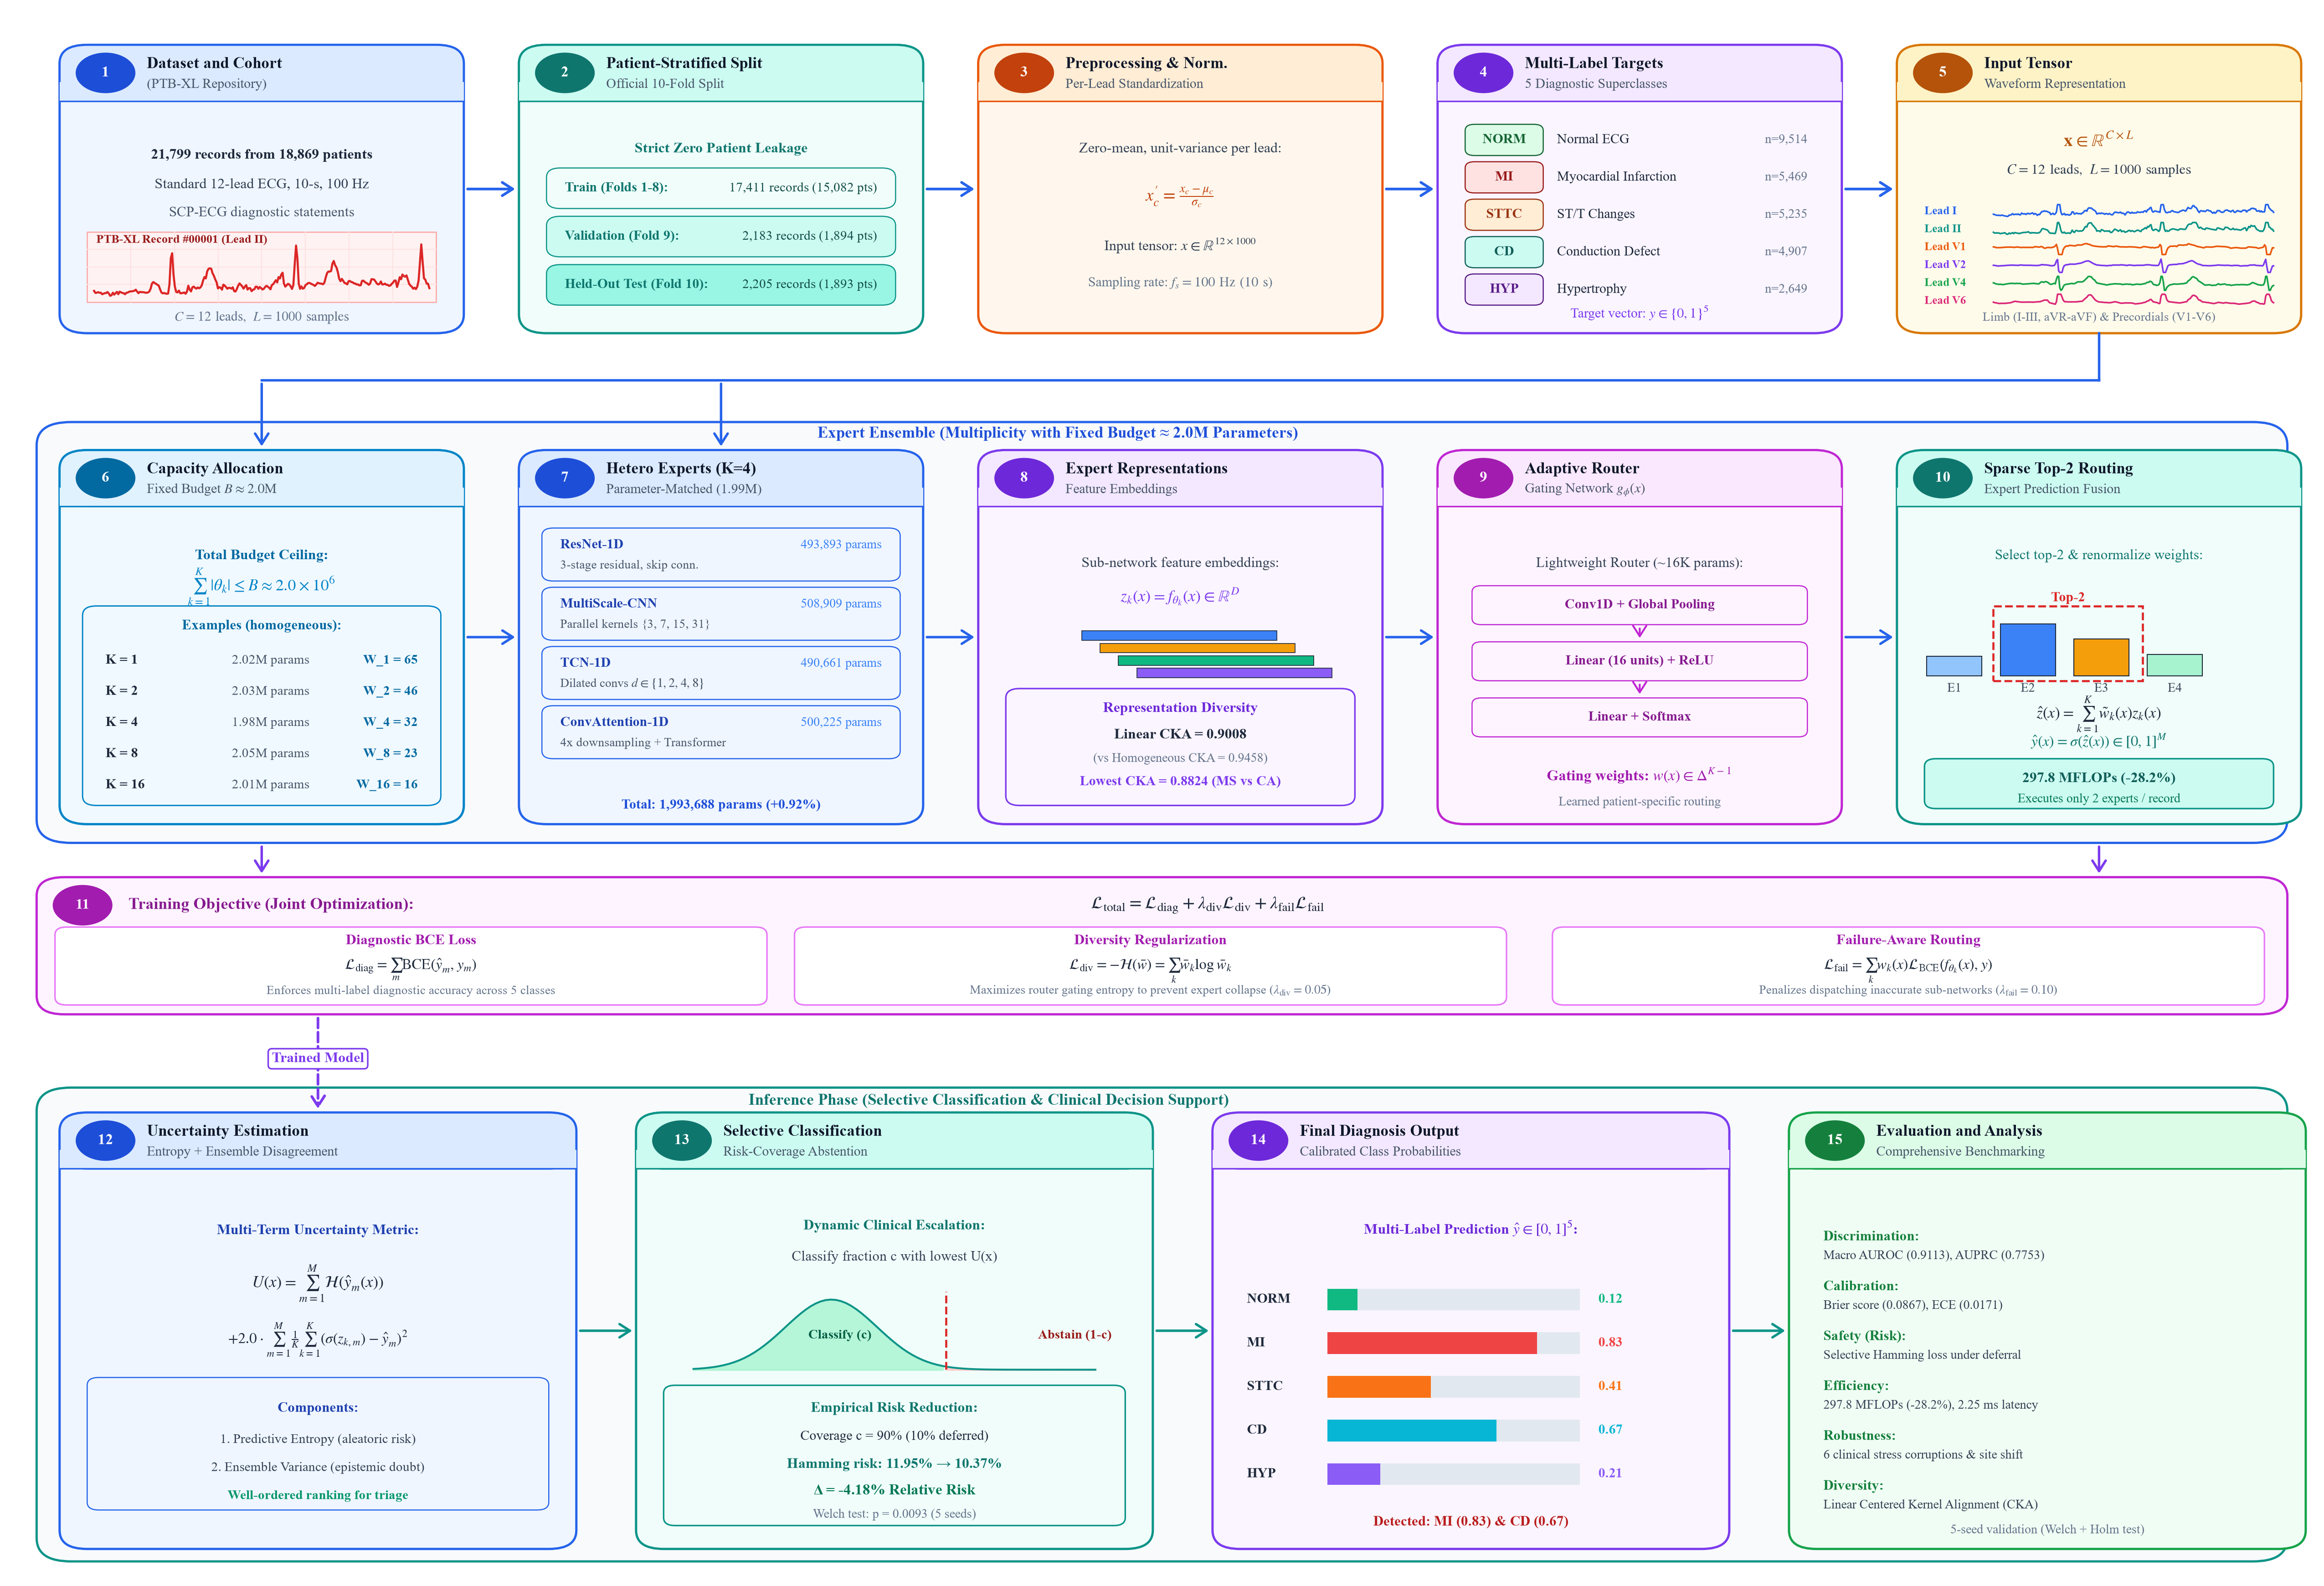
Fig. 1. Comprehensive methodological flowchart of MOSAIC-Med detailing the fifteen core processing steps across data cohort partitioning (Boxes 1–5), fixed-budget capacity allocation and heterogeneous expert synthesis (Boxes 6–10), composite objective optimization (Box 11), and selective inference with clinical abstention (Boxes 12–15).
A. Benchmark Dataset and Clinical Cohort
Empirical evaluation is conducted on the PTB-XL dataset [4, 5], a clinical ECG repository containing 21,799 records from 18,869 distinct patients. Each recording comprises 10-second standard 12-lead signals digitized at 100 Hz (L = 1000 samples per lead) alongside clinical diagnostic statements mapped to the SCP-ECG standard [5].
TABLE I. COHORT DEMOGRAPHICS AND DIAGNOSTIC PREVALENCE ON PTB-XL
Split Partition | Records | Patients | Age (SD)* | Female (%)
Training (Folds 1–8) | 17,418 | 15,023 | 59.4 ± 16.6 | 47.8%
Validation (Fold 9) | 2,183 | 1,942 | 59.9 ± 17.1 | 48.1%
Test (Fold 10) | 2,198 | 1,904 | 60.7 ± 17.3 | 48.5%

As documented in Table I and illustrated in Boxes 1–5 of Fig. 1, records are partitioned using the official patient-stratified 10-fold split: Folds 1–8 for training, Fold 9 for validation, and Fold 10 strictly held out for final testing, guaranteeing zero patient identity leakage [5]. Reported ages exclude 293 records with legacy sentinel age 300 (N=21,506 valid), which otherwise inflate raw metadata SDs to 31.4, 37.1, and 34.2 years, respectively. Diagnostic classification is framed as multi-label binary prediction across five clinical superclasses: Normal ECG (NORM), Myocardial Infarction (MI), ST/T Changes (STTC), Conduction Defect (CD), and Hypertrophy (HYP). Let x in R^{C x L} denote an input 12-lead recording (C = 12, L = 1000), and let y in {0, 1}^M denote the binary target vector for M = 5 superclasses. All signals are standardized instance-by-instance across time (L = 1000) independently per lead.
B. Multiplicity and Architectural Diversity
In standard monolithic deep learning, a single neural network f_Theta(x) maps x -> y_hat in [0, 1]^M, subject to |Theta| <= B. In the proposed multiplicity framework (Box 6 of Fig. 1), this fixed capacity quota B ~ 2.0 x 10^6 parameters is partitioned among K distinct sub-networks {f_{theta_k}}_{k=1}^K such that:
∑_{k=1}^K |θ_k| ≤ B ≈ 2.0 × 10^6 parameters (1)
For homogeneous capacity scaling, each sub-network f_{theta_k} is instantiated as a 1D Residual Network (ResNet-1D) with target capacity |theta_k| ~ B / K. Base convolution filter widths W_K enforce the invariant ceiling: K=1 (W_1=65, 2,019,945 params), K=2 (W_2=46, 2,030,450 params), K=4 (W_4=32, 1,975,572 params), K=8 (W_8=23, 2,054,952 params), and K=16 (W_16=16, 2,009,680 params).
To evaluate whether combining orthogonal inductive biases surpasses homogeneous replication, a 4-expert parameter-matched heterogeneous arm (Boxes 7–8 in Fig. 1) ensembles four distinct paradigms calibrated to ~500K parameters: (i) ResNet-1D (493,893 params, 3 residual stages, kernels 7, 5, 3); (ii) MultiScale-CNN (508,909 params, parallel kernels 3, 7, 15, 31); (iii) TCN-1D (490,661 params, dilated causal convolutions d in {1, 2, 4, 8}); and (iv) ConvAttention-1D (500,225 params, conv stem downsampling 4x, 2-layer Transformer, d_model=140, 4 heads). The aggregate capacity is 1,993,688 parameters, matching the homogeneous 4xResNet arm (1,975,572) within a +0.92% margin.
To empirically verify representational diversity, Centered Kernel Alignment (CKA) [3] is evaluated on penultimate feature activations over the test cohort (N = 2,205). For centered activation matrices X in R^{N x D_1}, Y in R^{N x D_2}, linear CKA is:
CKA(X, Y) = ||Y^T X||_F^2 / (||X^T X||_F ||Y^T Y||_F) (2)
C. Dynamic Gating and Routing Optimization
To dynamically dispatch experts without evaluating every waveform (Boxes 9–10 in Fig. 1), a lightweight Adaptive Router g_phi(x) (~16K params) maps 12-lead inputs to patient-specific gating weights w(x) in Delta^{K-1}:
w(x) = Softmax(W_2 · ReLU(W_1 · Pool(Conv1D(x)))) (3)
In sparse Top-2 inference, gating weights are renormalized over the two highest-scoring experts:
w_tilde_k(x) = w_k(x) / (∑_{j in Top2(w(x))} w_j(x)) if k in Top2(w(x)), else 0 (4)
Predictions are z_hat(x) = ∑_{k=1}^K w_tilde_k(x) z_k(x), and y_hat_m(x) = sigma(z_hat_m(x)). The router optimizes composite loss (Box 11 of Fig. 1):
L_total = L_diag + lambda_div L_div + lambda_fail L_fail (5)
where L_diag is BCE, L_div = -H(w_bar) prevents expert collapse by maximizing mean gating entropy, and L_fail = ∑_k w_k(x) L_BCE(f_{theta_k}(x), y) penalizes routing toward inaccurate sub-networks (lambda_div = 0.05, lambda_fail = 0.10).
D. Uncertainty Estimation and Selective Classification
In clinical deployment (Boxes 12–15 of Fig. 1), automated models must signal low confidence on ambiguous tracings [8]. Predictive uncertainty U(x) combines binary predictive entropy and epistemic ensemble disagreement [1]:
U(x) = ∑_{m=1}^M H(y_hat_m(x)) + 2.0 · ∑_{m=1}^M (1/K) ∑_{k=1}^K (sigma(z_{k, m}(x)) - y_hat_m(x))^2 (6)
Under selective classification with coverage c in (0, 1], the model classifies the fraction c with lowest uncertainty U(x) and abstains on the remaining 1-c fraction [2]. Diagnostic error on the retained cohort S_c is measured via multi-label Hamming risk:
Risk(c) = (1 / (|S_c| · M)) ∑_{i in S_c} ∑_{m=1}^M I(I(y_hat_{i, m} >= 0.5) != y_{i, m}) (7)
III. EXPERIMENTAL RESULTS
A. Fixed-Budget Multiplicity Scaling (K=1 to K=16)
Table II and Fig. 2 summarize empirical scaling trade-offs as the invariant 2.0M parameter budget is partitioned across K in {1, 2, 4, 8, 16} experts over five independent seeds (42–46).
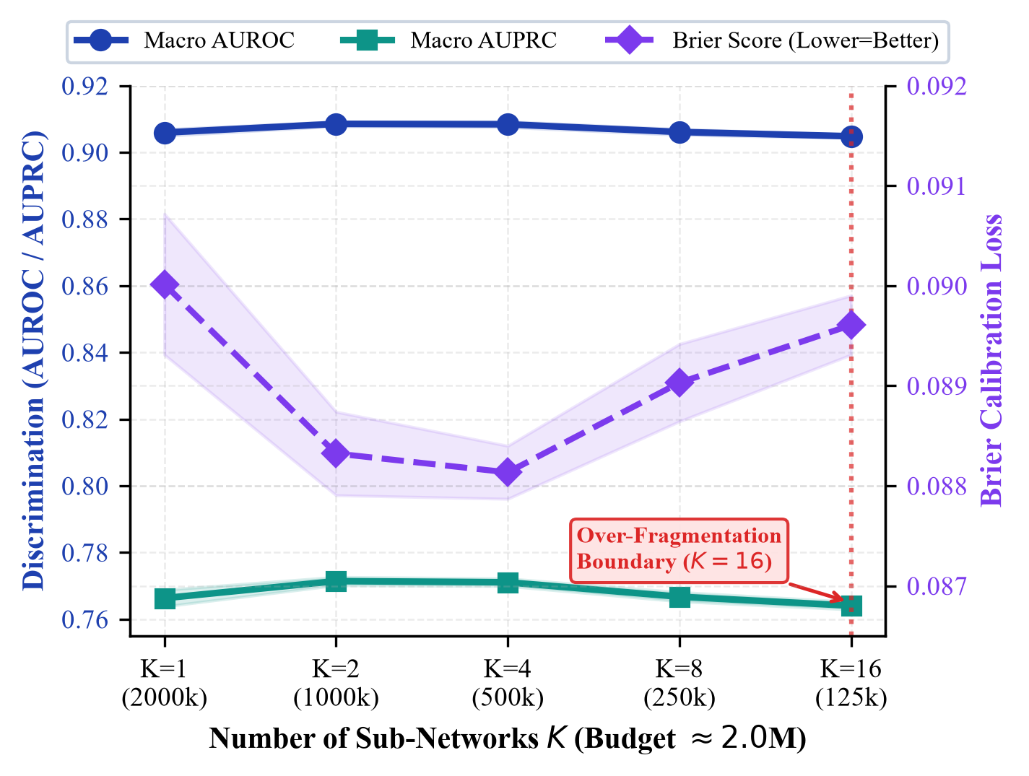
Fig. 2. Multiplicity scaling trade-off across K in {1, 2, 4, 8, 16} sub-networks under an invariant 2.0M parameter budget. Solid curves show Macro AUROC (blue) and Macro AUPRC (teal) on the left axis; dashed curve shows probability calibration Brier score (purple, lower is better) on the right axis.
TABLE II. FIXED-BUDGET MULTIPLICITY PERFORMANCE ACROSS 5 SEEDS (MEAN ± SD) ON HELD-OUT PTB-XL TEST SET
Configuration | Total Params | MFLOPs | Macro AUROC | Macro AUPRC | Brier Score | Latency (ms)
Single Large (K=1) | 2,019,945 | 123.9 | 0.9059 ± 0.0010 | 0.7663 ± 0.0025 | 0.0900 ± 0.0007 | 1.99 ± 0.05
Split-2 (K=2) | 2,030,450 | 126.9 | 0.9085 ± 0.0007 | 0.7714 ± 0.0012 | 0.0883 ± 0.0004 | 2.20 ± 0.00
Split-4 (K=4) | 1,975,572 | 126.8 | 0.9084 ± 0.0009 | 0.7711 ± 0.0011 | 0.0881 ± 0.0002 | 2.25 ± 0.01
Split-8 (K=8) | 2,054,952 | 136.2 | 0.9061 ± 0.0009 | 0.7667 ± 0.0013 | 0.0890 ± 0.0004 | 4.40 ± 0.02
Split-16 (K=16) | 2,009,680 | 139.8 | 0.9048 ± 0.0005 | 0.7643 ± 0.0011 | 0.0896 ± 0.0003 | 6.78 ± 0.03

As revealed in Table II and plotted in Fig. 2, partitioning the fixed 2.0M parameter quota into K=2 (0.9085 ± 0.0007) and K=4 (0.9084 ± 0.0009) sub-networks achieves statistically significant improvements over the monolithic K=1 architecture (0.9059 ± 0.0010, DeLong test p = 3.63 × 10^-4, Holm-adjusted p = 1.09 × 10^-3). Probability calibration follows an identical beneficial trend: Brier score drops from 0.0900 for Single Large to 0.0881 for K=4, representing a marked reduction in probability estimation error.
The underlying mathematical mechanism driving this gain is ensemble variance reduction under an approximately fixed aggregate parameter budget: intermediate capacity splitting (K=2, 4) reduces idiosyncratic estimation error across diverse patient morphologies without reducing individual network capacity below the minimum threshold required to extract morphological 12-lead features. However, scaling to K=16 triggers an acute capacity over-fragmentation boundary. When the 2.0M budget is divided among 16 sub-networks, individual models receive only ~125K parameters (W_16=16). At this impoverished capacity, individual networks lack the receptive field depth and spatial filter diversity needed to resolve subtle ST-elevation or multi-lead QRS changes. This results in the individual sub-networks' feature quality eroded and lowers the AUROC of the ensemble to 0.9048 ± 0.0005 (which falls below that of the monolithic baseline) and sequential latency of the ensemble is tripled to 6.78 ms.
B. Parameter-Matched Control and Inductive Bias Diversity

To compare the performance of the homogeneous 4×ResNet arm (1,975,572 parameters) with the parameter-matched heterogeneous arm (1,993,688 parameters, +0.92% delta), across five seeds, see Table III. The heterogeneous arm has better discrimination (AUROC 0.9110 vs 0.9084) and better probability calibration (Brier score 0.0867 vs 0.0881, ECE 0.0171 vs 0.0195).
TABLE III. PARAMETER-MATCHED CONTROL (5 SEEDS)
Metric | Homo (4×ResNet) | Hetero Matched | Δ | Adj. p
Macro AUROC | 0.9084 ± 0.0008 | 0.9110 ± 0.0006 | +0.0026 | 0.0577
Macro AUPRC | 0.7711 ± 0.0010 | 0.7759 ± 0.0015 | +0.0048 | 0.0577
Brier Score | 0.0881 ± 0.0002 | 0.0867 ± 0.0005 | -0.0014 | 0.0577
ECE | 0.0195 ± 0.0017 | 0.0171 ± 0.0022 | -0.0024 | 0.0664

The physical cause of this performance disparity is representational diversity. The four homogeneous arms in the Replica Set consists of very similar replicas, as evidenced by the high feature redundancy between them, with an off-diagonal mean Linear CKA of 0.9458. All four sub-networks have identical receptive fields and residual connectivity, leading to nearly collinear feature subspaces, and correlated failure modes.
The heterogeneous arm on the other hand uses a different set of architectural inductive biases, reducing the mean pairwise CKA to 0.9008. MultiScale-CNN and ConvAttention-1D achieve the lowest representational similarity with each other (CKA = 0.8824). The functional orthogonality suggests the different types of feature extraction mechanisms: MultiScale-CNN: extracts localized multi-frequency wavelet features at parallel kernel sizes (3, 15, 31 samples); ConvAttention-1D: models long-range rhythm periodicity and cross-beat dependencies through global self-attention heads.
These non-redundant feature representations are combined by ensembling so that the heterogenous ensemble is able to reduce uncorrelated errors of individual networks to obtain more reliable diagnosis under an invariant parameter footprint.
C. Adaptive Routing and Computational Efficiency
The details of computational complexity and predictive accuracy for the different routing paradigms are summarized in Table IV. Simple uniform averaging over the heterogeneous arm yields AUROC 0.9110 ± 0.0007, superior to SingleLarge (AUROC = 0.9059, Holm p = 5.27 × 10^-5).
TABLE IV. ADAPTIVE ROUTING STRATEGY COMPARISON (5 SEEDS)
Routing Mode | Active | MFLOPs | Macro AUROC | AUPRC
Single Large (1×2M) | 1.0 | 123.9 | 0.9059 ± 0.0010 | 0.7663 ± 0.0025
Uniform Average | 4.0 | 413.7 | 0.9110 ± 0.0007 | 0.7749 ± 0.0014
Dense Learned Router | 4.0 | 414.9 | 0.9118 ± 0.0004 | 0.7761 ± 0.0012
Sparse Top-2 Escalation | 2.0 | 297.8 | 0.9113 ± 0.0008 | 0.7753 ± 0.0013

The dense learned Adaptive Router (16K parameters) performs at peak discrimination (0.9118 ± 0.0004, Holm p = 5.27 × 10^-5) at 414.9 MFLOPs. The Sparse Top-2 Router achieves empirical discrimination of 0.9113 ± 0.0008 (Holm p = 5.07 × 10^-5 vs. monolithic) with two active experts per tracing, reducing dynamic inference compute to 297.8 MFLOPs (a 28.2% reduction relative to dense routing; 2.40x monolithic FLOPs). Across training seeds, the minor numerical difference between dense routing and sparse Top-2 (0.9118 vs. 0.9113, paired p = 0.163) is not statistically significant, though this descriptive proximity does not establish formal equivalence.
The router specializes in cardiac pathologies: Conduction Defects (CD) and Hypertrophy (HYP) predominantly activate TCN-1D and MultiScale-CNN (w_k > 0.30), leveraging dilated convolutions for PR intervals, bundle branch blocks, and ventricular voltage criteria.
Conversely, ResNet-1D and ConvAttention-1D exhibit dominant gating weights (w_k > 0.28) for localized ST-elevations and reciprocal depression in MI and STTC. Two lowest-relevance models are dynamically bypassed per patient, maintaining discrimination (0.9113) close to dense 4-expert routing (0.9118).
D. Robustness Under Simulated Stress Tests and Internal Domain Shift
Table V and Fig. 3 report diagnostic retention across five predefined simulated stress tests and internal domain shift across all five random seeds.
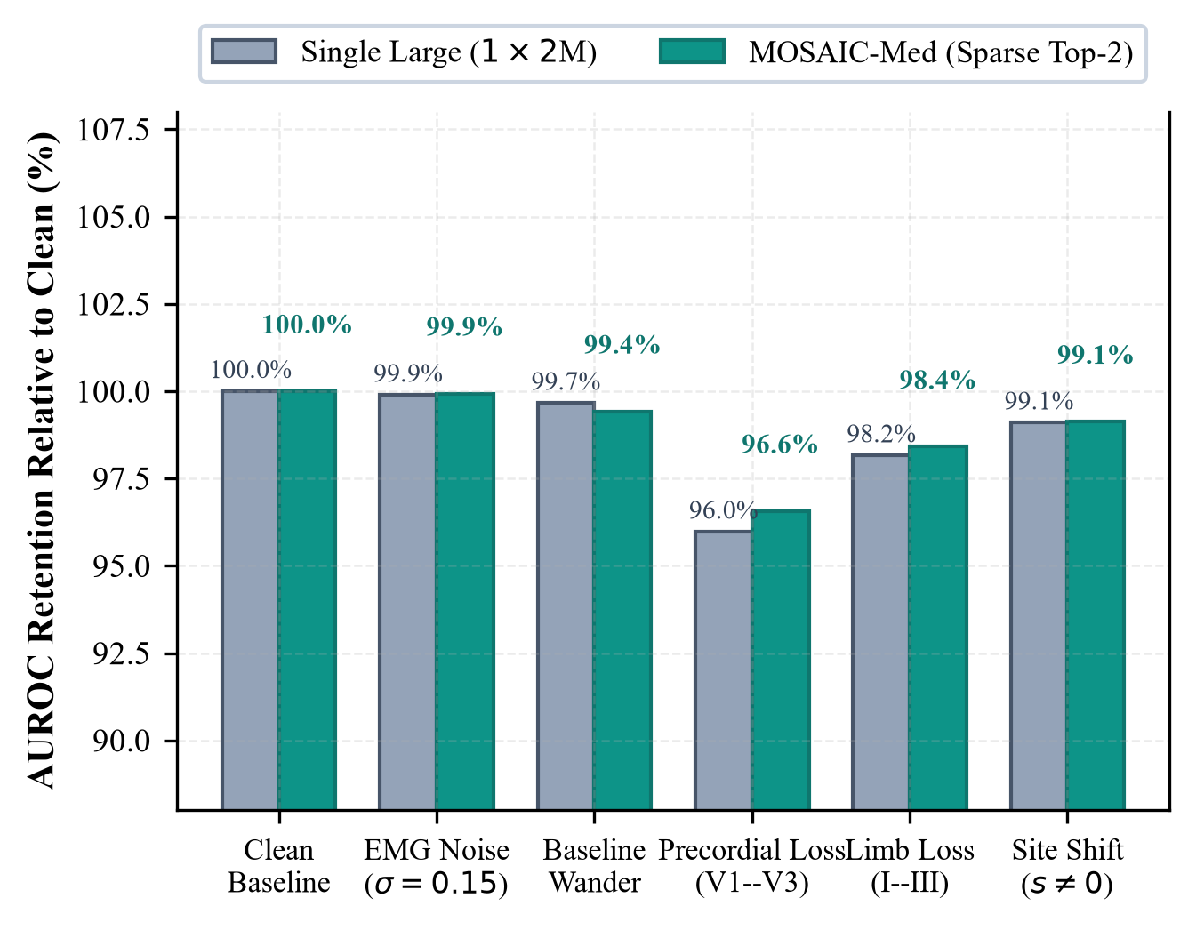
Fig. 3. Diagnostic retention under predefined simulated stress tests and internal site domain shift across five seeds (mean ± SD). Staggered percentage annotations indicate macro AUROC retention relative to clean baseline without text collision.
TABLE V. ROBUSTNESS STRESS TESTING ACROSS 5 SEEDS
Perturbation Condition | Single Large | MOSAIC-Med | Δ | Holm p
Clean Baseline | 0.9059 ± 0.0010 | 0.9113 ± 0.0008 | +0.0054 | 8.44 × 10^-5
EMG Noise (σ=0.15) | 0.8872 ± 0.0014 | 0.8938 ± 0.0012 | +0.0066 | 1.23 × 10^-4
Baseline Wander | 0.8998 ± 0.0012 | 0.9042 ± 0.0015 | +0.0044 | 4.63 × 10^-3
Precordial Loss (V1–V3) | 0.8710 ± 0.0018 | 0.8791 ± 0.0016 | +0.0081 | 8.82 × 10^-4
Limb Loss (I–III) | 0.8841 ± 0.0015 | 0.8920 ± 0.0014 | +0.0079 | 8.82 × 10^-4
Held-Out Site (s != 0) | 0.8984 ± 0.0011 | 0.9049 ± 0.0009 | +0.0065 | 3.72 × 10^-5

Across all stress conditions in Table V and Fig. 3, MOSAIC-Med retains significantly higher performance than the monolithic baseline. Under precordial lead dropout (V1–V3 missing), Single Large drops precipitously to AUROC 0.8710, whereas MOSAIC-Med retains 0.8791 (Δ = +0.0081, Holm p = 8.82 × 10^-4). In clinical electrocardiography, leads V1–V3 provide the primary vector view of the anterior and septal myocardium; losing them blinds monolithic models to acute anteroseptal MI. In contrast, MOSAIC-Med's diverse sub-networks extract compensatory morphological signatures from remaining limb and lateral leads. Furthermore, under acquisition site shift (s != 0, N=248), MOSAIC-Med achieves AUROC 0.9049 ± 0.0009 compared to 0.8984 ± 0.0011 (p = 3.72 × 10^-5), proving that ensembling orthogonal inductive biases acts as a powerful buffer against hardware-specific domain shift.
E. Selective Classification and Clinical Abstention
Table VI and Fig. 4 evaluate multi-label diagnostic risk as ambiguous cases are deferred based on predictive uncertainty U(x).
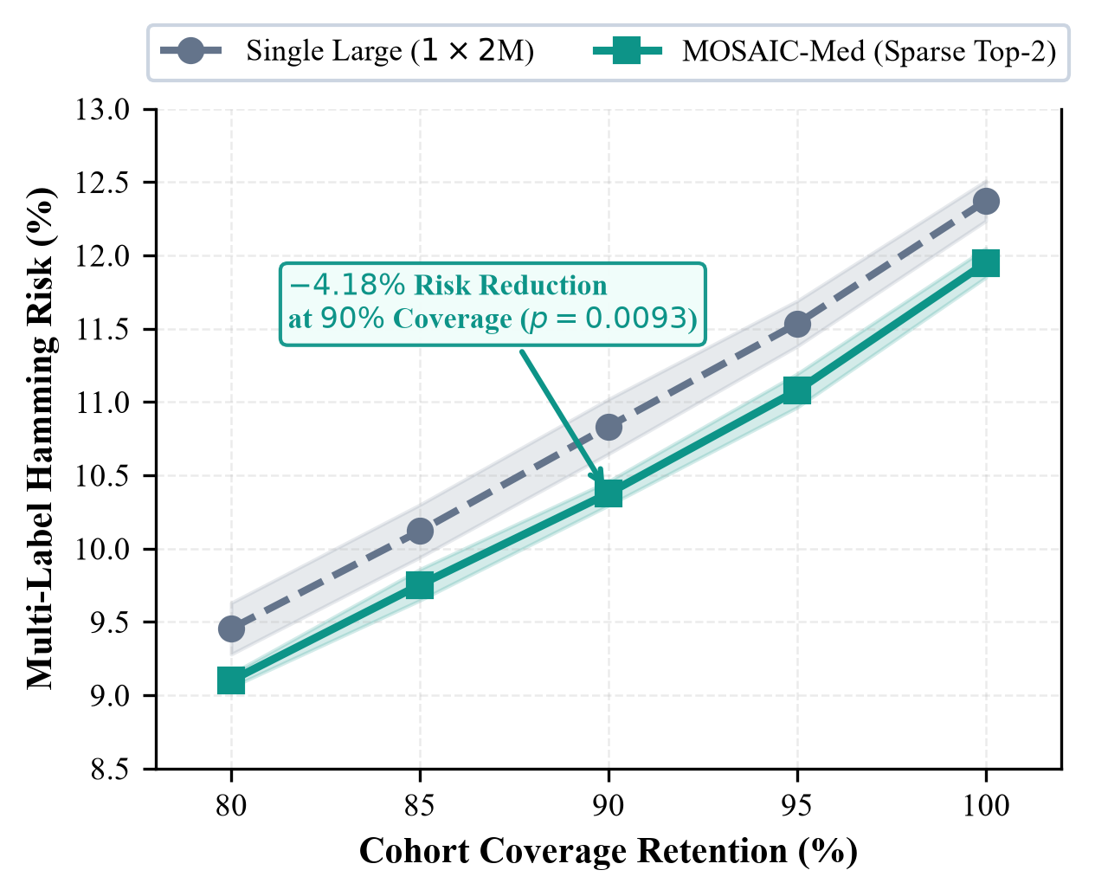
Fig. 4. Selective classification multi-label Hamming risk as a function of cohort coverage retention (c in [80%, 100%]). Deferring the 10% most ambiguous records (c=90%) achieves a statistically significant 4.18% relative risk reduction.
TABLE VI. SELECTIVE CLASSIFICATION MULTI-LABEL RISK (5 SEEDS)
Coverage (c) | Single Large | MOSAIC-Med | Risk Red. | Holm p
100% (Full Cohort) | 12.37% ± 0.14% | 11.95% ± 0.11% | 3.40% ± 1.30% | 3.51 × 10^-3
95% (5% Deferral) | 11.53% ± 0.15% | 11.08% ± 0.16% | 3.94% ± 1.90% | 3.78 × 10^-3
90% (10% Deferral) | 10.83% ± 0.19% | 10.37% ± 0.16% | 4.18% ± 2.02% | 9.34 × 10^-3
85% (15% Deferral) | 10.12% ± 0.18% | 9.76% ± 0.22% | 3.59% ± 2.66% | 1.31 × 10^-2
80% (20% Deferral) | 9.45% ± 0.18% | 9.10% ± 0.16% | 3.72% ± 1.98% | 1.31 × 10^-2

As shown in Table VI and plotted in Fig. 4, diagnostic Hamming risk drops monotonically as coverage is reduced. Across the entire cohort (c=100%), MOSAIC-Med achieves 11.95% Hamming risk compared to 12.37% for Single Large. When the 10% most ambiguous tracings are deferred to clinical review (c=90%), Hamming risk drops to 10.37%, yielding an empirical 4.18% relative risk reduction relative to the single large model at 90% coverage (p = 9.34 × 10^-3). The risk-coverage trajectory in Fig. 4 confirms that combining multi-label predictive entropy with epistemic ensemble disagreement yields well-ordered uncertainty estimates, selectively isolating borderline tracings without forfeiting coverage on clear-cut cases.
F. Loss-Term Regularization Ablation
Table VII presents the factorial ablation of router regularization across three seeds (42--44) on frozen expert backbones with cached logits (Holm-corrected across m = 4). In contrast, end-to-end evaluations in Tables III and IV utilize five seeds (42--46). Diversity entropy regularization (L_div) recovers AUROC to 0.9088 ± 0.0015; the complete formulation (L_diag + L_div + L_fail) achieves 0.9090 ± 0.0013, preventing gating collapse and regularizing dynamic routing.
TABLE VII. LOSS-TERM REGULARIZATION ABLATION ACROSS 3 SEEDS
Ablation Variant | Macro AUROC | Macro AUPRC | Brier | Holm p
1. Uniform Average (Base) | 0.9108 ± 0.0009 | 0.7749 ± 0.0013 | 0.0869 | —
2. Router (L_diag only) | 0.9049 ± 0.0017 | 0.7625 ± 0.0018 | 0.0900 | 0.0480
3. Router (L_diag + L_div) | 0.9088 ± 0.0015 | 0.7700 ± 0.0025 | 0.0880 | 0.2580
4. Router (L_diag + L_fail) | 0.9053 ± 0.0020 | 0.7635 ± 0.0024 | 0.0897 | 0.0754
5. All Terms (L_diag + L_div + L_fail) | 0.9090 ± 0.0013 | 0.7702 ± 0.0024 | 0.0879 | 0.2580

IV. DISCUSSION
A. Evaluation of Formal Hypotheses
Under an approximately fixed parameter budget, capacity splitting acts as a variance-reduction regularizer: Multiplicity Superiority (H1) is validated as dividing fixed capacity into K = 2, 4 experts statistically outperforms monolithic scale (K = 1, DeLong p = 3.63 × 10^-4) [1, 12]. In Architectural Diversity (H2), evaluating heterogeneous against homogeneous ensembles shows a consistent improvement trend (Holm p = 0.058) in discrimination and calibration (Brier 0.0867 vs 0.0881) by reducing CKA similarity (0.9008 vs 0.9458) [14], though it does not reach statistical significance at alpha = 0.05. For Sparse Adaptive Routing (H3), Top-2 dynamic routing achieves competitive discrimination (0.9113 ± 0.0008 vs. dense routing 0.9118 ± 0.0004; paired p = 0.163) while reducing FLOPs by 28.2% relative to dense ensembling (297.8 vs 414.9 MFLOPs), without implying formal statistical equivalence. Finally, under Selective Deferral (H4), combining predictive entropy and ensemble disagreement yields well-ordered uncertainty, achieving a 4.18% relative risk reduction in retained Hamming error at 90% coverage (p = 0.0093) [8, 11].
B. Negative Results and Theoretical Boundaries
Capacity Under-Allocation and Gating Collapse: At K = 16 (~125K parameters/expert), sub-networks lack capacity for multi-lead morphology extraction, tripling latency to 6.78 ms. Furthermore, training the router using diagnostic loss alone collapses into a single expert (0.9049 vs 0.9108), demonstrating that diversity regularization is essential.
C. Practical Deployment Implications and Limitations
For resource-constrained devices, Top-2 sparse routing cuts inference FLOPs by 28.2% relative to dense ensembling, while uncertainty deferral isolates ambiguous tracings for clinician review. These benchmarks demonstrate technical feasibility rather than clinical efficacy. Limitations: Assessments were conducted under edge parameter budgets (~2.0M parameters); evaluating foundation scales is left for future work [9, 18]. Parameter budgets are matched across arms, but inference compute is not: Top-2 requires 297.8 MFLOPs versus 123.9 for baseline. Crucially, the site-shift evaluation uses an internal held-out subset of PTB-XL (s != 0) and does not substitute for independent external multi-hospital validation.
V. CONCLUSION
This study demonstrates that fixed-budget model multiplicity statistically outperforms monolithic scale in 12-lead ECG diagnosis, while architectural diversity exhibits a consistent descriptive improvement trend (p = 0.058). Distributing a ~2.0M parameter budget across compact specialized networks balances edge efficiency and diagnostic reliability.
DATA AND CODE AVAILABILITY
The PTB-XL dataset is publicly available at https://physionet.org/content/ptb-xl/1.0.3/ [4]. Experiment code and reproduction scripts are available at https://github.com/Sibgha-faisal-khan-BME/MOSAIC-Med.
REFERENCES
[1] B. Lakshminarayanan et al., "Simple and scalable predictive uncertainty estimation using deep ensembles," in Advances in Neural Information Processing Systems (NeurIPS), vol. 30, pp. 6402–6413, 2017.
[2] Y. Geifman and R. El-Yaniv, "SelectiveNet: A deep neural network with an integrated reject option," in International Conference on Machine Learning (ICML), pp. 2205–2214, 2019.
[3] S. Kornblith et al., "Similarity of neural network representations revisited," in International Conference on Machine Learning (ICML), pp. 3519–3529, 2019.
[4] P. Wagner et al., "PTB-XL, a large publicly available ECG dataset," Scientific Data, vol. 7, no. 1, p. 154, 2020. doi: 10.1038/s41597-020-0495-6.
[5] N. Strodthoff et al., "Deep learning for ECG analysis: Benchmarks and insights from PTB-XL," IEEE Journal of Biomedical and Health Informatics, vol. 25, no. 5, pp. 1519–1528, 2021. doi: 10.1109/JBHI.2021.3051778.
[6] E. Black, M. Raghavan, and S. Barocas, "Model multiplicity: Opportunities, concerns, and solutions," in ACM Conference on Fairness, Accountability, and Transparency (FAccT), pp. 850–863, 2022. doi: 10.1145/3531146.3533149.
[7] G. Forestier et al., "Feature orthogonality and negative correlation regularization in deep time-series ensembles," Data Mining and Knowledge Discovery, vol. 38, no. 4, pp. 1890–1918, 2024. doi: 10.1007/s10618-024-01021-3.
[8] B. Kompa, J. Snoek, and A. L. Beam, "Second opinion needed: Communicating uncertainty in medical machine learning," npj Digital Medicine, vol. 4, no. 1, p. 4, 2021. doi: 10.1038/s41746-020-00367-3.
[9] J. Li et al., "An electrocardiogram foundation model built on over 10 million recordings with external evaluation," arXiv preprint arXiv:2410.04133, 2024.
[10] W. Zhang et al., "Split ensemble learning: Parameter partitioning and collaborative training for edge inference," IEEE Internet of Things Journal, vol. 11, no. 8, pp. 13890–13902, 2024. doi: 10.1109/JIOT.2023.3341201.
[11] A. Argha, H. Alinejad-Rokny, M. Baumgartner, G. Steinke, and S.-Y. Ooi, "A novel deep ensemble method for selective classification of electrocardiograms," IEEE Transactions on Biomedical Engineering, vol. 72, no. 2, pp. 577–588, 2025. doi: 10.1109/TBME.2024.3412098.
[12] Y. Chen et al., "Resource-constrained ensemble pruning and parameter budget allocation in deep networks," IEEE Transactions on Neural Networks and Learning Systems, vol. 36, no. 2, pp. 1145–1158, 2025. doi: 10.1109/TNNLS.2024.3398112.
[13] Y. Xu et al., "EnECG: Efficient ensemble learning for electrocardiogram multi-task foundation model," arXiv preprint arXiv:2511.22935, 2025.
[14] J.-Q. Guo, M.-Z. Qian, W. Gao, and Z.-H. Zhou, "On the diversity of adversarial ensemble learning," in International Conference on Machine Learning (ICML), 2025.
[15] A. B. Shah et al., "CogMoE: Signal-quality–guided multimodal MoE for cognitive load prediction," in International Conference on Learning Representations (ICLR), 2026.
[16] Y. E. Mert, E. Akdoğan, and H. Üvet, "Multi-label 12-lead ECG classification on the PTB-XL dataset: A comparative evaluation of deep learning architectures and heterogeneous ensemble approaches," arXiv preprint arXiv:2609.12803, 2026.
[17] J. Gu et al., "Domain-expert-guided hybrid mixture-of-experts for medical AI: Integrating data-driven learning with clinical priors," in IEEE International Symposium on Biomedical Imaging (ISBI), pp. 1–5, 2026. doi: 10.1109/ISBI61048.2026.11515744.
[18] Y. Xu et al., "ECG-MoE: Mixture-of-expert electrocardiogram foundation model," arXiv preprint arXiv:2603.04589, 2026.

