**LAB 2**

**Step-by-Step Instructions for LAN Configuration in Cisco Packet Tracer**

1. **Set Up Your Network in Cisco Packet Tracer:**
   * Open Cisco Packet Tracer and create a new project.
   * Add 6 PCs and a 2960 switch to your workspace.
   * Use the "Straight-Through Cable" to connect each PC’s FastEthernet port to the switch.
2. **Assign IP Addresses to PCs:**
   * For each PC, go to Desktop -> IP Configuration.
   * Assign IP addresses as follows:

| **PC Number** | **IP Address** |
| --- | --- |
| PC1 | 192.168.1.1 |
| PC2 | 192.168.1.2 |
| PC3 | 192.168.1.3 |
| PC4 | 192.168.1.4 |
| PC5 | 192.168.1.5 |
| PC6 | 192.168.1.6 |

1. **Test Network Connectivity:**
   * Open Command Prompt on each PC.
   * Ping the other PCs by typing ping 192.168.1.X (replace X with the IP of another PC).
2. **Configure the Switch:**
   * Access the switch’s CLI.
   * Type enable then configure terminal.
3. **Create VLANs:**

Type the following commands to create VLANs:

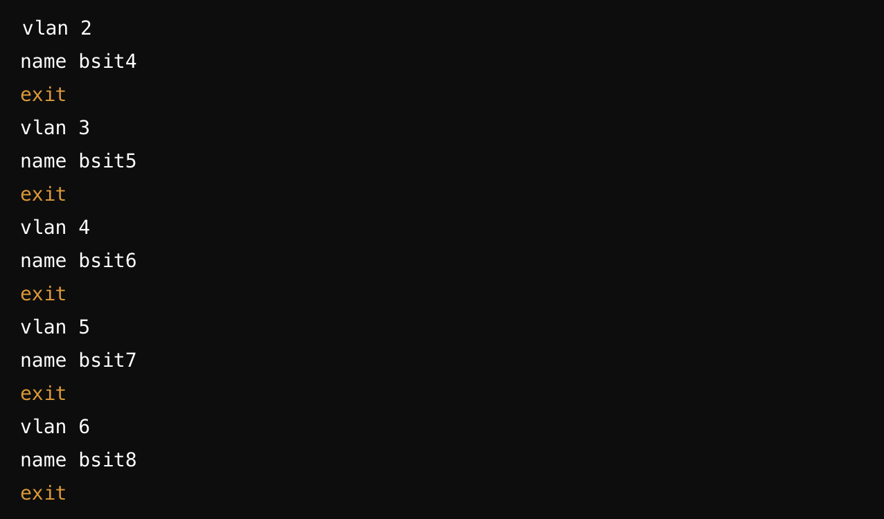

1. **Assign Ports to VLANs:**

**For each PC’s port, assign the VLAN as follows:**

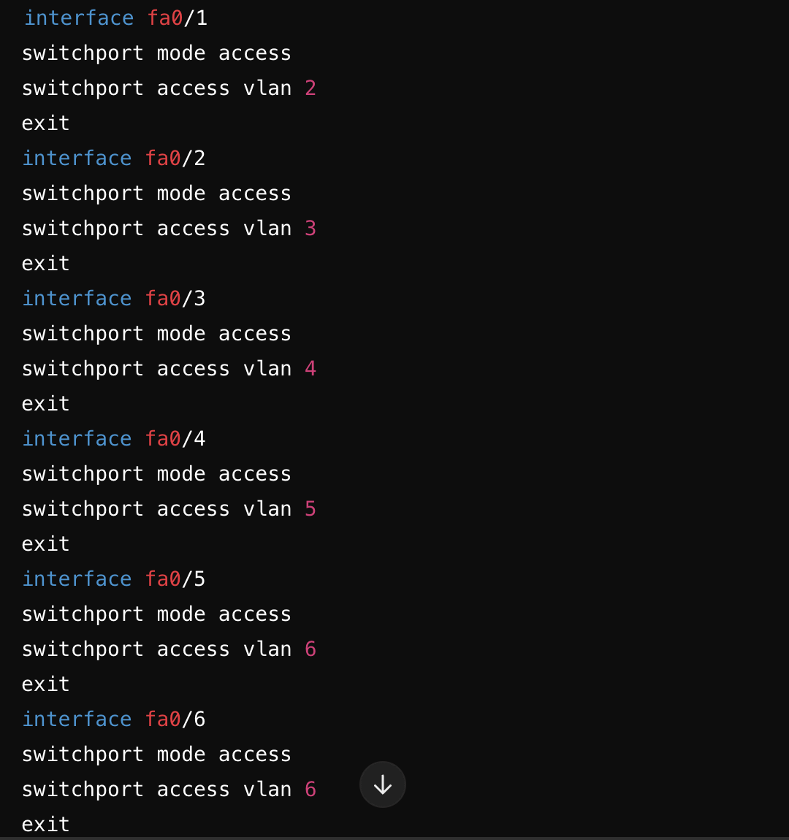

1. **Verify VLAN Configuration:**
   * Run the command show vlan brief to check VLAN assignments.
2. **Save Configuration:**
   * Type write memory to save the configuration.

Representation on Cisco Packet Tracker:

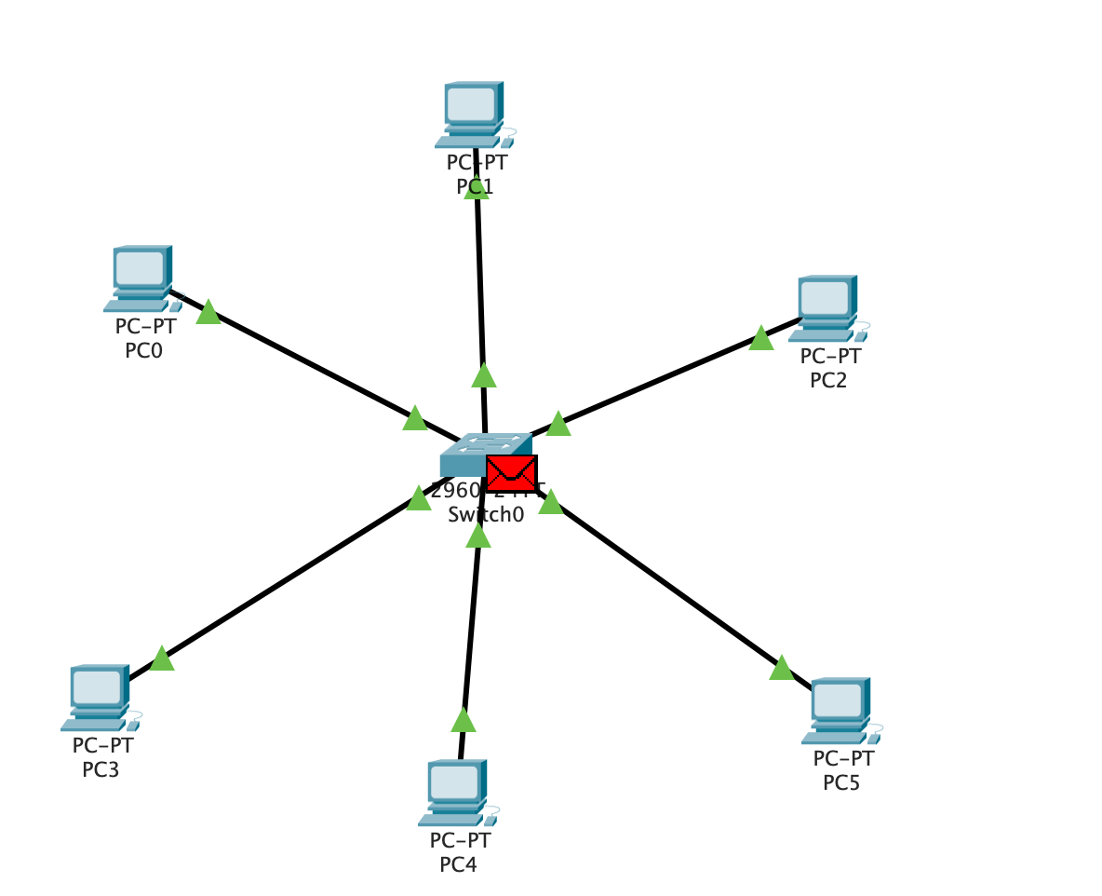

**Objective:**

The goal of this lab was to configure a router and connect it to a PC using Cisco Packet Tracer, setting up basic configurations such as hostname, password, and IP address on the router’s interface.

**Steps Performed:**

1. **Device Setup:**
   * A **PC** and a **Router** were placed in the workspace.
   * The devices were connected using a **copper straight-through cable**.
2. **Accessing the Router CLI:**
   * Accessed the router’s **Command Line Interface (CLI)** through the Packet Tracer interface.
3. **Entering Privileged Mode:**
   * Entered privileged mode by typing the en command
4. **Configuring the Router:**

* Entered **global configuration mode** with the configure terminal command

1. **Setting the Hostname:**

* Changed the router’s hostname to MyRouter

1. **Setting the Enable Password:**

* Configured the enable password as NetworkPass123 to secure access to privileged mode

1. **Configuring the Router Interface:**

* Configured **GigabitEthernet0/0/0** with the IP address 10.10.10.1 and subnet mask 255.0.0.0
* Activated the interface using the no shutdown command

1. **Verifying the Configuration:**

* Used the show ip interface brief command to check the interface status and IP configuration

1. **Saving and Exiting:**

* Exited interface configuration and global configuration mode

**Results:**

* The **PC** was successfully connected to the **router**.
* The **router** was configured with a meaningful **hostname** (MyRouter), a secure **password** (NetworkPass123), and an appropriate **IP address** (10.10.10.1/8).
* The interface was brought up and verified to be functioning properly using the show ip interface brief command.

**Conclusion:**

This lab demonstrated how to configure a basic router in Cisco Packet Tracer, including setting up a hostname, password, and IP address for the interface, and verifying the configuration.

**Representation via Cisco Packet Tracer:**

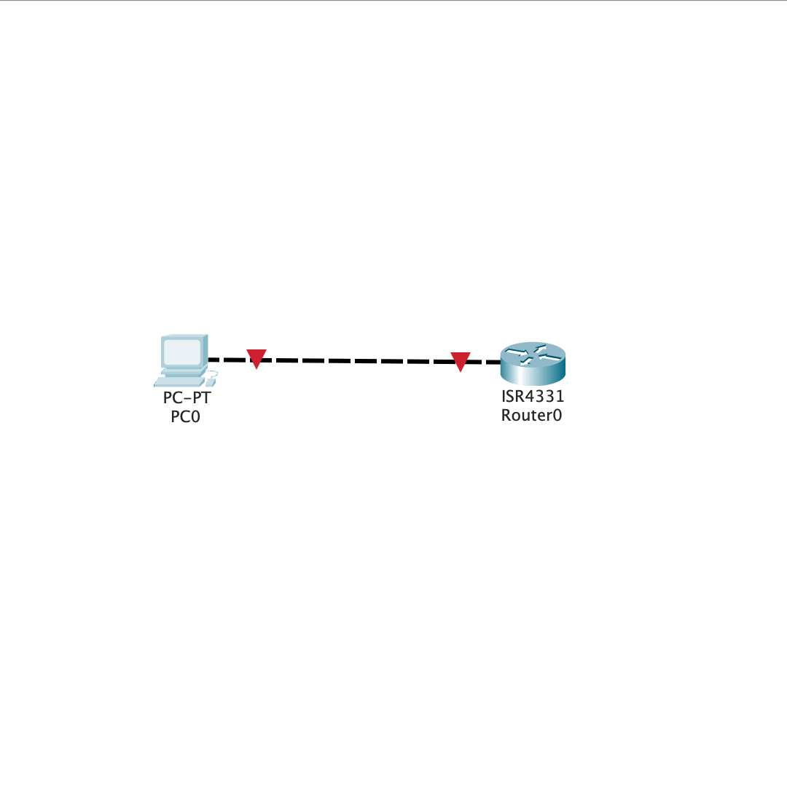

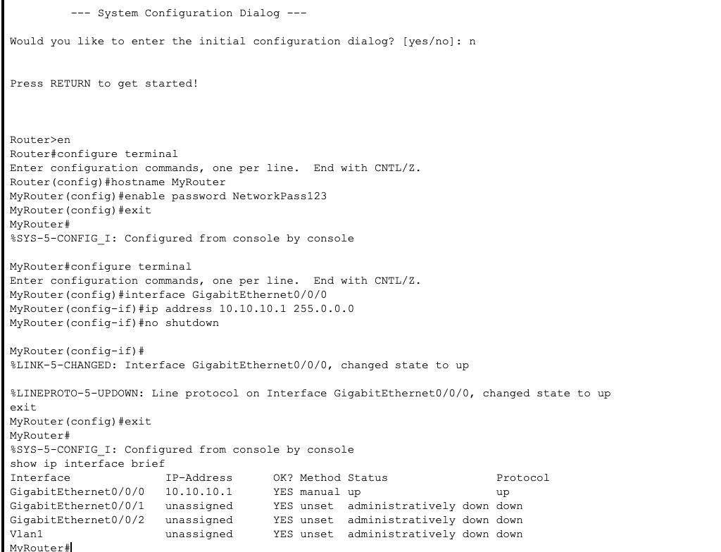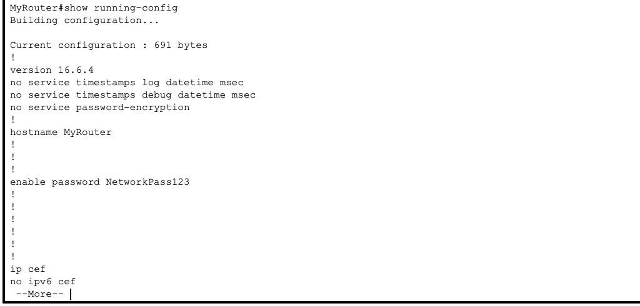

**Computer Networks**

**Lab 4**

**Network Configuration Report**

This report outlines the steps taken to configure the network setup involving two PCs connected to a switch, and the switch connected to a router via the GigabitEthernet0/0/0 port. The goal was to configure both the router and the switch to enable proper communication between the devices.

**Router Configuration**

1. **Access Privileged Mode:**
   * The router was accessed, and privileged mode was entered using the command:

enable

1. **Enter Global Configuration Mode:**
   * The global configuration mode was accessed using:

configure terminal

1. **Set the Hostname:**
   * The hostname of the router was configured as "ali" using the command:

hostname usman

1. **Set the Enable Password:**
   * A password was set to secure privileged mode:

enable password 123

1. **Assign IP Address to Router Interface:**
   * The GigabitEthernet0/0/0 interface was configured with an IP address and subnet mask:

interface gigabitEthernet 0/0/0

ip address 192.168.1.1 255.255.255.0

no shutdown

1. **Exit Configuration Mode:**
   * After configuring the router, global configuration mode was exited using:

exit

1. **Save Configuration:**
   * The router configuration was saved to memory using:

write memory

**Switch Configuration**

1. **Access Privileged Mode:**
   * The switch was accessed, and privileged mode was entered using the enable command.
2. **Enter Global Configuration Mode:**
   * The global configuration mode was accessed using:

configure terminal

1. **Configure Ports for PCs:**
   * The switch ports connected to the PCs (ports FastEthernet0/1 and FastEthernet0/2) were configured in access mode, and the interfaces were enabled using the following commands:
     + For PC 1 (FastEthernet0/1):

interface fastEthernet 0/1

switchport mode access

no shutdown

exit

* + - For PC 2 (FastEthernet0/2):

interface fastEthernet 0/2

switchport mode access

no shutdown

exit

1. **Configure Port for Router Connection:**
   * The switch port connected to the router (likely FastEthernet0/3) was configured similarly in access mode and enabled:

interface fastEthernet 0/3

switchport mode access

no shutdown

exit

1. **(Optional) Configure Management IP Address:**
   * A management IP address was assigned to VLAN 1 to allow for network-based switch management:

interface vlan 1

ip address 192.168.1.2 255.255.255.0

no shutdown

exit

1. **Save Configuration:**
   * The switch configuration was saved to memory using: write memory

**Conclusion**

The router and switch were successfully configured with appropriate IP addressing and port settings. The PCs should now be able to communicate with the router via the switch, and the network is ready for further testing and verification.

**Visual Representation:**

1. **Router Configuration:**

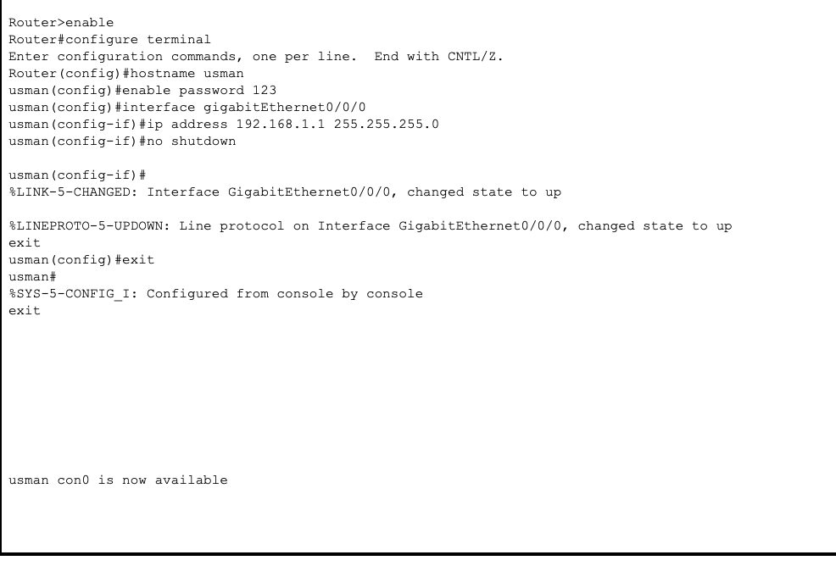

1. **Switch Configuation:**

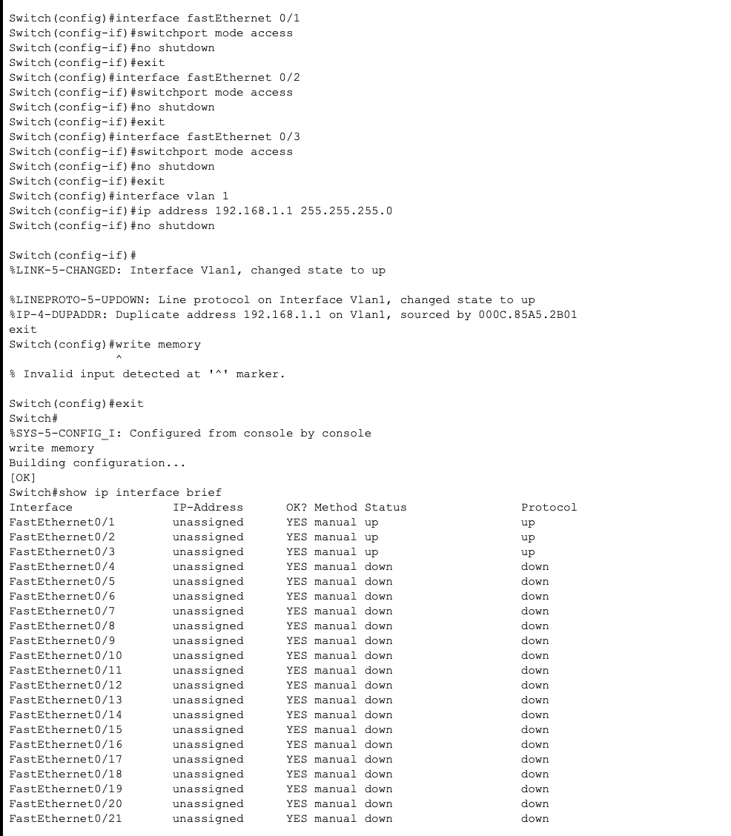

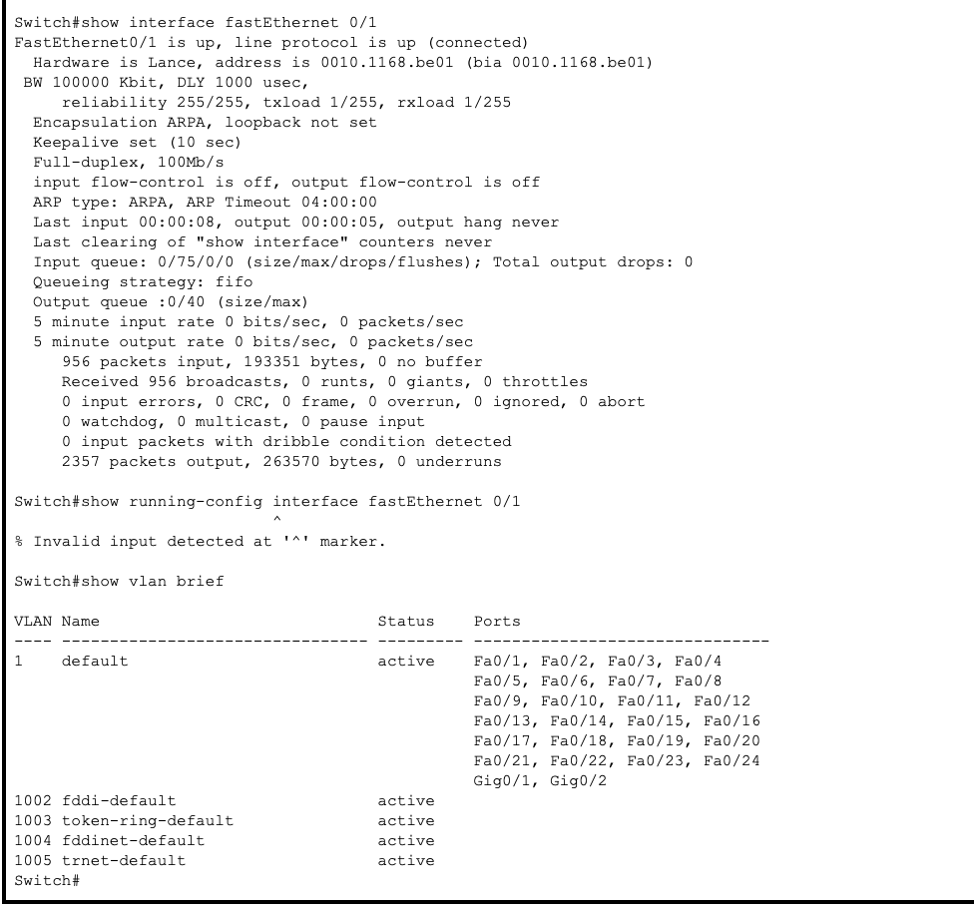

**Ping Command:**

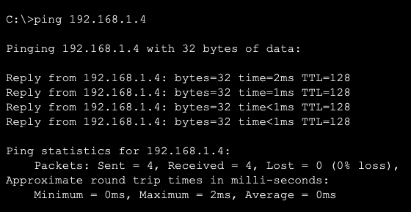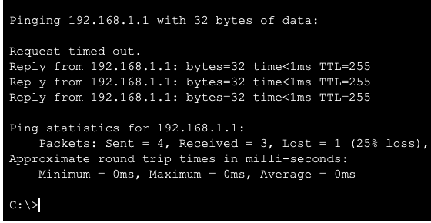

**Connection:**

