
Assignment Cover Sheet
Subject Code: | CSCI262
Subject Name: | System Security
Submission Type: | Report
Assignment Title: | Assignment/Project
Student Name: | Ahan Sunil, Hriday Pradeep, Sibi Varghese, Amberlily El moumni berdai, Huangfu Pinxi
Student Number: | 8398112, 8890766, 8935166, 8983835, 8409043
Student Email | as8997@uowmail.edu.au, hpk687@uowmail.edu.au, svp967@uowmail.edu.au, aemb887@uowmail.edu.au, ph382@uowmail.edu.au
Lecturer Name: | Dr. Halim
Due Date: | 3rd July, 2026
Date Submitted: | 3rd July, 2026

PLAGIARISM:  The penalty for deliberate plagiarism is FAILURE in the subject. Plagiarism is cheating by using the written ideas or submitted work of someone else. UOWD has a strong policy against plagiarism.  The University of Wollongong in Dubai also endorses a policy of non-discriminatory language practice and presentation.  PLEASE NOTE: STUDENTS MUST RETAIN A COPY OF ANY WORK SUBMITTED | DECLARATION:  I/We certify that this is entirely my/our own work, except where I/we have given fully-documented references to the work of others, and that the material contained in this document has not previously been submitted for assessment in any formal course of study. I/we understand the definition and consequences of plagiarism.  Signature of Student: Ahan Sunil, Hriday Pradeep, Sibi Varghese, Amberlily El moumni berdai, Huangfu Pinxi

Optional Marks:
Comments:

Lecturer Assignment Receipt (To be filled in by student and retained by Lecturer upon return of assignment)
Subject: | Assignment Title:
Student Name: | Student Number:
Due Date: | Date Submitted:
Signature of Student:

Student Assignment Receipt (To be filled in and retained by Student upon submission of assignment)
Subject: | Assignment Title:
Student Name: | Student Number:
Due Date: | Date Submitted:
Signature of Lecturer:

Table of Contents

Task Distribution 3
Introduction 4
Cryptographic Hash Functions 5
SHA-256 (Secure Hash Algorithm 256-bit) 5
MD5 (Message Digest 5) 5
Design 6
Data structure justification: 6
Implementation 7
Bloom Filter Construction 7
Dice Similarity Function 7
Cosine Similarity Function 8
Jaccard Similarity Function 8
Dataset Loading 8
Precomputing Dataset Bloom Filter 9
Password Checking Process 9
Justification of algorithm choice 10
Bloom Filter Output Verification 11
Results 12
Discussion 14
A. Why We Use All Three Metrics: Accept/Reject Logic 14
B. Threshold Justification 14
C. Critical Analysis 15
References 17
Appendix 18

Task Distribution

Name | Student ID | Work
Ahan Sunil | 8398112 | Implemented the Jaccard similarity function; formatted and compiled the full report, wrote up bigrams, Bloom filter construction, the three-similarity metrics and in the data structure justification, and assisted other parts of coding
Sibi Varghese | 8935166 | Implemented bloom filter and justif table; wrote the problem introduction and the conceptual explanation of SHA-256 and MD5, and assisted in other parts of coding
Huangfu Pinxi | 8409043 | Implemented the dice and cosine functions, wrote the Implemetation section,function/module descriptions, algorithm choice justification (bigrams + double hashing)
Hriday Pradeep | 8890766 | Built the main app, including dataset loading, precomputing dataset filters, comparing candidate against dataset using all 3 metrics, accept/reject logic, and helped write the accept/reject decision logic subsection
Amberlily El moumni berdai | 8983835 | Ran threshold testing (0.5/0.6/0.7/0.8) across test password pairs; wrote the test results tables; wrote the threshold justification, critical analysis/discussion of limitations and assisted in coding parts

Introduction
Periodic credential changes are often a key feature of enterprise password authentication policies, but a frequent reality is that the policies are a significant usability problem for users. People are then able to avoid these types of security protocols by using random and minor changes, such as adding a single number, changing capitalization, or swapping out a special character for the earlier established password (Berardi et al., 2021). Such common behavior inevitably weakens an organization's security architecture, in a way that easily allows a hacker to use a large, expanded credential database (like RockYou) to carry out automated credential mutation attacks on these very minute variations.

This project implements a highly efficient similarity-based detection mechanism to proactively detect such passwords at the point of user registration and to block the registration of passwords with unsafe structural properties with already compromised passwords. Instead of having to apply any exact-match method or use a computationally expensive plaintext string comparison, the proposed system uses Bloom filters, a space efficient probabilistic data structure known for how quickly it can answer a query membership operation (Blustein and El-Maazawi, 2002; Antognini and Trivadis, 2008).

The program hashes plaintext data by using a powerful double-hashing algorithm based on two cryptographic functions (SHA-256 and MD5) and translates the password sequences into bi-grams which obfuscates the plaintext against cryptanalysis performed by attackers (Kroll and Steinmetzer, 2015). Finally, this mathematical representation enables the system to accurately use similarity to determine how much one algorithmic password matches another in a blacklist of compromised passwords. Hence, it allows only structurally robust (and therefore structurally different) passwords to be entered into the system.

Cryptographic Hash Functions

SHA-256 (Secure Hash Algorithm 256-bit)
The system uses SHA-256 as the main algorithm to map password bi-grams to the Bloom filter. SHA-256 has the ability to generate an output of fixed length 256 bits on a plain text of any size. This is accomplished using a complex 64 round compression function which scrambles the data through bitwise operations into 512-bit blocks. The one-way property of SHA-256 means that the function cannot be used to recover the original password from the hash because the compression function will change the data and throw it away.

MD5 (Message Digest 5)
MD5 is used as the secondary hash function, which reduces the input to a shorter 128-bit digest. It is like SHA-256, except that it processes the data in 512-bit chunks but uses a very efficient, four-round compression function with non-linear mathematics. MD5 is also designed in such a way that it is one way, hence it cannot be reversed at all. Though MD5 is vulnerable to collisions in present security, it is also highly efficient for fast hashing of arrays, as well as uniformly distributing data. Hence, it was well suited for use with our double hashing formula.

Design
The system follows a two-stage design: a representation stage and a comparison stage.

In the representation stage, every password is converted into a fixed-length Bloom filter β(p), a 1000-bit vector of 0s and 1s. The goal is to turn a password into a kind of "fingerprint" that can be compared mathematically instead of comparing raw characters. The password is first padded with a leading and trailing space, then split into bigrams (2-character sliding windows), for example, "abc" becomes " a", "ab", "bc", "c ". Breaking the password into small overlapping pieces means a slightly tweaked password will still share most of the same pieces as the original, which is what lets the system catch tweaked passwords later, even when only one or two characters have changed.

Each bigram is hashed twice, once with SHA-256 and once with MD5, to produce two seed values, f and g. These drive a double-hashing scheme that generates 20 hash positions per bigram: h_i = (f + i·g) mod 1000, for i = 0 to 19. This reuses the same two hash values to generate 20 positions quickly, instead of needing 20 separate hash functions, which keeps the computation lightweight while still spreading bits across the vector. Each bigram produces its own 1000-bit "atom," with up to 20 bits set to 1. All atoms are combined into the final filter β(p) by setting the corresponding bits across all bigrams, so the final vector reflects every bigram in the password at once.

In the comparison stage, two filters β1 and β2 are compared using three metrics, Jaccard, Dice, and Cosine, all built from γ (positions set to 1 in both filters) and k1, k2 (1-bit counts in each filter). The more bigrams two passwords share, the more their filters overlap, and the higher these scores are. Using all three together lets the system cross-check decisions rather than relying on a single number, a candidate password is rejected if any metric exceeds the chosen threshold against any password in the dataset.

Data structure justification:
The bit vector is implemented as a plain Python list of 1000 integers (0s and 1s). This was chosen because it gives direct O(1) access to any position by index, which matches exactly how the bloom filter model works, each hash output maps straight to a list index, with no need for more complex structures like dictionaries or sets, since the size (1000) is fixed and known in advance.

Implementation
This section describes the main implementation of the whole password similarity checking system. The passwords are converted to Bloom filters, and the candidate password is compared with assessing passwords stored in the dataset using a similarity metric. Implementation is done in Python and uses Hashlib library for hashing and math library to compute cosine similarity.
Bloom Filter Construction
The compute_bloom_filter() function turns the password into a bloom filter with 1000 positions. First, the password will have spaces added to the start and end of it. Next, the password will be split into groups of two letters that are called bigrams. Finally, each bigram will have its SHA-256 and MD5 hashed results used to choose 20 positions in the bloom filter and set each of them to 1.
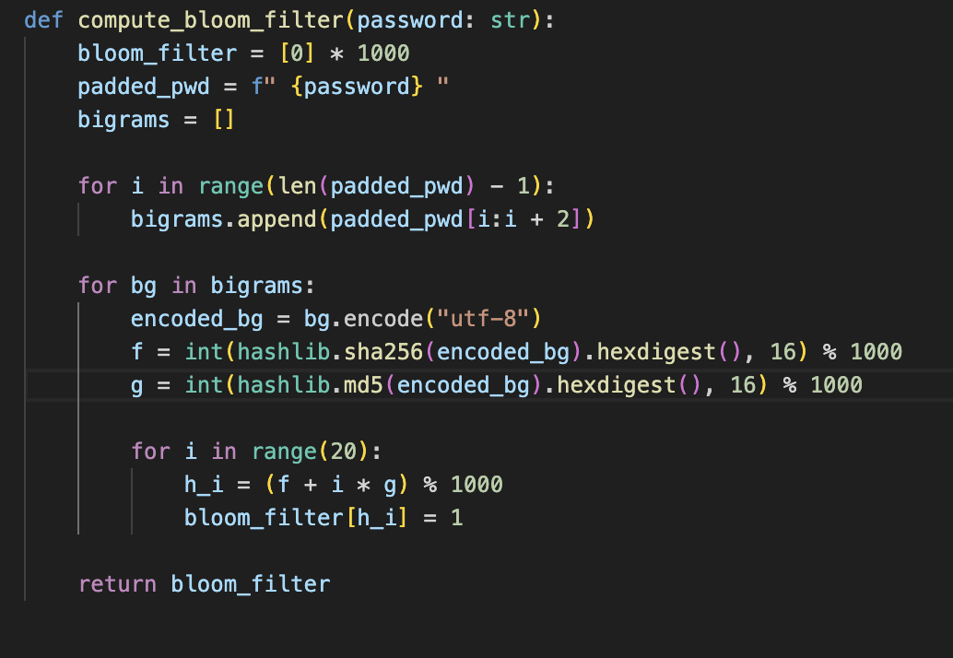

Dice Similarity Function
The dice () function compares how similar two Bloom filters are based on their shared 1 position. The more alike the two passwords, the higher the Dice score.
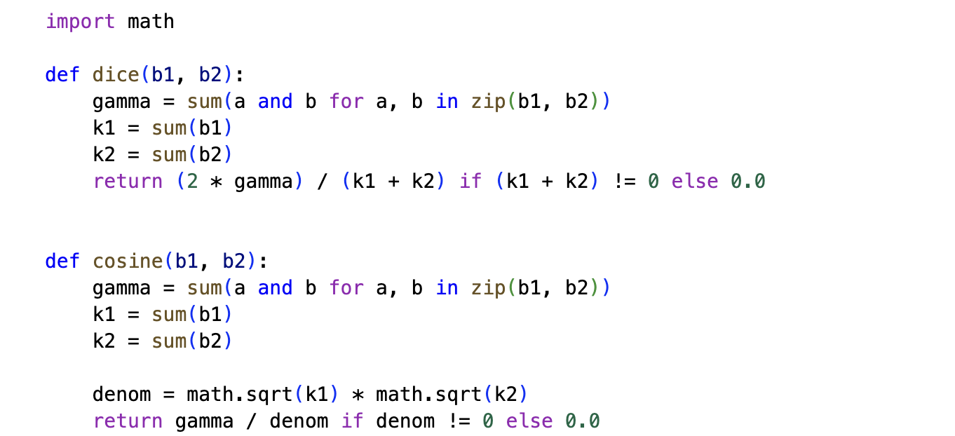
Cosine Similarity Function
The cosine () function makes similar comparisons like dice, although we treat the filters like vectors here. The closer to 1 the higher to the similarity.

Jaccard Similarity Function
The Jaccard() function compares two Bloom filters based on how many of their shared 1 positions there are relative to the total 1 positions across both. The more alike the two passwords, the higher the Jaccard score.

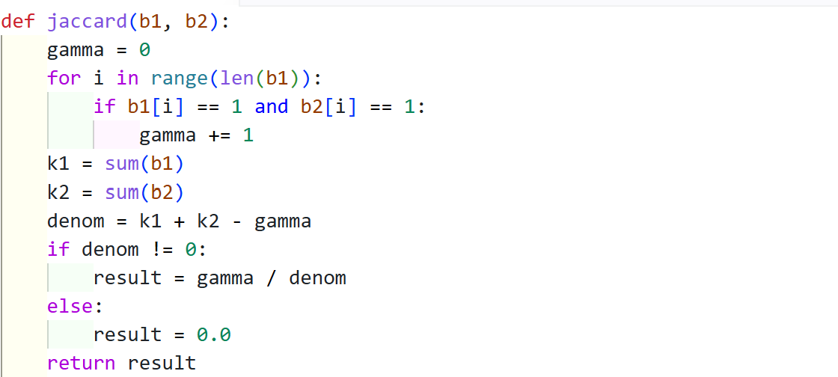

Dataset Loading
The load_password_dataset() function reads passwords from the dataset file. It removes empty lines and extra spaces and then stores the passwords in a list.

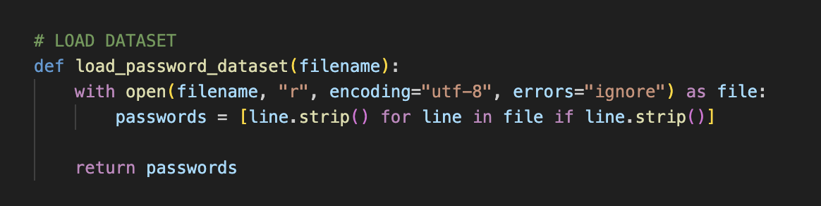

Precomputing Dataset Bloom Filter
The precompute_dataset_filters( ) function changes all the dataset passwords into Bloom filters to do the comparisons against. This makes the program faster as you don’t have to process the dataset passwords on every check.

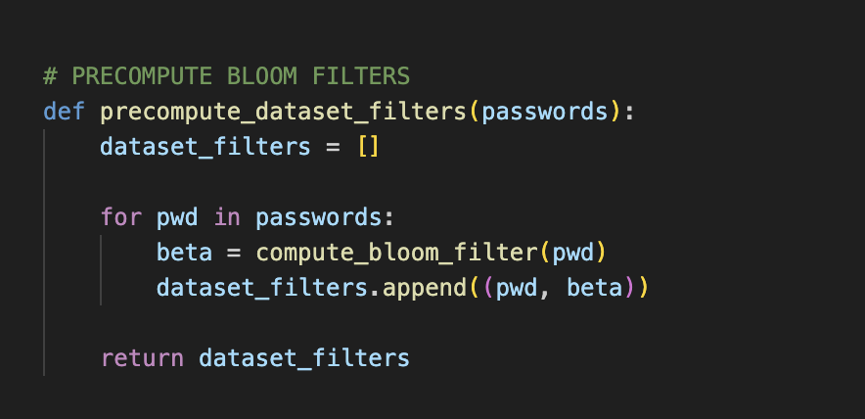

Password Checking Process
In password_checker(), it’ll take the candidate password and compare it against all the dataset passwords using Jaccard, Dice, and Cosine. An early stop is done where as soon as one score exceeds the threshold, the candidate is rejected. If no password in the dataset exceeds the threshold, then it’ll record the closest matching password found across them all.

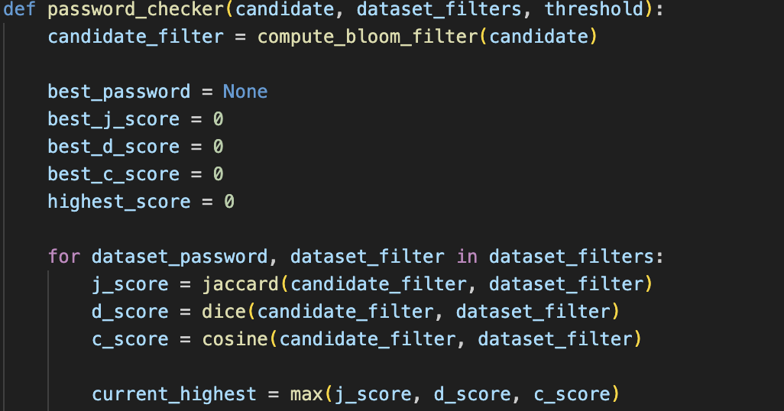

Justification of algorithm choice
System utilizes bigrams to divide a user's password into pairs of characters thus allowing the ability to recognize passwords which have only been changed slightly, like "password" vs "passw0rd". Double hashing is additionally used to increase the efficiency of the Bloom filter. Rather than computing 20 independent hash values, only two hash functions are utilized (SHA-256 and MD5) and produce multiple positions for each hash value produced.
This approach provides both efficiency and determinism; each password produces the same Bloom filter thus ensuring that any given comparison results remain consistent.

Bloom Filter Output Verification
The following results demonstrate the core implementation of the Bloom filter component executing successfully against the provided dataset. Below are the terminal outputs proving the calculation of the 1000-bit vectors for specific target passwords.

Figure 1: Bloom Filter Array for the 17th Password
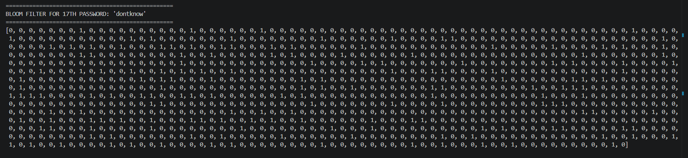

Figure 2: Bloom Filter Array for the 55th Password
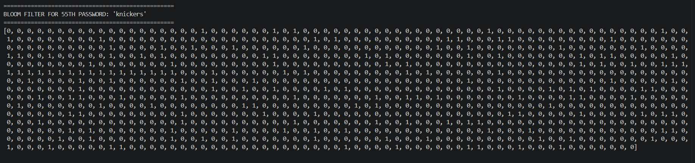

Results
The password similarity detection system was evaluated using eight representative test cases covering exact matches of modified passwords, unrelated passwords, edge cases, common passwords, and randomly generated passwords. Each candidate password was compared against every password within the rockyousubset15.txt dataset using a Bloom filter representation and the Jaccard, Dice, and Cosine similarity metrics. These four threshold values (0.5, 0.6, 0.7, and 0.8) were used to analyze and evaluate how the effect of each threshold selection would impact the selection of the final accept/reject decision of the system.

Tables 1–4 present the similarity scores and classification decisions obtained for each candidate password across the four evaluated threshold values. These experimental results form the basis of the threshold selection and discussion presented in the following section.

Threshold | Test ID | Candidate Password | Closest Dataset Password | Jaccard | Dice | Cosine | Decision
0.5 | TC1 | password13 | password13 | 1 | 1 | 1 | REJECTED
0.5 | TC2 | p@ssw0rd13 | password13 | 0.511 | 0.6764 | 0.6764 | REJECTED
0.5 | TC3 | CoffeeCup! | greenday! | 0.1883 | 0.3169 | 0.3171 | ACCEPTED
0.5 | TC4 | aaaaaaaa | andreina | 0.2303 | 0.3744 | 0.4243 | ACCEPTED
0.5 | TC5 | password1 | password13 | 0.7844 | 0.8792 | 0.8805 | REJECTED
0.5 | TC6 | football | softball27 | 0.3333 | 0.5 | 0.5015 | REJECTED
0.5 | TC7 | xk92LmQa | mirabela | 0.1908 | 0.3205 | 0.3205 | ACCEPTED
0.5 | TC8 | qwerty12 | froggy12 | 0.2934 | 0.4537 | 0.4537 | ACCEPTED
Table 1: 0.5 Threshold testing

Threshold | Test ID | Candidate Password | Closest Dataset Password | Jaccard | Dice | Cosine | Decision
0.6 | TC1 | password13 | password13 | 1 | 1 | 1 | REJECTED
0.6 | TC2 | p@ssw0rd13 | password13 | 0.511 | 0.6764 | 0.6764 | REJECTED
0.6 | TC3 | CoffeeCup! | greenday! | 0.1883 | 0.3169 | 0.3171 | ACCEPTED
0.6 | TC4 | aaaaaaaa | andreina | 0.2303 | 0.3744 | 0.4243 | ACCEPTED
0.6 | TC5 | password1 | password13 | 0.7844 | 0.8792 | 0.8805 | REJECTED
0.6 | TC6 | football | goofball | 0.4402 | 0.6113 | 0.6113 | REJECTED
0.6 | TC7 | xk92LmQa | mirabela | 0.1908 | 0.3205 | 0.3205 | ACCEPTED
0.6 | TC8 | qwerty12 | froggy12 | 0.2934 | 0.4537 | 0.4537 | ACCEPTED
Table 2: 0.6 Threshold testing

Threshold | Test ID | Candidate Password | Closest Dataset Password | Jaccard | Dice | Cosine | Decision
0.7 | TC1 | password13 | password13 | 1.000 | 1.000 | 1.000 | REJECTED
0.7 | TC2 | p@ssw0rd13 | password13 | 0.511 | 0.6764 | 0.6764 | ACCEPTED
0.7 | TC3 | CoffeeCup! | greenday! | 0.1883 | 0.3169 | 0.3171 | ACCEPTED
0.7 | TC4 | aaaaaaaa | andreina | 0.2303 | 0.3744 | 0.4243 | ACCEPTED
0.7 | TC5 | password1 | password13 | 0.7844 | 0.8792 | 0.8805 | REJECTED
0.7 | TC6 | football | goofball | 0.4402 | 0.6113 | 0.6113 | ACCEPTED
0.7 | TC7 | xk92LmQa | mirabela | 0.1908 | 0.3205 | 0.3205 | ACCEPTED
0.7 | TC8 | qwerty12 | froggy12 | 0.2934 | 0.4537 | 0.4537 | ACCEPTED
Table 3: 0.7 Threshold testing

Threshold | Test ID | Candidate Password | Closest Dataset Password | Jaccard | Dice | Cosine | Decision
0.8 | TC1 | password13 | password13 | 1 | 1 | 1 | REJECTED
0.8 | TC2 | p@ssw0rd13 | password13 | 0.511 | 0.6764 | 0.6764 | ACCEPTED
0.8 | TC3 | CoffeeCup! | greenday! | 0.1883 | 0.3169 | 0.3171 | ACCEPTED
0.8 | TC4 | aaaaaaaa | andreina | 0.2303 | 0.3744 | 0.4243 | ACCEPTED
0.8 | TC5 | password1 | password13 | 0.7844 | 0.8792 | 0.8805 | REJECTED
0.8 | TC6 | football | goofball | 0.4402 | 0.6113 | 0.6113 | ACCEPTED
0.8 | TC7 | xk92LmQa | mirabela | 0.1908 | 0.3205 | 0.3205 | ACCEPTED
0.8 | TC8 | qwerty12 | froggy12 | 0.2934 | 0.4537 | 0.4537 | ACCEPTED
Table 4: 0.8 Threshold testing

Additionally, this Threshold Summary Table summarizes the testing for each of the four individual thresholds we analyzed and includes our observations. The stricter threshold means that even the most moderate similarities between the passwords we chose and the passwords within the RockYou dataset were enough to reject the password. Whereas the higher the threshold, similar passwords to the compromised ones started to become accepted display the thresholds permissive nature and therefore reduce security.

Threshold | Passwords Rejected | Passwords Accepted | Observation
0.5 | 4 | 4 | Very strict. Rejected exact matches, modified passwords and moderately similar passwords such as football.
0.6 | 4 | 4 | Similar behavior to 0.5. Continued to reject modified and moderately similar passwords while accepting unrelated passwords.
0.7 | 2 | 6 | More permissive. Accepted football but also accepted the modified password p@ssw0rd13.
0.8 | 2 | 6 | Produced the same results as 0.7 in this dataset. No additional security benefits were observed.

Table 5: Threshold Summary Table

Discussion

Why We Use All Three Metrics: Accept/Reject Logic
Candidate password and dataset password comparison are measured through Jaccard, Dice and Cosine metrics. These metrics involve comparing the Bloom filter corresponding to the password candidate to the Bloom filters of the passwords in the set. When applying the three similarity scores, if one of the three is above the selected threshold value of 0.6 then the password is rejected. The password is accepted if all three similarities are less than 0.6.
This method was selected because all similarity measures define how they should look at the bloom filters differently. The Jaccard coefficient indicates how much overlap there is between the two Bloom filters, the Dice coefficient places more weight on the common bits shared by the two Bloom filters, and the Cosine similarity measures how similar the two Bloom filter vectors are. Employing the three measures simultaneously gives better information of the comparison of the two bodies than using a single similarity measure.

In a security application, if any of the three metrics is above the threshold, the password is rejected because there is at least one strong indicator that the password is a slight variant of one of the most common or compromised passwords. This conservative approach minimizes the likelihood of accepting too easy passwords while at the same time permitting truly unique passwords to pass. That 0.6 is a good balance between catching the same passwords, and allowing unique, secure passwords.

B. Threshold Justification
Selecting an appropriate similarity threshold is crucial because it determines the balance between security and usability. Specifically, the threshold controls how similar a candidate password can be to a compromised password before it is rejected. Selecting a low threshold may reject legitimate passwords that only share moderate structural similarity with compromised passwords (false positives), whereas selecting a threshold that is too high may allow modified versions of compromised passwords to be accepted (false negatives). To evaluate the impact of threshold selection, four threshold values were tested using eight representative password test cases against the rockyou_subset_15.txt dataset, which contains a subset of commonly used compromised passwords derived from the RockYou password leak. Previous research on Bloom filter-based password similarity systems suggests that threshold values should be selected according to application requirements by balancing security and usability rather than relying on a universally optimal threshold (Berardi et al., 2021).

The experimental results showed that thresholds of 0.5 and 0.6 both rejected four passwords and accepted four passwords, representing a stricter security policy. By comparison, thresholds of 0.7 and 0.8 rejected only two passwords while accepting six passwords. These results show that 0.5 and 0.6 produced identical classification decisions, while 0.7 and 0.8 also produced identical results. Therefore, increasing the threshold beyond 0.6 did not improve discrimination between the tested candidate passwords.

An important observation was how changes in the similarity threshold affected the system's ability to distinguish between secure and insecure passwords. The compromised password password13 produced similarity scores of 1.0 across all metrics and was correctly rejected under every threshold. We then tested p@ssw0rd13, which replaces the letters 'a' with '@' and 'o' with '0', representing a common password mutation. At thresholds of 0.5 and 0.6, it was correctly rejected because its similarity exceeded the threshold. However, at thresholds of 0.7 and 0.8, it was accepted. These results suggest that higher threshold values reduce the sensitivity of the detection system, allowing structurally similar passwords to bypass security checks and weakening password security (Berardi et al., 2021).

The password football further illustrates the trade-off between security and usability. At thresholds of 0.5 and 0.6, it was rejected because its Bloom filter representation shared moderate structural similarity with passwords in the RockYou subset dataset. At thresholds of 0.7 and 0.8, however, it was accepted. This demonstrates that lower thresholds are more conservative, improving security but also increasing the likelihood of false positives by rejecting passwords that are not simple modifications of compromised passwords (Blustein and El-Maazawi, 2002; Antognini and Trivadis, 2008).

Overall, the experimental evaluation suggests that 0.6 provided the most appropriate balance for this implementation. Although 0.5 and 0.6 produced identical classification decisions, 0.6 was selected because it is the least restrictive threshold that still rejected the exact compromised password (password13) and its modified version (p@ssw0rd13), while continuing to accept unrelated passwords such as CoffeeCup!, aaaaaaaa, xk92LmQa, and qwerty12. Selecting the highest threshold that maintains these security properties reduces the likelihood of unnecessarily rejecting legitimate passwords when applied to larger datasets (Berardi et al., 2021).

C. Critical Analysis
The proposed password similarity detection system successfully identified exact password matches as well as passwords which were structurally similar to compromised passwords contained in the RockYou subset dataset. Using bloom filters with Jaccard, Dice, and Cosine similarity metrics allowed effective password comparisons whilst avoiding direct comparison of plaintext passwords (Berardi et al., 2021; Antognini and Trivadis, 2008).

The experimental evaluation demonstrated that threshold selection has a crucial impact on system behavior. The lower threshold values increase security by rejecting more structurally similar passwords. In contrast, higher threshold values improve usability; however, increase the likelihood of accepting modified compromised passwords which rejects the concept of a secure password. This can highlight the importance of selecting a threshold based on the desired balance between security and usability, rather than the assumption of a higher threshold automatically producing better results.

However, one limitation of the proposed approach consists of Bloom Filters being probabilistic for data structures, leading to the concern that they can produce false positives due to hash collisions (Blustein and El-Maazawi, 2002; Antognini and Trivadis, 2008). In addition, similarity is measured using password structure rather than password semantics. This can indicate that two different passwords with similar character patterns may receive relatively high similarity scores. Future works could evaluate the system using a larger passwords dataset, additional similarity metrics, or adaptive threshold selection techniques to further improve accuracy.

References

- Khelalfa, H. (2026) CSCI262 System Security lecture slides, University of Wollongong in Dubai.
- GeeksforGeeks (2024) 'Bloom Filters – Introduction and Python Implementation', GeeksforGeeks. Available at: https://www.geeksforgeeks.org/bloom-filters-introduction-and-python-implementation/ (Accessed: 26 June 2026).
- Antognini, C. and Trivadis, A. (2008) Bloom filters. Trivadis Technical Paper. Available at: https://antognini.ch/papers/BloomFilters20080620.pdf (Accessed: 26 June 2026).
- Berardi, D., Callegati, F., Melis, A. and Prandini, M. (2021) 'Password similarity using probabilistic data structures', Journal of Cybersecurity and Privacy, 1(1), pp. 78–92. Available at: https://doi.org/10.3390/jcp1010005 (Accessed: 26 June 2026).
- Blustein, J. and El-Maazawi, A. (2002) Bloom filters: a tutorial, analysis, and survey. Technical Report. Halifax: Dalhousie University.
- Kroll, M. and Steinmetzer, S. (2015) Automated cryptanalysis of Bloom filter encryptions of health records. Available at: https://arxiv.org/abs/1410.6739 (Accessed: 26 June 2026).

Appendix
Main Code:
import hashlib
import math

# BLOOM FILTER
def compute_bloom_filter(password: str):
bloom_filter = [0] * 1000
padded_pwd = f" {password} "
bigrams = []

for i in range(len(padded_pwd) - 1):
bigrams.append(padded_pwd[i:i + 2])

for bg in bigrams:
encoded_bg = bg.encode("utf-8")
f = int(hashlib.sha256(encoded_bg).hexdigest(), 16) % 1000
g = int(hashlib.md5(encoded_bg).hexdigest(), 16) % 1000

for i in range(20):
h_i = (f + i * g) % 1000
bloom_filter[h_i] = 1

return bloom_filter

# JACCARD
def jaccard(b1, b2):
gamma = 0

for i in range(len(b1)):
if b1[i] == 1 and b2[i] == 1:
gamma += 1

k1 = sum(b1)
k2 = sum(b2)
denom = k1 + k2 - gamma

if denom != 0:
return gamma / denom
else:
return 0.0

# DICE
def dice(b1, b2):
gamma = sum(a and b for a, b in zip(b1, b2))
k1 = sum(b1)
k2 = sum(b2)

return (2 * gamma) / (k1 + k2) if (k1 + k2) != 0 else 0.0

# COSINE
def cosine(b1, b2):
gamma = sum(a and b for a, b in zip(b1, b2))
k1 = sum(b1)
k2 = sum(b2)
denom = math.sqrt(k1) * math.sqrt(k2)

return gamma / denom if denom != 0 else 0.0

# LOAD DATASET
def load_password_dataset(filename):
with open(filename, "r", encoding="utf-8", errors="ignore") as file:
passwords = [line.strip() for line in file if line.strip()]

return passwords

# PRECOMPUTE BLOOM FILTERS
def precompute_dataset_filters(passwords):
dataset_filters = []

for pwd in passwords:
beta = compute_bloom_filter(pwd)
dataset_filters.append((pwd, beta))

return dataset_filters

# MAIN PASSWORD CHECKER
def password_checker(candidate, dataset_filters, threshold):
candidate_filter = compute_bloom_filter(candidate)

best_password = None
best_j_score = 0
best_d_score = 0
best_c_score = 0
highest_score = 0

for dataset_password, dataset_filter in dataset_filters:
j_score = jaccard(candidate_filter, dataset_filter)
d_score = dice(candidate_filter, dataset_filter)
c_score = cosine(candidate_filter, dataset_filter)

current_highest = max(j_score, d_score, c_score)

if current_highest > highest_score:
highest_score = current_highest
best_password = dataset_password
best_j_score = j_score
best_d_score = d_score
best_c_score = c_score

if j_score >= threshold or d_score >= threshold or c_score >= threshold:
return ("REJECTED", dataset_password, j_score, d_score, c_score)

return ("ACCEPTED", best_password, best_j_score, best_d_score, best_c_score)

# MAIN PROGRAM
DATASET_FILE = "rockyou_subset_15.txt"
THRESHOLD = 0.6

passwords = load_password_dataset(DATASET_FILE)
dataset_filters = precompute_dataset_filters(passwords)

candidate = input("Enter a candidate password: ")
while len(candidate) < 8 or len(candidate) > 10:
print("Invalid password length. Password must be between 8 and 10 characters.")
candidate = input("Please enter another password: ")

result, matched_password, j_score, d_score, c_score = password_checker(
candidate,
dataset_filters,
THRESHOLD,
)

# THE JUSTIF TABLE

print("\n" + "="*85)
print(" JUSTIF TABLE")
print("="*85)
print(f"{'Original data set':<20} | {'Jaccard coefficient':<18} | {'The Dice':<18} | {'The Cosine'}")
print(f"{'password P':<20} | {'between β(P)&β(UserP)':<18} | {'coefficient':<18} | {'Similarity'}")
print("-" * 85)
print(f"{str(matched_password):<20} | {round(j_score, 4):<18} | {round(d_score, 4):<18} | {round(c_score, 4)}")
print("="*85)

#JUSTIFICATION / PROOF
print("\nJUSTIFICATION (PROOF)")
print(f"Final Decision: {result}")

if result == "REJECTED":
print(f"Proof: The candidate password (UserP) is structurally too similar to '{matched_password}'.")
print(f"Based on the JUSTIF table above, the system enforces a strict threshold of {THRESHOLD}.")

reasons = []
if j_score >= THRESHOLD: reasons.append(f"Jaccard ({round(j_score, 4)})")
if d_score >= THRESHOLD: reasons.append(f"Dice ({round(d_score, 4)})")
if c_score >= THRESHOLD: reasons.append(f"Cosine ({round(c_score, 4)})")

print("The password was rejected because the following metrics met or exceeded that threshold:")
for r in reasons:
print(f"{r} >= {THRESHOLD}")
else:
print("Proof: The candidate password (UserP) is structurally distinct from all compromised passwords.")
print(f"Based on the JUSTIF table above, the closest matching password was '{matched_password}'.")
print(f"However, all calculated similarity metrics remained strictly below the {THRESHOLD} threshold.")
print("Therefore, the password is safe to be ACCEPTED.")

