**Design and Development of CHATBOT: A Review**

**Abstract.** This paper focuses on a newly emerging tool for learning from CHATBOT, whichis a learning-cum-assisted tool. A CHATBOT is an artificially created virtual entity that interacts with users using interactive textual or speech skills. This CHATBOT directly chats with the people using artificial intelligence and Machine Learning concepts. This paper reviews the technique, terminology, and different platforms used to design and develop the CHATBOT. It also presents some actual practical life typical applications and examples of CHATBOT. The utility of the CHATBOT tool for Computer-Aided Design (CAD) applications is proposed from this review.

**Keywords.** CHATBOT, Artificial Intelligence, Machine Learning, CAD.

**1.** **Introduction**

Computer-aided design packages are the primary software to help Mechanical Designers throughout the world. In the beginning, it used to replace hand-drawn technical drawings. The technology of the 21st century led engineers to develop software and hardware so that CAD [1] software and its tools integrate with computers and mobile, easy to use, affordable that way, the organization and higher institutes started incorporating these type of courses into their education curriculum. The user uses these 2D drafting and 3D models developed by the software in the form of technical design to present their design ideas and concepts to other users [2]. The most commonly used CAD software is Autodesk AutoCAD, Dassault Catia, Dassault Solidwork, Autodesk Inventor, Autodesk Fusion 360, PTC Creo, and Siemens NX. Technical drafting generates after model completion submitted for evaluation by instructors. The user mainly focuses on learning the CAD software through procedural-based knowledge, which means knowing the associated commands useful for a particular problem.

While learning CAD software for a specific CAD problem, users may face many problems or get stuck when a new CAD design problem is issue for assessment. For a new CAD problem, users try to implement the procedural manner for solving, using the same commands and tools repeatedly, which results in the neglection of new commands and tools through which the same CAD problem is dealt with efficiently.

Speech and textual forms of information play a vital role in communicating among peoples. Nowadays, speech and textual conversation are primary communication forms between humans and computers that occur through web applications. The purpose of a CHATBOT is to help answer user queries [3]. CHATBOT is a computer program that processes a user’s natural-language input and generates relatively smart, affluent, and intelligent responses sent back to the user [4]. CHATBOT help with human request and allow conversation 24 hours out of every day and improve productivity by assuming control over all activities where people are not required. However, the most significant advantage of CHATBOT is that it can reach a wide-ranging audience on a messaging system and automate customized messages [5]. Some common examples of CHATBOT are ASK DISHA for IRCTC inquiry, Amazon chat customer service, HDFC bank bot EVA, etc. CHATBOT has been utilized in several industries to convey specific information or perform tasks, like telling the weather of Delhi, making flight reservations from Mumbai to Kolkata, answering educational-based queries, or purchasing

products and groceries. Telegram, WhatsApp messenger, Signal, IBM, Microsoft Cortana, Slack, Google Assistant, Siri, WeChat, Facebook Messenger [5], etc. popular famous applications are using these technologies.

**1.1 A Brief Historical Account for Chatbot**

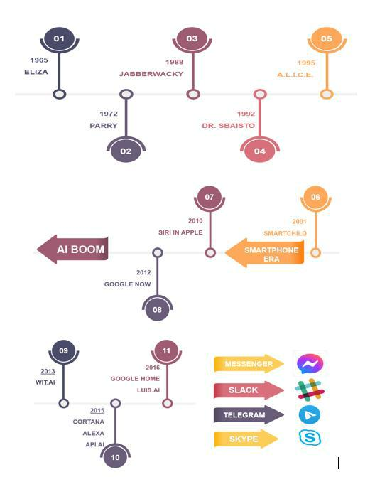

Fig 1. Brief History of CHATBOT [4]

ELIZA, the very first CHATBOT introduce prior to the development of the first personalized computer. In 1966, Joseph Weizenbaum developed ELIZA [6] at the MIT Artificial Intelligence Laboratory (figure 1). According to a defined set of rules, ELIZA processes the keywords received as input and then triggered the output responses. Several CHATBOTs still use this methodology of generating output. After ELIZA, PARRY came relatively soon afterward called “ELIZA with attitude.” Standford University therapist Kenneth Colby process Parry, which stimulates an individual with distrustful paranoid or paranoid schizophrenia. In 1995, ALICE or Alicebot, the inspiration of ELIZA, evolved by Richard Wallace. Although it neglected to breeze through the Turing assessment, ALICE remained one of the most rooted of its kind and honored with the Loebner Prize, an annual AI competition, on several occasions.

**1.2 Design Technique / Procedure**

Any designer generally follows the necessary five steps before designing CHATBOT (figure 2). The first step is to determine the Bot’s purpose (Why do customers need a bot?). After that

designer must decide between a platform based on rules or NLPs. That means after the why, how does it come into play? Rule-based bots have defined decision trees through which they chat. It is similar to step by step diagram or schema chart where the conversation plan predicts what a client might ask and how CHATBOT should respond. Natural language bot (NLPs) can understand the context, even though the questions are more complicated. Because of their ability to learn from their mistakes, they improve their response to the customer’s inquiry. Think of all the different scenarios or tasks that designer want their CHATBOT to do and put together all the related questions in other forms to accomplish these same tasks.

Each task users wish CHATBOT to do will set by an intention [7]. After this designer tests CHATBOT by conversing or text like a human. As a result, every question asked or intended by clients can be expressed in many ways. That depends on the manner in which the user wants wishes to convey. For instance, Alexas, turn off the TV. Alexas, could you please turn off the TV? Why don’t you turn off the TV? A user may use either of these phrases to instruct the Bot to turn off the television. These phrases have the same intention/task of turning off the TV, but they request different expressions /variants [7]. In the next step designer design the flow of conversation. A designer needs to write all the logic to keep the user bound to the flow after acknowledging the user’s goal. For instance, let’s say the organization is building a bot to schedule a medical appointment with the doctor. The Bot asks the user to give their working mobile number, name, and a specialist to whom to consult, and then the Bot shows the open slots and then book the slot by user confirmation through a one-time password through a registered mobile number [7]. The designer has to select a suitable platform for deployment, choosing the right platform where BOT can deploy, such that it is easily accessible for users— for example, WhatsApp, Telegram, Your Website, Facebook Messenger Slack, etc.

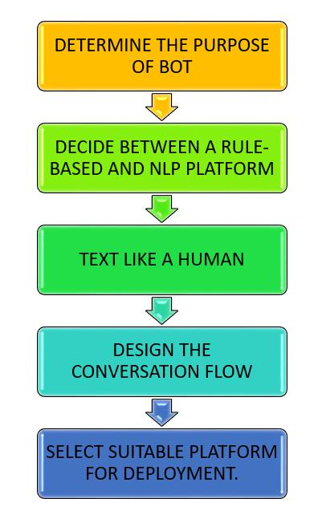

Fig 2. Designing CHATBOT [7].

**2.** **Architecture of Chatbot**

The architecture means working of CHATBOT starting from user requests to the Bot response (figure 3). The Chatbot background process begins with the user’s appeal, for example, “What is PTSD ?” to the BOT deployed to the messenger system app like Facebook, Telegram, WhatsApp, Website, Slack, etc. or to the device using speech as input like Google Assitant, Amazon Alexa, Amazon echo dot. After receiving the user’s request, the Natural Language Understanding (NLUs) component analyzes it or maps it to the user’s intention and, consequently, gathers further related information (intent: “translate,” entities: [word: “PTSD”]). Once a CHATBOT reaches the high-level interpretation or confidence score, it must decide how to further proceed and respond accordingly. It can act directly on new information, recall what it has understood, and wait to see what happens next, require more

contextual information, or seek clarification [8]. For example, “User request to book a Train ticket from Delhi to Mumbai, but to book a ticket other additional information is also required like date of journey, time for the trip. When there is a clear understanding of the request, execution/further action and retrieval of the information occurs. After retrieving the data, BOT intended to perform the requested actions or retrieves the data of interest from its data sources, a BOT Knowledge Base database, or an API call that access external resources [8]. The dialogue Management system keeps the information about all the conversations with the users.

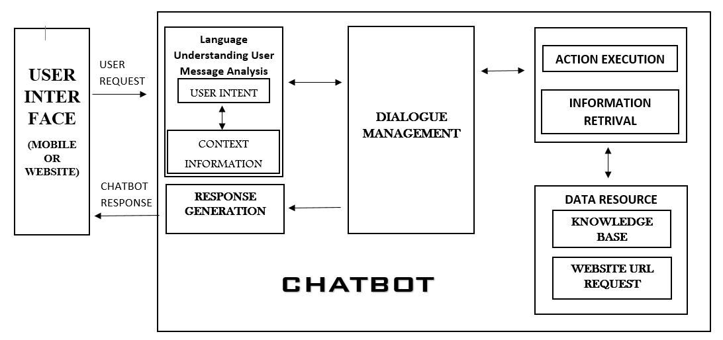

Fig 3 Architecture of CHATBOT

**2.1** **Types of Chatbot**

CHATBOTS can be classed using other variables, such as the interaction level and how responses are generated [9]. A brief schematic classification of CHATBOT is shown in Figure

1. The first type of CHATBOT is a domain of knowledge classified according to the knowledge available to them or the amount of data trained. They are further classified into Open Domain and Closed domain. *Open-domain bots* can address general topics and answer them appropriately. *Closed domain bots* focus on one specific area of knowledge and may not answer other questions. For instance, a flight booking Bot won’t tell you the name of Canada first President. It may tell you a joke or reply the way your day is, but it is not meant to do any other tasks, considering that its job is to book a flight and give the user all the necessary information about the booked flight [9]. The second one is service provided; these Bots are sentimental proximity to the user, how much intimate interaction occurs, and depends on the Bot’s task.

Further classified into Interpersonal, Intrapersonal, and Inter-agent. *Interpersonal bots* are for communication and allow services such as Table booking in Restaurants, Train booking, FAQ bots, etc. These CHATBOTS are supposed to get information and pass it on to the user. These types of BOT can become user-friendly and likely to remember previous information about the user. *Intrapersonal* bots will exist in the user’s personal domain, such as chat applications like Facebook messenger, Telegram, and WhatsApp, and perform tasks under the user’s intimate part. Managing calendar, storing the user’s opinion, etc. They will become the companions of the user and understand the user as a human [9]. *Inter-agent* bots are becoming ubiquitous as all CHATBOTS require opportunities for intercommunication. There is an emerging need for Inter-agent CHATBOT protocols for communication. The Alexa-Cortana integration is one example of an Inter-agent BOT [8].

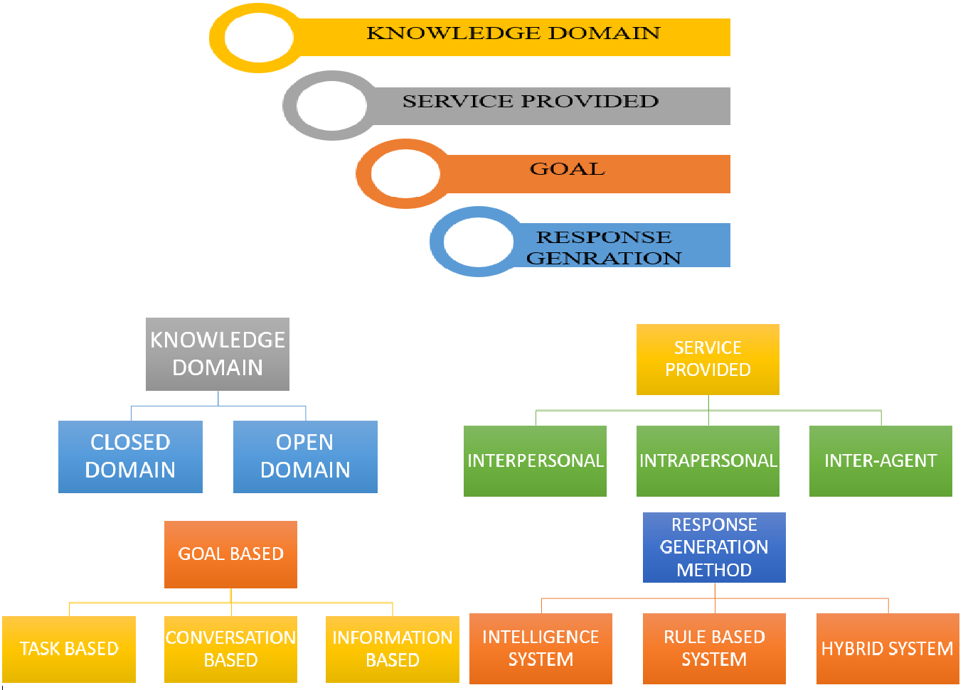

**2.2 Chatbot Engineering and Design Approaches**

To develop a Bot, the developer must be aware of several techniques. Some techniques used to build CHATBOT are shown in Figure 5. The parsing involves input text analysis and uses several NLP functions to manipulate the inputs, such as Python NLTK decision trees [10]. Besides, it includes Dependency Tree, Syntactical Parsing, Parts-of-Speech Tagging, Named Entity Recognition, Entity Parsing, and Topic Modeling [11]. Pattern matching is the technique employed by almost all CHATBOTs. In a question-answering Bot, systems depend on the types of correspondence, such as natural language inputs, simple statements, or domain-specific inquiries. *AIML* Artificial intelligence Mark-up Language, insights from Pattern Matching and Pattern Recognition technique. The stimulus-response approach is to model natural language to understand the human and Bot dialogue system [10]. Chat script comes into play when no matches happen with user input phrase in AIML. It emphasizes the structure best sentence for constructing a sensitive default response. It involves a network of functionalities, for instance, factor ideas, logic, etc. [10], [11].

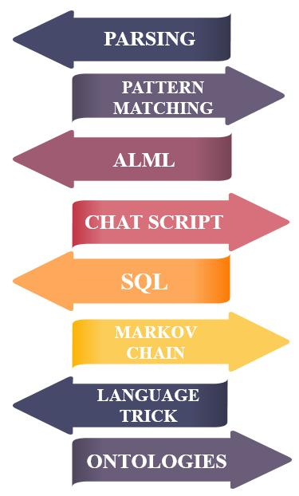

Fig 5 Techniques use in CHATBOT

SQL tool used to memorize earlier conversations for Bot [10]. Markov Chain is used to construct better probabilistic and precise responses. Markov Chains states a fixed probability of every letter or word occurrence in the same textual dataset [10]. Language tricks are a form of phrases and fragments of sentences available for Bot to attach knowledge base such that make that part more convincing. Canned responses are that predetermined answers to some particular questions are known, Typo errors and simulating keystrokes, personal history, and Non-Sequitur are not logical conclusions used as language trick. These linguistic tricks are used to assure user input and provide alternative responses to respective questions [10]. An ontology represents a structural representation of the domain’s entities and relationships between them. It is a treelike arrangement that assembles all entities into one realm, their subclasses, and instances. Additionally, it establishes connections between the tree leaves by specifying one way, two ways, and transient relationships. Moreover, it creates links between the tree leaves by defining unilateral and bilateral pathways and temporary relations.

**2.3 Common Terminologies Used in Chatbot**

Since Dialogflow Essential, IBM Watson, Amazon Lex, ManyChat, etc., provide ML algorithms training, this section addresses how user intentions, entities, & fulfillment are utilized to build and train Bot. Figure 6 shows the common terminologies used in the CHATBOT.

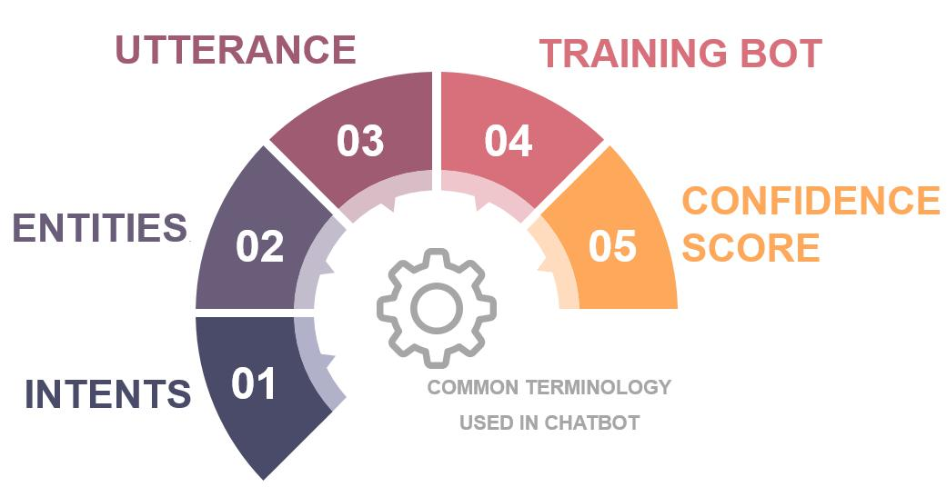

Fig 6 Terminologies used in CHATBOT

Intents are potential user statements that can trigger the user’s purpose [12]. When an end-user connects with BOT, they intend to; use BOT to know the information they want? Suppose an end-user asks Bot to “Book a movie ticket,” in this scenario, if this conversation happens at a theatre, we can understand that the customer wants to book a movie ticket. Now to understand the same for BOT, the designer uses *INTENT* to identify what the user requesting. As a result, “Book a movie ticket” could be named “*book_movie*” intent. Intents are the aim, purpose, goal, motives of the users interacting with the BOT application or web service. Now user’s intention is categorized into two parts [13]: the first user Seeking for Something – for instance, patron purpose of finding the information about train tickets, of seeking weather condition of Toronto for next week, [13] etc. The second one is for taking action, such as booking a table at a food restaurant and booking movie tickets. Entities are modifiers to intents, which are used to add knowledge or information to intent. Bot finds the exact matches for the training phrase of the user input [12]. Suppose two phrases of user input, “Book a movie ticket.” or “Book a flight ticket,” in this intent is “*book”* similarly here *“movie” or “flight”* act as a modifier, hence acts as entities. Designing CHATBOT entities is equally crucial to fed-up on the database concerning intent [13]; if this will not happen, Bot fails miserably if they cannot give required information after identifying user intention.

In simple word, Utterance is the same synonyms but for phrase or sentences; means the exact terms or question asked by different users in different forms. Examples for utterances from different travel-agent are; “Book a flight from London to Paris today,” “ Could you please, book a flight from London to Paris today,” “I want to fly on December 22, 2017, from Mumbai to Hong Kong.” [13]. After feeding intents, entities, the utterance designer must train the Bot to build a model such that it will recognize the existing set of defined intents/entities when new statements are provided. The confidence score is that score that tells how confident or the amount in percentage model is recognizing user intents with the intents exiting into the trained database.

**3.** **Platform to Build Chatbot**

A CHATBOT platform is a program that makes system software by the developer to create and improve Bot. The platform selection depends on a different parameter, such as what type of Bot organization has to develop, whether Bot will be goal-oriented, use for conversation, etc.

1. A conversational-based Bot concentrates on conversing with the user only; it does not rely upon understanding what the user is requesting, and also Bot need not remember the entire or previous conversations. The whole purpose of making this Bot is used for entertainment purposes. While goal-oriented CHATBOT is often used for business, education, FAQ purpose only. This type of Bot helps users achieve the requested tasks such as buying movie tickets, detailed information admission at XYZ college, ordering groceries or pantry. [14].

Platform build to CHATBOT platforms categories into three major categories, as shown in Figure 7.

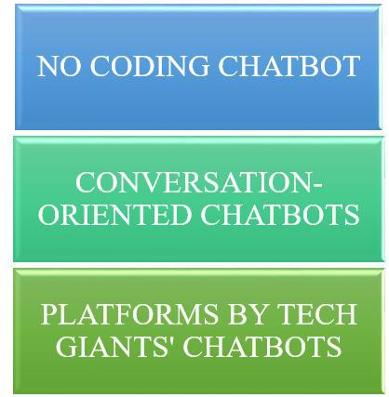

Fig 7. The platform used to build to CHATBOT

No-programming platforms are that platform design by the developer uses to build Bot without any programming language, machine learning algorithm, and natural language processing and understanding skills. These platforms are impeccable for small-scale projects and simple Bot. Codes for these platforms are easy to develop without knowing programming skills, ML algorithm, NLP, and NLU expertise. The widespread example of the non-coding platform is Chatfuel, ManyChat, and Motion.ai [14]. Now come to platforms build by tech giants for CHATBOT since they recognize as a symbol of standard. These platforms are robust in nature; significant memory and a learning curve are also significantly elevated. These are commonly used to build complex BOTs which involves a design conversation flow means flowchart though they have to consider that Bot should never misunderstand user requests or it should be rare. Commonly used tech giants platforms such as Google develop Dialogflow Essential, Dialogflow CX, Facebook generates Wit.ai, Microsoft develops LUIS, Amazon develops Lex, and IBM develops Watson from this they are easy to deploy [15] to the Application, website, Telegram, etc.

GOOGLE DIALOGFLOW (Figure 8) allows users to use a new methodology to unite with their product by building CHATBOT by involving text, speech, or voice conversation in the interfaces. For example, the voice recognition technology deployed CHATBOTs; for instance, Amazon echoes dot. GOOGLE DIALOGFLOW allows its users to connect or deploy on the organization’s website, mobile application, Google Assistant, Amazon Alexa, Facebook Messenger, and other popular platforms. CHATBOT builds using Google Dialogflow, for example: Developing English Conversation CHATBOT Using Dialogflow [16], CHATBOT

Utilization for Medical Consultant System, MedBot [17], and Jamura: A Conversational Smart Home Assistant [18], Development of the CHATBOT Einstein Application as a Virtual Teacher of Physical Learning [19], Developing the CHATBOT Speech-to-Text interface based through Google API [20].

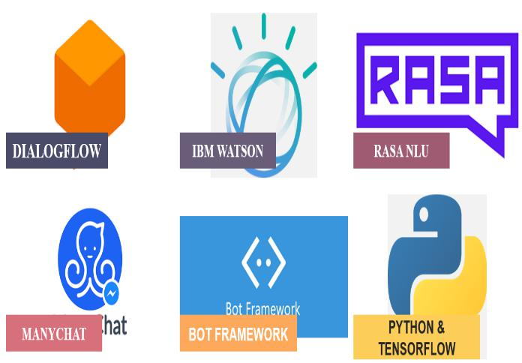

Fig 8. Various Tech-giant platform to Build CHATBOT

IBM WATSON (Figure 8) has a service, IBM Assistant, that lets designers develop, train, test, and deploy on the web server, application, devices. CHATBOTs are built to mimic human interactions, such that conversations between Bot and customer should like conversing between two humans. Watson Assistant can search for an answer from a knowledge base, ask for clarification for the question requested, and direct users to a human if the Bot cannot solve the user’s queries. CHATBOT builds using IBM Watson, for instance, A Voice Interactive, Multilingual Student Assistance System, based on IBM Watson [21], Implementation of CHATBOT for ITSM Application based on IBM Watson [22], Smart Assistance supporting Students and Staff Living in a Campus [23].

RASA NLU (Figure 8) ***is*** an open-source NLP library for identifying the intent and extraction of entities in CHATBOTs. It helps the designer to create and write customization NLP for CHATBOTs. In RASA Conversational, the designer has to deal with two components: Rasa NLU and Rasa Core. Rasa NLU is likely to be ear, taking inputs from the requested user, and Rasa Core is expected to be the brain, making decisions or giving response for user input. [24]. Rasa NLU is not the only library having a bunch of algorithms to achieve what designers want. RASA can develop almost all kinds of CHATBOT that designers imagine and users requiring from the organization. CHATBOT builds using RASA NLU, for example, FLOSS FAQ CHATBOT project reuse [25], Self-Learning Chabot from User Interactions and Preferences [26].

MANYCHAT (Figure 8) is a web service that allows the designer to make CHATBOTs, especially Facebook Messenger. The designer can use this platform to build various purposes, like marketing the product and customer care. The key point of this platform is its simplicity in use. ManyChat claims that customers can use these platforms to set up a CHATBOT in about two minutes, free of coding, does not have to be an expert in any programming language. This enables the designer to make Bot even more targeted broadcasts by deploying onto the Facebook Messenger system. CHATBOT builds using

ManyChat, for example: Improve the Security of Social Media Accounts [27], CHATBOT for Institutional purpose [28].

MICROSOFT BOT FRAMEWORK (Figure 8) is a sophisticated framework for building CHATBOTs. It’s compelling when combined with other Microsoft tools and services, such as an Azure Bot Service, Cognitive Services, and Bot Builder. From basic CHATBOTs to intelligent virtual assistants, customers can build pretty much anything with Microsoft Bot Framework. Like several other big tech companies, Microsoft offers a comprehensive bot development framework and additional services that streamline the creation of full - featured CHATBOT. CHATBOT builds using Microsoft Bot Framework, for example, Understanding CHATBOT-mediated Task Management [29].

In PYTHON (Figure 8), ChatterBot is a library enable the automated response to user’s request. ChatterBot library has diverse Data Structures and Algorithms for machine learning algorithms to create varied types of responses. It also adds human-like interaction [30]. CHATBOT builds using Microsoft Bot Framework, for example, Charlie: CHATBOT in Python [31].

TensorFlow is an open-source library of free software for machine learning. This platform utilized amongst various tasks and mainly focuses on training using deep neural networks. TF Basically a math library consisting of dataflow and differentiable programming. It has an extensively flexible system of tools, sub-libraries, resources that led the designer to quickly build and deploy ML-powered applications. CHATBOT makes using Tensorflow; for example, CHATBOT using TensorFlow for small Businesses [32].

**4.** **Advancement in Chatbot and Filed Chatbot Used**

There is the various domain in which Chatbot is used such as Customer service, Feedback, Education, Business, Railway, etc. Some of the most common examples are:

HUMAN-TYPE ACADEMIC INTERACTIVE ROBOT BASED ON ARTIFICIAL INTELLIGENCE AND THE WEB (UNIBOT) [33]. Generally, when students have to admission to any college, they have to visit universities or colleges to gather various information like Tuition Fees, Hostel Fee, Library, Term Schedule, etc. It is a time-consuming process, which requires human presence to give a visit to collect the required information. As a result, CHATBOT has been developed. This project aims to interact between users and Academic CHATBOT, accessed from anywhere, anytime. The CHATBOT can be easily integrated with a university or college website with few simple language conversions.

MARKETING THROUGH ARTIFICIAL INTELLIGENCE CHATBOTS [34]. Using AI in the marketing team’s field to create highly personalized human touch experiences costs less than expensive, compared to traditional marketing pamphlets, newspaper articles, and campaigns. Artificial intelligence has transitioned from a science fiction concept to today’s real technology. Using AI in industries and marking organizations can produce more consumer-orient products, consumer-oriented services, accurate target market, and audience results in a higher conversion rate and fully meet their customers’ needs.

CSIEC: A COMPUTER ASSISTED ENGLISH LEARNING CHATBOT BASED ON TEXTUAL KNOWLEDGE AND REASONING [35]. English is a very well-known international language key tool for developing and for cross-cultural communication ability. In China, the English language is now listed as one of the three core courses in elementary and secondary education and a compulsory course in higher education. To make more awareness

amongst students, Computer Simulation in Educational Communication (CSIEC) system with English instruction functions acts virtual chatting partner (CHATBOT), which chat in English with the English learner’s students anytime, anywhere. According to the user, input knowledge such as dialogue, personality, experience, common sense, and inference knowledge generate a communicative response with the learner.

DEVELOPMENT OF A CHATBOT FOR THE COLLEGE CURRICULUM COUNCIL [36]. Elective courses’ selection is challenging for students to make decisions considering their very interests, class schedule, syllabi to study, difficulty level, and help after graduation plans. Generally, having conversations with academic officials and peers seeks to get official and informal information, rearrange priorities, and compromise the decision. EASElective is AI Bot designed where existing educational advising services uploaded and set up an online natural language interactive interface that will support a conversation with officials to provide course data to informal students’ opinions.

TELEGRAM CHATBOT FOR SMART WORKSPACE BASED IOT WITH ARTIFICIAL INTELLIGENCE [37]. The concept of IoT (Internet of things) allows us to take advantage of internet connectivity continuously. IoT has abilities that include sharing data, remote control, and controlling several electronic devices on the workspace through the internet, such as a lamp, fan, AC, washing machine, electrical outlet, and temperature check. This research was carried out using ESP 8266 remote control devices to access local control using Artificial Intelligence CHATBOT by using Telegram Messenger. This made it easier for employees to control several electronic devices on their respective workspace through smartphones or PCs without manually switching ON or OFF and going back to the office to turn off or turn on the lights. As a result, this workspace is called Smart Workspace.

INTELLIBOT: A DIALOGUE-BASED CHATBOT FOR THE INSURANCE INDUSTRY

1. CHATBOT is now being used in various businesses to provide their customers with a virtual assistant to answer their requested questions. Using AI Bot, companies can develop an improvised way to connect with their retail and corporate customers and increasing customer satisfaction. For customers, the organization provides a better and convenient way of conversing with company peoples without waiting on the phone or sending many emails. In countries such as South Korea, China, Japan, Singapore, India, and the USA, CHATBOTs is the customers’ preferred platform for communication with a business.

MULTILINGUAL CHATBOT WITH HUMAN CONVERSATIONAL ABILITY [39]. Most of the CHATBOTs support the English language only, and very few have the skill to communicate in multiple languages. So designers come up with the idea of developing CHATBOT that can speak or talk in many languages as google translator. Aim to create virtual assistants that converse more like human to human rather than human to the Bot and communicate in multiple languages. As technology develops, new approaches come into the market to build various types of Chatbot. There are various new services [40] to add to CHATBOT to make it interesting, such as Deploy CHATBOT in Google Assistant, Alexa. Make a 3D avatar CHATBOT and publish it on the website using Amazon Sumerian. Design of CHATBOT with 3D Avatar, Voice Interface, and Facial Expression [41].

3D CHATBOT IN HIGHER EDUCATION, HELPING STUDENTS WITH PROCRASTINATION AND STUDY PLANNING PROBLEMS [42]. The bachelor’s degree (Digital Arts and Entertainment) has many motivated and passionate students. Though the task is high in colleges, it becomes difficult for all students to meet all the curriculum requirements and maintain a balanced healthy work/life. The study program is open to all students, and, as a

publicly funded institute, the organization often does not care to monitor students and help them achieve their objectives. As a result, the organization comes up with the idea of developing a 3D CHATBOT that helps students and acts as a coach. Learning management integrate virtual 3-D avatar to their web services. It utilizes cognitive therapy elements to help students overcome typical problems that afflict our students, procrastination, lack of study planning, and communication problems (with peers and staff). This CHATBOT is so smart to make enough decisions and forward students to the correct persons if the system cannot determine the proper course of action.

After Deployment Learning from Diaglogue: Feed Yourself, CHATBOT [43].

**5.** **Conclusions**

In this paper, a review of a new learning-cum assistance tool, i.e., CHATBOT, is introduced. The CHATBOT utilizes the concepts of Artificial Intelligence and Machine Learning to interact with people virtually. Firstly, the development history is reviewed, followed by an explanation of the architecture, and different CHATBOT classifications according to their utility are presented. After that, various design techniques and approaches and varying platforms of build Bot are reviewed, followed by the advancement in CHATBOT is presented. Real-life practical examples and application of CHATBOT are also presented. This review proposed that CHATBOT can be very well utilized for Computer Aided Design (CAD) software applications, which can overcome the difficulty faced in procedural-based knowledge method. Since Artificial Intelligence concepts are used in CHATBOT, it can give the best alternative way to solve the same CAD problem.