PROJECT DOCUMENTATION
Fraud Detection & Streaming Analytics
Using Python, MySQL and Power BI
Submitted by
V. Sibi Manikandan

MYFCS Institution
Under the guidance of Arunagiri
October 2026
ACKNOWLEDGEMENT
I would like to express my sincere gratitude to MYFCS for allocating this project as part of the Data Analytics course, and to my project guide and the faculty members for their guidance, encouragement and valuable suggestions throughout the course of this project.

I also thank my family and friends for their constant support, and the open-source community behind Python, Pandas, MySQL and Power BI, whose tools made this work possible.

Yours faithfully,
V. Sibi Manikandan

TABLE OF CONTENTS
1. Abstract 4
2. Introduction 5
2.1 Background 5
2.2 Problem Statement 5
2.3 Objectives 5
2.4 Scope 6
3. System Requirements 7
3.1 Software Requirements 7
3.2 Hardware Requirements 7
4. Dataset Description 8
5. System Design and Methodology 9
5.1 Overall Workflow 9
5.2 Data Cleaning and Preparation 10
5.3 Exploratory Data Analysis 11
6. MySQL Database and SQL Analysis 12
6.1 Database and Table Creation 12
6.2 Analytical Queries 13
6.3 Validation 13
7. Rule-Based Fraud Detection 14
7.1 Detection Rules 14
7.2 Evaluation Metrics 15
7.3 Results 16
7.4 Discussion 16
8. Streaming Analytics (Batch Simulation) 17
9. Power BI Dashboard 18
9.1 Connecting Power BI to the Data 18
9.2 Fraud Detection Overview 19
9.3 Fraud Rule Analysis 19
9.4 Streaming Analytics 20
10. Testing and Validation 21
11. Limitations 21
12. Future Enhancements 22
13. Key Learning Outcomes 22
14. Conclusion 23
15. References 23

1. Abstract
Credit card fraud causes significant financial loss, and detecting it early requires careful analysis of large volumes of transaction data. This project, Fraud Detection & Streaming Analytics, analyses credit card transactions to identify potentially fraudulent activity using Python, MySQL and Power BI.
The project covers data cleaning, exploratory analysis, SQL-based validation, rule-based fraud detection using transaction amount thresholds, and a simulated batch-processing workflow that imitates incremental (streaming-style) processing. Detection performance is evaluated against the dataset's actual fraud labels using a confusion matrix, precision, recall, false positives and false negatives. An interactive Power BI dashboard presents fraud patterns, rule performance, and batch-processing results.
The thresholds used are experimental rules intended for learning and portfolio demonstration. They are not a production-ready fraud detection model, and the streaming component is a simulation rather than a live pipeline.

2. Introduction

2.1 Background
Digital payments have grown rapidly, and with them the number of fraudulent transactions. Fraudulent transactions are usually a very small share of all transactions, which makes them hard to find using simple inspection. Analysts therefore combine data cleaning, database queries, rules and dashboards to understand fraud patterns and monitor suspicious activity.

2.2 Problem Statement
Given a set of credit card transactions labelled as legitimate or fraudulent, the problem is to prepare the data, analyse how the two groups differ, flag suspicious transactions using simple amount-based rules, measure how well those rules perform, and present the findings in an interactive dashboard.

2.3 Objectives
- Clean and prepare transaction data for reliable analysis.
- Analyse legitimate and fraudulent transactions using Python and SQL.
- Implement rule-based fraud detection using transaction amount thresholds.
- Simulate streaming analytics through batch-wise transaction processing.
- Evaluate detection performance and identify the limitations of simple threshold-based rules.
- Build interactive Power BI dashboards for data visualisation and reporting.

2.4 Scope
This project was allocated by MYFCS as part of the Data Analytics course. The project works on a historical transaction dataset. It demonstrates the fundamentals of rule-based detection and incremental processing. It does not train a machine learning model and does not connect to a live payment stream.

3. System Requirements

3.1 Software Requirements
Table 1: Technology stack
Tool | Purpose
Python | Data cleaning, exploratory data analysis, rule implementation, batch simulation
Pandas | Data manipulation and analysis
MySQL | Transaction storage, querying and analytical validation
SQL | Aggregations, fraud analysis and validation queries
Power BI | Interactive dashboards, KPIs and visual reporting
Jupyter Notebook | Development, experimentation and documentation

3.2 Hardware Requirements
A standard laptop or desktop is sufficient. Typical configuration:
- Processor: Intel Core i3 or higher (or equivalent)
- RAM: 8 GB recommended
- Operating System: Windows 10 / 11 (Power BI Desktop requires Windows)
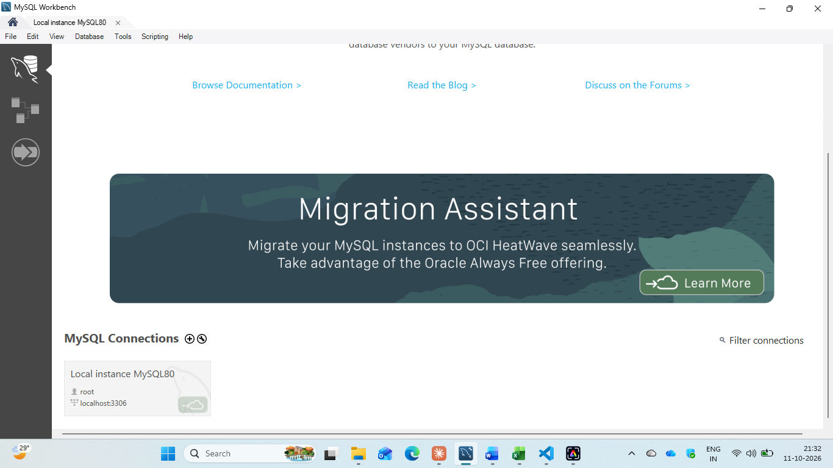

4. Dataset Description
The project uses a credit card transaction dataset in which every transaction carries an actual fraud label. Fields used in the analysis include the transaction time, the transaction amount and the fraud label (fraudulent or legitimate). The label is used only for evaluating the rules, not for flagging.
- Total transactions: 284,808
- Fraudulent: 492
- Legitimate: 284,316
- Fraud percentage: 0.17%
Key fields
Field | Description
Time | Time of the transaction
Amount | Transaction amount
Class / label | Actual fraud label (1 = fraud, 0 = legitimate)
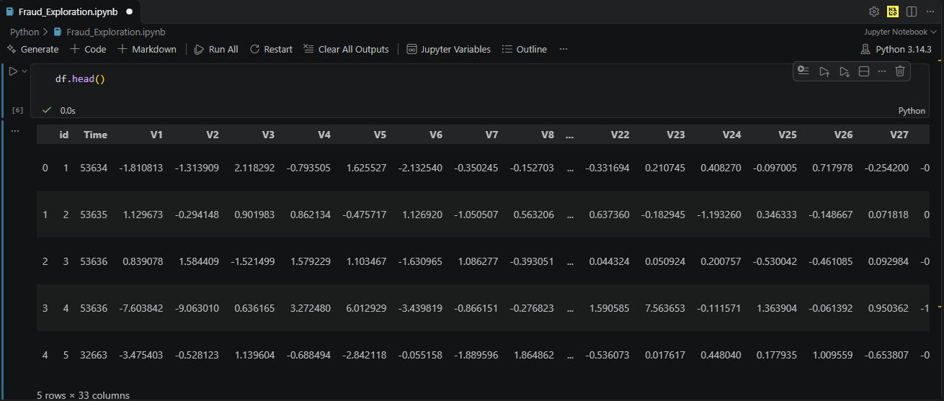
Dataset preview

5. System Design and Methodology

5.1 Overall Workflow
- Load the raw transaction data into Python using Pandas.
- Clean and prepare the data (missing values, duplicates, data types).
- Perform exploratory data analysis on legitimate versus fraudulent transactions.
- Load the cleaned data into MySQL and run analytical and validation queries.
- Apply the rule-based fraud detection thresholds.
- Evaluate the flags against actual labels using a confusion matrix.
- Simulate streaming by processing transactions in small batches.
- Visualise the results in a Power BI dashboard.

Fraud-Detection-Streaming-Analytics/
├── dashboard/
│ ├── Fraud_Detection_Dashboard.pbix
│ ├── screenshots/
│ ├── dashboard_guide.md
│ └── data_dictionary.md
├── docs/
├── reports/
├── sql/
├── dataset/
├── Fraud_Detection_Streaming_Analytics.ipynb
├── README.md
├── requirements.txt
└── .gitignore
Project architecture / workflow diagram

5.2 Data Cleaning and Preparation
Reliable analysis depends on clean data. The cleaning stage checks for missing values, removes duplicate records, confirms that each column has a suitable data type, and verifies that the amount and label columns contain valid values.
import pandas as pd

df = pd.read_csv('transactions.csv') # use your file name
print(df.shape)
print(df.isnull().sum())

df = df.drop_duplicates()
df = df.dropna(subset=['Amount', 'Class'])
df['Class'] = df['Class'].astype(int)

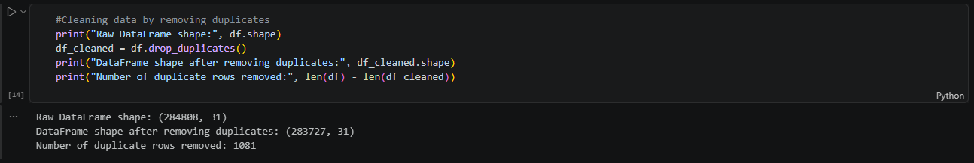
Data cleaning output

5.3 Exploratory Data Analysis
Exploratory analysis compares legitimate and fraudulent transactions: how many of each exist, how their amounts are distributed, and how they vary over time.
print(df['Class'].value_counts())
print(df.groupby('Class')['Amount'].describe())

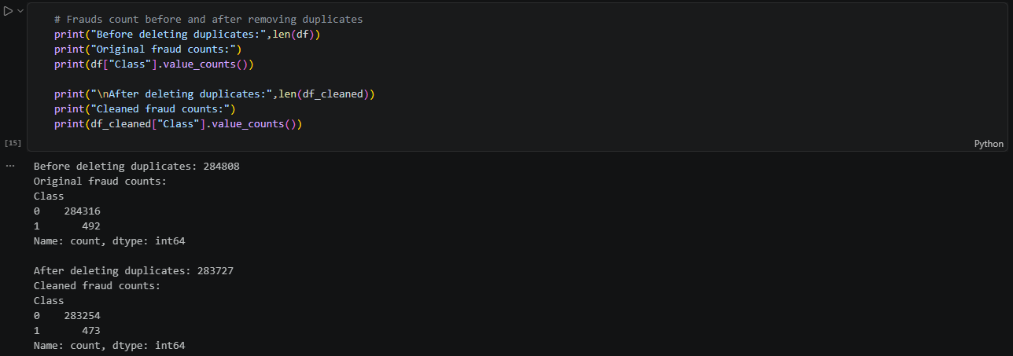
Exploratory analysis output
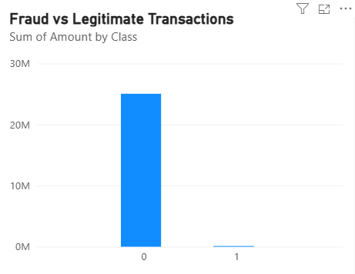
Amount distribution chart

6. MySQL Database and SQL Analysis
SQL queries are used to aggregate the data and to validate that the numbers produced in Python match those in the database.

6.1 Database and Table Creation
CREATE DATABASE fraud_detection;
USE fraud_detection;
SHOW tables;

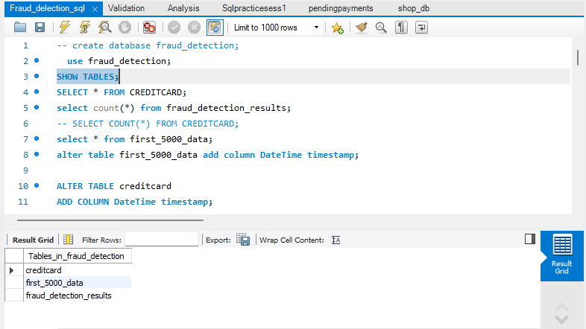
MySQL database and table

6.2 Analytical Queries
-- Total, fraudulent and legitimate transactions
SELECT class, COUNT(*) AS total_transactions
FROM transactions
GROUP BY class;

-- Amount statistics by class
SELECT class,
AVG(amount) AS avg_amount,
MAX(amount) AS max_amount,
SUM(amount) AS total_amount
FROM transactions
GROUP BY class;

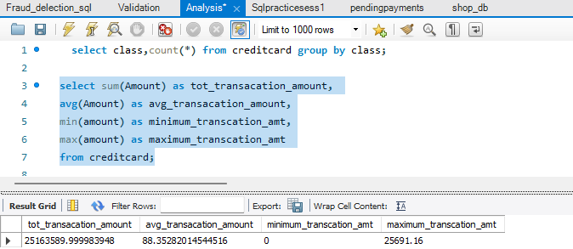
SQL query results

6.3 Validation
The counts and totals returned by SQL are compared with the figures from Python to confirm that the data was loaded without loss or change.
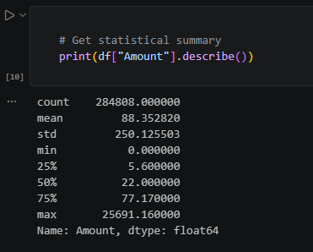
Python versus SQL validation

7. Rule-Based Fraud Detection

7.1 Detection Rules
Two experimental amount thresholds are used to flag a transaction as suspicious:
Table 3: Fraud detection rules
Rule | Condition
Rule 1 | Flag the transaction if Amount > 100
Rule 2 | Flag the transaction if Amount > 1,000

The flags are then compared with the dataset's actual fraud labels. These thresholds are experimental and are not a production-ready fraud model.
df['flag_100'] = (df['Amount'] > 100).astype(int)
df['flag_1000'] = (df['Amount'] > 1000).astype(int)

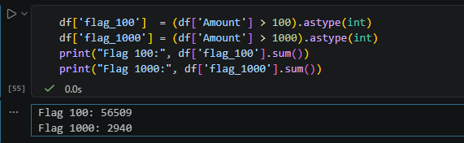
Rule implementation output

7.2 Evaluation Metrics
Evaluation terms
Term | Meaning
True Positive (TP) | Fraudulent transaction correctly flagged
False Positive (FP) | Legitimate transaction wrongly flagged
False Negative (FN) | Fraudulent transaction missed (not flagged)
True Negative (TN) | Legitimate transaction correctly not flagged
Precision | TP / (TP + FP): share of flagged transactions that are truly fraud
Recall | TP / (TP + FN): share of actual fraud that was caught

from sklearn.metrics import precision_score, recall_score

y_actual = df_cleaned["Class"]
y_predicted_100 = df_cleaned["rule_flag_100"]

precision_100 = precision_score(y_actual, y_predicted_100)
recall_100 = recall_score(y_actual, y_predicted_100)

print("Precision:", round(precision_100 * 100, 2), "%")
print("Recall:", round(recall_100 * 100, 2), "%")
Confusion matrix and metrics output
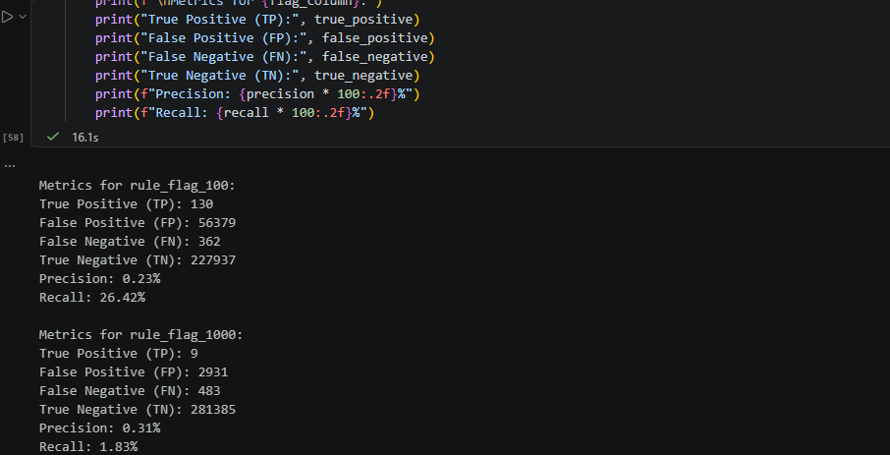

7.3 Results
Rule performance comparison
Metric | Amount > 100 | Amount > 1,000
Transactions flagged | 56509 | 2940
True Positives | 130 | 9
False Positives | 56379 | 2931
False Negatives | 362 | 483
True Negatives | 227937 | 281385
Precision | 0.23% | 0.31%
Recall | 26.42% | 1.83%

7.4 Discussion
A lower threshold usually catches more fraud (higher recall) but flags many legitimate transactions (more false positives, lower precision). A higher threshold flags fewer legitimate transactions but misses more fraud (more false negatives). This trade-off shows the main weakness of single-feature rules: fraud is not always a large-amount event, and many large transactions are legitimate.
Recall: Amount > 100 is better. It catches 26.42% of fraud (130 of 492 cases), against only 1.83% (9 cases) for Amount > 1,000.
Precision: Amount > 1,000 is slightly better, at 0.31% against 0.23%. That gap is tiny, and both values are very low. Nearly everything either rule flags is legitimate.

8. Streaming Analytics (Batch Simulation)
To demonstrate the fundamentals of incremental processing, transactions are processed in small batches. For each batch, the process tracks the number of transactions processed, the number flagged, and the number not flagged. This is a simulation of streaming; it does not represent a live production pipeline.
batch_size = 5000

total_processed = 0
total_flagged = 0

for start in range(0, len(df_cleaned), batch_size):
batch = df_cleaned.iloc[start:start + batch_size].copy()
batch["rule_flag"] = (batch["Amount"] > 100).astype(int)
total_processed += len(batch)
total_flagged += batch["rule_flag"].sum()
print(f"Batch processed: {total_processed}")
print(f"Transactions flagged: {total_flagged}")

print("--- Full Dataset Streaming Summary ---")
print("Total transactions processed:", total_processed)
print("Total transactions flagged:", total_flagged)
print("Total transactions not flagged:", total_processed - total_flagged)

OUTPUT:
Batch processed: 5000
Transactions flagged: 1000
…………………….
Batch processed: 284808
Transactions flagged: 56509
--- Full Dataset Streaming Summary ---
Total transactions processed: 284808
Total transactions flagged: 56509
Total transactions not flagged: 228299

9. Power BI Dashboard
The Power BI dashboard turns the analysis into an interactive report. It provides insights into overall transaction and fraud statistics, fraud detection rule performance, transaction amount and time-based patterns, flagged versus unflagged transactions, and the simulated batch-processing results.

9.1 Connecting Power BI to the Data
The data is loaded into Power BI from the MySQL database (or the exported CSV files from Python), and relationships and measures are prepared for the visuals.
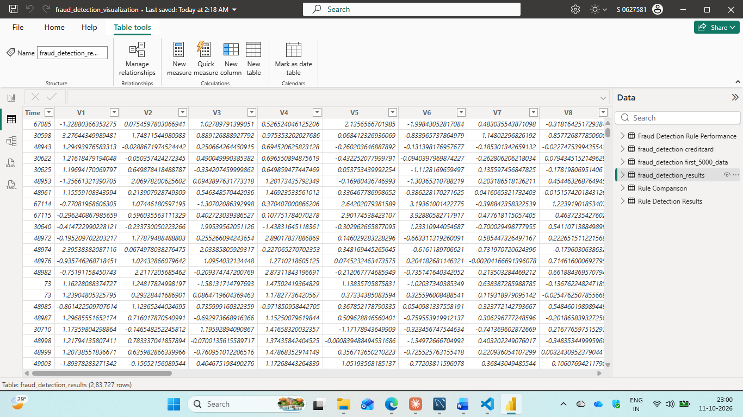
Power BI data connection / model

9.2 Fraud Detection Overview
Summarises overall transaction counts, fraud counts, and key KPIs.
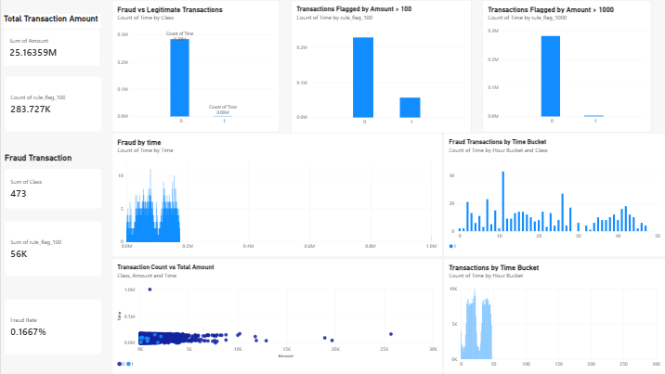
Fraud Detection Overview

9.3 Fraud Rule Analysis
This page shows how the Amount > 100 and Amount > 1,000 rules performed, including flagged and missed fraud and the false-positive trade-off. 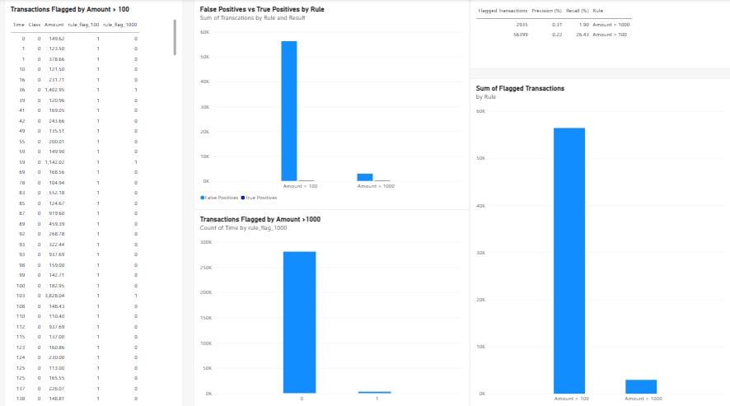

Fraud Rule Analysis

9.4 Streaming Analytics
This page shows the batch-wise results: transactions processed, flagged and not flagged per batch.
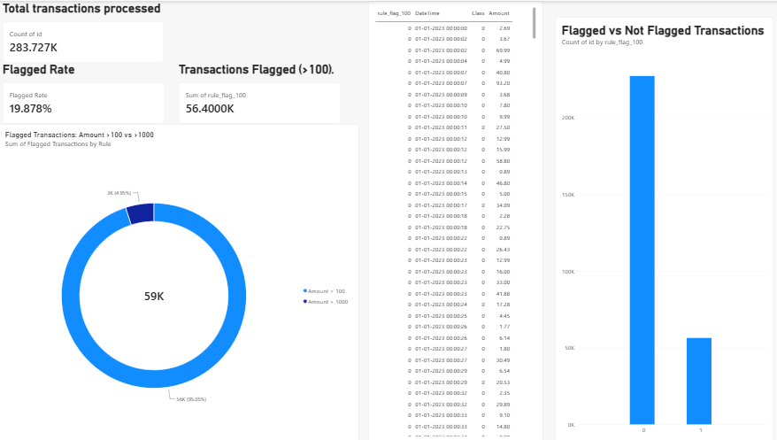
Streaming Analytics

10. Testing and Validation
Test cases
No. | Test | Expected result | Status
1 | Data loads without errors | All rows loaded into DataFrame | Pass
2 | Missing values and duplicates removed | No nulls or duplicates remain | Pass
3 | Python counts match SQL counts | Fraud and legitimate counts are equal | Pass
4 | Amount > 100 rule flags correctly | Only amounts above 100 are flagged | Pass
5 | Amount > 1,000 rule flags correctly | Only amounts above 1,000 are flagged | Pass
6 | Batch totals add up | Sum of batch counts equals total rows | Pass
7 | Dashboard figures match notebook | KPIs match Python / SQL results | Pass

11.Limitation
- The detection logic is rule-based and may generate false positives or miss fraudulent transactions.
- The streaming component is simulated using batches and does not represent a live production pipeline.
- A single feature (transaction amount) is used, so fraud patterns involving other behaviour are not captured.
- The project is intended for learning and portfolio demonstration, not for production use.

12. Future Enhancements
- Train machine learning models (for example logistic regression or random forest) and compare them with the rules.
- Handle class imbalance using techniques such as resampling or class weights.
- Combine several features (time, amount, frequency) into richer rules or models.
- Replace the batch simulation with a real streaming tool such as Apache Kafka or Spark Structured Streaming.
- Add automated alerts and scheduled dashboard refresh.

13. Key Learning Outcomes
- Practical data cleaning and exploratory analysis.
- SQL integration and transaction analysis.
- Rule-based classification and confusion matrix evaluation.
- Understanding precision, recall and false-positive trade-offs.
- Batch processing and dashboard development.
- Communicating analytical findings through visualisations.

14. Conclusion
The Fraud Detection & Streaming Analytics project shows how transaction data can be cleaned, analysed, checked with SQL, screened with simple rules, evaluated with standard metrics, and presented in an interactive dashboard. The experiments highlight the trade-off between catching more fraud and raising more false alarms, and they show why simple threshold rules are only a starting point. The batch simulation introduces the idea of incremental processing, and the Power BI dashboard makes the findings easy to communicate.

15. References
- Python Software Foundation. Python Documentation. https://docs.python.org
- Pandas Development Team. Pandas Documentation. https://pandas.pydata.org/docs
- Oracle Corporation. MySQL Reference Manual. https://dev.mysql.com/doc
- Microsoft. Power BI Documentation. https://learn.microsoft.com/power-bi
- scikit-learn. Model evaluation: confusion matrix, precision and recall. https://scikit-learn.org
- Dataset source.
https://www.kaggle.com/datasets/mlg-ulb/creditcardfraud

