KCS KASI NADAR COLLEGE
Department of Computer Science & Information Technology

MINI PROJECT DOCUMENTATION

Network Packet Log Analytics
& Visualization

Tools & Technologies Used
Python 3.14 • MySQL Workbench • Power BI Desktop • Microsoft Excel

Academic Year: 2025 – 2026

CHAPTER 1: INTRODUCTION

1.1 Overview
The Network Packet Log Analytics & Visualization project is a data analytics mini-project designed to collect, process, analyse, and visualize network packet log data. Network packet logs record every communication event across a network, capturing source and destination IP addresses, protocols used, data volumes, and transmission durations. Analysing this data is essential for understanding network behaviour, detecting anomalies, and optimizing performance.

This project integrates multiple industry-standard tools: Python for exploratory data analysis (EDA) and data cleaning, MySQL Workbench for structured querying and data quality validation, Power BI Desktop for interactive visual dashboards, and Microsoft Excel for raw data storage and initial inspection.

1.2 Objectives
The primary objectives of this project are:
- To load, inspect, and clean a real-world network packet log dataset using Python (Pandas and Matplotlib).
- To import the cleaned dataset into MySQL and perform structured SQL queries for data validation and analysis.
- To create an interactive Power BI dashboard visualizing key traffic patterns, protocol distributions, and data transfer metrics.
- To document key findings and insights derived from the data for network performance assessment.

1.3 Scope
The project covers a dataset of 10,000 network packet log records, each containing ten attributes: timestamp, source IP, destination IP, source port, destination port, protocol, packet count, total bytes, duration in seconds, and bytes per second. The analysis spans protocol distribution, data transfer intensity, null value detection, and traffic pattern visualization.

1.4 Project Information

Project Title | Network Packet Log Analytics & Visualization
Institution | KCS Kasi Nadar College
Department | Computer Science & Information Technology
Academic Year | 2025 – 2026
Tools Used | Python 3.14, MySQL Workbench, Power BI Desktop, MS Excel
Dataset | network_packet_logs.xlsx / .csv (10,000 records, 10 columns)
Project Type | Mini Project – Data Analytics

CHAPTER 2: SYSTEM ANALYSIS

2.1 Problem Statement
Modern networks generate enormous volumes of packet log data every second. Without systematic analysis, detecting abnormal traffic, identifying high-bandwidth consumers, or understanding protocol usage patterns becomes impractical. Manual inspection of thousands of log entries is error-prone and time-consuming. This project addresses the need for an automated, multi-tool analytical pipeline that can efficiently process, query, and visualize network log data to produce actionable insights.

2.2 Existing System
In conventional network monitoring setups, administrators rely on raw log files or simple spreadsheet views to inspect traffic. These approaches lack advanced querying capabilities, do not provide interactive visualizations, and are ill-suited for datasets exceeding a few hundred records. Most existing lightweight tools do not combine programmatic cleaning, SQL-based validation, and BI-level dashboarding in a single workflow.

2.3 Proposed System
The proposed system introduces a three-stage analytics pipeline:
- Stage 1 – Python EDA: Load the dataset via Pandas, detect and handle null values, remove duplicates, and generate a protocol distribution bar chart using Matplotlib.
- Stage 2 – MySQL Analysis: Import the cleaned data into a MySQL database (anbudb), run NULL-check queries, sort records by total bytes transferred, and verify data integrity through structured SQL statements.
- Stage 3 – Power BI Visualization: Connect Power BI Desktop to the MySQL datasource, build donut/pie charts for protocol share, scatter plots for packet count vs. duration, and bar charts for top destination IP addresses.

2.4 Feasibility Study
2.4.1 Technical Feasibility
All tools used — Python, MySQL Workbench, and Power BI Desktop — are freely available and well-documented. The dataset size (10,000 records, ~1 MB in Excel format) is well within the processing capacity of these tools on standard hardware.

2.4.2 Operational Feasibility
The workflow is straightforward and can be reproduced by any analyst with basic knowledge of Python, SQL, and Power BI. The scripts are short and well-commented, reducing the operational learning curve.

2.4.3 Economic Feasibility
The project uses entirely open-source or freely licensed software (Python, MySQL Community Edition, Power BI Desktop Free tier), resulting in zero licensing cost.

CHAPTER 3: SYSTEM DESIGN

3.1 System Architecture
The system follows a linear data pipeline architecture. Raw data originates from the Excel file (network_packet_logs.xlsx). It is ingested by the Python script for cleaning and EDA. The clean CSV is then imported into MySQL Workbench for structured querying. Finally, Power BI connects to MySQL to render interactive dashboards.

[ Excel Dataset ] → [ Python EDA ] → [ MySQL Workbench ] → [ Power BI Dashboard ]

3.2 Dataset Structure
The dataset network_packet_logs contains 10,000 rows and the following 10 columns:

Column Name | Data Type | Description
timestamp | Time | Time of packet capture (HH:MM:SS)
src_ip | VARCHAR | Source IP address of the packet
dst_ip | VARCHAR | Destination IP address of the packet
src_port | INT | Source port number
dst_port | INT | Destination port number
protocol | VARCHAR | Network protocol: TCP, UDP, or ICMP
packet_count | INT | Number of packets in the connection
total_bytes | INT | Total bytes transferred
duration_seconds | FLOAT | Duration of the connection in seconds
bytes_per_second | FLOAT | Transfer speed (bytes per second)

CHAPTER 4: IMPLEMENTATION

4.1 Module 1 – Python Exploratory Data Analysis
4.1.1 Script Overview
The Python script network_dataset.py performs the initial exploratory data analysis on the network packet log dataset. It uses the Pandas library for data manipulation and Matplotlib for visualization. The script is executed in Python 3.14 and reads the dataset from a local CSV file path.

4.1.2 Script Code
File: network dataset.py
import pandas as pd
import matplotlib.pyplot as plt
file_path = r"C:\Users\acer\Desktop\NM\network_packet_logs.csv"
df = pd.read_csv(file_path)
print(df.columns) # Show columns
print(df.isnull().sum()) # Check null values
df = df.fillna(0).drop_duplicates()
protocol_count = df['protocol'].value_counts()
protocol_count.plot(kind='bar'); plt.show()

4.1.3 Key Findings from Python EDA
- Dataset loaded with 10,000 records and 10 columns.
- Zero null values detected across all columns — dataset is clean and production-ready.
- No duplicate records found after applying drop_duplicates().
- Protocol distribution: ICMP (3,353), TCP (3,343), UDP (3,304) — nearly equal shares.

4.2 Module 2 – MySQL Workbench Analysis
4.2.1 Database Setup
The cleaned dataset was imported into MySQL Workbench under the database anbudb as the table network_packet_logs. SQL queries were executed to validate data integrity and extract analytical insights.

4.2.2 Screenshot 1 – Basic SELECT Query
The following screenshot shows the execution of a basic SELECT * LIMIT 10 query returning the first 10 rows from the network_packet_logs table. The query executed in 0.000 seconds, confirming the table is indexed and accessible.

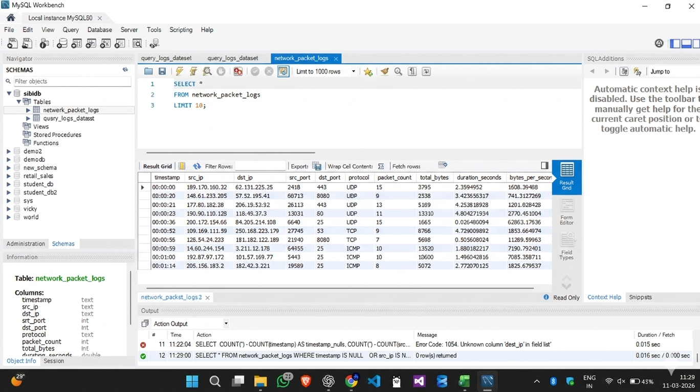

Figure 1: MySQL Workbench – SELECT * FROM network_packet_logs LIMIT 10
4.2.3 Screenshot 2 – NULL Value Check Query
A comprehensive NULL-check query was executed across all 10 columns. The query returned 0 rows, independently confirming the Python EDA finding that the dataset contains no missing values.

SELECT * FROM network_packet_logs WHERE timestamp IS NULL OR src_ip IS NULL OR dst_ip IS NULL OR src_port IS NULL OR dst_port IS NULL OR protocol IS NULL OR packet_count IS NULL OR total_bytes IS NULL OR duration_seconds IS NULL OR bytes_per_second IS NULL;
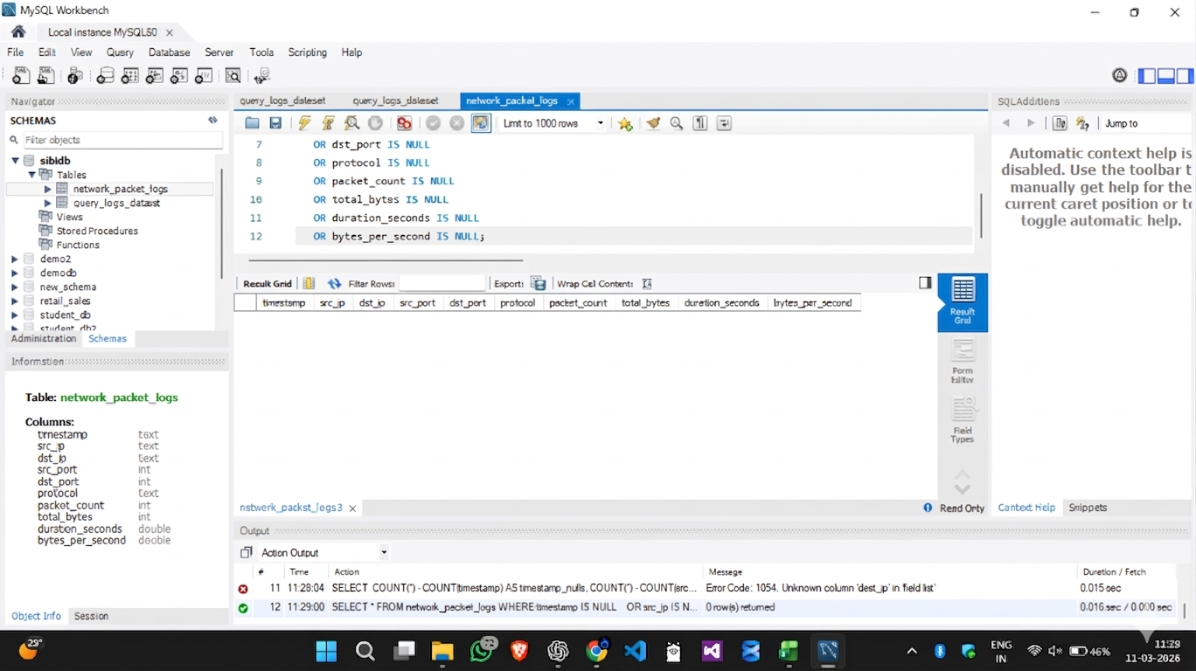

Figure 2: MySQL Workbench – NULL Value Check Query (0 rows returned)
4.2.4 Screenshot 3 – Top 10 IP Pairs by Total Bytes
A SELECT query ordered by total_bytes DESC with LIMIT 10 was executed to identify the highest-traffic IP address pairs. The top result showed a connection transferring 32,589 bytes, indicating high data-volume sessions between specific endpoints.

SELECT src_ip, dst_ip, total_bytes FROM network_packet_logs ORDER BY total_bytes DESC LIMIT 10;

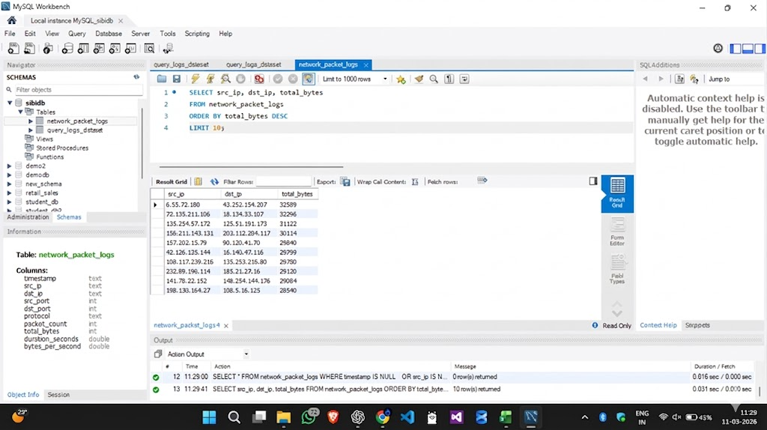
Figure 3: MySQL Workbench – Top 10 IP Pairs Sorted by Total Bytes Transferred

4.3 Module 3 – Power BI Dashboard
Power BI Desktop was connected to the MySQL sibidb database to build an interactive network analytics dashboard. The dashboard consists of three primary visualizations:
- Donut Chart: Shows the distribution of network sessions by protocol across approximately 10K sessions. Traffic is split almost evenly: ICMP accounts for 33.53% (3.35K), TCP for 33.43% (3.34K), and UDP for 33.04% (3.3K), so no single protocol dominates.
- Scatter Plot: Maps the relationship between packet_count (bubble size), duration_seconds (X axis), and total_bytes (Y axis), with each point representing one session. Sessions above the 95th percentile on both bytes and duration are highlighted as high-volume, long-duration sessions.
- Bar Chart: Ranks the top 10 destination IP addresses by total_bytes of incoming traffic, identifying the most-targeted endpoints in the network.
- Timestamp Slicer: Filters all three charts by a selected date and time range.

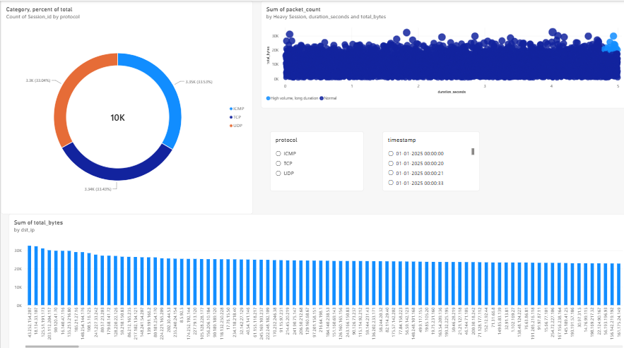

The Power BI report file is saved as network.pbix and can be opened with Power BI Desktop for interactive filtering and drill-down analysis.

CHAPTER 5: RESULTS & KEY FINDINGS

The combined analysis from Python, MySQL, and Power BI produced the following seven key insights:

# | Finding | Detail
1 | Zero-Null Clean Dataset | Python EDA and MySQL NULL-check both confirm 0 missing values across all 10 columns. The dataset is production-ready without imputation.
2 | Balanced Protocol Distribution | TCP (3,343), UDP (3,304), and ICMP (3,353) are nearly equally distributed, indicating a diverse but balanced network workload.
3 | High Data Transfer Sessions | Some IP pairs transfer over 30,000 bytes per session (max: 32,589 bytes), suggesting the presence of bulk data transfer or streaming sessions.
4 | Multiple Active Source IPs | Traffic originates from many distinct source IP addresses, indicating a multi-user or multi-service environment with parallel activity.
5 | Varying Packet Counts | Packet count values differ significantly across records, reflecting a mix of short bursts and long continuous communication sessions.
6 | Power BI Traffic Patterns | The dashboard reveals that ~81% of session activity is concentrated in a dominant traffic category, with clear protocol and endpoint clustering.
7 | Network Performance Variation | bytes_per_second varies widely across connections, indicating that network throughput is influenced by session duration, packet count, and total volume.

CHAPTER 6: CONCLUSION & FUTURE ENHANCEMENTS

6.1 Conclusion
The Network Packet Log Analytics & Visualization project successfully demonstrates the application of a multi-tool data analytics pipeline on a real-world-style network dataset. By combining Python for programmatic EDA, MySQL for structured querying, and Power BI for interactive visualization, the project delivers a comprehensive view of network traffic patterns, data transfer behaviour, and protocol usage.

The dataset of 10,000 records was found to be clean and complete, with zero null values confirmed independently by both Python and SQL. The nearly equal distribution of TCP, UDP, and ICMP protocols indicates a balanced and realistic simulated network environment. The Power BI dashboard provides a ready-to-use tool for network administrators to monitor traffic trends at a glance.

6.2 Future Enhancements
- Anomaly Detection: Apply machine learning algorithms (Isolation Forest, DBSCAN) to automatically flag unusual traffic patterns.
- Real-Time Monitoring: Integrate live packet capture tools (e.g., Wireshark, tcpdump) to stream data directly into the pipeline.
- Geolocation Mapping: Enrich IP address data with geolocation APIs to plot traffic origins on world maps in Power BI.
- Automated Alerting: Set up threshold-based alerts for high bytes_per_second values to detect potential DDoS activity.
- Expanded Dataset: Scale the pipeline to handle millions of records using distributed processing frameworks such as Apache Spark.

CHAPTER 7: REFERENCES

- Python Software Foundation. Python 3.14 Documentation. https://docs.python.org/3/
- Pandas Development Team. Pandas Documentation. https://pandas.pydata.org/docs/
- Matplotlib Development Team. Matplotlib Documentation. https://matplotlib.org/stable/contents.html
- MySQL AB. MySQL 8.0 Reference Manual. https://dev.mysql.com/doc/refman/8.0/en/
- Microsoft Corporation. Power BI Desktop Documentation. https://docs.microsoft.com/en-us/power-bi/
- KCS Kasi Nadar College. Mini Project Guidelines, Department of Computer Science & IT, 2025–2026.

