

GT COMPANION
Built by the GTs for the GTs

GT Companion is a learning and knowledge-sharing platform created by Graduate Trainees, for Graduate Trainees. The name reflects its purpose, where GT represents the Graduate Trainee community and Companion symbolizes a trusted guide throughout the learning journey. The platform brings together training materials and organizational knowledge shared by trainers and previous GT batches, helping future trainees build a strong foundation, learn from past experiences, and better understand how projects are delivered at OwlSure.

USER MANUAL

Prepared for: Graduate Trainees & Learning and Development Team
August 2026

GT COMPANION
Built by the GTs for the GTs

1. About GT Companion
GT Companion is a centralized learning and knowledge platform created by Graduate Trainees, for Graduate Trainees. It brings together training materials, project knowledge, and practical insights shared by trainers, including their real-world experience and guidance on how projects are executed at Owlsure. Managed by the Learning & Development (L&D) team, the platform serves as a single source of knowledge where future GTs can learn from past training sessions, resources, assignments, and experiences, ensuring valuable knowledge is preserved and passed on across batches.

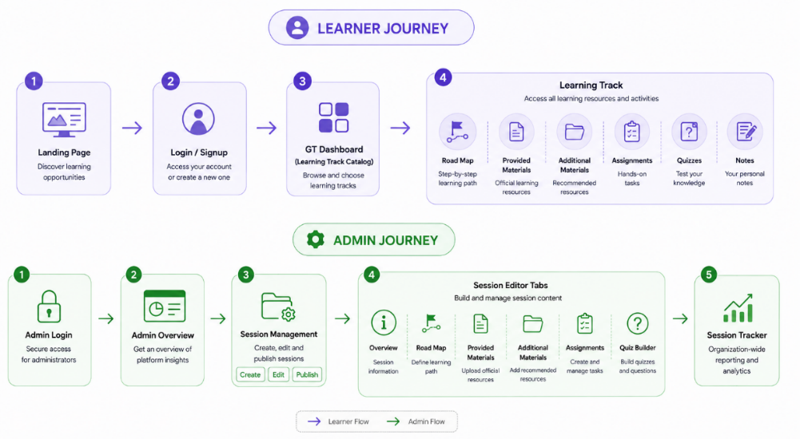

1.2 Technology Architecture
GT Companion is built on a modern technology stack designed to support learning, knowledge sharing, and long-term knowledge retention for Graduate Trainees. The platform uses React and TypeScript to deliver a responsive user experience, while ASP.NET Core powers the backend services, a technology intentionally chosen because .NET was one of the key topics covered during our GT training program. To enable relevant knowledge retrieval, GT Companion incorporates an AI-powered RAG service using Python FastAPI, LangChain, and Gemini 3.6 Flash. The platform is supported by PostgreSQL with pgvector for data storage, Redis for caching, and GitHub with Railway for deployment and continuous delivery, ensuring a scalable and reliable learning ecosystem for current and future GT batches.

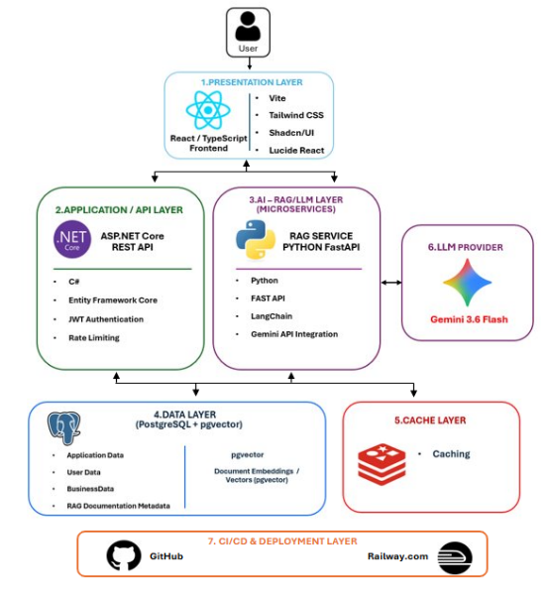

Figure 1.1 shows the overall technology architecture of the GT Companion platform.

1.3 ER Diagram

The GT Companion database schema is centered around Users, Sessions, and learning content management. Sessions are organized into Roadmap Topics, Subtopics, Study Materials, Assignments, and Quizzes, creating a structured learning journey for Graduate Trainees. The schema also supports learner engagement through progress tracking, quiz attempts, assignment submissions, and personal notes, while activity logs, session tracking records, and material versioning enable monitoring, auditing, and content management. Together, these entities form a scalable platform that facilitates knowledge sharing, learning assessment, progress monitoring, and long-term preservation of training content for current and future GT batches.

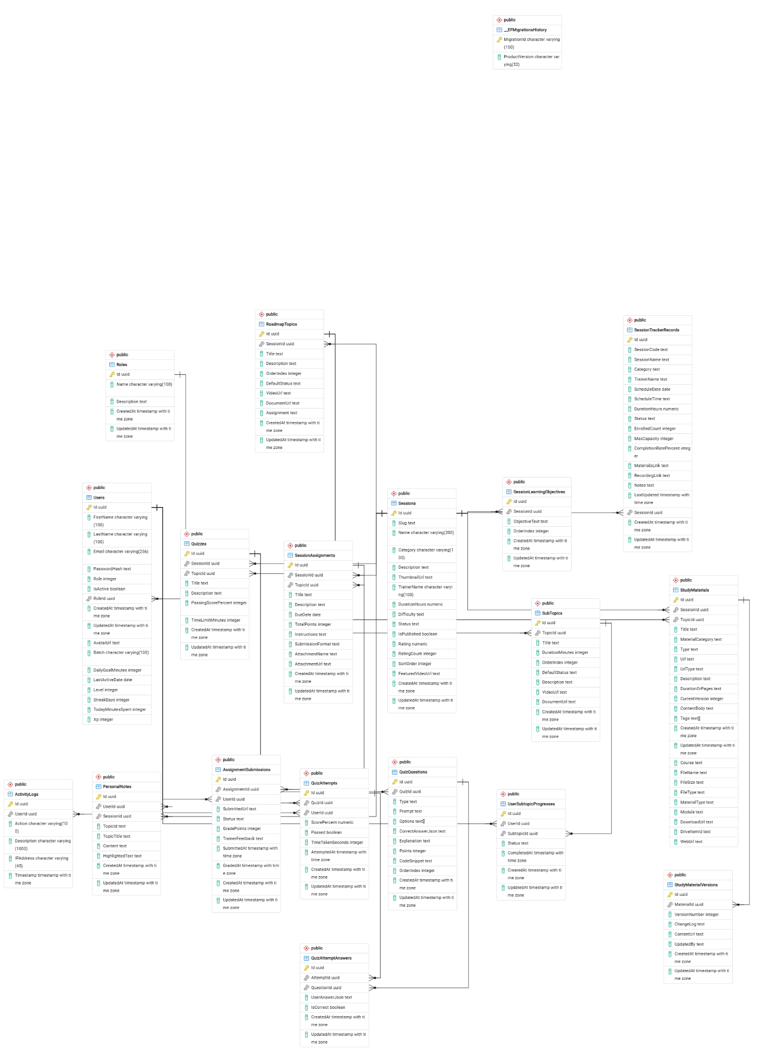

Figure 1.2 shows the overall ER Diagram of the GT Companion platform.

1.4 Video Production Flow
The GT Companion session videos were created by first analyzing the trainer-led sessions, presentation materials, and shared knowledge to ensure all key topics, practical experiences, project-related insights, and OwlSure working practices were accurately captured. Based on this content, detailed scripts were prepared for nine training sessions, along with an overview video introducing the complete learning journey and a Leadership Connect video featuring insights from OwlSure executives. Storyboards and visual content were then designed in Canva, supported by assets sourced from platforms such as Pixabay, Pexels, Unsplash, iStock, and Magnific. Voice-overs were recorded by Graduate Trainees and refined using Audacity, while Google AI Studio assisted in content refinement and production efficiency. Finally, all visuals, audio, and supporting elements were assembled into polished training videos, creating a structured knowledge repository that preserves valuable learning and experiences for future GT batches.

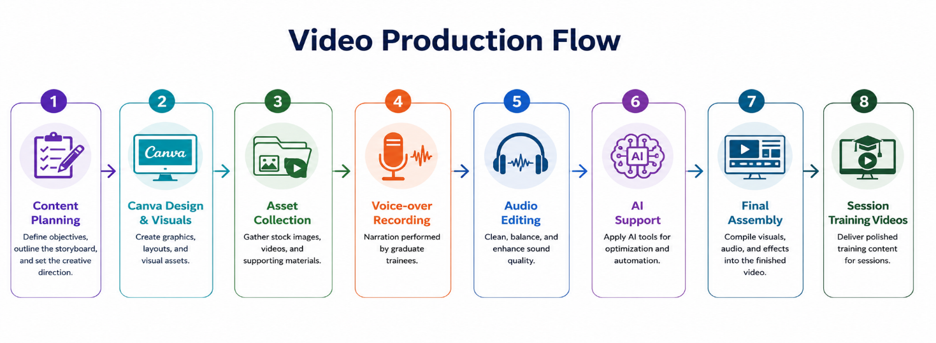

1.4 Getting Started
A single Corporate Login screen serves both roles. A role toggle (Associates / Learning & Development) decides which portal you land in — Associates go to the GT Dashboard; L&D Admins go to the Admin Portal. “Forgot Password?” resets a forgotten password by email; the profile avatar in the header opens Change Password anytime. A persistent header — logo, a portal-status pill (GT Portal / Admin Portal), a User Guide button, and the profile avatar — stays visible on every screen so you always know where you are and can reach help without losing your place.
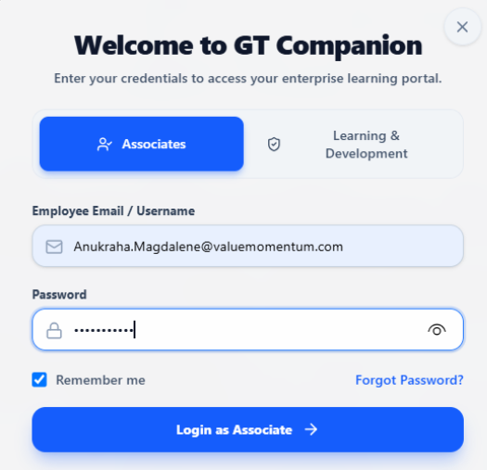
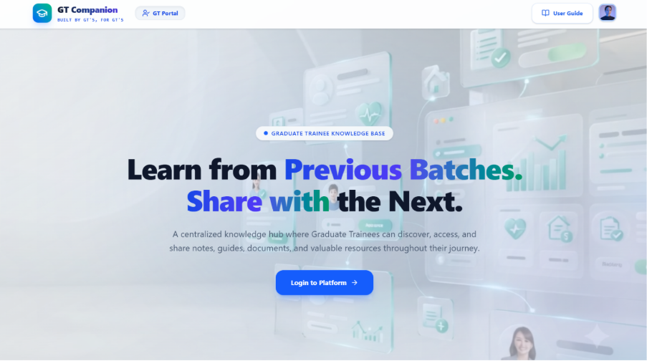
2. Graduate Trainee Experience

2.1 GT Dashboard — Finding a Learning Track
Logging in as an Associate takes you to the GT Dashboard, your starting point every time. A Featured Videos panel highlights short, spotlighted content (e.g., “Leadership Insights”), while the track catalog below lets you search or filter by track/category and shows a live “Showing X of Y tracks” count. Each track card shows a domain tag and trainer name — select “Open Learning Track” to begin. Only tracks an Administrator has Published appear here.

2.2 Working Through a Track — Session Overview
Opening a track brings you to its Session Overview, the hub you'll return to throughout the track. An embedded walkthrough video covers concepts, expectations, and prerequisites. Below it, a six-tab bar — each with a live item count — organizes everything else:
- Road Map — a structured, expandable view of each module and its subtopics, showing the trainer's full coverage plan.
- Provided Materials — official docs, PPTs, videos, and notes assigned by L&D, filterable by content type and searchable by title.
- Additional Materials — supplementary content contributed by peers and mentors, tagged with a source/contributor and date.
- Assignments — hands-on tasks with due dates, points, submission format, instructions, and a status chip (e.g., Pending).
- Quiz — a short assessment (title, topic, question count) started on demand and worked one question at a time.
- Notes — a private space to save timestamped personal notes, scoped to that track and visible only to you.

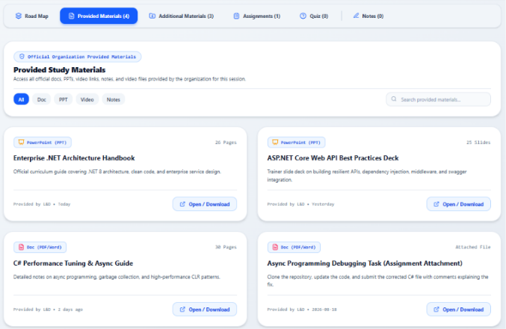
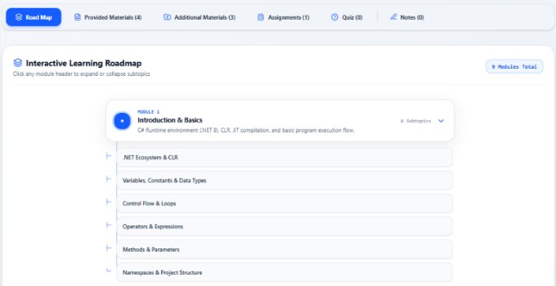
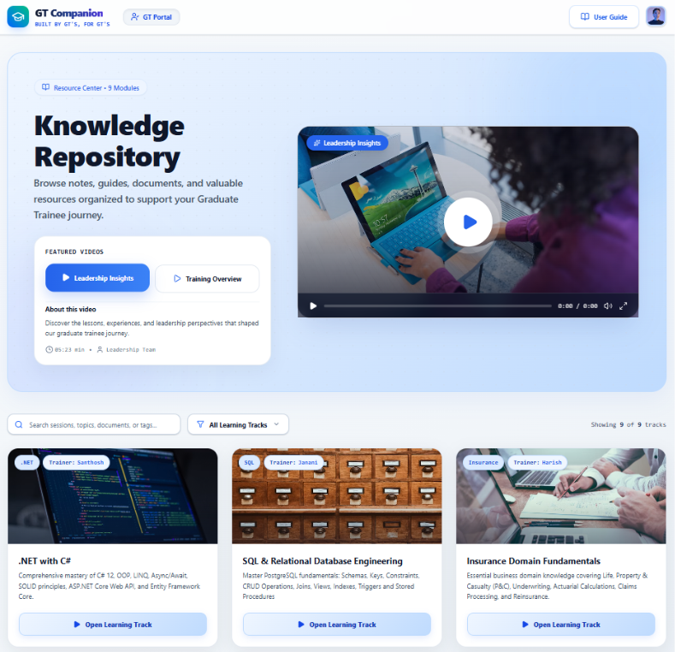

3. L&D Administrator Experience

3.1 Admin Overview & Session Management
Logging in as L&D lands you in the Admin Portal, with three workspaces on the top navigation bar: Admin Overview, Session Management, and Session Tracker.
- Admin Overview — a quick, read-only preview of what's already live — shows only Published sessions with a “View Session” option to check exactly what learners see.
- Session Management — the workspace for maintaining curriculum. Filter sessions by status (Published, Draft, Archived), then Edit, Publish, or Delete any session. Select “+ Create New Session” to start a new track.
NOTE: The Publish button disables automatically once a session is already Published, preventing accidental re-publishing.

3.2 Building a Session — the Session Editor
Creating or editing a session opens the same six-tab Session Editor. Every new session starts in Draft Mode so it can be built out fully before anyone sees it. Work across as many tabs as needed, then select “Save All Session Changes” once to commit everything at once:
- Session Overview — Title, Description, Category Track, Trainer Name, Session Status (Draft/Published/Archived), and the overview walkthrough video.
- Road Map — add topic nodes and subtopic nodes to define the order trainees will work through the material.
- Provided / Additional Materials — attach official curriculum files or links, each with a document type, description, and file/URL.
- Assignments — define tasks with a name, due date, supporting file, and full instructions.
- Quiz Builder — author multiple-choice questions with four options each and mark the correct answer for auto-scoring.
Set Session Status to Published only once the session is genuinely ready — this is what makes it visible on the GT Dashboard and in Admin Overview.

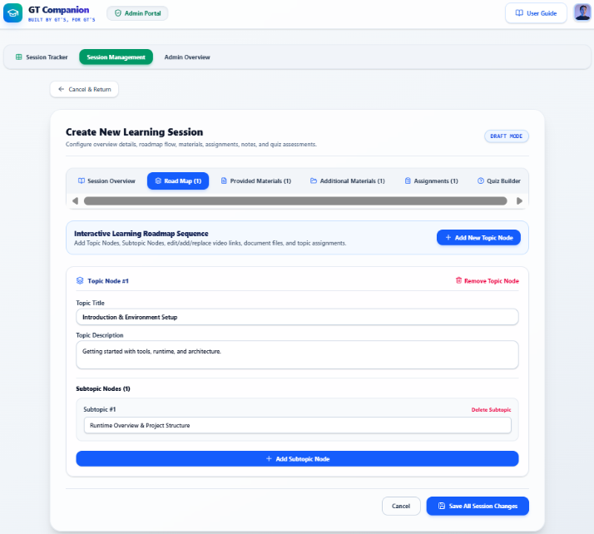
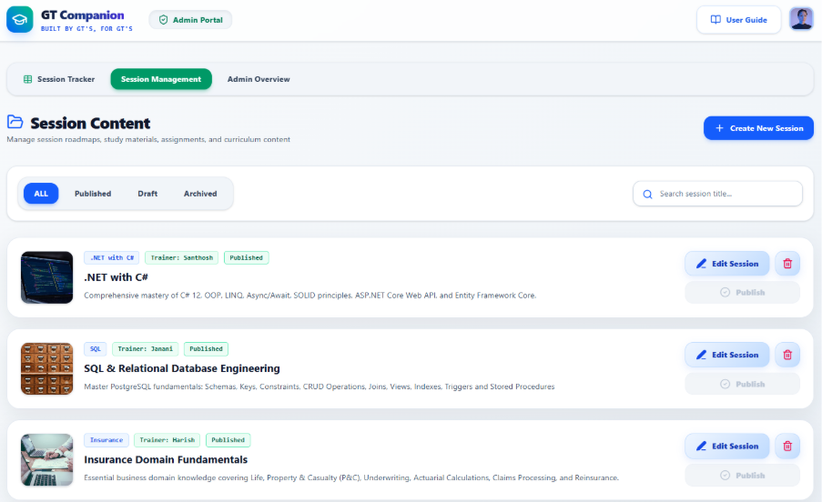

4. Reporting — the Session Tracker
The Session Tracker is an organization-wide, spreadsheet-style log of every scheduled session instance across all tracks and trainers — distinct from Session Management, which manages curriculum content rather than individual scheduled runs.
- Filter & Search — filter records by Session Code, Session Name, Trainer, Schedule Date/Time, or Category, or search Global Keywords for anything in notes or linked URLs.
- Add / Edit — select “+ Add Record” to log a new scheduled instance, or the pencil icon to edit an existing one — both open the same form (Session Code, Category, Title, Trainer, Schedule Date/Time, Hours, Remarks).
- Delete — remove a record via the trash icon once it's no longer needed for reporting, audits, or reference.
- Export Excel — download the currently filtered records to Excel for offline analysis or stakeholder sharing.

4.1 How GT Companion supports L&D
GT Companion addresses the challenges of fragmented onboarding and inconsistent knowledge transfer by providing a centralized, structured, and scalable learning platform. By combining learning content, assessments, practical exercises, and administrative tools within a single system, it enables effective onboarding, preserves organizational knowledge, and creates a consistent learning experience for current and future Graduate Trainee batches.

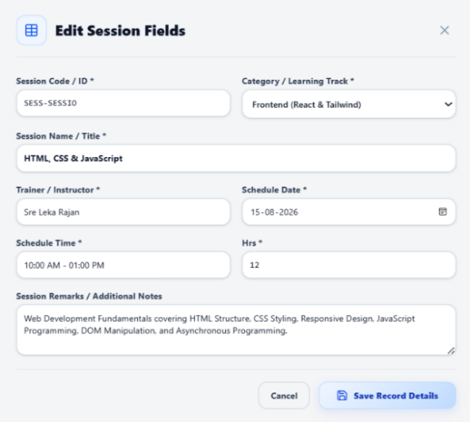
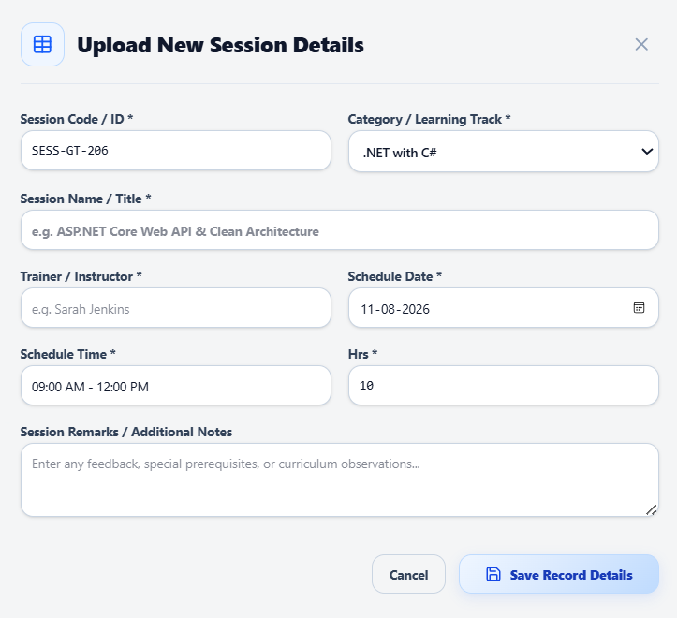
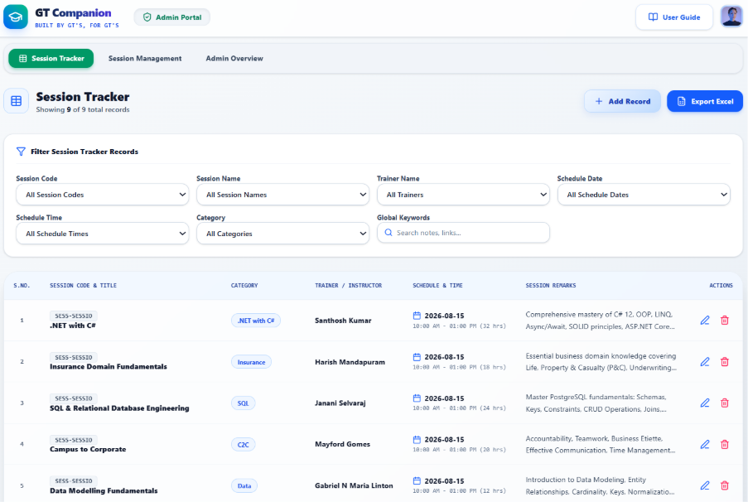

5. Quick Reference

5.1 Learner Screens
Screen | Purpose
GT Dashboard | Browse and search the published track catalog; preview featured videos.
Session Overview | Central hub for a track — watch the intro video and reach all six content tabs.
Provided / Additional Materials | Access official and supplementary study resources.
Assignments | View tasks, due dates, points, and submission status.
Quiz | Take a timed assessment, one question at a time.
Notes | Save private, timestamped study notes per track.

5.2 Administrator Screens
Screen | Purpose
Admin Overview | Preview the live (Published) catalog exactly as learners see it.
Session Management | Create, edit, publish, or delete learning tracks.
Session Editor | Build a session's overview, roadmap, materials, assignments, and quiz.
Session Tracker | Log, filter, and export scheduled session instances org-wide.
GT Companion — Built by the GTs for the GTs

