CLEANCONNECT+
A SMART WASTE MANAGEMENT AND CITIZEN-MUNICIPALITY COORDINATION PLATFORM

R SIBIDHARAN - 25MX120
R G A SAKTHIVEL MALLAIAH - 25MX217

DISSERTATION SUBMITTED IN PARTIAL FULFILLMENT OF THE REQUIREMENTS FOR THE DEGREE OF

MASTER OF COMPUTER APPLICATIONS

ANNA UNIVERSITY


OCTOBER 2026
DEPARTMENT OF COMPUTER APPLICATIONS PSG COLLEGE OF TECHNOLOGY
(Autonomous Institution)
COIMBATORE - 641 004

PSG COLLEGE OF TECHNOLOGY
(Autonomous Institution)

COIMBATORE - 641 004

23MX37 – MINI PROJECT

CLEANCONNECT+

A SMART WASTE MANAGEMENT AND CITIZEN-MUNICIPALITY COORDINATION PLATFORM

Bonafide record of work done by

R SIBIDHARAN - 25MX120
R G A SAKTHIVEL MALLAIAH - 25MX217
23MX37 - MINI PROJECT

REPORT SUBMITTED IN PARTIAL FULFILLMENT OF THE REQUIREMENTS FOR THE DEGREE OF
MASTER OF COMPUTER APPLICATIONS ANNA UNIVERSITY
OCTOBER 2026

Faculty Guide

.……………………….

Ms. A. S. AARTHI MAI

 | TABLE OF CONTENTS
S.NO | CONTENTS | PAGE NO.
 | ACKNOWLEDGEMENT | i
 | SYNOPSIS | ii
1. | INTRODUCTION | 1
 | 1.1 Project Overview | 1
 | 1.2 Project Objectives | 2
 | 1.3 Scope of the Project | 3
 | 1.4 Tools and Technologies Used | 3
2. | SYSTEM ANALYSIS | 6
 | 2.1 Existing System | 6
 | 2.2 Limitations of Existing System | 6
 | 2.3 Proposed System | 7
 | 2.4 Advantages of Proposed System | 8
 | 2.5 Functional Requirements | 9
 | 2.6 Non-Functional Requirements | 10
3. | SYSTEM DESIGN | 12
 | 3.1 System Architecture | 12
 | 3.2 System Workflow | 13
 | 3.3 UML Activity Diagram | 14
 | 3.4 BPMN Diagram | 15
 | 3.5 Database Design | 16
 | 3.6 Entity Description | 17
4. | SYSTEM IMPLEMENTATION | 23
 | 4.1 Home / Dashboard | 23
 | 4.2 Administrator Module | 23
 | 4.3 Complaint Management | 25
 | 4.4 Route Management | 26
 | 4.5 Garbage Hotspot Analysis and Zone Prioritization | 27
 | 4.6 Fleet and Vehicle Management | 28
 | 4.7 Smart Missed-Collection Detection | 28
 | 4.8 Citizen Mobile Application Module | 30
 | 4.9 Driver Field Operations and Live Navigation Module | 35
 | 4.10 RESTful API Implementation | 39
5. | SYSTEM TESTING | 42
 | 5.1 Testing Introduction | 42
 | 5.2 Testing Techniques | 42
 | 5.3 Test Cases | 43
6. | CONCLUSION | 45
 | 6.1 Conclusion | 45
 | 6.2 Future Enhancements | 45
 | BIBLIOGRAPHY | 46

ACKNOWLEDGEMENT

We immensely take this opportunity to express our sincere gratitude to Dr. G. Thilagavathi, Principal, PSG College of Technology, for providing us all the facilities within the campus for the completion of the project.

We profoundly thank Dr. N. Ilayaraja, Assistant Professor and Head i/c , Department of Computer Applications, PSG College of Technology, for his moral support and guidance.

We owe an extremely unbound gratitude and extend our thanks to our Programme Coordinator, Ms. A. Kalyani, Assistant Professor (S.G.), Department of Computer Applications, PSG College of Technology, whose motivation and support encouraged us in taking up and completing this project work.

We are overwhelmed in all humbleness and gratefulness in acknowledging our guide Ms. A.S. Aarthi Mai , Assistant Professor, Department of Computer Applications, PSG College of Technology, for her priceless suggestions and unrelenting support in all our efforts to improve our project and for piloting the right way for the successful completion of our project.

We also express our sincere thanks to all the faculty members of the Department of Computer Applications for their encouragement. We also thank our parents and all the hands that helped us.

SYNOPSIS

Rapid urbanization and increasing population density have created challenges in municipal solid waste collection, vehicle coordination, and resource management. Traditional waste collection systems often rely on fixed schedules and manual coordination, leading to delays, inefficient vehicle utilization, and difficulties in resolving citizen complaints. To address these issues, CleanConnect+ is developed as an integrated smart municipal management platform that connects citizens, drivers, and administrators through a unified digital system. The platform comprises a web-based administrative dashboard, React Native mobile applications, a Node.js and Express.js backend, and a MongoDB database. Its key features include citizen complaint management, collection scheduling, driver and route assignments, notifications, and centralized administrative monitoring.

CleanConnect+ incorporates GPS-based vehicle tracking, location monitoring, and real-time updates using Socket.IO to improve the visibility of waste collection activities. Interactive maps support vehicle and route monitoring, while the Smart Collection Verification and Missed-Collection Detection Engine helps administrators investigate missed collections using citizen reports and available collection-related information. The system was evaluated through functional testing of major workflows, including authentication, complaint handling, scheduling, route management, GPS tracking, and real-time communication. Overall, CleanConnect+ aims to improve coordination, operational monitoring, and the efficiency of municipal waste collection. Future enhancements may include IoT-based bin monitoring, predictive waste analysis, and advanced route optimization.

CHAPTER 1 INTRODUCTION

Project Overview
The rapid pace of urbanization and increasing population density have made municipal solid waste management a significant challenge for modern cities. Effective waste collection requires proper coordination between municipal administrators, drivers, collection teams, and citizens. Conventional waste management processes often rely on fixed schedules, manual coordination, and reactive complaint handling, which can result in inefficient vehicle deployment, delays in collection, limited visibility of vehicle movements, and difficulties in resolving citizen complaints.
CleanConnect+ is an integrated smart municipal management platform developed to improve the coordination and monitoring of municipal waste-collection operations. The system connects municipal administrators, drivers, and citizens through a web-based administrative dashboard and cross-platform mobile applications. It is supported by a Node.js and Express backend with MongoDB for application data management and provides features such as user authentication, citizen complaint management, driver route management, collection scheduling, and notifications.
A key feature of CleanConnect+ is GPS-based vehicle tracking and real-time location monitoring. The mobile application captures driver location data and communicates it to the backend, while Socket.IO enables real-time updates for vehicle tracking. Geospatial and map-based services are used to visualize locations and routes, providing administrators and users with improved visibility of ongoing collection activities.
By digitizing these municipal workflows, CleanConnect+ provides a unified platform for managing complaints, routes, schedules, and vehicle movements. The system aims to improve operational coordination, enhance communication between stakeholders, and support more efficient municipal waste-collection management. The platform also provides a foundation for future enhancements such as IoT-based bin monitoring, advanced route optimization, and predictive analytics.

Project Objectives
The primary objective of this project is to develop an integrated municipal waste management and fleet tracking system that improves coordination between citizens, drivers, and municipal administrators. To achieve this goal, the following specific objectives have been formulated:
    - GPS-Based Fleet Telemetry and Real-Time Tracking: To capture and transmit driver and vehicle location data through the mobile application and provide real-time vehicle tracking using GPS and Socket.IO-based communication.
    - Route Management: To provide drivers with assigned collection routes and stops through the mobile application and support route progress and collection activity management.
    - Collection Schedule Management: To enable administrators to create and manage collection schedules and allow drivers to access their assigned schedules through the mobile application.
    - Citizen Complaint Management: To provide citizens with a mobile interface for submitting waste-related complaints, including descriptions, images, and location information, while enabling administrators to monitor and manage complaint status.
    - Role-Based Authentication and Access Control: To implement secure authentication and role-based access for administrators, drivers, and citizens, ensuring that users can access the appropriate system functions.
    - Real-Time Notifications and Communication: To provide notifications and real-time communication between system components to support timely updates regarding complaints, schedules, and vehicle activities.
    - Smart Collection Verification and Missed-Collection Detection: To implement an intelligent verification engine that cross-analyzes citizen missed-collection complaints with driver telemetry, scheduled route stops, and spatial geofences, automatically detecting missed collection patterns across streets and generating prioritized administrative alerts.
    - Driver Navigation and Exception Management: To provide drivers with interactive turn-by-turn route navigation, collection stop progress tracking, and structured exception reporting for inaccessible or blocked collection points.
    - Centralized Municipal Administration: To develop a web-based administrative dashboard for managing users, complaints, drivers, routes, schedules, and vehicle-tracking information from a centralized interface.

Scope of the Project
The scope of CleanConnect+ focuses on developing an integrated digital platform for municipal solid waste management by connecting municipal administrators, drivers, and citizens through web and mobile applications. The system aims to improve waste collection coordination, vehicle monitoring, and complaint management while reducing dependence on manual processes. The web-based administrative dashboard enables administrators to manage drivers, collection routes, schedules, citizen complaints, and collection activities. The driver mobile application allows drivers to view assigned routes, access collection stops, update collection progress, and share GPS location data for real-time vehicle tracking. The citizen mobile application enables users to view collection schedules, track collection vehicles, submit waste-related complaints with images and location details, and monitor complaint status. These features provide a structured communication channel between stakeholders, support efficient task allocation, and improve the visibility of municipal waste collection operations.
The platform incorporates GPS-based location services and Socket.IO communication to provide real-time vehicle location updates, while notifications help keep users informed about relevant collection activities and complaint updates. CleanConnect+ also supports complaint monitoring and hotspot detection by analyzing the spatial distribution of reported issues, helping administrators identify areas that may require additional attention and prioritize collection efforts. The system primarily focuses on software-based municipal waste management, including complaint handling, route management, scheduling, fleet monitoring, and vehicle tracking. Physical IoT sensors, automated waste-level detection, and advanced route optimization are excluded from the current implementation, while machine learning is limited to hotspot detection. Features such as sensor-based bin monitoring, predictive waste analysis, and intelligent traffic-based routing may be introduced in future versions. Overall, CleanConnect+ aims to provide a unified digital environment that strengthens coordination among stakeholders, supports timely complaint resolution, and improves the monitoring and management of municipal waste collection activities.

Tools and Technologies Used
CleanConnect+ is developed using modern web and mobile technologies that support municipal administration, mobile field operations, database management, real-time
communication, and GPS-based tracking. The complete technology stack used in the system is presented in Table 1.1.
Table 1.1: Technology Stack and Tooling Infrastructure

Layer / Domain | Technology / Framework | Version / Spec | Operational Purpose
Web Administration | React.js | 18.3.1 | Development of the web-based administrative dashboard and user interfaces
Build Tool | Vite | 5.3.4 | Development and production build management for the web application
Mobile Application | React Native | 0.81.5 | Development of  cross-platform mobile applications for drivers and citizens
Mobile Framework | Expo | 54 | Mobile application development, device services, and application management
Backend Server | Node.js, Express.js | - | REST API  development, authentication, routing, and application logic
Database | MongoDB, Mongoose | Mongoose 8.5.1 | Storage and management of users, complaints, routes, schedules, notifications, and location data
Authentication & Security | JWT, bcryptjs | - | User authentication, role-based access control, and password hashing
Real-Time Communication | Socket.IO | - | Real-time transmission and updating of vehicle tracking information

Layer / Domain | Technology / Framework | Version / Spec | Operational Purpose
Location Services | Expo Location | - | Obtaining GPS-based location information from mobile devices
Mapping | React Native Maps / Google Maps | - | Displaying maps, routes, vehicle locations, and geographic information
Reverse Geocoding | OpenStreetMap Nominatim | - | Converting geographic coordinates into readable location information
File Upload | Multer | - | Handling image and file uploads, particularly for citizen complaints
Notifications | Expo Notifications | - | Providing mobile notifications to users
HTTP Client | Axios | - | Communication between the frontend/mobile applications and backend APIs

The selection of Node.js and Express.js provides an asynchronous, non-blocking I/O event loop ideally suited for high-frequency telemetry ingestion. MongoDB offers dynamic schema flexibility for heterogeneous telemetry payloads. React.js and React Native ensure consistent user experience paradigms across administrative desktops and mobile devices.

CHAPTER 2 SYSTEM ANALYSIS

Existing System
Conventional municipal solid waste management systems often rely on fixed collection schedules, manual coordination, and limited digital monitoring. Collection vehicles are generally assigned to predefined routes and schedules, while information about collection activities is communicated between municipal administrators and field staff through manual records, telephone communication, or other conventional methods.
Citizen complaints regarding uncollected waste, overflowing bins, or other waste-related issues are commonly handled through manual or centralized processes. The absence of an integrated digital platform can make it difficult for administrators to monitor complaints, coordinate drivers, track collection activities, and maintain up-to-date operational information.
In such systems, vehicle locations and route progress may not be continuously available to municipal administrators. This limits the ability to monitor ongoing collection activities and respond quickly to operational issues. These limitations highlight the need for a centralized system that connects citizens, drivers, and municipal administrators through digital services.

Limitations of Existing System
The existing approach to municipal waste collection has several limitations that can affect the efficiency and coordination of collection operations. The major limitations include:
    - Fixed and Less Flexible Collection Management: Collection activities often depend on predetermined schedules and routes, making it difficult to respond efficiently to changes in collection requirements or operational conditions.
    - Limited Real-Time Vehicle Visibility: Conventional systems may not provide administrators with continuous information about the current location and movement of collection vehicles, making real-time monitoring difficult.
    - Manual Complaint Handling: Waste-related complaints may require manual recording and follow-up, which can make complaint management slower and make it difficult for citizens and administrators to track complaint status.
    - Limited Coordination Between Stakeholders: Communication between citizens, drivers, and municipal administrators may be fragmented when separate manual processes are used for complaints, routes, schedules, and collection activities.
    - Lack of Centralized Operational Information: Information related to drivers, routes, schedules, complaints, notifications, and vehicle locations may not be available through a single integrated platform, making administrative monitoring and coordination more difficult.

Proposed System
CleanConnect+ replaces disconnected and manual municipal waste management processes with a unified digital platform that connects municipal administrators, drivers, and citizens. The proposed system provides a centralized environment for managing complaints, collection routes, schedules, notifications, and vehicle locations.
The system consists of a web-based administrative dashboard and cross-platform mobile applications supported by a Node.js and Express.js backend and MongoDB database. Administrators can manage operational information and monitor collection activities, while drivers can access their assigned routes and collection stops through the mobile application. Citizens can submit waste-related complaints with images and location information and monitor the status of their complaints.
A key feature of the proposed system is GPS-based vehicle tracking and real-time communication. The mobile application obtains the driver's location and sends location updates to the backend, while Socket.IO enables real-time tracking information to be shared with connected users. Map-based services provide visualization of routes and vehicle locations, improving operational visibility and coordination.
The proposed system therefore provides an integrated platform for digital complaint management, route management, collection scheduling, GPS-based tracking,
notifications, and communication between the different stakeholders involved in municipal waste collection.

Advantages of Proposed System
The proposed CleanConnect+ platform provides an integrated digital approach to municipal waste collection management. By connecting administrators, drivers, and citizens through web and mobile applications, the system improves coordination, monitoring, and accessibility of municipal operations. The major advantages of the proposed system are summarized in Table 2.1.

Table 2.1: Comparative Evaluation of Existing vs. Proposed System

Evaluation Area | Existing System | Proposed CleanConnect+ System
Route Management | Routes and collection activities are commonly managed through fixed schedules and manual coordination. | Drivers can access assigned routes and collection stops through the mobile application.
Vehicle Visibility | Limited visibility of vehicle locations during collection activities. | GPS-based vehicle tracking provides real-time location information.
Complaint Management | Complaints may be handled through manual or disconnected processes. | Citizens can submit complaints digitally with descriptions, images, and location information.
Complaint Monitoring | Manual follow-up can make complaint status difficult to track. | Administrators can manage and monitor complaint information through the centralized system.
Collection Scheduling | Scheduling may depend on manual records and communication. | Collection schedules can be created and managed digitally and accessed by drivers.
Communication | Communication between stakeholders may rely on conventional methods. | Socket.IO provides  real-time communication for vehicle tracking and system updates.

Evaluation Area | Existing System | Proposed CleanConnect+ System
Notifications | Updates may require manual communication with users. | Mobile notifications can be used to provide timely system updates.
Administrative Management | Operational information may be distributed across separate processes. | A centralized web dashboard provides a unified interface for managing municipal activities.
Citizen Accessibility | Citizens may need to use conventional channels to report waste-related issues. | A mobile application provides direct access to complaint submission and related services.

Functional Requirements
The functional requirements define the specific software capabilities and operations provided by the CleanConnect+ system:
    - FR-01: Authentication and Role-Based Access Control: The system shall authenticate users using JWT-based authentication and enforce role-based access for administrators, drivers, and citizens.
    - FR-02: GPS-Based Vehicle Tracking: The system shall obtain GPS location information from driver mobile devices and transmit location data to the backend for vehicle tracking and monitoring.
    - FR-03: Real-Time Tracking Updates: The system shall use Socket.IO to transmit and display vehicle location updates in real time to authorized connected clients.
    - FR-04: Route Management: The system shall allow administrators to manage collection routes and assign routes to drivers. Drivers shall be able to view their assigned routes and collection stops through the mobile application.
    - FR-05: Collection Schedule Management: The system shall allow administrators to create and manage collection schedules and enable drivers to access their assigned schedules through the mobile application.
    - FR-06: Citizen Complaint Management: The system shall allow citizens to submit waste-related complaints with descriptions, images, and location information. Administrators shall be able to view and manage submitted complaints.
    - FR-07: Notification Management: The system shall provide notifications to users for relevant system updates and operational activities.
    - FR-08: Administrative Management: The system shall provide a web-based administrative dashboard for managing users, drivers, complaints, routes, schedules, and monitoring collection-related activities.
    - FR-09: Map-Based Location Visualization: The system shall provide map-based visualization of routes and vehicle locations using GPS and mapping services.
    - FR-10: Smart Missed-Collection Detection: The system shall analyze citizen missed-collection reports within a configurable spatial and temporal window against driver GPS breadcrumbs to identify unserviced streets and generate confidence-scored alerts.
    - FR-11: Admin Investigation & Recollection Workflow: The system shall provide an administrative investigation panel to review driver GPS evidence against complaints, log investigation notes, request recollections, and update alert resolution status.
    - FR-12: Driver Exception Logging: The system shall enable drivers to mark collection stops as 'Unable to Collect' with standardized reasons (road blocked, bin missing, construction obstruction) through the mobile navigation interface.
    - FR-13: Dynamic Citizen Notification History: The system shall maintain an auditable timeline of status notifications accessible to citizens, updating them in real time as their complaints and missed-collection reports are processed and resolved.

Non-Functional Requirements
The non-functional requirements define the quality attributes and operational characteristics expected from the CleanConnect+ system:
    - NFR-01: Performance: The system shall provide responsive interactions for normal user operations, including authentication, complaint management, route management, schedule access, and GPS tracking.
    - NFR-02: Security: The system shall provide secure user authentication and access control using JWT-based authentication. User passwords shall be securely hashed using bcryptjs before being stored in the database.
    - NFR-03: Reliability: The system shall reliably process user requests, complaint submissions, route information, schedule information, and GPS location updates during normal system operation.
    - NFR-04: Usability and Accessibility: The web and mobile interfaces shall provide simple and responsive user interfaces that can be accessed across supported desktop and mobile devices.
    - NFR-05: Maintainability: The system shall maintain a modular structure by separating the web administration interface, mobile applications, backend services, and database components, allowing individual components to be modified and maintained independently
    - NFR-06: Scalability: The system shall be designed so that its backend, database, and client applications can be extended to support additional users, municipal operations, and future functionality.
    - NFR-07: Cross-Platform Support: The mobile application shall support cross-platform development through React Native and Expo, while the administrative interface shall be accessible through modern web browsers.

CHAPTER 3

SYSTEM DESIGN

System Architecture
CleanConnect+ follows a modular multi-tier architecture that separates the client applications, backend services, real-time communication, and data management components. The architecture is designed to provide a clear separation of responsibilities and support maintainability and future expansion of the system. The major components of the architecture are the Client Layer, Application/API Layer, Real-Time Communication Layer, and Data Layer.
The Client Layer consists of the web-based administrative dashboard and cross-platform mobile applications developed using React.js, React Native, and Expo. The web application provides administrators with interfaces for managing users, complaints, routes, schedules, and collection activities. The mobile applications provide citizens with complaint management features and provide drivers with access to assigned routes, schedules, and GPS-based location services.
The Application/API Layer is implemented using Node.js and Express.js. It provides REST APIs for authentication, complaint management, route management, schedule management, notifications, driver operations, and tracking. JWT-based authentication and role-based access control are used to restrict access to appropriate system functions. The backend communicates with the MongoDB database through Mongoose.
The Real-Time Communication Layer uses Socket.IO to support real-time vehicle tracking. Driver mobile applications transmit GPS location information to the backend, which processes the location updates and communicates them to authorized connected clients. This enables administrators and other permitted users to view updated vehicle locations without relying entirely on manual refresh operations.
The Data Layer uses MongoDB for storing application data, including user information, driver details, complaints, routes, schedules, notifications, and vehicle location records. Mongoose provides the object data modelling layer for interacting with the MongoDB database. Mapping and location services are integrated through React Native Maps, Google Maps, Expo Location, and OpenStreetMap Navigation.
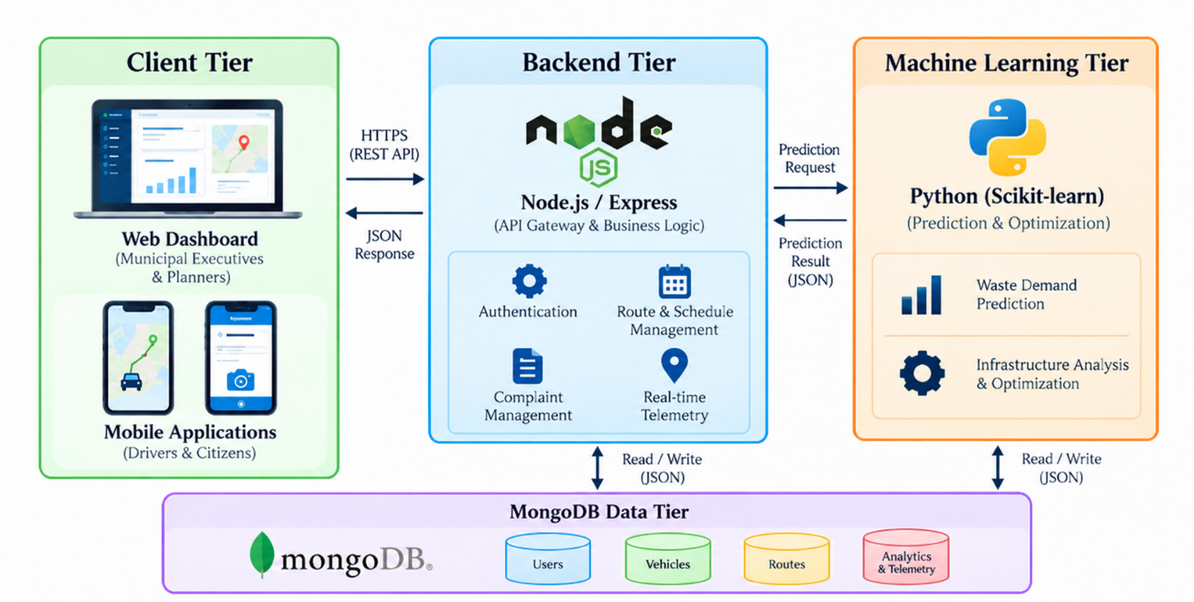
Figure 3.1: Multi-Tier System Architecture of CleanConnect+

System Workflow
The operational workflow of CleanConnect+ connects citizens, drivers, and administrators through a centralized digital platform. When a citizen identifies uncollected waste or another waste-related issue, the mobile application allows the citizen to submit a complaint with a description, image, and location information. The complaint is transmitted to the backend and stored in the database, where administrators can view and manage the submitted complaint.
For collection operations, administrators manage routes and collection schedules and assign them to drivers. When a driver accesses the mobile application, the assigned route
and collection stops are retrieved from the backend. The driver can view the route information and update the progress of collection activities through the application.
During collection activities, the mobile application obtains the driver's GPS location using the device's location services and sends location updates to the backend. Socket.IO is used to communicate these updates in real time to connected clients, allowing authorized users to monitor vehicle locations on the map.
The system also provides notifications and centralized administrative functions for managing complaints, routes, schedules, drivers, and tracking information. This workflow enables CleanConnect+ to provide a connected digital environment for coordinating and monitoring municipal waste collection activities.
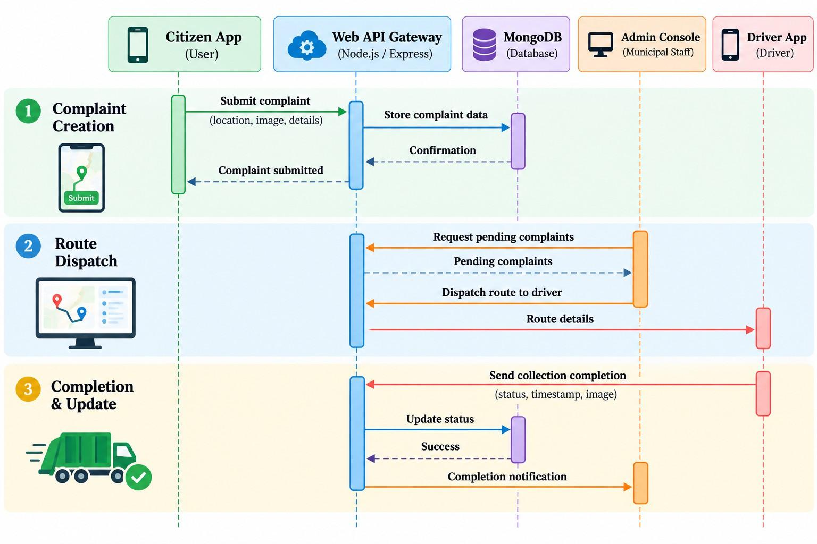

Figure 3.2: End-to-End System Workflow Sequence Diagram

UML Activity Diagram
The UML Activity Diagram illustrates the flow of major activities in CleanConnect+ across four operational swimlanes: Citizen, Backend, Administrator, and Driver. The
workflow begins when a citizen submits a waste-related complaint through the mobile application by providing relevant details, location information, and an image.
The complaint is transmitted to the backend, where the submitted information is validated and stored in the database. The administrator is then able to view pending complaints through the web dashboard and take appropriate action, including managing the complaint and assigning relevant collection activities to a driver.
The driver receives the assigned route through the mobile application and can view the assigned collection locations. During collection activities, the driver can update the collection status through the application. The backend stores these updates and communicates relevant status information to the citizen through notifications.
The activity diagram therefore represents the interaction between citizens, administrators, drivers, and the backend system during complaint submission, route assignment, collection activities, status updates, and notification delivery.
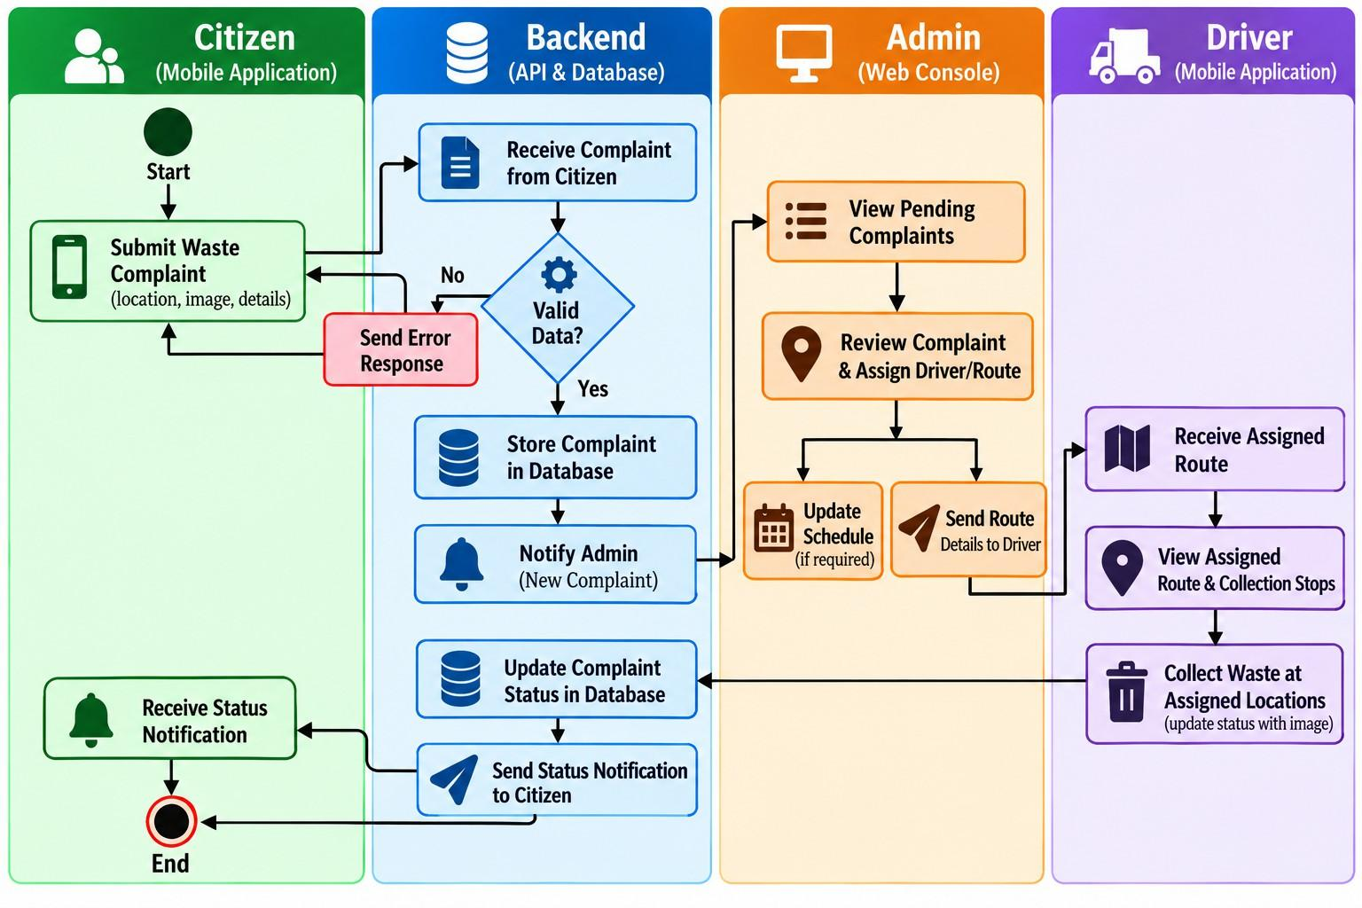

Figure 3.3: UML Activity Diagram for Waste Dispatch & Citizen Incident Reporting

BPMN Diagram
The BPMN 2.0 diagram represents the major business processes involved in CleanConnect+'s municipal waste collection workflow. The process involves citizens, administrators, drivers, and the backend system, with each participant performing specific activities within the overall workflow.
The process begins when a citizen submits a waste-related complaint or when an administrator manages an existing collection activity. Citizen complaints are received and processed by the backend, after which administrators can review the submitted complaints and manage the appropriate collection activities.
Administrators can manage collection routes and schedules and assign the required information to drivers. Drivers access their assigned routes and collection stops through the mobile application and update collection activities through the system. The backend stores these updates and maintains the corresponding complaint, route, and schedules.
The BPMN workflow also represents the exchange of information between the different participants, including complaint submission, route assignment, collection status updates, GPS-based tracking information, and notifications. This provides a clear representation of how CleanConnect+ coordinates municipal administrators, drivers, citizens, and backend services during waste collection operations.
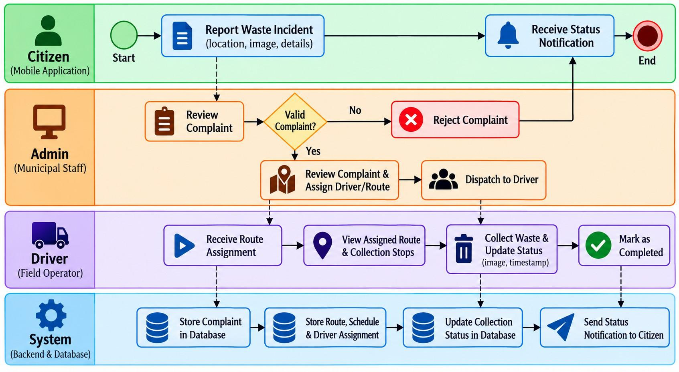
Figure 3.4: BPMN 2.0 Diagram for Municipal Logistics & Fleet Lifecycle

Database Design
CleanConnect+ uses MongoDB as its primary database for storing and managing application data. Mongoose is used as the Object Data Modeling (ODM) library to define and interact with the database models. The database stores information related to users, drivers, complaints, notifications, routes, collection schedules, and vehicle location updates.
The database design consists of seven major entities: User, Driver, Complaint, Notification, Route, Schedule, and VehicleLocation. The User entity stores the basic information and role of system users, including administrators, drivers, and citizens. The Driver entity maintains driver-specific information associated with user accounts. Complaint records store citizen-reported waste issues along with relevant descriptions, images, locations, status information, and assignment details.
The Route and Schedule entities support the management of collection routes, collection stops, and scheduled collection activities. The Notification entity stores notification information associated with users. The VehicleLocation entity stores GPS-based location information such as vehicle identifier, latitude, longitude, and recorded time, enabling the system to maintain vehicle tracking information.
MongoDB provides flexible document-based storage suitable for the different types of information handled by CleanConnect+. Database queries and filtering are performed through Mongoose, while appropriate indexing can be used to improve the retrieval of frequently accessed data. The database design therefore supports the major operational functions of the system, including authentication, complaint management, route management, scheduling, notifications, and real-time vehicle tracking.

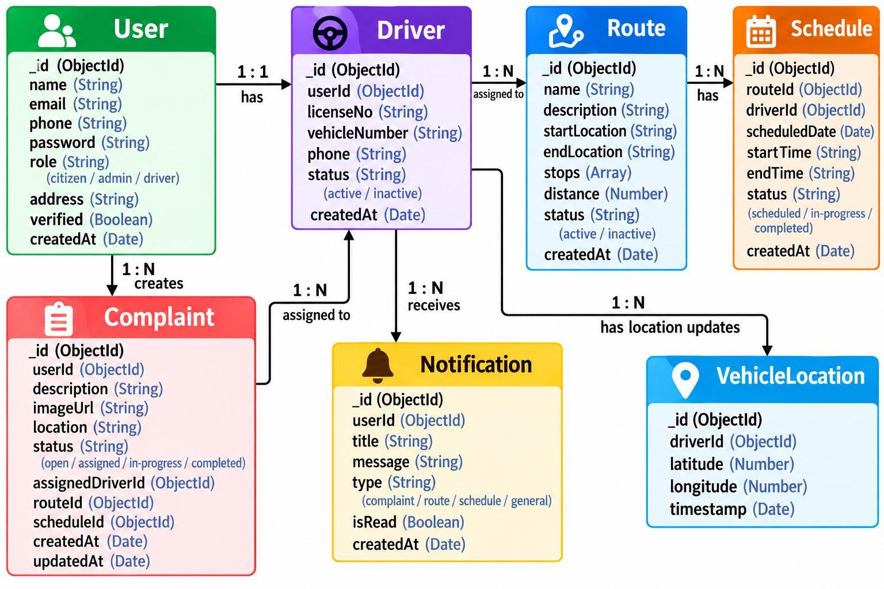

Figure 3.5: Entity Relationship (ER) & Schema Architecture Diagram

Entity Description
The CleanConnect+ database is implemented using MongoDB with Mongoose as the Object Data Modeling (ODM) library. The database consists of seven major collections that support user management, driver operations, citizen complaints, route management, collection scheduling, notifications, and GPS-based vehicle tracking.
The major entities are User, Driver, Complaint, Route, Schedule, Notification, and VehicleLocation. The User collection stores common account information and role details for citizens, drivers, and administrators. The Driver collection maintains driver-specific operational information associated with a user account. The Complaint collection stores waste-related complaints submitted by citizens, including location, images, priority, status, and complaint timeline information.
The Route collection stores driver-assigned collection routes and their individual collection stops. The Schedule collection stores collection schedules based on area, zone, waste type, day, and time slot. The Notification collection stores notifications delivered to users, while the VehicleLocation collection stores GPS coordinates and timestamps used for vehicle tracking.
Mongoose automatically provides the _id, createdAt, and updatedAt fields where applicable through the schema definitions. The following tables describe the major entities and their attributes.

Table 3.1: Entity Data Dictionary: User Collection

Attribute / Field | Data Type | Constraint / Specification | Functional Description
_id | ObjectId | Primary Key, Auto-gen | Unique system identifier for the user account
name | String | Required, Max 100 chars | Full legal name of the user or employee
email | String | Required, Unique Index | User email address used for login and notifications
password | String | Required, BCrypt Hash | Cryptographically salted password hash
role | String | Enum: admin/driver/citizen | Security authorization role determining portal access
phone | String | Required, 10 Digits | Contact telephone number for SMS alerts
assignedVehicle | ObjectId | Optional, Ref: Vehicle | Vehicle ID currently assigned to the driver
createdAt | Date | Default: Date.now() | Timestamp of user account creation

Table 3.2: Entity Data Dictionary: Complaint Collection

Attribute / Field | BSON / Data Type | Constraint / Index | Functional Description
_id | ObjectId | Primary Key, Auto-gen | Unique identifier for the citizen complaint ticket
title | String | Required, Max 150 chars | Brief descriptive title of the waste incident
description | String | Required, Max 1000 chars | Detailed description of the violation or overflow
category | String | Enum: Overflow/Garbage/etc. | Categorization of the reported waste issue
status | String | Enum: Pending/Assigned/etc. | Current lifecycle state of the complaint ticket
priority | String | Enum: Low/Medium/High | Urgency level calculated by algorithm/admin
location.coordinates | [Double, Double] | 2dsphere Spatial Index | [Longitude, Latitude] geo-coordinates
location.address | String | Required | Reverse-geocoded human-readable street address
imageUrl | String | Optional, URI String | Cloud storage URL of the photo proof
createdBy | ObjectId | Required, Ref: User | Foreign reference to the reporting citizen
assignedTo | ObjectId | Optional, Ref: User | Foreign reference to the driver assigned to remediate

Table 3.3: Entity Data Dictionary: Route Collection

Attribute / Field | BSON / Data Type | Constraint / Index | Functional Description
_id | ObjectId | Primary Key, Auto-gen | Unique identifier for the collection route
name | String | Required, Max 100 chars | Descriptive name of the route (e.g., Ward 12 Morning)
ward | String | Required, Indexed | Municipal administrative ward or zone identifier
startPoint.coordinates | [Double, Double] | Required GeoJSON | Starting depot/garage GPS coordinates
endPoint.coordinates | [Double, Double] | Required GeoJSON | Final landfill/processing depot GPS coordinates
waypoints | Array of Objects | Ordered List | Sequence of collection bin GPS coordinates and names
totalDistanceKm | Double | Calculated Float | Total calculated travel distance in kilometers
estimatedDurationMin | Integer | Calculated Integer | Estimated completion duration under standard traffic

Table 3.4: Entity Data Dictionary: Vehicle Collection

Attribute / Field | BSON / Data Type | Constraint / Index | Functional Description
_id | ObjectId | Primary Key, Auto-gen | Unique identifier for the fleet vehicle
vehicleNumber | String | Required, Unique Index | Official vehicle registration license plate
model | String | Required | Manufacturer make and vehicle model specifications
type | String | Enum: Compactor/Tipper/etc. | Classification of vehicle compaction mechanism

Attribute / Field | BSON / Data Type | Constraint / Index | Functional Description
capacityTons | Double | Required, Float > 0 | Maximum payload capacity in metric tonnes
fuelType | String | Enum: Diesel/CNG/Electric | Propulsion fuel type for emission modeling
status | String | Enum: Active/Maintenance/etc. | Operational availability state of the vehicle
currentLocation | GeoJSON Point | 2dsphere Index | Latest ingested GPS coordinates from telemetry

The MissedCollectionAlert entity stores verified exception alerts generated by the smart detection engine. It aggregates multiple citizen complaints submitted across the same street within a temporal threshold, records assigned driver telemetry evidence, tracks administrative investigation status, and maintains recollection dispatch records.
Table 3.5: Entity Data Dictionary: MissedCollectionAlert Collection
Attribute / Field | BSON / Data Type | Constraint / Index | Functional Description
_id | ObjectId | Primary Key, Auto-gen | Unique system identifier for the detection alert
street | String | Required, Indexed | Name of the street where missed collection was flagged
zone | String | Required | Municipal operational zone (e.g., Peelamedu – PSG Zone)
date | String | Required (YYYY-MM-DD) | Collection service date when the incident occurred
status | String | Enum: new / under_review / driver_contacted / recollection_required / resolved / dismissed | Current lifecycle status of the investigation workflow
priority | String | Enum: low / medium / high / urgent | Calculated severity based on report count and time
detectionType | String | Enum: citizen_cluster / driver_exception / gps_discrepancy | Mechanism by which the missed collection was flagged
reports | Array of ObjectId | Ref: Complaint | List of linked citizen complaint IDs for the street
driver | ObjectId | Optional, Ref: Driver | Assigned driver responsible for the scheduled route
vehicleId | String | Optional | Assigned municipal collection vehicle identifier
notes | Array of Objects | Embedded Subdocument | Investigation log history: admin ID, note, timestamp
recollection | Object | Embedded Subdocument | Recollection details: status, requestedAt, assignedDriver, completedAt

CHAPTER 4

SYSTEM IMPLEMENTATION

Home / Dashboard
The CleanConnect+ Executive Dashboard serves as the central administrative interface for municipal waste-management operations. Built using React.js and Lucide iconography, the interface provides a unified view of important operational information through responsive dashboard components.
The dashboard provides a centralized overview of municipal operations through summary cards displaying complaint counts, resolved complaints, registered drivers, and fleet vehicle information. It also provides complaint-category statistics and complaint trend information to support quick administrative monitoring and decision-making.
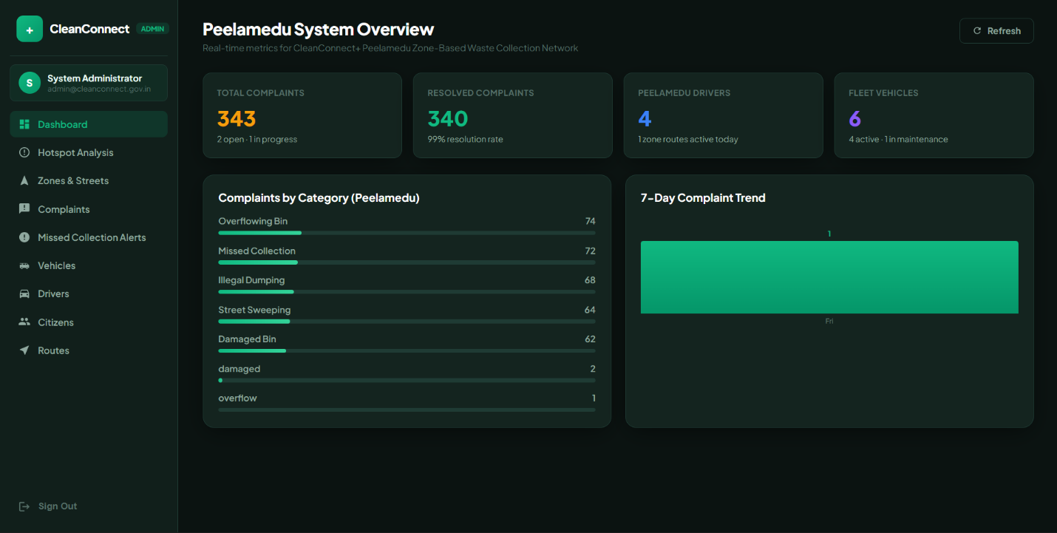

Figure 4.1: CleanConnect+ Executive Dashboard & Live Fleet Monitoring UI

Administrator Module
The Administrator Module provides centralized management of drivers and their assigned collection activities. Administrators can view registered drivers along with their employee details, assigned vehicle information, operational zone, shift timings, current route status, collection stops, and complaint-handling information.
The Driver Fleet interface allows administrators to monitor driver assignments and review collection-related activities from a centralized dashboard. This helps administrators coordinate drivers with their assigned vehicles, routes, and collection operations.
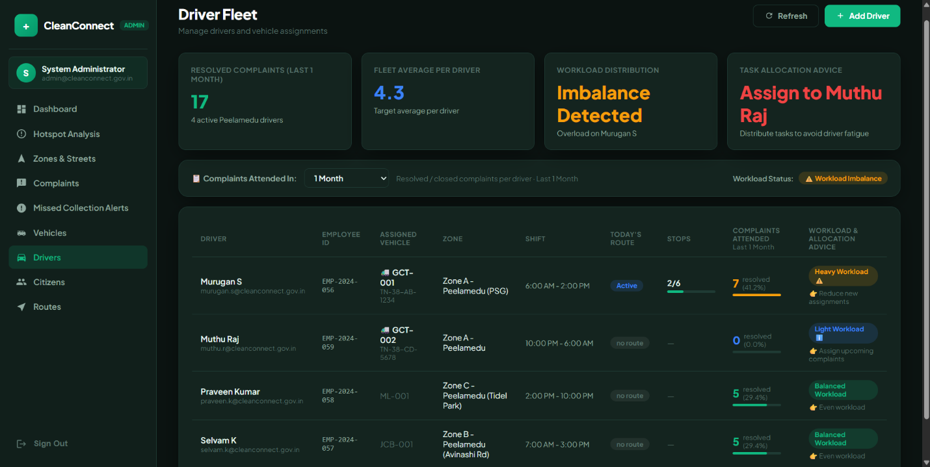
Figure 4.2: Driver and Fleet Resource Management Interface

The Zones & Streets module enables administrators to view and manage municipal operational zones and their associated streets. This interface supports the organization of collection areas for effective waste-management operations.
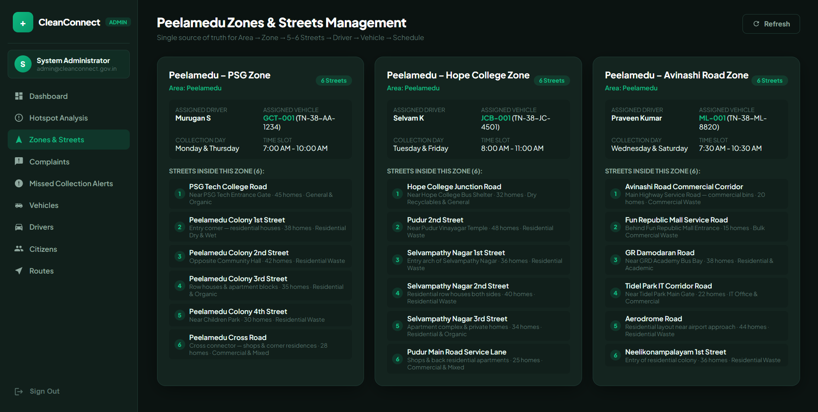
Figure 4.3: Zones and Streets Management Interface

The Citizens module provides administrators with an interface to view registered citizen accounts and their available details. This helps administrators review citizen information associated with the platform.
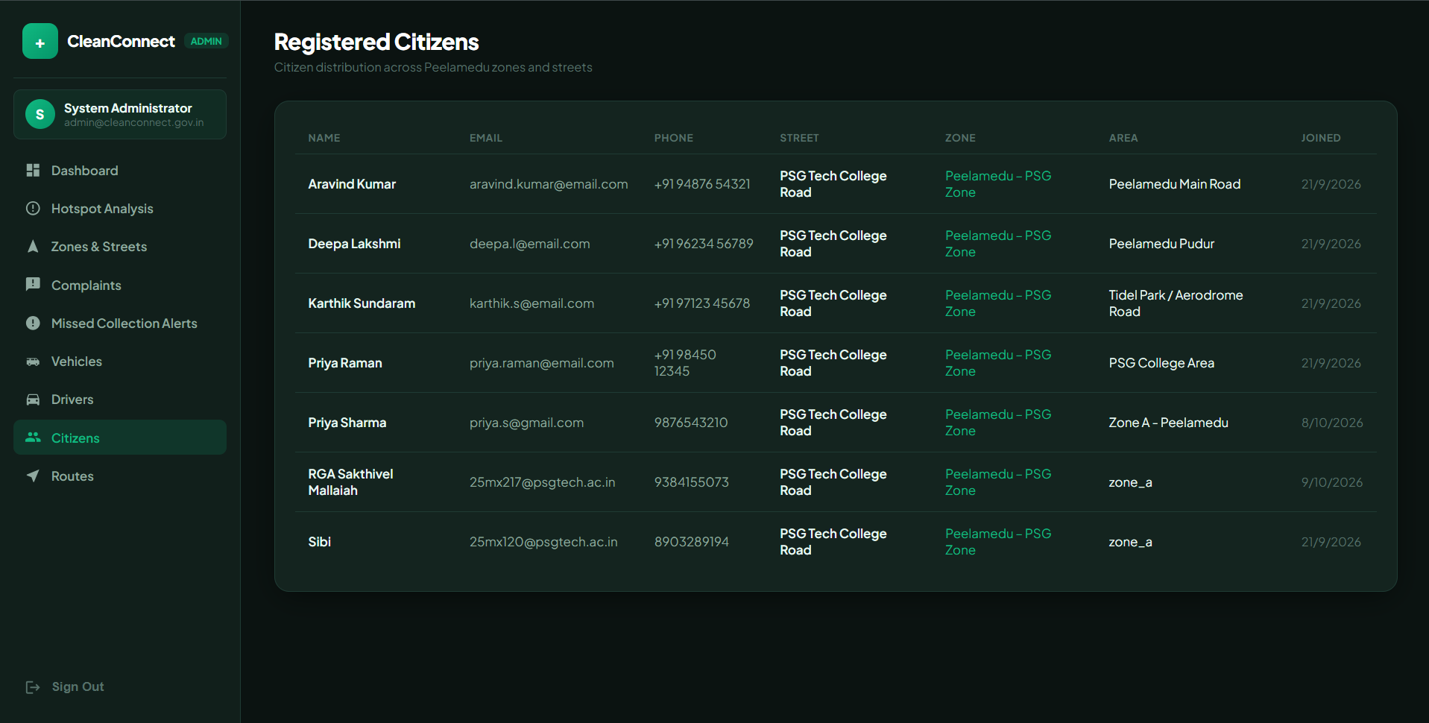
Figure 4.4: Citizen Management Interface

Complaint Management

The Complaint Management module provides administrators with a centralized interface for monitoring and managing waste-related complaints submitted by citizens. The interface displays important complaint information such as complaint ID, citizen details, complaint title, location, priority, current status, and assigned driver.
Administrators can search and filter complaints based on their status and review individual complaint details. Depending on the complaint status, administrators can assign a driver, update the complaint as resolved, or remove a complaint record. This provides a structured workflow for tracking citizen-reported waste issues and coordinating the required collection activities.
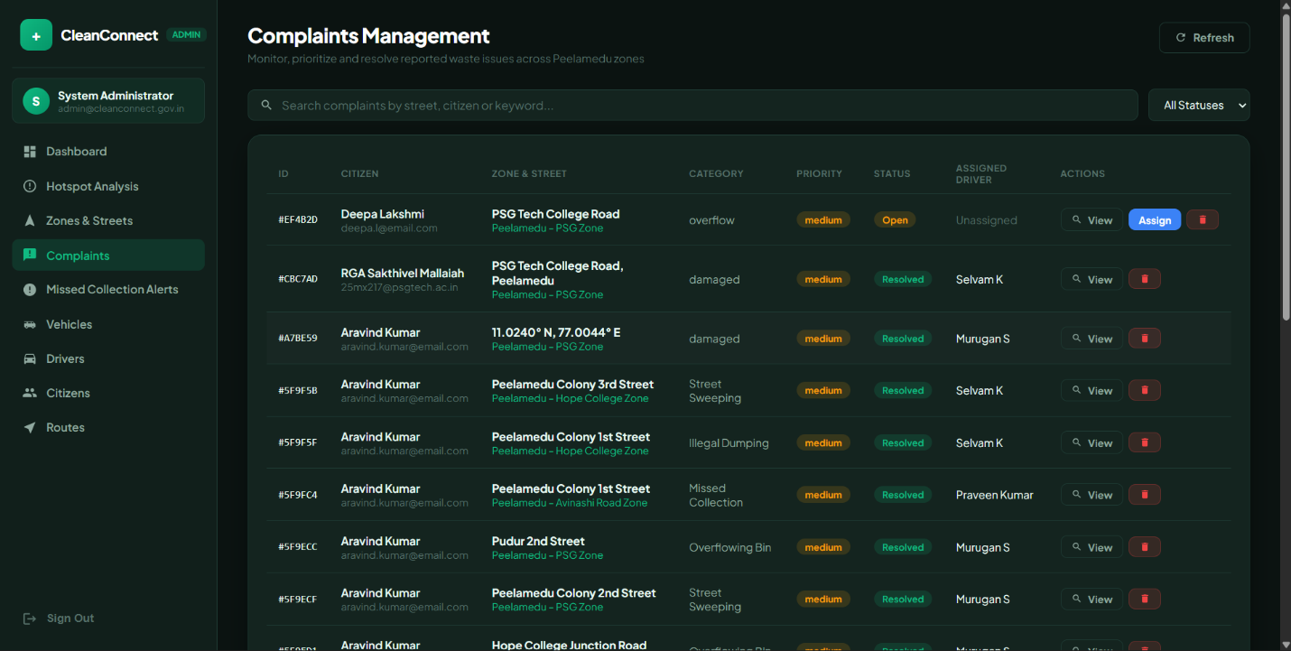
Figure 4.5: CleanConnect+ Complaint Management Interface

Route Management
The Route Management module enables administrators to manage and monitor waste collection routes efficiently. It provides details such as the assigned driver, vehicle ID, collection zone, route status, total stops, and collection progress. Administrators can track active and pending routes and reset routes when necessary. Drivers can access their assigned routes through the mobile application and view the corresponding collection stops. This helps drivers organize their daily collection activities, while administrators can monitor route progress and ensure that collection operations are carried out effectively.
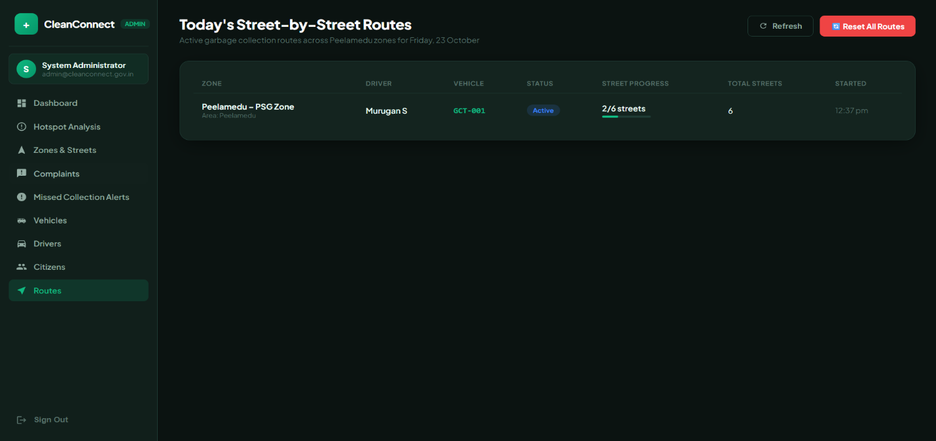
Figure 4.6: CleanConnect+ Route Management Interface

Garbage Hotspot Analysis & Zone Prioritization

To assist administrators in identifying areas requiring urgent cleanup, CleanConnect+ incorporates a lightweight machine learning module for automated hotspot detection. Instead of relying on manual inspection or basic complaint lists, the system applies spatial clustering algorithms (such as density-based clustering) on incoming geo-tagged complaint data (latitude, longitude, and timestamps) to identify recurring waste accumulation zones.
    - Spatial Clustering: Incoming citizen complaint coordinates are grouped based on spatial proximity and report frequency within a defined radius, automatically flagging high-density complaint clusters.
    - Priority Zone Scoring: Identified clusters are assigned a priority score based on complaint density, severity, and time elapsed without resolution.
    - Decision Support for Fleet Allocation: Administrators can view these predicted hotspot clusters directly on the analytical dashboard map, enabling them to prioritize high-density zones when dispatching drivers and collection vehicles.

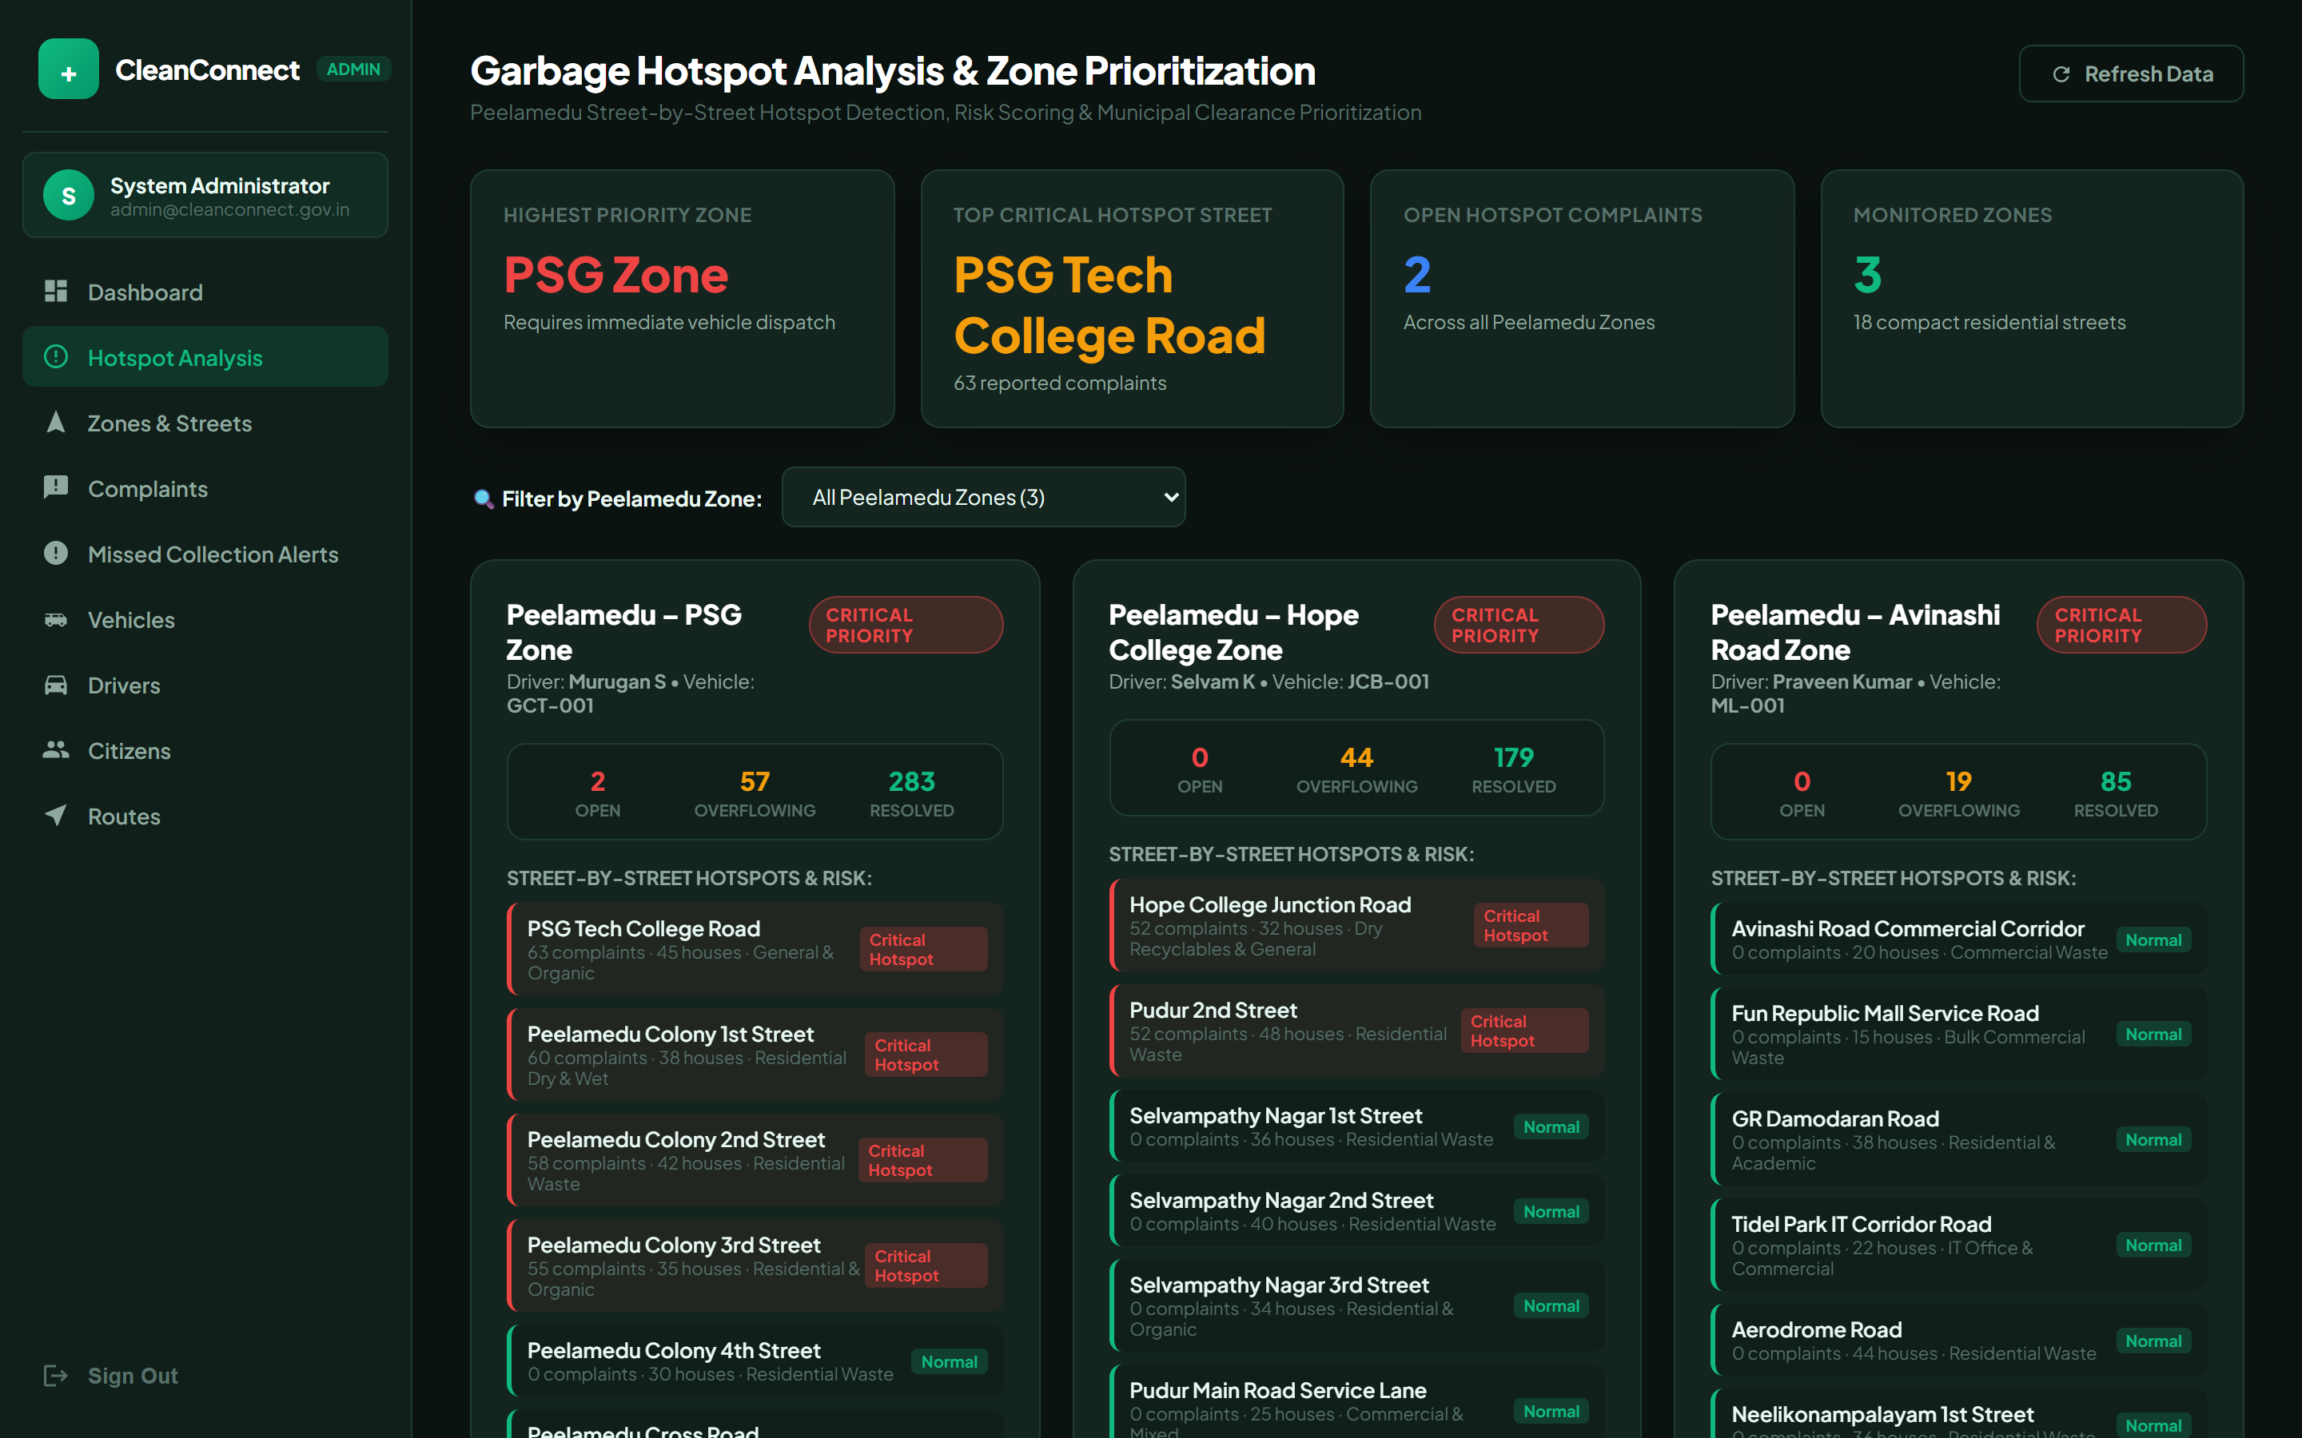
Figure 4.7: Hotspot Identification & High-Priority Zone Analytics Interface

Fleet & Vehicle Management

The Fleet & Vehicle Management module provides administrators with a centralized interface for monitoring and managing municipal sanitation vehicles and machinery. The interface displays key operational details including vehicle identification, vehicle type, registration number, carrying capacity, assigned operational zone, current operational status, and assigned driver.
Administrators can assign specific vehicles to drivers based on daily route demands and predicted hotspot priority levels, update maintenance status, toggle vehicle availability, and remove decommissioned units from the active fleet. By consolidating
fleet readiness and assignment tracking into a single dashboard view, the module ensures efficient resource deployment across municipal wards.
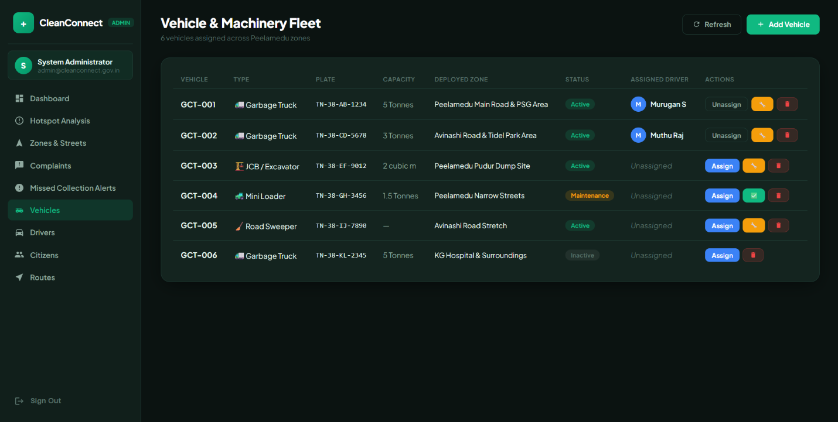

Figure 4.8: Vehicle and Machinery Fleet Management Interface

4.7 Smart Missed-Collection Detection & Administrative Investigation
A critical innovation in CleanConnect+ is the Smart Collection Verification and Missed-Collection Detection Engine (implemented in backend/services/detectionEngine.js). In conventional waste management systems, municipalities rely on scattered, subjective phone calls or delayed citizen complaints to know if a collection was missed. CleanConnect+ replaces this with an automated correlation model that reconciles three independent data streams:
1. Citizen Incident Telemetry: Citizen missed-collection reports submitted through the mobile application with precise GPS coordinates, street addresses, and timestamps.
2. Driver Route Breadcrumbs & Stop Logs: Real-time GPS trajectory recorded by the driver's device, comparing distance to scheduled route waypoints using the Haversine formula (geofence threshold: 50–100 meters).
3. Driver Exception Logs: Explicit reports logged by drivers when unable to complete a stop due to road blockages, construction, or inaccessible bin placement.
When two or more citizen reports are detected on the same street within a configurable 2-hour window on a service day, or when a driver records an unserviced stop exception, the engine synthesizes a MissedCollectionAlert document with a calculated priority score (Low, Medium, High, Urgent). Administrators are alerted immediately via the web dashboard.
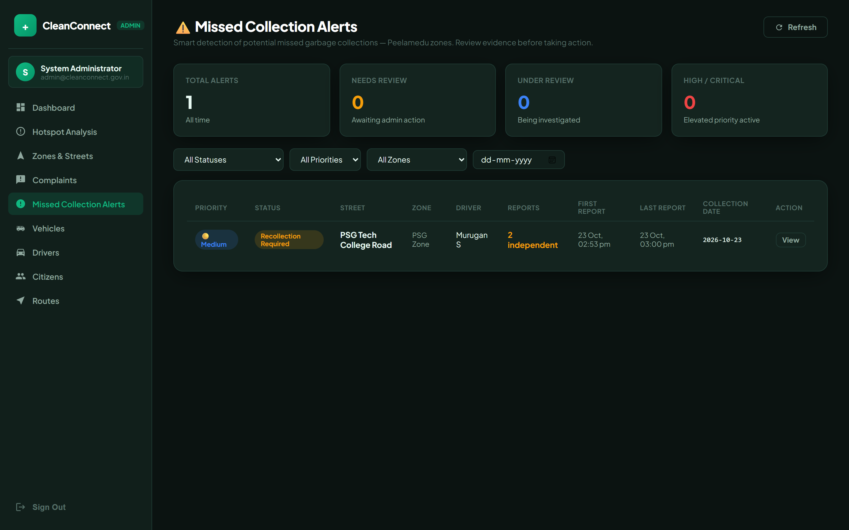
Figure 4.9: CleanConnect+ Missed Collection Alerts Dashboard
Administrative Investigation Workflow: Clicking an alert opens the detailed evidence panel (Figure 4.10). Administrators can inspect all linked citizen reports, view driver shift details, verify whether the driver's GPS passed near the street, and add investigation notes. Municipal officers can execute structured lifecycle actions: 'Mark Under Review', 'Driver Contacted', 'Request Recollection' (dispatching an on-demand recollection unit), 'Resolve', or 'Dismiss' (with mandatory audit reason logging).
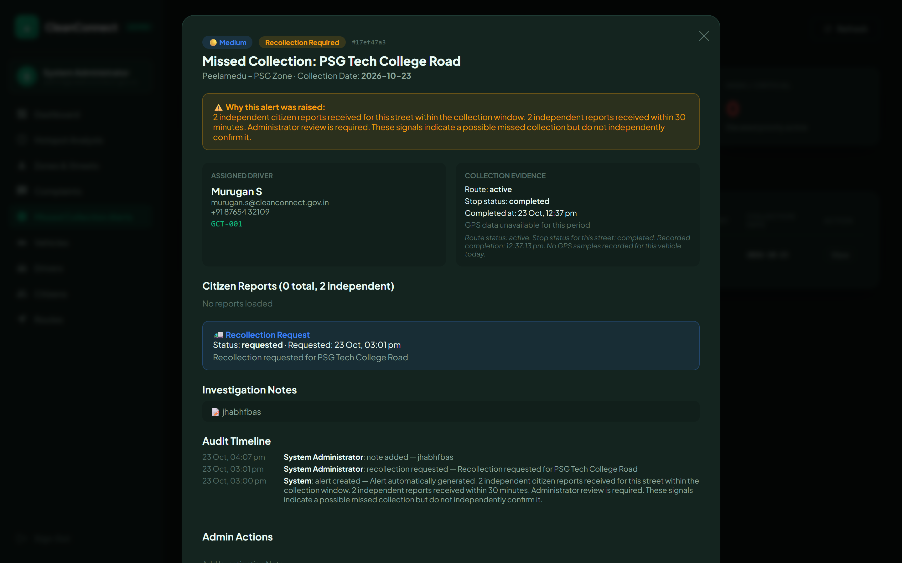
Figure 4.10: Alert Investigation, Evidence Review & Resolution Workflow Interface

4.8 Citizen Mobile Application Module
The Citizen Mobile Application is engineered using React Native and Expo to provide intuitive, cross-platform engagement for residents across municipal wards. The module delivers four essential operational capabilities:
● Collection Schedule & Live Tracking: Citizens can review daily waste pickup schedules categorized by waste type (Organic, Recyclable, Hazardous) and monitor the live GPS location of approaching municipal collection vehicles in real time via Socket.IO.
● Dedicated Missed-Collection & Incident Reporting: A streamlined reporting flow allows citizens to submit photographic evidence, automated reverse-geocoded street addresses, and issue categories (Missed Collection, Overflowing Bin, Illegal Dumping).
● Dynamic Notification Center: Maintains an active notification history that informs citizens when their complaint is assigned, when recollection is scheduled, and upon successful resolution.
● Complaint Status & Resolution Auditing: Provides transparent lifecycle tracking for all submitted reports, including admin remarks and resolution verification.
The mobile application is built with React Native (Expo SDK 54) and renders identically on both Android 10+ and iOS 15+ devices. User authentication supports role-based login for Citizens and Drivers, each presented with a dedicated flow and dashboard upon sign-in. The following screens illustrate the principal citizen-facing workflows.
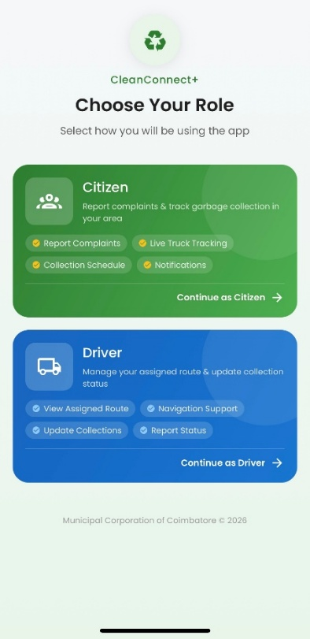

Figure 4.11: CleanConnect Mobile App - Login Screen with Role Selection (Citizen / Driver)

Figure 4.11 illustrates the authentication entry point. Citizens and drivers select their role via a segmented tab control. Upon successful JWT authentication the application navigates directly to the role-appropriate dashboard. Failed attempts surface inline validation messages with field-level highlighting.
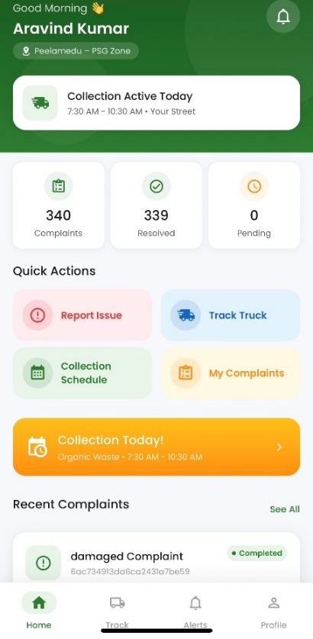
Figure 4.12: CleanConnect Mobile App - Citizen Home Dashboard with Quick Action Grid

Figure 4.12 shows the citizen home dashboard rendered after successful login. The four Quick Action cards (Report Complaint, Live Tracking, My Schedule, Notifications) provide single-tap navigation to the most frequently used features. The Recent Complaints strip beneath shows the citizen's latest submissions with live status badges (Pending, Assigned, Resolved) updated in real time via Socket.IO.
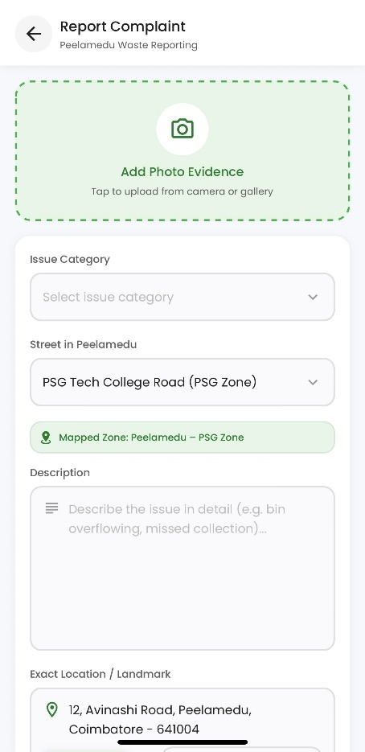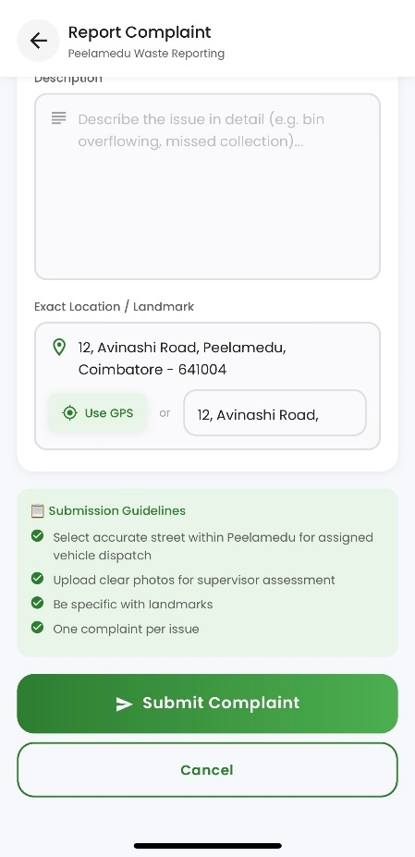
Figure 4.13: CleanConnect Mobile App - Report a Complaint Screen with GPS Auto-Detection

Figure 4.13 depicts the complaint submission interface. Category chips allow citizens to classify the incident (Missed Collection, Overflowing Bin, Illegal Dumping, Street Sweeping). The location field is automatically populated using the device GPS with reverse-geocoding via the Nominatim API. Citizens may optionally attach photographic evidence before submitting.
Collection Schedule Calendar: Displays the ward-specific daily pickup schedule organised by waste type - Organic, Recyclable, and Hazardous. Citizens receive push notifications 30 minutes before the vehicle enters their street.
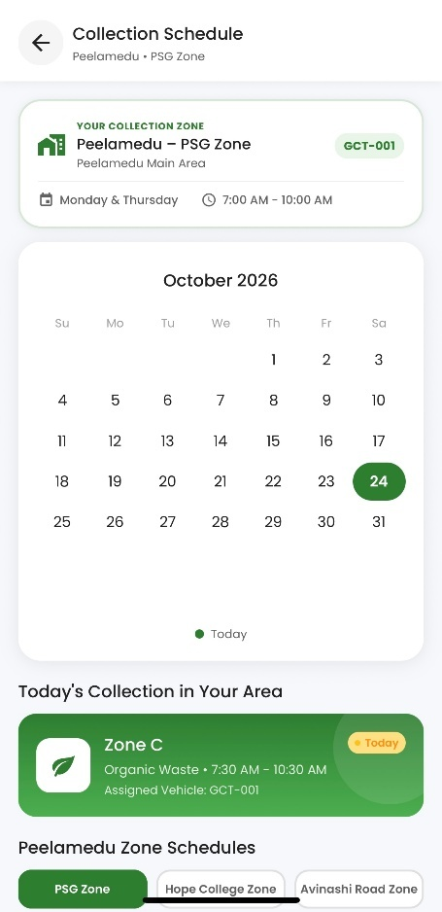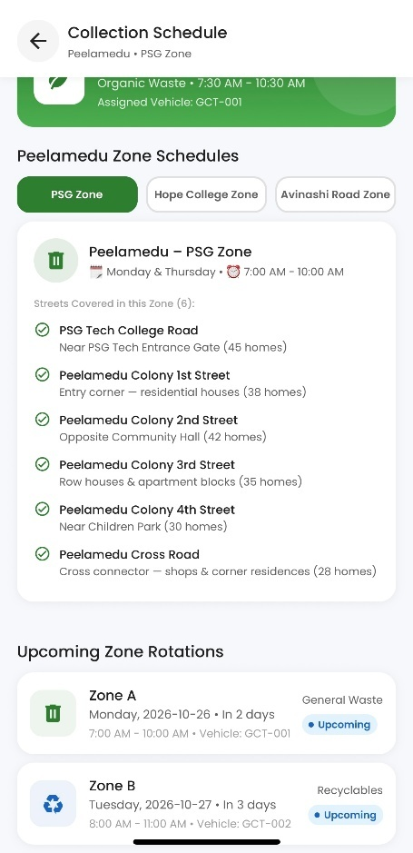
Fig 4.14: Collection Schedule Calendar
Live Vehicle Tracking Map: An interactive map renders the real-time GPS location of the approaching garbage collection vehicle. ETA and remaining stops are computed dynamically and refreshed every 5 seconds via Socket.IO.
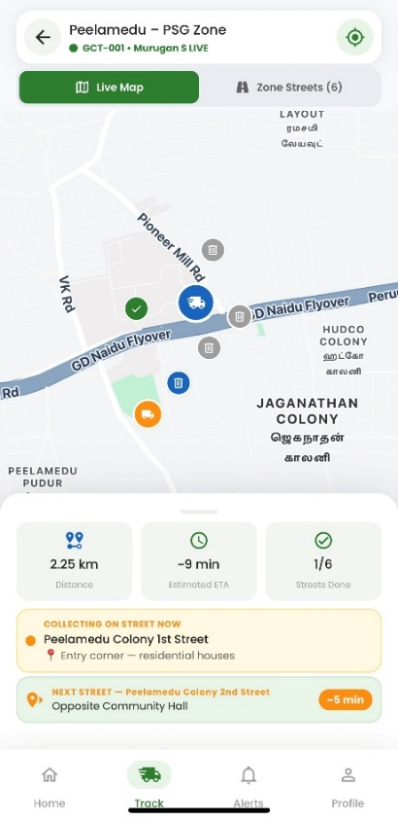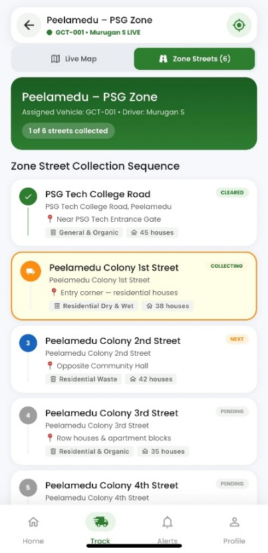
Fig 4.15: Live Vehicle Tracking Map & Zone and Street Collection Details

Notification History Centre: An auditable timeline of all system-generated notifications including complaint assignment confirmations, recollection scheduling alerts, and resolution confirmations with admin remarks.
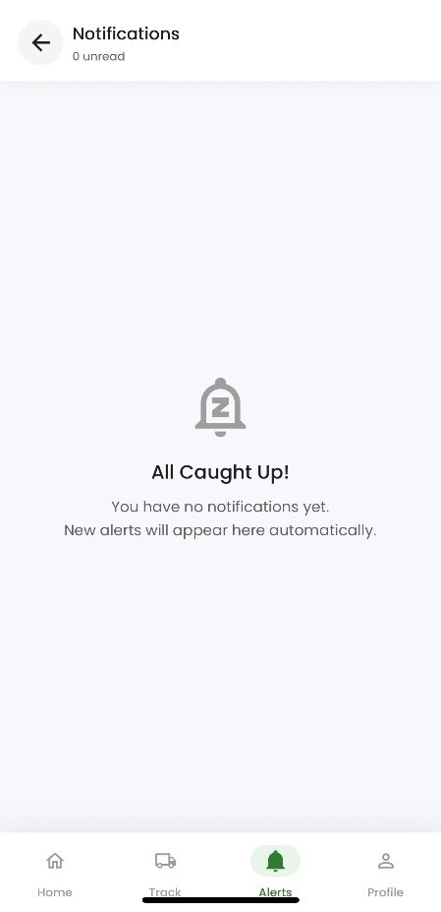
Fig 4.16: Citizen Notification Centre
My Complaints and Status Tracking: Displays the citizen’s submitted complaints and their current status, enabling them to monitor complaint progress.
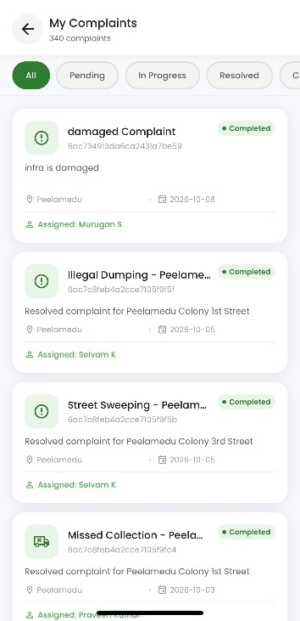
Fig 4.17: My Complaints and Status Tracking
Citizen Profile and Application Settings: Figures 4.18 illustrate the citizen’s profile information and available application settings for managing their account and preferences.
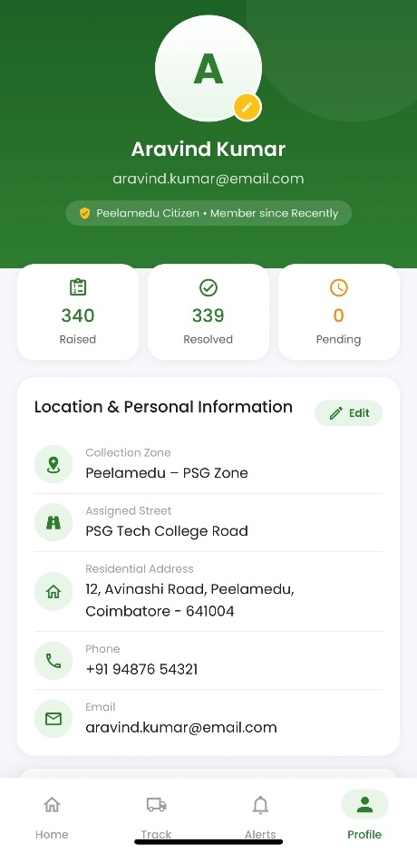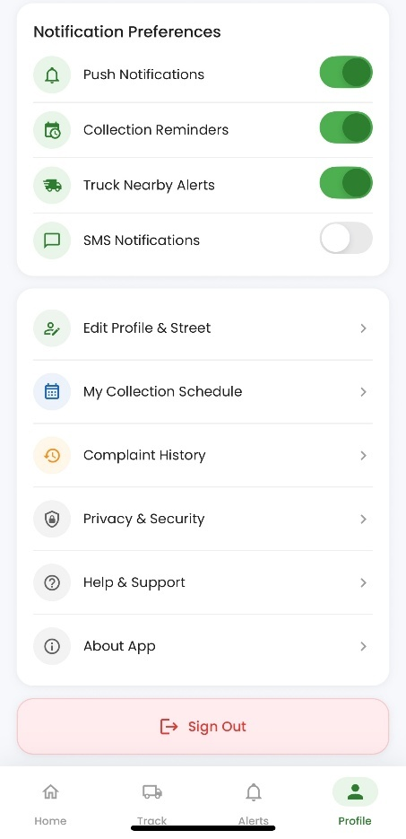
Fig 4.18: Citizen Profile and Personal Information & Application Settings

4.9 Driver Field Operations & Live Navigation Module
The Driver Mobile Application, developed using React Native and Expo, provides field-operation features for managing collection routes, monitoring vehicle locations, and recording collection activities.
The main features of the driver module are described below:
- Driver Dashboard and Route Management: Drivers can access their route information, assigned collection stops, and collection progress through the mobile application. Route and vehicle information is retrieved from the backend, with fallback values available for certain fields when data is unavailable.
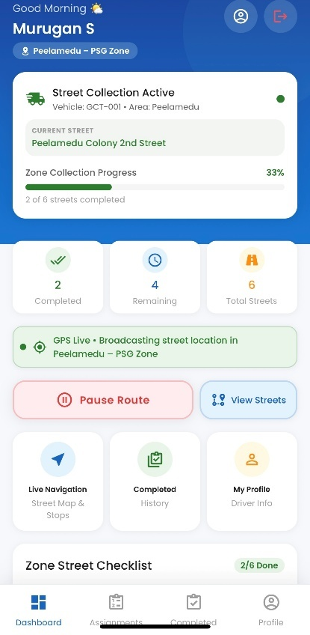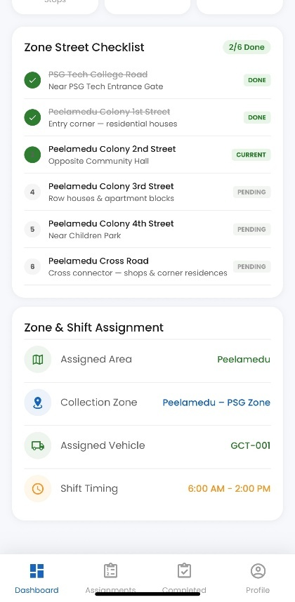
Figure 4.19: Driver Dashboard and Collection Overview
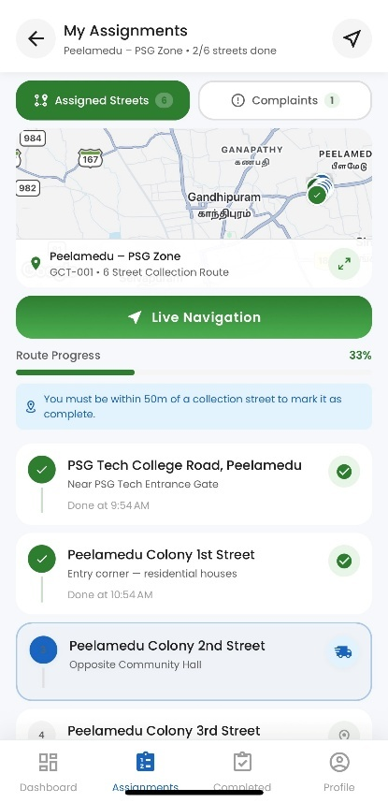
Figure 4.20: Driver Assignments and Collection Progress
- Map-Based Route Visualization: The Live Navigation module displays collection stops on an interactive map and draws route polylines between locations. Drivers can view the current stop, remaining collection stops, and their proximity to the next collection location. The interface supports route visualization and stop guidance rather than full turn-by-turn voice navigation.
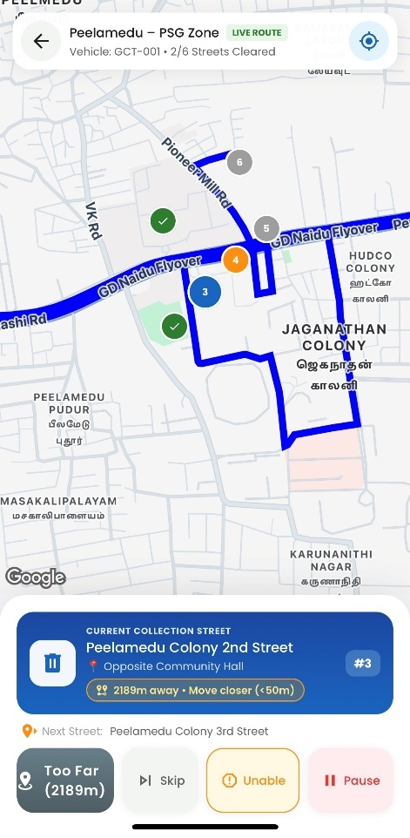
Figure 4.21: Driver Route Map and Collection Locations
- GPS Location Tracking: When a driver starts a route, the application watches the device's location and sends location updates to the backend. The location watcher is configured to request updates at a three-second interval or when the device moves five metres. Actual update frequency depends on device location services and operating conditions.
- Collection Stop Completion: Drivers can mark a collection stop as completed after confirming the action in the application. The mobile interface checks whether the driver's reported location is within the configured proximity threshold of the stop. The backend performs an additional proximity check when valid coordinates are supplied, using a 100-metre threshold. The backend check is conditional on the availability of the required coordinates.
- Unable-to-Collect Exception Reporting: When a collection stop cannot be serviced, drivers can select a reason such as an inaccessible or blocked street, vehicle breakdown, safety issue, or absence of waste for collection. The backend records the selected reason against the stop and marks it as skipped rather than completed. The route status is retained, and the application can advance to another pending stop.

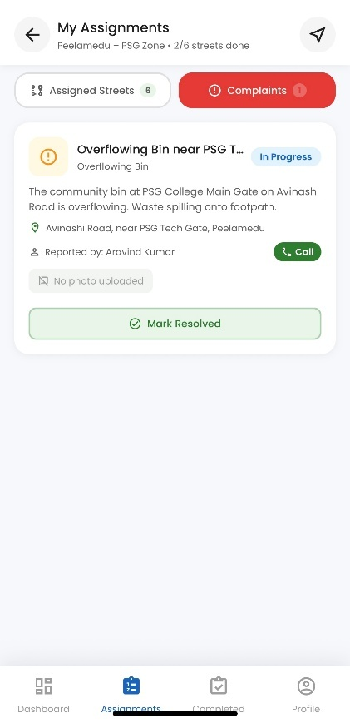
Figure 4.22: Driver Complaint Assignments
- Completed Collection History: The application provides a history view of completed stops retrieved from the driver's route data. It displays available stop details and completion times, allowing drivers to review collection activities.
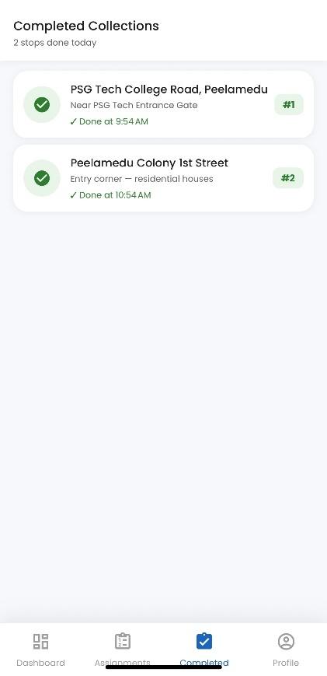
Figure 4.23: Completed Collection Records

- Driver Profile page: The Driver Profile page displays the driver's personal and employment details, availability status, assigned vehicle and route information, shift timings, and collection progress. It also provides quick access to features such as Collection History, Performance Report, Help & Support, and Privacy & Security, along with a Sign Out option.
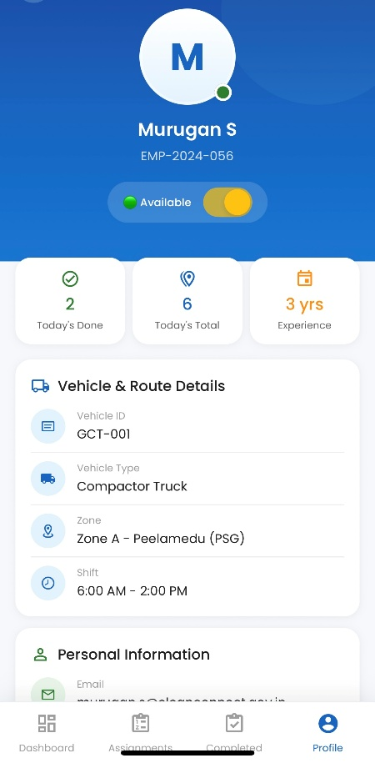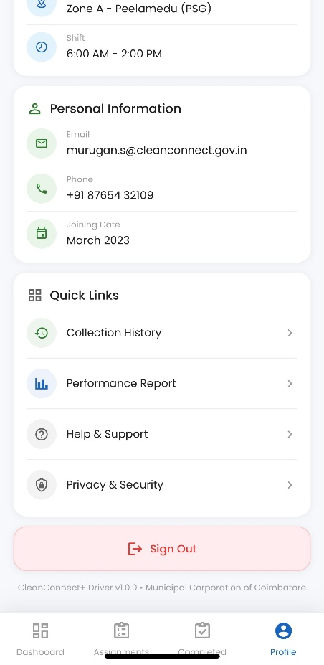
Figure 4.24: Driver Profile and Vehicle Details & Operational Details
These features provide a mobile interface for driver route management, GPS-based vehicle tracking, collection-stop updates, and exception recording. The application communicates with the backend to persist route and stop information and to share relevant operational updates with connected system components.

4.10 RESTful API Implementation
CleanConnect+ exposes a suite of RESTful API endpoints organized modularly under
/api/auth, /api/admin, /api/driver, /api/complaints, /api/schedules, /api/tracking, and
/api/notifications.
Key endpoints supporting system integration and data retrieval are documented in Table 4.1 below.

Table 4.1: Core RESTful API Endpoint Specifications

HTTP Method | Endpoint URI | Auth Role Required | Operational Contract  / Handler
POST | /api/auth/login | Public | Authenticates credentials, returns signed JWT & user profile
GET | /api/admin/stats | Admin | Aggregates live counts of vehicles, routes, and complaints
GET | /api/admin/vehicles | Admin | Retrieves comprehensive fleet inventory
POST | /api/admin/vehicles | Admin | Registers new sanitation vehicle with payload specifications
GET | /api/schedules | Authenticated | Lists collection schedules
POST | /api/driver/location | Driver | Stores GPS location and broadcasts it through Socket.IO
POST | /api/complaints | Citizen | Submits geo-tagged incident ticket with multipart photo
GET | /api/admin/complaints | Admin | Retrieves all citizen complaints for management
GET | /api/alerts | Admin | Retrieves paginated missed-collection alerts with status/zone filters
GET | /api/alerts/:id | Admin | Retrieves alert detail, linked citizen complaints, and GPS breadcrumbs
PATCH | /api/alerts/:id/status | Admin | Updates alert lifecycle status and logs investigation notes
POST | /api/alerts/:id/recollection | Admin | Dispatches on-demand recollection order for uncollected street
POST | /api/driver/routes/:id/stops/:stopId/unable | Driver | Logs 'Unable to Collect' exception report with standardized reason
GET | /api/notifications | Authenticated | Fetches user notification history with read/unread tracking

CHAPTER 5 SYSTEM TESTING

Testing Introduction
Software testing represents an essential phase in verifying that CleanConnect+ functions correctly, reliably, and securely under real-world municipal operating conditions. The primary objective is to systematically discover, diagnose, and remediate software defects across individual backend endpoints, database persistence layers, and frontend user interfaces. Testing focused on functional verification across the mobile and web platforms, ensuring that role-based access control, real-time complaint submissions, hotspot density aggregations, and route management workflows operate as expected.
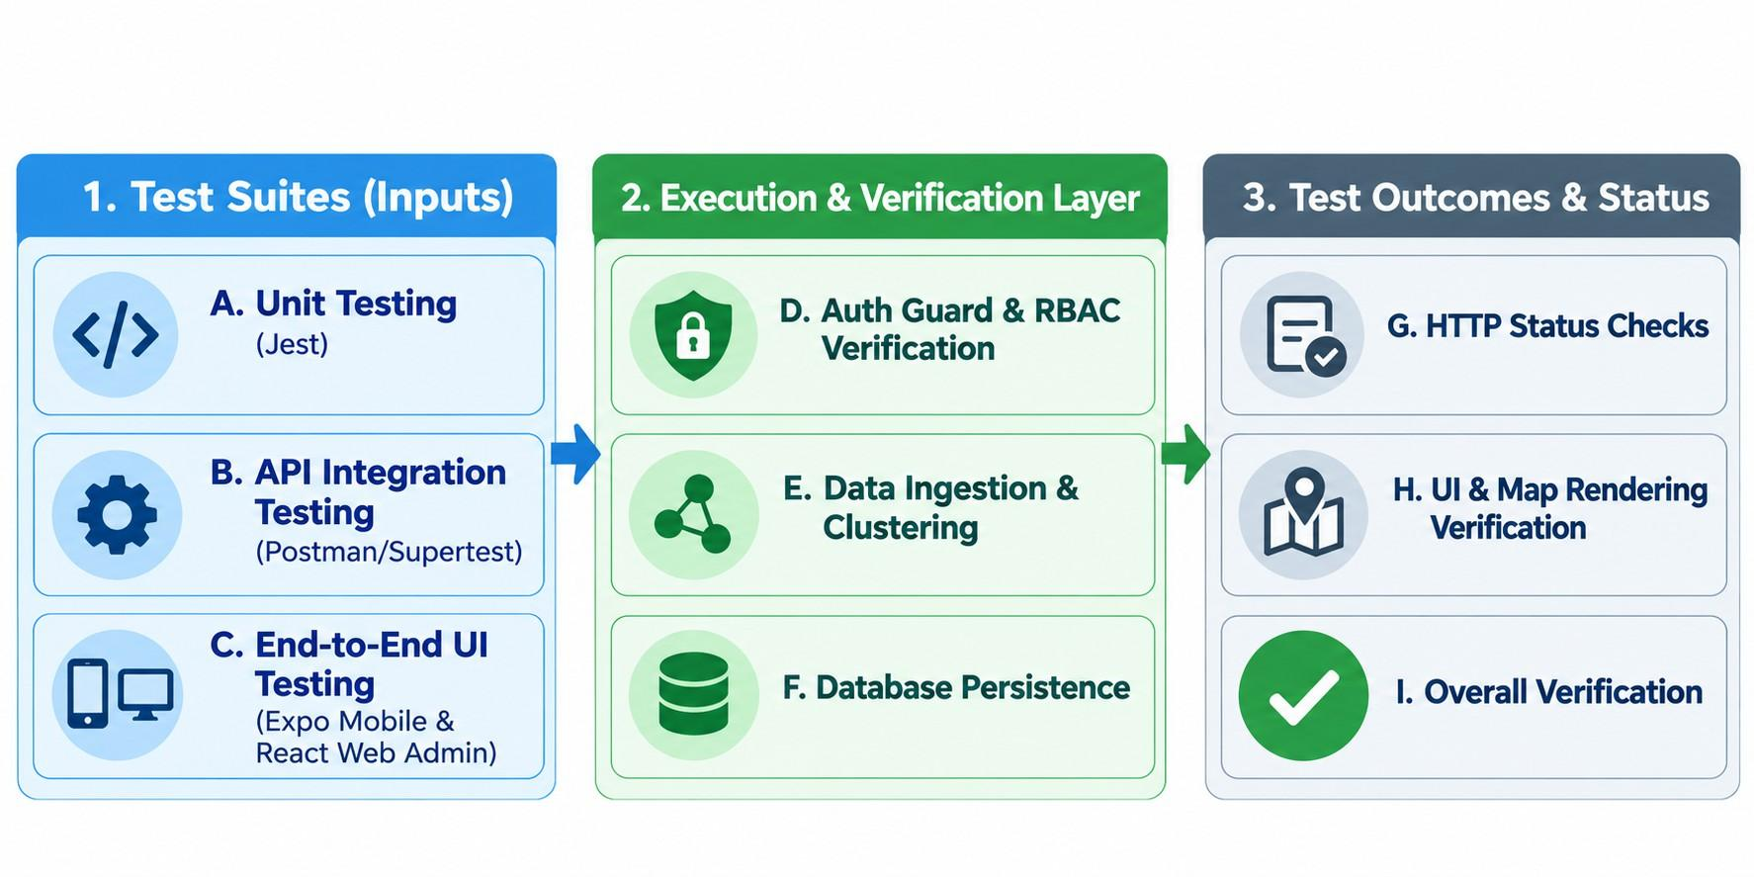

Figure 5.1: CleanConnect+ System Testing Workflow Architecture

5.2 Testing Techniques

Selected testing strategies were implemented to evaluate distinct functional and structural facets of the application:
    - Unit & Controller Testing: Conducted using Jest to test isolated utility functions, middleware authentication logic, and geo-coordinate helper calculations.
    - Integration & API Testing: Executed using Supertest and API clients (such as Postman) to validate HTTP status codes, request validation middleware, JWT authorization headers, and MongoDB CRUD operations.
    - End-to-End (E2E) Functional Testing: Simulated citizen complaint submissions via the Expo mobile app, administrative dispatch workflows via the React web portal, and driver status updates.
    - Security & Role Boundary Testing: Verified that unauthorized users (e.g., citizen accounts) cannot access administrative endpoints (/api/admin), and verified password hashing via BCrypt.

Test Cases
Formal test cases were executed across critical functional pathways of CleanConnect+. Table 5.1 documents representative test cases and their empirical outcomes.

Table 5.1: Comprehensive System Test Case Execution Log

TC ID | Module / Feature |  | Input / Test Condition |  |  | Expected Outcome | Actual Outcome |  | Status
TC-01 | Auth Service |  | Valid email & password for Admin |  |  | HTTP 200,  JWT token returned, Admin role | HTTP 200,  Valid JWT received |  | PASS
TC-02 | Auth Service |  | Invalid password attempt (3 times) |  |  | HTTP 401  Unauthorized, Error message | HTTP 401,  Invalid credentials |  | PASS
TC-03 | RBAC Guard |  | Citizen token requesting Admin route |  |  | HTTP 403  Forbidden, Access denied | HTTP 403,  Forbidden error |  | PASS
TC-04 | Telemetry Ingest |  | Driver GPS coord payload [76.96, 11.01] |  |  | HTTP 200,  Vehicle location updated in DB | HTTP 200,  Location stored & broadcast |  | PASS
TC-05 |  | Complaint Module |  | Citizen submit with JPG image & coords | HTTP 201  Created, Complaint status 'Pending' |  | HTTP 201,  Record created with image | PASS
TC-06 |  | Route Validation |  | Route created with invalid depot coords | HTTP 400 Bad  Request, Validation error |  | HTTP 400,  Coordinate schema error | PASS

TC ID | Module / Feature | Input / Test Condition | Expected Outcome | Actual Outcome | Status
TC-07 | Live Tracking UI | Driver moves 500m along route | Vehicle marker moves smoothly on the map | Marker animated to new coordinates | PASS
TC-08 | Missed-Collection Detection | 2 complaints on same street within 2 hrs | HTTP 201, MissedCollectionAlert generated with priority | Alert auto-created, flagged High Priority on Admin portal | PASS
TC-09 | Driver Exception Ingest | Stop marked 'Road Blocked' via navigation | HTTP 200, Stop marked with unable reason & details | Exception logged, alert updated without penalizing driver | PASS
TC-10 | Fleet Synchronization | Admin assigns Driver A to Vehicle B | Vehicle assignedDriver and Driver vehicleId sync in DB | Both documents updated synchronously, verified via API | PASS
TC-11 | Notification Timeline | Complaint status changed to 'Resolved' | Notification created in DB and delivered via socket/feed | Citizen notification feed updated with resolution timestamp | PASS

CHAPTER 6 CONCLUSION

Conclusion
The development of CleanConnect+ addresses key challenges in municipal waste collection, fleet coordination, citizen complaint handling, and priority zone monitoring. By integrating a React-based administrative dashboard, React Native mobile applications, a Node.js and Express.js backend, and MongoDB, the system provides a unified platform for digital waste management. It streamlines complaint registration, driver assignments, GPS tracking, and fleet management, improving coordination among citizens, drivers, and administrators.
The platform also uses spatial complaint aggregation and hotspot density analysis to help administrators prioritize cleanup activities. Functional testing evaluated the core modules, role-based access control, and operational workflows. Overall, CleanConnect+ provides a scalable foundation for modernizing waste collection, improving service monitoring, and enhancing responsiveness across municipal wards.

Future Enhancements
Although CleanConnect+ provides an effective foundation for smart municipal waste management, several enhancements can be introduced in future versions. Integrating IoT-based bin sensors would enable real-time monitoring of garbage fill levels and automated alerts when bins reach capacity. Dynamic route optimization using live traffic data could help reassign vehicles during road closures, accidents, or other disruptions, improving collection efficiency and reducing unnecessary travel.
Further improvements could include automated photo verification using computer vision to validate citizen complaints and categorize waste types. The mobile application could also be enhanced with multilingual support, automated pickup schedule notifications, and a reward system to encourage active citizen participation. These enhancements would improve automation, operational efficiency, and community engagement in municipal waste management.

BIBLIOGRAPHY

- Fielding, R. T. (2000). 'Architectural Styles and the Design of Network-based
Software Architectures.' Doctoral dissertation, University of California, Irvine.
- Goodchild, M. F. (2007). 'Citizens as sensors: The world of volunteered geographic information.' GeoJournal, 69(4), 211-221.
- Hoornweg, D., & Bhada-Tata, P. (2012). 'What a Waste: A Global Review of Solid Waste Management.' Urban Development Series Knowledge Papers, World Bank, Washington, DC.
- Kaza, S., Yao, L. C., Bhada-Tata, P., & Van Woerden, F. (2018). What a Waste 2.0: A Global Snapshot of Solid Waste Management to 2050. Urban Development Series. Washington, DC: World Bank. doi:10.1596/978-1-4648-1329-0.
- Kumar, S., Smith, S. R., Fowler, G., Velis, C., Kumar, S. J., Arya, S., ... &
Cheeseman, C. (2017). 'Challenges and opportunities associated with waste management in India.' Royal Society Open Science, 4(3), 160764.
- MongoDB Inc. (2024). Geospatial Queries. MongoDB Database Manual, Version 7.0.
- OpenStreetMap Contributors. (2024). OpenStreetMap. OpenStreetMap. Available:
https://www.openstreetmap.org/about
- Pedregosa, F., Varoquaux, G., Gramfort, A., Michel, V., Thirion, B., Grisel, O., ... &
Duchesnay, E. (2011). 'Scikit-learn: Machine Learning in Python.' Journal of Machine Learning Research, 12, 2825-2830.
- React Native. (2024). React Native. Meta Platforms, Inc. Available:
https://reactnative.dev/
- Rovetta, A., Xiumin, F., Vicentini, F., Zhu, M., Giusti, A., & He, Q. (2009). “Early detection and evaluation of waste through sensorized containers for a collection monitoring application.” Waste Management, 29(12), 2939–2949.
- Toth, P., & Vigo, D. (2014). 'Vehicle Routing: Problems, Methods, and Applications.' Society for Industrial and Applied Mathematics (SIAM), Second Edition.

