**FAKE NEWS DETECTION USING NLP**

**Program Code for Loading and Preprocessing Dataset:**

**( Based on Passive Aggressive Classifier )**

import pandas as pd

import sklearn

import itertools

import numpy as np

import seaborn as sb

import re

import nltk

import pickle

from sklearn.model_selection import train_test_split

from sklearn.feature_extraction.text import TfidfVectorizer

from sklearn import metrics

from sklearn.metrics import confusion_matrix

from matplotlib import pyplot as plt

from sklearn.linear_model import PassiveAggressiveClassifier

from nltk.stem import WordNetLemmatizer

from nltk.corpus import stopwords

train_df = pd.read_csv(r'C:\Users\Mayur\Downloads\train.csv')

train_df.head(15)

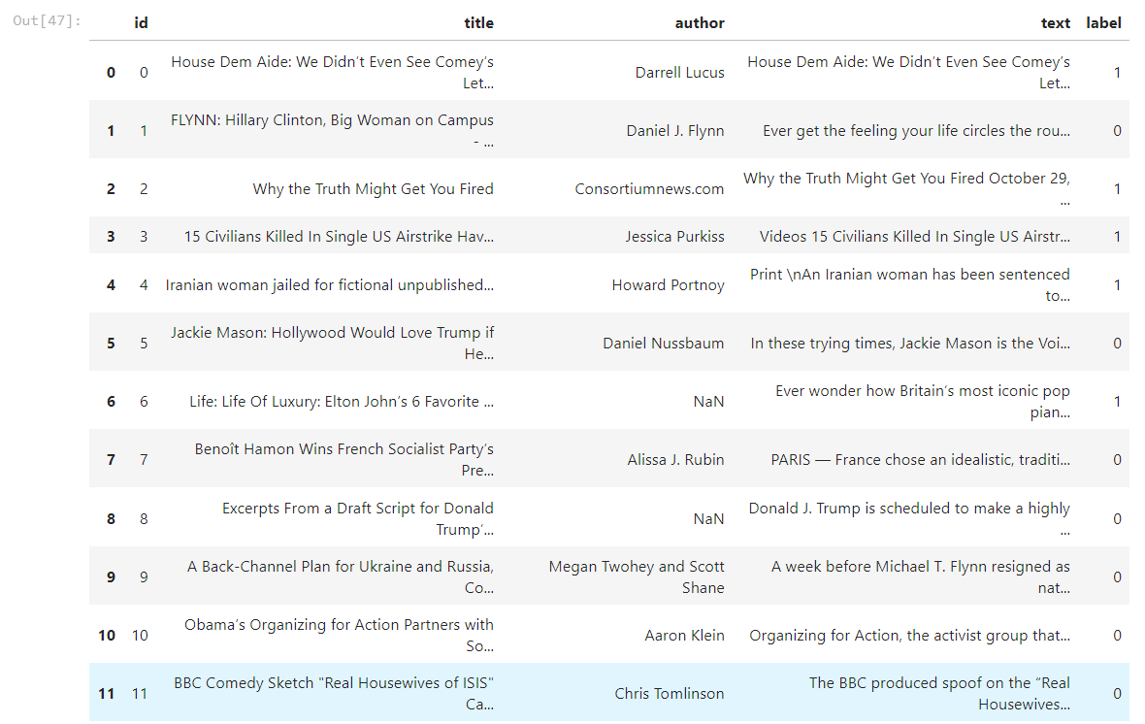

train_df = train_df.drop("author", axis = 1)

train_df = train_df.drop("title", axis = 1)

train_df = train_df.drop("id", axis = 1)

train_df.shape



train_df.head(15)

