**FAKE NEWS DETECTION USING NLP**

**Program Code for Loading and Preprocessing Dataset:**

**( Based on Passive Aggressive Classifier )**

import pandas as pd

import sklearn

import itertools

import numpy as np

import seaborn as sb

import re

import nltk

import pickle

from sklearn.model_selection import train_test_split

from sklearn.feature_extraction.text import TfidfVectorizer

from sklearn import metrics

from sklearn.metrics import confusion_matrix

from matplotlib import pyplot as plt

from sklearn.linear_model import PassiveAggressiveClassifier

from nltk.stem import WordNetLemmatizer

from nltk.corpus import stopwords

train_df = pd.read_csv(r'C:\Users\Mayur\Downloads\train.csv')

train_df.head(15)

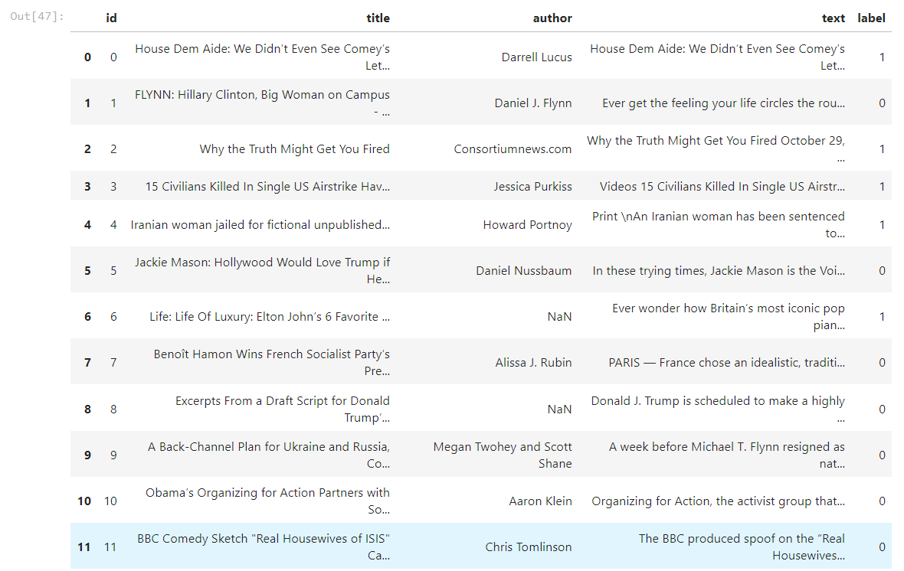

train_df = train_df.drop("author", axis = 1)

train_df = train_df.drop("title", axis = 1)

train_df = train_df.drop("id", axis = 1)

train_df.shape



train_df.head(15)

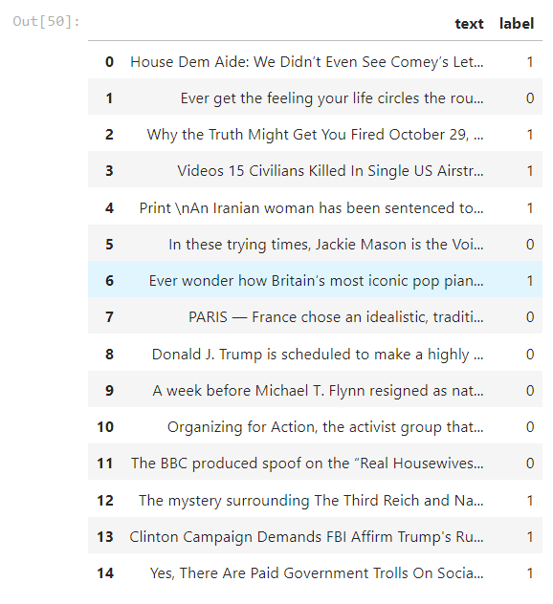

**Program Code for Feature-Extraction and Classification:**

def create_distribution(dataFile):

return sb.countplot(x='label', data=dataFile, palette='hls')

# by calling below we can see that training, test and valid data seems to be failry evenly distributed between the classes

create_distribution(train_df)

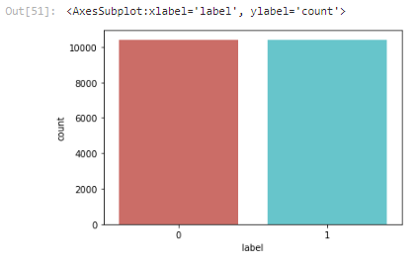

def data_qualityCheck():

print("Checking data qualitites...")

train_df.isnull().sum()

train_df.info()

print("check finished.")

data_qualityCheck()

train_df = train_df.dropna()

data_qualityCheck()

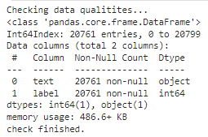

train_df.shape



train_df.head(10)



train_df.reset_index(drop= True,inplace=True)

train_df.head(10)



label_train = train_df.label

label_train.head(10)

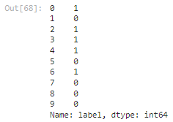

train_df = train_df.drop("label", axis = 1)

train_df.head(10)



train_df['text'][2188]



lemmatizer = WordNetLemmatizer()

stpwrds = list(stopwords.words('english'))

stpwrds

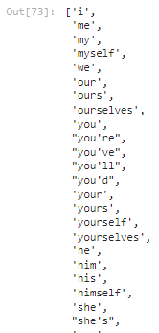

for x in range(len(train_df)) :

corpus = []

review = train_df['text'][x]

review = re.sub(r'[^a-zA-Z\s]', '', review)

review = review.lower()

review = nltk.word_tokenize(review)

for y in review :

if y not in stpwrds :

corpus.append(lemmatizer.lemmatize(y))

review = ' '.join(corpus)

train_df['text'][x] = review

train_df['text'][2182]

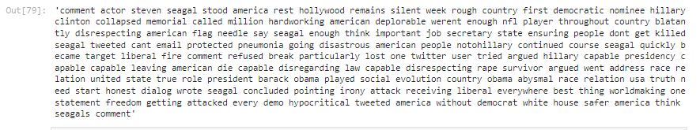

X_train, X_test, Y_train, Y_test = train_test_split(train_df['text'], label_train, test_size=0.3, random_state=1)

X_train

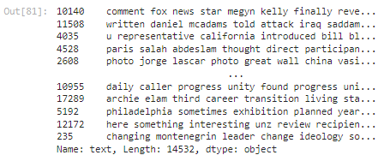

X_train.shape



Y_train

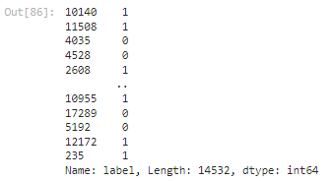

tfidf_v = TfidfVectorizer()

tfidf_X_train = tfidf_v.fit_transform(X_train)

tfidf_X_test = tfidf_v.transform(X_test)

tfidf_X_train.shape



def plot_confusion_matrix(cm, classes,

normalize=False,

title='Confusion matrix',

cmap=plt.cm.Blues):

plt.imshow(cm, interpolation='nearest', cmap=cmap)

plt.title(title)

plt.colorbar()

tick_marks = np.arange(len(classes))

plt.xticks(tick_marks, classes, rotation=45)

plt.yticks(tick_marks, classes)

if normalize:

cm = cm.astype('float') / cm.sum(axis=1)[:, np.newaxis]

print("Normalized confusion matrix")

else:

print('Confusion matrix, without normalization')

thresh = cm.max() / 2.

for i, j in itertools.product(range(cm.shape[0]), range(cm.shape[1])):

plt.text(j, i, cm[i, j],

horizontalalignment="center",

color="white" if cm[i, j] > thresh else "black")

plt.tight_layout()

plt.ylabel('True label')

plt.xlabel('Predicted label')

classifier = PassiveAggressiveClassifier()

classifier.fit(tfidf_X_train,Y_train)



Y_pred = classifier.predict(tfidf_X_test)

score = metrics.accuracy_score(Y_test, Y_pred)

print(f'Accuracy: {round(score*100,2)}%')

cm = metrics.confusion_matrix(Y_test, Y_pred)

plot_confusion_matrix(cm, classes=['FAKE Data', 'REAL Data'])

