Calculator Test

* Verification of all buttons are present, and text written on them is readable – **PASS**
* Check the simple arithmetic operations are working fine +,-,*,.- **PASS**

**FUNCTIONAL TEST CASES TESTED**

* Check the addition of two number -PASS.
* Check the addition of two negative number -PASS.
* Check the addition of one positive and negative number -PASS.
* Check the subtraction of two integer number -PASS.
* Check the subtraction of one negative and one positive number -PASS.
* Check the subtraction of two negative integer number -PASS.
* Check the multiplication of two integers -PASS.
* Check the multiplication of one negative number and one positive number -PASS.
* Division of two positive one-digit number -PASS

**BUGS**

* Division only works with one-digit number.

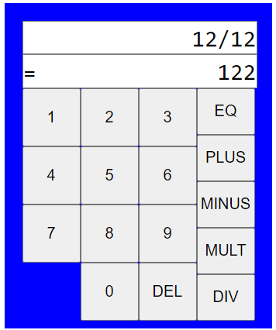

Expected=1

* Multiplication of two negative number.

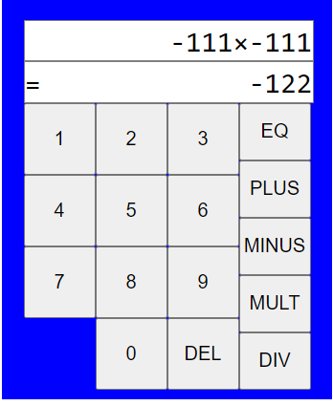

Expected 12321 or ‘**ERR**’.

* Multiplication of 11 end up in showing **wrong value.**

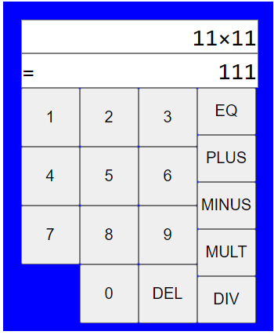

Expected **121**

* Division by large number

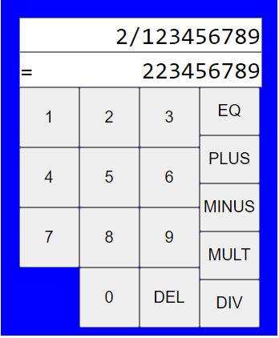

Expected 1.6

* Test with random operator multiple time. Instead of showing **ERR** it showing **1.**

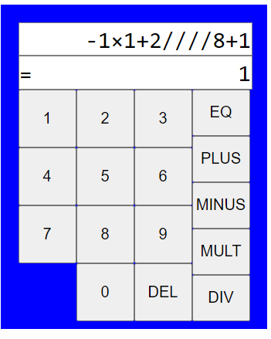

* After entering 17 numbers the numbers are not moving forward.

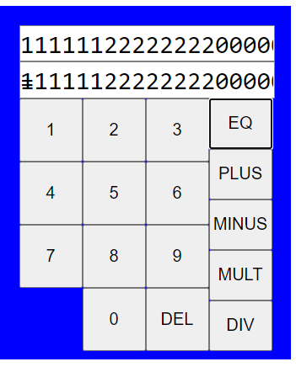

**DESIGN ISSUES**

* Numbers are not separated by comma.
* Over writing of = symbol by 1

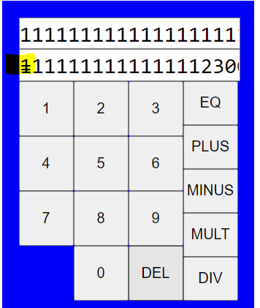

* The end of the EQ button and result area is not aligned properly.

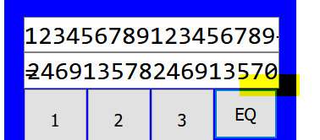

* Multiplication of two large integers 123456789*210987654000=26047858281483006000

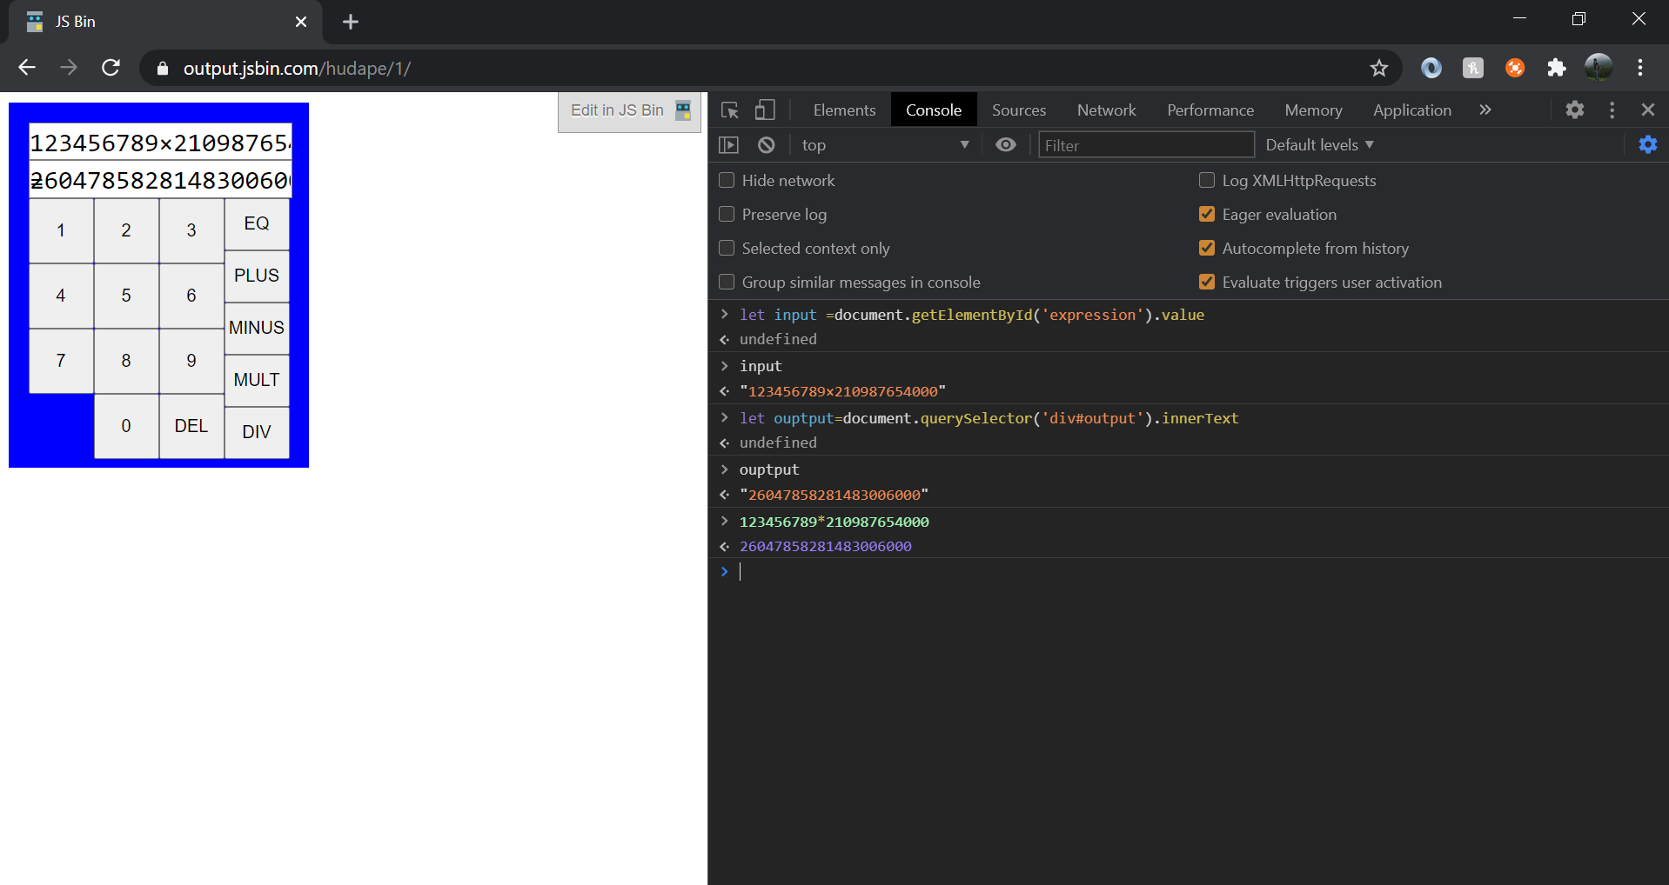

Problem: Result is not completely **visible**; the output textbox cannot be moved.

**SECURITY**

* Usage of **EVAL ()**

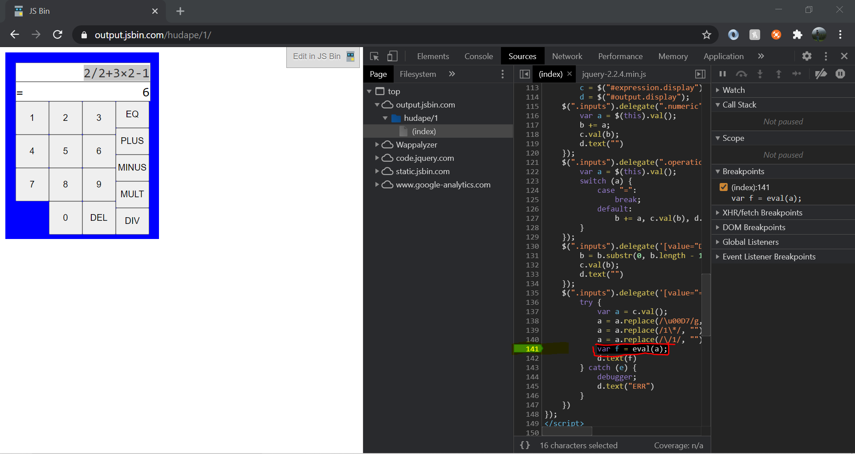

**TEST CASES**

**ADD**

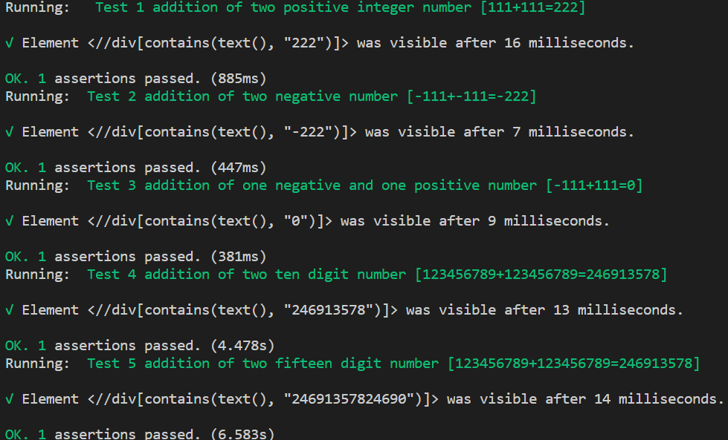

**SUBTRACT**

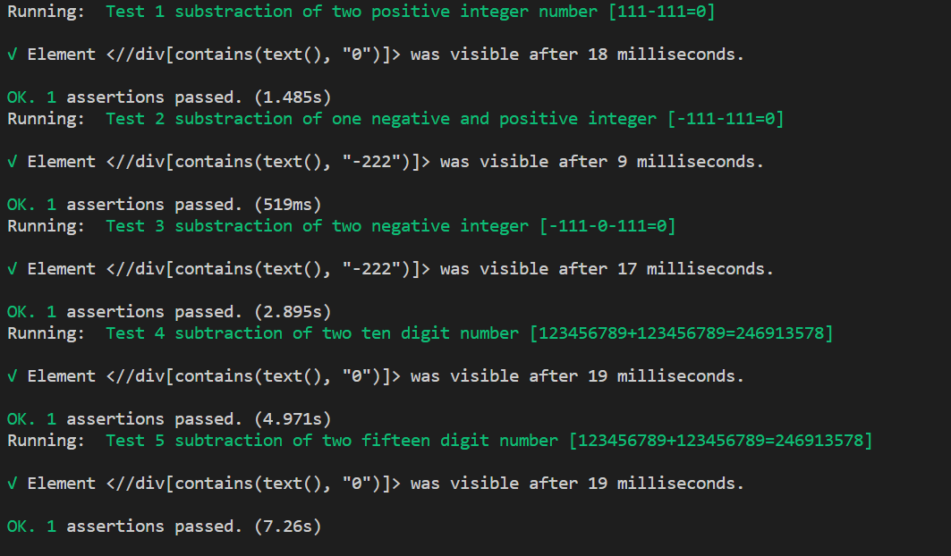

**MULTIPLICATION**

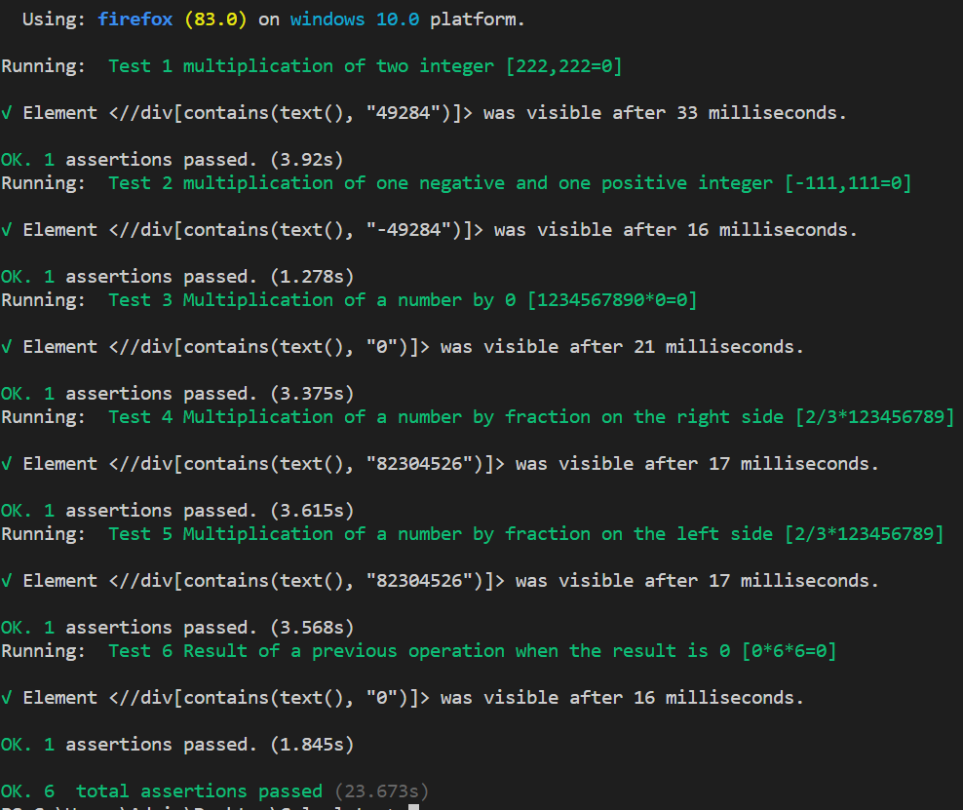

**DIVISION**

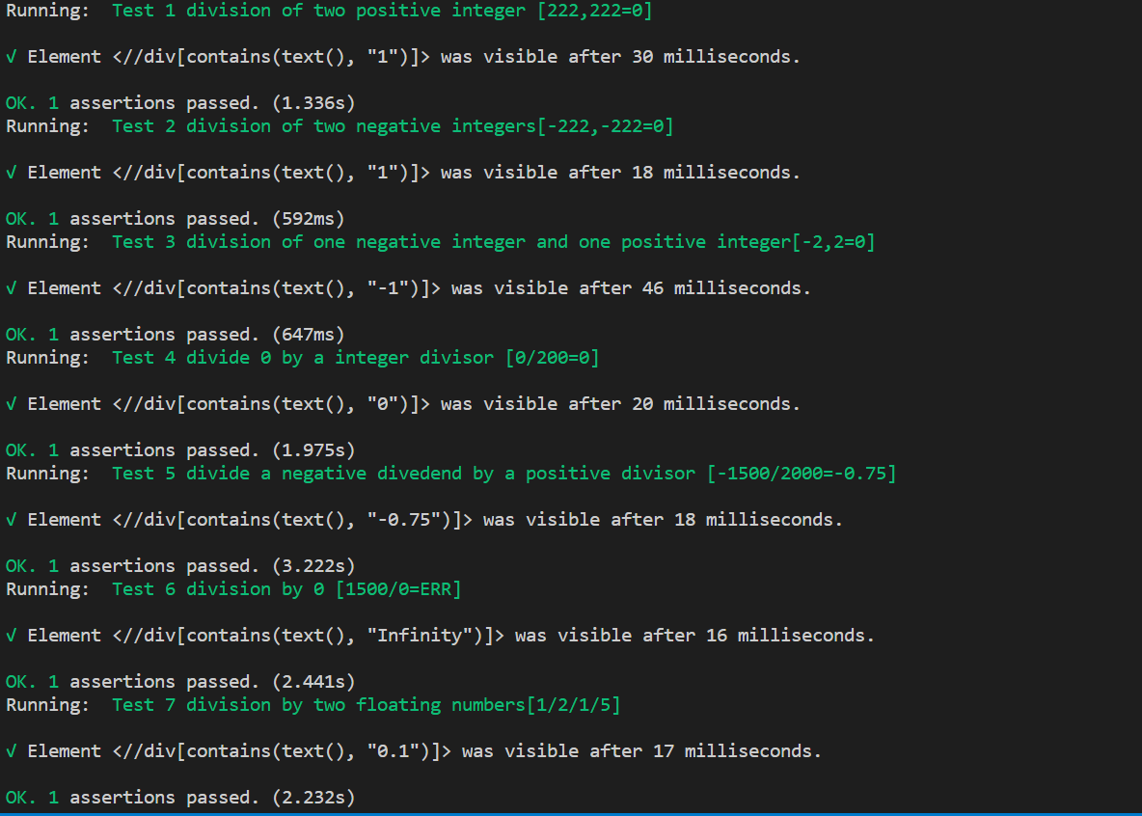

**EXPRESSION**