**Task 0**

Installing ubuntu server and exposing port

* 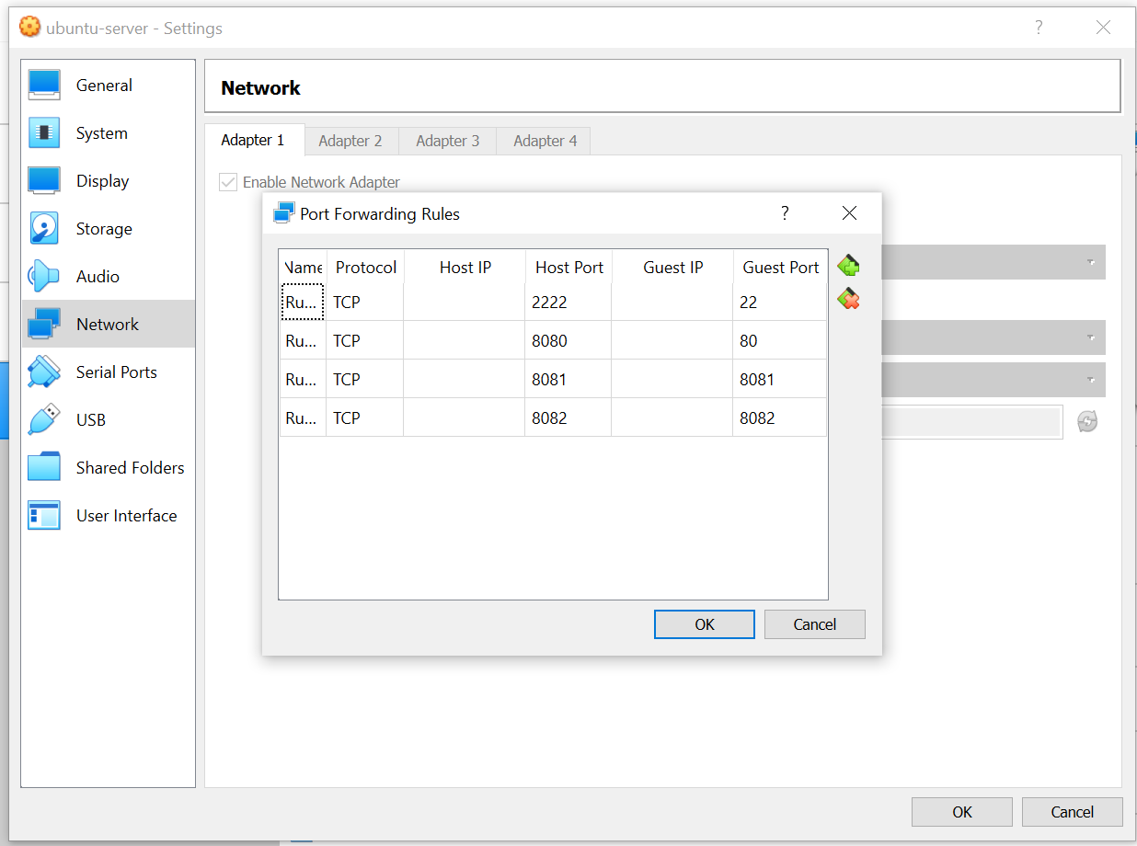

Task 1: update system

Accessing ubuntu server using shh

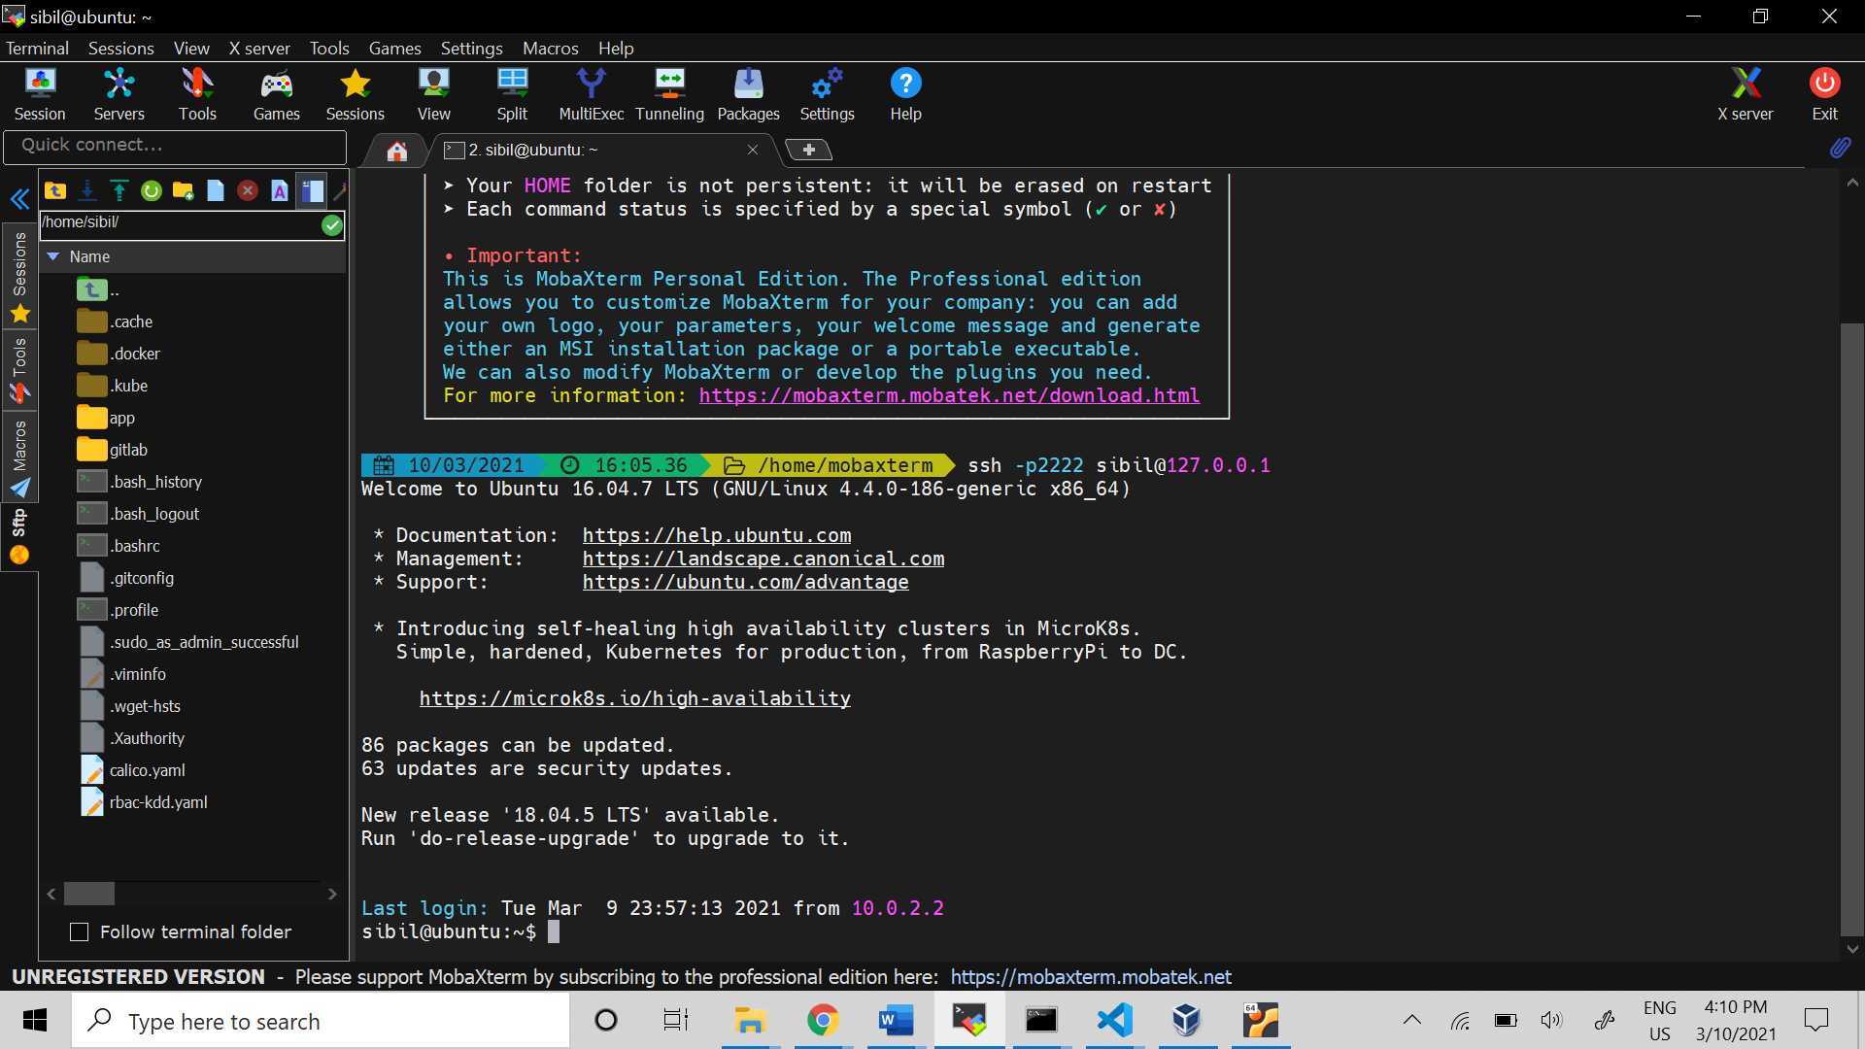

* Updating ubuntu server

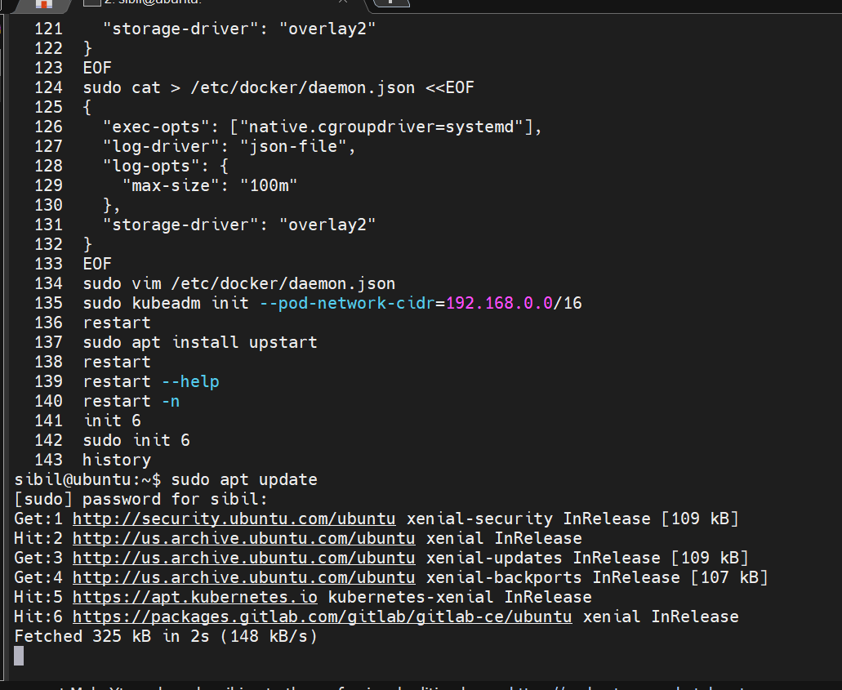

Task 3 Install gitlab

Accessing gitlab in host machine

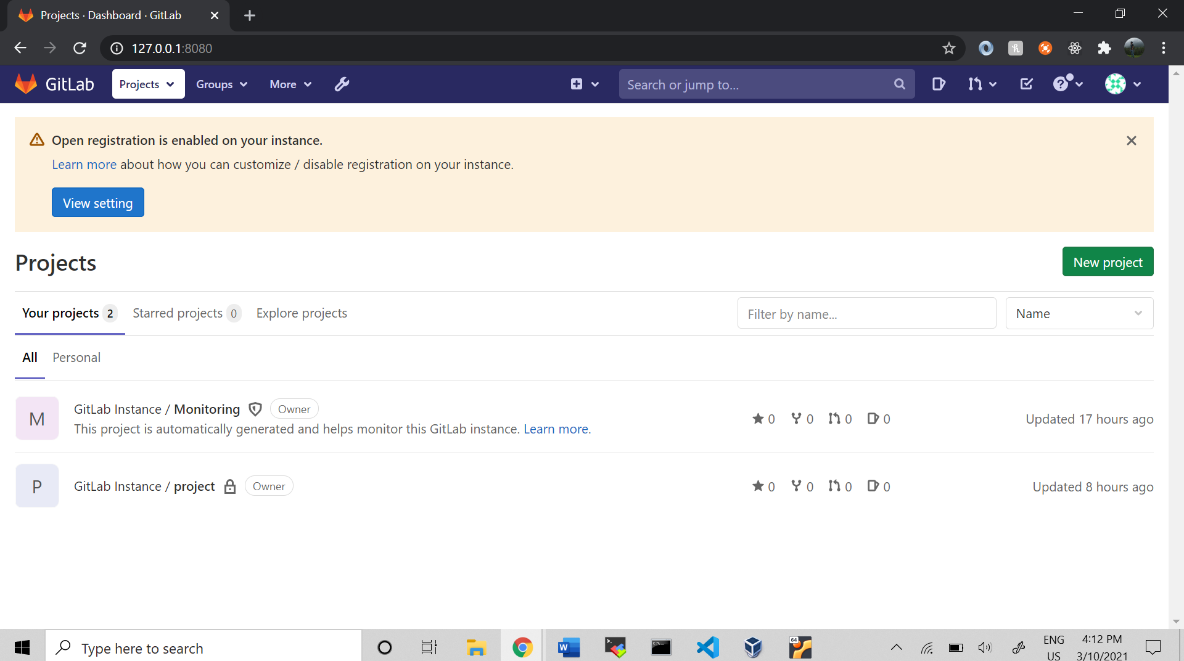

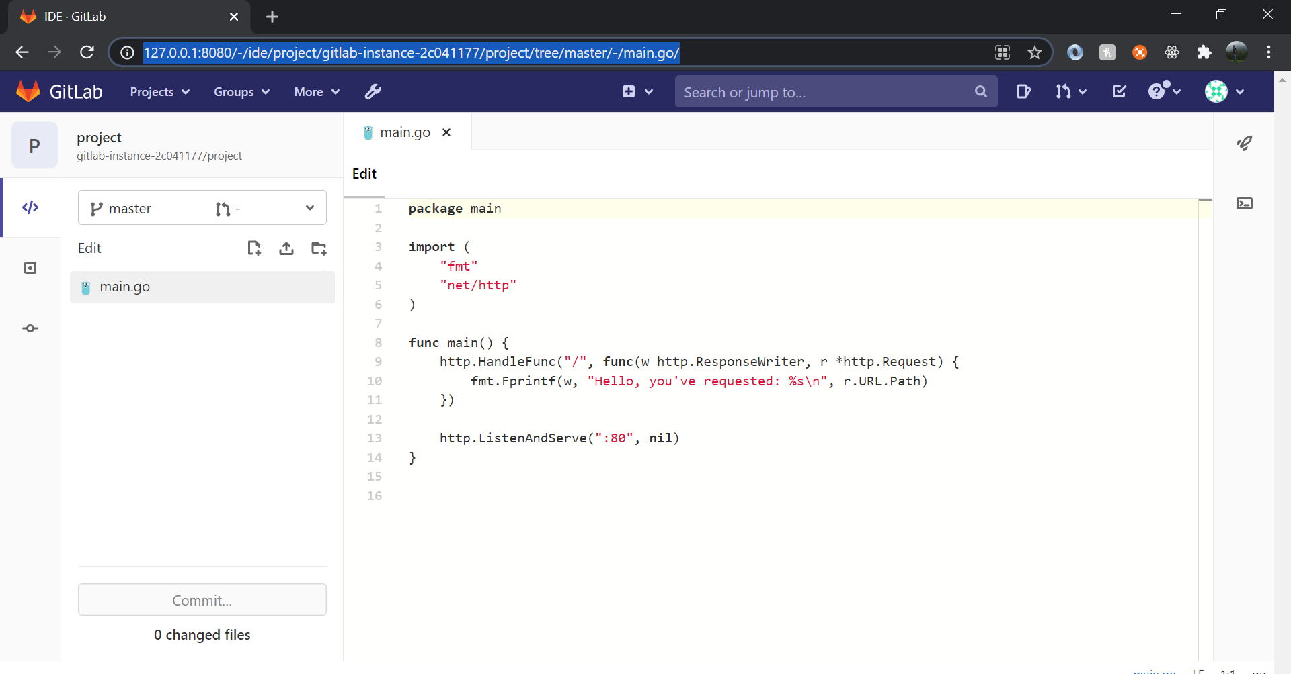

Task 4 App and expose port to 8081

Accessing application in 8081

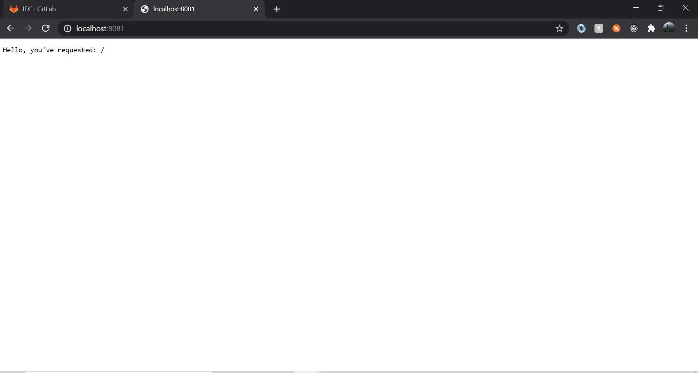

Task 5 and Task 6

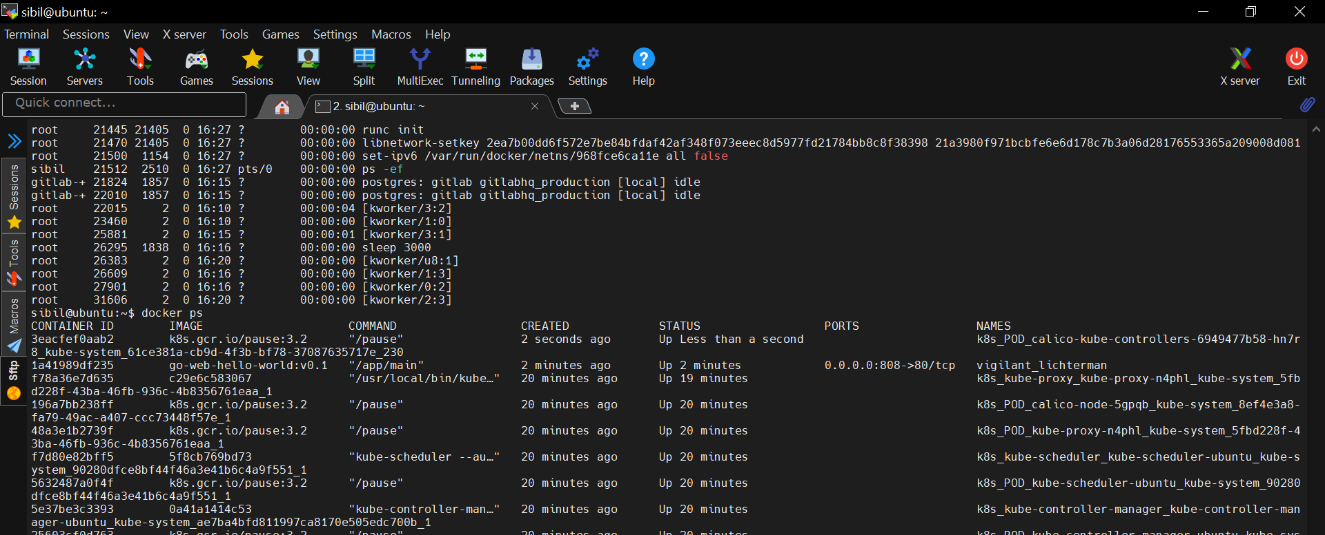

Here I mapped 80 into 808 host port

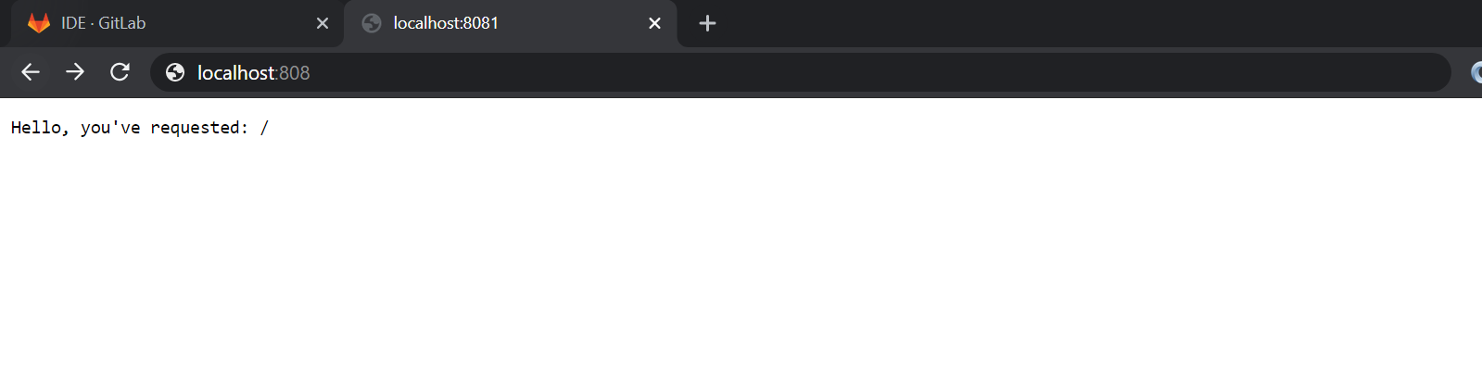

Docker File

FROM golang:1-alpine3.10

RUN mkdir /app

ADD . /app

WORKDIR /app

RUN go build -o main .

CMD ["/app/main"]

Task 7

Push image to docker hub

Docker hub url: https://hub.docker.com/r/sibiljoekurian/go-web-hello-world

Pull command: docker pull sibiljoekurian/go-web-hello-world

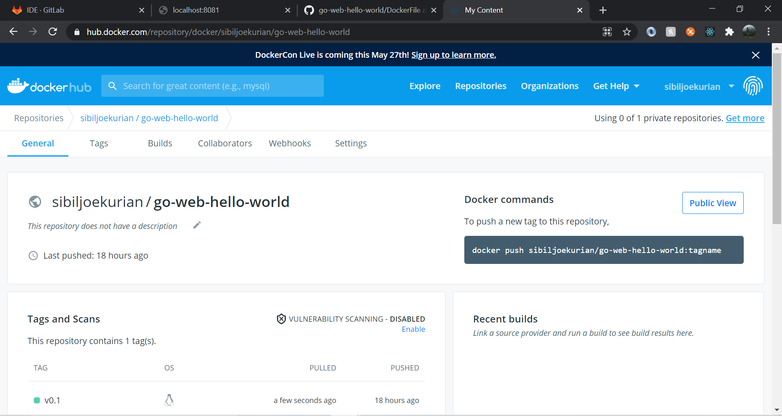

Task 8

Created a readme file in git.

Git hub link: <https://github.com/SibilJoeKurian/go-web-hello-world>

Task 9

Installation of Kubernetes

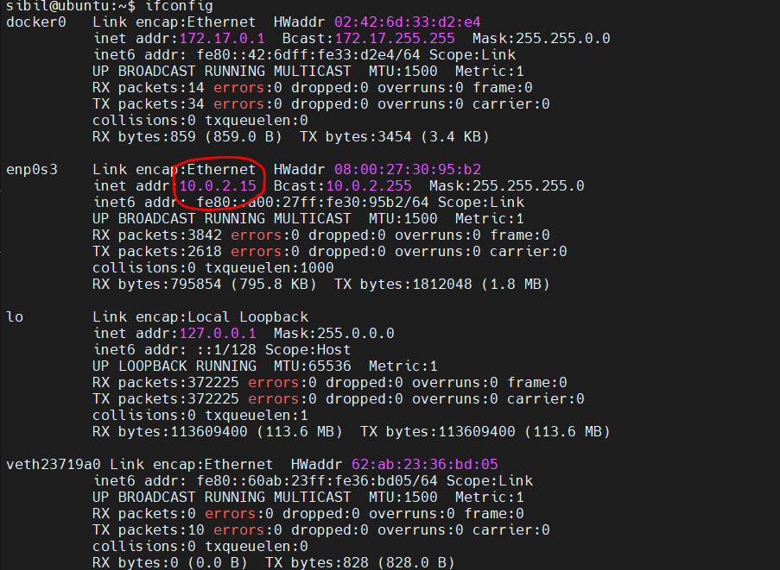

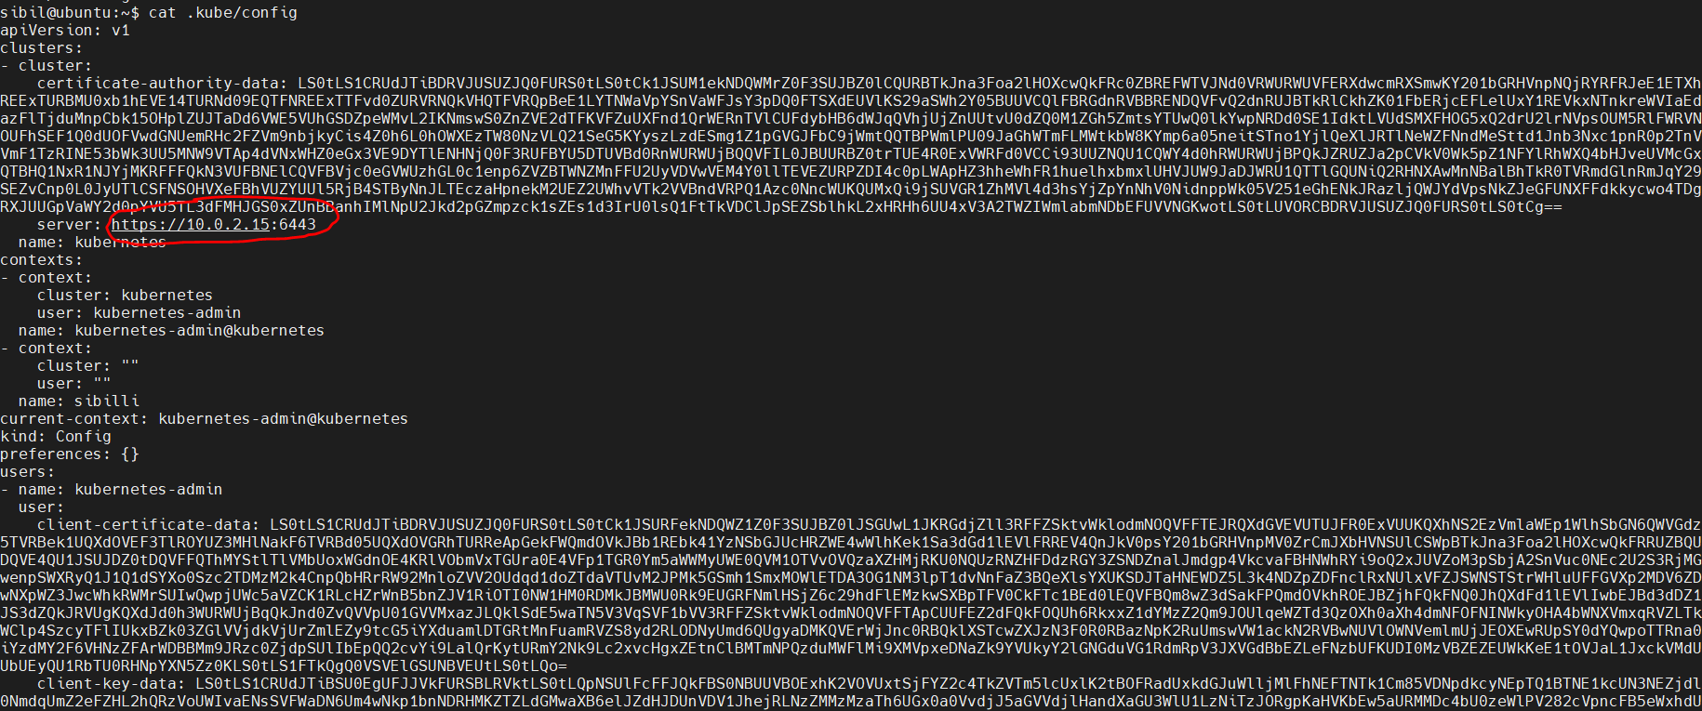

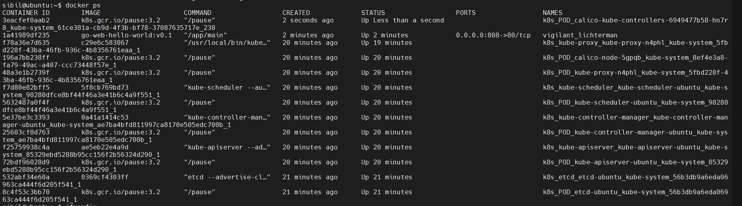

Note

I only completed up to task 9. After that I did not get time.

Thank you for giving me the project.

Much appreciated if you give me a feed back.