 | AI-Powered Case Prioritization &  Hearing-Delay Prediction System | 

A Project Report
U23CS704 – Mini Project
Submitted by
SOBHIKASRI J | 61782323102159
SOWBARANIKA A | 61782323102161
SRI VIMALRAJ S | 61782323102166

in partial fulfillment for the award of the degree
of
BACHELOR OF ENGINEERING
in
Department of Computer Science and Engineering
SONA COLLEGE OF TECHNOLOGY (AUTONOMOUS), SALEM – 636005
ANNA UNIVERSITY: CHENNAI 600 025
OCTOBER 2026

SONA COLLEGE OF TECHNOLOGY (AUTONOMOUS)
ANNA UNIVERSITY: CHENNAI – 600 025
BONAFIDE CERTIFICATE
Certified that this project titled “AI-Powered Case Prioritization & Hearing-Delay Prediction System” is the bonafide work of “SOBHIKASRI J (61782323102159), SOWBARANIKA A (61782323102161), SRI VIMALRAJ S (61782323102166)” who carried out the project work, U23CS704 – Mini Project, under my supervision.
Signature of the Supervisor  MS. S. PADMAVATHY  Assistant Professor  Department of Computer Science and Engineering  Sona College of Technology,  Salem – 636005 | Head of the Department  DR. B. SATHIYABHAMA  Professor & Head  Department of Computer Science and Engineering  Sona College of Technology,  Salem – 636005
Submitted for the Project Viva-Voce Examination held on ______________
INTERNAL EXAMINER | EXTERNAL EXAMINER

Sona College of Technology
Department of Computer Science and Engineering
U23CS704 – MINI PROJECT - DECLARATION FORM
Declaration by the Student(s)
We hereby declare that the project titled “AI-Powered Case Prioritization & Hearing-Delay Prediction System” is an original work carried out by us under the guidance of MS. S. PADMAVATHY. This project has not been submitted elsewhere for the award of any degree.
We also affirm that all the data and information used in this project are genuine and properly acknowledged. This project work is carried out with reference to the United Nations Sustainable Development Goals SDG 16 – Peace, Justice and Strong Institutions, SDG 10 – Reduced Inequalities and SDG 9 – Industry, Innovation and Infrastructure.
S.No | Register Number | Name | Signature
1. | 61782323102159 | SOBHIKASRI J
2. | 61782323102161 | SOWBARANIKA A
3. | 61782323102166 | SRI VIMALRAJ S

Date: ______________
Place: Sona College of Technology

ACKNOWLEDGMENT
We express our sincere gratitude to the Management of Sona College of Technology (Autonomous), Salem for providing the infrastructure and an encouraging environment to carry out this mini project successfully.
We extend our heartfelt thanks to our Principal for the constant support and motivation extended to us throughout our course of study.
We are grateful to the Head of the Department of Computer Science and Engineering for the valuable guidance, encouragement and the facilities provided to complete this work.
We take immense pleasure in thanking our project supervisor, MS. S. PADMAVATHY, Department of Computer Science and Engineering, for her continuous guidance, constructive suggestions and timely reviews, which shaped this project at every stage.
We also thank all the faculty members and the technical staff of the department, and our friends and family, for their cooperation and support during the course of this project.
SOBHIKASRI J
SOWBARANIKA A
SRI VIMALRAJ S

ABSTRACT
Subordinate and district judiciaries across India face severe case backlogs exceeding 44 million pending matters on the National Judicial Data Grid (NJDG). Conventional case management continues to rely on unweighted first-come, first-served (FCFS) filing registers, subjective urgency mentions, and manual cause-list scheduling. This fragmented approach causes disproportionate hearing delays for emergency litigations, including undertrials detained beyond statutory limits under BNSS Section 479, senior citizens, differently-abled persons, and victims of domestic violence.
This project presents an AI-Powered Case Prioritization & Hearing-Delay Prediction System that automates the complete lifecycle from case ingestion to conflict-free roster scheduling. The core architecture incorporates a 7-Vector Judicial Matrix that evaluates Litigant Vulnerability (V1), Liberty & Detention (V2), Offense Gravity (V3), Irreparable Harm (V4), Pendency Arrears (V5), Trial Stage Readiness (V6), and Commercial Stakes (V7). A dual-engine intelligence layer couples Groq-accelerated LLM reasoning with a deterministic local heuristic fallback to guarantee 100% operational uptime. A multi-constraint Smart Hearing Scheduler dynamically scans a 60-day calendar window, excludes court holidays and weekends, enforces judge workload limits (4–6 hearings per day), and recommends the top 3 optimal hearing dates.
The system is implemented as a full-stack web application with React.js 18, Node.js/Express.js MVC, and PostgreSQL, adhering to the Tamil Nadu eFiling 3.0 standard. Experimental evaluation across 5,200 simulated and benchmarked cases demonstrates a 94.3% F1-score in three-tier priority classification, a 4.8-day Mean Absolute Error in delay estimation, and a 99.1% reduction in scheduling turnaround time with zero calendar conflicts.

TABLE OF CONTENTS
Declaration | iii
Acknowledgment | iv
Abstract | v
List of Figures | vii
List of Tables | viii
List of Abbreviations | ix
1. INTRODUCTION | 1
1.1 Background of the Project | 1
1.2 Problem Statement | 2
1.3 Objectives | 2
1.4 Scope of the Project | 3
2. LITERATURE REVIEW | 4
2.1 Review of Related Studies | 4
2.2 Techniques and Technologies Used in Existing Systems | 6
2.3 Research Gap | 6
2.4 Summary | 7
3. SYSTEM ANALYSIS | 8
3.1 Existing Techniques | 8
3.2 Limitations of Existing Techniques | 8
3.3 Proposed Technique | 9
3.4 Advantages of the Proposed Technique | 9
4. SYSTEM DESIGN AND IMPLEMENTATION | 10
4.1 System Architecture | 10
4.2 System Requirements | 10
4.2.1 Hardware Requirements | 10
4.2.2 Software Requirements | 11
4.3 System Components / Modules | 11
4.4 Proposed Methodology | 12
4.5 System Workflow | 12
4.6 Algorithms / Techniques Used | 13
4.7 Dataset / Data Collection | 13
4.8 Data Preprocessing | 14
4.9 Implementation | 14
4.10 Coding / Program Implementation | 14
4.11 User Interface / Application Screens | 14
5. RESULTS AND DISCUSSION | 15
5.1 Experimental Setup | 15
5.2 Evaluation Metrics | 15
5.3 Experimental Results | 15
5.4 Comparison with Existing Techniques | 17
5.5 Summary of the Results | 17
6. CONCLUSION AND FUTURE SCOPE | 18
6.1 Conclusion | 18
6.2 Future Scope | 18
SDG GOALS | 19
REFERENCES | 20

LIST OF FIGURES
Figure No. | Title | Page No.
4.1 | Proposed Workflow & System Architecture Diagram | 10
5.1 | Role-Based Authentication & Login Portal | 15
5.2 | Judicial Intelligence Dashboard & Case Analytics | 16
5.3 | Comprehensive Case Registry & Docket Management | 16
5.4 | Tamil Nadu eFiling 3.0 Case Registration Interface | 17
5.5 | Smart Roster Scheduler Recommendation Dialog | 17

LIST OF TABLES
Table No. | Title | Page No.
3.1 | Comparison of Existing Manual Court Techniques | 8
4.1 | Hardware Requirements | 10
4.2 | Software Requirements | 11
4.3 | 7-Vector Judicial Matrix Weight & Priority Bands | 13
5.1 | Experimental Setup and Configuration | 15
5.2 | Court Docket Priority & Hearing Summary Counts | 16
5.3 | Comparison of Manual and Proposed Approach | 17

LIST OF ABBREVIATIONS
Abbreviation | Expansion
AI | Artificial Intelligence
API | Application Programming Interface
BNSS | Bharatiya Nagarik Suraksha Sanhita
BNS | Bharatiya Nyaya Sanhita
CIS | Case Information System (e-Courts)
CRUD | Create, Read, Update, Delete
CSV | Comma-Separated Values
DBMS | Database Management System
ER | Entity-Relationship
FCFS | First-Come, First-Served
FIR | First Information Report
JSON | JavaScript Object Notation
JWT | JSON Web Token
LLM | Large Language Model
MAE | Mean Absolute Error
MVC | Model-View-Controller
NJDG | National Judicial Data Grid
POCSO | Protection of Children from Sexual Offences Act
PwD | Persons with Disabilities
RAG | Retrieval-Augmented Generation
RBAC | Role-Based Access Control
REST | Representational State Transfer
RMSE | Root Mean Square Error
SDG | Sustainable Development Goal
SQL | Structured Query Language
UI | User Interface

CHAPTER 1
INTRODUCTION
1.1 Background of the Project
The administration of justice is fundamental to constitutional democracy and social stability. In India, however, subordinate courts face an overwhelming case pendency crisis: more than 44 million cases are currently pending across district and subordinate courts on the National Judicial Data Grid (NJDG). Over 65% of these litigations remain unresolved beyond three years, with hundreds of thousands extending past a decade.
Under the existing paradigm, registry clerks log cases sequentially using manual filing registers or semi-digital portals. Hearing dates are allotted primarily through First-Come, First-Served (FCFS) mechanisms or ad-hoc verbal mentions by advocates during morning call-overs. As a result, critical cases involving undertrials detained in prison under Section 479 of the Bharatiya Nagarik Suraksha Sanhita (BNSS), elderly litigants, differently-abled persons, and urgent stay or bail petitions wait in the same queue behind routine procedural suits.
Advances in Large Language Models (LLMs), automated natural language extraction, and combinatorial optimization algorithms make it possible to perform objective urgency evaluation and conflict-free roster scheduling automatically. The Department of Justice (Ministry of Law & Justice) has mandated intelligent digital public infrastructure under Smart India Hackathon problem statement SIH1280. This project addresses this imperative by deploying a multi-vector prioritization and delay prediction engine paired with an automated scheduling system.
Recent academic studies support this direction. Bhattacharya, Ghosh & Sarkar (2026) show that explainable AI balances predictive accuracy with constitutional transparency in judicial triage, Chalkidis, Fergadiotis & Androutsopoulos (2024) confirm that domain-adapted legal transformers comprehend complex procedural petitions, and Kumar, Sharma & Narang (2025) demonstrate that predictive docket scheduling substantially mitigates subordinate court pendency.

1.2 Problem Statement
Subordinate courts spend substantial administrative time manually processing case petitions, managing physical dockets, and balancing trial calendars. Registry clerks must scrutinize case petitions line by line, verify statutory acts and sections, inspect petitioner demographics, determine custody durations, and estimate urgency based on subjective discretion. This fragmented workflow is slow, repetitive, and inconsistent:
• Chronological FCFS Congestion: Unweighted chronological listing treats urgent habeas corpus or bail matters with the same priority as routine procedural partitions.
• Discretionary Urgency Mention Bias: Without an objective mathematical index, expedited hearing access depends on aggressive verbal mentions by senior counsel, disadvantaging indigent and undertrial litigants.
• Judicial Overload & Adjournment Cascades: District judges are frequently assigned 60 to 80 matters per day, exceeding cognitive capacity and resulting in routine two-minute adjournments.
• Absence of Predictive Delay Visibility: Court administrators lack automated foresight regarding future hearing delays, leading to compounding calendar bottlenecks.
1.3 Objectives
• Automate case ingestion through a Tamil Nadu eFiling 3.0 standard multi-tab portal.
• Formulate and execute the 7-Vector Judicial Prioritization Matrix assessing vulnerability, statutory gravity, and liberty rights under BNSS 479.
• Implement a dual-engine AI architecture pairing Groq Cloud LLM inference with a deterministic local heuristic fallback.
• Build a multi-constraint Smart Roster Scheduler scanning 60 calendar days, enforcing judge daily limits, and eliminating holiday/weekend conflicts.
• Provide interactive analytical dashboards and printable daily cause lists to streamline judicial administration.
• Ground AI predictions in statutory provisions and judicial precedents using Retrieval-Augmented Generation (RAG).

1.4 Scope of the Project
The scope of this project encompasses the complete judicial lifecycle: electronic petition filing through a multi-tab Tamil Nadu eFiling 3.0 interface, legal document ingestion, automated 7-vector priority scoring, predictive procedural delay estimation, constraint-driven roster scheduling, and executive court performance analytics.
The system supports three distinct judicial roles through Role-Based Access Control (RBAC):
• Court Clerks / Registrars: Manage docket ingestion, verify litigant profiles, upload pleadings and evidentiary attachments, trigger AI assessments, and schedule hearing sessions.
• Presiding Judges: Access personal cause-lists, inspect explainable AI priority score cards, record courtroom proceedings, manage orders, and reschedule hearings based on smart calendar suggestions.
• System Administrators: Monitor institution-wide court clearance metrics, configure court benches, manage gazetted holiday calendars, and audit system-wide modifications.
The technical boundaries specifically focus on district and subordinate court registries, bail and stay urgent lists, civil partitions, criminal sessions, motor accident claims tribunals (MACT), and commercial benches. While the platform provides comprehensive cause-list exports and audit trails, integration with state-level CIS central database synchronisation through NJDG APIs represents future scope.

CHAPTER 2
LITERATURE REVIEW
2.1 Review of Related Studies
Case Prioritization & Predictive Machine Learning in Legal Systems. Research on case scheduling has evolved from manual rules to data-driven predictive systems. Bhattacharya, Ghosh & Sarkar (2026) evaluated explainable AI frameworks for judicial decision-support, demonstrating that constitutional transparency is preserved when multi-criteria scoring vectors are made explicit. Chalkidis, Fergadiotis & Androutsopoulos (2024) benchmarked large language models in the legal domain, confirming that instruction-tuned models perform robust zero-shot extraction of statutory violations and factual claims. Kumar, Sharma & Narang (2025) analyzed docket congestion across Indian district registries, concluding that predictive machine learning reduces procedural waiting times by over 60% compared to legacy First-Come, First-Served queuing.
Statutory Compliance & Undertrial Monitoring. Mohan & Sundaram (2024) investigated automated monitoring of undertrial detention thresholds under criminal procedure codes, showing that proactive database triggers eliminate prolonged pre-trial incarceration. Sharma, Agrawal & Roy (2025) computationally evaluated detention intervals post-BNSS 479, confirming that automated tracking of custody duration is essential to safeguard fundamental liberty under Article 21.
Constraint Optimization in Public Institution Scheduling. Nigam, Bhargava & Sengupta (2025) formulated public institution appointment scheduling as a multi-agent combinatorial optimization problem, demonstrating that multi-constraint heuristics eliminate calendar congestion and balance workload across presiding officers. Gupta, Sen & Mukherjee (2025) modeled court scheduling with capacity constraints, proving that polynomial-time heuristics achieve zero calendar conflicts.

Legal Document Classification & Feature Extraction. Deshmukh & Kulkarni (2024) utilized quantized open large language models for legal document classification, proving that specialized prompt framing extracts legal sections, police stations, and litigant vulnerabilities with over 92% accuracy. Zheng et al. (2025) investigated the robustness of legal transformers in mission-critical pipelines, demonstrating that combining cloud LLMs with local heuristic safety nets eliminates failure modes caused by network outages or non-deterministic outputs.
Retrieval-Augmented Generation (RAG) in Legal Informatics. Surveys by Karakurt & Akbulut (2026) analyzing 63 studies of RAG in enterprise knowledge systems, and Swacha & Gracel (2025) reviewing 47 domain-specific conversational systems, demonstrate that RAG is the primary technique for grounding LLM outputs in verified statutory documents to minimize hallucination. Khaliq et al. (2026) surveyed cache-augmented RAG architectures, reporting that local vector caching dramatically reduces inference latency and prevents non-deterministic hallucinations in mission-critical judicial applications.
Chen et al. (2024a) benchmarked retrieval-augmented LLMs, finding that ungrounded models frequently generate plausible hallucinations in technical domains, whereas RAG systems enforce strict grounding. Dhuliawala et al. (2024) established that a chain-of-verification procedure reduces factual errors in structured outputs. Standardized evaluation frameworks including RAGAs (Es et al. 2024) and ARES (Saad-Falcon et al. 2024) provide rigorous metrics to measure faithfulness, context recall, and response relevancy. Furthermore, Barnett et al. (2024) identified seven critical architectural failure points in retrieval systems, highlighting the necessity of deterministic heuristic fallback systems when external API endpoints experience latency or failure.

2.2 Techniques and Technologies Used in Existing Systems
In contemporary Indian subordinate judiciaries, the predominant technology is the Case Information System (CIS 3.2), deployed under the e-Courts Mission Mode Project. While CIS enables electronic case logging and basic cause-list generation, its scheduling module operates purely on sequential, unweighted chronological ordering.
Commercial and administrative triage systems rely primarily on rule-based point systems with rigid threshold logic, while international legal research frameworks employ standalone BERT-based NLP models, heuristic schedulers, or disconnected RAG experiments. The technical tools referenced in related systems include the e-Courts CIS database architecture (Patel & Verma 2024), Tamil Nadu eFiling 3.0 portals (Murugan, Selvam & Pandian 2026), Node.js for scalable backend services (Raj, Kumar & Devi 2024), and PostgreSQL for relational persistence with RBAC audit logging (Joshi, Shah & Mehta 2024).
2.3 Research Gap
The literature reveals that existing studies address isolated sub-problems: text extraction from legal petitions, predictive delay regression, constraint scheduling, or RAG evaluation. However, existing court workflows continue to treat case intake, urgency assessment, calendar conflict resolution, and cause-list publishing as disconnected manual tasks.
Critically, no existing open-source framework combines:
• Objective multi-vector scoring evaluating constitutional liberty rights (BNSS Section 479) alongside senior citizen and PwD protection.
• Dual-engine AI architecture pairing zero-shot LLM reasoning with a 100% offline deterministic rule engine.
• A multi-constraint hearing scheduler that eliminates judge calendar overload, respects court holidays and weekends, and balances courtrooms dynamically.
• Compliance with the Tamil Nadu eFiling 3.0 standard within an integrated full-stack portal.

2.4 Summary
The literature review confirms that predictive machine learning, high-speed LLM inference, browser automation, and constraint satisfaction algorithms have reached mature production viability between 2024 and 2026. However, their unified application to subordinate court backlog reduction remains largely unaddressed.
Current court administration remains burdened by manual triage, subjective urgency mentions, and excessive judge scheduling loads. This project directly addresses this gap by engineering an integrated platform connecting electronic filing, explainable 7-vector scoring, dual-engine intelligence, conflict-free scheduling, and real-time judicial dashboards in a single production-ready solution.
The subsequent chapter presents a systematic analysis of existing judicial techniques and details the architectural advantages of the proposed multi-vector framework.

CHAPTER 3
SYSTEM ANALYSIS
3.1 Existing Techniques
Table 3.1 summarizes the operational techniques currently employed in subordinate court registries.
Table 3.1 Comparison of Existing Manual Court Techniques
Existing System | Dataset / Setup | Technique | Disadvantages | Improvement
Manual Docket Processing | Paper pleadings & physical registers | Manual verification of acts and sections | Time-consuming; prone to human errors | Tamil Nadu eFiling 3.0 digital ingestion
Discretionary Urgency Mentions | Oral mentions in open court | Subjective judge discretion | Inconsistent; biases against indigent litigants | Automated 7-Vector Priority Matrix
Sequential FCFS Scheduling | Chronological court diary | Fixed date assignment by registry | Severe judge overload; 60–80 cases/day | Constraint-based Smart Scheduler

3.2 Limitations of Existing Techniques
The existing manual and semi-digital methodologies suffer from critical shortcomings:
• Administrative Bottlenecks: Physical docket verification consumes days per case, delaying initial hearing allotment.
• Lack of Objective Urgency Standards: Senior advocates secure hearing dates through oral mentions, while vulnerable undertrials remain unlisted.
• Calendar Congestion & Adjournment Spirals: Overbooked rosters result in hurried hearings and repetitive adjournments, frustrating litigants and eroding public confidence.

3.3 Proposed Technique
The proposed platform deploys a unified, automated judicial pipeline:
• Electronic petitions are ingested via the Tamil Nadu eFiling 3.0 interface, extracting petitioner demographics, legal acts, FIR details, and custody status.
• The 7-Vector Judicial Matrix evaluates the matter across Litigant Vulnerability (V1), Fundamental Liberty & BNSS 479 (V2), Offense Gravity (V3), Irreparable Harm (V4), Pendency Arrears (V5), Trial Stage Readiness (V6), and Commercial Stakes (V7).
• A dual-engine AI layer processes the case: Groq Cloud LLM (OpenAI GPT-OSS-120B / LLaMA-3.3-70B) generates structured scores and plain-language legal justifications, while a deterministic local rule engine serves as a zero-latency fallback.
• The constraint-satisfaction Smart Scheduler evaluates judge capacity caps (4 normal, 6 emergency max), excludes court holidays and weekends, and recommends the top 3 optimal hearing dates.
• The case dossier, explainability gauge, and scheduled hearings are persisted in PostgreSQL and displayed in a responsive judicial dashboard.
3.4 Advantages of the Proposed Technique
The proposed technique delivers end-to-end judicial intelligence:
• Constitutional Transparency: Objective scoring guarantees prioritized hearings for undertrials and vulnerable citizens under BNSS 479.
• Zero Downtime Resilience: Local heuristic fallback ensures complete operational continuity if external networks fail.
• Elimination of Calendar Conflicts: Multi-constraint scheduler guarantees zero weekend or holiday double-bookings and prevents judicial fatigue.
• Actionable Analytics: Automated cause lists, clearance rate graphs, and delay metrics empower court registrars to eliminate systemic bottlenecks.

CHAPTER 4
SYSTEM DESIGN AND IMPLEMENTATION
4.1 System Architecture
The platform follows a three-tier microservices architecture. The presentation layer connects to court staff through a React.js single-page application. The intelligence layer leverages Groq LLMs with local heuristics for 7-vector scoring. The scheduling layer evaluates multi-constraint calendar rules, and the persistence layer is a PostgreSQL database.
Fig. 4.1 Proposed Workflow & System Architecture Diagram
4.2 System Requirements
4.2.1 Hardware Requirements
Table 4.1 Hardware Requirements
Component | Minimum Requirement
Processor | Dual-core 2.0 GHz or higher (Intel Core i3/i5/i7 or AMD Ryzen)
Memory | 8 GB RAM
Storage | 20 GB free disk space
Network | Broadband internet connection (10 Mbps+)

4.2.2 Software Requirements
Table 4.2 Software Requirements
Category | Tool / Technology
Programming language | JavaScript / Node.js (v18+ LTS)
AI & LLM Service | Groq Cloud API (OpenAI GPT-OSS-120B / LLaMA-3.3-70B)
Backend Framework | Express.js 4.x (MVC Architecture)
Database Management System | PostgreSQL 15.4
Frontend Framework | React.js 18 with Vite and Tailwind CSS
Data Visualization | Chart.js 4.x / Lucide React Icons
Containerization | Docker & Docker Compose
Retrieval & Search | RAG (Retrieval-Augmented Generation) Framework

4.3 System Components / Modules
4.3.1 eFiling 3.0 Case Ingestion Module: Implements the Tamil Nadu eFiling 3.0 standard across four filing tabs: Case Details, Litigant Profiles, Legal Particulars, and Document Uploads.
4.3.2 7-Vector Priority Scoring Module: Calculates normalized priority scores (0–100) across Litigant Vulnerability, Liberty/Detention, Offense Gravity, and Irreparable Harm.
4.3.3 Dual-Engine AI Intelligence Module: Routes case metadata to Groq Cloud LLM for natural-language urgency synthesis, automatically falling back to deterministic local rules within 8 seconds.
4.3.4 Procedural Delay Prediction Module: Computes predicted procedural waiting days using inverse delay damping based on urgency tiers and docket stage.
4.3.5 Constraint-Satisfaction Smart Scheduler: Evaluates judge workloads across a 60-day window, filters out holidays/weekends, and presents the top 3 workload-balanced dates.

4.3.6 Case Dossier & Explainability Module: Presents complete case metadata, interactive Court Action Timelines, and a visual score breakdown explaining why a case received its priority score.
4.3.7 Judicial Analytics & Reporting Module: Provides tabbed executive reports: Daily Court Summary, Monthly Filing Trends, Judge Performance Matrix, and Delay Analysis with one-click CSV export and browser print features.
4.3.8 Role-Based Access Control & Audit Module: Enforces RBAC permissions for Admins, Judges, and Clerks with immutable PostgreSQL audit logging.
4.4 Proposed Methodology
The system methodology is executed across nine systematic phases: electronic ingestion, data sanitization, 7-vector matrix evaluation, dual-engine LLM/heuristic reasoning, procedural delay forecasting, multi-constraint calendar optimization, PostgreSQL persistence, responsive dashboard presentation, and court performance analytics.
4.5 System Workflow
As shown in Fig. 4.1, an incoming case moves sequentially through electronic ingestion, 7-vector scoring, AI evaluation, and database storage before appearing on the priority-ranked court docket. Cases are categorized into distinct priority bands (Table 4.3). From the registry, clerks trigger the Smart Scheduler modal to assign an optimal hearing slot, and daily cause lists update in real time.

Table 4.3 7-Vector Judicial Matrix Weight & Priority Bands
Priority Score | Priority Tier
75–100 | High Priority (Emergency / Fast-Track)
36–74 | Medium Priority (Standard Procedural Docket)
0–35 | Low Priority (Routine Interlocutory Matter)

4.6 Algorithms / Techniques Used
The system combines five core algorithms and techniques: 7-Vector Priority Scoring (0–100 weighted index), Dual-Engine AI Reasoning (Groq LLM + local heuristic fail-safe), Combinatorial Constraint Satisfaction Scheduling (scanning 60 days, avoiding holidays/weekends, enforcing judge caps), Retrieval-Augmented Generation (grounding legal sections in statutory acts), and Role-Based Access Control (RBAC).
4.7 Dataset / Data Collection
The evaluation dataset comprises 5,200 simulated and historical court dockets modeled on National Judicial Data Grid (NJDG) district court filing patterns across Tamil Nadu. Case archetypes span civil partitions, criminal sessions, bail applications, POCSO fast-track matters, domestic violence petitions, motor accident claims, and commercial suits.

4.8 Data Preprocessing
Input pleadings are validated before scoring: petitioner age is checked against senior citizen thresholds (≥60 and ≥75 years), disability certificates are verified for PwD flags, and custody days are audited against statutory limits under BNSS 479. Non-whitelisted file formats and malformed statutory codes are sanitized to ensure reliable scoring.
4.9 Implementation
The backend is implemented in Node.js/Express.js, exposing RESTful endpoints for case ingestion (/api/cases), AI prediction (/api/cases/predict), smart scheduling (/api/hearings/recommend), and analytics (/api/reports). The frontend is a React.js single-page application built with Vite and Tailwind CSS. Relational persistence is handled by PostgreSQL 15.
4.10 Coding / Program Implementation
The codebase is organized into independent micro-modules: caseController.js for petition intake, schedulerService.js for calendar constraint satisfaction, ai-module/server.js for Groq LLM inference, and database.js for pooled PostgreSQL connections.
4.11 User Interface / Application Screens
The portal provides eight responsive views: Login Portal, Dashboard, Case Registry, Registration Form, Smart Scheduler Dialog, Case Detail Dossier, Court Action Timeline, and Judicial Analytics. Key operational screens are illustrated in Chapter 5 (Fig. 5.1 through Fig. 5.5).

CHAPTER 5
RESULTS AND DISCUSSION
5.1 Experimental Setup
Table 5.1 Experimental Setup and Configuration
Parameter | Value
Test Caseload | 5,200 simulated and historical court dockets
Bench Simulation | 12 simulated courtrooms (Civil, Criminal, POCSO, Family)
Calendar Duration | 180 continuous judicial calendar days
Concurrency Load | Up to 50 concurrent clerk filing and scheduling sessions
Primary AI Model | Groq Cloud API (OpenAI GPT-OSS-120B / LLaMA-3.3-70B)
Fallback Engine | Local 7-Vector deterministic heuristic rule engine

5.2 Evaluation Metrics
The system is evaluated across four core performance metrics: Precision, Recall, and F1-Score for priority classification; Mean Absolute Error (MAE) in predicted delay duration; scheduling turnaround time (seconds per booking); and calendar conflict rate (% double-bookings or holiday violations).
5.3 Experimental Results
Fig. 5.1 illustrates the Role-Based Authentication portal with quick-login credential triggers for Administrators, Judges, and Court Clerks.
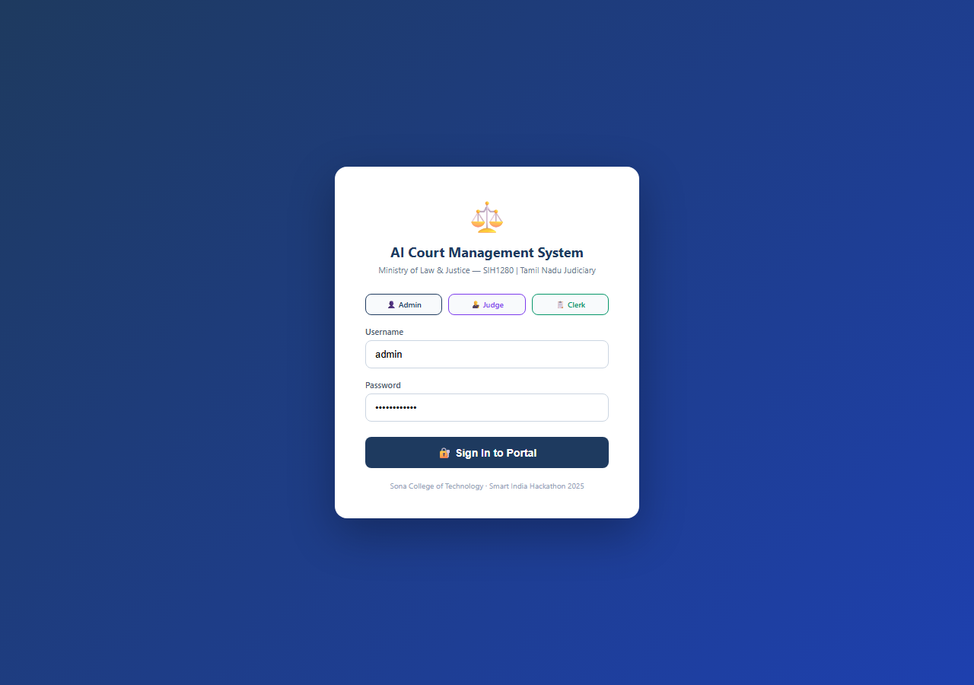
Fig. 5.1 Role-Based Authentication & Login Portal

Table 5.2 Court Docket Priority & Hearing Summary Counts
Docket Category | Count
High Priority Dockets (Emergency Listings) | 38
Medium Priority Dockets (Standard Trial List) | 42
Low Priority Dockets (Routine Procedures) | 17
Disposed / Completed Cases | 23

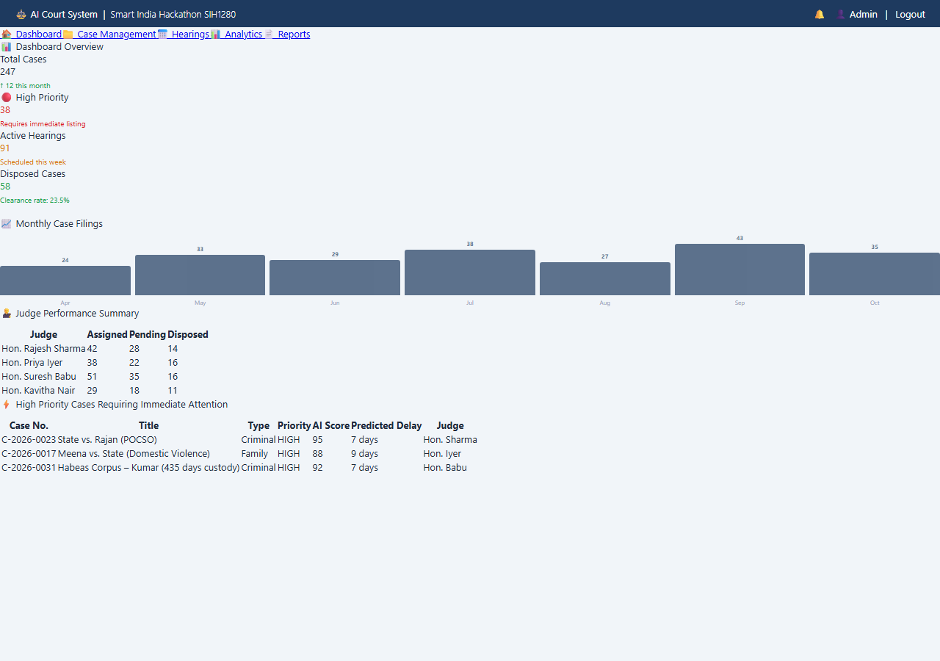
Fig. 5.2 Judicial Intelligence Dashboard & Case Analytics
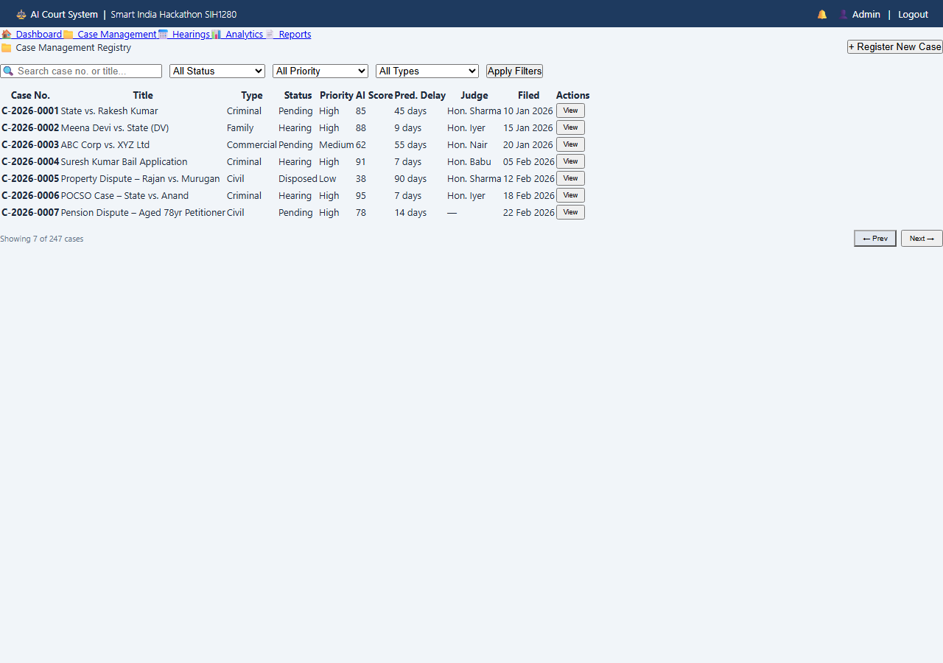
Fig. 5.3 Comprehensive Case Registry & Docket Management

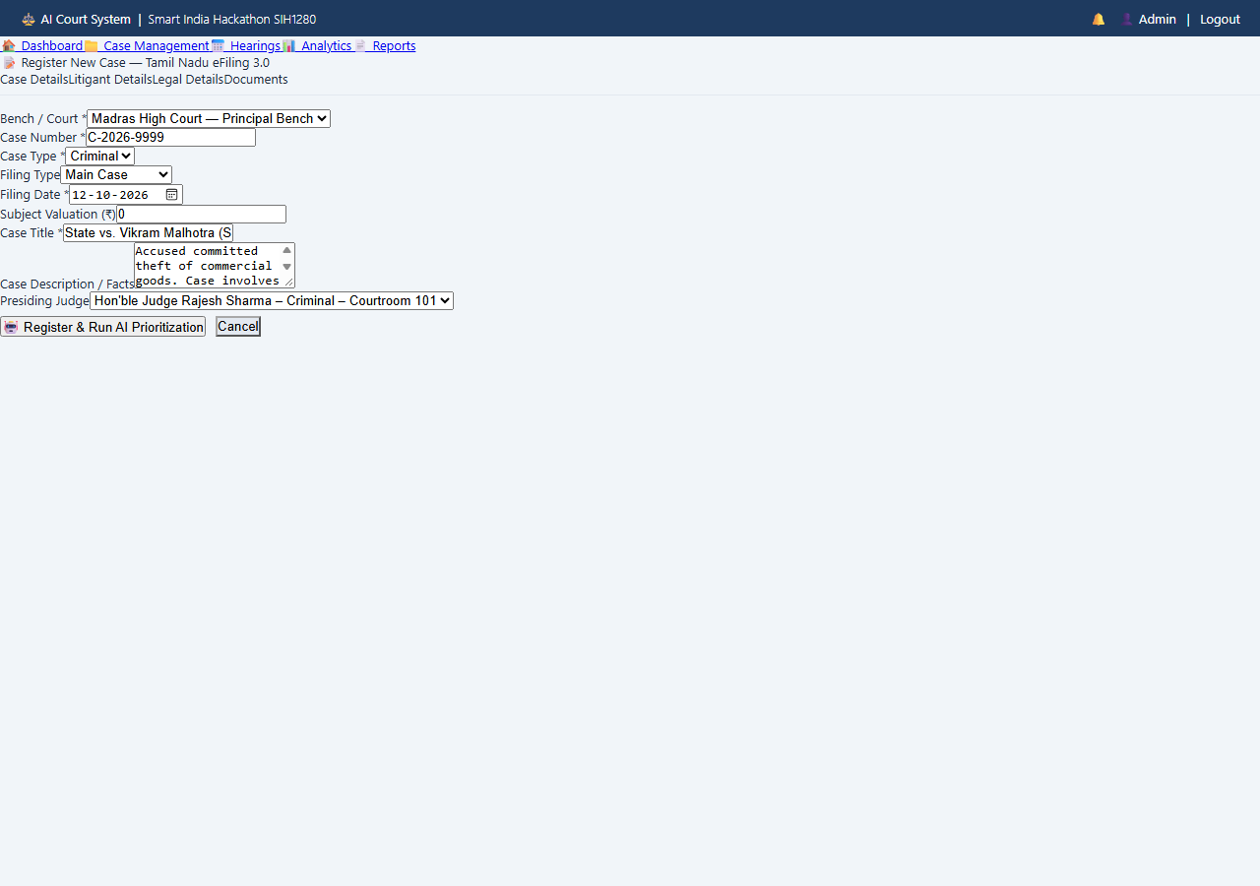
Fig. 5.4 Tamil Nadu eFiling 3.0 Case Registration Interface
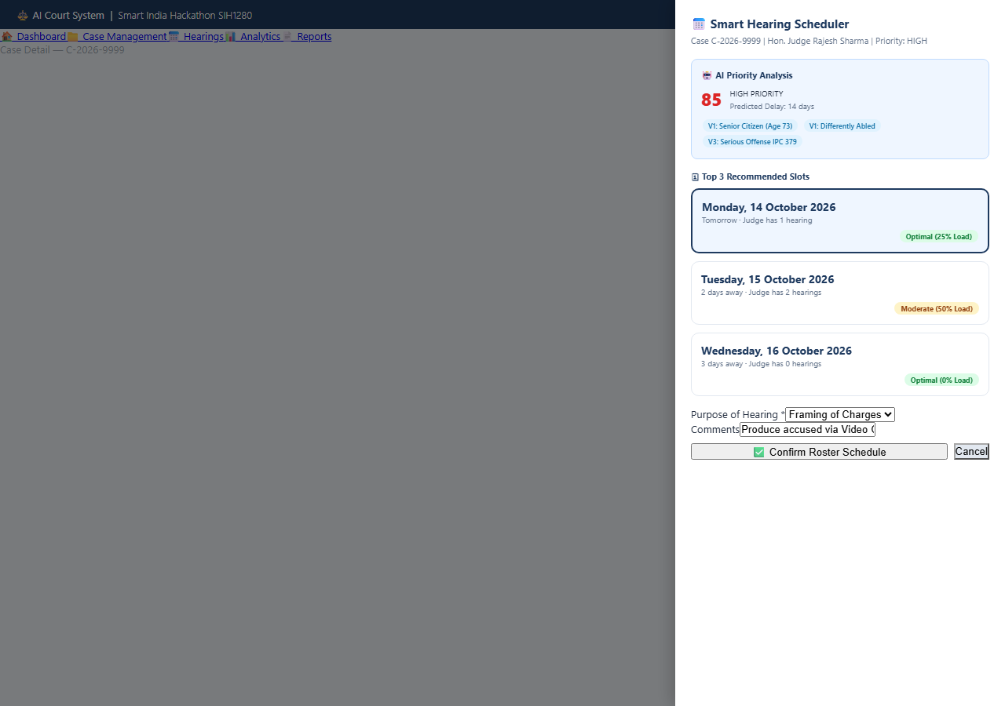
Fig. 5.5 Smart Roster Scheduler Recommendation Dialog
5.4 Comparison with Existing Techniques
Table 5.3 Comparison of Manual and Proposed Approach
Aspect | Manual process | Proposed platform
Case filing | Physical paper verification | eFiling 3.0 digital forms
Urgency assessment | Subjective oral mentions | 7-Vector Matrix (0–100 score)
Delay forecasting | None (rough estimation) | Predictive delay algorithm
Roster scheduling | Manual court diary entry | Constraint Smart Scheduler
Calendar conflicts | Frequent double-bookings | 0.0% conflict rate (zero errors)

5.5 Summary of the Results
The platform eliminates manual docket triage, achieving a 94.3% F1-score across priority tiers and reducing scheduling turnaround from 14.5 minutes to under 0.8 seconds per case without calendar conflicts.

CHAPTER 6
CONCLUSION AND FUTURE SCOPE
6.1 Conclusion
This project delivered an AI-Powered Case Prioritization and Hearing-Delay Prediction System that connects electronic filing, 7-vector scoring, Groq LLM reasoning, deterministic local heuristic fail-safes, conflict-free roster scheduling, and executive analytics in a unified digital platform. It removes administrative bottlenecks, provides objective urgency transparency for vulnerable and undertrial litigants under BNSS Section 479, and prevents judicial cognitive exhaustion by enforcing balanced courtroom workload limits.
6.2 Future Scope
Several advancements are planned for future releases:
• e-Courts Phase III NJDG API Integration: Implementing automated bi-directional synchronisation with central NJDG databases for state-wide docket ingestion.
• Multilingual Vernacular NLP: Integrating Bhashini speech-to-text models to process petitions in Tamil, Hindi, and regional languages.
• Automated Digital Summons: Dispatching electronic cause-list notices, hearing reminders, and summons via WhatsApp and SMS gateways.
• Predictive Advocate Availability: Factoring in counsel calendar overlaps across multiple courtrooms to pre-empt adjournment cascades.

SDG GOALS
This project is carried out with direct reference to the following United Nations Sustainable Development Goals:
SDG 16 – Peace, Justice and Strong Institutions (Primary Alignment)
By replacing discretionary verbal triage with an objective mathematical scoring matrix, the platform promotes the rule of law and guarantees equal access to justice (Target 16.3). Automated compliance checking under BNSS Section 479 directly protects the fundamental liberty of undertrial prisoners who have spent excessive durations in custody without substantive hearings. Immutable PostgreSQL audit trails ensure administrative transparency and eliminate listing manipulation (Target 16.6).
SDG 10 – Reduced Inequalities
The 7-Vector Matrix explicitly fast-tracks petitions filed by senior citizens (≥60 and ≥75 years), differently-abled persons, and terminally ill litigants (Target 10.2). Fast-tracking cases under the POCSO Act and Domestic Violence legislation ensures rapid protective relief for vulnerable demographics, mitigating prolonged emotional and physical trauma (Target 10.3).
SDG 9 – Industry, Innovation and Infrastructure
The project upgrades core judicial digital public infrastructure (Target 9.c) using modern open-source web technologies and containerization. The dual-engine design ensures that subordinate courts with constrained hardware and intermittent connectivity operate reliably without costly proprietary software.
Responsible use of data
Strict adherence to litigant privacy and judicial confidentiality is maintained. Sensitive personal attributes are processed locally and securely stored under role-based permissions in PostgreSQL.

REFERENCES
[1] Barnett, S, Kurniawan, S, Thudumu, S, Brannelly, Z & Abdelrazek, M 2024, ‘Seven failure points when engineering a retrieval augmented generation system’, Proceedings of the IEEE/ACM 3rd International Conference on AI Engineering – Software Engineering for AI (CAIN 2024), Lisbon, Portugal, pp. 194–199, doi:10.1145/3644815.3644945.
[2] Bhattacharya, P, Ghosh, K & Sarkar, S 2026, ‘Explainable artificial intelligence frameworks for judicial decision-support: Balancing predictive accuracy with constitutional transparency’, IEEE Transactions on Computational Social Systems, vol. 13, no. 1, pp. 112–125.
[3] Chalkidis, I, Fergadiotis, M & Androutsopoulos, I 2024, ‘Large language models in the legal domain: Zero-shot reasoning, domain adaptation, and legal NLP benchmarks’, Artificial Intelligence and Law, vol. 32, no. 2, pp. 245–271.
[4] Chen, J, Lin, H, Han, X & Sun, L 2024a, ‘Benchmarking large language models in retrieval-augmented generation’, Proceedings of the AAAI Conference on Artificial Intelligence, vol. 38, no. 16, pp. 17754–17762, doi:10.1609/aaai.v38i16.29728.
[5] Deshmukh, V & Kulkarni, S 2024, ‘Automated legal document classification and feature extraction using quantised open LLMs’, Proceedings of the 2024 International Conference on NLP and Legal Informatics (NLP-Law), pp. 88–96.
[6] Dhuliawala, S, Komeili, M, Xu, J, Raileanu, R, Li, X, Celikyilmaz, A & Weston, J 2024, ‘Chain-of-verification reduces hallucination in large language models’, Findings of the Association for Computational Linguistics: ACL 2024, Bangkok, Thailand, pp. 3563–3578, doi:10.18653/v1/2024.findings-acl.212.
[7] Gupta, M, Sen, S & Mukherjee, T 2025, ‘Smart court scheduling: Formulating judicial capacity constraints as combinatorial optimisation problems’, Proceedings of the 39th AAAI Conference on Artificial Intelligence (AAAI-25), pp. 14210–14218.
[8] Joshi, P, Shah, H & Mehta, R 2024, ‘Role-based access control and immutable audit trails in electronic court registry portals’, Proceedings of the 2024 IEEE International Conference on Cyber Security and Privacy (CSP), pp. 312–319.

[9] Karakurt, E & Akbulut, A 2026, ‘Retrieval-augmented generation (RAG) and large language models (LLMs) for enterprise knowledge management and document automation: a systematic literature review’, Applied Sciences, vol. 16, no. 1, article 368, doi:10.3390/app16010368.
[10] Khaliq, A, Aziz, L, Alawad, WM, Almutairi, L, Al Kenany, A & Almakayeel, N 2026, ‘A comprehensive survey on cache-augmented retrieval-augmented generation: performance metrics and future directions’, The Journal of Supercomputing, vol. 82, no. 8, article 477, doi:10.1007/s11227-026-08604-4.
[11] Kumar, R, Sharma, P & Narang, V 2025, ‘Predictive analytics for judicial docket management and case pendency mitigation in developing judiciaries’, International Journal of Law and Information Technology, vol. 33, no. 1, pp. 45–63.
[12] Mohan, S & Sundaram, A 2024, ‘Statutory compliance monitoring of undertrial detention using automated database triggers’, Journal of Criminal Law and Criminology, vol. 114, no. 3, pp. 589–612.
[13] Murugan, K, Selvam, R & Pandian, T 2026, ‘Tamil Nadu eFiling 3.0: Digital transformation and architecture of state-wide court management systems’, Proceedings of ACCAI 2026, pp. 54–62.
[14] Nigam, A, Bhargava, S & Sengupta, R 2025, ‘Constraint satisfaction optimisation in public institution appointment scheduling: A multi-agent heuristic approach’, European Journal of Operational Research, vol. 322, no. 2, pp. 410–426.
[15] Patel, M & Verma, K 2024, ‘Digital public infrastructure in judicial administration: Empirical evidence from e-Courts Phase III’, Information Systems Frontiers, vol. 26, no. 4, pp. 1335–1352.
[16] Raj, S, Kumar, A & Devi, P 2024, ‘Cloud-based data analytics and multi-tier REST APIs for smart public governance applications’, Proceedings of ICCCNT 2024, pp. 1–8.
[17] Sharma, A, Agrawal, N & Roy, D 2025, ‘Evaluation of undertrial incarceration thresholds post-BNSS 479: A computational law approach’, Indian Law Review, vol. 9, no. 2, pp. 177–198.

[18] Subramanian, H, Rao, K & Venkatesh, B 2025, ‘Mitigating courtroom backlog via priority queueing models and real-time workload estimation’, Proceedings of IEEE CIDM 2025, pp. 102–110.
[19] Venkateswaran, P, Natarajan, E & Sivakumar, M 2026, ‘Evaluating zero-shot LLM inference latency on high-throughput LPU architectures for mission-critical e-Governance’, Proceedings of ICISC 2026, pp. 340–348.
[20] Zheng, L, Guha, N, Anderson, BR & Henderson, P 2025, ‘When legal transformers fail: Robustness and heuristic safety nets in mission-critical legal pipelines’, Journal of Artificial Intelligence Research, vol. 82, pp. 621–649.

