APEX LOGISTICS HUB

Business Analysis Report
Consolidated BA-01 to BA-05 | November 2026
This report consolidates the business analysis and testing work completed for the Apex Logistics Hub warehouse performance analytics project. It documents the project scope, the current-state process at a high level, requirements, verification activities, user acceptance results, and open or proposed items.

1. Business context and purpose
Apex Logistics Hub is a fictional warehouse operation used to demonstrate how warehouse management data can be prepared, modelled, checked and presented to support operational performance monitoring. The project uses Python for data generation and data-quality checks, SQL Server for the analytical data model, and Power BI for reporting.
The report is intended to help operational users monitor order fulfilment and related warehouse performance measures, identify trends and compare selected operational groupings. It also documents the requirements and tests used to assess the implemented analytics solution.

2. Scope and boundaries
In scope:
- Outbound order fulfilment reporting, from the order being recorded through to the order being shipped and recorded.
- Preparation and validation of source data using Python data-quality checks.
- A SQL Server dimensional model supporting analytical reporting.
- Power BI reporting for fulfilment KPIs, OTIF trends, priority comparisons, order-type filtering and pick accuracy by warehouse zone.
Out of scope:
- Transport execution and last-mile delivery after shipment is recorded.
- Operational exception workflows that are not documented in the project source material.

3. Current-state process (As-Is)
The process map is a high-level representation of the documented outbound workflow. The confirmed boundary is that the process ends when the order has been shipped and the shipment has been recorded.
- Customer order is recorded.
- Order and order-line information is reviewed.
- Allocation and picking information is checked.
- A stock-allocation decision is reached.
- Where allocation proceeds, order lines are picked and the picked SKU and quantity are checked.
- Shipment is prepared and recorded, including shipment date and shipped quantities.
- The order is recorded as shipped; fulfilment performance can then be assessed against the project's KPI rules.
Important process caveat: The handling of insufficient stock and picking discrepancies is not documented. The report therefore does not assume backorders, partial shipments, cancellations, corrections, re-picking, holds or escalations. These exception paths require confirmation from a process owner before the As-Is map can be treated as fully validated.
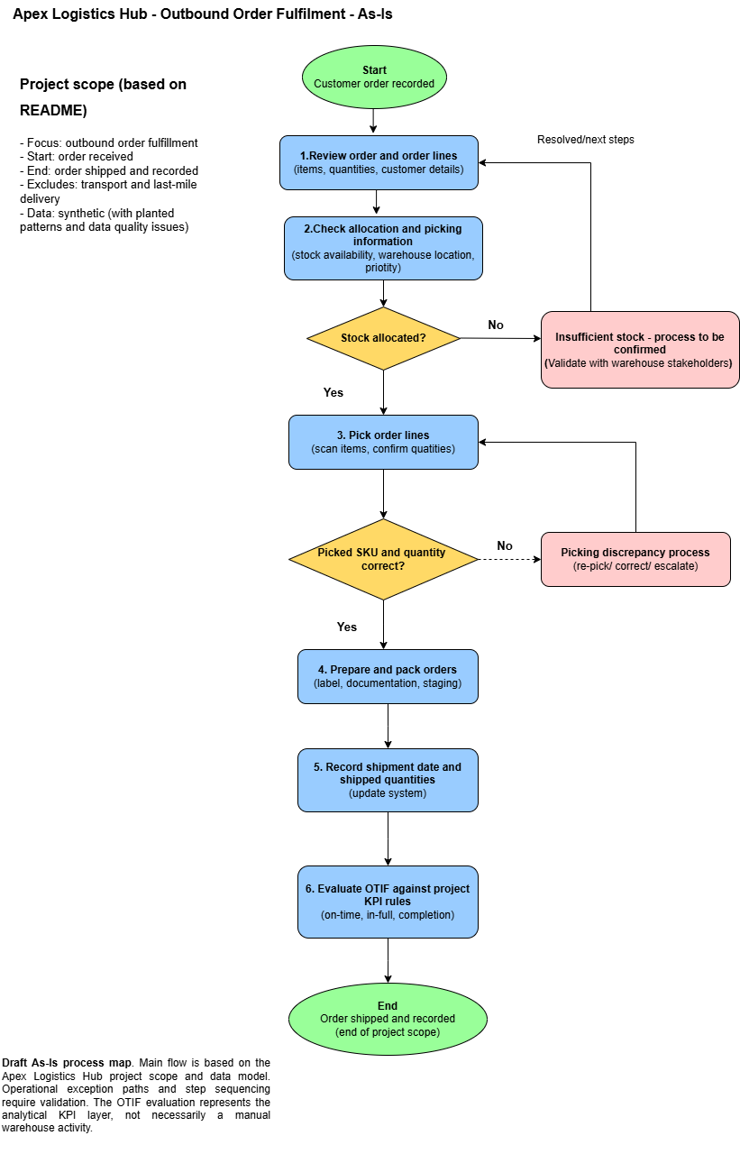

Figure 1: Apex Logistics Hub – As-Is Outbound Order Fulfilment Process

4. Proposed Future-State Process (To-Be)
The proposed future-state process adds validation, exception handling, and verification controls to improve the consistency and traceability of outbound order fulfilment. These improvements are proposed and remain subject to business validation.
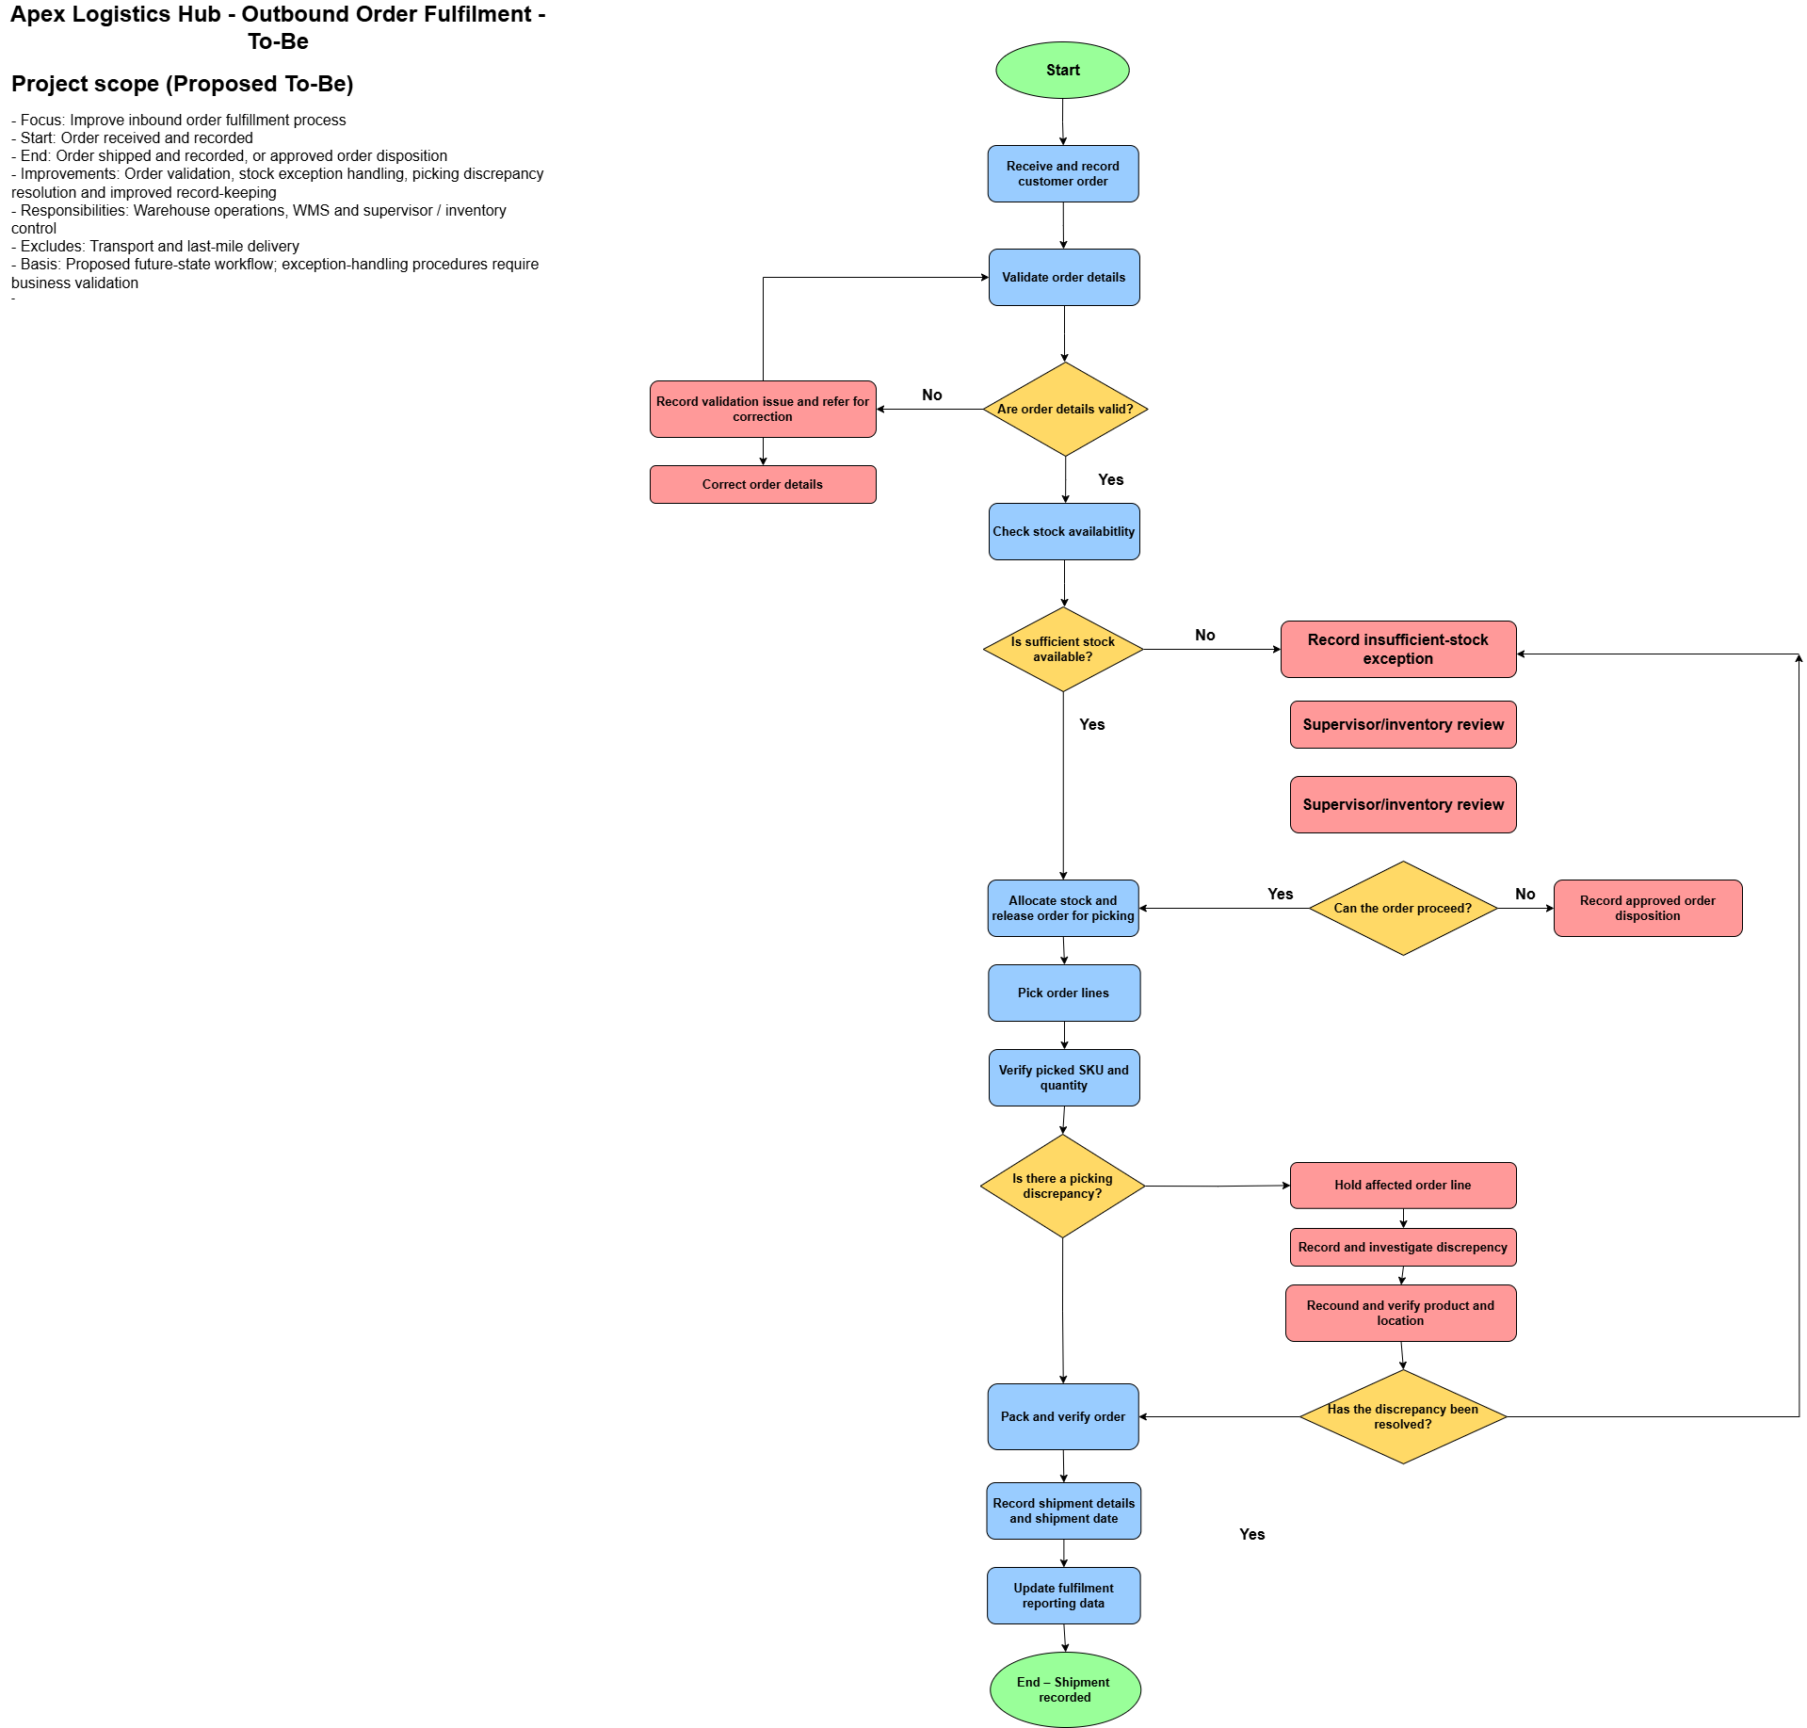

Figure 2: Apex Logistics Hub – Proposed To-Be Outbound Order Fulfilment Process

5. Business requirements
The consolidated business requirements are to provide operational users with a reliable view of fulfilment performance; enable review of OTIF performance over time and by order priority; allow users to filter results by order type; support comparison of picking accuracy across warehouse zones; and provide confidence in the underlying data through data-quality checks and a structured analytical model.
The requirements are supported by the functional requirements and test scenarios below. The Requirements are identified as FR-01 to FR-09 in Section 6.

6. Functional requirements and implementation status
ID | Requirement | Status
FR-01 | Display overall fulfilment KPI cards. | Implemented and user-verified
FR-02 | Display monthly OTIF performance trend. | Implemented and user-verified
FR-03 | Compare OTIF performance by order priority. | Implemented and user-verified
FR-04 | Allow filtering by order type. | Implemented and user-verified
FR-05 | Compare overall fulfilment performance across warehouse or regional groupings. | Not evidenced in the current dashboard; requirement needs revision or implementation
FR-06 | Run Python data-quality checks on project data. | Implemented and verified
FR-07 | Provide a SQL Server dimensional model for reporting. | Implemented and structurally verified
FR-08 | Identify failed OTIF orders for investigation. | Proposed; not implemented or tested
FR-09 | Document operational exception handling. | Proposed; process-owner validation required
FR-05 clarification: The dashboard contains a visual titled “Pick Accuracy % by Warehouse Zone”, comparing Zones A, B and C. This is a valid zone-level picking comparison, but it does not compare overall fulfilment performance by warehouse or region. UAT-05 was therefore revised to test the implemented pick-accuracy visual. FR-05 should be renamed to match that capability or the originally intended fulfilment comparison should be added in a future iteration.

7. Acceptance testing
The acceptance test register covered the report visuals and interactions (AT-01 to AT-05), the Python data-quality process (AT-06), and the SQL Server dimensional model (AT-07).
Test ID | Area | Result
AT-01 to AT-05 | Power BI report visuals and interactions | Carried forward to UAT; see Section 7.
AT-06 | Python data-quality checks | Pass. The user ran 02_dq_check.py; the expected input files were identified and control totals were independently checked and reconciled.
AT-07 | SQL Server dimensional model | Pass for the structural checks performed. The dw schema contained 6 dimension tables and 5 fact tables. The Power BI model showed 14 active relationships. fact_orders.order_id had no duplicates, and the orphaned order-line check returned zero rows.
The SQL Server foreign-key metadata query returned no relationship rows. This did not invalidate the model verification: the relationships were configured and verified in the Power BI model. The recorded AT-07 pass is limited to the structural checks described above.

8. User acceptance testing (UAT)
UAT ID | Scenario | Result | Observation
UAT-01 | Review overall fulfilment KPIs | Pass | None supplied
UAT-02 | Review monthly OTIF performance trend | Pass | None supplied
UAT-03 | Compare performance by order priority | Pass | None supplied
UAT-04 | Filter the report by order type | Pass | None supplied
UAT-05 | Compare Pick Accuracy % across warehouse Zones A, B and C | Pass | None supplied
UAT outcome: All five executed UAT scenarios passed (5/5).
UAT-05 was deliberately revised after the dashboard was re-checked. The test validates pick accuracy by warehouse zone, not an overall fulfilment comparison by warehouse or region.

9. Open items and proposed improvements
- Confirm the operational process for insufficient stock and picking discrepancies with a process owner; update the As-Is map only when verified.
- Clarify whether FR-05 should be revised to “Pick Accuracy % by Warehouse Zone” or whether a separate overall fulfilment comparison by warehouse/region is required.
- Consider FR-08 (failed OTIF order investigation) as a future enhancement.
- Consider FR-09 (documented operational exception handling) after the actual exception workflows have been validated.
- Retain Test evidence: the Python data-quality report (reports/dq_report.txt) and control totals (data/control_totals.csv) are in the repository.

10. Conclusion
The Apex Logistics Hub analytics solution has passed the five executed UAT scenarios. The Python data-quality checks and the structural checks of the SQL Server dimensional model were also recorded as passed. The report provides a usable demonstration of fulfilment KPI monitoring, OTIF analysis, order-type filtering and pick-accuracy comparison by warehouse zone. The principal documentation items to resolve are the exact scope of FR-05 and validation of undocumented operational exception paths.

End of report

