**BOLALOY’S RICE MILLING AND SALES SYSTEM**

**System Description**

The (BRMSS) Bolaloy’s Rice Milling and Sales System is a system that make the work of a cashier or a user easy. This kind of a system is having attribute of what you called saving the data where you entered the information of costumer in the said system. This system having also automatic computing of a cost of a product or item.

The Rice Milling and Sales System is easy to use. Like for an instance, the user will fill up the form according or based to the information and identification of the costumer. And it have a solution provided or guide for you to be not lost in the procedure. And talking to the quality of a system, the efficiency, learnability, and effectiveness is used in creating in this system.

This system is suit to any users for the reason that it is not complicated. I mean there is no process that a user can not complete. This system have the ability to manage the incoming and outgoing of a product, A rice volume, Rice variety.

This will also count the quantity of a rice in stock and updating you of how many exactly stocks is remaining. The (BRMSS) Bolaloy’s Rice Milling and Sales System is making your business to manage easily. It make your lifestyle easy and not hustle to do. This system having also a database that will save your data and kept for safety reason. Any time you want to modify your information of the remaining stocks in your database you can make it. And this have the ability to change form, if you want to change the form into miller to supplier and to retailer.

**Bolaloy’s Rice Milling and Sales System Background**

Bolaloy’s Rice Milling and Sales System is located in brgy Rumirang Municipality of Isabela Negros occidental. The name of System is based on the lastname of the owner..

**Features from Admin:**

* Manage costumer
  + - * + Add Information Of customer and store it to database.
        + Edit the records of customer if some changes from it.
        + Removing the data of customer from database if the records are no longer used.
* Computing cost:
  + - * + Allow admin to compute all the payments of every customer.
* Check remaining stocks:
  + - * + Admin can check the stocks anytime he/she wanted to. And there are action in this system that can see automatically the records of stocks.

Bulaloy’s Data flow:

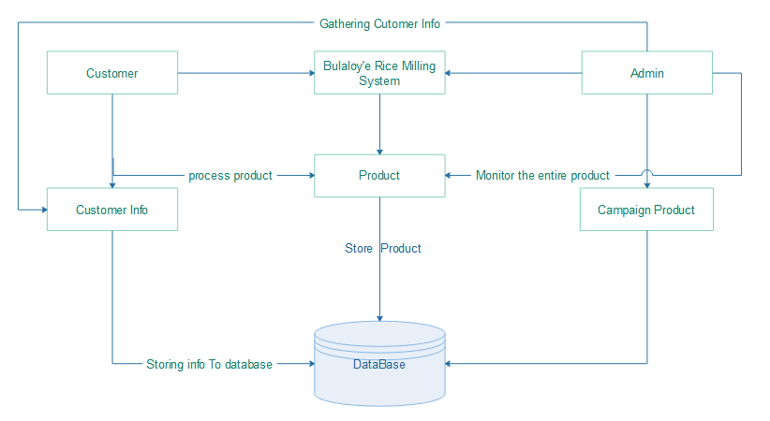

**Figure 1:** Shows the entire processes and relationship of all features in the system. The customer is able to send his/her request for ordering the product and store his/her stocks for milling process.