TECHNICAL IMPLEMENTATION REPORT
Enterprise Network Architecture & Design | Home Affairs Regional Office (Klerksdorp)

STUDENT NAME  SIBONISO MPEHLA | STUDENT ID  37277022
CLIENT ID / PROJECT ID  CLI-093 | CMPG325-2026-093 | ASSIGNED BASE BLOCK  10.38.0.0/16
ASSIGNED FEATURE  Port Security (Switchport Access Control) | CHANGE REQUEST  CR5 (25% Host Growth Absorption)
1. Executive Summary & Project Requirements
This technical report details the design, configuration, and verification of the Local Area Network (LAN) for the Home Affairs Regional Office in Klerksdorp (Client ID: CLI-093). The primary network architecture utilizes a hierarchical model consisting of a Cisco 2911 Core Router (R1-CORE) providing 802.1Q sub-interface Inter-VLAN routing connected via an 802.1Q trunk to a Cisco Catalyst 2960 Access Switch (S1-ACCESS). The network enforces strict logical segregation and access control through Port Security.
2. IP Addressing Plan & Change Request (CR5)
The overall facility allocation is derived from the assigned base block 10.38.0.0/16. To accommodate Change Request 5 (CR5), which mandated a 25% host growth absorption for Staff Operations, the segment was assigned a /23 subnet (10.38.20.0/23), providing up to 510 usable host addresses.
VLAN / Segment | Subnet Block | Subnet Mask | Default Gateway | Assigned Endpoints
VLAN 10: IT Admin | 10.38.10.0/24 | 255.255.255.0 | 10.38.10.1 | PC-IT-Admin (10.38.10.10)
VLAN 20: Staff Ops (CR5) | 10.38.20.0/23 | 255.255.254.0 | 10.38.20.1 | PC-Staff-01 (10.38.20.10)
VLAN 30: Public Counters | 10.38.30.0/24 | 255.255.255.0 | 10.38.30.1 | PC-Public-01 (10.38.30.10)
VLAN 40: Server Farm | 10.38.40.0/27 | 255.255.255.224 | 10.38.40.1 | Server-Main (10.38.40.10)

3. Router & Switch IOS Configuration Scripts
- R1-CORE Sub-interface Configuration (Inter-VLAN Routing):
! R1-CORE GigabitEthernet0/0 Sub-interface Configuration
interface GigabitEthernet0/0
no shutdown
exit
interface GigabitEthernet0/0.10
encapsulation dot1Q 10
ip address 10.38.10.1 255.255.255.0
exit
interface GigabitEthernet0/0.20
encapsulation dot1Q 20
ip address 10.38.20.1 255.255.254.0
exit
interface GigabitEthernet0/0.30
encapsulation dot1Q 30
ip address 10.38.30.1 255.255.255.0
exit
interface GigabitEthernet0/0.40
encapsulation dot1Q 40
ip address 10.38.40.1 255.255.255.224
exit

- S1-ACCESS Port Security Enforcement Script:

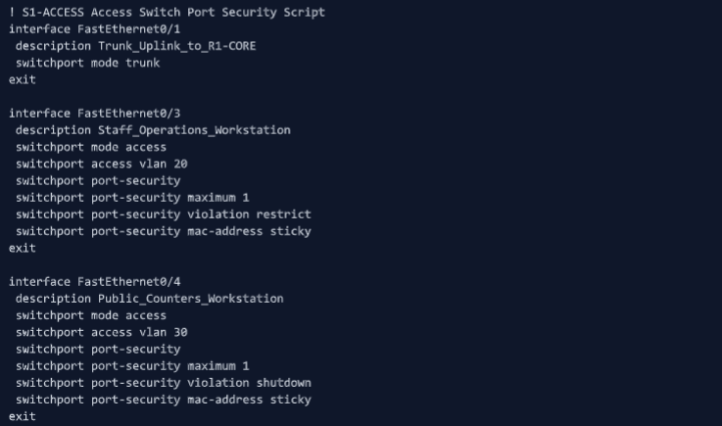

4. Packet Tracer Verification & Evidence
A. ICMP Ping Tests (Inter-VLAN Communication):
- • Execution: Executed directly from PC-Staff-01 Command Prompt to verify default gateway and inter-VLAN routing.
[SCREENSHOT 1: Gateway Ping (10.38.20.1)]
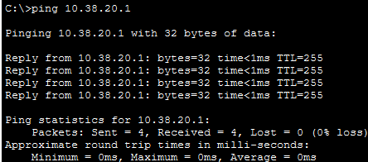

[SCREENSHOT 2: Server Ping (10.38.40.10)]
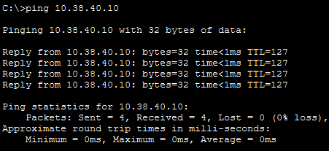

[SCREENSHOT 3: IT-Admin Ping (10.38.10.10)]
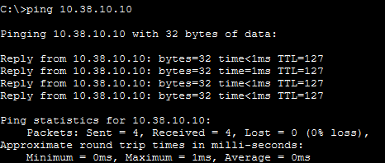

B. Switch Port Security Verification (S1-ACCESS CLI):
- • Execution: Executed on S1-ACCESS switch CLI to confirm maximum MAC limits and sticky address learning.
[SCREENSHOT 4: Switch CLI Port Security Status]

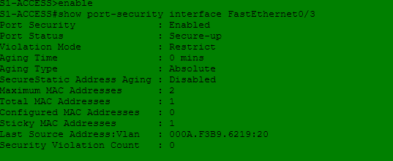.

C. Port Security Violation Penalty Simulation:
- Execution: Attached unauthorized device to Fa0/4 to trigger shutdown state.
[SCREENSHOT 5: Err-Disabled / Port Shutdown Violation Evidence]
5. GitHub Portfolio Repository
- Repository URL: https://github.com/Siboniso-Mpehla/CMPG325-Home_Affairs_Klerksdorp
- Repository Organization Includes: Home Affairs Klerksdorp.pkt, Milestone1_Client_Design_Review.docx, Milestone2_Working_Packet_Tracer_Implementation_Review.docx, CMPG325_Technical_Report_CLI093.docx.

