CLIENT IMPLEMENTATION REVIEW
Working Packet Tracer Implementation & Verification Report | Home Affairs Regional Office (Klerksdorp)

STUDENT NAME  SIBONISO MPEHLA | STUDENT ID  37277022
CLIENT ID / PROJECT ID  CLI-093 | CMPG325-2026-093 | ASSIGNED NET BLOCK  10.38.0.0/16
ASSIGNED FEATURE  Port Security (Switchport Access Control) | CHANGE REQUEST  CR5 (25% Host Growth Absorption)
1. Working Packet Tracer File Overview
- File Name: Home_Affairs_Klerksdorp_Implementation.pkt
- Software Compatibility: Cisco Packet Tracer v8.2+
- File Location in Repo: /topology/Home_Affairs_Klerksdorp_Implementation.pkt
- Configured Network Devices:
- • Router (R1-CORE): Cisco 2911 integrated with 802.1Q sub-interfaces for inter-VLAN routing.
- • Access Switch (S1-ACCESS): Cisco Catalyst 2960 enforcing VLAN tags, trunking, and port security.
- • Endpoints Configured: PC-IT-Admin (10.38.10.10/24), PC-Staff-01 (10.38.20.10/23), PC-Public-01 (10.38.30.10/24), Server-Main (10.38.40.10/27).
2. Assigned Feature Implemented: Port Security
- VLAN 20 (Staff Operations - Fa0/3): Configured with maximum 2 dynamic sticky MAC addresses and Restrict violation penalty.
- VLAN 30 (Public Counters - Fa0/4): Configured with maximum 1 dynamic sticky MAC address and Shutdown violation penalty.
! S1-ACCESS Port Security Implementation Script
interface FastEthernet0/3
description Staff_Operations Workstation Port
switchport mode access
switchport access vlan 20
switchport port-security
switchport port-security maximum 2
switchport port-security violation restrict
switchport port-security mac-address sticky
exit
interface FastEthernet0/4
description Public_Counters Workstation Port
switchport mode access
switchport access vlan 30
switchport port-security
switchport port-security maximum 1
switchport port-security violation shutdown
switchport port-security mac-address sticky
exit
3. Packet Tracer Testing & Verification Evidence
- A. ICMP Ping Tests (Inter-VLAN &amp; Gateway Routing):
- Execution: Executed directly from PC-Staff-01 Command Prompt to verify routing across subnets.

[SCREENSHOT 1: Gateway Ping (10.38.20.1)]

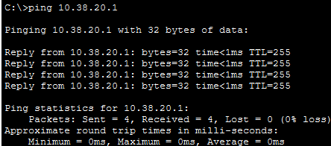

[SCREENSHOT 2: Server Ping (10.38.40.10)]

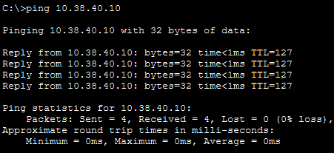

[SCREENSHOT 3: IT-Admin Ping (10.38.10.10)]

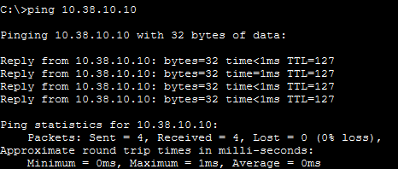

- Port Security Status Verification: Executed `show port-security interface Fa0/3` and `show port-security interface Fa0/4` confirming active enforcement.

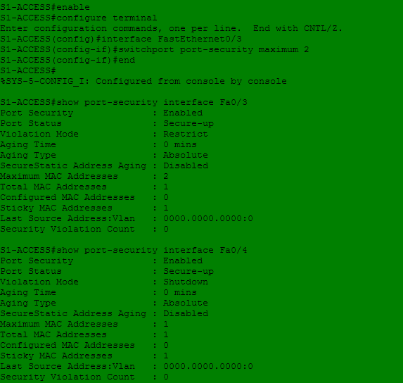

- Violation Penalty Simulation: Attached rogue device to Fa0/4. System immediately triggered `err-disabled` state on interface, shutting down the port.

4. Updated GitHub Portfolio Link
- Repository URL: https://github.com/Siboniso-Mpehla/CMPG325-Home_Affairs_Klerksdorp
- Repository Contents: Includes Home Affairs Klerksdorp.pkt, Milestone1_Client_Design_Review.docx, Milestone2_Working_Packet_Tracer_Implementation_Review.docx.

