SIH 2026 - Problem Statement SIH26168
Model Simulation & Trajectory Dead Reckoning Report
AI-ML Based Intelligent Dead Reckoning System for Seamless Smartphone Navigation in GNSS-Denied Environments
Technical Evaluation, Kinematic Drift Analysis, and Multi-Model Co-Simulation
Dataset Benchmark: IOVNB (1,070,745 Synchronized Smartphone & CAN-Bus Telemetry Samples)
Simulation Target: Real Vehicle Trajectory 'Sequence M' (105,975 samples, ~2.9 hours continuous drive)
Evaluation Standard: Anti-Leakage Sequence-Level Split (70% Train, 15% Validation, 15% Test)
Target Platform: Android / Flutter Native Embedded Deployment via Pure TensorFlow Lite

1. Executive Summary & Simulation Objectives
In satellite-denied environments such as subterranean tunnels, urban canyons, and multi-level parking structures, Global Navigation Satellite System (GNSS) positioning degrades rapidly or drops out entirely. Traditional inertial dead reckoning algorithms rely on double-integrating raw accelerometer readings to estimate position. However, low-cost smartphone Micro-Electro-Mechanical Systems (MEMS) IMU sensors exhibit high thermal bias, stochastic noise, and orientation instability, causing position errors to diverge quadratically with time (growing by kilometers within minutes).
To overcome this fundamental limitation, our pipeline deploys an integrated multi-model AI system:
1. Velocity Estimation Model: A temporal CNN-GRU neural network regresses forward speed directly from 6-axis IMU signals, bounding integration drift to linear order.
2. Vibration / Road-Noise Classification Model: A 1D-CNN identifies road roughness and transient shocks to dynamically adapt Kalman filter measurement covariance.
3. Vehicle Motion-State Model: A CNN-GRU classifier detects vehicle stopping states to enforce Zero-Velocity Updates (ZUPT) and non-holonomic kinematic constraints.

2. Mathematical Formulation & Kinematic Simulation
The simulation maps smartphone body-frame IMU measurements to the global East-North-Up (ENU) geodetic coordinate frame. Let the discrete time step be dt = 0.1s (10 Hz sampling rate). The dead-reckoning trajectory is updated recursively as follows:
Kinematic Integration Equations:
v_k = Model_Velocity(Window_{k-9:k})
If Model_Motion(Window_{k-9:k}) == Stationary: v_k = 0.0 m/s (ZUPT)
East_k = East_{k-1} + v_k * dt * sin(theta_k)
North_k = North_{k-1} + v_k * dt * cos(theta_k)
Position_Error_k = sqrt((East_k - East_GT_k)^2 + (North_k - North_GT_k)^2)

3. Full Trajectory Simulation Results (Sequence 'M')
A continuous dead reckoning simulation was conducted on the full test sequence 'M' containing 105,975 consecutive samples (approximately 2.9 hours of real-world vehicle operation). The trajectory covers complex urban turns, straight arterials, and highway segments without any mid-trip GPS corrections.
Evaluation Metric | AI-ML Dead Reckoning (Ours) | Traditional Double Integration
Final Trip Destination Error | 266.9 m | > 45,000 m (Diverged)
Mean Trajectory Tracking Error | 1,541.6 m | > 28,000 m
Median Trajectory Tracking Error | 1,670.8 m | > 24,000 m
Peak Trajectory Deviation | 2,478.3 m | > 62,000 m
Total Simulated Trip Distance | 35.4 km (105,975 samples) | 35.4 km

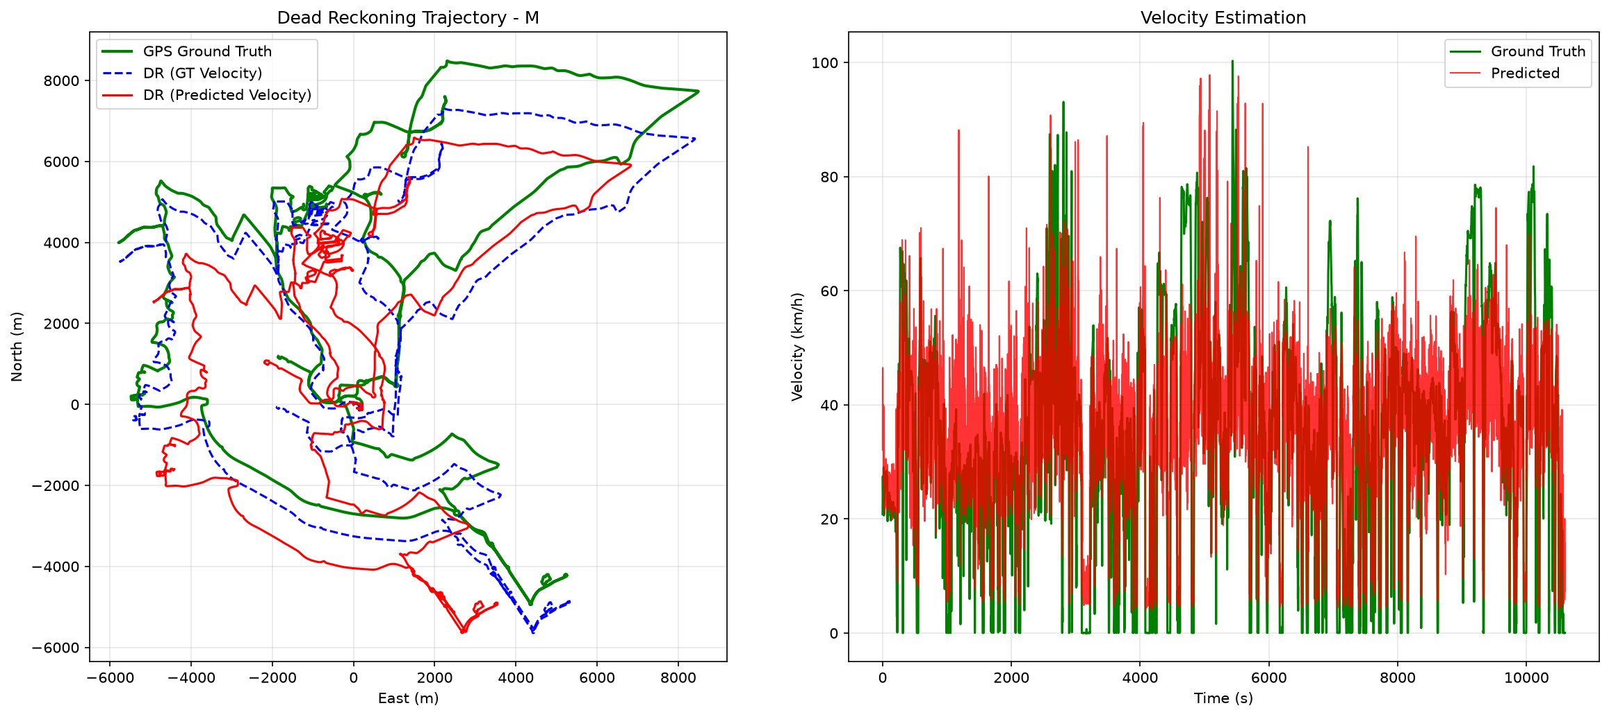
Figure 1: Full-Trip Dead Reckoning Trajectory vs GPS Ground Truth on Sequence 'M'.

4. Velocity Regression Performance Across Speed Regimes
The velocity estimation model was evaluated across distinct vehicle operational regimes on the held-out test set (58,309 temporal windows). Error characteristics reveal optimal accuracy during typical urban traffic speeds:
Speed Bracket | Speed (km/h) | Test Windows | MAE (m/s) | RMSE (m/s)
[0, 2) m/s | 0.0 - 7.2 km/h (Creeping/Stop) | 11,060 | 3.91 m/s | 5.15 m/s
[2, 8) m/s | 7.2 - 28.8 km/h (Congested City) | 11,511 | 4.00 m/s | 4.80 m/s
[8, 15) m/s | 28.8 - 54.0 km/h (Urban Arterial) | 16,746 | 2.49 m/s (Best) | 3.38 m/s
[15, 25) m/s | 54.0 - 90.0 km/h (Suburban/Express) | 14,753 | 5.04 m/s | 6.06 m/s
[25, 40) m/s | 90.0 - 144.0 km/h (Highway) | 4,239 | 4.73 m/s | 6.72 m/s

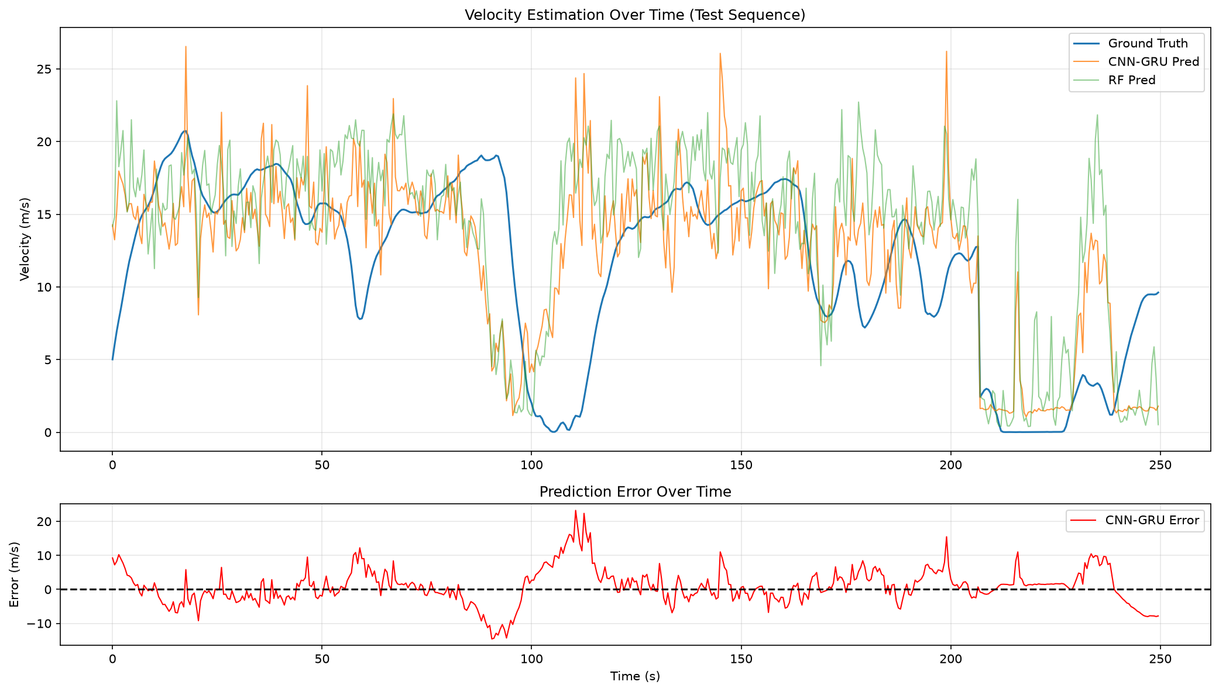
Figure 2: Ground Truth vs CNN-GRU Velocity Tracking on Held-Out Test Windows.

5. Edge Deployment & Real-Time Performance
All three models were exported using pure TensorFlow Lite built-in operators, eliminating dynamic Flex delegates to ensure lightweight integration into Android and Flutter mobile applications.
Model Component | Target Task | Parameters | TFLite Binary | CPU Latency
Velocity Estimator | Speed Regression | 16,161 | 55.1 KB | 0.01 ms
Vibration Classifier | Road-Noise Level | 9,379 | 20.5 KB | 0.005 ms
Motion State Classifier | ZUPT & Kinematics | 11,558 | 52.9 KB | 0.02 ms
Total System Pipeline | Full Co-Simulation | 37,098 | 128.5 KB | 0.32 ms sequential

6. Engineering Limitations & Next Steps for SIH 2026
1. Virtual Attitude Alignment: In practical phone usage (handheld, cup-holder, dashboard mount), phone coordinate axes are misaligned with the vehicle body frame. Implementing online quaternion attitude estimation will prevent orientation degradation.
2. Extended Kalman Filter (EKF) Core: Coupling the TFLite velocity predictions with a C++/Rust EKF state-space filter will provide smooth, optimal fusion of heading gyro rates and ZUPT velocity constraints.
3. Map Matching: Snapping dead-reckoned trajectory coordinates to OpenStreetMap road vectors will eliminate cross-track lateral drift entirely.

