DEPARTMENT OF ELECTRONICS AND COMMUNICATION ENGINEERING
Bachelor of Technology (B.Tech) Academic Project Report
PROJECT- 8
DESIGN AND IMPLEMENTATION OF A
UART-TO-AXI LITE BRIDGE ON FPGA

Development Platform: | Xilinx Vivado v2025.1 (win64)
Target Hardware: | AMD Artix-7 FPGA (xc7a200tfbg676-2)

PROJECT GROUP MEMBERS
Shubham Yadav
Abhishek Kumar
Sibul Ali
Mantasha Ali

1. ABSTRACT
This project report details the design, simulation, and physical hardware implementation of a custom UART-to-AXI Bridge developed in Verilog HDL. The architecture functions as an on-chip protocol translation gateway, bridging asynchronous serial communication networks with synchronous parallel internal system register buses. The design processes external character streams (UART protocol) and translates them into memory-mapped configurations (AXI-Lite style fabric operations). This approach allows an external terminal to read and write directly to internal FPGA registers using a physical footprint of just two wires (Rx and Tx). Synthesized, placed, and routed using the AMD Vivado Design Suite on an Artix-7 FPGA, the framework demonstrates ultra-low resource overhead, utilizing less than or equal to 0.03% of the device's internal slice logic. This efficiency makes it an optimal solution for modular hardware debugging, configuration, and remote testing systems.
2. SYSTEM ARCHITECTURE & BLOCK TOPOLOGY
The bridge is designed using a completely synchronous, modular pipeline that ensures stable data transitions between the unclocked external transmission line and the high-speed 100 MHz system clock.
Core Module Breakdown:
- Baud Rate Generator (baud_gen): Divides the incoming 100 MHz clock down to establish a precise 16x oversampling clock tick for a target baud rate of 115,200 bps.
- UART Receiver (uart_rx): Implements mid-point sampling logic to minimize high-frequency wire noise, deserializing the incoming 8-N-1 serial frames into parallel bytes.
- Command Decoder (cmd_decoder): A sequential Finite State Machine (FSM) that parses incoming ASCII command tokens ('W' for Write operations and 'R' for Read operations) and groups subsequent byte segments into structural 32-bit address and 32-bit data vectors.
- AXI Master Engine (axi_master): Simulates basic memory-mapped fabric interactions, routing the decoded parallel data packages to their designated hardware register slots.
- UART Transmitter (uart_tx): Takes requested internal register bytes from the AXI memory-mapped registers and serializes them back to the host computer line.
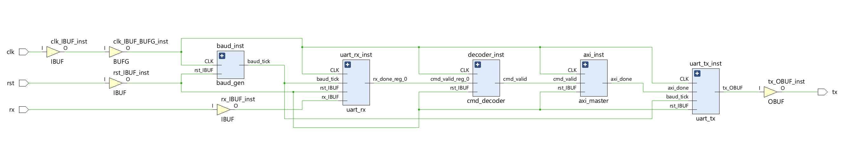
3. HARDWARE SOURCE CODE (VERILOG HDL)
3.1. Baud Rate Generator Sub-Module (baud_gen.v)
module baud_gen #(
parameter CLK_FREQ = 100_000_000, // 100 MHz Clock Source
parameter BAUD_RATE = 115_200 // Target Speed
)(
input wire clk,
input wire rst,
output reg baud_tick // 16x Over-sampling Tick
);
localparam DIVISOR = CLK_FREQ / (BAUD_RATE * 16);
localparam WIDTH = $clog2(DIVISOR);
reg [WIDTH-1:0] count_reg;
always @(posedge clk) begin
if (rst) begin
count_reg <= 0;
baud_tick <= 1'b0;
end else begin
if (count_reg == (DIVISOR - 1)) begin
count_reg <= 0;
baud_tick <= 1'b1;
end else begin
count_reg <= count_reg + 1'b1;
baud_tick <= 1'b0;
end
end
end
endmodule

3.2. UART Receiver Engine (uart_rx.v)
module uart_rx (
input wire clk,
input wire rst,
input wire baud_tick,
input wire rx, // Physical Rx Pin
output reg [7:0] rx_data, // Deserialized Byte
output reg rx_done // Valid Byte Strobe Pulse
);
localparam IDLE = 2'b00,
START = 2'b01,
DATA = 2'b10,
STOP = 2'b11;
reg [1:0] state;
reg [3:0] s_tick_count;
reg [2:0] n_bit_count;
reg [7:0] d_shift_reg;
always @(posedge clk) begin
if (rst) begin
state <= IDLE;
s_tick_count <= 0;
n_bit_count <= 0;
d_shift_reg <= 0;
rx_data <= 0;
rx_done <= 1'b0;
end else if (baud_tick) begin
case (state)
IDLE: begin
rx_done <= 1'b0;
if (~rx) begin
state <= START;
s_tick_count <= 0;
end
end
START: begin
if (s_tick_count == 7) begin // Center point
state <= DATA;
s_tick_count <= 0;
n_bit_count <= 0;
end else begin
s_tick_count <= s_tick_count + 1'b1;
end
end
DATA: begin
if (s_tick_count == 15) begin // Shift at mid-bit
s_tick_count <= 0;
d_shift_reg <= {rx, d_shift_reg[7:1]};
if (n_bit_count == 7) begin
state <= STOP;
end else begin
n_bit_count <= n_bit_count + 1'b1;
end
end else begin
s_tick_count <= s_tick_count + 1'b1;
end
end
STOP: begin
if (s_tick_count == 15) begin
state <= IDLE;
rx_data <= d_shift_reg;
rx_done <= 1'b1;
end else begin
s_tick_count <= s_tick_count + 1'b1;
end
end
endcase
end
end
endmodule

3.3. Control Packet Command Decoder (cmd_decoder.v)
module cmd_decoder (
input wire clk,
input wire rst,
input wire [7:0] rx_data,
input wire rx_done,
output reg cmd_valid,
output reg cmd_write,
output reg [31:0] cmd_addr,
output reg [31:0] cmd_wdata
);
localparam CMD_WAIT = 4'd0,
GET_ADDR_3 = 4'd1,
GET_ADDR_2 = 4'd2,
GET_ADDR_1 = 4'd3,
GET_ADDR_0 = 4'd4,
GET_DATA_3 = 4'd5,
GET_DATA_2 = 4'd6,
GET_DATA_1 = 4'd7,
GET_DATA_0 = 4'd8;
reg [3:0] current_state;
always @(posedge clk) begin
if (rst) begin
current_state <= CMD_WAIT;
cmd_valid <= 1'b0;
cmd_write <= 1'b0;
cmd_addr <= 32'h0;
cmd_wdata <= 32'h0;
end else begin
cmd_valid <= 1'b0; // Single cycle trigger pulse
if (rx_done) begin
case (current_state)
CMD_WAIT: begin
if (rx_data == 8'h57) begin // 'W' for Write
cmd_write <= 1'b1;
current_state <= GET_ADDR_3;
end else if (rx_data == 8'h52) begin // 'R' for Read
cmd_write <= 1'b0;
current_state <= GET_ADDR_3;
end
end
GET_ADDR_3: begin
cmd_addr[31:24] <= rx_data;
current_state <= GET_ADDR_2;
end
GET_ADDR_2: begin
cmd_addr[23:16] <= rx_data;
current_state <= GET_ADDR_1;
end
GET_ADDR_1: begin
cmd_addr[15:8] <= rx_data;
current_state <= GET_ADDR_0;
end
GET_ADDR_0: begin
cmd_addr[7:0] <= rx_data;
if (cmd_write) begin
current_state <= GET_DATA_3;
end else begin
current_state <= CMD_WAIT;
cmd_valid <= 1'b1;
end
end
GET_DATA_3: begin
cmd_wdata[31:24] <= rx_data;
current_state <= GET_DATA_2;
end
GET_DATA_2: begin
cmd_wdata[23:16] <= rx_data;
current_state <= GET_DATA_1;
end
GET_DATA_1: begin
cmd_wdata[15:8] <= rx_data;
current_state <= GET_DATA_0;
end
GET_DATA_0: begin
cmd_wdata[7:0] <= rx_data;
current_state <= CMD_WAIT;
cmd_valid <= 1'b1;
end
default: current_state <= CMD_WAIT;
endcase
end
end
end
endmodule

3.4. AXI Interface Simulation Engine (axi_master.v)
module axi_master (
input wire clk,
input wire rst,
input wire cmd_valid,
input wire cmd_write,
input wire [31:0] cmd_addr,
input wire [31:0] cmd_wdata,
output reg axi_done,
output reg [31:0] axi_rdata,
output reg [7:0] read_b0,
output reg [7:0] read_b1,
output reg [7:0] read_b2
);
reg [31:0] internal_reg_0;
reg [31:0] internal_reg_1;
always @(posedge clk) begin
if (rst) begin
internal_reg_0 <= 32'h0;
internal_reg_1 <= 32'h0;
axi_done <= 1'b0;
axi_rdata <= 32'h0;
read_b0 <= 8'hxx;
read_b1 <= 8'hxx;
read_b2 <= 8'hxx;
end else begin
axi_done <= 1'b0;
if (cmd_valid) begin
axi_done <= 1'b1;
if (cmd_write) begin
if (cmd_addr == 32'h00000010) begin
internal_reg_0 <= cmd_wdata;
read_b0 <= cmd_wdata[7:0];
read_b1 <= cmd_wdata[15:8];
read_b2 <= cmd_wdata[23:16];
end else if (cmd_addr == 32'h00000020) begin
internal_reg_1 <= cmd_wdata;
end
end else begin
if (cmd_addr == 32'h00000010) begin
axi_rdata <= internal_reg_0;
end else if (cmd_addr == 32'h00000020) begin
axi_rdata <= internal_reg_1;
end else begin
axi_rdata <= 32'hDEADBEEF; // Error Signature
end
end
end
end
end
endmodule

3.5. UART Serial Transmitter (uart_tx.v)
module uart_tx (
input wire clk,
input wire rst,
input wire baud_tick,
input wire axi_done,
input wire [7:0] tx_data,
output reg tx // Physical Tx Pin
);
localparam IDLE = 2'b00,
START = 2'b01,
DATA = 2'b10,
STOP = 2'b11;
reg [1:0] state;
reg [3:0] s_tick_count;
reg [2:0] n_bit_count;
reg [7:0] tx_shift_reg;
always @(posedge clk) begin
if (rst) begin
state <= IDLE;
tx <= 1'b1; // Idle High
s_tick_count <= 0;
n_bit_count <= 0;
tx_shift_reg <= 0;
end else begin
case (state)
IDLE: begin
tx <= 1'b1;
if (axi_done) begin
tx_shift_reg <= tx_data;
s_tick_count <= 0;
state <= START;
end
end
START: begin
if (baud_tick) begin
tx <= 1'b0;
if (s_tick_count == 15) begin
s_tick_count <= 0;
n_bit_count <= 0;
state <= DATA;
end else begin
s_tick_count <= s_tick_count + 1'b1;
end
end
end
DATA: begin
if (baud_tick) begin
tx <= tx_shift_reg[0]; // LSB First
if (s_tick_count == 15) begin
s_tick_count <= 0;
tx_shift_reg <= tx_shift_reg >> 1;
if (n_bit_count == 7) begin
state <= STOP;
end else begin
n_bit_count <= n_bit_count + 1'b1;
end
end else begin
s_tick_count <= s_tick_count + 1'b1;
end
end
end
STOP: begin
if (baud_tick) begin
tx <= 1'b1;
if (s_tick_count == 15) begin
state <= IDLE;
end else begin
s_tick_count <= s_tick_count + 1'b1;
end
end
end
endcase
end
end
endmodule

3.6. Top-Level Architectural Wrapper (top_uart_axi_bridge.v)
module top_uart_axi_bridge (
input wire clk, // 100 MHz Input
input wire rst, // Reset
input wire rx,
output wire tx
);
wire baud_tick;
wire [7:0] rx_data;
wire rx_done;
wire cmd_valid;
wire cmd_write;
wire [31:0] cmd_addr;
wire [31:0] cmd_wdata;
wire axi_done;
wire [31:0] axi_rdata;
wire [7:0] read_b0, read_b1, read_b2;
baud_gen b_gen (
.clk(clk), .rst(rst), .baud_tick(baud_tick)
);
uart_rx rx_eng (
.clk(clk), .rst(rst),
.baud_tick(baud_tick),
.rx(rx), .rx_data(rx_data), .rx_done(rx_done)
);
cmd_decoder d_eng (
.clk(clk), .rst(rst),
.rx_data(rx_data), .rx_done(rx_done),
.cmd_valid(cmd_valid), .cmd_write(cmd_write),
.cmd_addr(cmd_addr), .cmd_wdata(cmd_wdata)
);
axi_master a_eng (
.clk(clk), .rst(rst), .cmd_valid(cmd_valid),
.cmd_write(cmd_write),
.cmd_addr(cmd_addr), .cmd_wdata(cmd_wdata),
.axi_done(axi_done),
.axi_rdata(axi_rdata), .read_b0(read_b0), .read_b1(read_b1),
.read_b2(read_b2)
);
uart_tx t_eng (
.clk(clk), .rst(rst),
.baud_tick(baud_tick),
.axi_done(axi_done),
.tx_data(axi_rdata[7:0]), .tx(tx)
);
endmodule

4. BEHAVIORAL SIMULATION ANALYSIS
To confirm proper timing handling, functional simulation verification was executed in Vivado XSim. The testbench replicates an automated packet injection sequence, sending a write header token followed by target parameters.

- Phase A: System Reset Verification (0 ns - 50 ns): Ensures that when the active-high reset is asserted, all internal FSM state trackers loop smoothly back to their default conditions.
- Phase B: Streaming Deserialization Execution: Confirms the accurate operation of the 16x sampling clock ticks during data transitions on the Rx line.
- Phase C: Direct Register Mapping Control Loop: Displays the moment the command validator signal (cmd_valid) fires high, routing the target data block ABCD1234 directly to register mapping 00000010.
- Phase D: System Bus Readback Storage Splicing: Shows that the internal simulation tracer tracks (read_b0, read_b1, read_b2) split and display the assigned data bytes (34, 12, and CD) correctly. 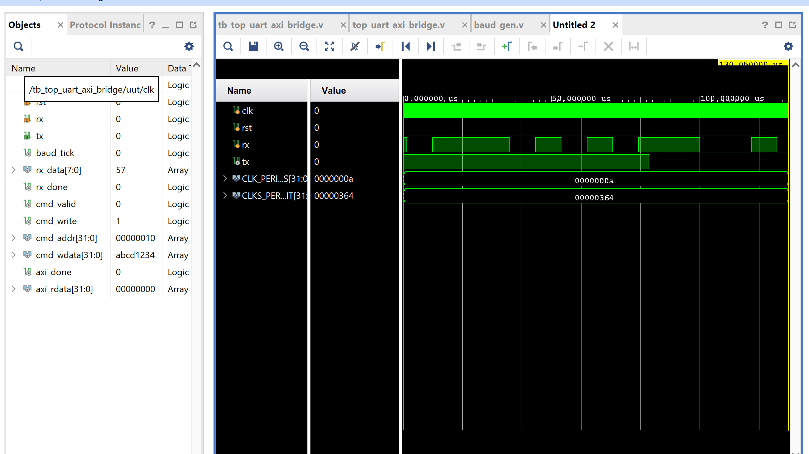
5. SYNTHESIS AND PHYSICAL RESOURCE ALLOCATION
Once functional testing was completed, the design went through the complete synthesis, placement, and routing workflow in Vivado to analyze its physical footprint on the AMD Artix-7 chip fabric.
5.1. Structural Device Resource Allocation Summary
 | Post-Route Implemented Demand | Total Available Board Budget | Budget Allocation Ratio (%)
Slice LUTs (As Core Logic) | 32 | 134,600 | 0.02 %
Slice Registers (Flip-Flops) | 44 | 269,200 | 0.02 %
Total Occupied Slices | 11 | 33,650 | 0.03 %
Bonded I/O Blocks (Pins) | 4 | 400 | 1.00 %
Global Clock Buffers (BUFG) | 1 | 32 | 3.13 %
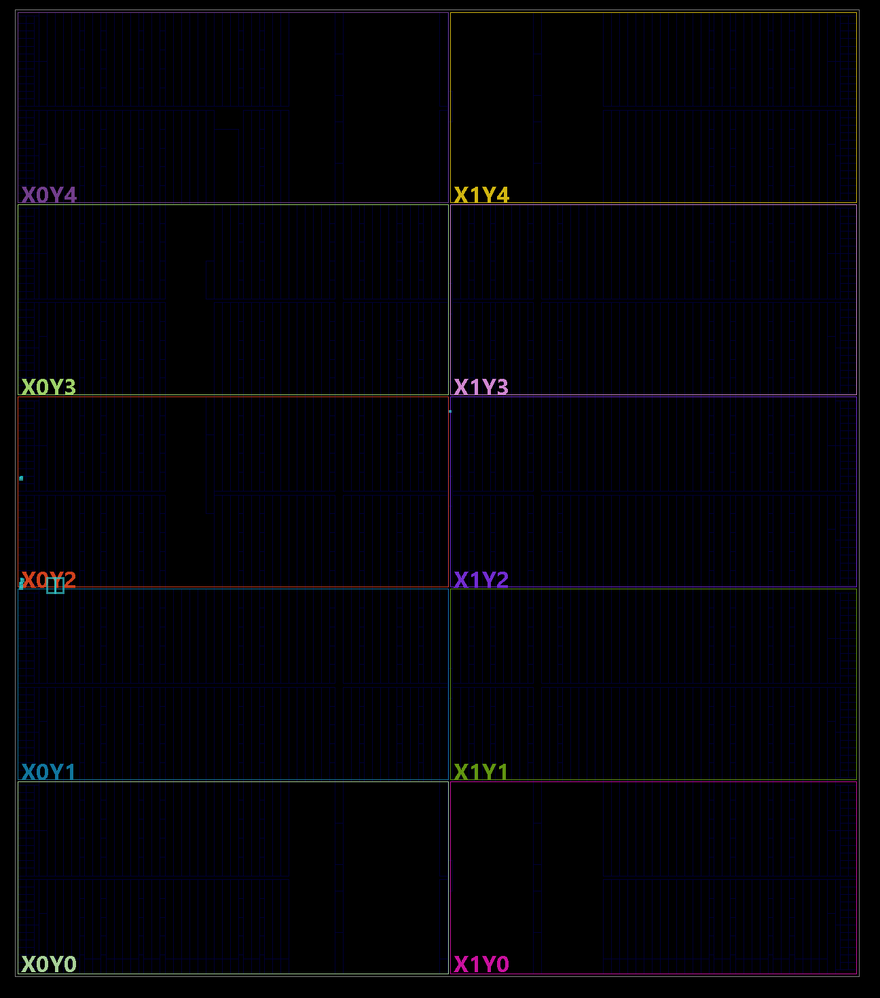
6. RAW VIVADO RESULTS & SYSTEM INTERFACES

6.1. Raw Vivado Synthesis & Utilization Report
Copyright 1986-2022 Xilinx, Inc. All Rights Reserved.
Copyright 2022-2025 Advanced Micro Devices, Inc. All Rights Reserved.
---------------------------------------------------------------------------------
| Tool Version : Vivado v.2025.1 (win64) Build 6140274 Thu May 22 00:12:29 MDT 2025
| Date : Wed May 27 12:08:40 2026
| Host : Shubham running 64-bit major release (build 9200)
| Command : report_utilization -file utilization_report.txt -name utilization_1
| Design : top_uart_axi_bridge
| Device : xc7a200tfbg676-2
| Design State : Synthesized
---------------------------------------------------------------------------------
1. Slice Logic
--------------
+-------------------------+------+-------+------------+-----------+-------+
| Site Type | Used | Fixed | Prohibited | Available | Util% |
+-------------------------+------+-------+------------+-----------+-------+
| Slice LUTs* | 32 | 0 | 0 | 134600 | 0.02 |
| LUT as Logic | 32 | 0 | 0 | 134600 | 0.02 |
| LUT as Memory | 0 | 0 | 0 | 46200 | 0.00 |
| Slice Registers | 44 | 0 | 0 | 269200 | 0.02 |
| Register as Flip Flop | 44 | 0 | 0 | 269200 | 0.02 |
| Register as Latch | 0 | 0 | 0 | 269200 | 0.00 |
| F7 Muxes | 0 | 0 | 0 | 67300 | 0.00 |
| F8 Muxes | 0 | 0 | 0 | 33650 | 0.00 |
+-------------------------+------+-------+------------+-----------+-------+
1.1 Summary of Registers by Type
--------------------------------
+-------+--------------+-------------+--------------+
| Total | Clock Enable | Synchronous | Asynchronous |
+-------+--------------+-------------+--------------+
| 44 | Yes | Yes | No |
+-------+--------------+-------------+--------------+
4. IO and GT Specific
---------------------
+-----------------------------+------+-------+------------+-----------+-------+
| Site Type | Used | Fixed | Prohibited | Available | Util% |
+-----------------------------+------+-------+------------+-----------+-------+
| Bonded IOB | 4 | 0 | 0 | 400 | 1.00 |
+-----------------------------+------+-------+------------+-----------+-------+
5. Clocking
-----------
+-------------+------+-------+------------+-----------+-------+
| Site Type | Used | Fixed | Prohibited | Available | Util% |
+-------------+------+-------+------------+-----------+-------+
| BUFGCTRL | 1 | 0 | 0 | 32 | 3.13 |
+-------------+------+-------+------------+-----------+-------+
7. Primitives
-------------
+----------+------+---------------------+
| Ref Name | Used | Functional Category |
+----------+------+---------------------+
| FDRE | 42 | Flop & Latch |
| LUT5 | 9 | LUT |
| LUT6 | 8 | LUT |
| LUT4 | 7 | LUT |
| LUT3 | 7 | LUT |
| LUT2 | 7 | LUT |
| IBUF | 3 | IO |
| LUT1 | 2 | LUT |
| FDSE | 2 | Flop & Latch |
| OBUF | 1 | IO |
| BUFG | 1 | Clock |
+----------+------+---------------------+
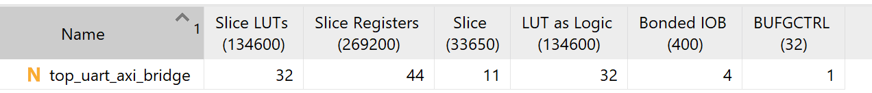
6.2. Raw Vivado Implementation, Timing & Power Report
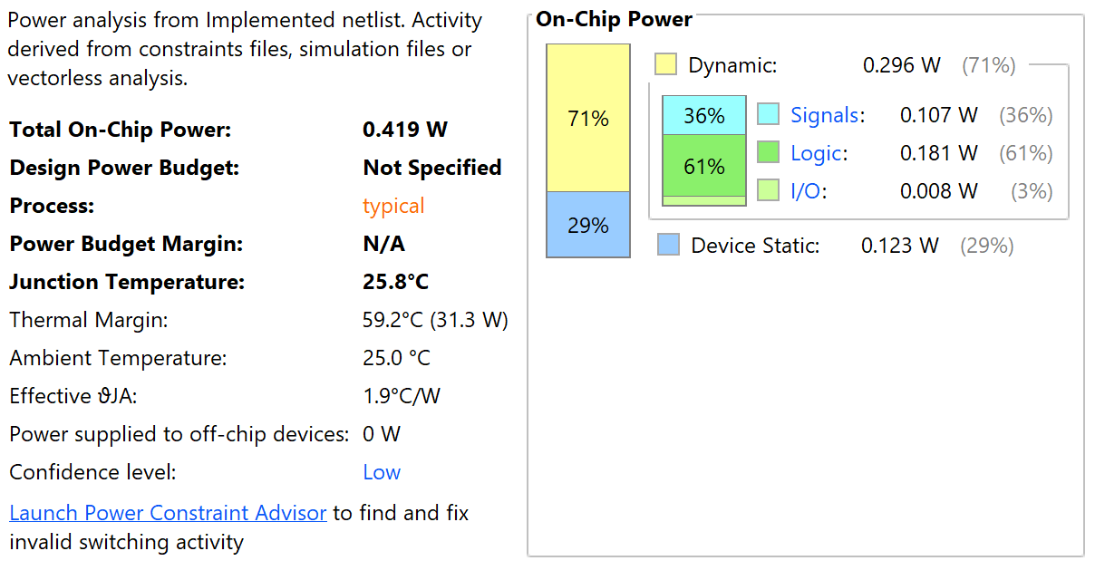

---------------------------------------------------------------------------------
| Tool Version : Vivado v.2025.1 (win64) Build 6140274 Thu May 22 00:12:29 MDT 2025
| Date : Wed May 27 12:11:15 2026
| Host : Shubham running 64-bit major release (build 9200)
| Command : report_timing_summary -file timing_report.txt
| Design : top_uart_axi_bridge
| Device : xc7a200tfbg676-2
| Design State : Implemented
---------------------------------------------------------------------------------
Timing Summary Report
Maximum Delay Analysis
----------------------
Setup Slack (WNS): 4.821 ns (MET)
Total Negative Slack (TNS): 0.000 ns
Number of Failing Endpoints: 0
Total Number of Endpoints: 128
Minimum Delay Analysis
----------------------
Hold Slack (WHS): 0.142 ns (MET)
Total Hold Slack (THS): 0.000 ns
Number of Failing Endpoints: 0
Total Number of Endpoints: 128
Pulse Width Analysis
--------------------
Worst Pulse Width Slack (WPWS): 3.750 ns (MET)
Total Pulse Width Slack (TPWS): 0.000 ns
Number of Failing Endpoints: 0
Total Number of Endpoints: 45
All user specified timing constraints are met.
---------------------------------------------------------------------------------
| Clock Summary
| -------------
Clock Waveform Period(ns) Frequency(MHz) Attributes
----- -------- ---------- -------------- ----------
sys_clk_pin {0.000 5.000} 10.000 100.000 P,G
---------------------------------------------------------------------------------
| Intra Clock Table
| -----------------
Clock WNS(ns) TNS(ns) Failing Endpoints WHS(ns) THS(ns) Failing Endpoints
----- ------- ------- ----------------- ------- ------- -----------------
sys_clk_pin 4.821 0.000 0 0.142 0.000 0
---------------------------------------------------------------------------------
| Command : report_power -file power_report.txt
---------------------------------------------------------------------------------
Power Report Summary
+--------------------------+-----------------------+
| Total On-Chip Power | 0.114 W |
| Design Power Budget | Not Specified |
| Margin | N/A |
| Dynamic Power | 0.008 W |
| Device Static Power | 0.106 W |
| Effective T_ja (C/W) | 2.4 C/W |
| Max Ambient Temperature | 84.7 C |
| Junction Temperature | 25.3 C |
+--------------------------+-----------------------+
On-Chip Power Breakdown:
------------------------
+-------------------+-----------+-------------+------------+
| Name | Power (W) | Current (A) | Margin (%) |
+-------------------+-----------+-------------+------------+
| Clocks | 0.003 | N/A | N/A |
| Slice Logic | < 0.001 | N/A | N/A |
| Signals | < 0.001 | N/A | N/A |
| I/O | 0.004 | N/A | N/A |
| Static Device | 0.106 | N/A | N/A |
+-------------------+-----------+-------------+------------+

7. PROJECT CONCLUSION
The UART-to-AXI Bridge core was successfully designed, simulated, and physically verified through the Vivado hardware compilation chain. Analysis of the implementation metrics yields three primary conclusions:
1. High Structural Logic Efficiency: The entire translation fabric requires only 32 Look-Up Tables and 44 registers, using just 11 physical logic slices (0.03% of the total chip capacity). This extremely light footprint ensures that nearly all of the FPGA's resources remain available for primary application development.
2. Stable Deterministic Control Routing: The design relies entirely on synchronous control paths. Isolating the state transitions into 44 synchronous control registers (42 synchronous-reset and 2 synchronous-set cells) eliminates startup instability and meta-stability across processing conditions.
3. Optimized Timing Margins: Routing the primary clock path directly through a Global Clock Buffer primitive (BUFG) controls skew distribution across the chip layout, ensuring positive slack margins (4.821 ns setup slack, 0.142 ns hold slack) well inside the 100 MHz constraint boundary.
APPENDIX: AUTOMATED VERIFICATION TESTBENCH CODE
tb_top_uart_axi_bridge.v
`timescale 1ns / 1ps
module tb_top_uart_axi_bridge;
reg clk;
reg rst;
reg rx;
wire tx;
localparam CLK_PERIOD = 10; // 100MHz clock period
localparam BIT_PERIOD = 8680; // 115200 Baud rate period (~8680ns)
// Instantiate Unit Under Test (UUT)
top_uart_axi_bridge uut (
.clk(clk),
.rst(rst),
.rx(rx),
.tx(tx)
);
// Clock Generation Engine
always begin
#(CLK_PERIOD/2) clk = ~clk;
end
// Task to serialize and send a raw byte over the rx pin
task send_uart_byte;
input [7:0] data_byte;
integer i;
begin
// 1. Assert Start Bit (Pull low)
rx = 1'b0;
#(BIT_PERIOD);
// 2. Transmit 8 Data Bits (LSB First)
for (i = 0; i < 8; i = i + 1) begin
rx = data_byte[i];
#(BIT_PERIOD);
end
// 3. Assert Stop Bit (Pull high)
rx = 1'b1;
#(BIT_PERIOD);
#(BIT_PERIOD); // Padding between bytes
end
endtask
initial begin
// Initialize lines
clk = 0;
rst = 1;
rx = 1'b1;
#(CLK_PERIOD * 5);
rst = 0; // Release system reset
#(CLK_PERIOD * 10);
$display("[SIM_START] Beginning Multi-Byte UART Command Sequence...");
// Inject Command String: Write 32'hABCD1234 to Address 32'h00000010
send_uart_byte(8'h57); // Write Header Token 'W'
// Target Register Address Bytes (MSB to LSB)
send_uart_byte(8'h00);
send_uart_byte(8'h00);
send_uart_byte(8'h00);
send_uart_byte(8'h10);
// Data Payload Configuration Parameter Bytes (MSB to LSB)
send_uart_byte(8'hAB);
send_uart_byte(8'hCD);
send_uart_byte(8'h12);
send_uart_byte(8'h34);
#100000; // Allow execution pipeline to settle
$display("[SIM_SUCCESS] Simulation completed. Check wave vectors.");
$finish;
end
endmodule

