Restaurant Manager

Use-Case Model

Version <1.0>

Revision History

|  |  |  |  |
| --- | --- | --- | --- |
| **Date** | **Version** | **Description** | **Author** |
| <22/02/23> | <1.0> | <details> | Sichet-Unguras Darius-Emanuel |
|  |  |  |  |
|  |  |  |  |
|  |  |  |  |

Table of Contents

1. Use-Cases Identification 4

2. UML Use-Case Diagrams 4

# Use-Cases Identification

**Use case:** Performing operations on employees activity and information.

**Primary actor:** Manager

**Level:**

**Main success scenario:** The manager logs into the application with valid username and password. Then he can perform CRUD operations on employees’ information and to check their activity.

**Extensions:**

**Use case:** Performing operations on orders and payments.

**Primary actor:** Waiter

**Level:**

**Main success scenario:** The waiter logs into the application with valid username and password. The system allows waiters to record orders in the system and to handle payments by considering discounts depending on the loyalty of the client.

**Extensions:**

**Use case:** Send notifications to waiters when an order is ready

**Primary actor:** Kitchen employees

**Level:**

**Main success scenario:** The kitchen employee logs into the application with valid username and password. The system allows kitchen employee to Send notifications to waiters when an order is ready.

**Extensions:**

# UML Use-Case Diagrams

Manager Use-Case Diagram

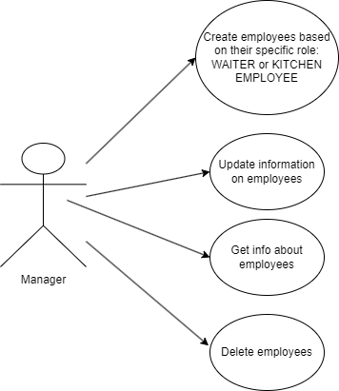

Kitchen Employee Use Case Diagram

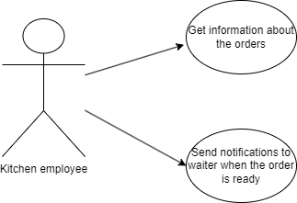

Waiter Use Case Diagram

