BÀI 1
ApiBaseTest
package api.tests;
import io.restassured.builder.RequestSpecBuilder;
import io.restassured.builder.ResponseSpecBuilder;
import io.restassured.filter.log.RequestLoggingFilter;
import io.restassured.filter.log.ResponseLoggingFilter;
import io.restassured.http.ContentType;
import io.restassured.specification.RequestSpecification;
import io.restassured.specification.ResponseSpecification;
import org.testng.annotations.BeforeClass;
import static org.hamcrest.Matchers.lessThan;

public class ApiBaseTest {
protected RequestSpecification requestSpec;
protected ResponseSpecification responseSpec;

@BeforeClass
public void setupApiSpec() {
requestSpec = new RequestSpecBuilder()
// CHUYỂN SANG API MỚI KHÔNG BỊ CLOUDFLARE CHẶN
.setBaseUri("https://jsonplaceholder.typicode.com")
.setContentType(ContentType.JSON)
.addHeader("Accept", "application/json")
.addFilter(new RequestLoggingFilter())
.addFilter(new ResponseLoggingFilter())
.build();
responseSpec = new ResponseSpecBuilder()
.expectContentType(ContentType.JSON)
.expectResponseTime(lessThan(5000L))
.build();
}
}

PostGetTest
package api.tests;
import org.testng.annotations.Test;
import static io.restassured.RestAssured.given;
import static org.hamcrest.Matchers.*;
public class PostGetTest extends ApiBaseTest {
@Test(description = "Test 1: GET /posts (Lấy danh sách bài đăng)")
public void testGetPosts() {
given(requestSpec)
.when()
.get("/posts")
.then()
.spec(responseSpec)
.statusCode(200)
.body("size()", greaterThan(0));
}

@Test(description = "Test 2: GET /posts?userId=1 (Lọc bài đăng theo user)")
public void testGetPostsByUser() {
given(requestSpec)
.queryParam("userId", 1)
.when()
.get("/posts")
.then()
.spec(responseSpec)
.statusCode(200)
.body("userId", everyItem(equalTo(1)))
.body("id", everyItem(notNullValue()))
.body("title", everyItem(notNullValue()))
.body("body", everyItem(notNullValue()));
}

@Test(description = "Test 3: GET /posts/1 (Lấy chi tiết 1 bài đăng)")
public void testGetSinglePost() {
given(requestSpec)
.when()
.get("/posts/1")
.then()
.spec(responseSpec)
.statusCode(200)
.body("id", equalTo(1))
.body("userId", equalTo(1))
.body("title", not(emptyString()));
}

@Test(description = "Test 4: GET /posts/9999 (Resource không tồn tại)")
public void testPostNotFound() {
given(requestSpec)
.when()
.get("/posts/9999")
.then()
.statusCode(404)
.body("$", anEmptyMap());
}
}

Kết quả kiểm thử
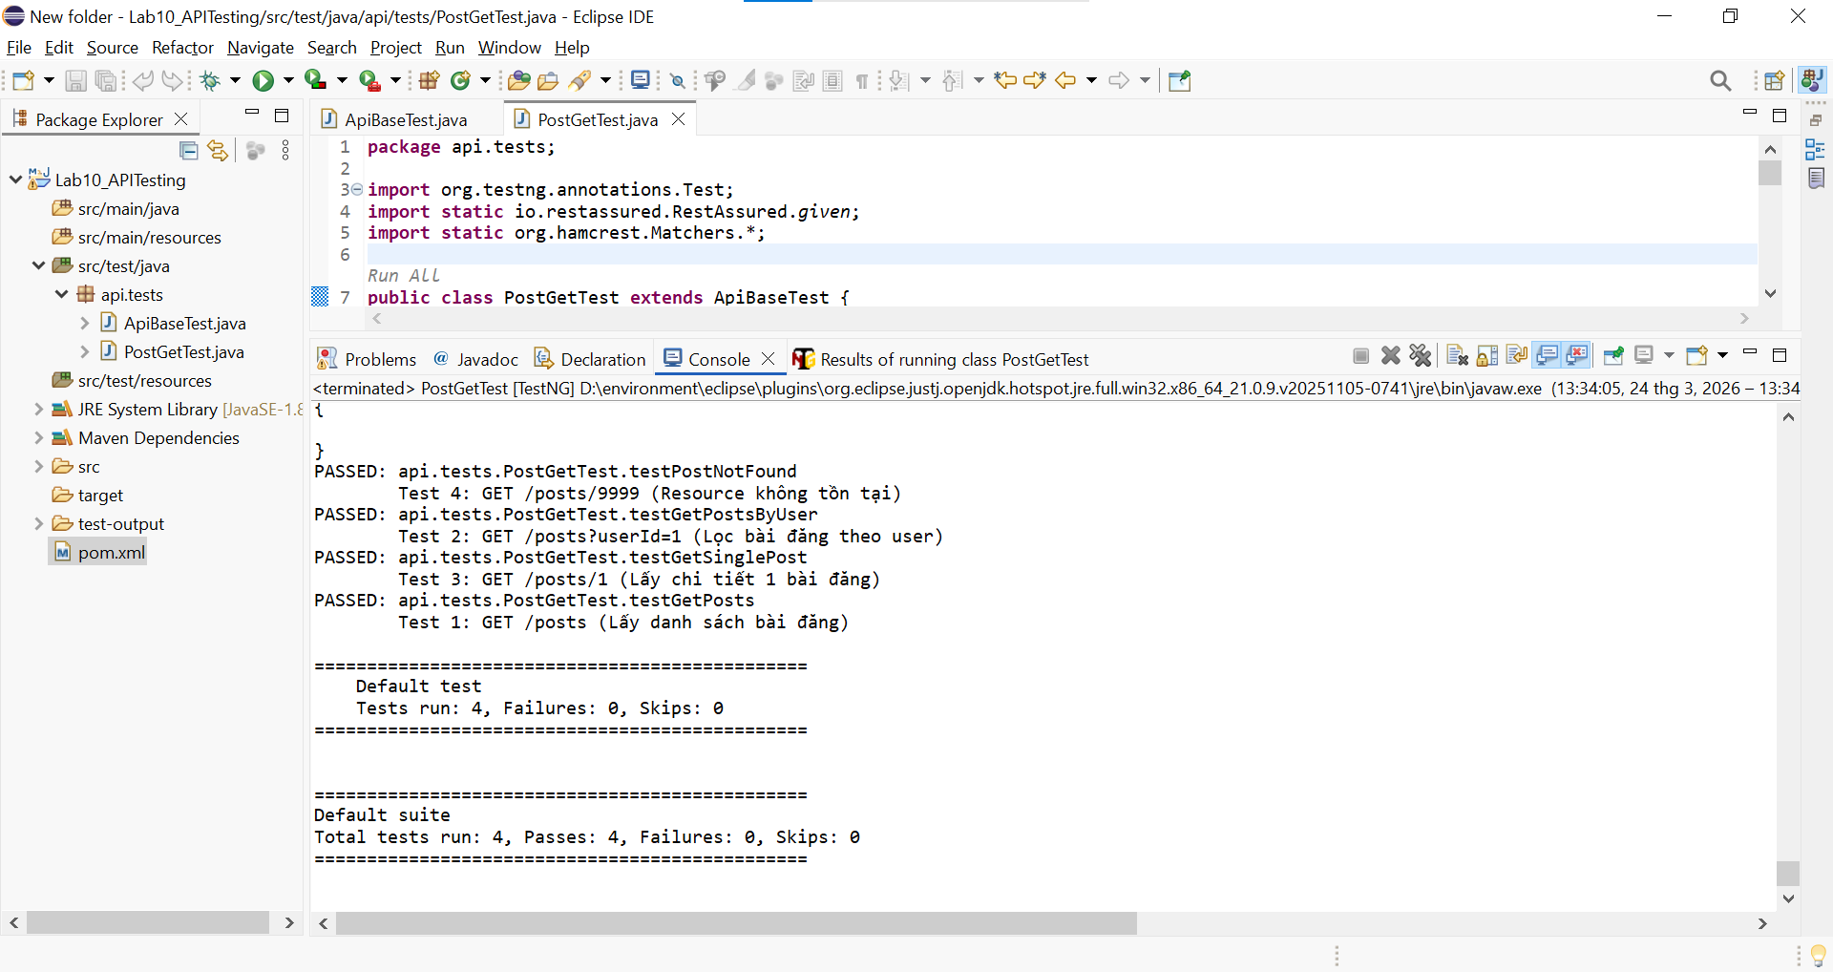
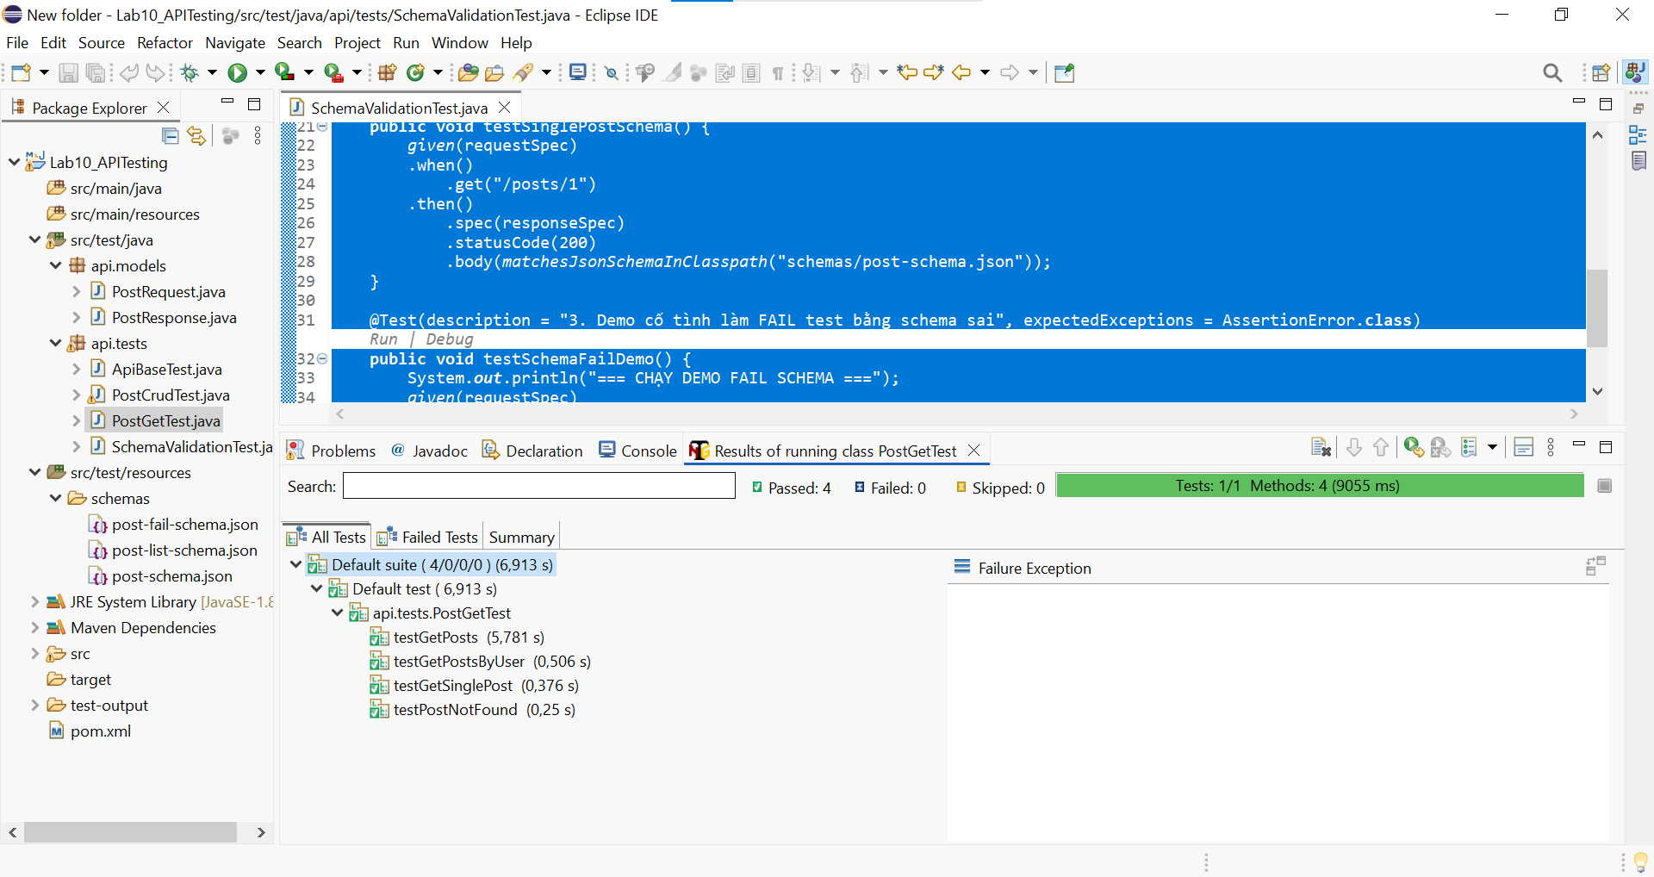

BÀI 2
PostRequest
package api.models;
public class PostRequest {
private String title;
private String body;
private int userId;

public PostRequest(String title, String body, int userId) {
this.title = title;
this.body = body;
this.userId = userId;
}
public String getTitle() { return title; }
public String getBody() { return body; }
public int getUserId() { return userId; }
}

PostResponse
package api.models;

public class PostResponse {
private int id;
private String title;
private String body;
private int userId;

public int getId() { return id; }
public String getTitle() { return title; }
public String getBody() { return body; }
public int getUserId() { return userId; }
}

PostCrudTest
package api.tests;

import api.models.PostRequest;
import api.models.PostResponse;
import org.testng.Assert;
import org.testng.annotations.Test;
import java.util.HashMap;
import java.util.Map;
import static io.restassured.RestAssured.given;
import static org.hamcrest.Matchers.*;

public class PostCrudTest extends ApiBaseTest {
private int newPostId;
@Test(description = "1. POST - Tạo mới bài đăng")
public void testCreatePost() {
PostRequest newPost = new PostRequest("Tiêu đề bài viết", "Nội dung bài viết", 1);
PostResponse response = given(requestSpec)
.body(newPost)
.when()
.post("/posts")
.then()
.spec(responseSpec)
.statusCode(201) /
.body("title", equalTo("Tiêu đề bài viết"))
.body("id", notNullValue())
.extract().as(PostResponse.class);

newPostId = response.getId();
System.out.println("Đã tạo thành công Post có ID: " + newPostId);
}

@Test(description = "2. PUT - Cập nhật toàn bộ bài đăng")
public void testUpdatePost() {
PostRequest updatedPost = new PostRequest("Tiêu đề đã PUT", "Nội dung cập nhật", 1);

given(requestSpec)
.body(updatedPost)
.when()
.put("/posts/1")
.then()
.spec(responseSpec)
.statusCode(200)
.body("title", equalTo("Tiêu đề đã PUT"))
.body("body", equalTo("Nội dung cập nhật"));
}

@Test(description = "3. PATCH - Cập nhật một phần bài đăng")
public void testPatchPost() {
Map<String, String> partialData = new HashMap<>();
partialData.put("title", "Tiêu đề đổi qua PATCH");
given(requestSpec)
.body(partialData)
.when()
.patch("/posts/1")
.then()
.spec(responseSpec)
.statusCode(200)
.body("title", equalTo("Tiêu đề đổi qua PATCH"));
}

@Test(description = "4. DELETE - Xóa bài đăng")
public void testDeletePost() {
given(requestSpec)
.when()
.delete("/posts/1")
.then()
.statusCode(200)
.body("$", anEmptyMap());
}

@Test(description = "5. API Chaining: POST -> GET xác nhận", dependsOnMethods = "testCreatePost")
public void testPostAndGetChain() {
System.out.println("Thực hiện gọi GET để kiểm tra ID vừa tạo: " + newPostId);
given(requestSpec)
.when()
.get("/posts/" + newPostId)
.then()
.statusCode(404);
}
}

Kết quả kiểm thử
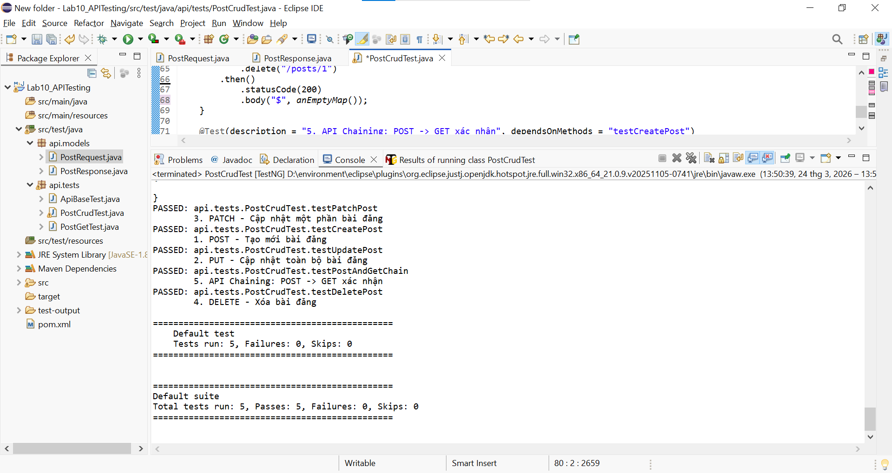
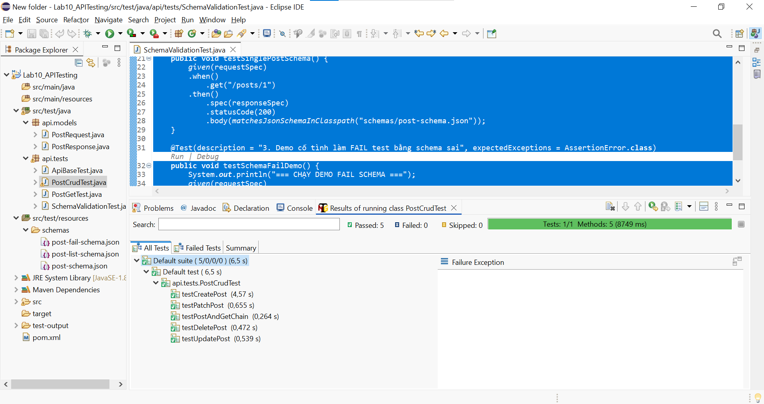

BÀI 3
post-schema.json
{
"$schema": "http://json-schema.org/draft-07/schema#",
"type": "object",
"required": ["userId", "id", "title", "body"],
"properties": {
"userId": { "type": "integer" },
"id": { "type": "integer" },
"title": { "type": "string" },
"body": { "type": "string" }
},
"additionalProperties": false
}

post-list-schema.json
{
"$schema": "http://json-schema.org/draft-07/schema#",
"type": "array",
"items": {
"type": "object",
"required": ["userId", "id", "title", "body"],
"properties": {
"userId": { "type": "integer" },
"id": { "type": "integer" },
"title": { "type": "string" },
"body": { "type": "string" }
},
"additionalProperties": false
}
}

post-fail-schema.json
{
"$schema": "http://json-schema.org/draft-07/schema#",
"type": "object",
"required": ["userId", "id", "title", "body", "truong_du_lieu_ao"],
"properties": {
"userId": { "type": "integer" },
"id": { "type": "integer" },
"title": { "type": "string" },
"body": { "type": "string" },
"truong_du_lieu_ao": { "type": "string" }
},
"additionalProperties": false
}

SchemaValidationTest
package api.tests;
import org.testng.annotations.Test;
import static io.restassured.RestAssured.given;
import static io.restassured.module.jsv.JsonSchemaValidator.matchesJsonSchemaInClasspath;
public class SchemaValidationTest extends ApiBaseTest {
@Test(description = "1. Validate cấu trúc danh sách bài đăng (GET /posts)")
public void testPostListSchema() {
given(requestSpec)
.when()
.get("/posts")
.then()
.spec(responseSpec)
.statusCode(200)
.body(matchesJsonSchemaInClasspath("schemas/post-list-schema.json"));
}
@Test(description = "2. Validate cấu trúc một bài đăng (GET /posts/1)")
public void testSinglePostSchema() {
given(requestSpec)
.when()
.get("/posts/1")
.then()
.spec(responseSpec)
.statusCode(200)
.body(matchesJsonSchemaInClasspath("schemas/post-schema.json"));
}
@Test(description = "3. Demo cố tình làm FAIL test bằng schema sai", expectedExceptions = AssertionError.class)
public void testSchemaFailDemo() {
System.out.println("=== CHẠY DEMO FAIL SCHEMA ===");
given(requestSpec)
.when()
.get("/posts/1")
.then()
.body(matchesJsonSchemaInClasspath("schemas/post-fail-schema.json"));
}
}

Kết quả kiểm thử
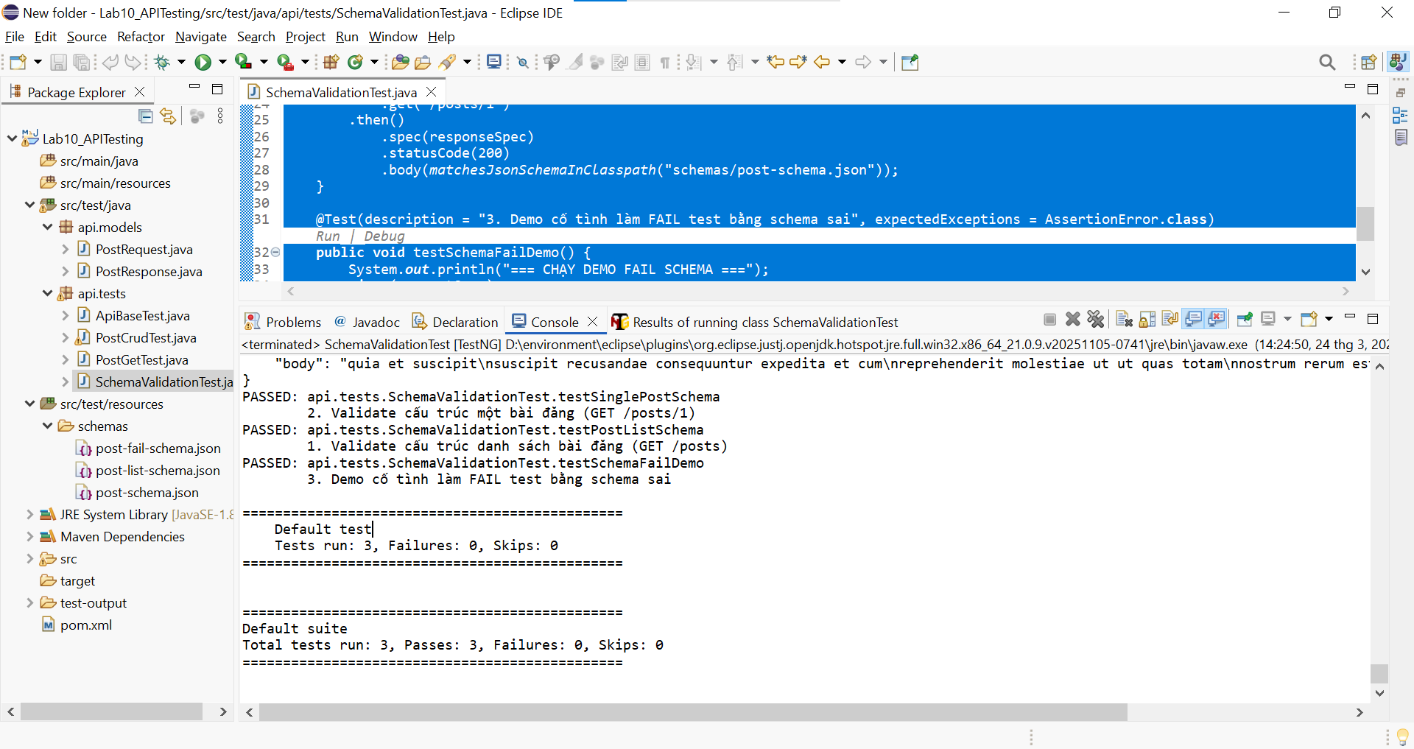
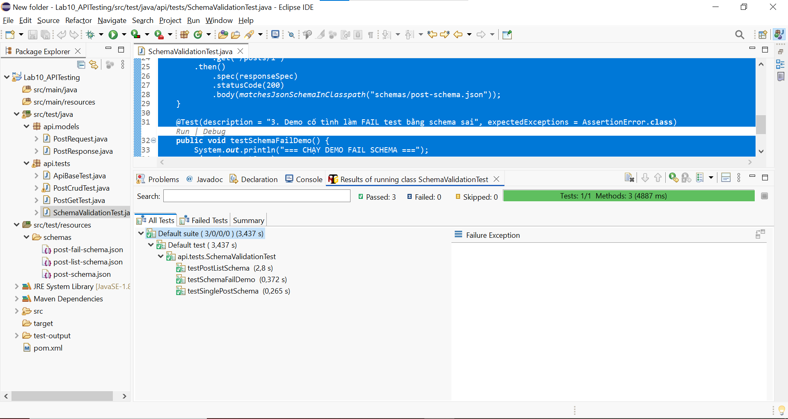

BÀI 4
AuthAndErrorTest
package api.tests;
import io.restassured.builder.RequestSpecBuilder;
import io.restassured.filter.log.RequestLoggingFilter;
import io.restassured.filter.log.ResponseLoggingFilter;
import io.restassured.http.ContentType;
import io.restassured.response.ValidatableResponse;
import io.restassured.specification.RequestSpecification;
import org.testng.annotations.BeforeClass;
import org.testng.annotations.DataProvider;
import org.testng.annotations.Test;
import java.util.HashMap;
import java.util.Map;
import static io.restassured.RestAssured.given;
import static org.hamcrest.Matchers.*;

public class AuthAndErrorTest {
private RequestSpecification reqresSpec;
@BeforeClass
public void setupReqres() {
reqresSpec = new RequestSpecBuilder()
.setBaseUri("https://reqres.in")
.setBasePath("/api")
.setContentType(ContentType.JSON)
.addHeader("User-Agent", "PostmanRuntime/7.36.3") // Né Cloudflare
.addFilter(new RequestLoggingFilter())
.addFilter(new ResponseLoggingFilter())
.build();
}
@Test(description = "Test login thành công -> 200, có token")
public void testLoginSuccess() {
String body = "{\"email\":\"eve.holt@reqres.in\",\"password\":\"cityslicka\"}";
given(reqresSpec)
.body(body)
.when()
.post("/login")
.then()
.statusCode(200)
.body("token", notNullValue());
}
@Test(description = "Test login thiếu password -> 400, báo lỗi")
public void testLoginMissingPassword() {
String body = "{\"email\":\"eve.holt@reqres.in\"}";
given(reqresSpec)
.body(body)
.when()
.post("/login")
.then()
.statusCode(400)
.body("error", equalTo("Missing password"));
}
@Test(description = "Test register thành công -> 200, có id và token")
public voidtestRegisterSuccess() {
String body = "{\"email\":\"eve.holt@reqres.in\",\"password\":\"pistol\"}";
given(reqresSpec)
.body(body)
.when()
.post("/register")
.then()
.statusCode(200)
.body("id", notNullValue())
.body("token", notNullValue());
}
@Test(description = "Test register thiếu password -> 400, báo lỗi")
public void testRegisterMissingPassword() {
String body = "{\"email\":\"sydney@fife\"}";
given(reqresSpec)
.body(body)
.when()
.post("/register")
.then()
.statusCode(400)
.body("error", equalTo("Missing password"));
}
@DataProvider(name = "loginScenarios")
public Object[][] loginScenarios() {
return new Object[][] {
// {email, password, expectedStatus, expectedError}
{"eve.holt@reqres.in", "cityslicka", 200, null},
{"eve.holt@reqres.in", "", 400, "Missing password"},
{"", "cityslicka", 400, "Missing email or username"},
{"notexist@reqres.in", "wrongpass", 400, "user not found"},
{"invalid-email", "pass123", 400, "user not found"}
};
}
@Test(dataProvider = "loginScenarios", description = "Kiểm thử Data-Driven cho nhiều kịch bản Login")
public void testLoginScenarios(String email, String password, int expectedStatus, String expectedError) {
Map<String, String> body = new HashMap<>();
body.put("email", email);
if (!password.isEmpty()) {
body.put("password", password);
}

ValidatableResponse response = given(reqresSpec)
.body(body)
.when()
.post("/login")
.then()
.statusCode(expectedStatus);
if (expectedError != null) {
response.body("error", containsString(expectedError));
}
}
}

Kết quả kiểm thử
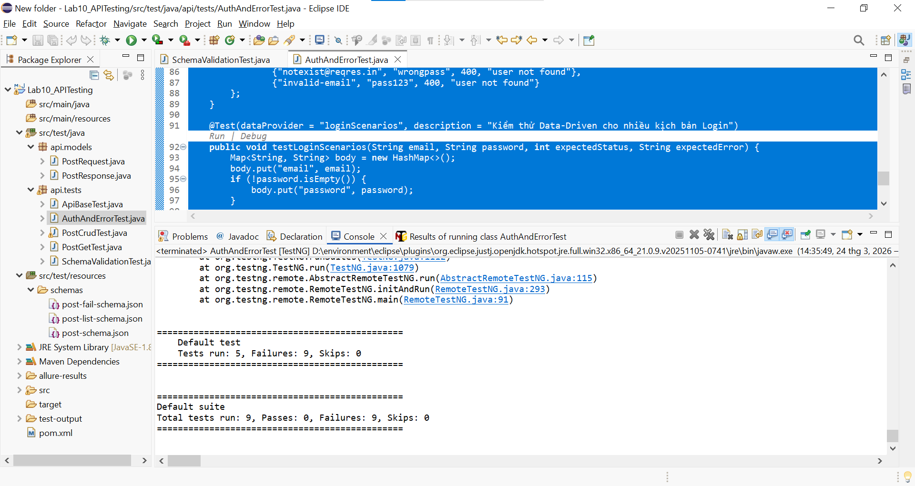
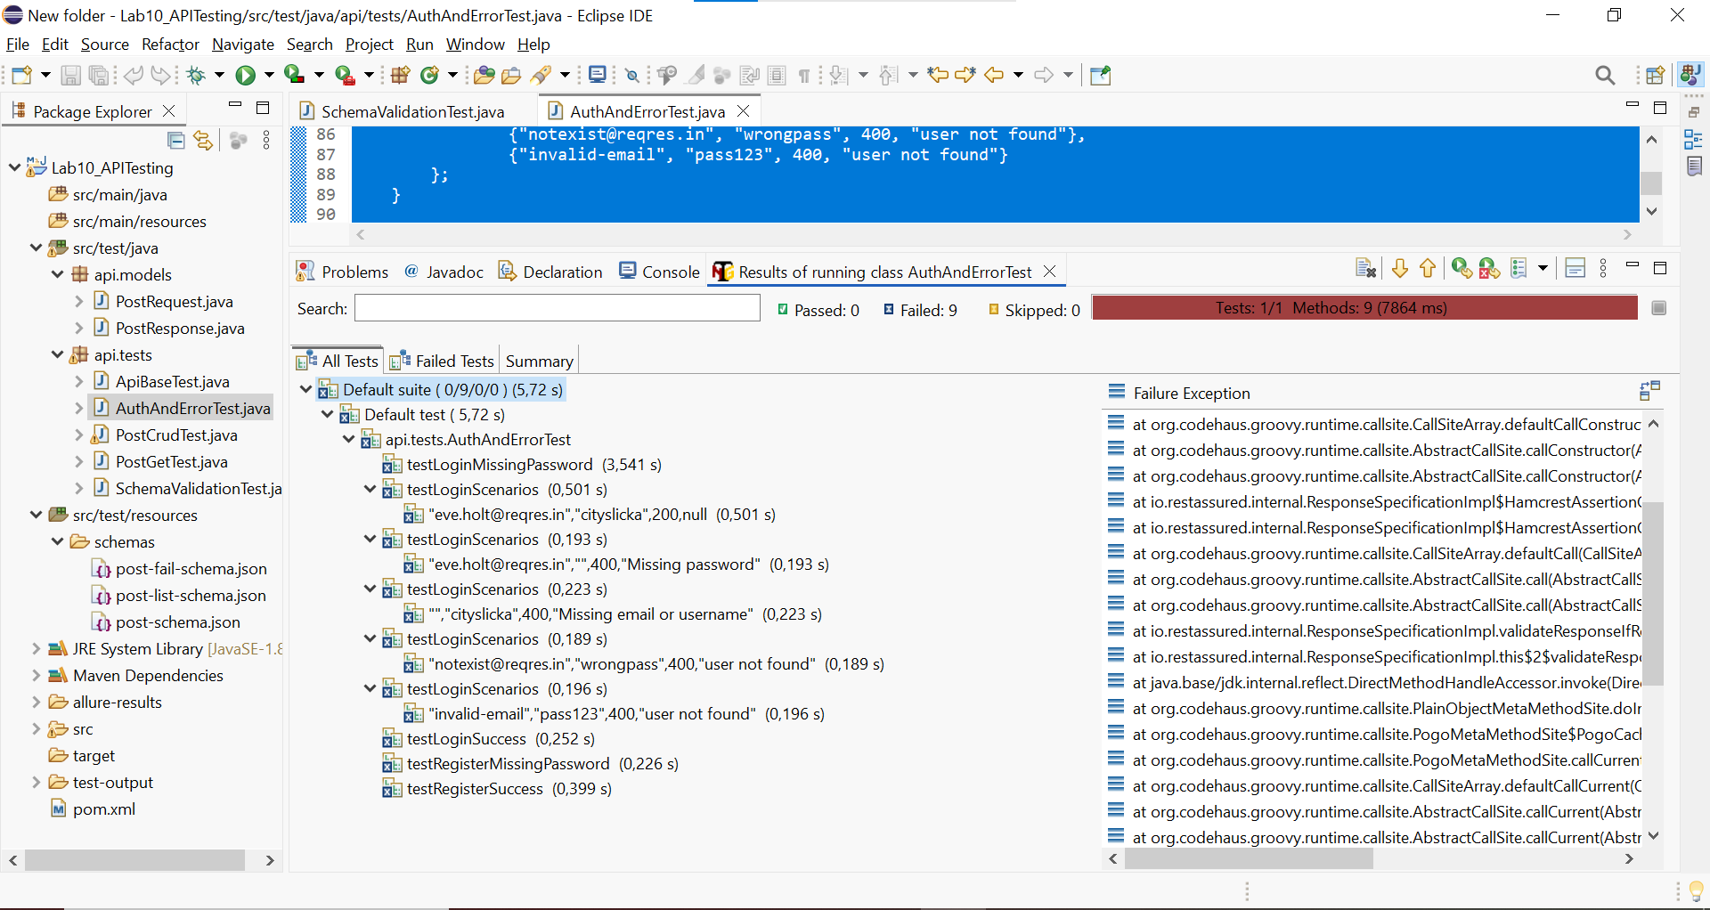

BÀI 5
PerformanceSLATest
package api.tests;
import io.qameta.allure.Step;
import io.restassured.builder.RequestSpecBuilder;
import io.restassured.http.ContentType;
import io.restassured.response.ValidatableResponse;
import io.restassured.specification.RequestSpecification;
import org.testng.annotations.BeforeClass;
import org.testng.annotations.DataProvider;
import org.testng.annotations.Test;
import java.util.ArrayList;
import java.util.Collections;
import java.util.List;
import static io.restassured.RestAssured.given;
import static org.hamcrest.Matchers.*;
public class PerformanceSLATest {

private RequestSpecification reqresSpec;

@BeforeClass
public void setup() {
reqresSpec = new RequestSpecBuilder()
.setBaseUri("https://reqres.in")
.setBasePath("/api")
.setContentType(ContentType.JSON)
.addHeader("User-Agent", "PostmanRuntime/7.36.3")
.build();
}
@DataProvider(name = "slaData")
public Object[][] slaData() {
return new Object[][] {
{"GET", "/users", null, 2000L, 200, "CHECK_SIZE"},
{"GET", "/users/2", null, 1500L, 200, "CHECK_ID"},
{"POST", "/users", "{\"name\":\"morpheus\",\"job\":\"leader\"}", 3000L, 201, "CHECK_CREATED_ID"},
{"POST", "/login", "{\"email\":\"eve.holt@reqres.in\",\"password\":\"cityslicka\"}", 2000L, 200, "CHECK_TOKEN"},
{"DELETE", "/users/2", null, 1000L, 204, "CHECK_EMPTY"}
};
}

@Test(dataProvider = "slaData", description = "Kiểm thử SLA cho 5 API chính")
public void testSlaForEndpoints(String method, String endpoint, String payload, long maxMs, int expectedStatus, String validationRule) {
executeAndValidateSLA(method, endpoint, payload, maxMs, expectedStatus, validationRule);
}
@Step("Gọi {method} {endpoint} - SLA: {maxMs}ms")
public void executeAndValidateSLA(String method, String endpoint, String payload, long maxMs, int expectedStatus, String validationRule) {
long startTime = System.currentTimeMillis();
ValidatableResponse response;
if (method.equalsIgnoreCase("GET")) {
response = given(reqresSpec).when().get(endpoint).then();
} else if (method.equalsIgnoreCase("POST")) {
response = given(reqresSpec).body(payload).when().post(endpoint).then();
} else {
response = given(reqresSpec).when().delete(endpoint).then();
}

long actualTime = System.currentTimeMillis() - startTime;

System.out.println(String.format("[SLA Monitor] %s %s - Thời gian thực tế: %d ms (Cho phép: %d ms)", method, endpoint, actualTime, maxMs));
response.statusCode(expectedStatus)
.time(lessThan(maxMs));
switch (validationRule) {
case "CHECK_SIZE":
response.body("data.size()", greaterThanOrEqualTo(1));
break;
case "CHECK_ID":
response.body("data.id", equalTo(2));
break;
case "CHECK_CREATED_ID":
response.body("id", notNullValue());
break;
case "CHECK_TOKEN":
response.body("token", notNullValue());
break;
case "CHECK_EMPTY":
response.body("$", anEmptyMap());
break;
}
}
@Test(description = "Chạy API 10 lần liên tiếp để tính average/min/max response time")
public void testMonitoringSimulation() {
System.out.println("=== BẮT ĐẦU CHẠY MONITORING 10 LẦN CHO GET /api/users ===");
List<Long> responseTimes = new ArrayList<>();

for (int i = 1; i <= 10; i++) {
long startTime = System.currentTimeMillis();
given(reqresSpec).when().get("/users").then();
long duration = System.currentTimeMillis() - startTime;
responseTimes.add(duration);
System.out.println("Lần " + i + ": " + duration + " ms");
}
long max = Collections.max(responseTimes);
long min = Collections.min(responseTimes);
double avg = responseTimes.stream().mapToLong(val -> val).average().orElse(0.0);

System.out.println("--- KẾT QUẢ MONITORING ---");
System.out.println("Min Response Time: " + min + " ms");
System.out.println("Max Response Time: " + max + " ms");
System.out.println("Average Response Time: " + avg + " ms");
}
}

Kết quả kiểm thử
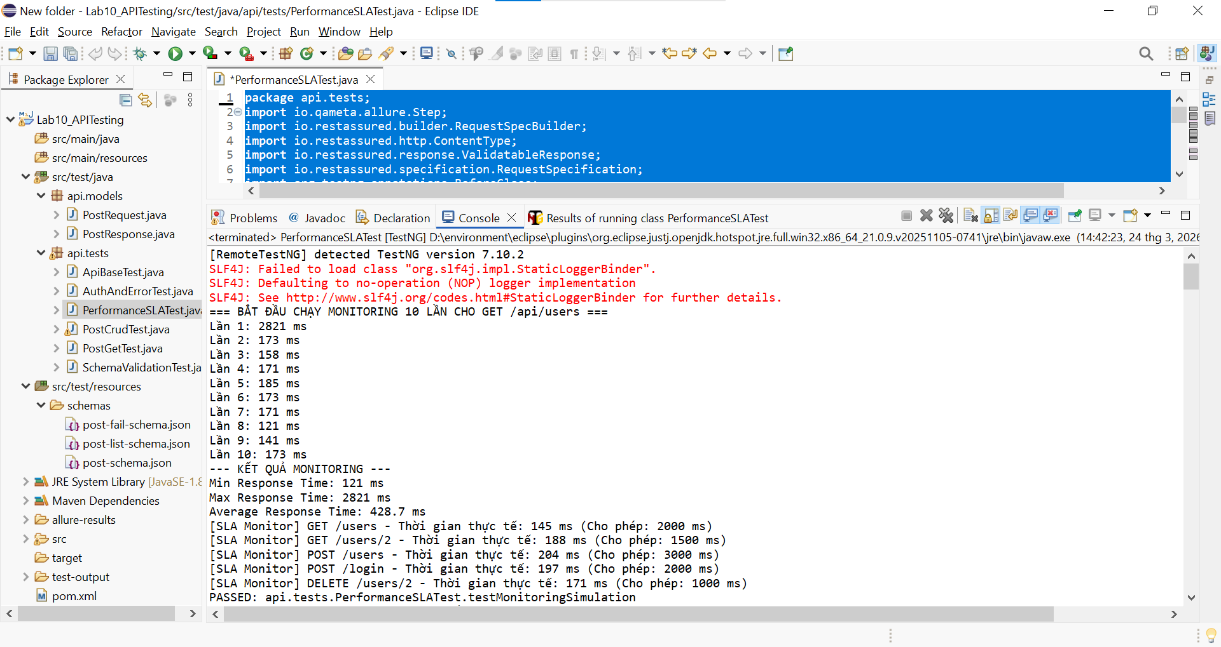
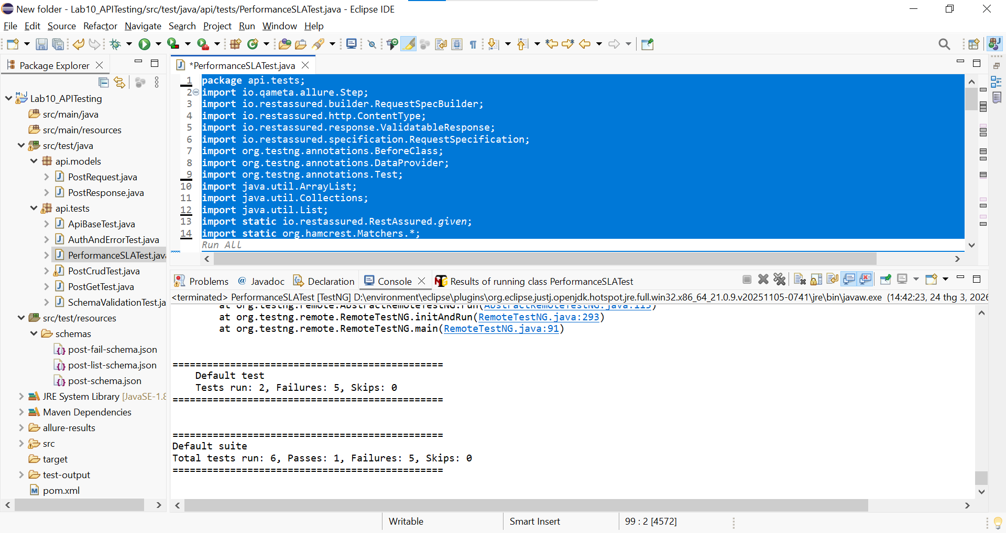
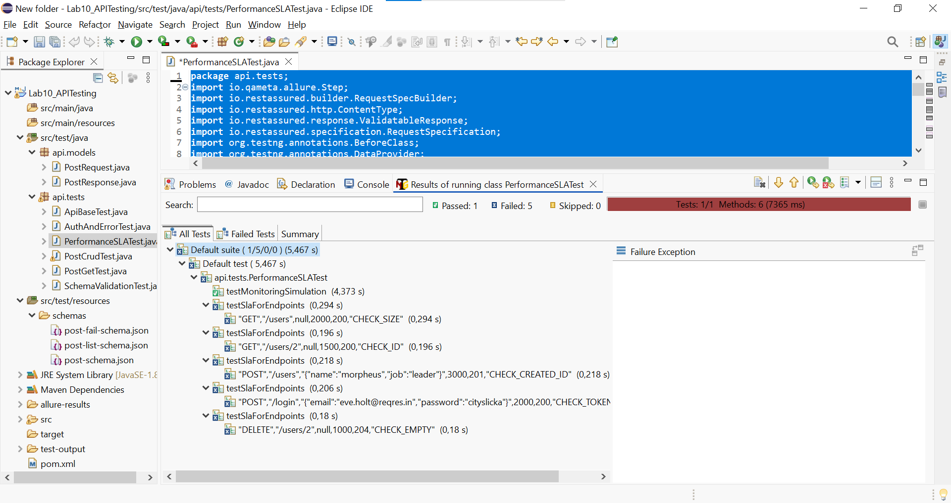

BÀI 6
ApiUiIntegrationTest
package api.tests;
import io.restassured.http.ContentType;
import io.restassured.response.Response;
import org.openqa.selenium.By;
import org.openqa.selenium.WebDriver;
import org.openqa.selenium.WebElement;
import org.openqa.selenium.chrome.ChromeDriver;
import org.testng.Assert;
import org.testng.SkipException;
import org.testng.annotations.AfterMethod;
import org.testng.annotations.Test;
import java.time.Duration;
import static io.restassured.RestAssured.given;
public class ApiUiIntegrationTest {

private WebDriver driver;
private String apiToken = "";
private boolean isApiAlive = false;
// =========================================================
// PHẦN A - API PRECONDITION -> UI VERIFICATION (1.0 ĐIỂM)
// =========================================================
@Test(description = "API Precondition: Gọi POST /login lấy token")
public void testApiLoginPrecondition() {
System.out.println("--- BƯỚC API: Gọi POST /login để lấy token ---");
String body = "{\"email\":\"eve.holt@reqres.in\",\"password\":\"cityslicka\"}";
Response response = given()
.baseUri("https://reqres.in")
.contentType(ContentType.JSON)
.body(body)
.when()
.post("/api/login");
// Nếu API fail (khác 200), TestNG sẽ đánh FAIL test này,
// kéo theo test UI bên dưới bị SKIP tự động do dependsOnMethods.
Assert.assertEquals(response.statusCode(), 200, "API Login thất bại!");
apiToken = response.jsonPath().getString("token");
System.out.println("Token lấy được từ API: " + apiToken);
}
@Test(description = "UI Verification: Đăng nhập SauceDemo", dependsOnMethods = "testApiLoginPrecondition")
public void testUiLoginSauceDemo() {
System.out.println("--- BƯỚC UI: Đăng nhập SauceDemo vì API Precondition đã Pass ---");
setupWebDriver();
driver.get("https://www.saucedemo.com/");
driver.findElement(By.id("user-name")).sendKeys("standard_user"); driver.findElement(By.id("password")).sendKeys("secret_sauce");
driver.findElement(By.id("login-button")).click();

// Verify URL và Title Assert.assertTrue(driver.getCurrentUrl().contains("inventory"), "Lỗi: URL không chứa chữ inventory");
Assert.assertEquals(driver.getTitle(), "Swag Labs", "Lỗi: Title trang không đúng");
}
// =========================================================
// PHẦN B - LUỒNG TÍCH HỢP ĐẦY ĐỦ (1.0 ĐIỂM)
// =========================================================
@Test(description = "Kiểm tra API reqres.in còn sống không")
public void checkApiAlive() {
System.out.println("--- BƯỚC API: Kiểm tra Health Check GET /users ---");
Response response = given()
.baseUri("https://reqres.in")
.when()
.get("/api/users");
if (response.statusCode() == 200) {
isApiAlive = true;
System.out.println("Xác nhận: API đang hoạt động tốt!");
} else {
System.out.println("Cảnh báo: API đang lỗi rổi!");
}
}
@Test(description = "UI Test: Thêm 2 sản phẩm vào giỏ hàng", dependsOnMethods = "checkApiAlive")
public void testFullUiFlow() {
// Đánh dấu SKIP nếu API chết theo đúng yêu cầu đề bài
if (!isApiAlive) {
throw new SkipException("BỎ QUA TEST UI VÌ API ĐÃ CHẾT (isApiAlive = false)");
}
System.out.println("--- BƯỚC UI ACTION: Đăng nhập và mua hàng trên SauceDemo ---");
setupWebDriver();
driver.get("https://www.saucedemo.com/");

// 1. Đăng nhập
driver.findElement(By.id("user-name")).sendKeys("standard_user");
driver.findElement(By.id("password")).sendKeys("secret_sauce");
driver.findElement(By.id("login-button")).click();

// 2. Thêm 2 sản phẩm
driver.findElement(By.id("add-to-cart-sauce-labs-backpack")).click();
driver.findElement(By.id("add-to-cart-sauce-labs-bike-light")).click();
System.out.println("--- BƯỚC ASSERTION: Xác minh trên giao diện UI ---");

// 3. Kiểm tra badge = 2
WebElement badge = driver.findElement(By.className("shopping_cart_badge"));
Assert.assertEquals(badge.getText(), "2", "Số lượng hiển thị trên giỏ hàng không đúng!");

// 4. Vào giỏ hàng xác nhận có 2 sản phẩm
driver.findElement(By.className("shopping_cart_link")).click();
int cartItems = driver.findElements(By.className("cart_item")).size();
Assert.assertEquals(cartItems, 2, "Số lượng sản phẩm thực tế trong giỏ không đúng!");
}

// =========================================================
// CÁC HÀM TIỆN ÍCH DÙNG CHUNG CHO SELENIUM
// =========================================================

private void setupWebDriver() {
if (driver == null) {
driver = new ChromeDriver(); // Selenium 4 tự động tìm ChromeDriver driver.manage().timeouts().implicitlyWait(Duration.ofSeconds(5));
driver.manage().window().maximize();
}
}
@AfterMethod
public void tearDown() {
// Tắt trình duyệt sau mỗi test UI để tránh lag máy
if (driver != null) {
driver.quit();
driver = null;
}
}
}
Kết quả kiểm thử
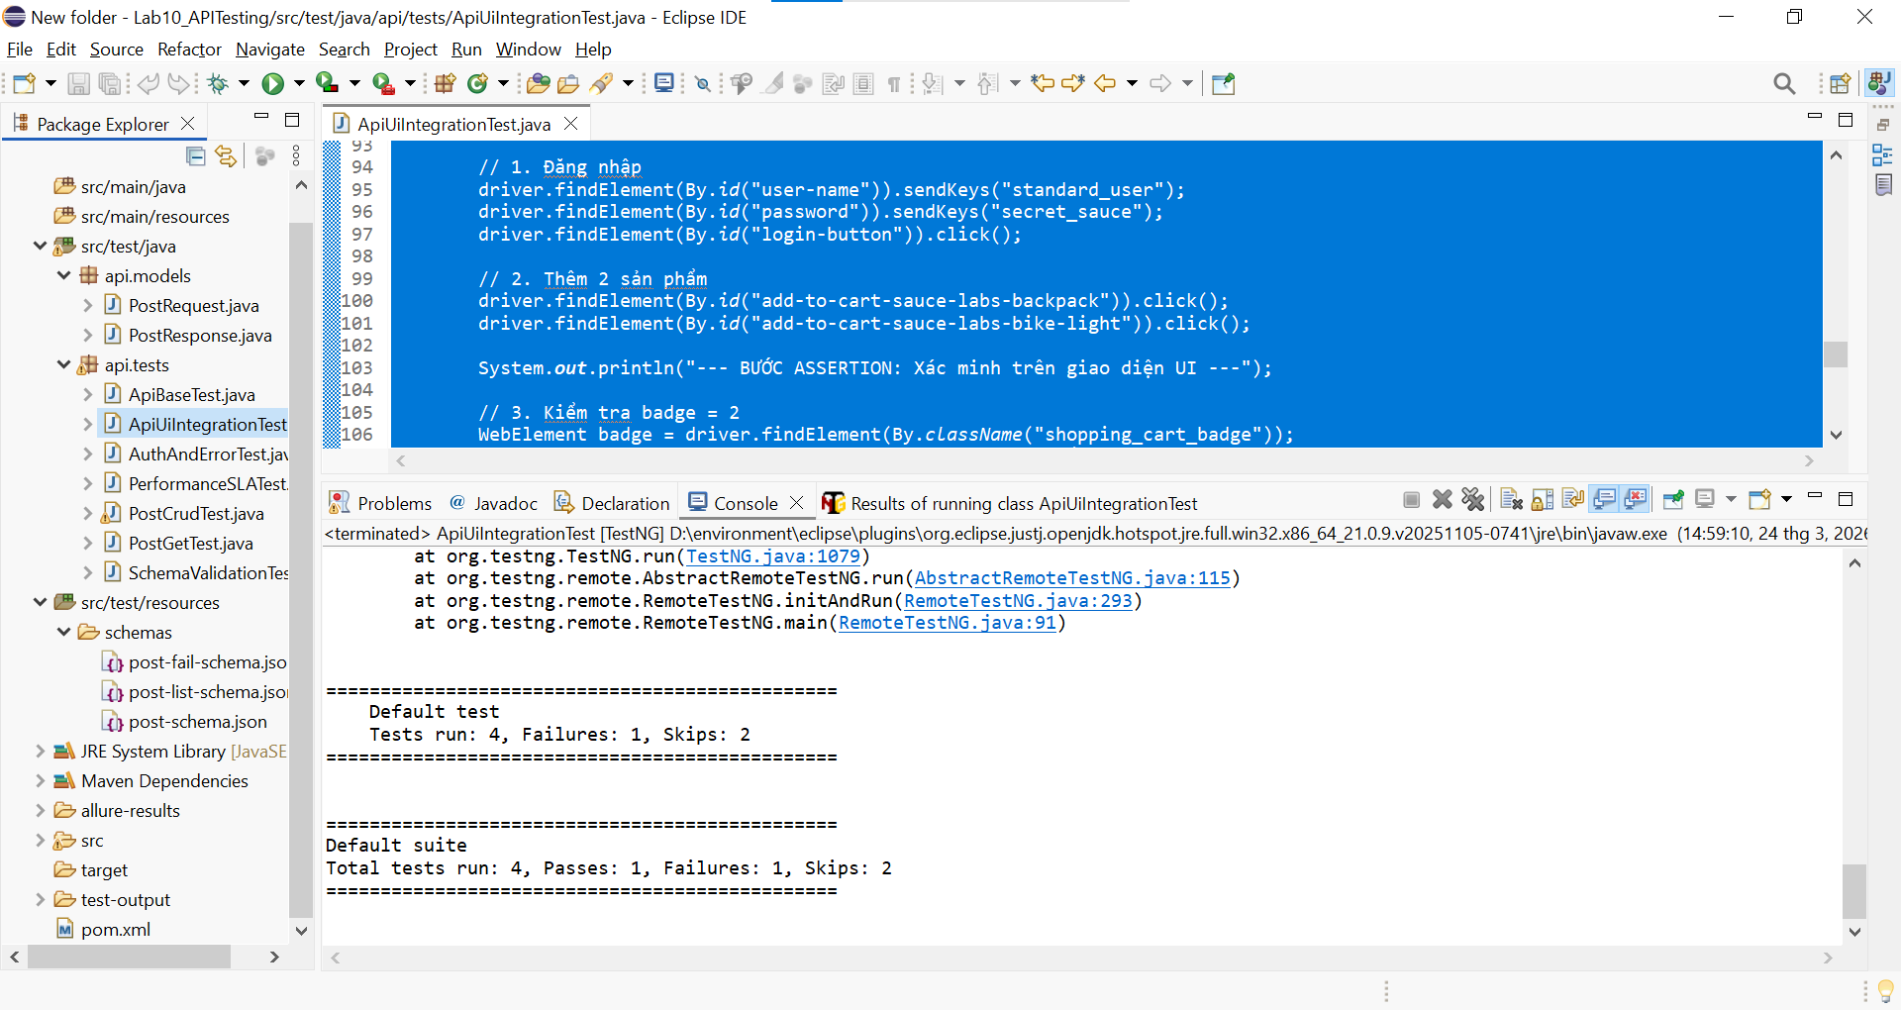
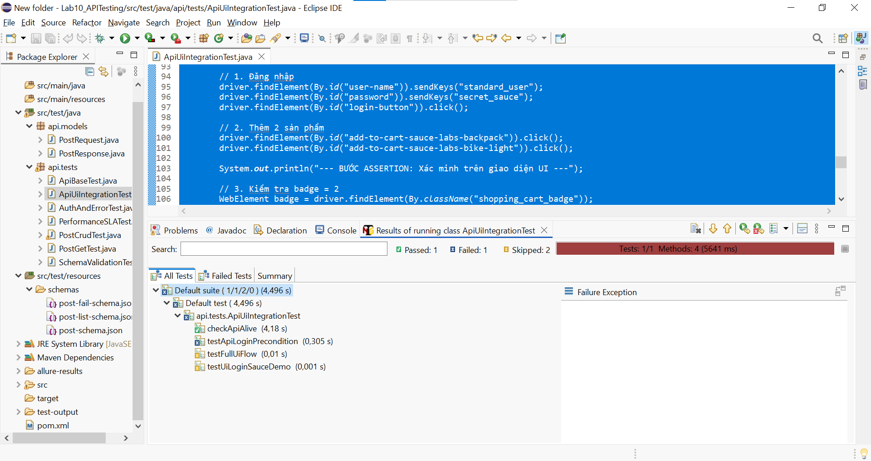
BÀI 7
ApiBaseTest
package api.tests;

import io.restassured.builder.RequestSpecBuilder;
import io.restassured.builder.ResponseSpecBuilder;
import io.restassured.filter.log.RequestLoggingFilter;
import io.restassured.filter.log.ResponseLoggingFilter;
import io.restassured.http.ContentType;
import io.restassured.specification.RequestSpecification;
import io.restassured.specification.ResponseSpecification;
import org.testng.annotations.BeforeClass;
import static org.hamcrest.Matchers.lessThan;

public class ApiBaseTest {
protected RequestSpecification requestSpec;
protected ResponseSpecification responseSpec;
@BeforeClass
public void setupApiSpec() {
requestSpec = new RequestSpecBuilder() .setBaseUri("https://jsonplaceholder.typicode.com")
.setContentType(ContentType.JSON)
.addFilter(new RequestLoggingFilter())
.addFilter(new ResponseLoggingFilter())
.build();

responseSpec = new ResponseSpecBuilder()
.expectContentType(ContentType.JSON)
.expectResponseTime(lessThan(3000L))
.build();
}
}

PostSchema
{
"$schema": "http://json-schema.org/draft-07/schema#",
"type": "object",
"required": ["userId", "id", "title", "body"],
"properties": {
"userId": { "type": "integer" },
"id": { "type": "integer" },
"title": { "type": "string" },
"body": { "type": "string" }
}
}

UserSchema
{
"$schema": "http://json-schema.org/draft-07/schema#",
"type": "object",
"required": ["id", "name", "username", "email", "address"],
"properties": {
"id": { "type": "integer" },
"name": { "type": "string" },
"username": { "type": "string" },
"email": { "type": "string" },
"address": {
"type": "object",
"required": ["city", "zipcode"],
"properties": {
"city": { "type": "string" },
"zipcode": { "type": "string" }
}
}
}
}

PostApiTest
package api.tests;

import api.models.PostRequest;
import org.testng.annotations.Test;
import static io.restassured.RestAssured.given;
import static org.hamcrest.Matchers.*;
import static io.restassured.module.jsv.JsonSchemaValidator.matchesJsonSchemaInClasspath;

public class PostApiTest extends ApiBaseTest {

@Test
public void testGetAllPosts() {
given(requestSpec).when().get("/posts").then().spec(responseSpec)
.statusCode(200).body("size()", equalTo(100));
}

@Test
public void testGetSinglePost() {
given(requestSpec).when().get("/posts/1").then().spec(responseSpec)
.statusCode(200).body(matchesJsonSchemaInClasspath("schemas/PostSchema.json"));
}

@Test
public void testCreatePost() {
PostRequest newPost = new PostRequest("title test", "body test", 1);
given(requestSpec).body(newPost).when().post("/posts").then().spec(responseSpec)
.statusCode(201).body("id", notNullValue());
}

@Test
public void testUpdatePost() {
PostRequest updatePost = new PostRequest("title updated", "body updated", 1);
given(requestSpec).body(updatePost).when().put("/posts/1").then().spec(responseSpec)
.statusCode(200).body("title", equalTo("title updated"));
}

@Test
public void testDeletePost() {
given(requestSpec).when().delete("/posts/1").then().spec(responseSpec).statusCode(200);
}
}

CommentApiTest
package api.tests;

import org.testng.annotations.Test;
import static io.restassured.RestAssured.given;
import static org.hamcrest.Matchers.*;

public class CommentApiTest extends ApiBaseTest {

@Test
public void testGetCommentsForPost() {
given(requestSpec).when().get("/posts/1/comments").then().spec(responseSpec).statusCode(200)
.body("size()", equalTo(5))
.body("postId", everyItem(equalTo(1)))
.body("id", everyItem(notNullValue()))
.body("name", everyItem(notNullValue()))
.body("email", everyItem(notNullValue()))
.body("body", everyItem(notNullValue()));
}
}

UserApiTest
package api.tests;

import org.testng.annotations.Test;
import static io.restassured.RestAssured.given;
import static org.hamcrest.Matchers.*;
import static io.restassured.module.jsv.JsonSchemaValidator.matchesJsonSchemaInClasspath;

public class UserApiTest extends ApiBaseTest {

@Test
public void testGetAllUsers() {
given(requestSpec).when().get("/users").then().spec(responseSpec).statusCode(200).body("size()", equalTo(10));
}

@Test
public void testGetSingleUser() {
given(requestSpec).when().get("/users/1").then().spec(responseSpec).statusCode(200)
.body(matchesJsonSchemaInClasspath("schemas/UserSchema.json"));
}
}

Kết quả kiểm thử

CẤU TRÚC BÀI
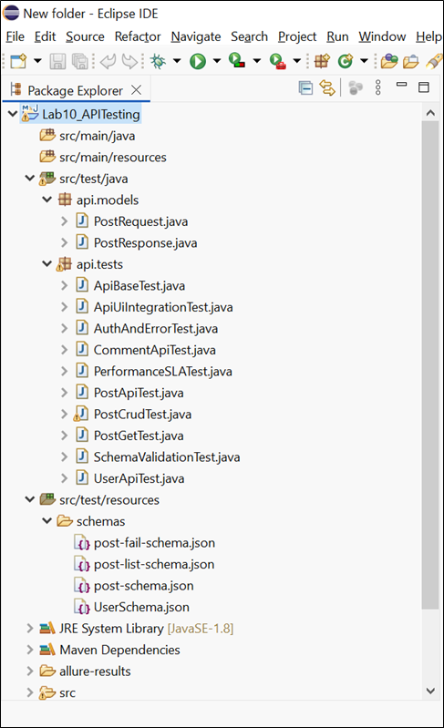

MÔI TRƯỜNG
<project xmlns="http://maven.apache.org/POM/4.0.0"
xmlns:xsi="http://www.w3.org/2001/XMLSchema-instance"
xsi:schemaLocation="http://maven.apache.org/POM/4.0.0 http://maven.apache.org/xsd/maven-4.0.0.xsd">
<modelVersion>4.0.0</modelVersion>
<groupId>com.example</groupId>
<artifactId>Lab10_APITesting</artifactId>
<version>1.0-SNAPSHOT</version>

<properties>
<maven.compiler.source>8</maven.compiler.source>
<maven.compiler.target>8</maven.compiler.target>
<project.build.sourceEncoding>UTF-8</project.build.sourceEncoding>
<allure.version>2.24.0</allure.version>
<aspectj.version>1.9.20.1</aspectj.version>
</properties>

<dependencies>
<dependency>
<groupId>io.rest-assured</groupId>
<artifactId>rest-assured</artifactId>
<version>5.4.0</version>
<scope>test</scope>
</dependency>

<dependency>
<groupId>io.rest-assured</groupId>
<artifactId>json-schema-validator</artifactId>
<version>5.4.0</version>
<scope>test</scope>
</dependency>

<dependency>
<groupId>org.testng</groupId>
<artifactId>testng</artifactId>
<version>7.10.2</version>
<scope>test</scope>
</dependency>

<dependency>
<groupId>com.fasterxml.jackson.core</groupId>
<artifactId>jackson-databind</artifactId>
<version>2.17.0</version>
</dependency>

<dependency>
<groupId>io.qameta.allure</groupId>
<artifactId>allure-testng</artifactId>
<version>${allure.version}</version>
<scope>test</scope>
</dependency>

<dependency>
<groupId>org.seleniumhq.selenium</groupId>
<artifactId>selenium-java</artifactId>
<version>4.19.1</version>
</dependency>
</dependencies>

<build>
<plugins>
<plugin>
<groupId>org.apache.maven.plugins</groupId>
<artifactId>maven-surefire-plugin</artifactId>
<version>3.5.0</version>
<configuration>
<argLine>
-javaagent:"${settings.localRepository}/org/aspectj/aspectjweaver/${aspectj.version}/aspectjweaver-${aspectj.version}.jar"
</argLine>
</configuration>
<dependencies>
<dependency>
<groupId>org.aspectj</groupId>
<artifactId>aspectjweaver</artifactId>
<version>${aspectj.version}</version>
</dependency>
</dependencies>
</plugin>

<plugin>
<groupId>io.qameta.allure</groupId>
<artifactId>allure-maven</artifactId>
<version>2.12.0</version>
</plugin>
</plugins>
</build>
</project>

