Project 1 Array Set 说明文档
* 编译环境 win64 TDM-GCC 4.9.2
- main函数实现操作如下：
1. Create a set called Sset
2. Print the contents of Sset
3. Search Sset for a particular element t
4. Find the number of elements in Sset
5. Boolean subset operation for Mset and Nset
6. Determine wheter Sset is empty
7. Store elements of Sset in a txt file
8. Create a new set Tset to compare with Sset
9. Find the intersection set Iset of Aset and Bset.
10. Find the Union set Unset of Cset and Dset.
11. Find the complement set Aset_ of Universal set Uset and Aset.
12. Find the maximum value in Unset
13. Add a new value z to Dset and keep it ordered.
14. Remove an item remitem b from Cset.
15. Remove the first element from Mset.
16. Remove the last element from Bset.
17. Make a copy of Uset and call it CUset.
18. Find the relative difference of Aset and Bset.
（2）函数及其功能注释如下：
// read data from txt file and create a new set
void CreateSet(int &m_Size, int &m_Max, char *m_Data, string filepath);
// add a new value to the set and sort it
void PushBack(int &m_Size, int &m_Max, char *m_Data, char dValue);
// Print the set
void Print(int m_Size, char m_Data[]);
// Serach for a particular element
void FindElem(int m_Size, char* m_Data, char searchElem);
// Get the size of set
int GetSize(char* m_Data);
// Determine wheter Mset is the subset of Nset
void IsSub(int m_Size, char* m_Data, int n_Size, char* n_Data);
// Determine wheter this set is empty
bool IsEmpty(char* m_Data);
// Store all elements of the set in an txt file
void StoreElem(char* m_Data, int m_Size, string filepath);
// Determine whether two sets are equal
bool IsEqual(int m_Size, char* m_Data, int n_Size, char* n_Data);
// find the intersection of two sets
void Intersection(int m_Size, char* m_Data, int n_Size, char* n_Data, int& i_Size, int& i_Max, char* i_Data);
// find the Union of two sets
void Union(int m_Size, char* m_Data, int n_Size, char* n_Data, int& u_Size, int& u_Max, char* u_Data);
//find the complement of the set
void Complement(int m_Size, char* m_Data, int n_Size, char* n_Data, int& u_Size, int& u_Max, char* u_Data);
// Get the max value element in the set
char GetMaxElem(int m_Size, char* m_Data);
// remove a particular item from the set
void RemoveRemItem(int& m_Size, char* m_Data, char remitem);
// Remove an element at a particular position
void RemoveAt(int m_Size, char* m_Data, int nIndex);
// copy n_Data to m_Data
char* CopySet(int& m_Size, int& m_Max, char* m_Data, int n_Size, int n_Max, char* n_Data);
（3）set基本数据结构（以Sset为例）
int s_Size = 0; // the number of elements in set
int s_Max = 100; // space preserved for set
char *Sset = new char[s_Max]; // the pointer for character data array
Sset是用于实现set结构的char数组；
s_Size是Sset内包含的元素个数；
s_Max是Sset数组的最大容量；（可在pushback函数中扩容）
（4）文件输入输出注意事项
【输入】
所有set创建时的初始元素都从file文件夹中的对应txt文件中读取
文件路径可自行修改
//create Mset
int m_Size = 0;
int m_Max = 100;
char *Mset = new char[m_Max];
CreateSet(m_Size, m_Max, Mset, "file/Mset.txt");
【！！以下很重要，必须注意！！】
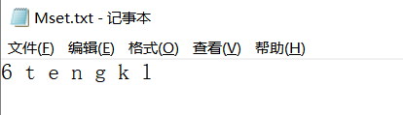
！！输入文件的最前一位数必须是该文件中包含的char数目！！
【输出】
程序运行结果全部打印在file/result.txt文件中
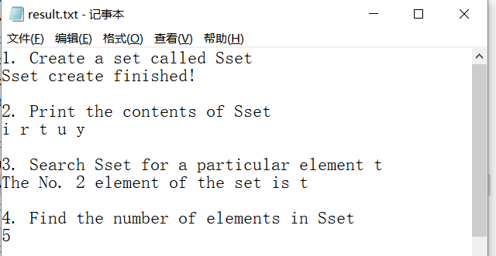
交并补等操作生成的新set也会独立保存到file文件夹的对应txt文件中
（以Intersection为例）
