**Intranasal Self-Administration SOP**

**Developed by the** [Siciliano Lab](https://sicilianolab.com/)

**Department of Pharmacology, Vanderbilt University**

Contents

Materials 2

General Experimental Guidelines 2

Rolling Cap Session Setup Instructions 4

# Materials

See <https://github.com/Siciliano-Lab/INSA> for a complete list of parts. Note that any standard head-fixed operant setup can be used in place of the described setup; the only parts that are not found in a standard setup are the high resolution (sub-microliter) syringe pump, miniature micromanipulator, and blunt needle.

# General Experimental Guidelines

1. Preparation
   1. Transport animals to the behavior room and allow them to habituate to the room and ambient noise for ≥ 30 minutes.
   2. In the behavior room:
      1. Turn on all the necessary equipment including power cabinet, MED-PC V software, lever, pump, and red light inside the chamber.
      2. Prepare the video recording system.
2. Prime the infusion line
   1. Prepare the cocaine solution (concentration as per experimental design).
   2. Load the syringe and attach it to the microinfusion pump.
   3. Fill the tubing with cocaine solution until fluid nearly exists the blunt needle.
   4. Manually advance the syringe by turning the pump knob to ensure consistent droplet formation at the needle tip.
      1. The volume of cocaine depends on tubing length, diameter, and syringe size.
3. System check
   1. Open MED-PC V and load the appropriate behavioral program.
   2. Confirm input detection by checking that the lever presses register on the live input display.
      1. If no input is detected, check wiring and device connections.
   3. Enter subject ID and session details.
   4. Ensure that each triggered delivery reliably results in fluid protruding from the needle
   5. *If running the rolling cap MED-PC code, see below.*
4. Box set-up
   1. Wipe down all the apparatus components (tunnel, platform, etc) with 0.03% acetic acid (or preferred cleaning solution).
   2. Secure tunnel to platform.
5. Head-fixation
   1. Gently lift the mouse by the tail and allow them to maneuver into the tunnel. Maintain a grip on their tail.
   2. Gently hold the mouse by one side of the implanted headbar and inset the otherside into the holder and tighten the screw.
      1. You can now let go of the tail.
   3. Attache and secure the opposite side of the headbar.
   4. Ensure:
      1. The mouse is centered on the platform.
      2. The forelimbs can comfortably reach the lever.
      3. The body is not too low or overextended – adjust platform height if needed.
6. Position the infusion needle:
   1. Using the 3-axis micromanipulator, align the blunt needle with the mouse’s nostril (**Figure 1**).
      1. Position the needle tip ~1mm away from the nostril opening.
7. Run the behavioral session
   1. Start the video recording.
   2. Start the MED-PC behavioral program.
      1. Again, if running rolling cap program, ensure the macros have been configured.
   3. Monitor the session until the program terminates or animal displays any signs of distress.
8. Post-session procedure
   1. Stop the video.
   2. Swivel the delivery needle away from the mouse.
   3. Unscrew both ends of the headbar holder and remove the mouse.
   4. Weigh the animal and return to its home cage.
9. Clean-up
   1. Wipe down the platform and headfix set up with 0.03% acetic acid (or preferred cleaning solution).
   2. Remove the syringe from the pump.
   3. Expel any remaining cocaine into the appropriate biohazard container.
   4. Flush tubing (including blunt needle) with water followed by air to remove any residual drug solution.
   5. Turn off all equipment and transfer data.

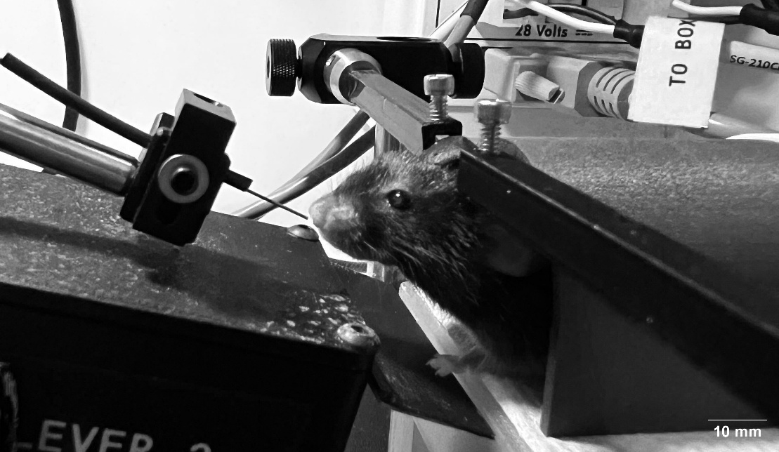

**Figure 1. Head-restraint apparatus for intranasal self-administration in mice.** Photograph of a mouse secured in the custom 3D-printed head-fixation system during an operant session. The animal is stabilized with padded restraint and adjustable bars to ensure consistent positioning. A microinfusion needle is precisely aligned with the mouse’s nostril to deliver a cocaine solution. (0.5 µL over 0.5 sec) contingent upon operant lever responding.

# Rolling Cap Session Setup Instructions

Follow the additional instructions below to execute a self-administration session in which mice receive intranasal cocaine deliveries with a *rolling cap*. To prevent overdose, the rolling cap programs are written such that the reinforcement schedule is temporarily discontinued if the rolling cap (e.g. 40 mg/kg) is reached within the timeframe specified (e.g. 60 minutes). The session continues regardless, and the schedule is re-instated as soon as the specified condition is false. To run these programs, it is necessary to specify the cocaine limit (in mg/kg), the rolling window duration (in minutes), and the cocaine dose that is being delivered (in mg/kg/delivery) through the use of a macro file.

1. Pre-session set up (only performed once per computer)
   1. Power on the MED-PC cabinet and open MED-PC V.
   2. In the menu bar navigate to:  
       Macros > Configure Context Dependent Macros > Add Program, then click OK.
      1. Select and add the rolling cap program from the list.
   3. With the rolling cap program highlighted, click Add macros to program, select CocaineDose.MAC, then click OK
   4. Click OK again to confirm and exit setup
2. Test Session Initialization
   1. On the main page select the appropriate box and load rolling cap program.
   2. With the box selected, go to context macros, and choose CocaineDose.mac
   3. When prompted, enter the following parameters:
      1. Cocaine Dose (mg/kg/delivery)
      2. Window size (minutes)
      3. Cocaine Cap (mg/kg)
   4. Test the program.
3. Follow the general instructions described in the section above