COMMUNICATION ENG.

ANSWERS

1. **Why is a sinusoidal signal classified as analog?**  
   **a)** It moves in both positive and negative directions  
   **b)** It is positive for half of its cycle  
   **c)** It is negative for half of its cycle  
   **d)** It has an infinite number of amplitude values within its range  
   **Answer: d)** It has an infinite number of amplitude values within its range
2. **What is analog communication?**  
   **a)** A technique where a carrier signal's property changes in proportion to the instantaneous value of the message signal  
   **b)** A method used for data and computer communication  
   **c)** A form of numerical coded communication  
   **d)** A communication method ideal for long-distance transmission  
   **Answer: a)** A technique where a carrier signal's property changes in proportion to the instantaneous value of the message signal
3. **What is a drawback of amplitude modulation?**  
   **a)** Suppression of sidebands  
   **b)** Intra-pulse modulation issues  
   **c)** Cross modulation interference  
   **d)** Carrier suppression  
   **Answer: c)** Cross modulation interference
4. **In what form do cell phones transmit information?**  
   **a)** Microwaves  
   **b)** Electrical signals  
   **c)** Infrared waves  
   **d)** Radio waves  
   **Answer: d)** Radio waves
5. **Where is modulation carried out in a communication system?**  
   **a)** At the receiver  
   **b)** In a transducer  
   **c)** Between the transmitter and receiver  
   **d)** At the transmitter  
   **Answer: d)** At the transmitter
6. **What is the primary application of square law modulators?**  
   **a)** Frequency modulation  
   **b)** Pulse width modulation  
   **c)** Amplitude modulation  
   **d)** Phase modulation  
   **Answer: c)** Amplitude modulation
7. **What is the purpose of an amplitude limiter in an FM receiver?**  
   **a)** To filter unwanted signals  
   **b)** To maintain consistent gain in the receiver  
   **c)** To amplify weaker signals  
   **d)** To demodulate the signal  
   **Answer: b)** To maintain consistent gain in the receiver
8. **Where is noise typically introduced in a receiver?**  
   **a)** Audio stage  
   **b)** Receiving antenna  
   **c)** RF stage  
   **d)** IF stage  
   **Answer: c)** RF stage
9. **What is the purpose of a varactor diode in a radio receiver?**  
   **a)** Demodulation  
   **b)** Mixing  
   **c)** Multiplexing  
   **d)** Tuning  
   **Answer: d)** Tuning
10. **When is noise added to a signal?**  
    **a)** In the channel  
    **b)** At the receiving antenna  
    **c)** At the transmitting antenna  
    **d)** During regeneration of information  
    **Answer: a)** In the channel
11. **What does the AM spectrum consist of?**  
    **a)** Carrier frequency  
    **b)** Upper sideband  
    **c)** Lower sideband  
    **d)** Carrier frequency with both upper and lower sidebands  
    **Answer: d)** Carrier frequency with both upper and lower sidebands
12. **For 100% modulation, the power in each sideband is ________ of the carrier power.**  
    **a)** 50%  
    **b)** 70%  
    **c)** 60%  
    **d)** 25%  
    **Answer: a)** 50%
13. **What is the effect of overmodulation?**  
    **a)** Distortion  
    **b)** Weakens the signal  
    **c)** Strengthens the signal  
    **d)** Provides immunity to noise  
    **Answer: a)** Distortion
14. **To achieve 100% modulation, the carrier amplitude should ________.**  
    **a)** Exceed the signal amplitude  
    **b)** Be equal to the signal amplitude  
    **c)** Be less than the signal amplitude  
    **d)** Be equal to 0  
    **Answer: b)** Be equal to the signal amplitude
15. **In frequency modulation (FM):**  
    **a)** The amplitude of the carrier remains the same  
    **b)** The frequency of the carrier varies with the modulating signal  
    **c)** The number of sidebands is infinite  
    **d)** All of the above  
    **Answer: d)** All of the above
16. **What determines the amount of frequency deviation in an FM signal?**  
    **a)** Amplitude of the modulating signal  
    **b)** Carrier frequency  
    **c)** Modulating frequency  
    **d)** Transmitter amplifier  
    **Answer: a)** Amplitude of the modulating signal
17. **What is an advantage of the direct method for generating an FM signal?**  
    **a)** It provides high stability to the FM signal frequency  
    **b)** It generates a distortion-free FM signal  
    **c)** It allows high-power FM generation  
    **d)** None of the above  
    **Answer: b)** It generates a distortion-free FM signal
18. **What does the DSB-SC signal consist of?**  
    **a)** Two sidebands and the carrier  
    **b)** One sideband and the carrier  
    **c)** Two sidebands  
    **d)** None of the above  
    **Answer: c)** Two sidebands
19. **In which type of modulation is the frequency of the modulated wave equal to the carrier wave frequency?**  
    **a)** Frequency modulation  
    **b)** Amplitude modulation  
    **c)** Phase modulation  
    **d)** None of the above  
    **Answer:** **a)** Frequency modulation
20. **Why is AM used for broadcasting in communication systems?**  
    **a)** It reduces receiver complexity  
    **b)** It is more immune to interference from other modulation systems  
    **c)** It requires less transmitting power  
    **d)** It eliminates noise disturbances  
    **Answer: a)** It reduces receiver complexity
21. **What does the AM spectrum consist of?**  
    **a)** Carrier frequency  
    **b)** Upper sideband frequency  
    **c)** Lower sideband frequency  
    **d)** All of the above  
    **Answer: d)** All of the above
22. **What is the bandwidth in amplitude modulation?**  
    **a)** Twice the audio signal frequency  
    **b)** Thrice the audio signal frequency  
    **c)** Thrice the carrier wave frequency  
    **d)** Twice the carrier wave frequency  
    **Answer: a)** Twice the audio signal frequency
23. **What is the ratio between the modulating signal voltage and the carrier voltage called?**  
    **a)** Amplitude modulation  
    **b)** Modulation frequency  
    **c)** Modulation index  
    **d)** Ratio of modulation  
    **Answer: c)** Modulation index
24. **What does the DSB-SC signal consist of?**  
    **a)** Two sidebands and carrier  
    **b)** One sideband and carrier  
    **c)** Two sidebands  
    **d)** None  
    **Answer: c)** Two sidebands
25. **What determines the amount of frequency deviation in an FM signal?**  
    **a)** Amplitude of the modulating signal  
    **b)** Carrier frequency  
    **c)** Modulating frequency  
    **d)** Transmitter amplifier  
    **Answer: a)** Amplitude of the modulating signal
26. **What is the process of converting a word into a stream of bits called?**  
    **a)** Binary coding  
    **b)** Source coding  
    **c)** Bit coding  
    **d)** Cipher coding  
    **Answer: b)** Source coding
27. **If a 120 V carrier peak changes from 170 V to 50 V due to a modulating signal, what is the modulation factor?**  
    **a)** 0.5  
    **b)** 1.5  
    **c)** 2.5  
    **d)** 3.5  
    **Answer: a)** 0.5  
    **Explanation:** Modulation factor = (170 - 50) / (170 + 50) = 120 / 240 = 0.5
28. **ASK (Amplitude Shift Keying) is a combination of shift keying and ________.**  
    **a)** Analog modulation  
    **b)** Amplitude modulation  
    **c)** Digital modulation  
    **d)** None of these  
    **Answer: b)** Amplitude modulation
29. **Which modulation techniques are used to convert analog signals to digital signals?**  
    **a)** Delta modulation  
    **b)** Adaptive delta modulation  
    **c)** Pulse code modulation  
    **d)** All of the above  
    **Answer: d)** All of the above
30. **What does a VCO (Voltage-Controlled Oscillator) generate?**  
    **a)** Direct FM  
    **b)** Indirect FM  
    **c)** SSB-SC  
    **d)** DSB-SC  
    **Answer: a)** Direct FM
31. **Which principle is used to construct a binary code that satisfies the prefix condition?**  
    **a)** Information rate  
    **b)** Noiseless channel  
    **c)** Channel coding theorem  
    **d)** Kraft inequality  
    **Answer: d)** Kraft inequality

# In which technique does quantization occur? a) TDM b) FDM c) PCM d) PWM Answer: c) PCM

1. **What techniques are used for sampling?**  
   **a)** Instantaneous sampling  
   **b)** Natural sampling  
   **c)** Flat-top sampling  
   **d)** All of these  
   **Answer: d)** All of these
2. **What are the characteristics of the compressor in µ-law companding?**  
   **a)** Continuous in nature  
   **b)** Logarithmic in nature  
   **c)** Linear in nature  
   **d)** Discrete in nature  
   **Answer: b)** Logarithmic in nature
3. **Which technique is most affected by noise?**  
   **a)** ASK  
   **b)** PSK  
   **c)** FSK  
   **d)** DPSK  
   **Answer: a)** ASK
4. **In an M-array PPM waveform, modulation is affected by:**  
   **a)** Delaying  
   **b)** Advancing  
   **c)** Delaying & Advancing  
   **d)** None of the mentioned  
   **Answer: c)** Delaying & Advancing
5. **What is the carrier frequency in the FM signal v(t)=5cos⁡(6600t+12sin⁡2500t)v(t) = 5 \cos(6600t + 12\sin2500t)v(t)=5cos(6600t+12sin2500t)?**  
   **a)** 1150 Hz  
   **b)** 6600 Hz  
   **c)** 2500 Hz  
   **d)** 1050 Hz  
   **Answer: b)** 6600 Hz
6. **Why are guard bands provided in FM signals?**  
   **a)** To prevent interference from adjacent channels  
   **b)** To increase noise  
   **c)** To increase bandwidth  
   **d)** None of the above  
   **Answer: a)** To prevent interference from adjacent channels
7. **What does the information rate represent?**  
   **a)** The amount of information generated per second by the source  
   **b)** The amount of information generated per minute by the source  
   **c)** The amount of information generated per hour by the source  
   **d)** None of the above  
   **Answer: a)** The amount of information generated per second by the source
8. **In polar RZ format, how is symbol '0' represented?**  
   **a)** Zero voltage  
   **b)** Negative voltage  
   **c)** Pulse is transmitted for half the duration  
   **d)** Both b) and c) are correct  
   **Answer: d)** Both b) and c) are correct
9. **What is the unit of average mutual information?**  
   **a)** Bits  
   **b)** Bytes  
   **c)** Bits per symbol  
   **d)** Bytes per symbol  
   **Answer: c)** Bits per symbol
10. **The event with minimum probability has the least number of bits.**  
    **a)** True  
    **b)** False  
    **Answer: b)** False
11. **What is the process of converting a word into a stream of bits called?**  
    **a)** Binary coding  
    **b)** Source coding  
    **c)** Bit coding  
    **d)** Cipher coding  
    **Answer: b)** Source coding
12. **When the probability of error during transmission is 0.5, what does it indicate?**  
    **a)** The channel is very noisy  
    **b)** No information is received  
    **c)** Both the channel is very noisy and no information is received  
    **d)** None of the mentioned  
    **Answer: c)** Both the channel is very noisy and no information is received
13. **What is the unit of average mutual information?**  
    **a)** Bits  
    **b)** Bytes  
    **c)** Bits per symbol  
    **d)** Bytes per symbol  
    **Answer: c)** Bits per symbol
14. **What type of code is binary Huffman coding?**  
    **a)** Prefix condition code  
    **b)** Suffix condition code  
    **c)** Both prefix and suffix condition code  
    **d)** None of the mentioned  
    **Answer: a)** Prefix condition code
15. **When the base of the logarithm is 2, what is the unit of measure for information?**  
    **a)** Bits  
    **b)** Bytes  
    **c)** Nats  
    **d)** None of the mentioned  
    **Answer: a)** Bits
16. **What is the process of converting a word into a stream of bits called?**  
    **a)** Binary coding  
    **b)** Source coding  
    **c)** Bit coding  
    **d)** Cipher coding  
    **Answer: b)** Source coding
17. **When XXX and YYY are statistically independent, what is I(X,Y)I(X, Y)I(X,Y)?**  
    **a)** 1  
    **b)** 0  
    **c)** ln2\ln 2ln2  
    **d)** Cannot be determined  
    **Answer: b)** 0
18. **What is the entropy of a random variable?**  
    **a)** 0  
    **b)** 1  
    **c)** Infinite  
    **d)** Cannot be determined  
    Answer: d) Cannot be determined

**SECTION B**

* **MODULE 1**

1.**What is the role of a channel in a communication system?**  
**Answer:**  
A channel in a communication system acts as the medium that carries the signal from the transmitter to the receiver. It can be a physical medium like a wire, optical Fiber, or wireless medium like air. Its primary role is to transmit the information signal while minimizing loss, noise, and distortion.

**2. Why is AM used for broadcasting?**  
**Answer:**  
Amplitude Modulation (AM) is used for broadcasting because:

* It is simple to implement and demodulate.
* AM signals can travel long distances, especially at lower frequencies, as they reflect off the ionosphere.
* AM broadcasting requires less bandwidth compared to Frequency Modulation (FM).

**3. Calculate the power in each sideband if the power of the carrier wave is 176 W and there is 60% modulation in the amplitude-modulated signal. Draw the spectrum diagram.**

**Solution:** 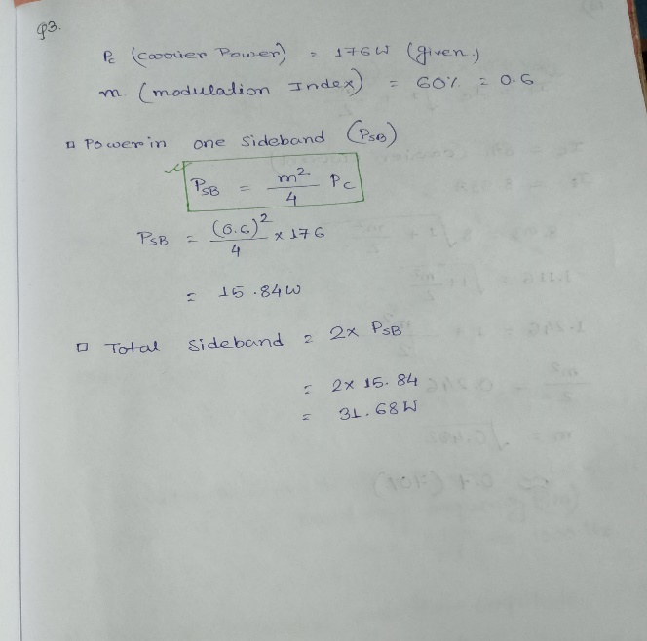

**4. Advantages of FM over AM.**  
**Answer:**  
Frequency Modulation (FM) has the following advantages over Amplitude Modulation (AM):

1. **Improved Noise Immunity**: FM is less susceptible to noise and interference as it depends on frequency variations rather than amplitude.
2. **Better Sound Quality**: FM provides higher fidelity audio signals due to larger bandwidth.
3. **Efficient Power Usage**: The transmitted power in FM remains constant regardless of the modulation index.

**5. Differences between FM and PM.**  
**Answer:**

| **Aspect** | **Frequency Modulation (FM)** | **Phase Modulation (PM)** |
| --- | --- | --- |
| **Modulation Parameter** | Frequency of the carrier varies with input signal amplitude. | Phase of the carrier varies with input signal amplitude. |
| **Noise Resistance** | Better noise resistance than PM. | Slightly less resistant to noise compared to FM. |
| **Applications** | Widely used in radio broadcasting. | Used in telemetry and digital communication systems. |

**6. Draw and explain the basic block diagram of a communication system.**

**Answer:**

The basic block diagram of a communication system consists of the following components:

1. **Information Source:** Produces the message signal to be transmitted, such as voice, text, video, etc.
2. **Transmitter:** Converts the message signal into a suitable form for transmission by modulating it with a carrier signal.
3. **Channel:** The medium through which the signal travels. It can be wired (e.g., cables) or wireless (e.g.air)
4. **Noise:** Any unwanted signal that interferes with the transmission of the original signal.
5. **Receiver:** Extracts and demodulates the original signal from the received waveform.
6. **Destination:** The endpoint where the message signal is delivered to the intended recipient.

*Diagram:*

***Information → Transmitter → Channel → Receiver → Destination***

***↳ Noise***

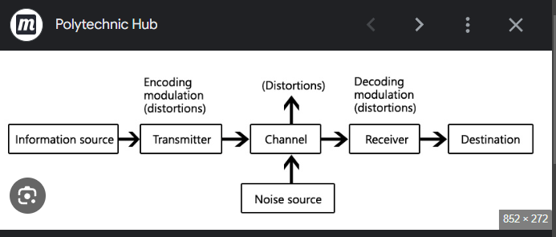

**7. Define modulation.**

**Answer:**  
Modulation is the process of varying a carrier wave's properties (amplitude, frequency, or phase) according to the message signal. It ensures efficient transmission of the signal over long distances.

**8. Why is modulation needed?**

**Answer:**

1. **Reduction in Antenna Size:** Modulation increases the frequency, reducing the required antenna size.
2. **Minimizing Interference:** It allows multiple signals to be transmitted simultaneously without interference.
3. **Efficient Power Transmission:** High-frequency signals travel more efficiently in free space.
4. **Improved Signal Quality:** Modulation helps in reducing noise interference.

**9. What are the types of analog modulation?**

**Answer:**  
The types of analog modulation are:

1. **Amplitude Modulation (AM):** The amplitude of the carrier signal is varied in accordance with the message signal.
2. **Frequency Modulation (FM):** The frequency of the carrier signal is varied based on the message signal.
3. **Phase Modulation (PM):** The phase of the carrier signal is varied according to the message signal.

**10. What is the difference between high-level and low-level modulation?**

| **Aspect** | **High-Level Modulation** | **Low-Level Modulation** |
| --- | --- | --- |
| **Power Amplification** | Occurs after modulation. | Occurs before modulation. |
| **Efficiency** | Higher efficiency for high-power transmitters. | Less efficient for high-power systems. |
| **Complexity** | Requires high-power amplifiers for modulated signals. | Simpler circuitry as modulation occurs at low power levels. |

**11. Derive an expression for amplitude-modulated wave and define the term modulation index.**

**Answer:**  
An amplitude-modulated wave is given by:

s(t)=Ac[1+mcos⁡(2πfmt)]cos⁡(2πfct)s(t) = A_c \left[1 + m \cos(2\pi f_m t)\right] \cos(2\pi f_c t)s(t)=Ac​[1+mcos(2πfm​t)]cos(2πfc​t)

Where:

* AcA_cAc​: Carrier amplitude.
* mmm: Modulation index.
* fmf_mfm​: Message signal frequency.
* fcf_cfc​: Carrier signal frequency.

**Modulation Index (mmm)**:

m=AmAcm = \frac{A_m}{A_c}m=Ac​Am​​

Where AmA_mAm​ is the amplitude of the message signal and AcA_cAc​ is the carrier amplitude.

**12. What are the disadvantages of DSB-FC?**

**Answer:**

1. **Inefficient Power Usage:** A significant amount of power is used in the carrier signal without conveying useful information.
2. **Bandwidth Requirement:** Double Sideband Full Carrier (DSB-FC) requires twice the bandwidth of the message signal.
3. **Susceptibility to Noise:** The presence of the carrier makes it more prone to interference.

**13. The antenna current of an AM transmitter is 8A when only the carrier is sent, but it increases to 8.93A when the carrier is sinusoidally modulated. Find the % modulation.**

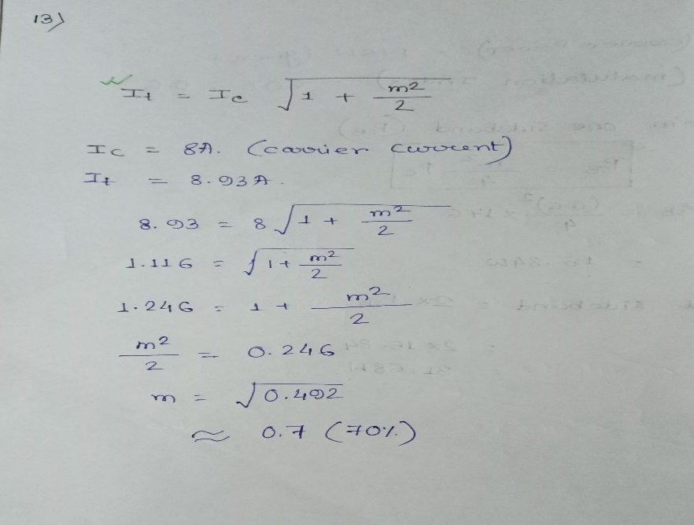

1. **An AM wave is represented by v=5(1+0.6cos6280t)sin211×104tv = 5 (1 + 0.6 \cos 6280t) \sin 211 \times 10^4tv=5(1+0.6cos6280t)sin211×104tvolts.**

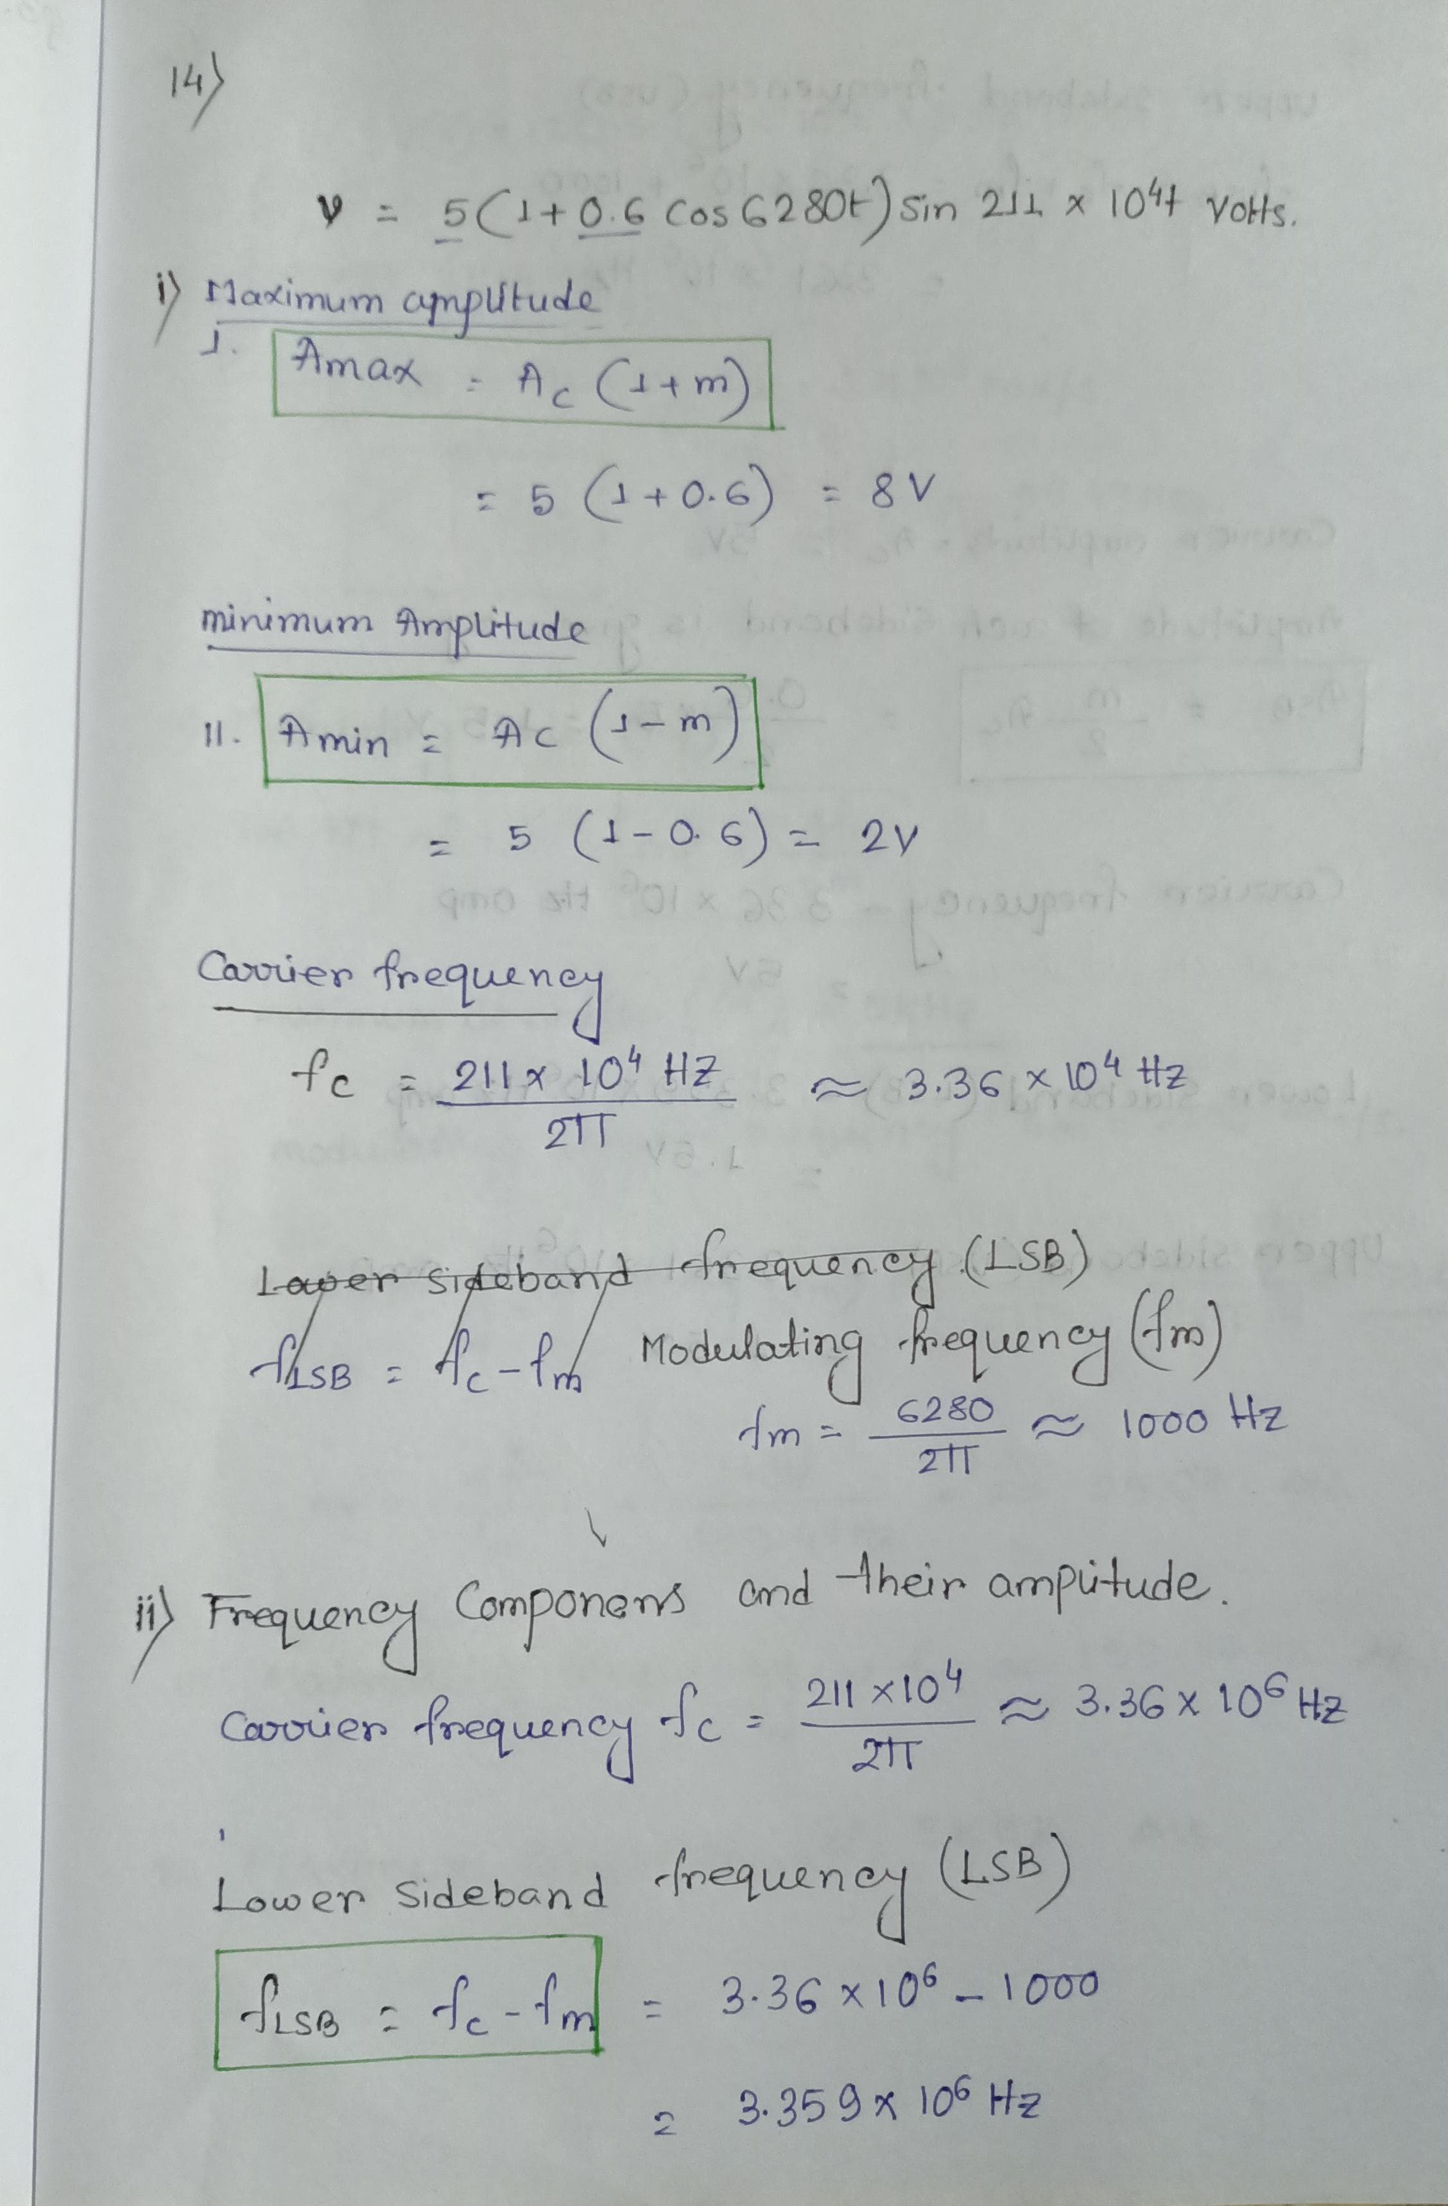

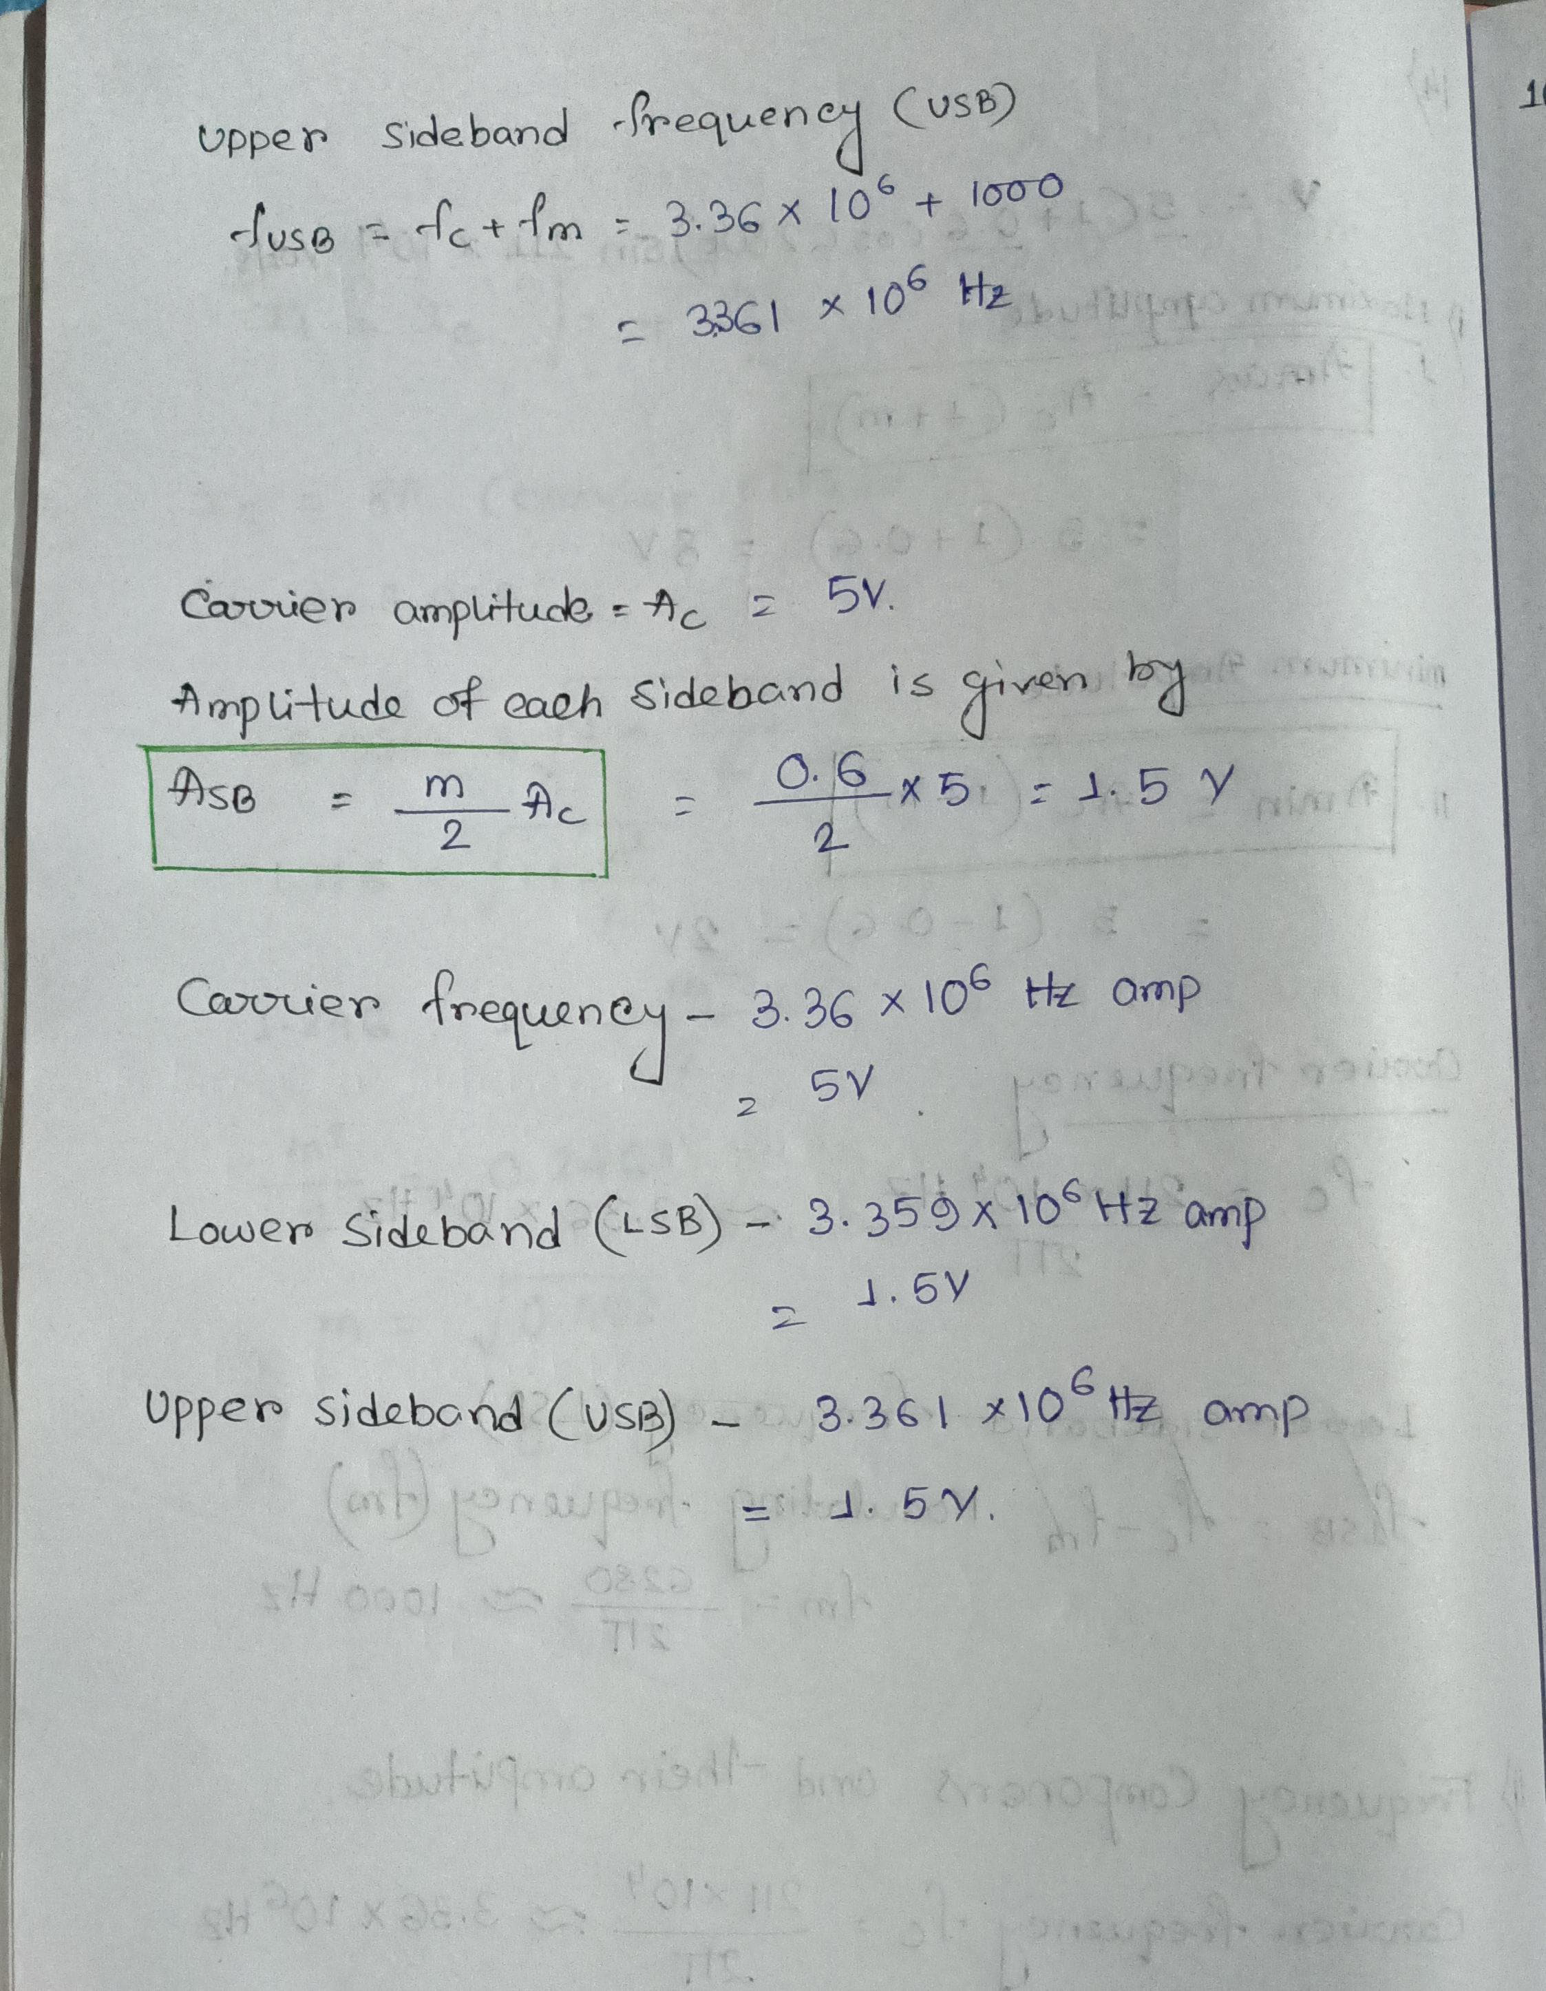

**15. Compare DSB-FC, DSB-SC, and SSB-SC**

| **Aspect** | **DSB-FC (Double Sideband Full Carrier)** | **DSB-SC (Double Sideband Suppressed Carrier)** | **SSB-SC (Single Sideband Suppressed Carrier)** |
| --- | --- | --- | --- |
| **Carrier Presence** | Contains a carrier signal | Carrier is suppressed | Carrier is suppressed |
| **Bandwidth** | 2fm2f_m2fm​ | 2fm2f_m2fm​ | fmf_mfm​ |
| **Power Efficiency** | Low (most power is in the carrier) | Higher (no carrier power, only sidebands) | Highest (only one sideband transmitted) |
| **Applications** | AM broadcasting | TV and radio transmission | Long-distance voice and data communication |

**16.A single-tone FM is represented by v(t)=12cos(6×108t+5sin1250t)v(t) = 12 \cos(6 \times 10^8 t + 5 \sin 1250 t)v(t)=12cos(6×108t+5sin1250t):**

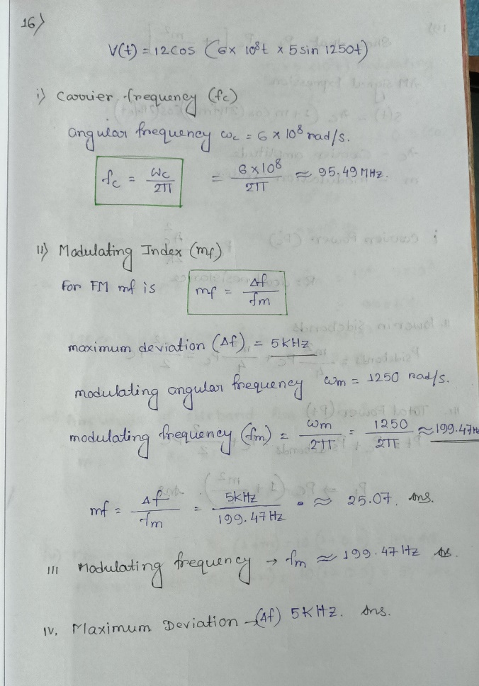

**17. State Carson’s Rule.**

**Answer:**  
Carson's rule provides an estimate of the bandwidth required for Frequency Modulation (FM) signals. It states:

BT=2(Δf+fm)B_T = 2(\Delta f + f_m)BT​=2(Δf+fm​)

Where:

* BTB_TBT​: Total bandwidth.
* Δf\Delta fΔf: Maximum frequency deviation.
* fmf_mfm​: Maximum modulating signal frequency.

**18. What are narrowband and wideband FM?**

| **Aspect** | **Narrowband FM (NBFM)** | **Wideband FM (WBFM)** |
| --- | --- | --- |
| **Bandwidth** | Small bandwidth (<2fm< 2f_m<2fm​). | Large bandwidth (typically much larger). |
| **Modulation Index** | mf<1m_f < 1mf​<1. | mf>1m_f > 1mf​>1. |
| **Applications** | Voice communication, e.g., walkie-talkies. | High-quality audio, e.g., FM radio. |

**19. Show that Pt=Pc[1+(m2/2)]P_t = P_c [1 + (m^2/2)]Pt​=Pc​[1+(m2/2)].**

**Proof:**  
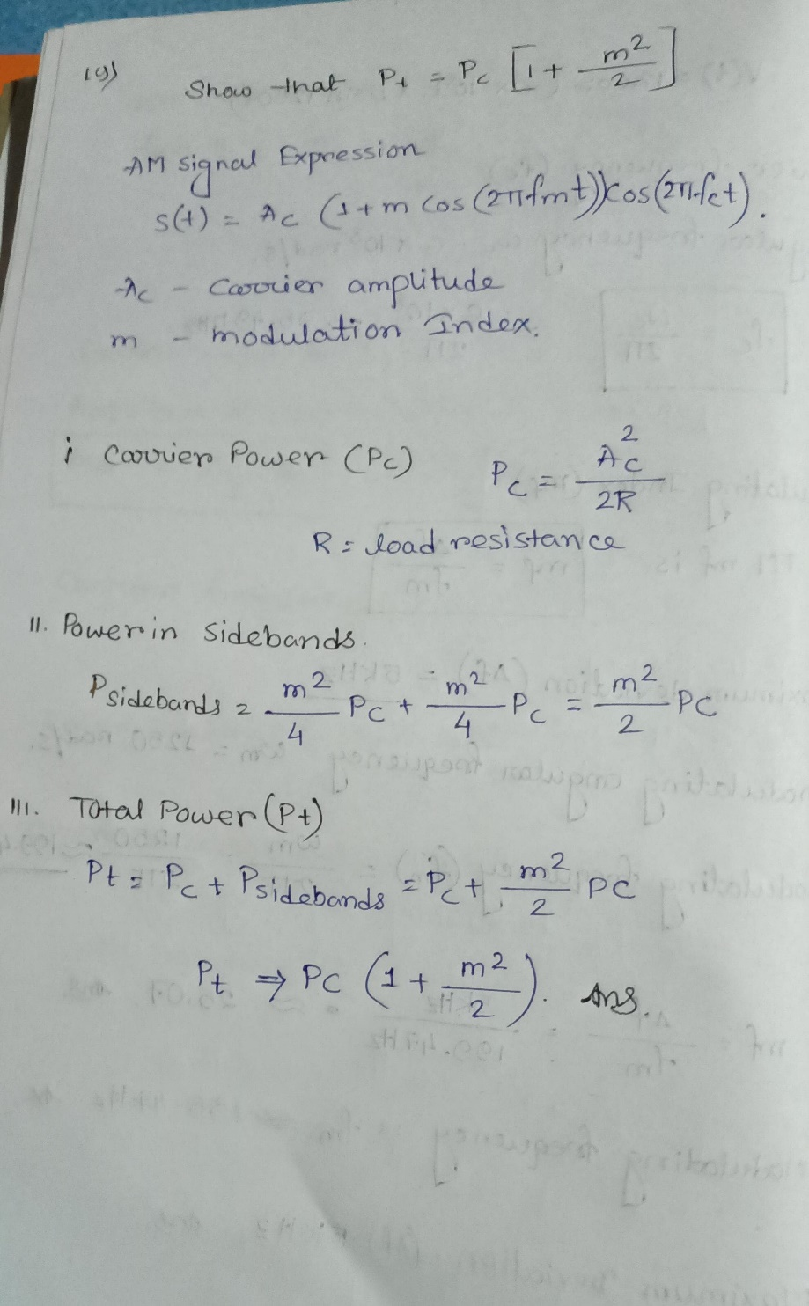

**20. Difference between AM and FM**

| **Aspect** | **Amplitude Modulation (AM)** | **Frequency Modulation (FM)** |
| --- | --- | --- |
| **Modulated Parameter** | Amplitude of the carrier signal varies. | Frequency of the carrier signal varies. |
| **Noise Resistance** | More susceptible to noise. | Better noise immunity. |
| **Bandwidth** | Requires smaller bandwidth. | Requires larger bandwidth. |
| **Applications** | Radio broadcasting. | High-fidelity music and video systems. |

1. **For the signal 5sin(2π×5×103t)5 \sin(2\pi \times 5 \times 10^3 t)5sin(2π×5×103t) modulating 10sin(2π×106t)10 \sin(2\pi \times 10^6 t)10sin(2π×106t):**

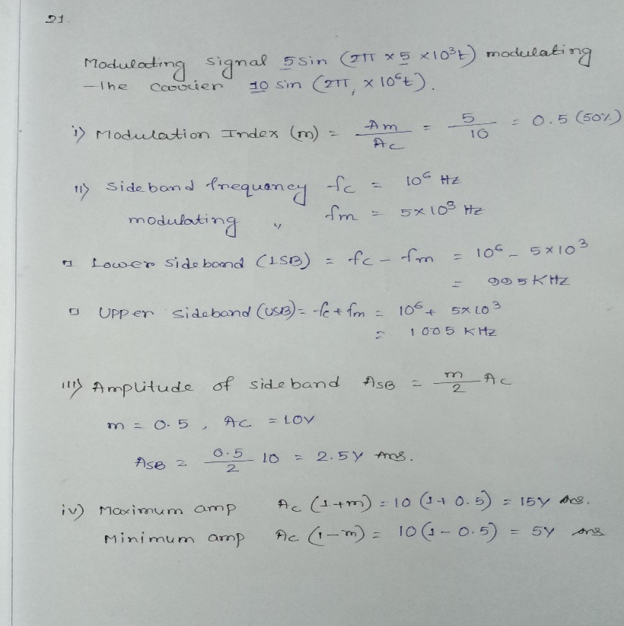

**(b) AM waveform:**  
An AM wave consists of a carrier plus the two sidebands. The plot would illustrate the combined signal over time, showing the envelope of the modulated signal.

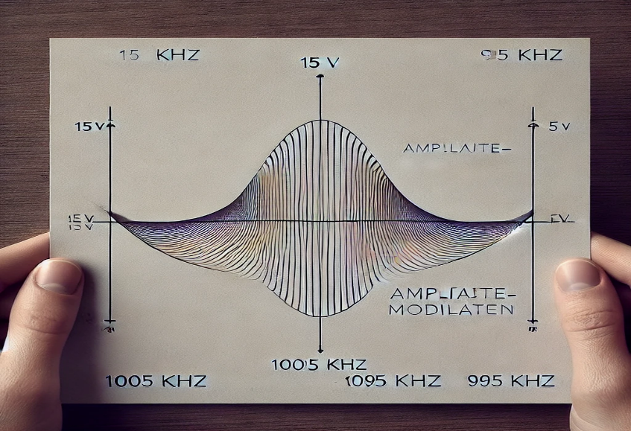

**22. Short Notes:**

**(a) Envelope Detector:**  
A circuit used to demodulate AM signals by extracting the envelope of the received waveform. Commonly used in radio receivers.

**(b) Balanced Modulator:**  
A device that generates DSB-SC signals by suppressing the carrier and producing only the sidebands.

**(c) Varactor Diode Frequency Modulator:**  
Uses a varactor diode to produce frequency modulation by varying its capacitance with the applied signal voltage.

**(d) Foster-Seeley Discriminator:**  
An FM demodulator that converts frequency variations into amplitude variations to retrieve the original message signal.

* **MODULE 2**