Lab4: SDN Open Virtual Switches

# Objectives

* Emulate a functional SDN network.
* Understand and get familiar with OVS.
* Understand and get familiar with controllers.

# Equipment

* Computers
* Internet

# References

* RYU programming guide: <http://osrg.github.io/ryu-book/en/html/>

# Experiments

* 1. Use Mininet to create the following topology: (4 Hosts, 4 OVSes ) with a remote controller
  2. Use RYU to implement the controller (you can use other controller such as BEACON, POX, etc...)

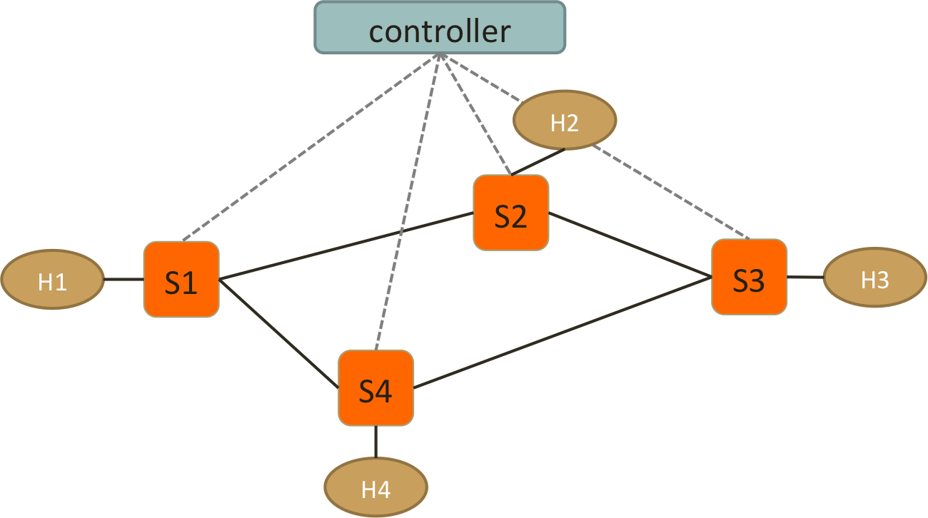

* 1. Test Connectivity using ping. (Hint: take care of ARP packets in the controller and install proper rules for them.)
  2. Enforce these policies:
* Everything follows shortest path
* When there are two shortest paths available
  + ICMP and TCP packets take the upper/right path
    - S1-S2-S3 and S2-S3-S4
  + UDP packets take the lower/left path
    - S1-S4-S3 and S2-S1-S4
  + H1 and H3 cannot have HTTP traffic (TCP with port:80)
    - New connections are dropped with a TCP RST sent back to H1 or H3
    - To be more specific, when the first TCP packet (SYN) arrives S1 or S3, forwarded it to controller, controller then create a RST packet and send it back to the host.
  + H2 and H3 cannot have UDP traffic
    - simply drop packets at switches

# Reports

1. Write a pseudo code to implement spanning tree in SDN network.
2. List the advantages of using OpenVSwitch and SDN controller compared to IP networks.
3. Include the controller’s code.
4. Include the topology file
5. Describe how you generate traffic to test your controller and switch behavior
6. Screenshots:

* Ping among all the hosts after setting up the platform.
* TCP, UDP and ICMP packets on their respective paths.
* Rules installed at each switch.

1. Challenges you’ve encountered while doing this experiment, and explain how you manage to solve them. If you do not experience any problem, simply say no problems.

**We have zero tolerance to forged or fabricated data!!** A single piece of forged/fabricated data would bring the total score down to zero.