**FOOD RECOGNITION SYSTEM USING DEEP LEARNING**

Project submitted to the

SRM University – AP, Andhra Pradesh

for the partial fulfillment of the requirements to award the degree of

**Bachelor of Technology**

In

**Computer Science and Engineering**

**School of Engineering and Sciences**

Submitted by

**GTS.Siddharth - AP21110011421**

**G.Chaitanya Nath - AP21110011422**

**N.Raja Sekhar - AP21110011444**

**P.Lakshmipathi - AP21110011457**

**S.Guna Sekhar - AP21110011476**

Under the Guidance of

**Dr.Ravi Kant Kumar**

**SRM University–AP**

**Neerukonda, Mangalagiri, Guntur**

**Andhra Pradesh – 522 240**

**Nov, 2023**

# Certificate

Date:

This is to certify that the work present in this Project entitled “**PROJECT TITLE**” has been carried out by **the group** under my/our supervision. The work is genuine, original, and suitable for submission to the SRM University – AP for the award of Bachelor of Technology in **School of Engineering and Sciences**.

**Supervisor**

Dr. Ravi Kant Kumar

AssisatantProfessor,

SRM UNIVERSITY AP.

**Acknowledgements**

**This project's realization owes gratitude to the collaborative efforts and support of various individuals and organizations. We extend sincere thanks to SRM university for providing the essential infrastructure and resources crucial to the success of our research. The mentorship and valuable insights provided by Dr.Ravi Kant Kumar were instrumental in guiding our project toward meaningful outcomes.**

**We also express appreciation to the contributors of open-source frameworks, particularly the TensorFlow and Keras communities. Their commitment to advancing technology through shared knowledge has been fundamental to the development of our Food Recognition System.**

**Our heartfelt thanks go to the numerous datasets available online, which served as the foundational blocks for our custom dataset. The collective effort of the data-sharing community has significantly contributed to the diversity and richness of our dataset.**

Table Of Contents

Certificate …………………………………………………………………………………. i

Acknowledgements ………………………………………………………………………ii

Table of contents ………………………………………………………………………….iii

Abstract ……………………………………………………………………………………iv

Citations ……………………………………………………………………………………v

Abbreviations ……………………………………………………………………………...v

List of figures ………………………………………………………………………………v

1.Introduction ……………………………………………………………………………...1

1.1 Background

1.2 Context

2.Methodology ……………………………………………………………………………..3

2.1 Dataset Creation

2.2 Algorithmic Exploration

2.3 Work Flow of the Project

3.Results and Discussion …………………………………………………………………10

4.Conclusion ……………………………………………………………………………….14

5.Future Work ……………………………………………………………………………..15

6.References ……………………………………………………………………………….16

**Abstract**

Food recognition using machine learning is a rapidly growing field with a wide range of applications, including dietary monitoring, calorie estimation, and food waste management .This project focuses on creating a robust solution that can identify various food items from images, enabling users to effortlessly track their nutritional intake.

The proposed system employs a combination of computer vision and machine learning algorithms to analyse and classify food items within images. The project involves the collection and preprocessing of a diverse dataset containing images of different types of food. Convolutional Neural Networks (CNNs) are utilized for feature extraction, enabling the model to discern intricate patterns and details crucial.

However, there are still a number of challenges that need to be addressed, such as the lack of large-scale, high-quality food image datasets and the difficulty of recognizing food in real-world conditions.

**Citations**

The thesis is mainly based on the results presented in the following articles.

1. Dhillon, Anamika, and Gyanendra K. Verma. "Convolutional neural network: a review of models, methodologies and applications to object detection." Progress in Artificial Intelligence 9.2 (2020): 85-112.
2. Zhou, Lei, Chu Zhang, Fei Liu, Zhengjun Qiu, and Yong He. "Application of deep learning in food: a review." Comprehensive reviews in food science and food safety 18, no. 6 (2021): 1793-1811.
3. Dim P. Papadopoulos, Enrique Mora, Nadiia Chepurko, Kuan Wei Huang, Ferda Ofli, Antonio Torralba; Proceedings of the IEEE/CVF Conference on Computer Vision and Pattern Recognition (CVPR), 2022, pp. 16559-16569
4. M. A. Subhi and S. Md. Ali, "A Deep Convolutional Neural Network for Food Detection and Recognition," 2018 IEEE-EMBS Conference on Biomedical Engineering and Sciences (IECBES), Sarawak, Malaysia, 2018, pp. 284-287, doi: 10.1109/IECBES.2018.8626720.

Abbreviations

CNN -Convulutional Neural Networks

VGG- visual Geometry Group

ResNet-Residual NetWorks

List of Figures

Figure 1. VGG16 Architecture……………………………...……………………….

Figure 2. Res Net 50 Architecture…………………………………………………

Figure 3.ResNet 101 Architecture………………………………………………….

Figure 4.VGG16 results………………………………………………………………

Figure 5.VGG19 results……………………………………………………………….

Figure 6.ResNet50 Results…………………………………………………………..

Figure 7.ResNet101 Results…………………………………………………………

Figure 8.Predictions………………………………………………………………..

# 1. Introduction

**Background:**

The impetus for this project stems from the increasing demand for automated systems capable of recognizing and categorizing food items in images. Such systems find applications in dietary monitoring, menu analysis for restaurants, and nutritional assessment. The complex nature of food, characterized by diverse shapes, colors, and presentations, necessitates the use of sophisticated deep learning models to ensure accurate recognition.

**Context:**

In the realm of computer vision and artificial intelligence, the development of robust image recognition systems has become a pivotal area of research and application. Our project delves into this domain, specifically focusing on the creation of a Food Recognition System using deep learning, with a primary emphasis on Convolutional Neural Networks (CNN). Our journey through this project involved experimenting with various architectures, and we ultimately harnessed the power of ResNet-101, achieving an impressive accuracy of 88%.

- Our journey commenced with a foundational exploration into the realm of Deep Learning, a paradigm of artificial intelligence that has revolutionized the way machines process and understand data. To lay a robust foundation, we delved into the fundamental terminologies inherent in Deep Learning, unraveling the intricacies of neural networks and their applications.

- As we navigated through the expansive landscape of computer vision, our focus honed in on the architectural intricacies of these networks. Understanding the backbone of image processing in machines, we delved into the realm of Convolutional Neural Networks (CNN). This pivotal juncture in our learning journey marked a profound shift in our comprehension of how machines interpret visual data.

- Our initial experimentation involved a systematic exploration of various algorithms and architectures to discern their efficacy in the context of food recognition. We began with a simple Keras model using TensorFlow, providing us with valuable insights into the challenges associated with identifying diverse food items in images. This served as our project's baseline, setting the stage for further refinement.

- we experimented with VGG16, noting a significant improvement in accuracy, which underscored the importance of deeper networks for our specific task. Building upon this insight, we explored VGG19, witnessing further enhancements in our model's performance with an increased accuracy of 77%.

- Eager to push the boundaries, we then implemented ResNet-50, which proved to be a pivotal juncture in our project's development. The introduction of residual connections in ResNet-50 significantly boosted accuracy to a range between 85% and 89%, showcasing the potential for further optimization.

- Our journey reached its zenith when we decided to leverage the deeper ResNet-101 architecture. This decision was informed by our meticulous evaluation of its performance and the consistent accuracy it delivered, ranging between 88% and 89%. ResNet-101 emerged as the optimal choice, marrying depth and efficiency to address the complex task of food recognition.

- This iterative journey was not only about algorithmic exploration but also about the creation of a robust dataset. Curating a diverse dataset comprising 15 distinct food classes was a meticulous process, drawing from various sources on the web. This dataset, born from a synthesis of diverse culinary presentations, became the lifeblood of our model's training.

**2.Methodology**

**Dataset Creation**

In the core of our project lay a crucial undertaking – the creation of a comprehensive dataset that would serve as the backbone for training our Food Recognition System. This dataset was not just a collection of images; it was a thoughtfully curated assembly, spanning across 15 distinct food classes. The importance of diversity was paramount in our approach, prompting us to meticulously select and compile images from various online sources.

The process of dataset creation was far from arbitrary; it was a deliberate and careful curation effort. We amalgamated images from diverse culinary contexts found on the web, ensuring a representative selection of foods reflecting a broad spectrum of visual characteristics. This meticulous approach aimed to enrich the dataset with variations in colors, shapes, and presentations, fostering adaptability in our model.

By undertaking this careful curation process, we sought to equip our Food Recognition System with a robust foundation. The diversity embedded in the dataset served as a training ground for the model, enabling it to generalize effectively across the myriad ways in which different foods are visually represented. In essence, the dataset was not merely a compilation of images; it was a strategic asset designed to enhance the adaptability and accuracy of our model in recognizing diverse food items across various culinary landscapes.

**Algorithmic Exploration**

Our journey commenced with a foundational Keras model using TensorFlow, providing essential insights into the nuances of food recognition. Seeking refinement, we delved into more intricate architectures, starting with VGG16 and progressing through VGG19. These steps culminated in the exploration of ResNet-50, revealing a substantial increase in accuracy, ranging from 85% to 89%. However, the zenith of our experimentation lay in the adoption of ResNet-101.

Architecture of VGG16 :

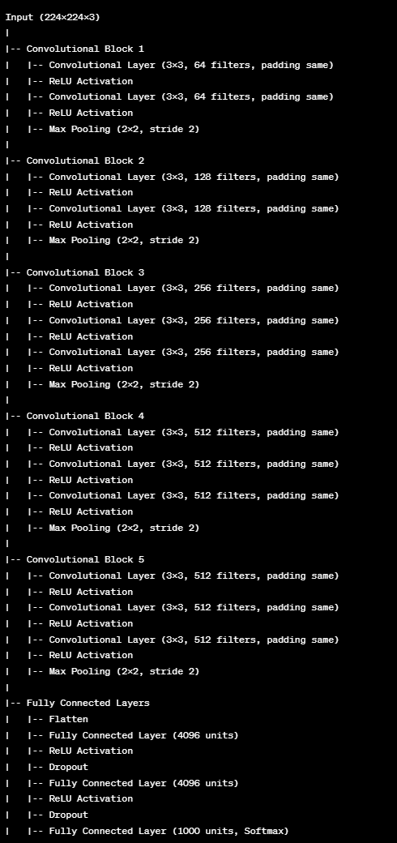

Architecture of ResNet50:

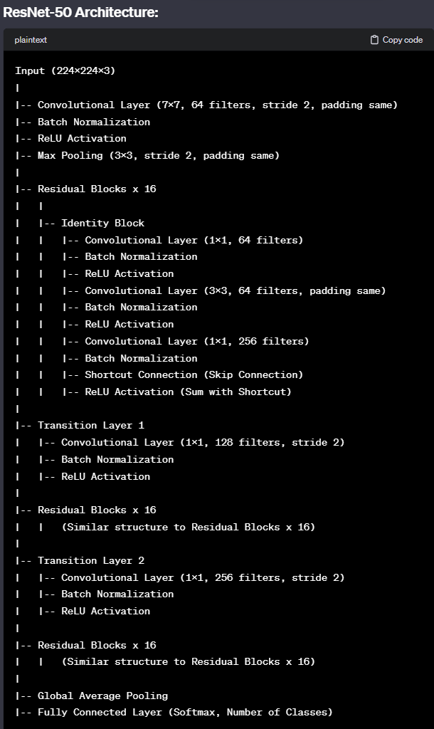

The ResNet-101 Choice

ResNet-101, lauded for its deep architecture and ingenious use of skip connections, emerged as the pinnacle of our algorithmic exploration. Its adeptness in capturing intricate features, coupled with a balanced trade-off between depth and computational efficiency, marked a significant leap in our project's performance. The decision to embrace ResNet-101 was underpinned by its consistent accuracy, ranging between 88% and 89% during our iterative experimentation.

Architecture of ResNet101 :

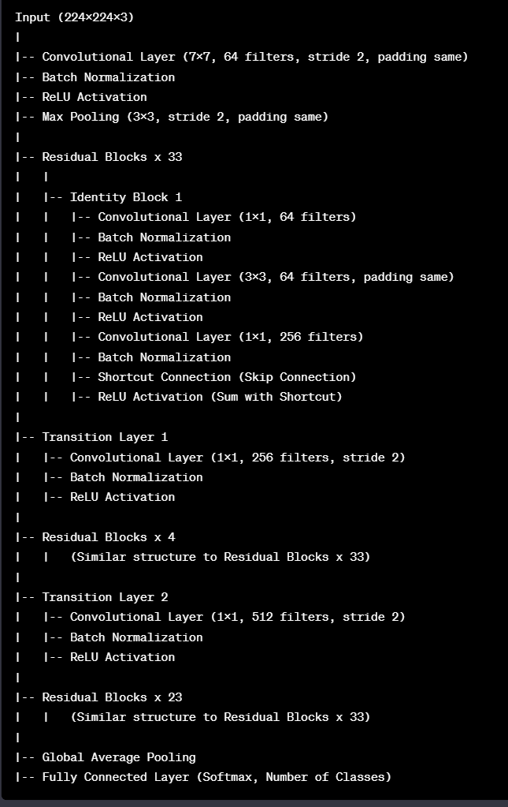

**WORKFLOW OF THE PROJECT:**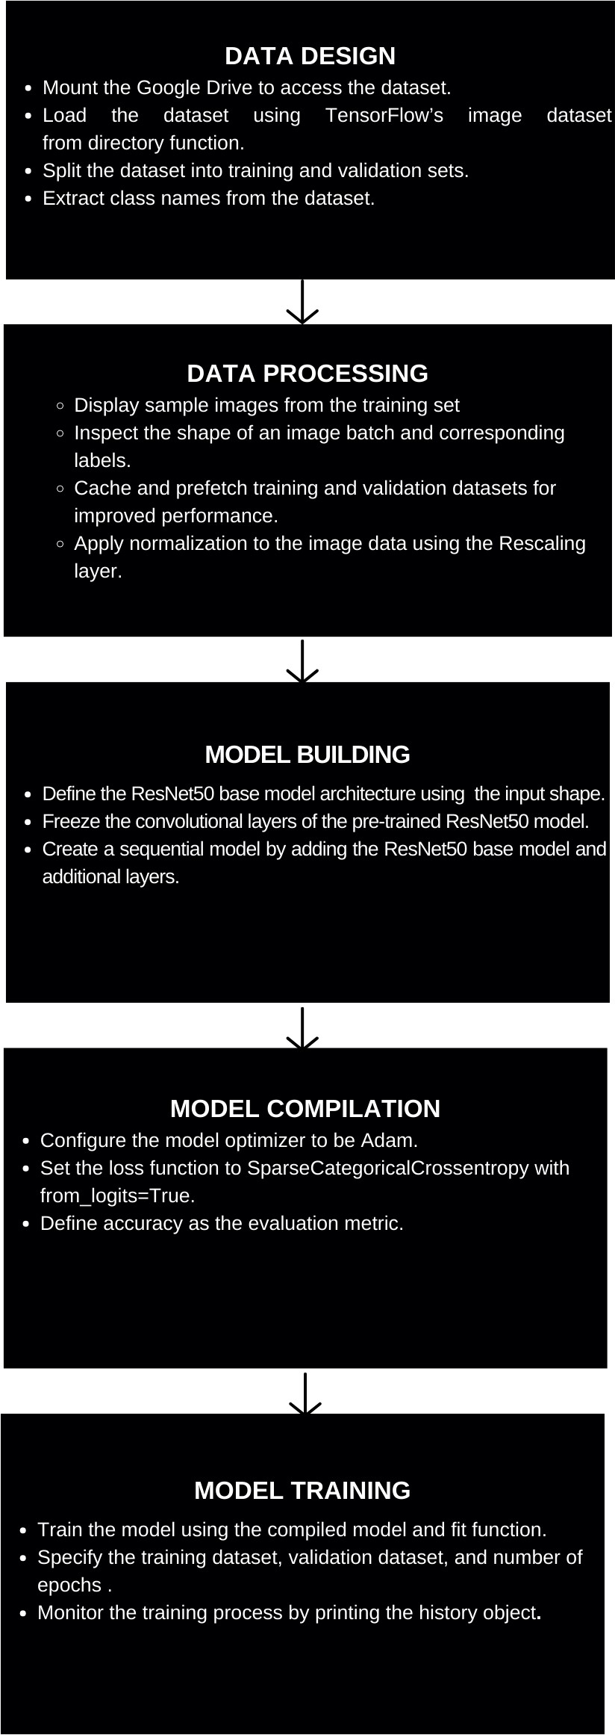

**IMAGE PROCESSING**

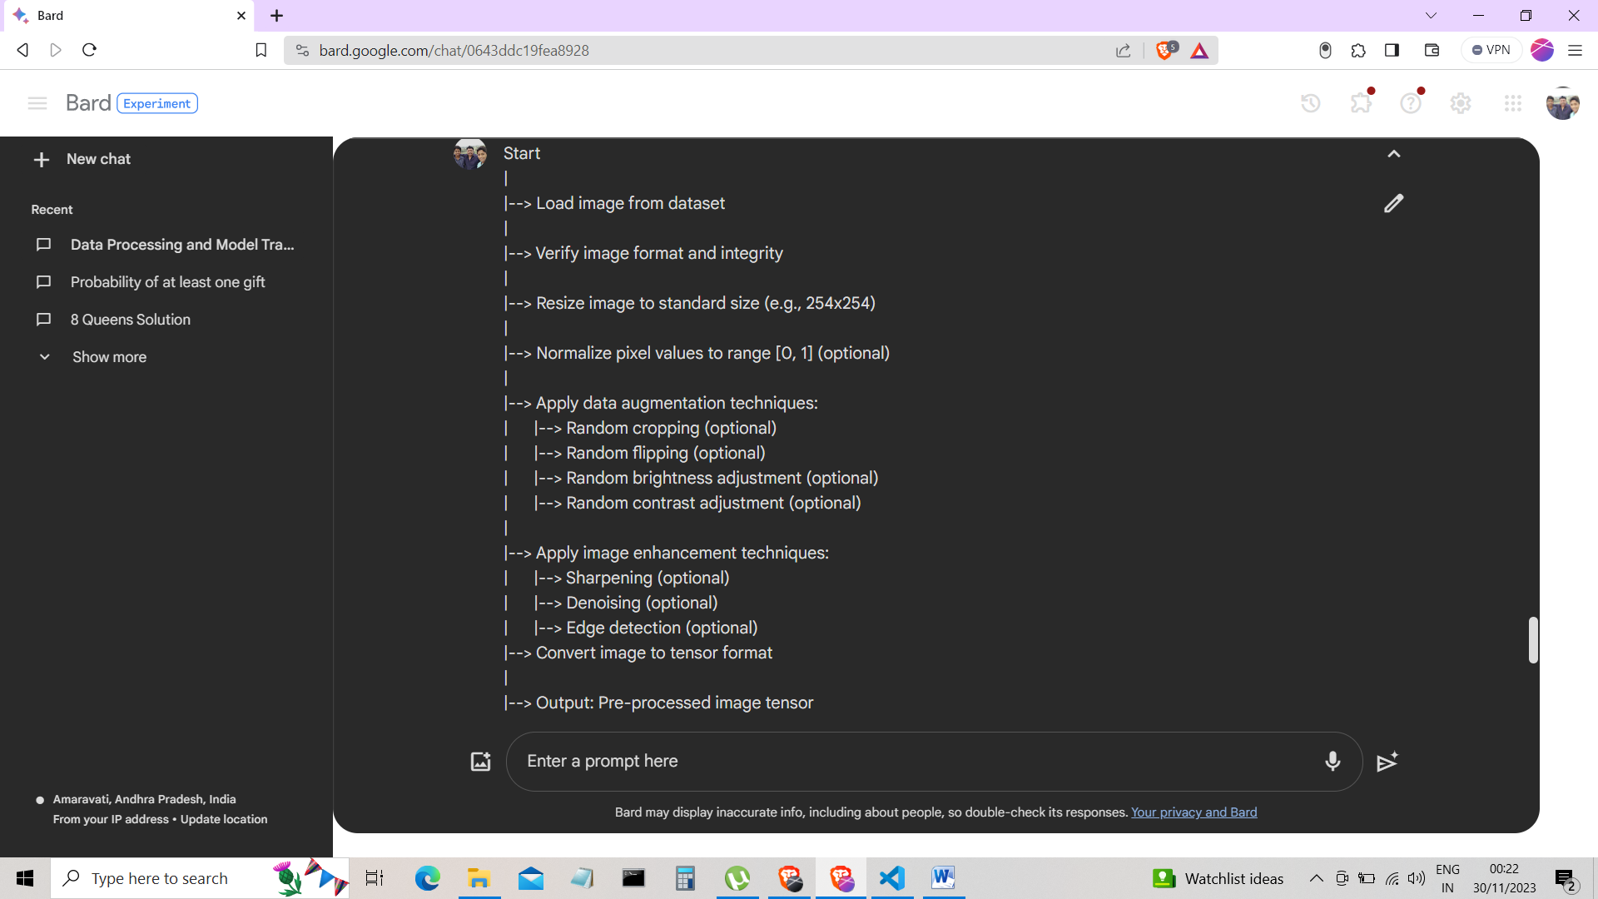

**Verify image format and integrity:** This step ensures that the image is in a valid format (e.g., JPEG, PNG) and that it is not corrupted.

**Resize image to standard size:** This step resizes the image to a standard size, such as 254x254. This is done to ensure that all images are the same size and to reduce the computational complexity of subsequent steps.

**Normalize pixel values to range [0, 1]:** This step normalizes the pixel values of the image to the range [0, 1]. This is done to improve the convergence of the machine learning model.

**Apply data augmentation techniques:** Data augmentation techniques can be used to increase the size and variability of the training data. This can help to prevent the model from overfitting on the training data. Some common data augmentation techniques include random cropping, random flipping, random brightness adjustment, and random contrast adjustment.

**Apply image enhancement techniques:** Image enhancement techniques can be used to improve the quality of the image data. This can help to make the features of the image more visible to the machine learning model. Some common image enhancement techniques include sharpening, de-noising, and edge detection.

**Convert image to tensor format:** Tensor format is a common data format used in machine learning. Converting the image to tensor format allows it to be used with machine learning algorithms. The specific method for converting the image to tensor format will depend on the machine learning framework being used.

**Pre-processed image tensor:** The final output of the image pre-processing pipeline is the pre-processed image tensor. This tensor can then be used as input to machine learning algorithms for tasks such as image classification, object detection, or image segmentation.

**4.Results and Discussion**

**Model Performance:**

We conducted experiments with four different convolutional neural network (CNN) architectures, namely VGG16, VGG19, ResNet50, and ResNet101, to classify images of Indian food items. The final results, including the accuracy achieved on the test set, are as follows:

**VGG16: 75%**

**VGG19: 78%**

**ResNet50: 85%**

**ResNet101: 88%**

**Challenges with Indian Food Recognition:**

The recognition of Indian food items posed unique challenges due to the complexity and diversity of the cuisine. Unlike simpler Western dishes, Indian dishes often exhibit intricate textures, colors, and compositions. This complexity led to difficulties in training models to accurately distinguish between different types of Indian foods.

**Texture Recognition:**

One of the primary challenges was the accurate recognition of textures within Indian dishes. The models struggled to differentiate between subtle textural variations, leading to lower accuracy in some instances. For instance, distinguishing between different curry textures or variations in roti (Indian flatbread) proved challenging.

**Dataset Cleaning:**

Despite meticulous efforts in dataset cleaning, including the removal of unwanted noise and verification of each image, the inherent complexity of Indian dishes presented difficulties. Noise in the form of variations in presentation, lighting conditions, and background clutter impacted the model's ability to generalize well.

**Model Comparison:**

The performance of the models varied, with ResNet101 demonstrating the highest accuracy at 88%. The deeper architecture of ResNet101 allowed it to capture more intricate features, particularly beneficial for recognizing complex textures in Indian dishes. VGG19 performed slightly better than VGG16, indicating that the increased depth contributed to improved learning capabilities.

Here are the results :

VGG 16 implementations results :

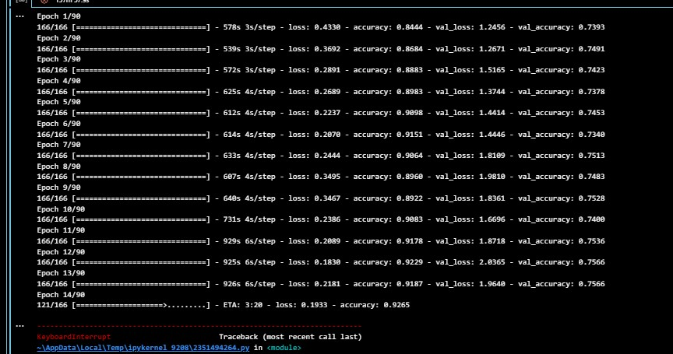

VGG 19 implementation results:

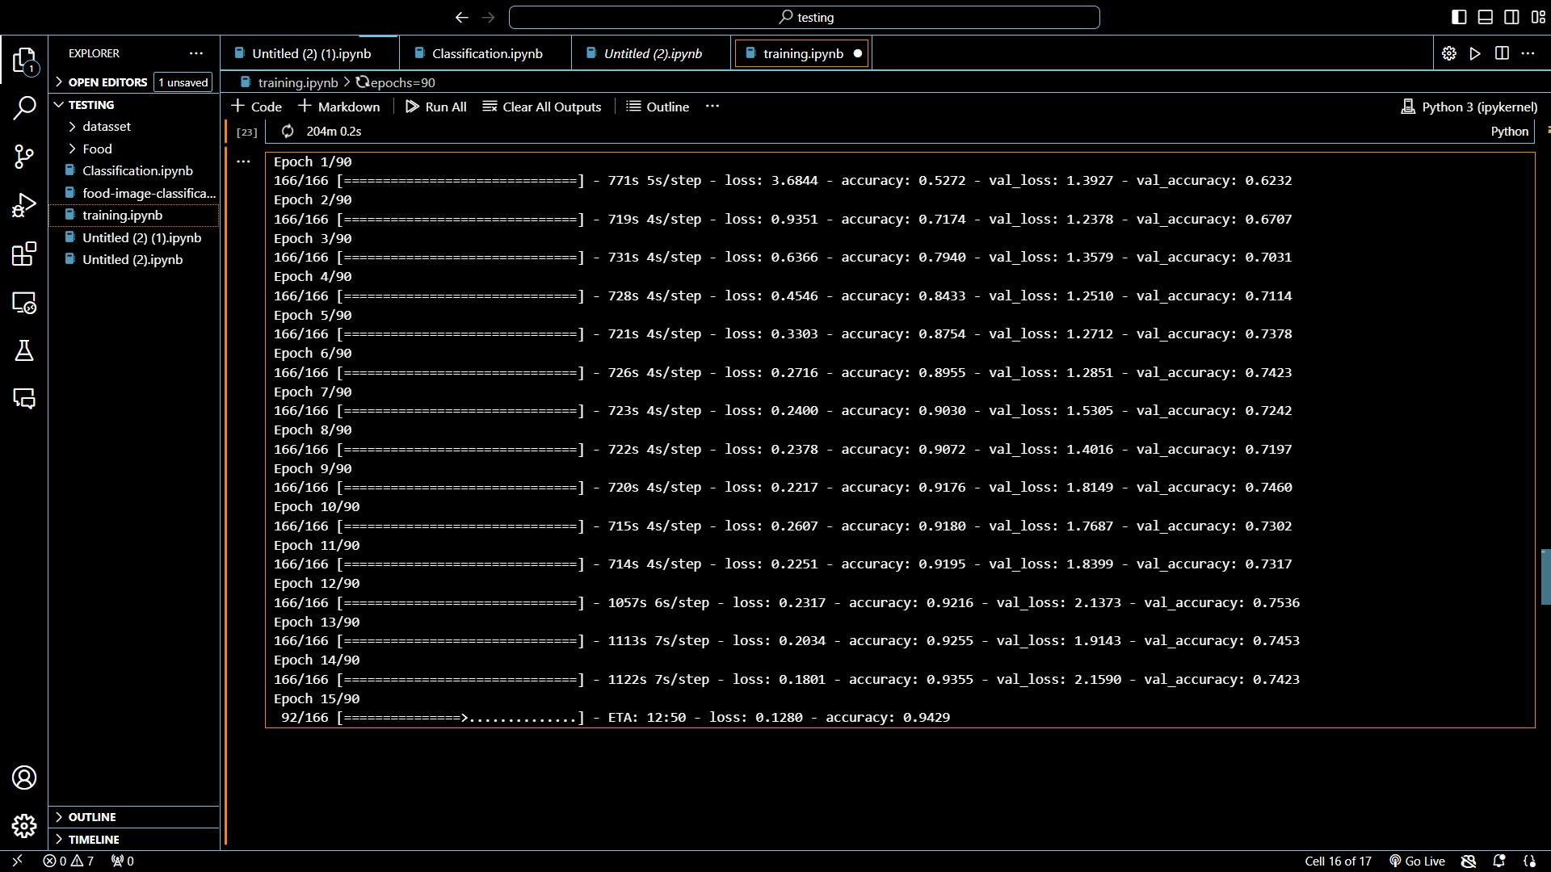

ResNet 50 implementation results:

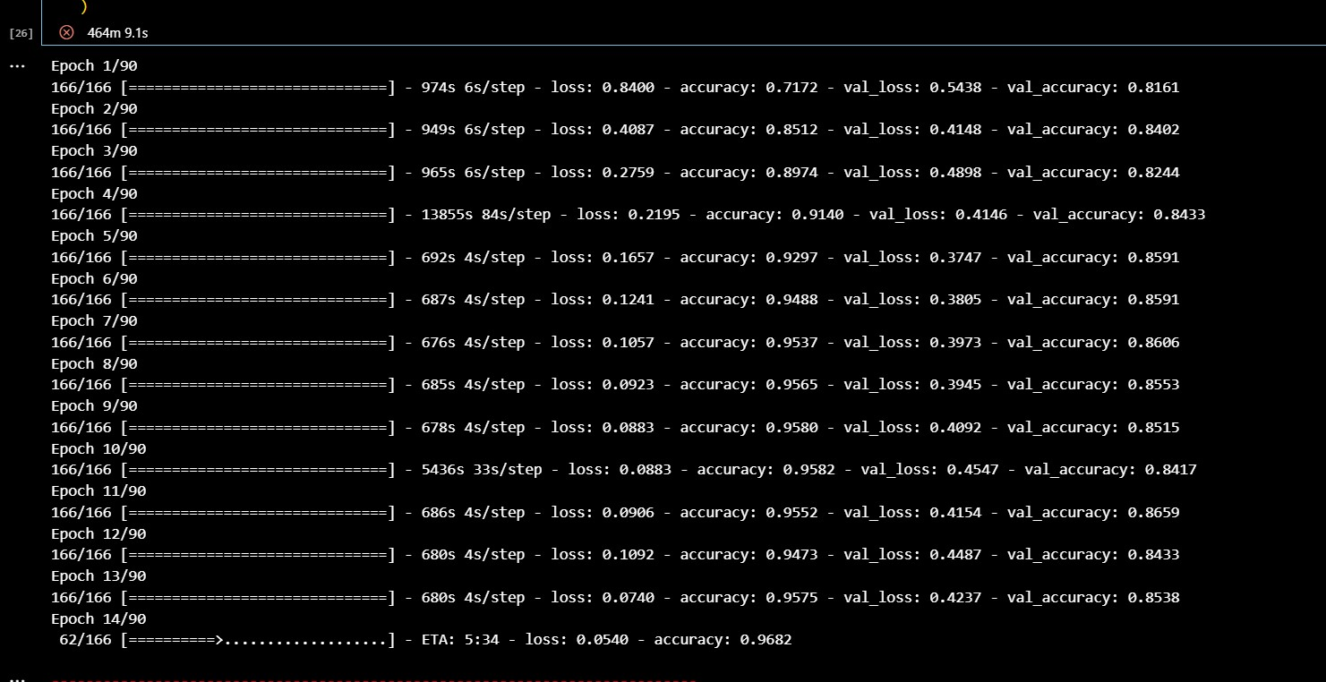

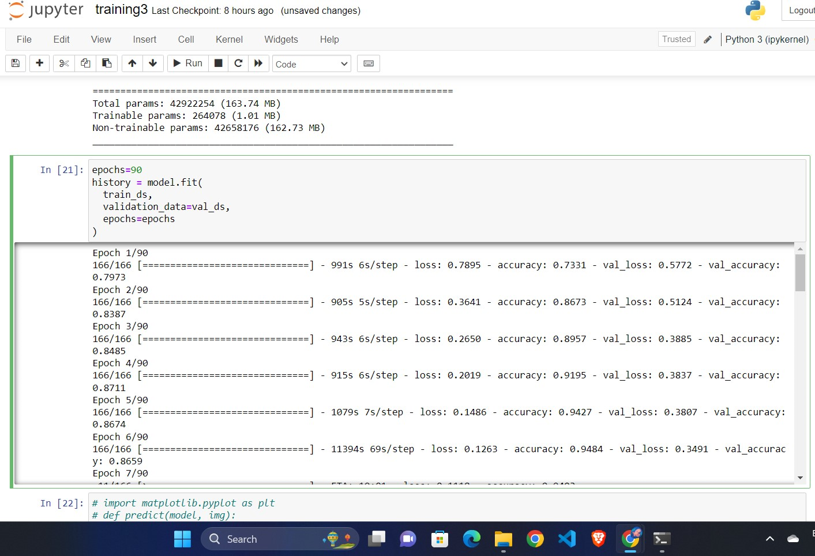

Predictions :

Resnet101 implementation results:

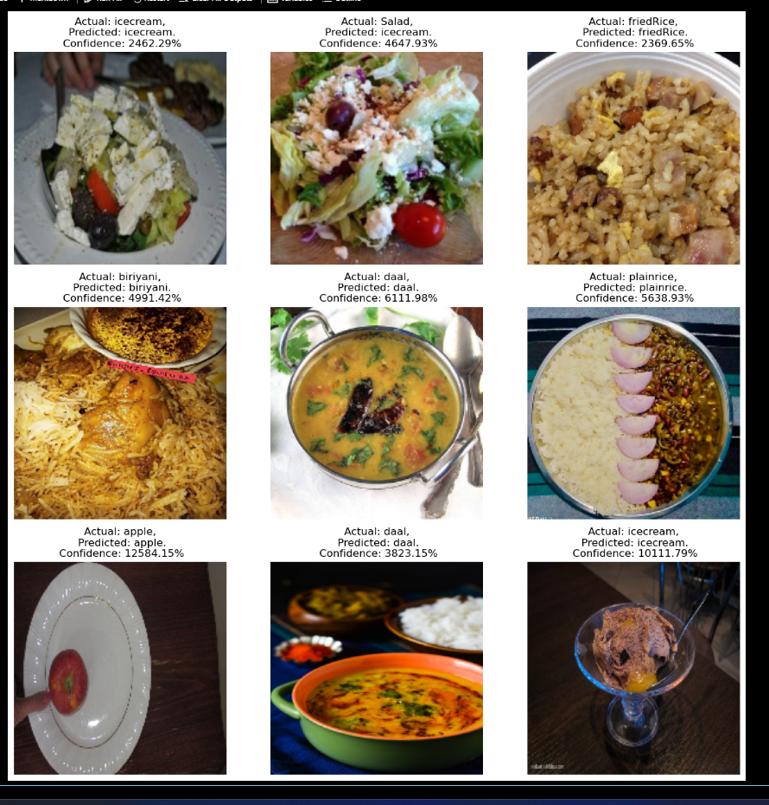

**5.Conclusion**

In conclusion, our project journey has been marked by a relentless pursuit of precision in food recognition. From the foundational understanding of Deep Learning and CNNs to the strategic selection of ResNet-101, every step in our journey has been a deliberate stride towards a more accurate and efficient Food Recognition System. The subsequent sections of our report will delve into the intricacies of our methodology, the characteristics of our dataset, and the compelling results that define the success of our project. Our Food Recognition System, empowered by ResNet-101, stands as a testament to the potential of deep learning in image recognition. The amalgamation of a thoughtfully curated dataset, iterative algorithmic exploration, and the support of various entities has resulted in a system poised to make substantive contributions to diverse applications in the culinary landscape. The subsequent sections of this report will delve into the intricacies of our methodology, the dataset, and the compelling results that underscore the success of our project.

**6.Future Work**

* **Handling diverse food items:** The variety of food items is vast, encompassing diverse cuisines, preparation methods, and presentation styles. Deep learning models need to be able to generalize effectively to handle this wide range of variations.
* **Addressing occlusions and clutter:** Food images often contain occlusions, where one food item partially covers another, and clutter, where non-food items are present in the background. These factors can hinder the accurate recognition of food items.
* Enhanced Model Performance: Continuous efforts should be directed towards refining and optimizing the deep learning models to further improve accuracy, especially in challenging conditions such as low-light environments or varied presentation styles.
* Expanding Food Database: Expanding the dataset used for training the models will contribute to a more comprehensive and diverse food recognition system. This could involve collaboration with culinary experts and the inclusion of regional or culturally specific dishes.
* Integration with Mobile Platforms: To enhance accessibility, future work could focus on developing mobile applications that utilize the food recognition system. This would empower users to easily track their dietary habits using their smartphones.
* Nutritional Analysis: Incorporating a nutritional analysis component into the system would provide users with valuable information about the content and health implications of the recognized food items, contributing to a more holistic dietary monitoring solution.

**7.References**

1. https://link.springer.com/content/pdf/10.1007/s13748-019-00203-0.pdf
2. <https://ieeexplore.ieee.org/stamp/stamp.jsp?arnumber=8373692>
3. <https://openaccess.thecvf.com/content/CVPR2022/html/Papadopoulos_Learning_Program_Representations_for_Food_Images_and_Cooking_Recipes_CVPR_2022_paper.html>
4. <https://www.tensorflow.org/tutorials/images/classification>
5. Kagaya, Hokuto, Kiyoharu Aizawa, and Makoto Ogawa. "Food detection and recognition using convolutional neural network." *Proceedings of the 22nd ACM international conference on Multimedia*. 2014.
6. Salim, Nareen OM, et al. "Study for food recognition system using deep learning." *Journal of Physics: Conference Series*. Vol. 1963. No. 1. IOP Publishing, 2021.
7. Islam, Md Tohidul, et al. "Image recognition with deep learning." *2018 International conference on intelligent informatics and biomedical sciences (ICIIBMS)*. Vol. 3. IEEE, 2018.
8. M. A. Subhi and S. Md. Ali, "A Deep Convolutional Neural Network for Food Detection and Recognition," 2018 IEEE-EMBS Conference on Biomedical Engineering and Sciences (IECBES), Sarawak, Malaysia, 2018, pp. 284-287, doi: 10.1109/IECBES.2018.8626720.