International Tuition Statistics for OUT

# **Overview**

These statistics present data collected from 2018 to 2024, encompassing all faculties and programs at Ontario Tech University. The focus is to highlight the trends and patterns of tuition cost increases during this period, providing insights into the financial impact on students across various academic disciplines. These statistics emphasize the need for attention and action regarding the rising education costs and their potential implications for students pursuing higher education at OTU.

# **Average Rate of Increase Across Faculties**

From 2019 to 2022, the average percentage increase in tuition costs was approximately 6%. However, in the academic year of 2022-2023, there was a significant spike in tuition increase, surpassing 10%. Looking ahead to the upcoming 2023-2024 academic year, the average tuition increase is projected to be over 8%.

# **Average Faculty-Wide Tuition Increase by Year**

From 2019 to 2022, the first-year tuition experienced a consistent 10% annual increase, while tuition for upper years saw a steady 5% increase each year. However, in the 2022-2023 academic year, there was a significant deviation from these rates. The first-year tuition increased by 12%, and the second-year tuition experienced a substantial jump of 20%. The third and fourth-year tuitions continued their 5% incremental increase. Looking ahead to the upcoming academic year, the first and fourth-year tuition saw an increase of less than 5%, the second-year tuition increased by approximately 10%, and the third-year tuition surged by over 15%.

# **Average International Tuition Cost Across Faculties**

From 2018 to 2022, the tuition costs experienced an overall increase from approximately $20,000 to $25,000. Notably, the first-year tuition steadily rose, reaching up to $30,000. However, following this period, there was a significant surge in average costs. The first year tuition rose to $35,000, the second year exceeded $30,000, the third year remained around $30,000, and the fourth year increased to over $25,000. These trends indicate a notable shift in the average costs for each year of study, with a substantial increase observed in the later years.

# **Bachelor of Commerce**

## **Average Rate Of Change**

For the Bachelorof Commerce, the average rate of change in tuition costs from 2019 to 2022 has been approximately 6%. This moderate increase reflected the general trend observed across the program during that period. However, starting in 2022, there was a notable deviation from this trend, with a significant 10% increase in tuition costs.

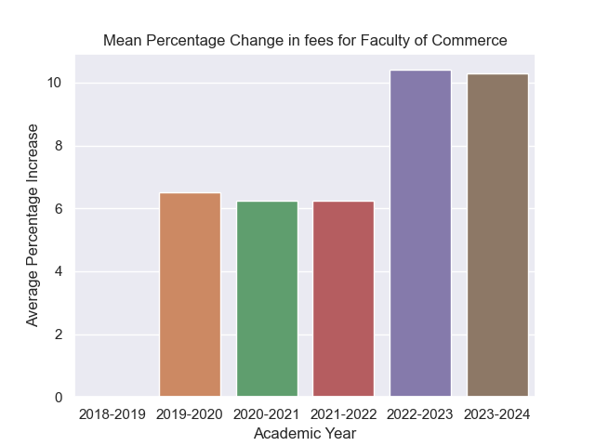

## **Average Rate of Change Based On Standing Year**

From 2019 to 2022, the Bachelorof Commerce witnessed a consistent pattern of tuition increases. The first-year tuition rose by 10% annually, while the upper years saw a steady 5% increase each academic year. However, in the 2022-2023 academic year, there was a significant departure from this trend. The second-year tuition experienced a sudden 20% spike, deviating from the previous years. Looking ahead to the upcoming academic year, the second-year tuition increased by 10%, and the third-year tuition fluctuated by 20% compared to the previous year.

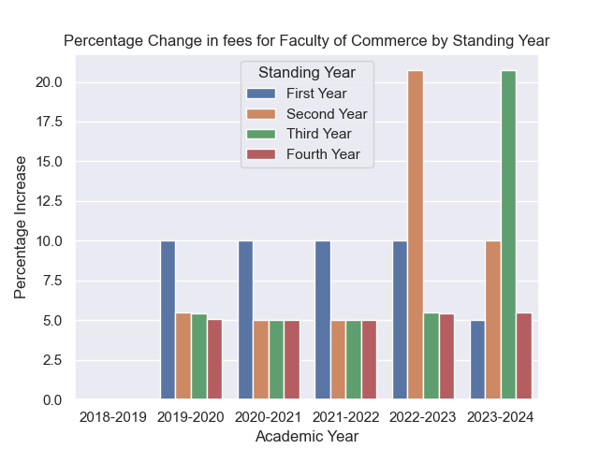

## **Average International Tuition Cost**

From 2018 to 2021, the average tuition cost for the Bachelorof Commerce started at $20,000 and gradually increased to $25,000. However, a significant change occurred after this period. The first-year tuition escalated to $30,000; subsequently, the upper years’ tuition followed suit. Each subsequent year experienced an increase, with only the fourth year remaining below $30,000. Looking ahead to the upcoming academic year, the trend continues, with the fourth-year tuition being the only standing year below $30,000.

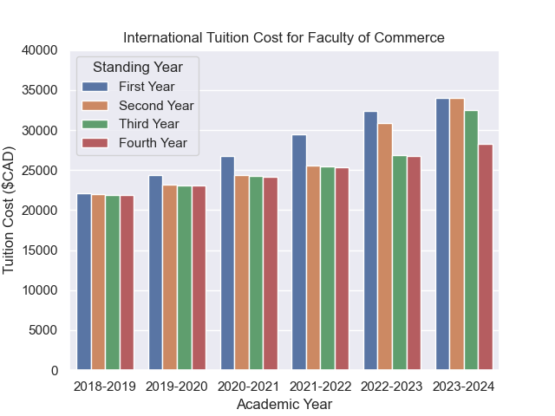

# **Bachelor of Science in Computer Science**

## **Average Rate Of Change**

For the Computer Science program, the average rate of change in tuition costs from 2019 to 2022 has been approximately 6%. This moderate increase reflected the general trend observed across the program during that period. However, starting in 2022, there was a notable deviation from this trend, with a significant 10% increase in tuition costs.

## **Average Rate of Change Based On Standing Year**

From 2019 to 2022, the Computer Science program witnessed a consistent pattern of tuition increases. The first-year tuition rose by 10% annually, while the upper years saw a steady 5% increase each academic year. However, in the 2022-2023 academic year, there was a significant departure from this trend. The first-year tuition experienced a sudden 15% increase. In comparison, the second year tuition saw an even more substantial spike of 20%, deviating from the previous years. Looking ahead to the upcoming academic year, the second year tuition increased by 15%, and the third year tuition fluctuated by 20% compared to the previous year.

## **Average International Tuition Cost**

From 2018 to 2021, the average tuition cost for the Bachelorof Commerce started at $20,000 and gradually increased to $25,000. However, a significant change occurred after this period. The first year tuition escalated to $30,000; subsequently, the upper years’ tuition followed suit. Each subsequent year experienced an increase, with only the fourth year remaining below $30,000. Looking ahead to the upcoming academic year, the trend continues, with the fourth and fifth year tuition being the only year below $30,000 and the first and second years nearing $35,000.

# **Faculty of Engineering**

## **Average Rate Of Change**

For the Faculty of Engineering, the average rate of change in tuition costs from 2019 to 2022 has been approximately 6%. This moderate increase reflected the general trend observed across the program during that period. However, starting in 2022, there was a notable deviation from this trend, with a significant 10% increase in tuition costs. There were no tuition changes in 2023-2024.

## **Average Rate of Change Based On Standing Year**

From 2019 to 2022, the Engineering program witnessed a consistent pattern of tuition increases. The first-year tuition rose by 10% annually, while the upper years saw a steady 5% increase each academic year. However, in the 2022-2023 academic year, there was a significant departure from this trend. The first-year tuition experienced a sudden 15% increase. In comparison, the second year tuition saw an even more substantial spike of 20%, deviating from the previous years. There are no changes for the upcoming academic year.

## **Average International Tuition Cost**

From 2018 to 2021, the average tuition cost for the Bachelorof Commerce started at more than $25,000. It gradually increased to $30,000, with the first year increasing to $35,000. However, a significant change occurred after this period. The first year tuition escalated to $40,000; subsequently, the upper years’ tuition followed suit. The second year rose to $35,000, and the upper years exceeded $30,000.

# **Bachelor of Health Science, Science and Arts**

## **Average Rate Of Change**

For the Bachelor of Health Science, Science and Arts, the average rate of change in tuition costs from 2019 to 2022 has been approximately 6%. This moderate increase reflected the general trend observed across the program during that period. However, starting in 2022, the fees increased by more than 8%.

## **Average Rate of Change Based On Standing Year**

From 2019 to 2022, there was a consistent pattern of tuition increases. The first-year tuition rose by 10% annually, while the upper years saw a steady 5% increase each academic year. However, in the 2022-2023 academic year, there was a significant departure from this trend. The second year tuition experienced a sudden 20% increase. Looking ahead to the upcoming academic year, the second year tuition increased by 10%, and the third year tuition fluctuated by 20% compared to the previous year.

## **Average International Tuition Cost**

From 2018 to 2022, the average tuition cost started at $20,000 and gradually increased to $25,000. However, a significant change occurred after this period. The first year tuition escalated to $30,000; subsequently, the upper years’ tuition followed suit. Each subsequent year experienced an increase, with only the fourth and fifth years remaining below $30,000.

# **Faculty of Information Technology**

## **Average Rate of Change**

For the Faculty of Information Technology, the average rate of change in tuition costs from 2019 to 2022 has been approximately 6%. This moderate increase reflected the general trend observed across the program during that period. However, starting in 2022, there was a notable deviation from this trend, with a significant 11% increase in tuition costs.

## **Average Rate of Change Based On Standing Year**

From 2019 to 2022, the Faculty of IT witnessed a consistent pattern of tuition increases. The first-year tuition rose by 10% annually, while the upper years saw a steady 5% increase each academic year. However, in the 2022-2023 academic year, there was a significant departure from this trend. The first-year tuition experienced a sudden 15% increase. In comparison, the second year tuition saw an even more substantial spike of more than 20%, deviating from the previous years. Looking ahead to the upcoming academic year, the second year tuition increased by 15%, and the third year tuition fluctuated by 20% compared to the previous year.

## **Average International Tuition Cost**

From 2018 to 2021, the average tuition cost for the Faculty of IT started at more than $20,000. It gradually increased to $25,000, with the first year exceeding this amount. However, a significant change occurred after this period. The first year tuition escalated to $30,000; subsequently, the upper years’ tuition followed suit. Each subsequent year experienced an increase to up to more than $35,000, with only the fourth year remaining below this amount.

# **Bachelor of Science in Nursing**

## **A picture containing text, screenshot, rectangle, colorfulness Description automatically generatedAverage Rate of Change**

For the Nursing program, the average rate of change in tuition costs from 2019 to 2022 was approximately 6% (around 2% for the 2019-2020 year). This moderate increase reflected the general trend observed across the program during that period. However, starting in 2022, there was a notable deviation from this trend, with a significant 10% increase in tuition costs.

## **Average Rate of Change Based On Standing Year**

From 2019 to 2022, there was a consistent pattern of tuition increases. The first-year tuition rose by 10% annually, while the upper years saw a steady 5% increase each academic year. However, in the 2022-2023 academic year, there was a significant departure from this trend. The second year tuition experienced a sudden 20% increase. Looking ahead to the upcoming academic year, the second year tuition increased by 10%, and the third year tuition fluctuated by 20% compared to the previous year.

## **Average International Tuition Cost**

From 2018 to 2022, the average tuition cost started at $20,000 and gradually increased to $25,000. However, a significant change occurred after this period. The first year tuition escalated to $30,000; subsequently, the upper years’ tuition followed suit. Each subsequent year experienced an increase, with only the fifth year remaining below $30,000.

# **Summary Stats Sheet**

## **Average Tuition Costs Across All Faculties (In $CAD):**

|  |  |  |  |  |
| --- | --- | --- | --- | --- |
| Academic Year | First Year | Second Year | Third Year | Fourth Year |
| 2018-2019 | 22103.88 | 22057.17 | 22012.15 | 21948.13 |
| 2019-2020 | 24314.27 | 23209.07 | 23160.02 | 23112.75 |
| 2020-2021 | 26745.68 | 24369.52 | 24313.51 | 24268.37 |
| 2021-2022 | 29420.24 | 25587.98 | 25533.9 | 25481.71 |
| 2022-2023 | 33141.21 | 30891.24 | 26867.38 | 26810.58 |
| 2023-2024 | 34466.53 | 33889.6 | 31343.82 | 27942.29 |

## **Average Tuition Percentage Increase Across All Faculties from Previous Academic Years (%):**

|  |  |  |  |  |  |
| --- | --- | --- | --- | --- | --- |
| Academic Year | First Year | Second Year | Third Year | Fourth Year | Average Percentage Change |
| 2018-2019 | 0 | 0 | 0 | 0 | 0 |
| 2019-2020 | 10 | 5.22 | 5.21 | 5.31 | 6.44 |
| 2020-2021 | 10 | 5 | 4.98 | 5 | 6.25 |
| 2021-2022 | 10 | 5 | 5.02 | 5 | 6.25 |
| 2022-2023 | 12.65 | 20.73 | 5.22 | 5.21 | 10.95 |
| 2023-2024 | 4 | 9.71 | 16.66 | 4.22 | 8.65 |

## **Faculty of Commerce percentage increase from previous academic years:**

|  |  |  |  |  |  |
| --- | --- | --- | --- | --- | --- |
| Academic Year | First Year | Second Year | Third Year | Fourth Year | Average Percentage Increase |
| 2018-2019 | 0.0 | 0.0 | 0.0 | 0.0 | 0.0 |
| 2019-2020 | 9.999991 | 5.50231 | 5.401506 | 5.103566 | 6.501843 |
| 2020-2021 | 9.999967 | 4.99997 | 4.999922 | 4.999935 | 6.249948 |
| 2021-2022 | 9.999955 | 4.999967 | 4.999992 | 4.999921 | 6.249959 |
| 2022-2023 | 9.99998 | 20.72561 | 5.502309 | 5.401556 | 10.40736 |
| 2023-2024 | 4.999963 | 9.999987 | 20.72562 | 5.502357 | 10.30698 |

## **Faculty of Computer Science percentage increase from previous academic years:**

|  |  |  |  |  |  |  |
| --- | --- | --- | --- | --- | --- | --- |
| Academic Year | First Year | Second Year | Third Year | Fourth Year | Fifth Year | Average Percentage Increase |
| 2018-2019 | 0.0 | 0.0 | 0.0 | 0.0 | 0.0 | 0.0 |
| 2019-2020 | 9.999991 | 5.100066 | 5.099995 | 5.100214 | 5.002074 | 6.060468 |
| 2020-2021 | 9.99994 | 4.999959 | 4.999946 | 4.999923 | 4.999995 | 5.999953 |
| 2021-2022 | 9.999937 | 4.999923 | 4.999966 | 5 | 4.999948 | 5.999955 |
| 2022-2023 | 14.99999 | 20.72562 | 5.100108 | 5.09997 | 5.100163 | 10.20517 |
| 2023-2024 | 4.999991 | 14.99998 | 20.72556 | 5.100111 | 5.099976 | 10.18512 |

## **Faculty of Engineering percentage increase from previous academic years:**

|  |  |  |  |  |  |  |
| --- | --- | --- | --- | --- | --- | --- |
| Academic Year | First Year | Second Year | Third Year | Fourth Year | Fifth Year | Average Percentage Increase |
| 2018-2019 | 0.0 | 0.0 | 0.0 | 0.0 | 0.0 | 0.0 |
| 2019-2020 | 9.999992 | 5.100017 | 5.100023 | 6.009643 | 6.418826 | 6.5257 |
| 2020-2021 | 9.999944 | 4.999967 | 4.999967 | 4.999963 | 4.999963 | 5.999961 |
| 2021-2022 | 9.999949 | 4.999937 | 4.999955 | 4.999969 | 5 | 5.999962 |
| 2022-2023 | 14.99995 | 20.72562 | 5.100049 | 5.100052 | 6.009616 | 10.38706 |
| 2023-2024 | 0 | 0 | 0 | 0 | 0 | 0 |

## **Faculty of Health Sciences, Science, and Arts percentage increase from previous academic years:**

|  |  |  |  |  |  |  |
| --- | --- | --- | --- | --- | --- | --- |
| Academic Year | First Year | Second Year | Third Year | Fourth Year | Fifth Year | Average Percentage Increase |
| 2018-2019 | 9.99992 | 5.465169 | 5.527668 | 5.10351 | 4.998551 | 6.218964 |
| 2019-2020 | 9.999982 | 5 | 4.99999 | 4.999952 | 4.999961 | 5.999977 |
| 2020-2021 | 9.999942 | 4.999977 | 4.999927 | 4.999986 | 4.999954 | 5.999957 |
| 2021-2022 | 9.999932 | 20.72549 | 5.465249 | 5.527612 | 5.103559 | 9.364368 |
| 2022-2023 | 4.999949 | 9.999914 | 20.72551 | 5.465327 | 1.830514 | 8.604243 |
| 2023-2024 | 9.99992 | 5.465169 | 5.527668 | 5.10351 | 4.998551 | 6.218964 |

## **Faculty of Information Technology percentage increase from previous academic years:**

|  |  |  |  |  |  |
| --- | --- | --- | --- | --- | --- |
| Academic Year | First Year | Second Year | Third Year | Fourth Year | Average Percentage Increase |
| 2018-2019 | 0.0 | 0.0 | 0.0 | 0.0 | 0.0 |
| 2019-2020 | 10 | 5.101956 | 5.102055 | 5.255484 | 6.364874 |
| 2020-2021 | 9.999953 | 4.999967 | 4.99995 | 4.999934 | 6.249951 |
| 2021-2022 | 9.99995 | 4.999992 | 4.999972 | 4.999953 | 6.249967 |
| 2022-2023 | 14.99995 | 20.7255 | 5.101966 | 5.102054 | 11.48237 |
| 2023-2024 | 4.999986 | 15 | 20.72548 | 5.101953 | 11.45686 |

## **Faculty of Nursing and Health Administration percentage increase from previous academic years:**

|  |  |  |  |  |  |
| --- | --- | --- | --- | --- | --- |
| Academic Year | First Year | Second Year | Third Year | Fourth Year | Average Percentage Increase |
| 2018-2019 | 0.0 | 0.0 | 0.0 | 0.0 | 0.0 |
| 2019-2020 | 9.999961 | 5.101963 | 5.101994 | 5.10212235 | 2.07345 |
| 2020-2021 | 9.999973 | 4.999963 | 4.873361 | 4.999920222 | 6.218304 |
| 2021-2022 | 9.999927 | 4.999982 | 5.126665 | 4.997903871 | 6.281119 |
| 2022-2023 | 9.999941 | 20.72554 | 5.102032 | 5.104023183 | 10.23288 |
| 2023-2024 | 4.999936 | 9.999944 | 20.72551 | 5.101992879 | 10.20685 |