DATABRICKS AND SNOWFLAKE | CAPSTONE PROJECT 2026
RetailLens
A retail sales lakehouse pipeline built on Databricks and served through Snowflake

NAME | [Student full name]
ROLL NUMBER | [Roll number]
BATCH | DATABRICKS & SNOWFLAKE 2026
SUBMITTED TO | [Trainer / Faculty name]
DATE | [DD Month 2026]

SAMPLE REFERENCE DOCUMENT This report shows the structure, depth and tone expected in a capstone submission. The project, data and results in it are illustrative. Use it as a guide for how to write, then document your own project with your own work and your own results.

How to Use This Sample
This document is a complete example of a capstone project report for Databricks and Snowflake. It follows a 14-section structure that works for any project in this subject. Read it once from start to finish, then write your own report section by section. Your project, your data and your results must be your own.
The table below lists what each section should contain and the mistake students most often make in it. Yellow boxes marked STUDENT TIP appear inside the sample to point out what a good section does.
# | Section | What to write | Common mistake
1 | Problem Statement | Who has the problem, what exactly goes wrong, and how you will measure success. | A vague goal such as "build a good app".
2 | Objectives and Scope | 3 to 6 measurable objectives. What is in scope and what is not. | Objectives that cannot be tested.
3 | Solution and Features | What you built, described in terms of what the user can do. | Listing technologies instead of features.
4 | Tech Stack | Every tool used, what it does and why you chose it. | A list of tools with no reason.
5 | Data Design and Layers | The data your system depends on: what it holds, how it is organised and how the parts connect. | Naming tables or files without fields or relationships.
6 | System Architecture | A diagram plus a short explanation of how a request flows through it. | A diagram with no explanation.
7 | Implementation Highlights | The 2 or 3 most important pieces of logic, with a short code excerpt each. | Pasting hundreds of lines of code.
8 | Testing and Results | A table of test cases: input, expected result, actual result, status. | Showing only tests that pass.
9 | Evaluation and Metrics | Measured numbers that prove the project meets its success criteria. | Numbers with no method behind them.
10 | Screenshots | Clear, captioned screenshots of the working project. | Blurry or unlabelled images.
11 | Challenges and Learnings | Real problems you hit and exactly how you solved them. | Writing that there were no challenges.
12 | Future Improvements | 2 to 5 realistic next steps. | An unrealistic wish list.
13 | Conclusion | What you built, what you achieved against the success criteria, what you learned. | Repeating the introduction.
14 | References and Links | GitHub repository, demo link or video, and documentation you used. | A missing or private repository link.

1. Problem Statement
A retail company receives its sales data as separate CSV files. The files contain duplicate orders, missing values and inconsistent formats. Analysts clean them by hand in spreadsheets, and every analyst ends up with slightly different numbers. Reports take hours and nobody fully trusts the results.
Domain | Retail and e-commerce analytics
Users | Business analysts, data engineers and category managers
Problem | Raw sales data is dirty and scattered, cleaning is manual and there is no single source of truth.
Success Criteria | The pipeline runs end to end with no manual steps. Revenue in the final tables matches source revenue exactly. Data quality pass rate is at least 98%. Dashboard queries return in under 5 seconds.
Dataset | Olist Brazilian E-Commerce public dataset from Kaggle, about 100,000 orders across orders, items, customers, products, payments and reviews

STUDENT TIP Name your dataset, its source and its size. An examiner should know exactly what data your pipeline processed.

2. Objectives and Scope
- Ingest raw files into Databricks as Delta tables without changing them (Bronze layer).
- Clean, validate and standardise the data with PySpark (Silver layer).
- Build business-ready aggregate tables for sales, delivery and customers (Gold layer).
- Load the Gold data into Snowflake and serve it to analysts through SQL and a dashboard.
- Refresh Snowflake incrementally and automatically with Streams and Tasks.
- Control access with roles and control cost with warehouse settings.

In scope  - Batch pipeline using the medallion architecture  - Data quality checks and a quarantine table  - Snowflake serving layer with role-based access  - Dashboard for key sales KPIs | Out of scope  - Real-time streaming ingestion  - Machine learning models  - Production CI/CD deployment  - Data from live source systems

3. Solution and Features
RetailLens uses Databricks for heavy data processing and Snowflake for fast, governed analytics. Data moves through three quality layers in Databricks, is loaded into Snowflake and is refreshed automatically when new data arrives.
- Medallion architecture: Bronze holds raw data, Silver holds clean data and Gold holds business-ready tables.
- Data quality rules: null keys, duplicates, invalid dates and negative payments are checked, and failing rows go to a quarantine table.
- Delta Lake features: ACID writes, schema enforcement and time travel to inspect earlier versions.
- Orchestration: a scheduled Databricks Job runs the notebooks in order.
- Incremental refresh: Snowflake Streams detect new rows and Tasks update the analytics tables.
- Access control: analysts use a read-only role and cannot modify data.
- Cost control: an X-Small warehouse with auto-suspend after 60 seconds.

4. Tech Stack
Technology | Purpose in this project | Why it was chosen
Databricks | Notebooks and Spark compute for processing | Scales to large data and supports Python and SQL together
PySpark and Spark SQL | Cleaning, joins and aggregations | Handles large tables in parallel
Delta Lake | Storage format for all layers | ACID transactions, schema enforcement and time travel
Databricks Workflows | Schedules and orders the pipeline steps | Built in, no extra tool to manage
Snowflake | Serving warehouse for analysts | Separate compute and storage, simple SQL, easy access control
Streams and Tasks | Incremental refresh inside Snowflake | Processes only new data, so it is cheaper
Spark-Snowflake connector | Moves Gold tables from Databricks to Snowflake | Direct write from a DataFrame to a table
Snowsight | Dashboard and SQL worksheets | Included with Snowflake, no separate BI licence
GitHub | Version control for notebooks and SQL | History, review and backup

5. Data Design and Layers

5.1 Layers and tables
Layer | Location | What it holds | Rules applied
Bronze | retail.bronze | orders_raw, order_items_raw, customers_raw, products_raw, payments_raw | Exact copy of source plus ingestion time and source file name
Silver | retail.silver | orders, order_items, customers, products, payments, quarantine | Remove duplicates, cast types, standardise text, drop null keys, quarantine bad rows
Gold | retail.gold | daily_sales, top_categories, delivery_performance, customer_rfm | Joins and aggregations for business questions
Snowflake | RETAIL_DB | Schemas RAW, CURATED and ANALYTICS | Loaded from Gold, refreshed by Streams and Tasks

5.2 Gold tables
Table | One row per | Business question it answers
daily_sales | Day | How much revenue and how many orders did we get each day?
top_categories | Category and month | Which product categories sell best?
delivery_performance | State and month | Where are deliveries late and by how many days?
customer_rfm | Customer | Who are our most recent, frequent and high-value customers?

STUDENT TIP Describe each table by its grain (what one row means) and the question it answers. This shows you designed the data for a purpose.

6. System Architecture
Raw files land in cloud storage and are read into the Bronze layer. Databricks notebooks move the data through Silver and Gold, and a connector loads the Gold tables into Snowflake. Inside Snowflake, Streams and Tasks keep the analytics tables up to date.
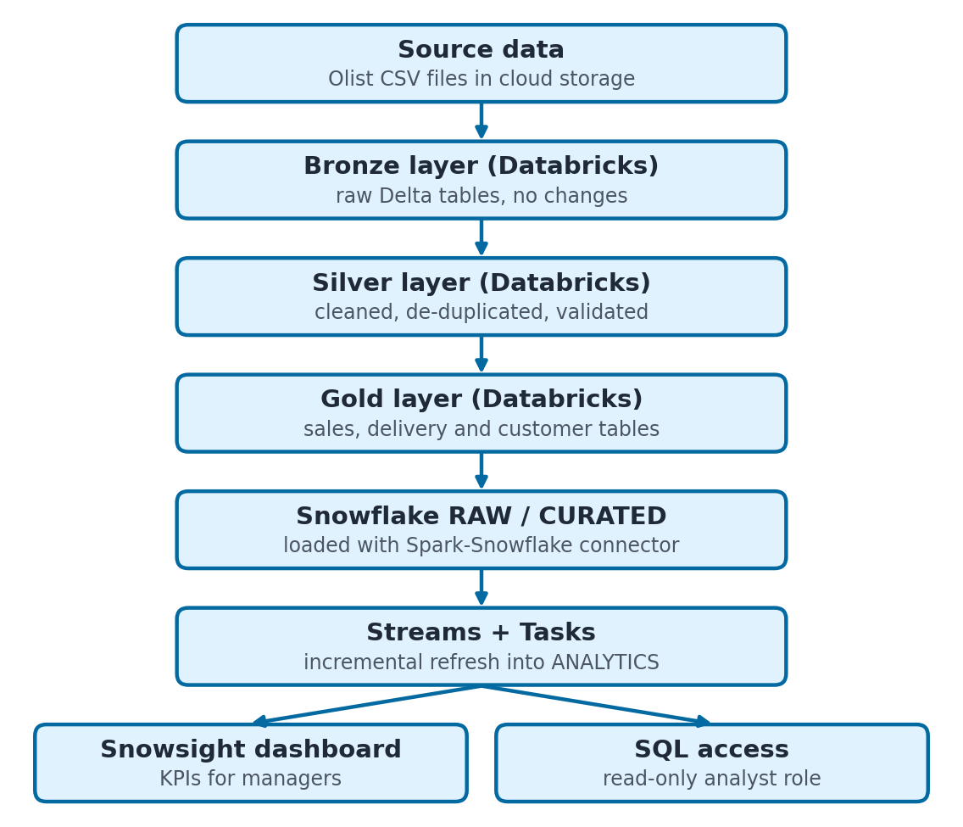
Figure 6.1: RetailLens end-to-end data flow

NOTE If your Databricks workspace blocks outbound connections to Snowflake, export the Gold tables as Parquet or CSV to a Snowflake stage and load them with COPY INTO. Document the route you actually used.

7. Implementation Highlights

7.1 Silver layer cleaning with PySpark
The Silver notebook reads a Bronze table, removes rows with missing keys, drops duplicate orders, converts text to proper timestamps and saves the result as a Delta table.
//Write your code here

7.2 Loading Gold data into Snowflake
Credentials are read from a Databricks secret scope. They are never typed into a notebook or committed to GitHub.
//Write your code here

7.3 Incremental refresh with a Stream and a Task
A stream records new rows added to the raw orders table. A scheduled task runs only when the stream has data, and merges the new revenue into the analytics table. A task must be resumed with ALTER TASK ... RESUME before it starts running.
//write your code

8. Testing and Results
NOTE The results below are illustrative. In your own report, replace every row with checks you actually ran and results you actually observed.
# | Check | Method | Expected | Result
1 | Bronze row count equals source file rows | Count in both places | Equal | PASS
2 | No duplicate order_id in Silver | GROUP BY with HAVING count > 1 | 0 rows | FAIL, then PASS after fix
3 | No null order_id or customer_id in Silver | Filter on nulls | 0 rows | PASS
4 | Delivery date before purchase date is quarantined | Rule check | Rows moved to quarantine | PASS
5 | Gold revenue equals source revenue | Compare SUM of both | Difference is 0 | PASS
6 | Gold rows equal Snowflake rows | Count in both systems | Equal | PASS
7 | Re-running the job creates no duplicates | Run the job twice | Same counts | PASS
8 | New rows reach the analytics table | Insert rows, wait for the task | daily_sales updated | PASS
9 | Analyst role tries to delete data | Run DELETE as ANALYST_ROLE | Permission denied | PASS
10 | Dashboard query speed | Timed in Snowsight | Under 5 seconds | PASS (2.1 s)

Summary: all 10 checks passed after one fix. Check 2 failed at first because the job was appended to the table on every run. It was fixed by overwriting the Silver table and using MERGE for incremental loads.

9. Evaluation and Metrics

9.1 Data quality results
Rule | Rows checked | Rows failed | Pass rate
Key columns are not null | 99,441 | 0 | 100%
order_id is unique | 99,441 | 0 | 100%
Delivery date is after purchase date | 99,441 | 1,342 | 98.65%
Payment value is positive | 103,886 | 9 | 99.99%

9.2 Performance and cost
Measure | Result | Target
Databricks job runtime (Bronze to Gold) | 6 min 40 s | Under 10 min
Load into Snowflake | 45 s | Under 2 min
Dashboard query time | 2.1 s | Under 5 s
Warehouse size and auto-suspend | X-Small, 60 s | Smallest that works
Snowflake credits used in the project | 3.2 | Within the trial credits

STUDENT TIP Data engineering reports are judged on trust and cost. Show how you proved the numbers are correct and how you kept the compute bill low.

10. Screenshots
[ Insert screenshot here ]  Figure 10.1: Databricks notebook with a successful Silver run | [ Insert screenshot here ]  Figure 10.2: Databricks Job run showing all tasks green
[ Insert screenshot here ]  Figure 10.3: Delta table history that demonstrates time travel | [ Insert screenshot here ]  Figure 10.4: Snowflake worksheet with row counts per schema
[ Insert screenshot here ]  Figure 10.5: Snowflake Stream and Task definitions | [ Insert screenshot here ]  Figure 10.6: Snowsight dashboard with the sales KPIs

11. Challenges and Learnings
Challenge | How it was solved
Dates were read as plain text and sorted wrongly | Defined an explicit schema and converted with to_timestamp
Duplicates appeared after re-running the job | Used overwrite for full loads and MERGE on business keys for incremental loads
The connector failed to authenticate | Checked the account URL format and stored credentials in a secret scope
Snowflake credits were used faster than planned | Switched to an X-Small warehouse with a 60-second auto-suspend

Key learning: a pipeline is only useful if its numbers can be trusted. Reconciliation checks between every layer are as important as the transformations.

12. Future Improvements
- Streaming ingestion: use Auto Loader so new files are picked up as soon as they arrive.
- Governance: add Unity Catalog permissions and data lineage.
- Automated testing and deployment: version the pipeline with Databricks Asset Bundles and GitHub Actions.
- Forecasting: train a demand forecast on the Gold tables and serve it from Snowflake.

13. Conclusion
RetailLens turned messy CSV files into trusted, analyst-ready data using a Databricks medallion pipeline and a Snowflake serving layer. It reached a 98.65% or higher pass rate on every quality rule, reconciled revenue exactly, and answered dashboard queries in 2.1 seconds. The project gave hands-on experience with Delta Lake, PySpark, warehouse design, Streams and Tasks, and cost control.

14. References and Links
Item | Details
GitHub repository | https://github.com/[username]/retaillens (notebooks and SQL scripts)
Dataset | Olist Brazilian E-Commerce Public Dataset, Kaggle
Demo video | [link to a 2 to 3 minute screen recording]
Documentation used | Databricks docs (Delta Lake, Workflows), Snowflake docs (Streams, Tasks, COPY INTO), Spark-Snowflake connector docs

Student Submission Checklist
Tick every item before you submit. If you cannot tick one, fix it first.
- Cover page is complete: name, roll number, batch, trainer and date.
- Problem statement names a real user and includes a testable success criterion.
- Every objective in Section 2 is answered by a result in Section 8 or 9.
- Architecture diagram is included and every box in it is explained.
- Code excerpts are short, correct and explained in plain words.
- Test table includes at least 2 failure or edge cases, not only happy paths.
- All numbers in the report come from your own project. Nothing is copied from this sample.
- Screenshots are sharp, cropped and captioned.
- GitHub repository is public or shared with your trainer and contains a README with run steps.
- No passwords, API keys or tokens appear in the report or in the repository.
- Spelling and title are proofread, including the project name on the cover.
- File is exported to PDF and named PROJECTNAME - ROLLNO - NAME.pdf.

Formatting guidelines
- Paper size A4. Font Calibri or Arial, 11 pt for body text. Headings numbered exactly as in this sample.
- Length: 8 to 12 pages including screenshots. Quality matters more than length.
- Write in your own words in clear, short sentences. Explain what you did and why.
- Number every figure and table, and give every screenshot a caption.
- Submit as a PDF. Keep the editable Word file and the source code repository as backup.

Suggested marking scheme
Your trainer may adjust these weights. Use them to see where marks are earned.
Criteria | Marks | What earns full marks
Problem definition and scope | 10 | Clear user, clear problem, measurable success criteria
Design and architecture | 15 | Sensible structure, diagram, data or schema design
Implementation and code quality | 30 | Working features, clean code, correct use of the tools
Testing and evaluation | 15 | Test coverage of normal, edge and failure cases; measured results
Documentation quality | 30 | Follows this structure, clear writing, proofread
Total | 100

