Full Stack Assignment-1
A.Y 2025-26
NAME : SIDDHARTH PRAKASH BHADAWALE
ROLL NO : 2501016 DIV : A
Q1.
import os from 'os';
console.log("OS Type", os.type());
console.log("Platform", os.platform());
console.log("CPU Architecture", os.arch());
console.log("Hostname", os.hostname());
console.log("Total Memory", os.totalmem());
console.log("Free Memory", os.freemem());
let uptimeSeconds= os.uptime();
const hours = Math.floor(uptimeSeconds / 3600);
const minutes = Math.floor((uptimeSeconds % 3600) / 60);
const seconds = Math.floor(uptimeSeconds % 60);
console.log("System Uptime: " + hours + "h " + minutes + "m " + seconds + "s");

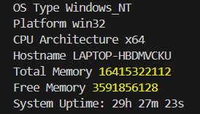

Q2.
import path from 'path';
import { fileURLToPath } from 'url';
const __filename = fileURLToPath(import.meta.url);
const __dirname = path.dirname(__filename);
console.log("Current File Name:", path.basename(__filename));
console.log("Current Directory Name:", __dirname);
console.log("File Extension:", path.extname(__filename));
const newFilePath = path.join(__dirname, 'folder', 'example.txt');
console.log("New File Path using path.join():", newFilePath);
const normalizedPath = path.normalize('/users/demo/../docs/file.txt');
console.log("Normalized Path:", normalizedPath);
const absolutePath = path.resolve('data', 'info.txt');
console.log("Absolute Path using path.resolve():", absolutePath);

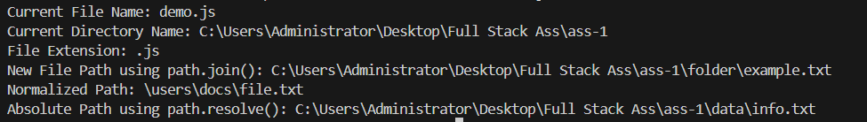

Q3.
import colors from 'colors';
console.log(colors.green.bgWhite("Welcome to IMCC"));
console.log("\n===== Custom Theme Demonstration =====\n");
colors.setTheme({
value: 'cyan',
success: 'green',
warning: 'magenta',
error: ['red', 'bold'],
note: ['white', 'underline'],
title: ['white', 'bgBlue']
});
console.log("Value: 500".value);
console.log("Data saved successfully!".success);
console.log("Warning: Low disk space".warning);
console.log("Error: Unable to connect to server".error);
console.log("Note: Submit assignment before deadline".note);
console.log("SYSTEM STATUS".title);

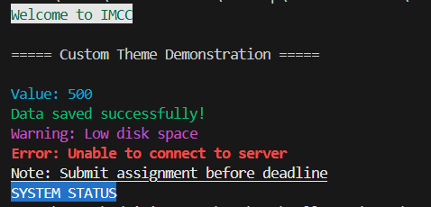

Q4.
import fs from 'fs';
try {
const filePath = 'myfile.txt';
if (!fs.existsSync(filePath)) {
fs.writeFileSync(filePath, "Welcome to IMCC!\nFull Stack Development 2026.");
}
const data = fs.readFileSync(filePath, 'utf8');
const characters = data.length;
const words = data.trim().split(/\s+/).length;
const lines = data.split('\n').length;
const vowels = (data.match(/[aeiou]/gi) || []).length;
const consonants = (data.match(/[bcdfghjklmnpqrstvwxyz]/gi) || []).length;
const digits = (data.match(/[0-9]/g) || []).length;
const specialChars = (data.match(/[^a-zA-Z0-9\s]/g) || []).length;
console.log("Characters:", characters);
console.log("Words:", words);
console.log("Lines:", lines);
console.log("Vowels:", vowels);
console.log("Consonants:", consonants);
console.log("Digits:", digits);
console.log("Special Characters:", specialChars);
} catch (err) {
console.error("Error:", err.message);
}
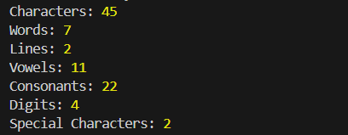

Q5.
import XLSX from 'xlsx';
try {
const studentData = [
{ Name: "Amit", Age: 20, Weight: 65 },
{ Name: "Riya", Age: 22, Weight: 55 }
];
const ws = XLSX.utils.json_to_sheet(studentData);
const wb = XLSX.utils.book_new();
XLSX.utils.book_append_sheet(wb, ws, "Students");
XLSX.writeFile(wb, "student.xlsx");
console.log("student.xlsx created.");
const readWb = XLSX.readFile("student.xlsx");
const readWs = readWb.Sheets["Students"];
const jsonData = XLSX.utils.sheet_to_json(readWs);
console.log("Excel Data in JSON:");
console.log(jsonData);
} catch (err) {
console.error("Error:", err.message);
}
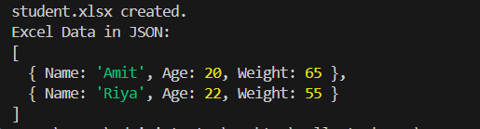

Q6.
import fs from 'fs';
try {
const empData = [
{ Name: "Raj", Email: "raj@gmail.com", JobProfile: "Developer" },
{ Name: "Sneha", Email: "sneha@gmail.com", JobProfile: "Designer" }
];
fs.writeFileSync('empdata.json', JSON.stringify(empData, null, 2));
console.log("empdata.json created.");
const data = fs.readFileSync('empdata.json');
const parsedData = JSON.parse(data);
console.log("Employee Data:");
console.log(parsedData);
} catch (err) {
console.error("Error:", err.message);
}
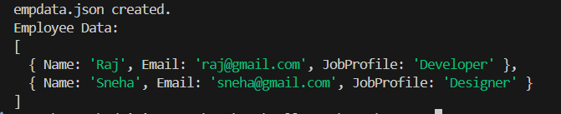

Q7.
import http from 'http';
try {
const server = http.createServer((req, res) => {
res.writeHead(200, { 'Content-Type': 'text/plain' });
res.write("Welcome to Node.js HTTP Server!");
res.end();
});
server.listen(3000, () => {
console.log("Server running at http://localhost:3000");
});
} catch (err) {
console.error("Server Error:", err.message);
}

Q8.
import EventEmitter from 'events';
class Order extends EventEmitter {}
const order = new Order();
function orderReceived() {
console.log("Order received.");
}
function paymentConfirmed() {
console.log("Payment confirmed.");
}
function orderDispatched() {
console.log("Order dispatched.");
}
try {
order.on("orderProcess", orderReceived);
order.on("orderProcess", paymentConfirmed);
order.on("orderProcess", orderDispatched);
console.log("\nFirst Emit:");
order.emit("orderProcess");
order.removeListener("orderProcess", paymentConfirmed);
console.log("\nAfter Removing Payment Listener:");
order.emit("orderProcess");
} catch (err) {
console.error("Error:", err.message);
}
