SALES ANALYSIS OVERVIEW
SUPERSTORE SALES PERFORMANCE DASHBOARD
Retail Sales & Profitability Analytics in Power BI
Project Documentation
Prepared as a Data Analytics Portfolio Project
Tool: Microsoft Power BI Desktop
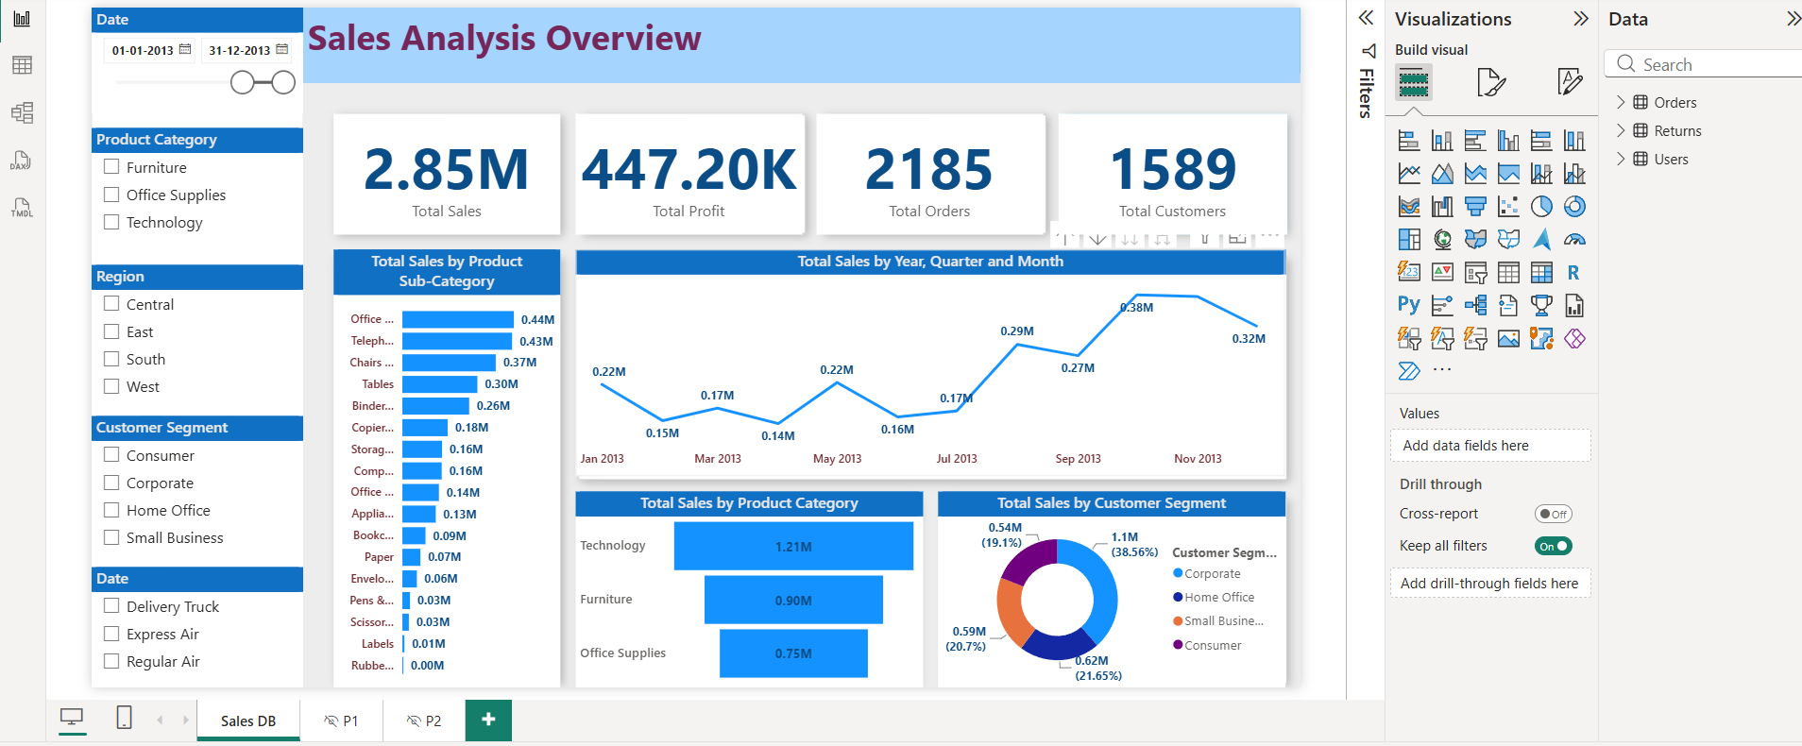

1. Project Overview
This project uses the well-known Sales Superstore dataset — a retail transactions dataset covering orders, products, customers, and shipping — to build an interactive Power BI sales performance dashboard. It tracks total sales, profit, order volume, and customer counts, and breaks performance down by product category, sub-category, customer segment, and time period.
The dashboard is built as a multi-page report: a summary landing page ("Sales DB") plus two supporting pages ("P1" and "P2") that are wired up as drill-through targets, allowing a user to click into a specific metric (e.g., Total Profit) from the summary page and land on a more detailed breakdown.

2. Business Objective
The dashboard was built to help a sales or merchandising team answer:
- What are our total sales, profit, order volume, and customer count for the selected period?
- Which product categories and sub-categories generate the most (and least) sales?
- How does sales performance trend across the year, by quarter and month?
- How is revenue distributed across customer segments (Corporate, Home Office, Consumer, Small Business)?
- How do sales vary by region and by shipping method?
- Where should the business focus to grow high-margin categories and shed low-performing sub-categories?

3. Dataset Description
The dashboard is built on the Sales Superstore dataset, a standard retail analytics training dataset. Based on the fields available in the data model, the underlying tables include an Orders/Sales fact table, a Returns table (linked by Order ID), and supporting fields for products, customers, geography, and shipping:
Field | Description
Order ID / Row ID | Unique identifiers for each order line item
Order Priority | Priority level assigned to the order (e.g., High, Medium, Critical)
Product Name / Category / Sub-Category | Product hierarchy used to group sales performance
Product Container / Base Margin | Packaging and margin attributes of each product
Region / State or Province / Postal Code | Geographic dimensions for location-based analysis
Customer Segment | Customer type: Corporate, Home Office, Consumer, Small Business
Sales / Profit / Quantity Ordered / Unit Price | Core transactional measures
Shipping Cost / Ship Mode / Ship Date | Fulfillment details (e.g., Regular Air, Express Air, Delivery Truck)
Returns (Order ID) | A related table flagging which orders were returned, joined to the fact table by Order ID
Note: exact table boundaries (e.g., whether Returns is a separate table or a flag column) should be confirmed against your Power BI model view — this summary reflects the fields visible in the field list.

4. Tools & Skills Demonstrated
Area | Details
BI Tool | Microsoft Power BI Desktop
Data Modeling | Multi-table model (Orders/Sales fact table + related Returns table) joined by Order ID
DAX | Aggregation measures for sales, profit, order count, and distinct customer count
Visuals Used | KPI cards, horizontal bar charts, line/trend chart, donut chart, slicers
Interactivity | Multi-select slicers (Date range, Product Category, Region, Customer Segment, Ship Mode) with cross-filtering
Navigation | Drill-through configured on a measure (Total Profit) routing to detail pages P1 and P2
Design | Clean card-based KPI layout with a consistent blue corporate theme

5. Data Model
The model is structured to support category, segment, geographic, and time-based analysis:
- Fact table: Orders / Sales — one row per order line, holding Sales, Profit, Quantity Ordered, Unit Price, Shipping Cost, and the product/customer/region keys.
- Returns table: linked to the fact table via Order ID, used to identify and (optionally) exclude or flag returned orders.
- Date table: an implicit or standalone date hierarchy (Year → Quarter → Month) drives the "Total Sales by Year, Quarter and Month" trend line and the report-level date slicer.
- Geography and product hierarchies (Region → State/Province → Postal Code; Product Category → Sub-Category → Product Name) support drill-down style filtering via slicers.

6. Key Measures
The KPI cards and visuals are driven by core aggregation measures:
Measure | Purpose
Total Sales | SUM of Sales across all order lines in the current filter context
Total Profit | SUM of Profit across all order lines
Total Orders | Distinct count of Order ID / Row ID — total number of orders placed
Total Customers | Distinct count of customers — unique customers served in the period
Additional supporting fields available in the model (Quantity Ordered, Unit Price, Shipping Cost) can be extended into measures such as Average Order Value, Profit Margin %, or Average Shipping Cost.

7. Dashboard Pages

Page 1 — Sales DB (Landing Page)
The main overview page gives a full sales performance snapshot for the selected date range and filters:
- KPI strip: Total Sales (2.85M), Total Profit (447.20K), Total Orders (2,185), Total Customers (1,589).
- Total Sales by Product Sub-Category (bar): ranks every sub-category from highest to lowest revenue contribution.
- Total Sales by Year, Quarter and Month (line): monthly sales trend across the selected year.
- Total Sales by Product Category (bar): high-level split across Technology, Furniture, and Office Supplies.
- Total Sales by Customer Segment (donut): revenue share across Corporate, Home Office, Small Business, and Consumer segments.
- Filter panel: Date range slider, Product Category, Region, Customer Segment, and Ship Mode (Delivery Truck, Express Air, Regular Air) slicers — all cross-filter the page simultaneously.

Pages 2 & 3 — P1 and P2 (Drill-Through Detail Pages)
Two additional pages, P1 and P2, are configured as drill-through targets — the report has "Total Profit" set as a drill-through field with "Keep all filters" enabled, so a user can right-click a value on the summary page and land on a filtered detail view without losing the current selections. These pages are intended to support deeper, row-level or metric-specific investigation (for example, order-level detail or a profit-focused breakdown) beyond the summary KPIs shown on the landing page.
Since P1 and P2 were not included in the screenshot reviewed, this section describes their configured purpose (drill-through targets) rather than their exact visual content — update this section with the specific visuals once finalized.

8. Key Insights
Based on the current view of the dashboard (Jan–Nov 2013 shown):
- Overall performance: $2.85M in total sales generated $447.2K in profit — an overall profit margin of roughly 15.7% for the period shown.
- Category mix: Technology is the leading category at $1.21M, ahead of Furniture ($0.90M) and Office Supplies ($0.75M) — despite Office Supplies containing the largest number of individual sub-categories.
- Sub-category concentration: Office Machines/Supplies, Telephones, and Chairs are the top three sub-categories (~$0.37M–$0.44M each), while Labels, Scissors, and Rubber Bands contribute negligible revenue — classic long-tail distribution.
- Segment split: Corporate is the largest customer segment at 38.6% of sales (~$1.1M), while Consumer, Small Business, and Home Office each contribute a fairly even 19–22% share.
- Seasonality: Monthly sales dip as low as ~$0.14M–0.17M in the early/mid-year months and climb sharply toward a peak of ~$0.38M around September, before easing slightly into November — suggesting a Q3 seasonal demand spike worth planning inventory and staffing around.

9. How to Use the Dashboard
- Adjust the date range slider to focus the entire report on a specific period.
- Use the Product Category, Region, Customer Segment, and Ship Mode checkboxes to slice every visual on the page at once.
- Hover over any bar, line point, or donut segment for exact values and percentages.
- Right-click a data point (e.g., a category or profit value) and choose Drill Through to jump to the P1 or P2 detail page with filters preserved; use the back arrow to return to the summary.

10. Potential Enhancements
- Add a Profit Margin % measure and surface it alongside Total Profit for a fuller profitability view.
- Add a geographic map visual (Region / State) to spot high- and low-performing markets.
- Incorporate the Returns table into a Return Rate % measure to flag problematic products or categories.
- Add Year-over-Year comparison once multiple years of data are available.
- Build a Top/Bottom 10 Products table for quick identification of best- and worst-sellers.
- Add Average Order Value and Average Shipping Cost measures using the existing Quantity Ordered and Shipping Cost fields.

11. Project Files
File
Description
Sales_Superstore_Dataset
Source retail transactions data (Orders, Returns, and related product/customer/geography fields)
Sales_Analysis_Overview.pbix
Power BI report file containing the data model, measures, and all report pages (Sales DB, P1, P2)
Project Documentation (this file)
Overview, methodology, and insights for portfolio presentation

