Experiment No. 1
Introduction to C Programming: Data Types and Operators

Aim
- To understand how to write, compile, and execute C programs.
- To study the basic structure of a C program.
- To understand output using printf() and input using scanf().
- To learn the fundamental data types, constants, and variables available in C.
- To write simple C programs using arithmetic, relational, logical, and assignment operators.

Theory

Writing, Compiling, and Running a C Program

Step 1: Writing C Code
  - Open a text editor (e.g., Notepad, or any C IDE).
  - Write the C source code.
  - Save the file with a .c extension, e.g., HelloC.c.

Step 2: Compiling the Program
Open the command prompt / terminal and navigate to the folder where the file is saved:
gcc HelloC.c -o HelloC
This step performs compilation (translating source code to object code, checking for syntax errors) and linking (combining it with library code such as printf), producing a single executable file.

Step 3: Running the Program
./HelloC (Linux / macOS)
HelloC.exe (Windows)
Note: Unlike Java, C does not require the file name to match any identifier inside the program — only the .c extension is mandatory.

First C Program: Hello World
# include <stdio .h>

int main () {
printf(" Hello World \ n"); return 0;
}

Explanation of C Program Structure
  - #include <stdio.h>: A preprocessor directive that brings in the declarations of standard input/output functions such as printf and scanf.
  - main() Function: The entry point of every C program — execution always begins here.
  - return 0;: Signals to the operating system that the program ended successfully.
int main() { ... }

Data Types, Constants, and Variables
A data type tells the compiler what kind of value a variable holds, which determines how much memory to reserve and which operations are valid on it.

Data Type | Holds | Typical Size | Format Specifier
int float double  char | Whole numbers Decimal numbers  Decimal (more precision)  A single character | 4 bytes  4 bytes  8 bytes  1 byte | %d  %f  %lf  %c

Constants vs. Variables:
  - A variable’s value can change while the program runs, e.g. int marks = 40;
  - A constant’s value is fixed for the program’s life, declared using const (e.g. const float PI = 3.14;) or #define (e.g. #define PI 3.14).

Understanding printf() and scanf()
printf("Sum = %d", sum); scanf("%d", &a);

Function | Purpose
printf()  scanf() | Displays output on the screen, using a format specifier per value  Reads a value typed by the user into a variable
Note: scanf() requires the address of the variable (using &), not the variable itself
— this is why scanf("%d", &a); uses &a, while printf("%d", a); uses plain a.

Operators in C
An operator is a symbol that tells the compiler to perform a specific operation on one or more operands.

Category | Operators | Example
Arithmetic | + - * / % | a + b, a % b
Relational | == != > < >= <= | a > b
Logical | && || ! | a > 0 && b > 0
Assignment | = += -= *= /= | x += 5;
Increment/Decrement | ++ – | i++, ++i

Points to remember:
  - a / b performs integer division when both operands are int — the decimal part is truncated, not rounded.
  - A relational expression such as a > b evaluates to 1 (true) or 0 (false) in C — there is no separate boolean type.
  - i++ (post-increment) uses the current value first, then increments; ++i (pre-increment) increments first, then uses the new value.

Sample Program: Sum of Two Numbers
# include <stdio .h>

int main () {
int a, b, sum ;

printf(" Enter first number: "); scanf("% d", & a);

printf(" Enter second number: "); scanf("% d", & b);

sum = a + b;

printf(" Sum = % d\n", sum ); return 0;
}

Laboratory Tasks

Task 1 : Different Data Types
Write a C program to declare and initialize variables of type int, float, and char (e.g., Age, Percentage, and Grade), and display all three values using printf() with the correct format specifier for each.

Task 2 : Arithmetic Operators
Write a C program that inputs two integers using scanf() and displays the result of applying all five arithmetic operators (+, -, *, /, %) on them, each on its own line.

Task 3 : Constants and Type Conversion
Write a C program that inputs the radius of a circle as a float, and calculates its area (πr²) and circumference (2πr) using a constant for π (declared with const or #define). Ensure the results are printed with two decimal places.

Additional Practice Tasks
1. Write a C program for sum of 2 numbers.
#include<stdio.h>
int main(){
int a,b,c;
printf(“Enter value of a: “);
scanf(“%d”,&a);
printf(“Enter value of b: “);
scanf(%d”,&b);
c=a+b;
printf(“Sum: %d”,c);
return0;
}
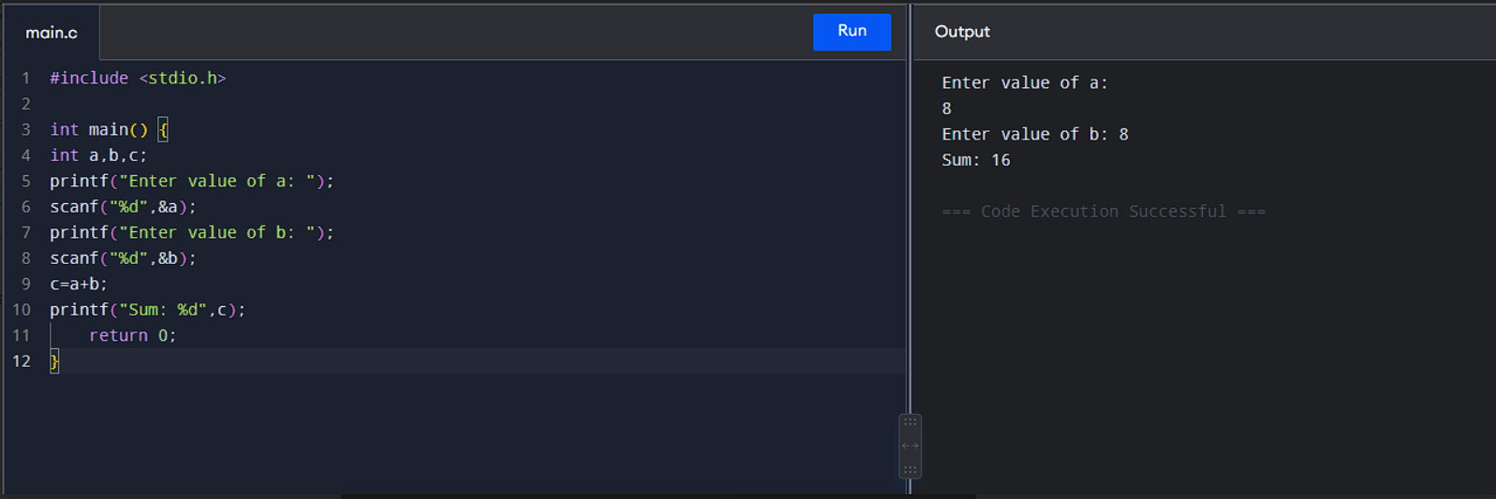

2. Write a C program to swap the values of two variables using a third (temporary) variable.
#include<stdio.h>
int main(){
int a,b,c;
printf(“Enter a,b: “);
scanf(“%d%d”,&a,&b);
c=a;
a=b;
b=c;
printf(“Swapped Number: a=%d , b=%d”,a,b);

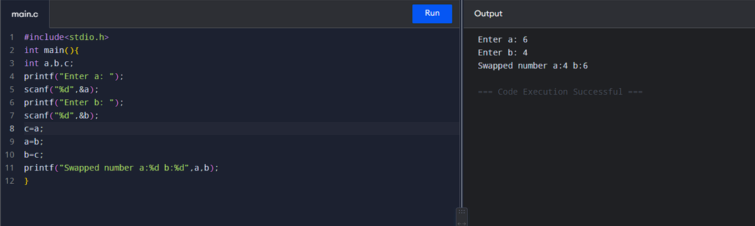

3.Write a C program to convert a temperature value from Celsius to Fahrenheit (F = (C × 9/5) + 32).
#include<stdio.h>
int main(){
float c,f;
printf(“Enter value to convert from Celsius to Fahrenheit: “);
scanf(“%d”,&c);
f=(c*9/5)+32;
printf(“Value in fahrenhiet: %.2f”,f);
return0;}
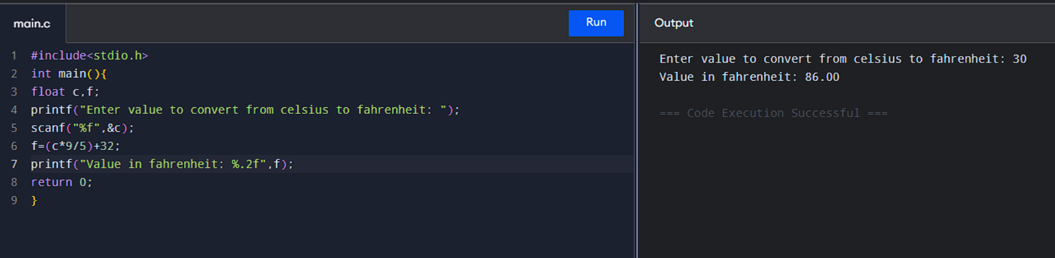

4.Write a C program to calculate simple interest, given principal, rate, and time, using a constant where appropriate

#include<stdio.h>
int main(){
int principal,time;
float rate,simple_interest;
printf(“Enter principal value: “);
scanf(“%d”,&principal);
printf(“Enter time in years: “);
scanf(“%d”,&time);
rate=7.8;
simple_interest=(principal*rate*time)/100;
printf(“Simple Interest at the rate %.2f: %.2f Rupees”,rate,simple_interest);
return0;}
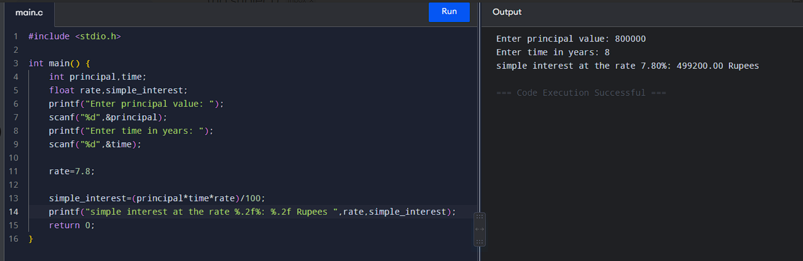5.Write a C program to find the average of three integers, expressed as a float — use explicit type casting to avoid integer division truncation.

1 #include <stdio.h>

2

3 int main() {

4 float a,b,c,avg:

5 printf("Enter value of a: ");

6 scanf("%f",&a);

7 printf("Enter value of b: "):

8 scanf("%f",&b);

9 printf("Enter value of c: "):

10 scanf("%f",&c);

11 avg=(a+b+c)/3:

12 printf("Average of a,b,c is %d", (int)avg);

13 return 0;}
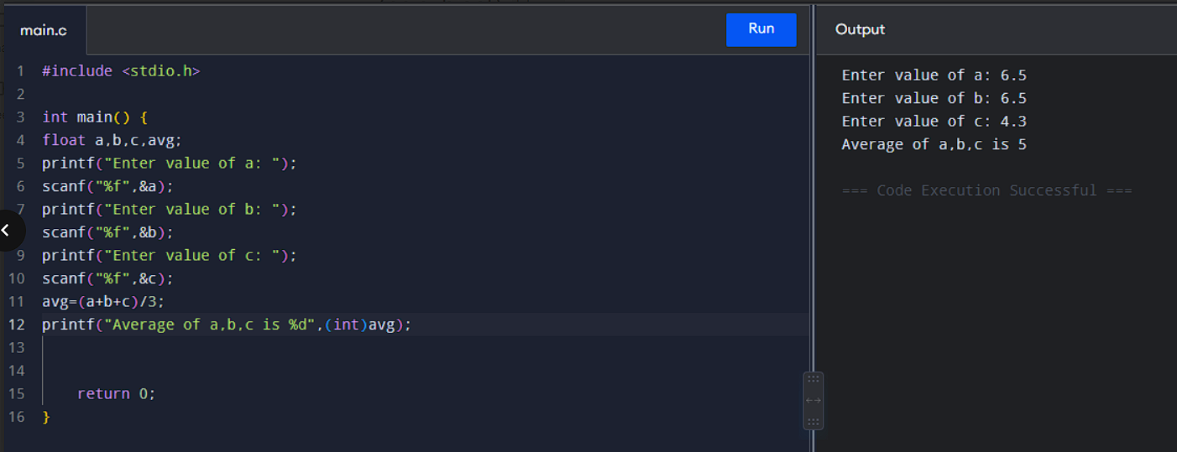

- Write a C program to demonstrate the difference between i++ and ++i by printing the results of both in separate printf() statements.

Post-Lab Questions

Conceptual Questions
- What is the difference between a compiler and an interpreter?
- Why must every variable in C be declared with a data type before it is used?
- What is the difference between a constant and a variable in C?
- What is the role of the #include directive and header files such as stdio.h?

Operator and Expression Questions
- Differentiate between the / and % operators when applied to two integers.
- Explain the difference between i++ and ++i with a suitable example.
- What is the difference between implicit and explicit type conversion? Give one example of each.
- What is operator precedence, and how does it affect the evaluation of an expression such as 10 + 2 * 3?

Basic C / Input-Output Questions
- What is the difference between printf() and scanf()?
- Why does dividing two integers in C truncate the decimal part? How can this be avoided?

Learning Outcome
After completing this experiment, students will be able to:
  - Compile and execute C programs using gcc.
  - Understand the basic structure of a C program.
  - Use printf() and scanf() effectively for input and output.
  - Declare and use variables, constants, and the fundamental C data types correctly.
  - Apply arithmetic, relational, logical, and assignment operators, and predict the type of an expression’s result.

