Experiment No. 2
Decision Making and Branching Control Structures

Aim
- To understand the concept of decision making in C programs.
- To study branching control structures: if, if-else, the else-if ladder, nested
if-else, and switch-case.
- To learn the conditional (ternary) operator as a shorthand for simple two-way de-cisions.
- To write C programs that select between alternative paths of execution based on a condition.

Theory

What is Decision Making?
A program that runs every statement once, top to bottom, is a pure sequence. Often a program must instead choose between alternative actions depending on a condition — this is called decision making or branching, and it is one of the three fundamental control structures of structured programming (along with sequence and iteration).

The if Statement (One-Way Selection)
if (condition) { statement(s); }
The block runs only if condition evaluates to non-zero (true).
Sample Program 1: Check if a Number is Positive
# include <stdio .h> int main () {
int num ;
printf(" Enter a number: "); scanf("% d", & num );

if ( num > 0) {
printf("% d is positive \ n", num );
}
return 0;
}

The if-else Statement (Two-Way Selection)

Sample Program 2: Check Even or Odd
# include <stdio .h>

int main () {
int num ;
printf(" Enter a number: "); scanf("% d", & num );
if ( num % 2 ==
printf("% d
} else {
printf("% d
}
return 0;
0)
is
{
Even \n", num );
is
Odd \ n", num );
}

The else-if Ladder (Multi-Way Selection)

Sample Program 3: Grade Calculator
# include <stdio .h>

int main () {
int marks;
printf(" Enter marks (0 -100): "); scanf("% d", & marks);

if ( marks >= 90) { printf(" Grade : A\ n");
} else if ( marks >= 75) { printf(" Grade : B\ n");
} else if ( marks >= 60) { printf(" Grade : C\ n");
} else if ( marks >= 40) { printf(" Grade : D\ n");
} else {
printf(" Grade : F\ n");
}
return 0;
}

- Nested if-else

Sample Program 4: Largest of Three Numbers
# include <stdio .h>

int main () {
int a, b, c;
printf(" Enter three numbers: "); scanf("% d % d % d", &a, &b, & c);
}

if (a > b) {
if (a > c)
printf(" Largest | = | % d\n", | a);
else
printf(" Largest | = | % d\n", | c);
} else {
if (b > c)
printf(" Largest | = | % d\n", | b);
else
printf(" Largest | = | % d\n", | c);
}
return 0;

- The switch-case Statement

Sample Program 5: Simple Calculator
# include <stdio .h>

int main () {
char op; float a, b;

printf(" Enter operator (+, -, *, /): "); scanf(" % c", & op);
printf(" Enter two numbers: "); scanf("% f % f", &a, & b);

switch ( op) {
case ’+’:
printf(" Result = %.2 f\n", a + b); break;
case ’-’:
printf(" Result = %.2 f\n", a - b);

break; case ’*’:
printf(" Result = %.2 f\n", a * b); break;
case ’/’:
if (b != 0)
printf(" Result = %.2 f\n", a / b);
else
printf(" Error: Division by zero \n"); break;
default:
printf(" Invalid operator\ n");
}
return 0;
}

The Conditional (Ternary) Operator

Sample Program 6: Maximum of Two Numbers
# include <stdio .h>

int main () {
int a, b, max;
printf(" Enter two numbers: "); scanf("% d % d", &a, & b);

max = (a > b) ? a : b; printf(" Largest = % d\n", max); return 0;
}

Points to remember:
  - The switch expression must evaluate to an integer or character type — it cannot be used directly with float or strings.
  - Without a break, execution falls through into the next case — this is a common source of bugs.
  - Nested if-else and an else-if ladder can often express the same logic; choose whichever is more readable for the problem.

Laboratory Tasks

Task 1 : Leap Year Check
Write a C program that accepts a year and determines whether it is a leap year, using the rule: a year is a leap year if it is divisible by 4, except centuries (divisible by 100), which must also be divisible by 400.
#include<stdio.h>
int main(){
int year;
printf("Enter a year to check if it is leap:");
scanf("%d",&year);
if(((year%4==0)&&(year%100!=0))||(year%400==0))
printf("%d is a leap year",year);
else
printf("%d is not a leap year",year);
return 0;
}

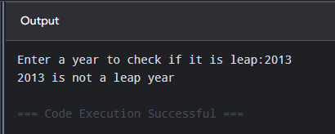

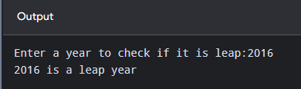

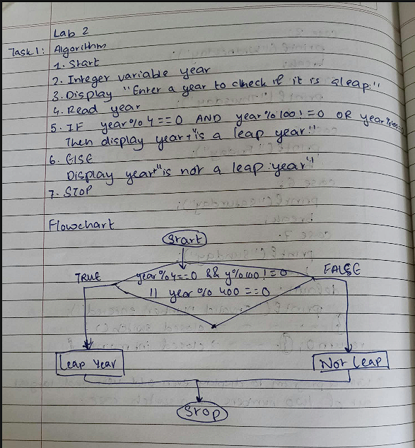

Task 2 : Vowel or Consonant
Write a C program that accepts a single alphabet character and uses a switch-case
statement to determine whether it is a vowel or a consonant.

#include<stdio.h>
int main(){
char a;
printf("Enter a alphabet: ");
scanf("%c",&a);
switch (a) {
case 'a':
printf("Alphabet is a vowel");
break;
case 'A':
printf("Alphabet is a vowel");
break;
case 'e':
printf("Alphabet is a vowel");
break;
case 'E':
printf("Alphabet is a vowel");
break;
case 'i':
printf("Alphabet is a vowel");
break;
case 'I':
printf("Alphabet is a vowel");
break;
case 'o':
printf("Alphabet is a vowel");
break;
case 'O':
printf("Alphabet is a vowel");
break;
case 'u':
printf("Alphabet is a vowel");
break;
case 'U':
printf("Alphabet is a vowel");
break;
default:
printf("Alphabet is a consonant");
}
return 0;
}
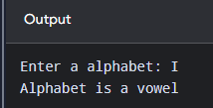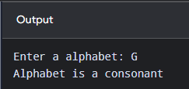
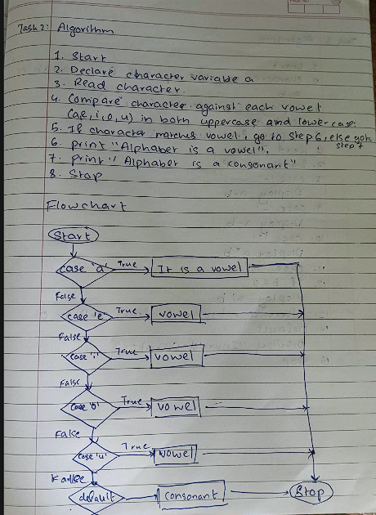

Task 3 : Menu-Driven Calculator
Write a C program that implements a menu-driven calculator using switch-case. The program should:
  - Display a menu of five operations: Addition, Subtraction, Multiplication, Division, and Modulus.
  - Accept two numbers and the user’s menu choice.
  - Perform the selected operation and display the result.
  - Handle division/modulus by zero, and any invalid menu choice, with a clear error message instead of crashing or showing a garbage result.
#include <stdio.h>
int main() {
char op;
float a,b;
printf("Enter operator (+,-,*,/):");
scanf("%c",&op);
printf("Enter two numbers");
scanf("%f%f",&a,&b);

switch (op){
case '+':
printf("Result %.2f\n",a+b);
break;
case '-':
printf("Result %.2f\n",a-b);
break;
case '*':
printf("Result %.2f\n",a*b);
break;
case '/':
if(b!=0)
printf("Result %.2f\n",a/b);
else
printf("Divident can't be 0");
break;
default:
printf("Invalid operator \n");}
return 0;
}
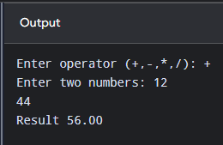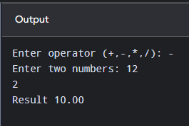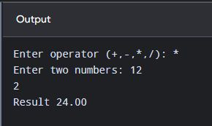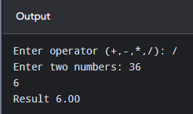
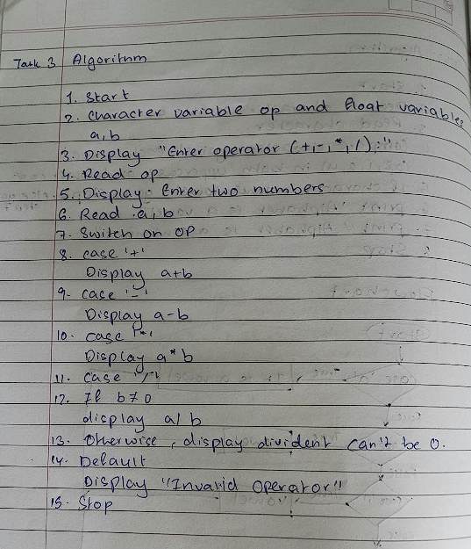

Flowchart
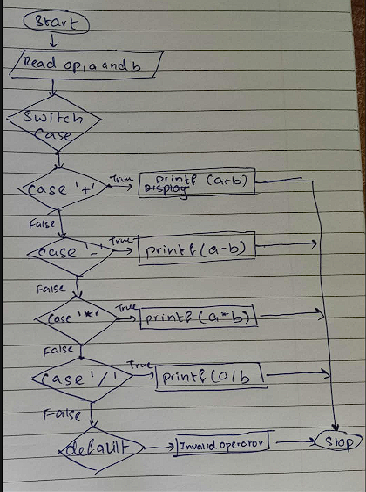

Additional Practice Tasks
- Write a C program to check whether a given number is positive, negative, or zero.
- Write a C program to find the largest of three numbers using nested if-else.
- Write a C program that accepts the three angles of a triangle and first checks whether they form a valid triangle (the angles must sum to 180◦); if valid, classify it as Equilateral, Isosceles, or Scalene.
- Write a C program to validate a 4-digit PIN entered by the user against a stored constant PIN, and print "Access Granted" or "Access Denied".
- Write a C program that accepts a day number (1–7) and prints the corresponding day name using switch-case.

Post-Lab Questions

Conceptual Questions
- What is meant by “decision making” in a program, and why is it necessary?
- What is the difference between a simple if-else and an else-if ladder?
- When would nested if-else be preferred over an else-if ladder, and vice versa?

Switch and Ternary Operator Questions
- What data types can a switch expression evaluate to in C?
- What is the purpose of the break statement inside a switch-case? What happens if it is omitted?
- What is the purpose of the default case in a switch statement?
- Rewrite the following using a single ternary expression:
if (a > b) max = a; else max = b;

Logic and Tracing Questions
- Trace the output: int x = 15; if (x % 3 == 0 && x % 5 == 0) printf("A"); else if (x % 3 == 0) printf("B"); else printf("C");
- Can a switch statement be used to test floating-point values? Why or why not?
- What is the difference between = and ==, and why is this distinction especially important inside a decision-making statement?

Learning Outcome
After completing this experiment, students will be able to:

  - Understand and apply decision-making constructs in C.
  - Differentiate between if-else, an else-if ladder, nested if-else, and
switch-case, and choose the appropriate structure for a given problem.
  - Use the ternary operator as a shorthand for simple two-way decisions.
  - Design and implement menu-driven programs with proper error handling.

