Experiment No. 5
Strings and String Handling Functions

Aim
- To understand how strings are represented internally in C.
- To learn how to declare, initialize, read, and display strings.
- To study and use the standard string handling functions: strlen(), strcpy(), strcat(), and strcmp().
- To write C programs that solve custom string problems using loops and array indexing.

Theory

What is a String in C?
A string in C is simply an array of characters, terminated by a special null character ’\0’, which marks where the string ends. This null terminator is why a string declared to hold 5 visible characters actually needs 6 bytes of storage.
char name[20]; char greeting[] = "Hi"; (stored as ’H’,’i’,’\0’)

Declaring, Initializing, and Displaying Strings

Sample Program 1: Declaring and Initializing Strings
# include <stdio .h>

int main () {
char name1 [20] = " Somaiya "; char name2 [] = " Engineering "; char name3 [20];

printf(" name1 = % s\n", name1 ); printf(" name2 = % s\n", name2 );

printf(" Enter name3 : "); scanf("% s", name3 ); printf(" name3 = % s\n", name3 ); return 0;
}

- Reading a Full Line: fgets() vs. scanf(x%sx, ...)
scanf("%s", str) stops reading at the first whitespace — it cannot read a sentence containing spaces. fgets() reads an entire line, including spaces, up to a newline or the given size limit.

Sample Program 2: Reading a Full Line with fgets()
# include <stdio .h>

int main () {
char sentence [50];

printf(" Enter a sentence : "); fgets( sentence , sizeof( sentence ), stdin );

printf(" You entered : % s", sentence ); return 0;
}

- Finding String Length: strlen()
Sample Program 3: Using strlen()
# include <stdio .h> # include <string .h>

int main () {
char str [20] = " Hello "; printf(" Length = % d\ n", strlen ( str)); return 0;
}

- Copying and Concatenating: strcpy() and strcat()
Sample Program 4: Using strcpy() and strcat()
# include <stdio .h> # include <string .h> int main () {
char first [20] = " Structured "; char second [20] = " Programming "; char result [50];
strcpy( result , first); strcat( result , second ); printf(" Result = % s\ n", result); return 0; }

- Comparing Strings: strcmp()
Sample Program 5: Using strcmp()
# include <stdio .h> # include <string .h>

int main () {
char s1 [20] = " apple "; char s2 [20] = " apple ";

if ( strcmp ( s1 , s2 ) == 0) printf(" Strings are equal\n");
else
printf(" Strings are not equal\n"); return 0;
}

Custom String Logic: Palindrome Check
Not every string problem has a ready-made library function — this example combines
strlen() with array indexing and a loop to check a property manually.

Sample Program 6: Palindrome Check
# include <stdio .h> # include <string .h> int main () {
char str [20];
int i, len , isPalindrome = 1;

printf(" Enter a string : "); scanf("% s", str);

len = strlen ( str);
for ( i = 0; i < len / 2; i++) {
if ( str[ i] != str[ len - 1 - i]) { isPalindrome = 0;
break;
}
}

if ( isPalindrome )
printf("% s is a palindrome \n", str);
else
printf("% s is not a palindrome \n", str); return 0; }

Points to remember:
  - strlen() counts only the visible characters — it does not include the null termi-nator in its result.
  - The destination array passed to strcpy() or strcat() must be large enough to hold the final result, including its null terminator, or the program’s behavior becomes unpredictable.
  - strcmp() returns 0 only when the two strings are exactly equal — any non-zero result means they differ.

Laboratory Tasks

Task 1 : String Length and Reversal
Write a C program to accept a string, display its length using strlen(), and then print the string in reverse using a loop (do not use any built-in reverse function).
#include<stdio.h>
#include<string.h>
int main(){
int i;
char str1[100];
printf("Enter string: ");
scanf("%s", &str1);
printf("Length = %d\n", strlen(str1));
printf("Reversed array = ");
for(i=strlen(str1)-1; i>=0; i--){
printf("%c", str1[i]);
}
printf("\n");
return 0;
}
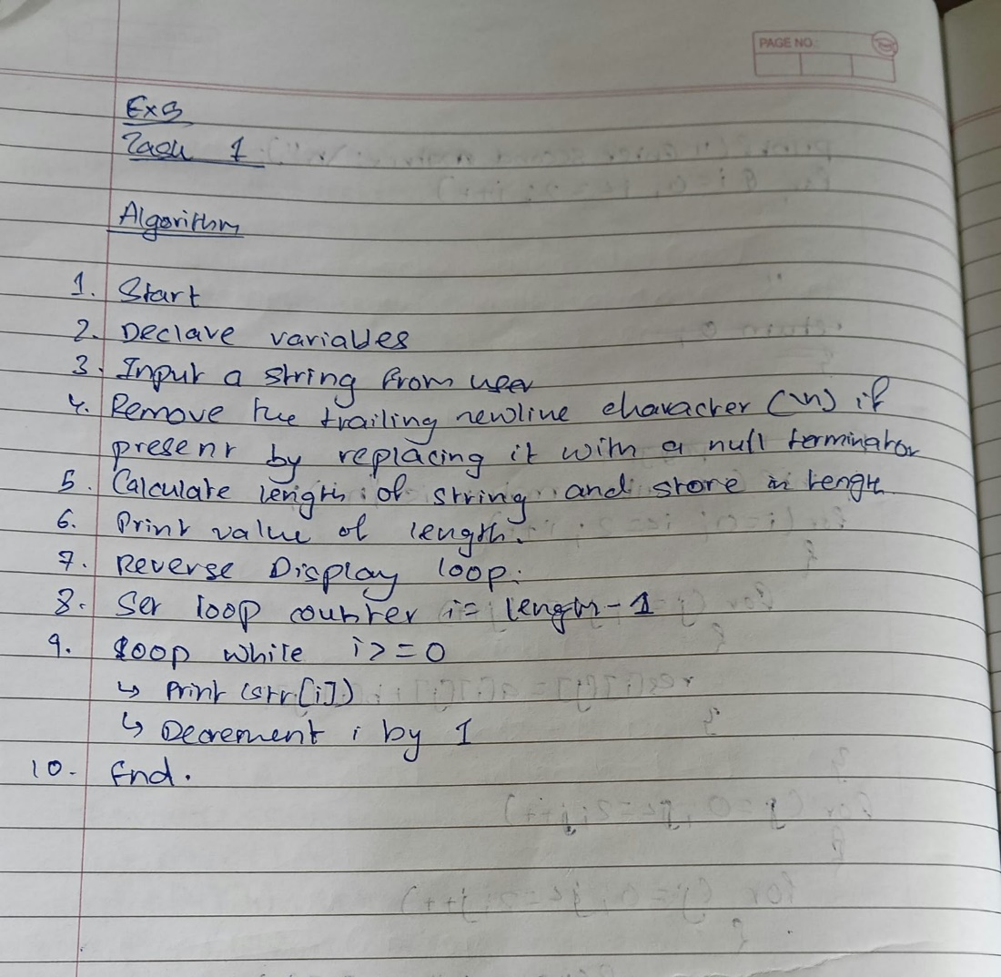
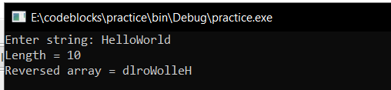

Task 2 : Concatenation and Comparison
Write a C program that accepts two strings, uses strcpy() and strcat() to combine them into a third character array, and then uses strcmp() to report whether the two original strings were equal to each other.
#include<stdio.h>
#include<string.h>
int main()
{
char s1[10],s2[10],s3[20],s4[20];
printf("Enter s1: ");
scanf("%s",s1);

printf("Enter s2: ");
scanf("%s",s2);
strcpy(s3,s1);
printf("Copied string is: ",s3);
strcat(s1,s2);
printf("%s\n",s1);

if (strcmp(s1,s2)==0)
printf("s1 and s2 are equal\n");
else
printf("s1 and s2 are not equal\n");
}
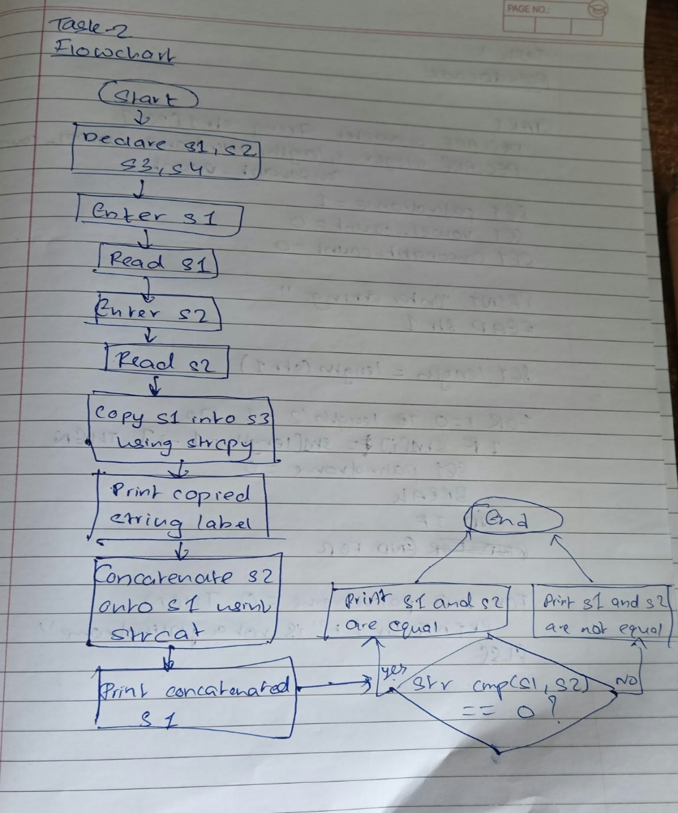
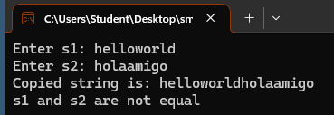

Task 3 : Palindrome and Vowel/Consonant Count
Write a C program that accepts a string and:
  - Checks whether it is a palindrome (ignoring case).
  - Counts and displays the number of vowels and consonants it contains.
#include<stdio.h>
#include<string.h>
int main(){
char s[20],s1[20];
int i,vow=0,con=0;
printf("Enter a string: ");
scanf("%s",s);
strcpy(s1,s);
strrev(s1);
if ((strcmp(s,s1))==0)
{
printf("\n%s is palindrome",s);
}
else
{
printf("\n%s is not a palindrome",s);
}
for (i=0;i<=strlen(s1)-1;i++)
{
if (s[i]=='a'||s[i]=='e'||s[i]=='i'||s[i]=='o'||s[i]=='u')
{
vow++;
}
else{
con++;
}
}
printf("\nNumber of vowels in string: %d",vow);
printf("\nNumber of consonants in string: %d",con);
return 0;
}
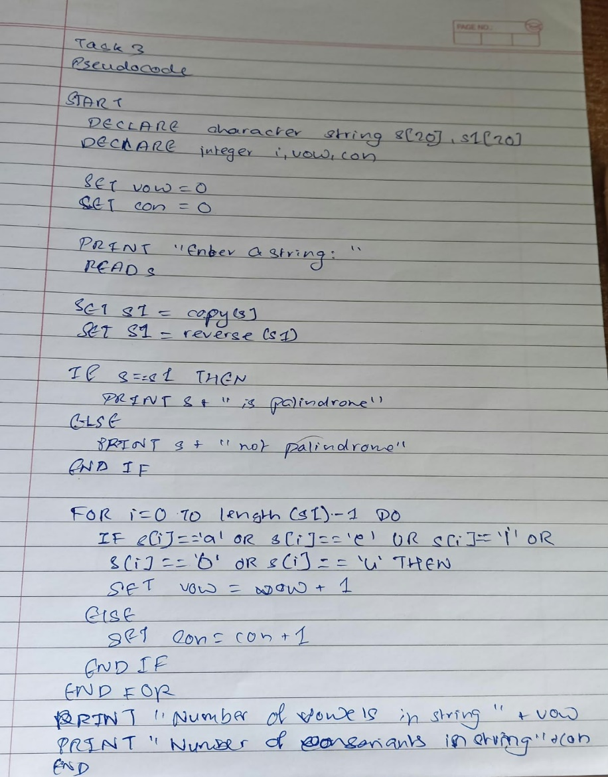
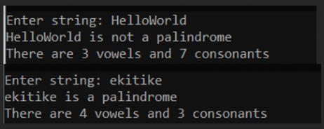

Additional Practice Tasks
- Write a C program to count the number of words in a sentence (words separated by spaces), reading the full line with fgets().
- Write a C program to count the number of times a specific character appears in a given string.
- Write a C program to convert a given string from lowercase to uppercase, without
using any built-in case-conversion function.
- Write a C program to check whether two given strings are anagrams of each other (i.e., contain exactly the same characters, just in a different order).

- Write a C program to remove all spaces from a given string and display the result.

Post-Lab Questions

Conceptual Questions
- What is the difference between a C string and a plain character array?
C String: A character array that must end with a null-terminator character ('\0'). Functions in <string.h> rely on this null character to know where the string ends.
Plain Character Array: A contiguous sequence of characters in memory that does not necessarily end with '\0'.
- Why does strlen("Hello") return 5, even though the array storing it occupies 6 bytes?
"Hello" contains 5 visible characters ('H', 'e', 'l', 'l', 'o') plus 1 hidden null-terminator ('\0') at the end, taking 6 bytes of memory total.
strlen() counts only the characters before the null terminator '\0', so it returns 5.
- Why is it risky to use scanf("%s", ...) to read a string that may contain spaces?
Using scanf("%s", ...) is risky for strings that may contain spaces because the %s format specifier stops reading at the first whitespace (space, tab, or newline). For instance, if the user inputs "Hello World", scanf will only capture "Hello". Furthermore, this format specifier does not perform bounds checking; if the user inputs a very long string, it can easily overflow the allocated buffer, leading to a crash or unexpected behavior.

String Function Questions
- What is the difference between strcpy() and strncpy()?
strcpy(dest, src): Copies the entire source string (src) into the destination buffer (dest). It does not check the size of the destination buffer, which can lead to a buffer overflow if the source string is larger than the destination array.
strncpy(dest, src, n): Copies up to n characters from the source string into the destination. If the source string is shorter than n, it pads the destination with null characters. This function is safer because it explicitly sets a maximum copy limit, helping to prevent buffer overflows.
- What could go wrong if the destination array passed to strcat() is not large enough to hold the combined result?
If the destination array passed to strcat() is not large enough to hold the combined length of the destination string and the source string, a buffer overflow occurs. The function will write past the allocated memory boundary, potentially corrupting adjacent data structures or causing a segmentation fault (crash).
- What does strcmp(s1, s2) return when s1 and s2 are exactly equal? What does a non-zero result indicate?
Identical Strings: If s1 and s2 are exactly equal (same characters in the same order), strcmp(s1, s2) returns 0.
Non-Zero Result: A non-zero result indicates the strings are different. The sign of the result shows the comparison in the "ASCII dictionary order". Generally, if the result is negative, the first character that differs in s1 has a lower ASCII value than the corresponding character in s2. If positive, the character in s1 has a higher ASCII value.

- Which header file must be included to use strlen(), strcpy(), strcat(), and
strcmp()?
The header file required to use the string manipulation functions (strlen, strcpy, strcat, strcmp) is <string.h>.

Tracing Questions
- Trace the output: char s[] = "Hello"; printf("%d", strlen(s));
5
- Trace, step by step, the index comparisons made by Sample Program 6 while check-ing whether "level" is a palindrome.
The string "level" has a length of 5.
First comparison: Index 0 containing character 'l' is compared with index 4 containing character 'l'. They match.
Second comparison: Index 1 containing character 'e' is compared with index 3 containing character 'e'. They match.
After checking index 1, the comparison loop ends because it has reached the middle of the string. Since all compared pairs of characters matched, "level" is confirmed to be a palindrome.
- Given char a[20] = "Data"; char b[] = "Structures"; strcat(a, b); what is the resulting content of a, and why must a be declared with extra space beyond just "Data"?
Resulting content of array a: DataStructures
Reason extra space is required: The function strcat appends the string stored in array b directly onto the end of array a. The combined string "DataStructures" consists of 14 characters plus 1 null-terminator character, requiring 15 bytes of space in total. Array a must be declared with enough memory capacity (such as size 20) to store all 15 characters. If array a was declared only large enough for "Data" (5 bytes), appending "Structures" would write past the boundary of the array, causing a buffer overflow that can corrupt memory or crash the program.

Learning Outcome
After completing this experiment, students will be able to:
  - Understand how strings are represented internally in C.
  - Read and display strings safely, including those containing spaces.
  - Use the standard string handling functions: strlen(), strcpy(), strcat(), and
strcmp().
  - Apply loops and array indexing to solve custom string problems such as palindrome checking.

