Experiment No. 3
Looping Control Structures

Aim
- To understand the concept of iteration (looping) in C programs.
- To study the three looping constructs: for, while, and do-while.
- To learn the use of break and continue to control loop execution.
- To write C programs using nested loops for computation and pattern-generation problems.

Theory

What is Iteration?
Iteration is the third fundamental control structure of structured programming (along with sequence and selection): it repeats a block of statements as long as a condition holds. C provides three loop constructs — for, while, and do-while — each suited to slightly different situations.

- The for Loop
for (initialization; condition; update) { statement(s); }
Best used when the number of iterations is known in advance.

Sample Program 1: Sum of First N Natural Numbers
# include <stdio .h>

int main () {
int n, i, sum = 0; printf(" Enter N: ");
scanf("% d", & n);

for ( i = 1; i <= n; i++) { sum += i;
}
printf(" Sum = % d\ n", sum ); return 0;
}

- The while Loop
while (condition) { statement(s); }
Best used when the number of iterations is not known in advance and depends on a condition evaluated at runtime.

Sample Program 2: Sum of Digits of a Number
# include <stdio .h>

int main () {
int num , digit , sum = 0; printf(" Enter a number: "); scanf("% d", & num );

while ( num != 0) { digit = num % 10; sum += digit;
num /= 10;
}
printf(" Sum of digits = % d\ n", sum ); return 0;
}

- The do-while Loop
do { statement(s); } while (condition);
Unlike for and while, the condition is checked after the body runs — so a do-while loop always executes its body at least once.

Sample Program 3: Input Validation
# include <stdio .h> int main () {
int num ;

do {
printf(" Enter a positive number: "); scanf("% d", & num );
if ( num <= 0)
printf(" Invalid input , try again .\ n");
} while ( num <= 0);

printf(" You entered : % d\ n", num ); return 0;
}

Comparing the Three Loops

Aspect | for | while | do-while
Condition checked | Before each iteration | Before each iteration | After each iteration
Minimum executions | 0 | 0 | 1 (always runs once)
Best used when | Iteration count known | Count unknown, condition-driven | Body must run at least once

Nested Loops
A loop placed inside another loop is a nested loop — the inner loop completes all its iterations for every single iteration of the outer loop. This is essential for two-dimensional patterns.

Sample Program 4: Right-Angled Triangle Pattern
# include <stdio .h>

int main () {
int i, j, rows;
printf(" Enter number of rows: "); scanf("% d", & rows);

for ( i = 1; i <= rows; i++) { for (j = 1; j <= i; j++) {
printf("* ");
}
printf("\ n");
}
return 0;
}

- The break and continue Statements
break exits the loop immediately; continue skips the rest of the current iteration and moves on to the next one.
Sample Program 5: Using continue and break
# include <stdio .h>

int main () {
int i;

printf("1 to 10 , skipping multiples of 3:\ n"); for ( i = 1; i <= 10; i++) {
if (i % 3 == 0) continue ;
printf("% d ", i);
}
printf("\ n");

printf(" First number divisible by 7 (50 -100): "); for ( i = 50; i <= 100; i++) {
if (i % 7 == 0) {
printf("% d\ n", i); break ;
}
}
return 0;
}

Points to remember:
  - A do-while loop is the natural choice for input validation and menus, since the prompt must be shown at least once before the condition can be checked.
  - Forgetting to update the loop variable (e.g., omitting i++) is one of the most com-mon causes of an infinite loop.
  - continue does not skip the loop’s update step (e.g., i++ in a for loop still runs)
— only the remaining body is skipped.

Laboratory Tasks

Task 1 : Natural Numbers and Their Sum
Write a C program to print the first N natural numbers and their sum, using a for loop.
#include <stdio.h>
int main() {
int i,n,sum=0;
printf("Enter a natural number: ");
scanf("%d",&n);
for (i=1;i<=n;i++)
{
printf("%d\n",i);
sum+=i;
}
printf("Sum: %d",sum);
return 0;
}
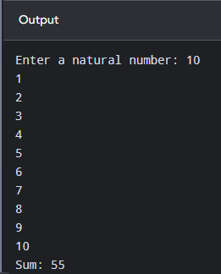
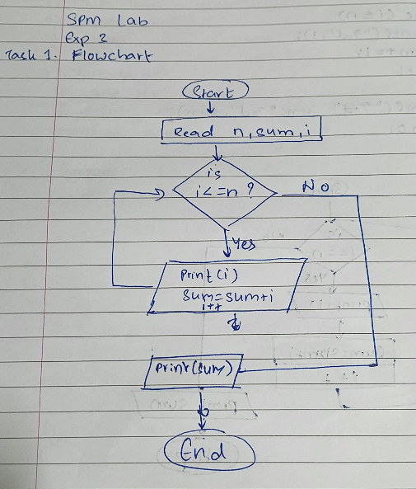

Task 2 : Prime Number Check
Write a C program that accepts a number and uses a for loop to determine whether it is prime.
#include<stdio.h>
int main() {
int n,i,rem;
printf("Enter a number: ");
scanf("%d",&n);
for (i=2;i<=n;i++){
rem = n%i;
if (rem==0 && i<n)
{
printf("Number is non prime");
}
else
{
printf("Number is prime");
}
break;
}
return 0;
}

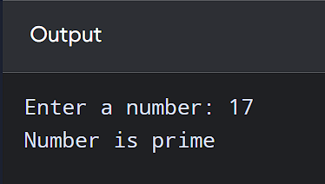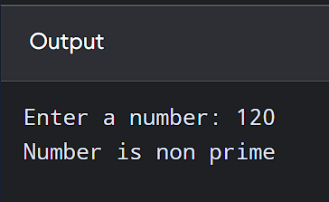
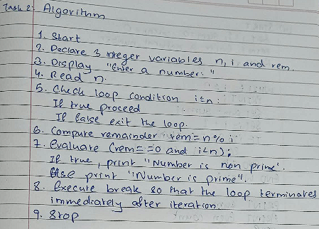

Task 3 : Fibonacci Series with Analysis
Write a C program that uses a while loop to generate the first N terms of the Fibonacci series, and additionally:
  - Displays the sum of all N terms.
#include<stdio.h>
int main(){
int i=1,f1=0,f2=1,f3;
printf("Fibonacci Series is:\n%d\n%d\n",f1,f2);
while(i<=10)
{
f3=f1+f2;
printf("%d\n",f3);
f1=f2;
f2=f3;
i++;
}
return 0;
}
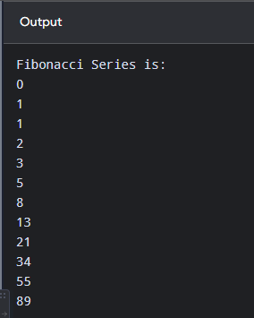

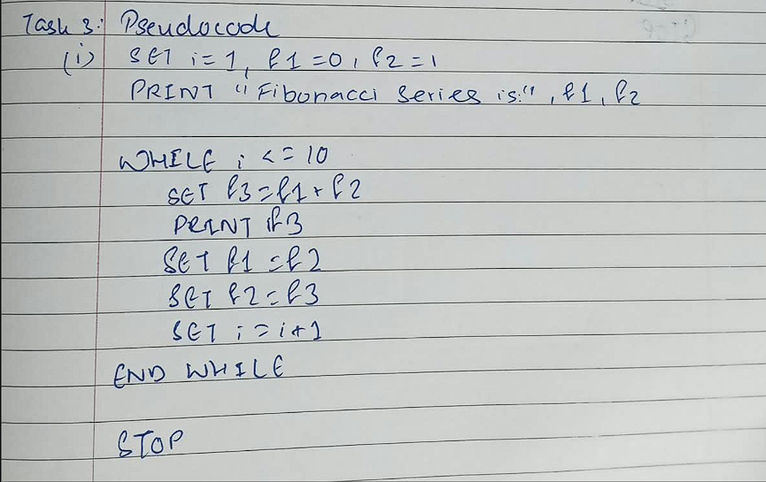
  - Counts and displays how many of those terms are even.
#include <stdio.h>

int main() {
int i=1,n,sum=0,count=0;
printf("Enter a natural number: ");
scanf("%d",&n);
while(i<=n)
{
printf("%d\n",i);
sum+=i;
i++;
if (i%2==0){
count+=1;}
}
printf("Sum: %d",sum);
printf("\nEven Count: %d",count);
return 0;}
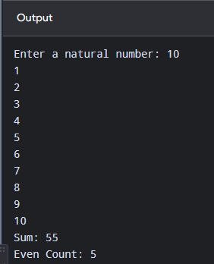

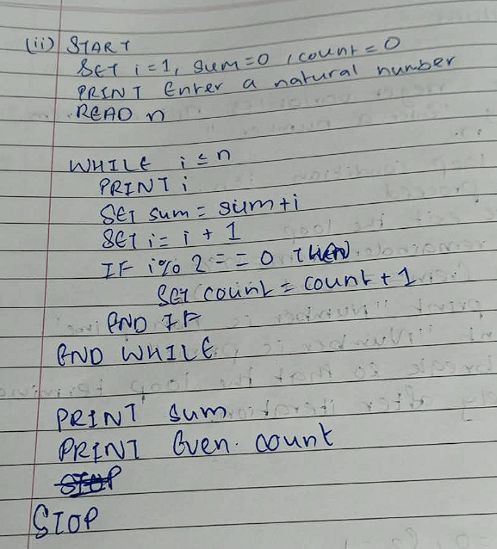

Additional Practice Tasks
- Write a C program to reverse the digits of a given number using a while loop.
- Write a C program to find the factorial of a number using a for loop.
- Write a C program to print the multiplication table (1 to 10) of a given number, using a for loop.
- Write a C program to count the number of digits in a given number using a while loop.
- Write a C program to print a right-angled triangle pattern of stars for a given number of rows, using nested for loops.

Post-Lab Questions

Conceptual Questions
- What is the difference between a for loop and a while loop, in terms of where the initialization, condition, and update are written?
The difference lies in where each element is placed within the code structure.
In a for loop, the initialization, condition, and update statement are all written together on a single line within the loop header.
In a while loop, these elements are split into three distinct locations. The initialization is written before the loop begins, the condition is placed alone in the loop header, and the update statement is written inside the loop body.

- Why does a do-while loop always execute its body at least once?

A do-while loop always executes its body at least once because it is an exit-controlled loop.
Unlike a for loop or a while loop, which test the condition at the very beginning before running any code, a do-while loop executes the statements inside its body first and checks the exit condition at the end of the iteration. Because the condition check happens after the loop body, the statements are guaranteed to run at least once, regardless of whether the condition evaluates to true or false.

- What is an infinite loop? Give one example of C code that causes one unintention-ally.
An infinite loop is a sequence of instructions in a program that executes repeatedly without ever stopping because the loop's exit condition is never satisfied or met.
A common way an infinite loop occurs unintentionally in C is when the loop control variable is modified in the wrong direction (or omitted entirely) inside the loop body, preventing the termination condition from ever becoming false.

Eg:- #include <stdio.h>
Int main() {
Int i=1;
While (i<=10)
{
Printf(“%d\n”,i);
i--;
}
Return 0;
}

Loop-Specific Questions
- What is the difference between break and continue?
- Rewrite the for loop from Sample Program 1 as an equivalent while loop.
- Why is nesting used in loops? Give one real-world pattern-printing problem that requires it.
- What happens if the update statement (e.g., i++) is accidentally left out of a for loop’s body?

Tracing Questions
- Trace the output: for (i = 1; i <= 5; i++) { if (i == 3) continue; printf("%d ", i); }
- Trace the output: int i = 1; while (i <= 3) { printf("%d ", i); i++; }
- What is the final value of sum after: int sum = 0; for (int i = 1; i <= 4; i++) sum += i;?

Learning Outcome
After completing this experiment, students will be able to:
  - Understand and apply the three looping constructs available in C.
  - Choose the appropriate loop (for/while/do-while) based on a problem’s require-ments.
  - Use break and continue to control loop execution.
  - Design and implement programs using nested loops for pattern generation and multi-level iteration.

