Course Name and Code: | Structured Programming Methodology LAB (316U06C107) | Semester: | FY SEM I
Date of Performance: | 12 / 10 / 2026 | Div and Batch No: | F-1
Faculty Name: | Prof. Jayesh Rane | Roll No: | 16010426069
Faculty Sign & Date: |  | Grade/Marks: | ___/15

Assignment No: 1

Note:
- Mention the Q. No. and the statement of the program allotted to you as per your roll number.
- Write the complete C program for each assigned question and include the corresponding output.
- Attach scanned copy of handwritten algorithm and/or flowchart for each program.

Section A — Data Types & Operators

Q. No:9. Write a program that uses the sizeof operator to display the number of bytes
occupied by each fundamental C data type (int, float, double, char), and at
least one qualified type (e.g., long int or unsigned int).
Code:
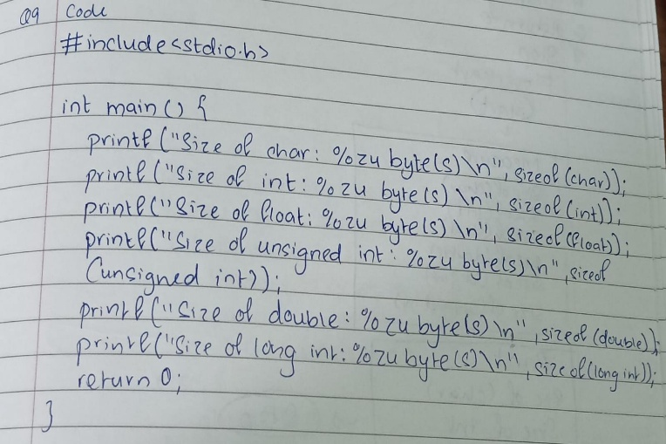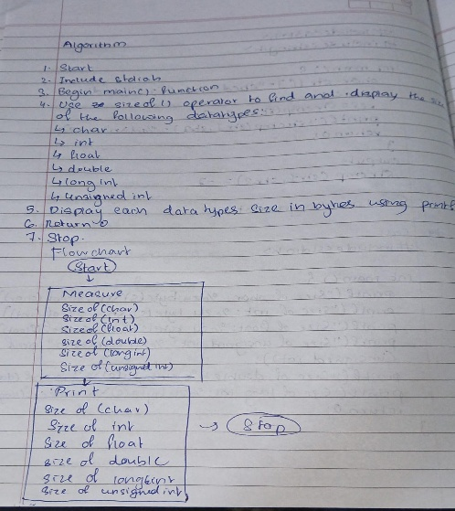
Output:
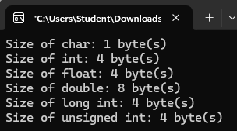

Section B — Decision Making & Branching

Q. No: 19. Write a menu-driven program (using switch-case) for a simplified ATM that lets
the user select one of: Check Balance, Deposit, or Withdraw, for a single transac-
tion. Assume a fixed starting balance. For a withdrawal, use an if-else check to
ensure the amount does not exceed the balance.
Code:
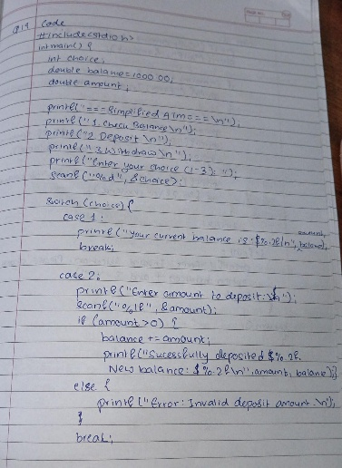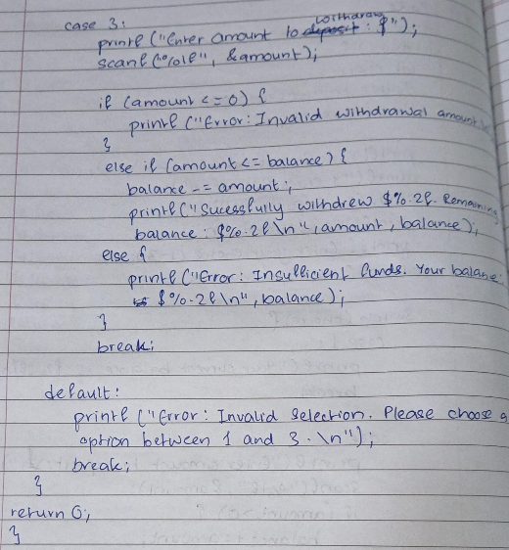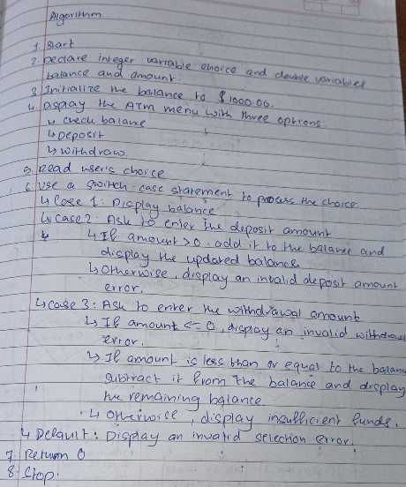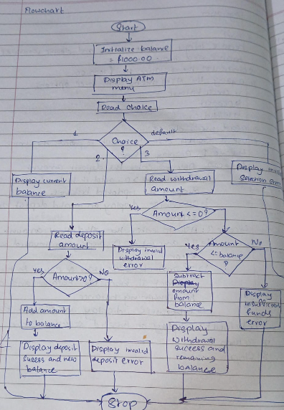
Output:
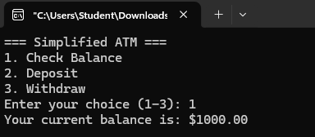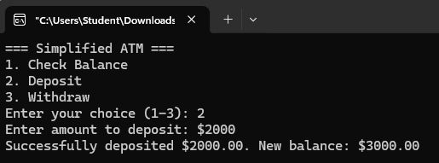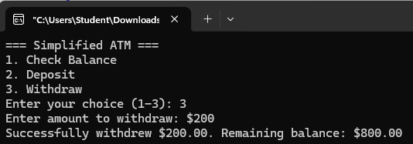

Section C — Looping Control Structures

Q. No: 29. Write a number-guessing game: the program stores a fixed secret number between
1 and 100, and the user has 7 attempts to guess it. After each guess, display "Too
High", "Too Low", or "Correct!", using a loop that ends when the number is
guessed or the attempts run out.
Code:
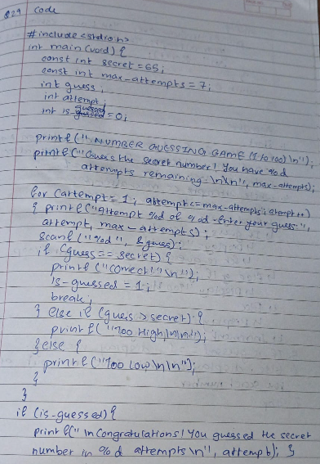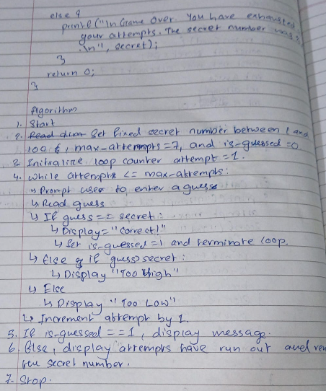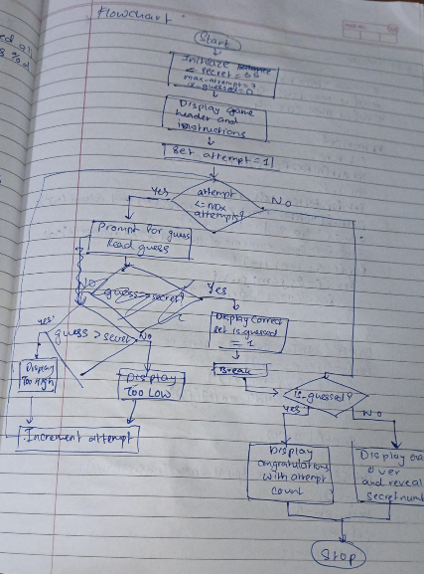

Output:
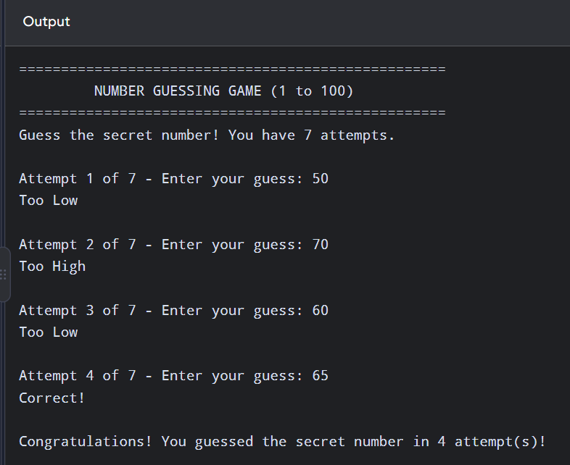

Section D — Arrays

Q. No: 39. Write a program to accept an N×M 2D array and display its elements in clockwise
spiral order.
Code:
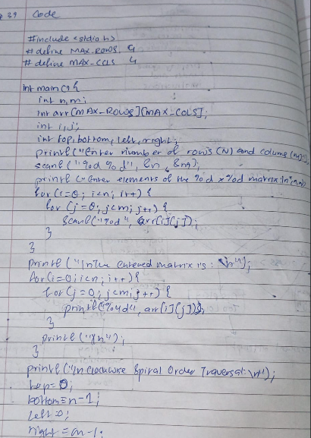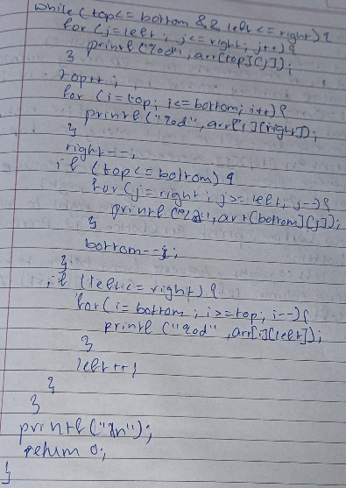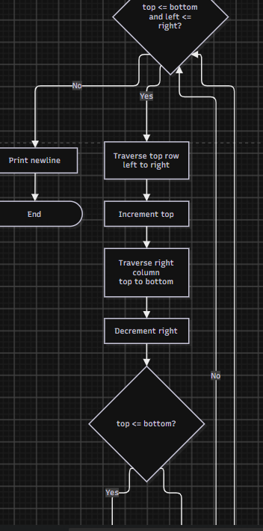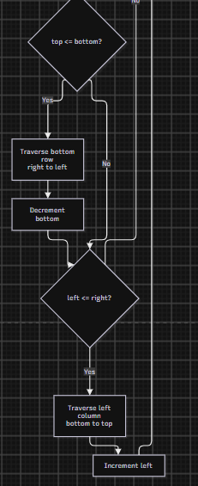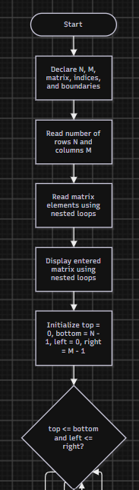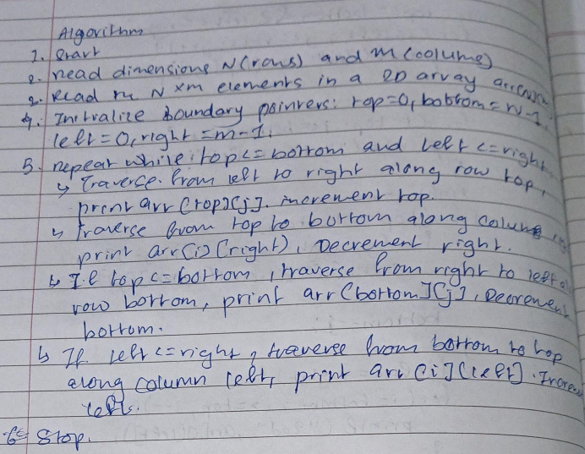
Output:
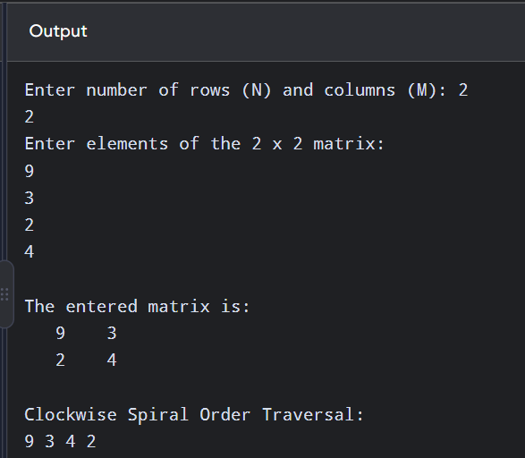

Section E — Strings & String Handling Functions

Q. No: 49. Write a program to check whether a given identifier name follows valid C naming
rules: it must start with a letter or underscore, contain only letters/digits/ under-
scores, and must not match any name in a small fixed list of C reserved keywords.
Code:
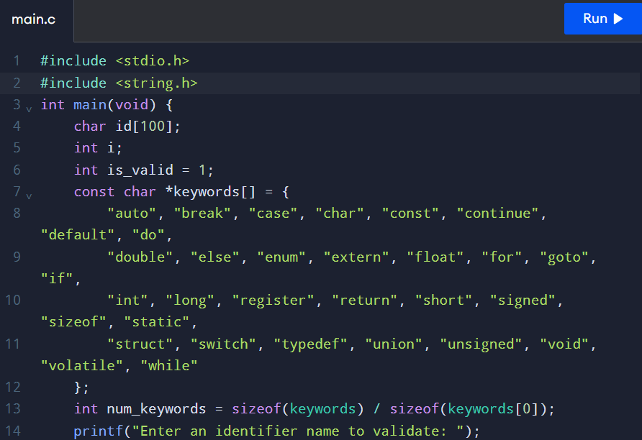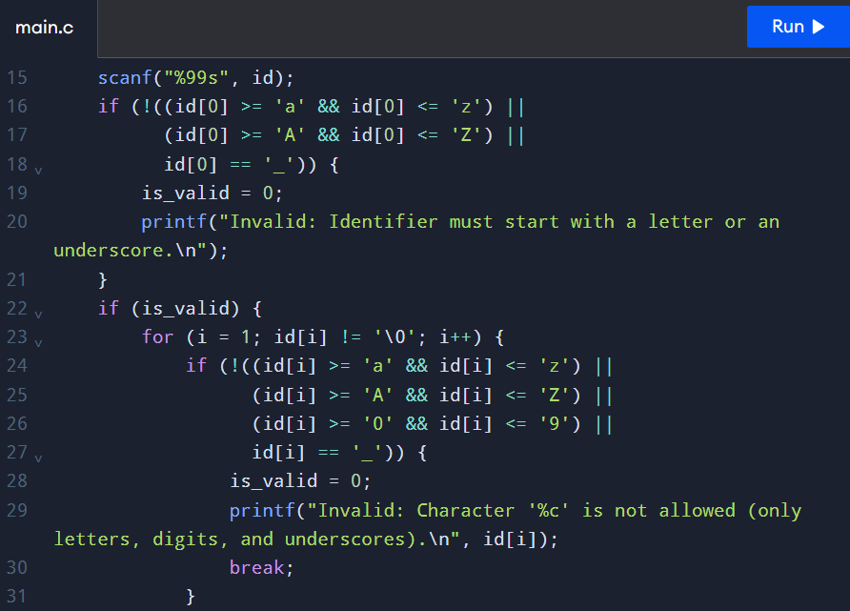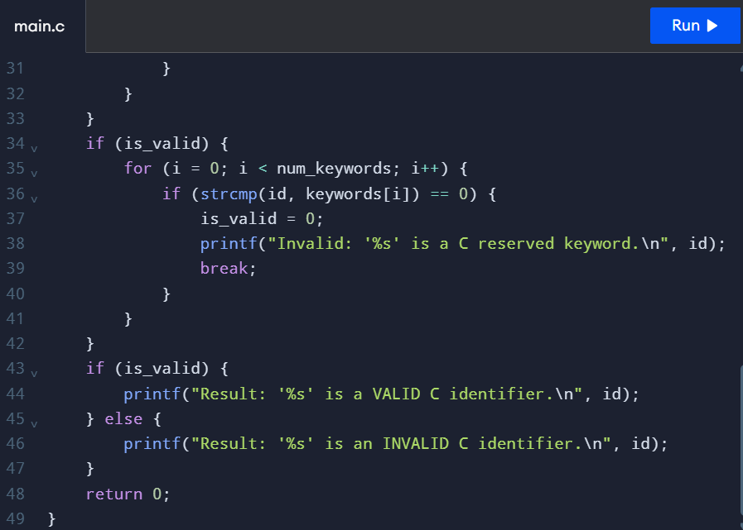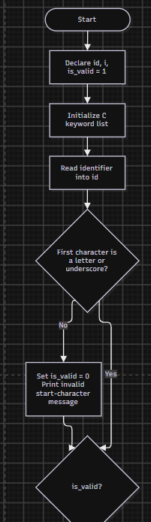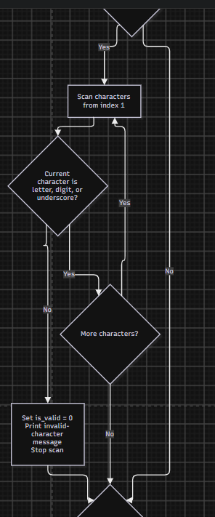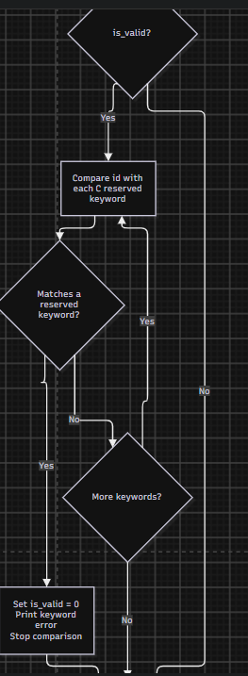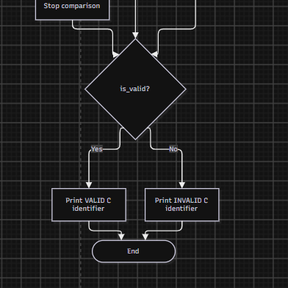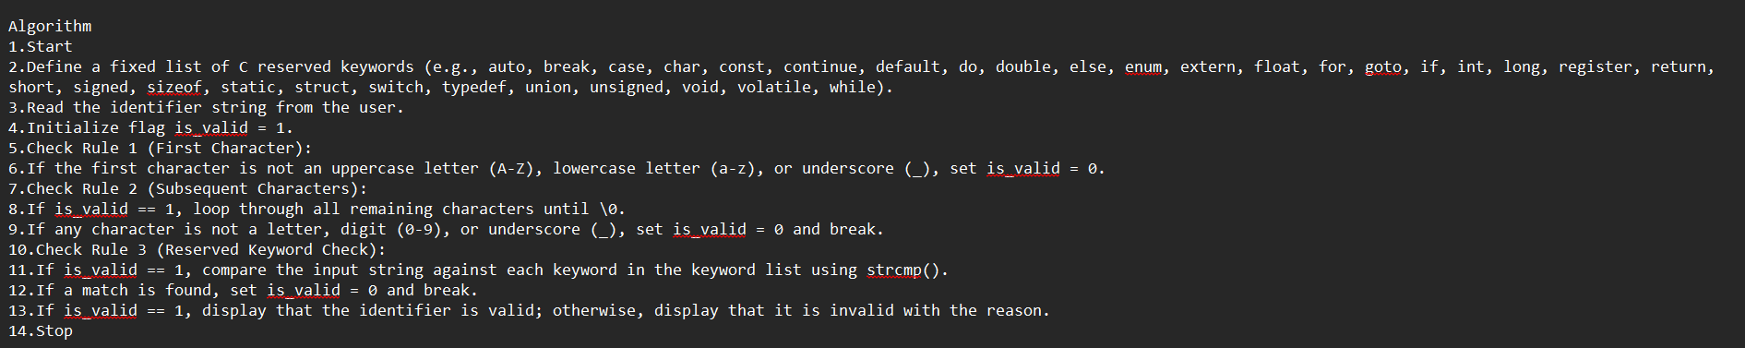

Output:
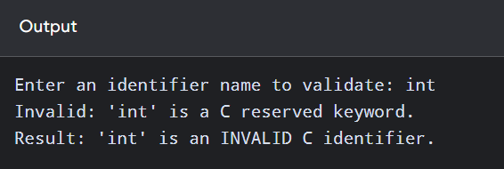

Signature of faculty in-charge with Date:

