Experiment No. 4
Arrays

Aim
- To understand the concept of an array as a collection of elements of the same type.
- To learn how to declare, initialize, and traverse one-dimensional and two-dimensional arrays.
- To perform common array operations: sum, average, searching, and finding the maximum/minimum.
- To perform basic operations on two-dimensional arrays (matrices).

Theory

What is an Array?
An array is a collection of elements of the same data type, stored in contiguous memory locations and accessed using a single variable name and an index. Instead of declaring marks1, marks2, marks3, ... separately, an array lets us write marks[0], marks[1], marks[2], ....
dataType arrayName[size];
Important: Array indices in C always start from 0, not 1. An array of size n has valid indices from 0 to n-1.

Declaring, Initializing, and Displaying a 1D Array
Sample Program 1: Declare, Initialize, and Display an Array
# include <stdio .h> int main () {
int arr [5] = {10 , 20 , 30 , 40 , 50};
int i;

printf(" Array elements: "); for ( i = 0; i < 5; i++) {
printf("% d ", arr[ i]);
}
printf("\ n"); return 0;
}

Reading Elements and Computing Sum/Average

Sample Program 2: Sum and Average of Array Elements
# include <stdio .h>

int main () {
int arr[5], i, sum = 0; float avg;

printf(" Enter 5 elements: "); for ( i = 0; i < 5; i++) {
scanf("% d", & arr[i]); sum += arr[i];
}
avg = ( float) sum / 5;

printf(" Sum = % d\ n", sum ); printf(" Average = %.2 f\ n", avg); return 0;
}

Searching an Array (Linear Search)

Sample Program 3: Linear Search
# include <stdio .h>

int main () {
int arr [5] = {12 , 45 , 7 , 23 , 9};
int key , i, found = 0;

printf(" Enter element to search : "); scanf("% d", & key );

for ( i = 0; i < 5; i++) { if ( arr[ i] == key ) {
printf(" Found at index % d\ n", i); found = 1;
break ;
}
}
if (! found )
printf(" Element not found \ n"); return 0;
}

Finding the Largest and Smallest Element

Sample Program 4: Largest and Smallest Element
# include <stdio .h>

int main () {
int
int
arr [6] = {34 , 12 , 89 , 5 , 67 , 23};
i,
max = arr[0], min = arr [0];
for ( i = 1; i < 6; i++) {
if ( arr[ i] > max) max = arr[i]; if ( arr[ i] < min ) min = arr[i];
}
printf(" Largest = % d\ n", max); printf(" Smallest = % d\ n", min ); return 0;
}

Introduction to Two-Dimensional (2D) Arrays
A 2D array stores data in rows and columns, declared as dataType arr[rows][cols];, and is stored in memory in row-major order.

Sample Program 5: Declare, Initialize, and Display a 2D Array
# include <stdio .h>

int main () {
int matrix [2][3] = {{1 , 2 , 3}, {4 , 5 , 6}};
int i, j;

for ( i = 0; i < 2; i++) {
for (j = 0; j < 3; j++) { printf("% d ", matrix [i][ j]);
}
printf("\ n");
}
return 0;
}

Basic Matrix Operation: Addition

Sample Program 6: Addition of Two Matrices
# include <stdio .h>

int main () {
int
int int int
a [2][2] =
b [2][2] =
c[2 ][2];
i, j;
{{1 , 2}, {3 , 4}};
{{5 , 6}, {7 , 8}};
for ( i = 0; i < 2; i++) {
for (j = 0;
c[ i][ j]
}
j < 2; j++)
= a[i][ j] +
{
b[ i][ j];
}

printf(" Sum Matrix :\ n"); for ( i = 0; i < 2; i++) {
for (j = 0; j < 2; j++) { printf("% d ", c[i][ j]);
}
printf("\ n");
}
return 0;
}

Points to remember:
  - An array’s size must be a constant known at compile time in basic C — it cannot be resized once declared.
  - Accessing an index outside the array’s valid range (e.g., arr[10] for a 10-element array) does not cause a compile error — it silently reads/writes unrelated memory, which is undefined behavior.
  - A 2D array arr[i][j] always needs two indices and, typically, a nested loop to traverse it fully.

Laboratory Tasks

Task 1 : Array Input, Sum, and Average
Write a C program to read N elements into an array and display them, along with their sum and average.
#include<stdio.h>
int main(){
int i,sum=0,n[10],average;
printf("Enter 5 values\n");
for (i=0;i<=4;i++)
{
printf("Enter value: ");
scanf("%d",&n[i]);
}
printf("\n");
for (i=0;i<=4;i++)
{
sum=sum+n[i];
printf("Array elements:%d\n",n[i]);
}
printf("\nSum of elements:%d\n",sum);
average=sum/5;
printf("\nAverage of elements:%d\n",average);
return 0;
}

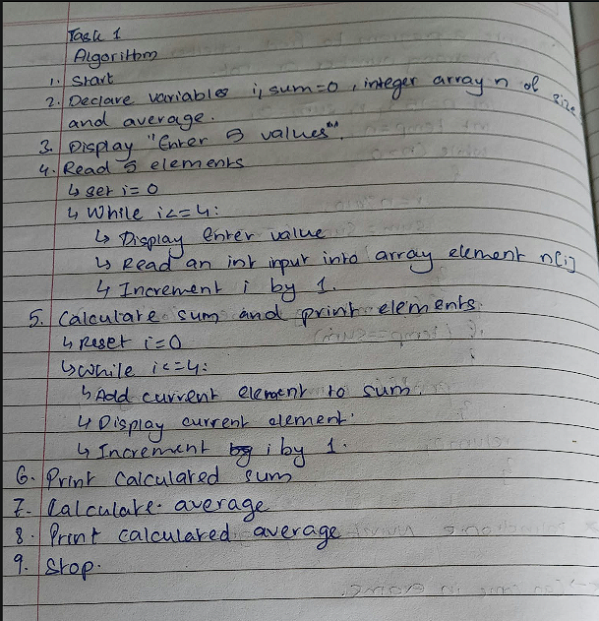

Task 2 : Largest, Smallest, and Their Positions
Write a C program to find the largest and smallest elements in an array, and also display the index (position) at which each was found.
#include<stdio.h>
int main(){
int i,n[10],max=0,min=0,pos,pos1=0;

printf("Enter 5 values\n");
for (i=0;i<=4;i++)
{
printf("Enter value: ");
scanf("%d",&n[i]);
}
max=n[0];
min=n[0];
for (i=1;i<=4;i++)
{
if (n[i]>max)
{
max=n[i];
pos=i;
}
}
for (i=1;i<=4;i++)
{
if (n[i]<min)
{
min=n[i];
pos1=i;
}
}
printf("Largest number is %d and its position is %d\n",max,pos);
printf("Smallest number is %d and its position is %d",min,pos1);

return 0;
}

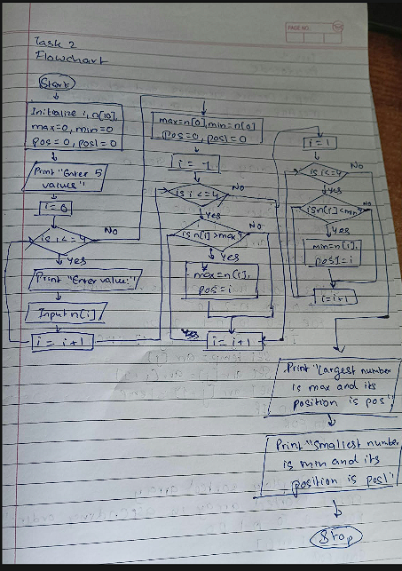

Task 3 : Sort and Search
Write a C program that:
  - Sorts an array of N elements in ascending order using the bubble sort technique.
  - Displays the sorted array.
  - Then accepts a search key from the user and performs a linear search on the sorted array, displaying the element’s position, or a “not found” message.
#include <stdio.h>

int main() {
int n, i, j, temp, key, found = 0;

printf("Enter the number of elements: ");
scanf("%d", &n);

int arr[n];
printf("Enter %d elements:\n", n);
for (i = 0; i < n; i++) {
scanf("%d", &arr[i]);
}
for (i = 0; i < n - 1; i++) {
for (j = 0; j < n - i - 1; j++) {
if (arr[j] > arr[j + 1]) {
// Swap adjacent elements
temp = arr[j];
arr[j] = arr[j + 1];
arr[j + 1] = temp;
}
}
}
printf("\nSorted array in ascending order:\n");
for (i = 0; i < n; i++) {
printf("%d ", arr[i]);
}
printf("\n");

printf("\nEnter the element to search: ");
scanf("%d", &key);

for (i = 0; i < n; i++) {
if (arr[i] == key) {
printf("Element %d found at position %d (index %d).\n", key, i + 1, i);
found = 1;
break;
}
}

if (!found) {
printf("Element %d not found in the array.\n", key);
}

return 0;
}

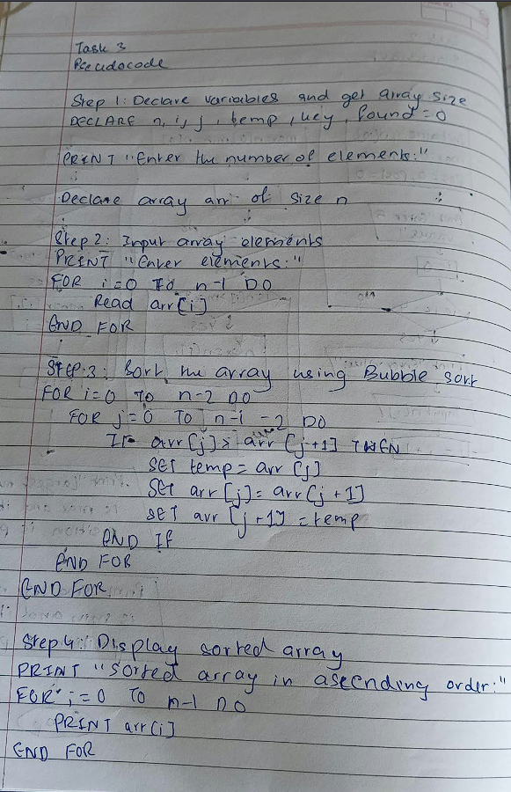

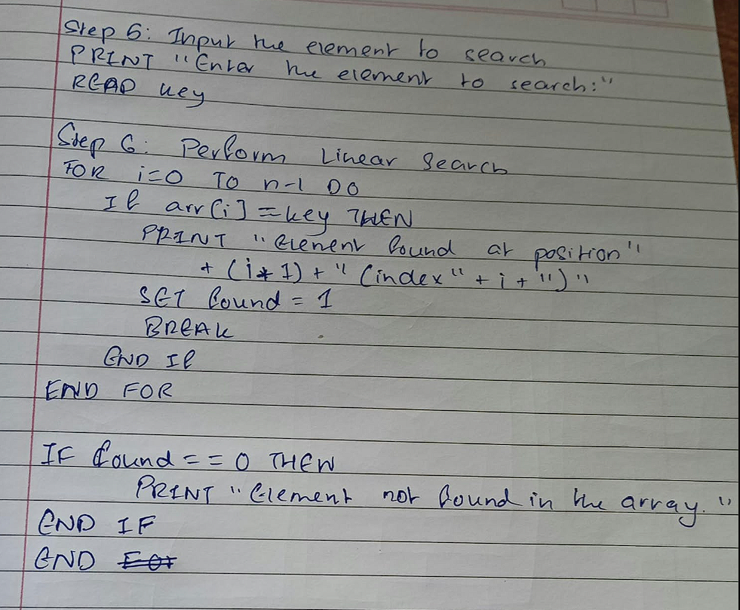

Additional Practice Tasks
- Write a C program to count how many even and odd numbers are present in an array.
- Write a C program to reverse the elements of an array in place (i.e., without using a second array).
- Write a C program to count the number of duplicate elements present in an array.
- Write a C program to merge two arrays into a third array, and then sort the merged array in ascending order.
- Write a C program to find the transpose of a given M × N matrix and display it.

Post-Lab Questions

Conceptual Questions
- What is an array? How does it differ from declaring several individual variables?
  - An array is a data structure that stores a fixed-size, sequential collection of elements of the same data type
  - With individual variables, you have to refer to each by its unique name (a,b,c). With an array, you use a single name and an index number (arr[0],arr[1],arr[2]), which allows you to use loops to quickly process thousands of items in a few lines of code.

- Why do array indices in C start from 0 instead of 1?
In C array indices start at 0 because the index represents an offset from the starting memory address of the array.
- What happens, in practice, if a program accesses an array element outside its declared bounds?
when you try to access a memory address outside the segment allocated to your program by the operating system. The OS detects the violation and immediately kills the program

Array Operations Questions
- Why is the technique used in Sample Program 3 called linear search?
The for (i = 0; i < 5; i++) loop forces the program to check the key against arr[0], then arr[1], then arr[2], and so on, without skipping any elements
- Write the general condition used to check whether an index i is within the valid bounds of an array of size n.
i<n
- How is a 2D array’s data organized in memory (row-major order), and why does this matter when choosing loop order?
  - In row-major order, a two-dimensional array is stored in contiguous 1D memory by placing consecutive elements of each row sequentially.
  - Loop order determines whether memory is accessed sequentially or with strided jumps. This choice directly impacts performance via spatial locality and CPU cache efficiency.Iterating through rows in the outer loop and columns in the inner loop accesses elements in the exact order they are stored in memory.Iterating through columns in the outer loop and rows in the inner loop jumps across memory by strides of C elements.

- Why must the size of a basic C array be known in advance, unlike in some higher-level languages?
  - A basic C array requires a fixed size for three primary reasons:
  - Local arrays are allocated on the call stack. The compiler needs to know the array's exact size upfront to calculate the size of the stack frame and generate direct memory offsets for variables.
  - Unlike higher-level languages (like Python or Java), C arrays have zero object overhead. They exist purely as raw, contiguous memory blocks with no hidden runtime metadata to track dynamic length or capacity.
  - Stack variables are stored sequentially adjacent to one another. Allowing a basic array to grow dynamically in place would overwrite neighboring stack variables, function return addresses, or frame pointers.

Tracing Questions
- Trace the first pass of bubble sort on the array {5, 2, 8, 1}, showing the array’s contents after each swap.
  - Initial Array: {5, 2, 8, 1}
  - First Pass Trace:
  - Compare 5 and 2: Since 5 > 2, swap 5 and 2.
  - Array after swap: {2, 5, 8, 1}
  - Compare 5 and 8: Since 5 < 8, no swap occurs.
  - Array contents: {2, 5, 8, 1}
  - Compare 8 and 1: Since 8 > 1, swap 8 and 1.
  - Array after swap: {2, 5, 1, 8}
  - Array at the end of Pass 1: {2, 5, 1, 8} (the largest element, 8, has bubbled to the final position).
- Trace the output: int arr[4] = {3, 6, 9, 12}; int sum = 0; for (int i
= 0; i < 4; i++) if (arr[i] % 2 == 0) sum += arr[i]; What is the final value of sum?
Iteration 0: i = 0, arr[0] = 3 -> Condition (3 % 2 == 0) is false -> sum = 0
Iteration 1: i = 1, arr[1] = 6 -> Condition (6 % 2 == 0) is true -> sum = 0 + 6 = 6
Iteration 2: i = 2, arr[2] = 9 -> Condition (9 % 2 == 0) is false -> sum = 6
Iteration 3: i = 3, arr[3] = 12 -> Condition (12 % 2 == 0) is true -> sum = 6 + 12 = 18
The final value of the sum is 18.
- For int arr[10];, explain why arr[10] is an invalid access, even though 10 seems like the natural “next” index after declaring 10 elements.
In C, array indexing is 0-based,meaning an array declared as int arr[10]; allocates space for 10 elements spanning indices 0 through 9. Accessing arr[10] attempts to access an 11th element, which lies outside the memory allocated for the array and results in undefined behavior.

Learning Outcome
After completing this experiment, students will be able to:
  - Declare, initialize, and traverse one-dimensional and two-dimensional arrays.
  - Perform common array operations: sum, average, searching, sorting, and finding the maximum/minimum.
  - Understand why array bounds checking matters in C.
  - Apply nested loops to process two-dimensional array (matrix) data.

