Name : Siddhant Patil

Scholar Number : 211112238

DS Assignment - 02

B.Tech. CSE

CSE Section -2

1) Time Complexity Analysis :

#include<bits/stdc++.h>

using namespace std;

typedef long long ll;

void timeAnalysis(int a[],int n){

    srand(0);

    int k = rand()%n ;

    clock_t s_time , e_time ;

            //start    end

    //O(1) Constant Time Complexity :: Accessing and increasing element by 1

    // cout<<a[k]<<endl;

    s_time = clock(); //Noting starting time

    a[k]=a[k]+1;

    e_time = clock(); //Noting end time

    double total_time = e_time - s_time; //Difference

    cout<<(double)total_time/(double)CLOCKS_PER_SEC<<"  ";

    //O(n) :: Increasing element by one

    s_time = clock();

    for (int i = 0; i < n; i++)

    {

        a[i]=a[i]+1;

    }

    e_time =clock();

    total_time = e_time - s_time; //Difference

    cout<<(double)total_time/(double)CLOCKS_PER_SEC<<"  ";

    //O(n^2) :: Sorting Array

    s_time = clock();

    for(int i=0;i<n-1;i++){

        for(int j=i+1;j<n;j++)

            if(a[i]>a[j+1]){

                swap(a[i],a[j]);

            }

            else

            continue;

    }

    e_time =clock();

    total_time = e_time - s_time; //Difference

    cout<<(double)total_time/(double)CLOCKS_PER_SEC<<"  ";

}

int main(){

ios_base::sync_with_stdio(false);

cin.tie(NULL);

cout<<"O(1)  O(n)  O(n^2)\n";

int t=4;

    int n=1000;

    while(t--){

    n=n*2;

    int a[n];

    srand(time(0));

    for(int i=0;i<n;i++) a[i]=rand()%n+1;

    timeAnalysis(a,n);

    cout<<"\n";

    }

return 0;

}

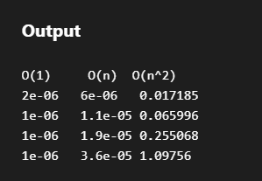

O(1) :Constant Value Function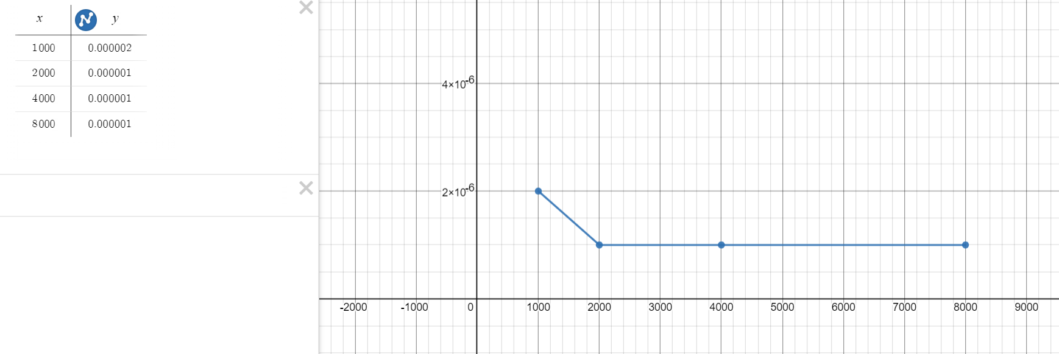

O(n) : Linear Curve

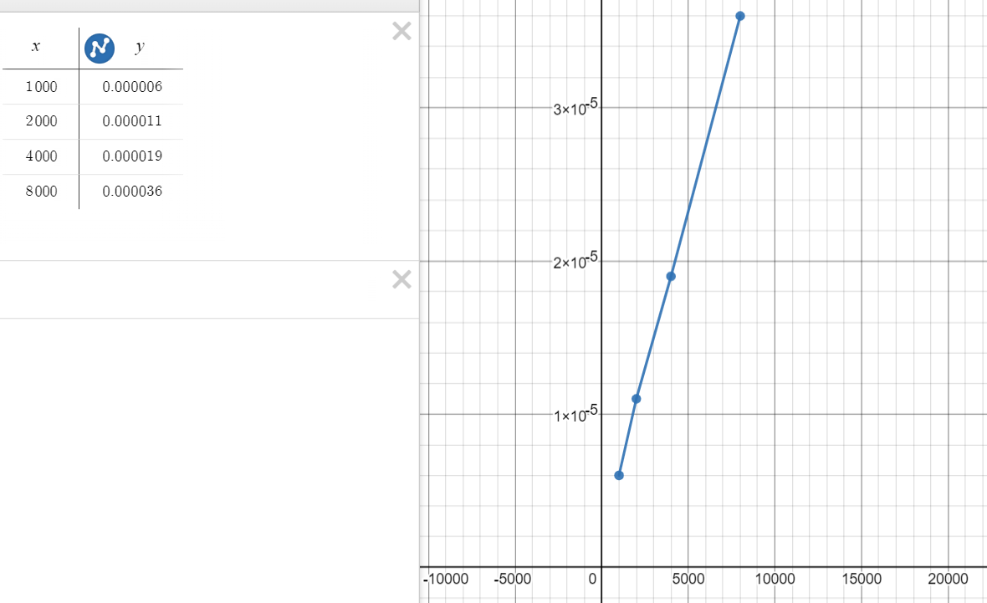

O(n^2) : Parabolic Curve

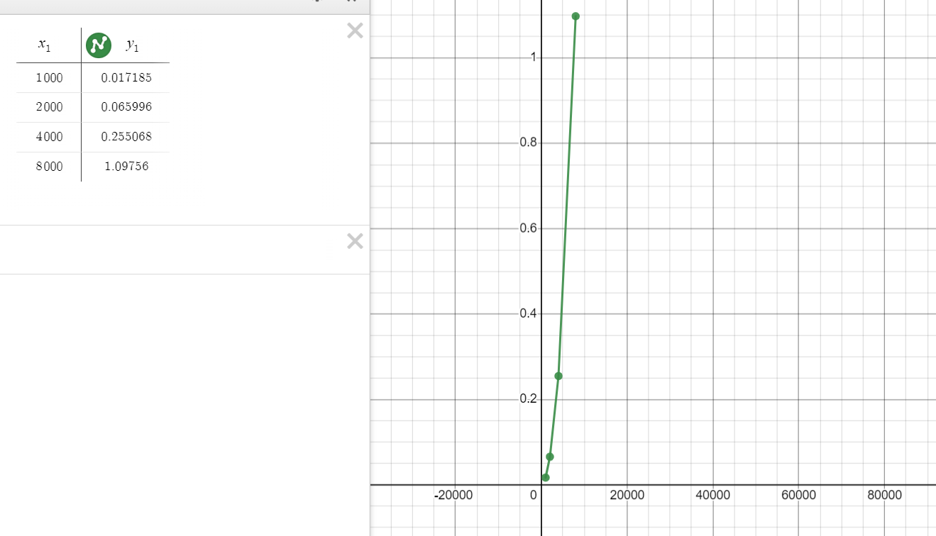

2) Program to find number of days between 2 given dates .

from datetime import date

# Function to find number of days

def numOfDays(date1, date2):

    return (date2-date1).days

d,m,y= input("Enter date-1 : ").split()

date1 = date( int(y), int(m), int(d))

d,m,y= input("Enter date-2 : ").split()

date2= date( int(y), int(m), int(d))

ans = numOfDays(date1,date2)

if ans>0:

    print(ans, "days");

else:

    print(-ans, "days")

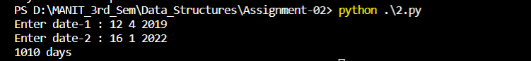

3) Find day of the week for the given date .

// C++ program to Find the Day

#include <bits/stdc++.h>

using namespace std;

int Zellercongruence(int day, int month, int year)

{

    if (month == 1) {

        month = 13;

        year--;

    }

    if (month == 2) {

        month = 14;

        year--;

    }

    int q = day;

    int m = month;

    int k = year % 100;

    int j = year / 100;

    //Zeller's Formula :

    int h = q + 13 * (m + 1) / 5 + k + k / 4 + j / 4 + 5 * j;

    h = h % 7;

    switch (h) {

    case 0:

        cout << "Saturday \n";

        break;

    case 1:

        cout << "Sunday \n";

        break;

    case 2:

        cout << "Monday \n";

        break;

    case 3:

        cout << "Tuesday \n";

        break;

    case 4:

        cout << "Wednesday \n";

        break;

    case 5:

        cout << "Thursday \n";

        break;

    case 6:

        cout << "Friday \n";

        break;

    }

    return 0;

}

int main()

{

int d,m,y;

    cin>>d>>m>>y;

    Zellercongruence(27,02,2023); // date (dd/mm/yyyy)

    return 0;

}



4) Convert integer ‘n seconds’ into days , hours , minutes , seconds .

#include<bits/stdc++.h>

using namespace std;

typedef long long ll;

int main(){

ios_base::sync_with_stdio(false);

cin.tie(NULL);

    int n; cin>>n;

    // 1h = 60*60 s

    // 24h = 3600*24

    int temp = n;

    int d = n/(24*3600);

    int h = (n%(24*3600))/(24*60);

    int m = ((n%(24*3600))%(24*60)/60);

    int s = ((n%(24*3600))%(24*60)%60);

    cout<<temp<<" Seconds = "<<d<<" Days "<<h<<" hours "<<m<<" minutes "<<s<<" seconds ";

return 0;

}

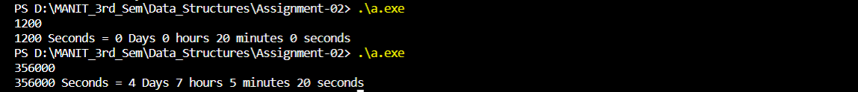

5) Convert number of days ‘n’ into years , weeks and days .

#include<bits/stdc++.h>

using namespace std;

typedef long long ll;

int main(){

ios_base::sync_with_stdio(false);

cin.tie(NULL);

    int n;

    cin>>n;

    int y = n/365;

    int w = (n%365)/7;

    int d = (n%365)%7;

    cout<<y<<" Years "<<w<<" Weeks "<<d<<" Days \n";

return 0;

}



6) Calculate age .

from datetime import date

def age(birthdate):

    today = date.today()

    age = today.year - birthdate.year - ((today.month, today.day) < (birthdate.month, birthdate.day))

    return age

birthdate = date(2002,2,1)

print(age(birthdate))



7) Leap Year or not ?

//Leap Year

#include <iostream>

using namespace std;

int main() {

    int year;

    cin>>year;

    if(((year % 4 == 0) && (year % 100 != 0)) ||(year % 400 == 0)){

        cout<<"Leap Year\n";

    }

    return 0;

}

