Siddhant Patil
211112238 CSE-2
ML Assignment 1

Ans.1.
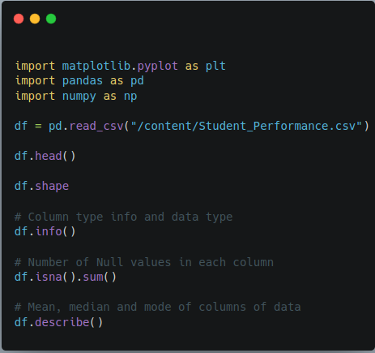

ML_theory_assignment.ipynb has been attached for all the output .
df.shape (important for next answer)
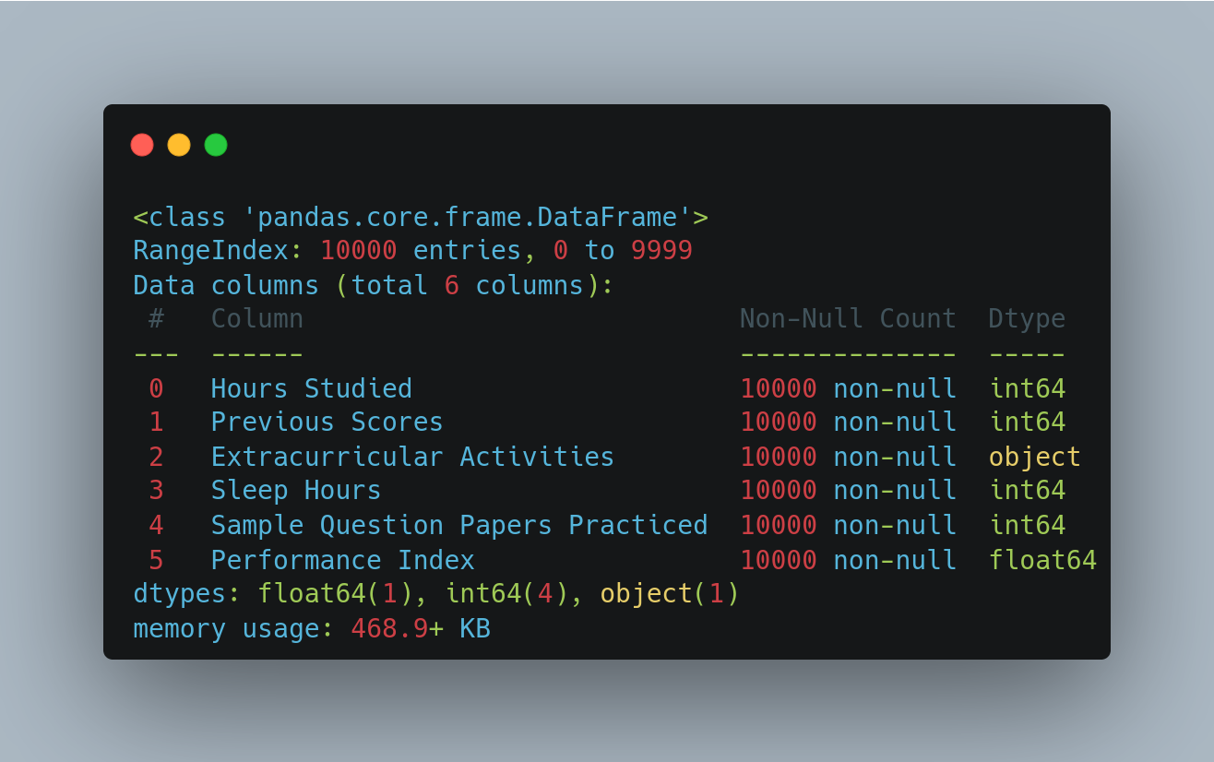

Ans.2.
