Speech Analysis Report

Objective
The purpose of this analysis is to examine the acoustic properties of spoken utterances using Praat software. The focus is on waveform, pitch contour, spectrogram, and phonetic segmentation for two speech samples.

Tools Used
Praat: A software tool for phonetic analysis of speech.
- Features Analyzed:
- Waveform
- Pitch contour
- Spectrogram
- TextGrid annotations (words and phonemes)

Data Description
Two segments of speech were analyzed:
1. Segment 1: “seventy and successor is expected to be named in March…”
2. Segment 2: “ago and for last year’s legislative approval of thirty…”
Each segment was annotated with:
- Word tier: Displays the spoken words.
- Phone tier: Shows phonetic transcription.
- Pitch tier: Indicates pitch variation in Hertz (Hz).

Observations

1. Waveform Analysis
The waveform shows amplitude variations corresponding to speech intensity.
Segment 1 duration: ~25.3 seconds; Segment 2 duration: ~30.7 seconds.
Peaks in amplitude correspond to stressed syllables (e.g., “seventy”, “approval”).
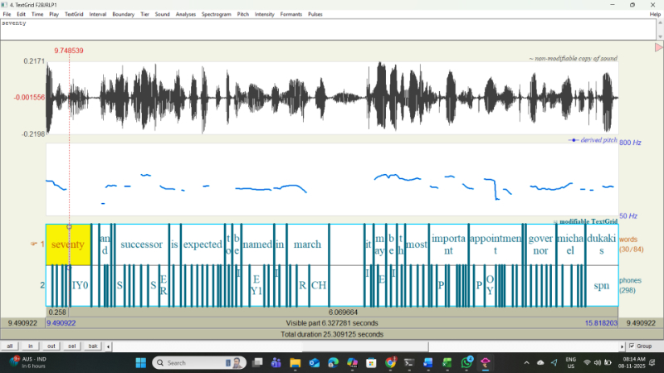
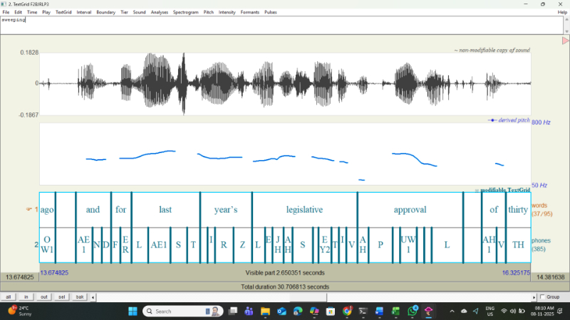

2. Pitch Contour
Pitch range for Segment 1: ~50 Hz to 800 Hz.
Pitch range for Segment 2: ~50 Hz to 800 Hz.
Smooth pitch transitions indicate normal intonation patterns.
Segment 1 shows a slight rise on “seventy” and fall towards “March”.
Segment 2 shows rising pitch on “last year’s” and falling on “approval”.

3. Spectrogram Analysis
Darker bands represent formants (resonant frequencies).
Segment 1: Clear formant structure visible for vowels in “seventy” and “successor”.
Segment 2: Dense formant patterns during “legislative approval”, indicating complex vowel-consonant clusters.
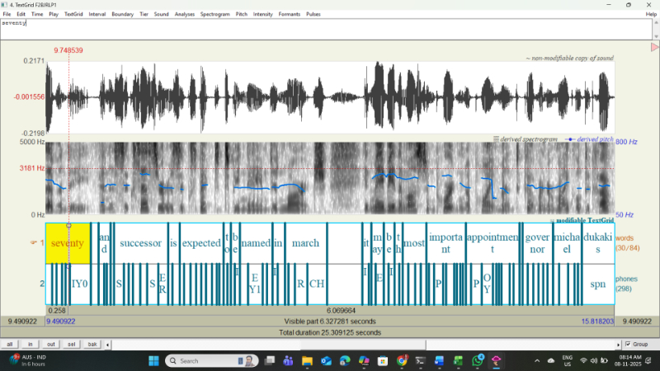
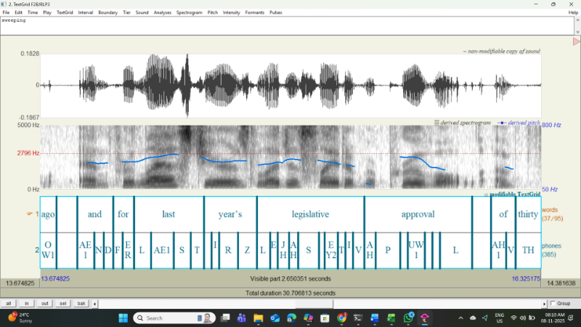

4. TextGrid Annotation
Words and phonemes are accurately segmented.
Segment 1: 30 words, 298 phonemes.
Segment 2: 37 words, 385 phonemes.
Phonetic tier includes IPA symbols for precise articulation analysis.

Acoustic Features
- Intensity: Higher during stressed syllables.
- Pitch: Indicates declarative sentence pattern with falling intonation.
- Spectral Energy: Concentrated in lower frequencies for vowels; higher for fricatives.

Conclusion
The analysis demonstrates typical English intonation and phonetic segmentation. Praat effectively visualizes acoustic properties, aiding linguistic and phonetic research. Both segments exhibit normal speech patterns with clear pitch and formant structures.

References
Boersma, P., & Weenink, D. (Praat: Doing Phonetics by Computer).
Acoustic Phonetics principles.

